Advisory
Circular

TITLE 14 OF THE CODE OF FEDERAL REGULATIONS (14 CFR) GUIDANCE MATERIAL

Subject: ACCEPTABLE METHODS, TECHNIQUES, AND PRACTICES⎯AIRCRAFT INSPECTION AND REPAIR | Date: 9/8/98  Initiated by: AFS-640 | AC No: 43.13-1B  Change: 1

- PURPOSE. This advisory circular (AC) contains methods, techniques, and practices acceptable to the Administrator for the inspection and repair of nonpressurized areas of civil aircraft, only when there are no manufacturer repair or maintenance instructions. This data generally pertains to minor repairs. The repairs identified in this AC may only be used as a basis for FAA approval for major repairs. The repair data may also be used as approved data, and the AC chapter, page, and paragraph listed in block 8 of FAA form 337 when:
- the user has determined that it is appropriate to the product being repaired;
- it is directly applicable to the repair being made; and
- it is not contrary to manufacturer’s data.
2. CANCELLATION. The AC 43.13-1A dated 1988 is canceled.
3. REFERENCE: Title 14 of the Code of Federal Regulations part 43, section 43.13(a) states that each person performing maintenance, alteration, or preventive maintenance on an aircraft, engine, propeller, or appliance shall use the methods, techniques, and practices prescribed in the current manufacturer’s maintenance manual or Instructions for Continued Airworthiness prepared by its manufacturer, or other methods, techniques, or practices acceptable to the Administrator, except as noted in section 43.16. FAA inspectors are prepared to answer questions that may arise in this regard. Persons engaged in the inspection and repair of civil aircraft should be familiar with 14 CFR part 43, Maintenance, Preventive Maintenance, Rebuilding, and Alteration, and part 65, Subparts A, D, and E of Certification: Airmen Other Than Flight Crewmembers, and the applicable airworthiness requirements under which the aircraft was type certificated.
4. ACKNOWLEDGMENTS. The FAA would like to thank the following persons and organization for their assistance in producing AC 43.13-1B: Richard Finch, Richard Fischer, Michael Grimes, Ray Stits, William A. Watkins, and the SAE, Aerospace Electronics and Electrical Systems Division. Acknowledgment is also extended to all in the aviation community who commented on the document.
5. COMMENTS INVITED. Comments regarding this AC should be directed to DOT/FAA;
ATTN: Airworthiness Programs Branch, AFS-610; PO Box 25082; Oklahoma City, OK 73125
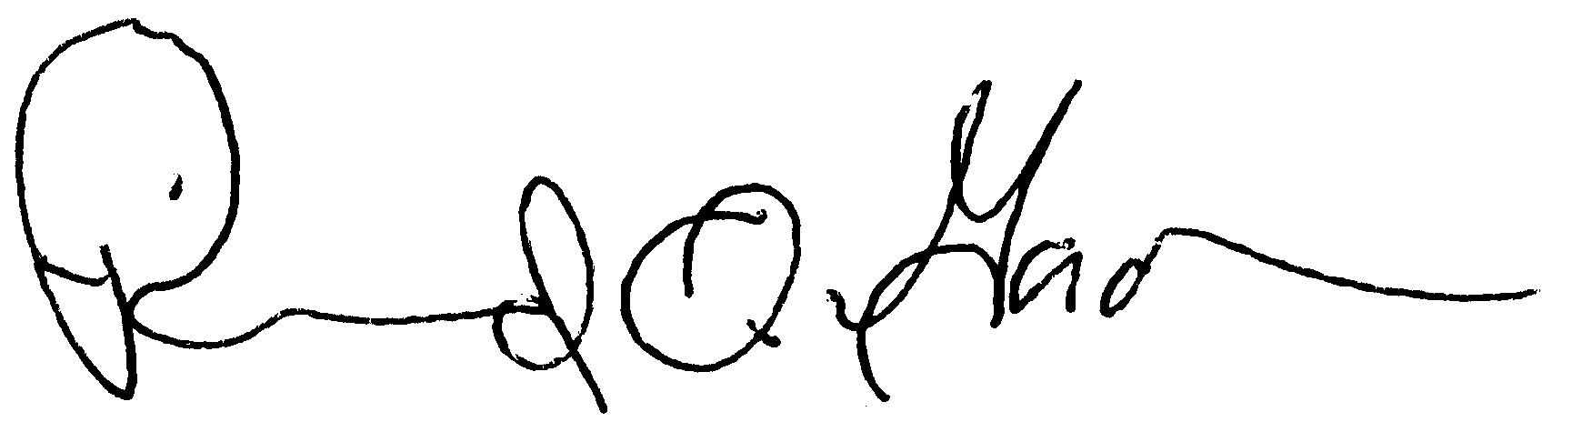
Acting Deputy Director, Flight Standards Service

