Section 4. REPAIRS

GENERAL. The basic standard for any aircraft repair is that the repaired structure must be as strong as the original structure and be equivalent to the original in rigidity and aerodynamic shape. Repairs should be made in accordance with manufacturer specifications whenever such data is available.

REPLACEMENT OF DRAIN HOLES AND SKIN STIFFENERS. Whenever repairs are made that require replacing a portion that includes drain holes, skin stiffeners, or any other items, the repaired portion must be provided with similar drain holes, skin stiffeners, or items of the same dimensions in the same location. Additional drain holes may be required if reinforcement under a skin repair interferes with waterflow to existing drain holes. Make any additional drain holes the same diameter as originals, usually 1/4 inch.

CONTROL SURFACE FLUTTER PRECAUTIONS. When repairing or refinishing control surfaces, especially on high-performance airplanes, care must be exercised that the repairs do not involve the addition of weight aft of the hinge line. Such a procedure may adversely affect the balance of the surface to a degree that could induce flutter. As a general rule, it will be necessary to repair control surfaces in such a manner that the structure is identical to the original, and that the stiffness, weight distribution, and mass balance are not affected in any way. Consult the aircraft maintenance manual or seek manufacturer’s direction for specific requirements on checking control surface balance after repair and refinishing of any control surface.

SCARF JOINTS. The scarf joint is the most satisfactory method of making an end joint between two solid wood members. Cut

both parts accurately. The strength of the joints depends upon good joint design and a thin, uniform bond line. Make the scarf cut in the general direction of the grain slope as shown in figure 1-4.

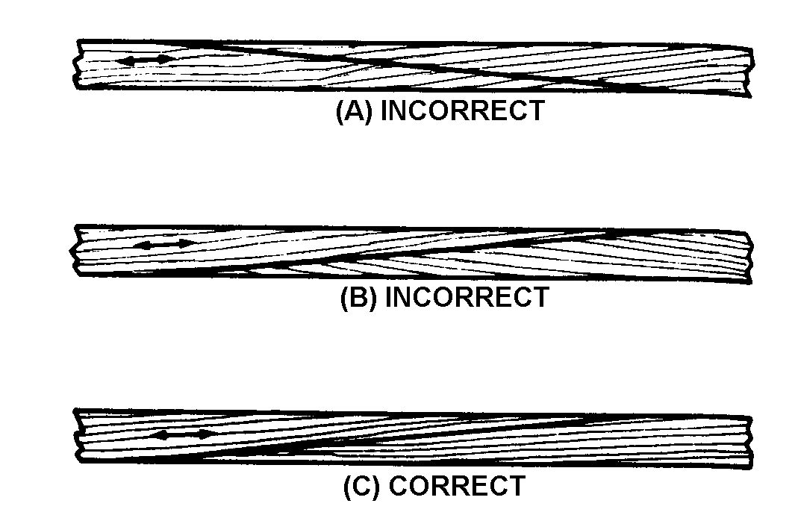

No grain deviation steeper than 1 in 15 should be present in an outer eighth of the depth of the spar. In adjacent eighths, deviations involving steeper slopes, such as a wave in a few growth layers, are unlikely to be harmful. Local grain slope deviations in excess of those specified may be permitted in spar flanges only in the inner one-fourth of the flange depth.

Figure 1-4. Consideration of grain direction when making scarf joints.

SPLICING OF SPARS. Unless otherwise specified by the manufacturer, a spar may be spliced at any point except under the wing attachment fittings, landing gear fittings, engine mount fittings, or lift and interplane strut fittings. These fittings may not overlap any part of the splice. A spar splice repair should not be made adjacent to a previous splice or adjacent to a reinforcing plate. Spacing between two splices or between a splice and a reinforcing plate should be no less than three times the length of the longer splice.

Splicing under minor fittings such as drag wire, antidrag wire, or compression strut fittings is acceptable under the following conditions:

The reinforcement plates of the splice should not interfere with the proper attachment or alignment of the fittings. Do not alter the locations of pulley support brackets, bellcrank support brackets, or control surface support brackets. Plates are to be tapered off, as depicted in figure 1-2.

The reinforcement plate may overlap drag wire, antidrag wire, or compression strut fittings, if the reinforcement plates are on the rear face of the rear spar or the front face of the front spar. In such cases, it will be necessary to install slightly longer bolts. The front face reinforcement plate should not overlap drag strut fittings, except when it does not require sufficient shortening of compression struts or changes in drag-truss geometry, to prevent adjustment for proper rigging. Even though take up is sufficient, it may be necessary to change the angles on the fittings. (Acceptable methods for splicing the various types of spars are shown in figure 1-4 through figure 1-9.) Reinforcement plates must be used as indicated on all scarf repairs to spars and the slopes of scarves shown are minimum slopes.

SPAR REPLACEMENT. Replacement of spars is a major repair. Spars may be replaced by new parts made by the manufacturer or the holder of a Parts Manufacturer Approval (PMA) for that part. Owner-produced spars may be installed providing they are made from a manufacturer-approved drawing. Also, a spar may be made by reference to an existing spar providing sufficient evidence is presented to verify that the existing spar is an original part, and that all materials and dimensions can be determined. The dimensions and type of wood used are critical to the structural strength

of the aircraft. Care should be taken that any replacement spars accurately match the manufacturer’s original design.

SPLICING OF BOX SPAR WEBS. Always splice and reinforce plywood webs with the same type of plywood as found on the original part. Do not use solid wood to replace plywood webs. Plywood is stronger in shear than solid wood of the same thickness due to the grain direction of the individual plies. The face-grain of plywood replacement webs and reinforcement plates must be in the same direction as the original member to ensure that the new web will have the required strength. (The method of splicing plywood webs is shown in figure 1-9.)

REPLACING SOLID-TYPE SPARS WITH LAMINATED-TYPE SPARS. Solid spars may be replaced with laminated spars or vice versa, provided the material is of the same high quality. External reinforcements (plywood or solid) must always be replaced as on the original member.

SPAR LONGITUDINAL CRACKS AND LOCAL DAMAGE. Cracked spars (except box spars) may be repaired by bonding plates of spruce or plywood of sufficient thickness to develop the longitudinal shear on both sides of the spar. Extend the plates well beyond the termination of the cracks, as shown in figure 1-10. A method of repairing small local damage to either the top or bottom side of a spar is also shown in figure 1-10.

Longitudinal Cracking of Wood Wing Spars of Aircraft Operating in Arid Regions. Aircraft having wood spars and operating in arid regions may develop longitudinal spar cracks in the vicinity of the plywood reinforcement plates. These cracks result from the tendency of the spar to shrink when drying takes place. Plywood resists this tendency to
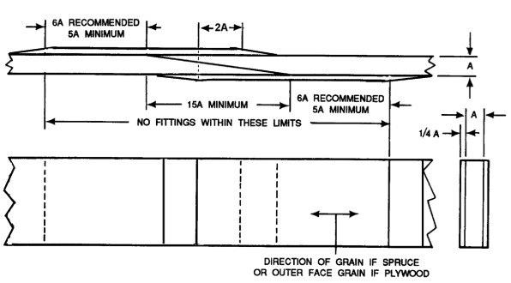

Reinforcement plates to be spruce or plywood and should be bonded only,
with the ends feathered off at 5:1 slope as depicted in Figure 1-2.
Solid spars may be replaced with laminated spars or vice versa,
provided the material is of the same high quality.

Figure 1-5. Method of splicing solid or laminated rectangular spars.

shrink and causes the basic spar stock to split (see paragraph 1-2c). Cracks start under the plywood plates, usually (but not necessarily) at a bolt hole or cutout, and usually spread in each direction until they extend a short distance beyond the ends of the plates where the resistance to spar shrinkage disappears. Cracks have also been found in the butt end of spars. Other factors, which have been found conducive to the formation of cracks are poor protective finishes, large cutouts, and metal fittings that utilize two lines of large diameter bolts.

Repairing Cracks Versus Installing a New Spar. The presence of cracks does not necessarily mean that the spar must be discarded. If the crack is not too long or too close to either edge and can be reinforced properly, it will probably be more economical and

satisfactory to perform repair rather than install a new spar or section. However, a generally acceptable procedure suitable for all airplane models is not available. Because of the possibility of strength deficiencies contact the manufacturer. In absence of the manufacturer, the FAA should be contacted for approval before making repairs not in accordance with the manufacturer-approved instructions or the recommendations of this advisory circular. Longitudinal cracking or the recurrence of cracking can be minimized by ensuring that the moisture content of the solid wood portion is within the proper range before bonding. In arid desert areas, during bonding the moisture content should be in the range of 6-8 percent before bonding, but in other areas 10-12 percent is satisfactory. If solid or plywood repair stock is procured from another climatic region, it should be allowed to season,

If splice is made where routing is feathered to full width of spar, tapered plates (conforming to the contour of the routing) should be added first; otherwise, the splice is the same as shown.
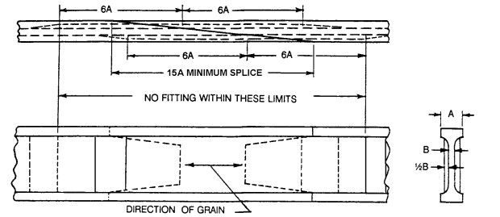

Reinforcement plates may be of plywood, the same material as the spar, or material of equal or higher quality; and should be bonded only with ends feathered out with a 5:1 slope.

Figure 1-6. Method of splicing solid “I” spars.

in the same storage area as the part to be repaired, for no less than 2 weeks.

Preventing Cracks. An important step in the prevention of longitudinal cracking, particularly in spar butts, is to ensure that the wood is thoroughly sealed with a penetrating and highly moisture-resistant finish. Application of a thin, slow-curing epoxy adhesive or sealer can be very effective in slowing or preventing moisture changes in spar butts.

ELONGATED HOLES IN SPARS. In cases of elongated bolt holes in a spar, or cracks in the vicinity of bolt holes, splice in a new section of spar, or replace the spar entirely. If hole elongation or cracking is minimal and the bolt holes are for noncritical fittings, repair (rather than replacement) may be feasible. Obtain approval for any such repair from the manufacturer or a representative of

the FAA. In many cases, it has been found advantageous to laminate the new section of the spar, particularly if the spar butts are being replaced.

RIB REPAIRS. Ribs may be replaced by new parts made by the manufacturer or the holder of a PMA for that part. Owner-produced ribs may be installed providing they are made from a manufacturer-approved drawing or by reference to an existing original rib. A rib may be made by reference to an existing rib providing sufficient evidence is presented to verify that the existing rib is an original part and that all materials and dimensions can be determined. The contour of the rib is important to the safe flying qualities of the aircraft, and care should be taken that any replacement ribs accurately match the manufacturer’s original design.

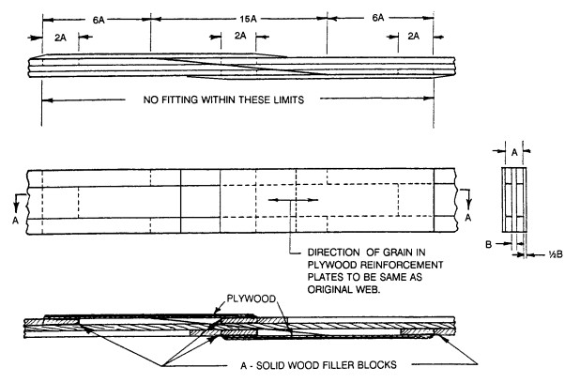
Ends of reinforcement plates
should be feathered out
Section A-A with a 5:1 slope.
Figure 1-7. Repairs to built-up “i” spar.

Rib Repair Methods. Acceptable methods of repairing damaged ribs are shown in figure 1-11. Wood ribs should not be nailed to wood spars by driving nails through the rib cap strips, as this weakens the rib materially. The attachment should be by means of adhesive with cement coated, barbed, or spiraled nails driven through the vertical rib members on each face of the spar.

Compression Rib Repair. Acceptable methods of repairing damaged compression ribs are shown in figure 1-12.

Figure 1-12(A) illustrates the repair of a compression rib of the “I” section type; i.e., wide, shallow cap strips, and a center plywood web with a rectangular compression member on each side of the web. The rib is assumed to be cracked through the cap strips, web member, and compression member in the illustration. Cut the compression member as shown in figure 1-12(D). Cut and replace the aft portion of the cap strips, and reinforce as shown in figure 1-11. The plywood side plates are bonded on, as indicated in figure 1-12(A). These plates are added to reinforce the damaged web.

Figure 1-12(B) illustrates a compression rib of the type that is basically a standard rib with rectangular compression members added to one side and plywood web to the other side. The method used in this repair is essentially the same as in figure 1-12(A) except that the plywood reinforcement plate,

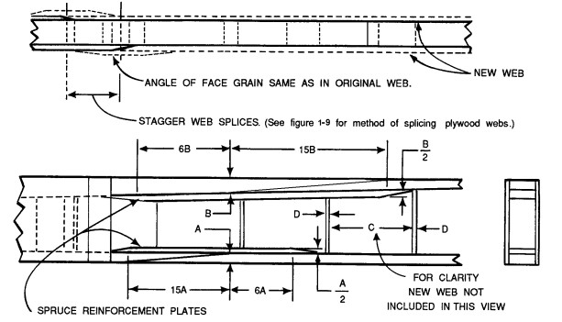
A, B, C, D = ORIGINAL DIMENSIONS

Figure 1-8. Method of splicing box spar flanges (plate method).

shown in section B-B, is continued the full distance between spars.

Figure 1-12(C) illustrates a compression rib of the “I” type with a rectangular vertical member on each side of the web. The method of repair is essentially the same as in figure 1-12(A) except the plywood reinforcement plates on each side, shown as striped blocks in section C-C, are continued the full distance between spars.

PLYWOOD SKIN REPAIR. Make extensive repairs to damaged stressed skin plywood structures in accordance with specific recommendations from the aircraft manufacturer. It is recommended that repairs be made by replacing the entire panel, from one structural member to the next, if damage is very extensive. When damaged plywood skin is repaired, carefully inspect the adjacent internal structure for possible hidden damage. Repair any defective frame members prior to making skin repairs.

Determination of Single or Double Curvature. Much of the outside surface of plywood aircraft is curved. On such areas, plywood used for repairs to the skin must be similarly curved. Curved skins are either of single curvature or of double (compound) curvature. A simple test to determine which type of curvature exists may be made by laying a sheet of heavy paper on the surface in question. If the sheet can be made to conform to the surface without wrinkling, the surface is either flat or single curvature. If the sheet cannot be made to conform to the surface without wrinkling, the surface is of double curvature.

REPAIRS TO SINGLE CURVATURE PLYWOOD SKIN. Repairs to single curvature plywood skin may usually be formed from flat plywood, either by bending it dry or after soaking it in hot water. The degree of curvature to which a piece of plywood can be bent will depend upon the direction of the grain and the thickness. Table 1-2 is a guide

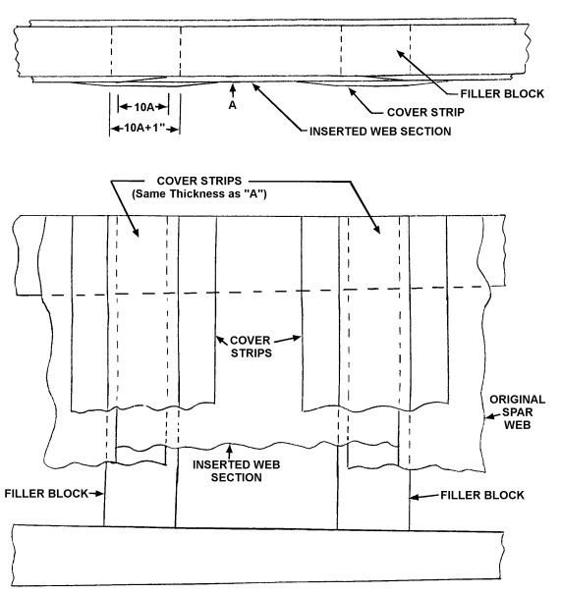

1. AFTER INSERTED WEB HAS BEEN BONDED IN PLACE, BOND COVER STRIPS OVER ENTIRE LENGTH OF
WEB SPLICE JOINTS.

2. SECTIONAL SHAPE OF FILLER BLOCKS MUST CONFORM EXACTLY TO TAPER OF SPAR. THEY MUST
NOT BE TOO TIGHTLY FITTED, FOR WEDGING ACTION WILL LOOSEN EXISTING BONDS OF WEBS TO
FLANGES. IF TOO LOOSELY FITTED, CRUSHING OF WEB WILL OCCUR WHEN CLAMPING.

3. DIRECTION OF FACE GRAIN OF INSERTED WEB SECTION AND COVER STRIPS TO BE SAME AS
ORIGINAL WEB.

Figure 1-9. Method of splicing box spar webs.

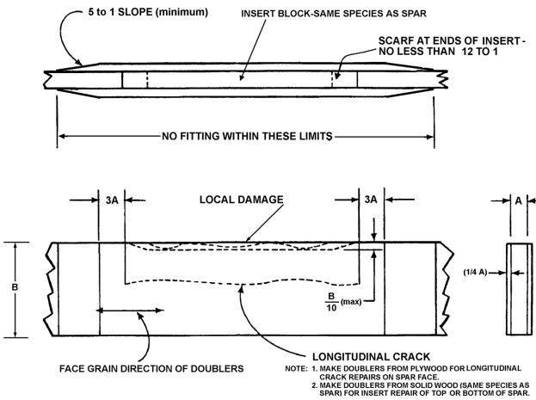
FIGURE 1-10. Method of reinforcing a longitudinal crack and/or local damage in a solid spar.

for determining which process of bending should be used for the curvature being considered.

Plywood, after softening, may be bent on a cold ventilated form, or it may be bent over the leading edge near the area being patched if space permits. In either method the repair part should be allowed to dry completely on the form. When bending plywood over a leading edge, drying may be hastened by laying a piece of coarse burlap over the leading edge before using it as a bending form. To speed drying, a fan may be used to circulate air around the repair part.

In bending pieces of small radii or to speed up the bending of a large number of parts of the same curvature, it may be necessary to use a heated bending form. The surface temperature of this form may be as high as 149 C (300 ▪F), if necessary, without danger of damage to the plywood. The plywood should be left on the heated form only long enough to dry to room conditions.

REPAIRS TO DOUBLE CURVATURE PLYWOOD SKIN. The molded plywood necessary for a repair to a damaged plywood skin of double curvature cannot be made from flat plywood unless the area to be repaired is very small or is of exceedingly slight double curvature; therefore, molded plywood of the proper curvature must be on hand before the repair can be made. If molded plywood of the proper curvature is available, the repair may be made using the same procedure as on single curvature skins.

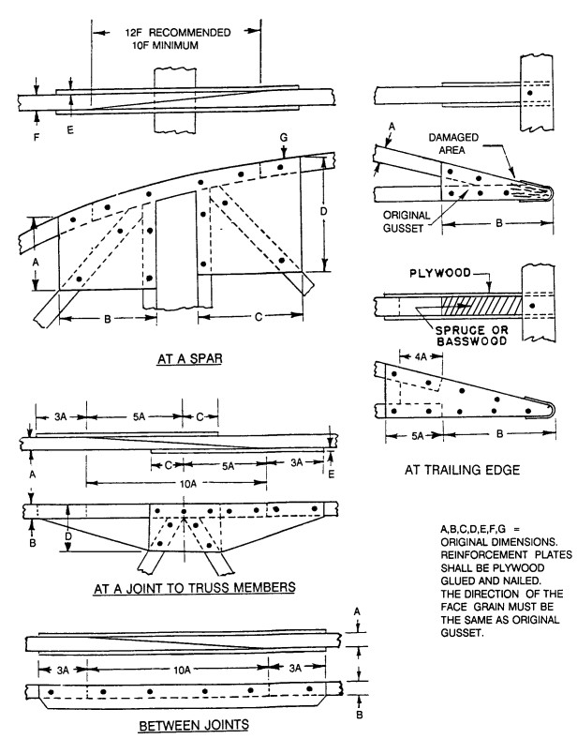
Figure 1-11. Repair of wood ribs.

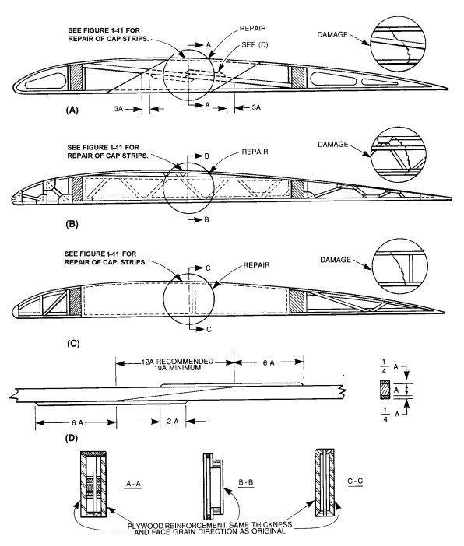
Figure 1-12. Typical wing compression rib repairs.

