Table 1-2. Minimum recommended bend radii for aircraft plywood.
 |  | 10 PERCENT MOISTURE  CONTENT, BENT ON COLD  MANDRELS |  |  | THOROUGHLY SOAKED IN HOT WATER AND BENT ON COLD  MANDRELS
PLYWOOD  CHARACTERISTICS |  | AT 90▪ TO AT 0▪ OR 45▪  FACE GRAIN TO FACE GRAIN  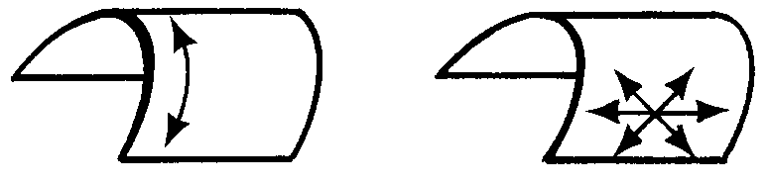 |  |  | AT 90▪ TO AT 0▪0R 45  FACE GRAIN TO FACE GRAIN
THICKNESS  (INCHES) | NUMBER  OF PLIES | MINIMUM BEND RADIUS (INCHES)
.035 | 3 | 2.0 | 1.1 | 0.5 |  | 0.1
.070 | 3 | 5.2 | 3.2 | 1.5 |  | 0.4
.100 | 3 | 8.6 | 5.2 | 2.6 |  | 0.8
.125 | 3 | 12 | 7.1 | 3.8 |  | 1.2
.155 | 3 | 16 | 10 | 5.3 |  | 1.8
.185 | 3 | 20 | 13 | 7.1 |  | 2.6
.160 | 5 | 17 | 11 | 6 |  | 2
.190 | 5 | 21 | 14 | 7 |  | 3
.225 | 5 | 27 | 17 | 10 |  | 4
.250 | 5 | 31 | 20 | 12 |  | 5
.315 | 5 | 43 | 28 | 16 |  | 7
.375 | 5 | 54 | 36 | 21 |  | 10

Types of Patches. There are four types of patches: splayed patch, surface (or overlay) patch, scarf patch, and plug patch. They are all acceptable for repairing plywood skins.

Splayed Patch. Small holes with their largest dimensions not over 15 times the skin thickness, in skins not more than 1/10 inch in thickness, may be repaired by using a circular splayed patch as illustrated in figure 1-13. The term “splayed” is used to denote that the edges of the patch are tapered, but the slope is steeper than is allowed in scarfing operations.

Lay out the patch according to figure 1-13. Tack a small piece of plywood over the hole for a center point and draw two circles with a divider, the inner circle to be the size of the hole and the outer circle marking the limits of the taper. The difference between the radii is 5T (5 times the thickness of the skin). If one leg of the dividers has been sharpened to a chisel edge, the dividers may be used to cut the inner circle.

Taper the hole evenly to the outer mark with a chisel, knife, or rasp.

Prepare a circular tapered patch to fit the prepared hole, and bond the patch into place with face-grain direction matching that of the original surface.

Use waxed paper or plastic wrap, (cut larger than the size of the patch) between the patch and the plywood pressure plate. This prevents excess adhesive from bonding the pressure plate to the skin. Center the pressure plate carefully over the patch.

As there is no reinforcement behind this patch, care must be used so that pressure is not great enough to crack the skin. On horizontal surfaces, weights or sandbags will be sufficient. On patches too far from any edge for the use of standard hand clamps, jaws of greater length may be improvised. Table 1-2, columns (1) and (3), may also be used for determining the maximum thickness of single laminations for curved members.

Fill, sand, and refinish the patch.

Surface Patch. Plywood skins that are damaged between or along framing members may be repaired by surface or overlay patches as shown in figure 1-14. Surface patches located entirely aft of the 10 percent chord line, or which wrap around the leading edge and terminate aft of the 10 percent chord line, are permissible. Surface patches may have as much as a 50 inch perimeter and may cover as much as 1 frame (or rib) space. Trim the damaged skin to a rectangular or triangular shape and round the corners. The radius of rounded corners must be at least 5 times the skin thickness. Bevel the forward edges of patches located entirely aft of the 10 percent chord line to 4 times the skin thickness. The face-grain direction must be the same as the original skin. Cover completed surface patches with fabric to match surrounding area. The fabric must overlap the original fabric at least 2 inches.

Scarf Patch. A properly prepared and inserted scarf patch is the best repair for damaged plywood skins and is preferred for most skin repairs. Figure 1-15 shows the details and dimensions to be used when installing typical scarf skin patches, when the back of the skin is accessible. Follow figure 1-16 when the back of the skin is not accessible. The scarf slope of 1 in 12, shown in both figures, is the steepest slope permitted for all kinds of plywood. If the radius of curvature of the skin at all points

on the trimmed opening is greater than 100 times the skin thickness, a scarf patch may be installed.

Scarf cuts in plywood may be made by hand plane, spoke shave, scraper, or accurate sandpaper block. Rasped surfaces, except at the corners of scarf patches and sawn surfaces, are not recommended as they are likely to be rough or inaccurate.

Nail strip or small screw clamping is often the only method available for bonding scarf joints in plywood skin repairs. It is essential that all scarf joints in plywood be backed with plywood or solid wood to provide adequate nail holding capacity. The face-grain direction of the plywood patch must be the same as that of the original skin.

If the back of a damaged plywood skin is accessible (such as a fuselage skin), it should be repaired with a scarf patch, following the details shown in figure 1-15. Whenever possible, the edges of the patch should be supported as shown in section C-C of figure 1-15. When the damage follows or extends to a framing member, the scarf may be supported as shown in section B-B of figure 1-15. Damages that do not exceed 25 times the skin thickness in diameter after being trimmed to a circular shape and are not less than 15 times the skin thickness to a framing member, may be repaired as shown in figure 1-15, section D-D.

The backing block is carefully shaped from solid wood and fitted to the inside surface of the skin, and is temporarily held in place with nails.

Use waxed paper or plastic wrap to prevent bonding of the backing block to the skin.

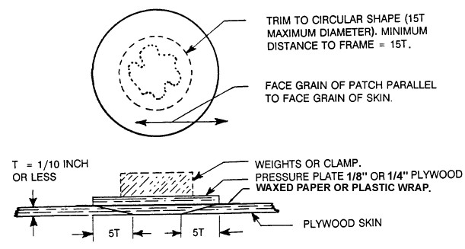
Figure 1-13. Splayed patch.

A hole, the exact size of the inside circle of the scarf patch, is made in the block, and is centered over the trimmed area of damage.

The block is removed, after the adhesive on the patch has set, leaving a flush surface to the repaired skin.

Steps in making a scarf patch when the back of the skin is not accessible are as follows:

After removing damaged sections, install backing strips, as shown in figure 1-16, along all edges that are not fully backed by a rib or a spar. To prevent warping of the skin, backing strips should be made of a soft-textured plywood, such as yellow poplar or spruce rather than solid wood. All junctions between backing strips and ribs or spars should have the end of the backing strip supported by a saddle gusset of plywood.

If needed, nail and bond the new gusset plate to rib. It may be necessary to

remove and replace the old gusset plate with a new saddle gusset, or it may be necessary to nail a saddle gusset over the original gusset.

Attach nailing strips to hold backing strips in place while the adhesive sets. Use a bucking bar, where necessary, to provide support for nailing. After the backing strips are fully bonded, install the patch.

Plug Patch. Either oval or round plug patches may be used on plywood skins provided the damage can be covered by the patches whose dimensions are given in figure 1-17 and figure 1-18. The plug patch is strictly a skin repair, and should be used only for damage that does not involve the supporting structure under the skin. The face-grain direction of the finished patch must match the surrounding skin.

Steps in making an oval plug patch are as follows:

Explore the area about the hole to be sure it lies at least the width of the oval

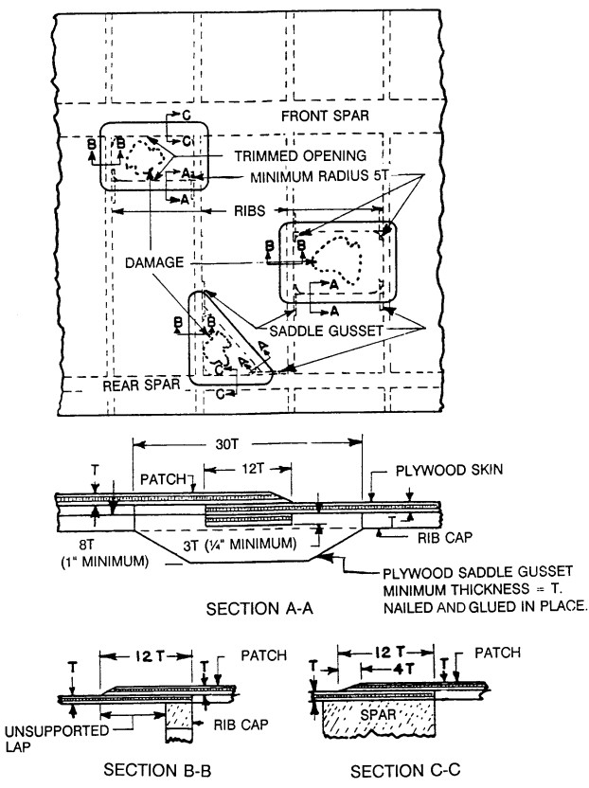
Figure 1-14. Surface patches.

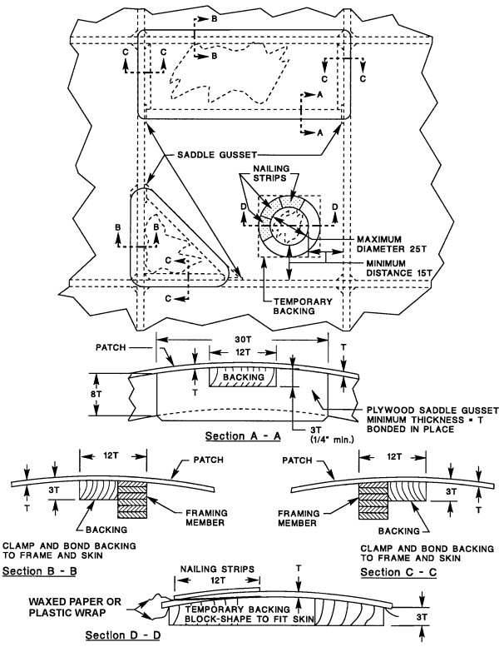

Figure 1-15. Scarf patches (back of skin accessible).
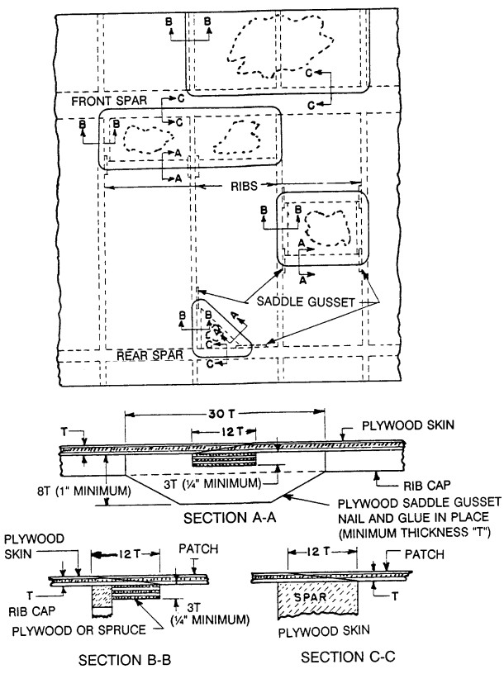
Figure 1-16. Scarf patches (back of skin not accessible).

doubler from a rib or a spar. Refer to figure 1-17 for repair details.

Prepare a patch and a doubler of the same species plywood as the surrounding skin using the dimensions shown in figure 1-17.

Lay the oval plug patch over the damage and trace the patch onto the skin. Saw to the line, and trim the hole edges with a knife and sandpaper.

Mark the exact size of the patch on one surface of the oval doubler and apply adhesive to the area outside the line. Insert doubler through the hole and bring it, adhesive side up, to the underside of the skin with the pencil outline of the patch matching the edges of the hole. If the curvature of the surface to be repaired is greater than a rise of 1/8 inch in 6 inches, the doubler should be preformed by hot water or steam bending to the approximate curvature. As an alternative to preforming of the 1/4 inch stock, the doubler may be laminated from two thicknesses of 1/8 inch ply.

Apply nailing strips outlining the hole to apply bonding pressure between doubler and skin. Use a bucking bar to provide support for nailing. When two rows of nails are used, stagger nail spacing. Allow adhesive to cure.

Apply adhesive to remaining surface of the doubler and to the mating surface on the patch. Lay the patch in position over the doubler, and screw the pressure plate to the patch assembly using a small nail to line up the holes that have been previously made with patch and plate matching. No. 4 round head screws are used. Lead holes in the plywood doubler are not necessary. Waxed paper or plastic wrap between the plate and patch prevents adhesive from bonding the plate to the patch. No clamps or further pressure need be applied, as the nailing strips and screws exert ample pressure.

Round plug patches may be made by following the steps in figure 1-18. The steps are identical to those for making the oval patch except for the insertion of the doubler. In using the round patch, where access is from only one side, the round doubler cannot be inserted unless it has been split.

FABRIC PATCH. Small holes not exceeding 1 inch in diameter, after being trimmed to a smooth outline, may be repaired by doping a fabric patch on the outside of the plywood skin. The edges of the trimmed hole should first be sealed, and the fabric patch should overlap the plywood skin by at least 1 inch. Holes nearer than 1 inch to any frame member, or in the leading edge or frontal area of the fuselage, should not be repaired with fabric patches.

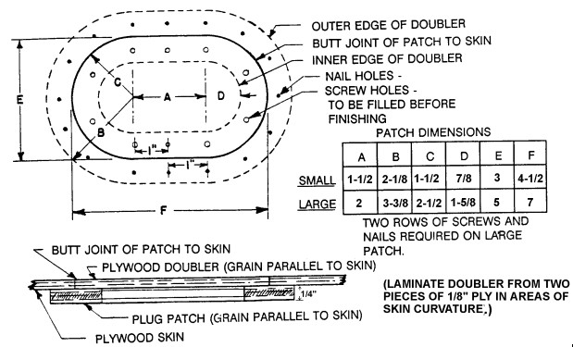
Figure 1-17. Oval plug patch assembly.

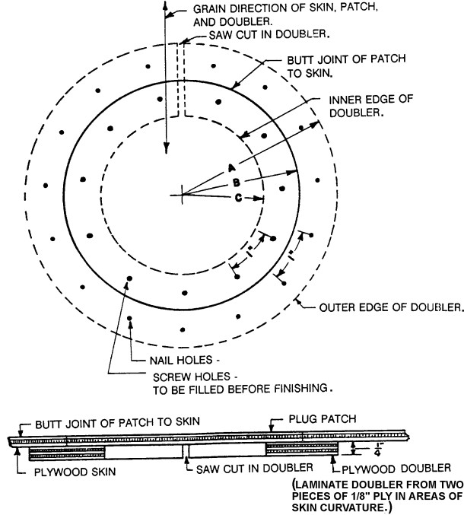
DIMENSIONS
 | A | B | C
SMALL CIRCULAR PLUG PATCH | 2 5/8 | 2 | 1 3/8
LARGE CIRCULAR PLUG PATCH | 3 7/8 | 3 | 2 1/8

(TWO ROWS OF SCREWS AND NAILS REQUIRED
FOR LARGE PATCH)

Figure 1-18. Round plug patch assembly.

1-53.1-63. [RESERVED.]

