CHAPTER 1. WOOD STRUCTURE

Section 1. MATERIALS AND PRACTICES

GENERAL. Wood aircraft construction dates back to the early days of certificated aircraft. Today only a limited number of wood aircraft structures are produced. However, many of the older airframes remain in service. With proper care, airframes from the 1930’s through the 1950’s have held up remarkably well considering the state of technology and long term experience available at that time. It is the responsibility of the mechanic to carefully inspect such structures for deterioration and continuing airworthiness.

WOODS.

Quality of Wood. All wood and plywood used in the repair of aircraft structures should be of aircraft quality (reference Army Navy Commerce Department Bulletin ANC-19, Wood Aircraft Inspection and Fabrication). Table 1-1 lists some permissible variations in characteristics and properties of aircraft wood. However, selection and approval of woodstock for aircraft structural use are specialized skills and should be done by personnel who are thoroughly familiar with inspection criteria and methods.

Substitution of Original Wood. The wood species used to repair a part should be the same as that of the original whenever possible; however, some permissible substitutes are given in table 1-1. Obtain approval from the airframe manufacturer or the Federal Aviation Administration (FAA) for the replacement of modified woods or other nonwood products with a substitute material.

Effects of Shrinkage. When the moisture content of a wooden part is lowered, the part shrinks. Since the shrinkage is not equal in all directions, the mechanic should consider the effect that the repair may have on the completed structure. The shrinkage is greatest in a tangential direction (across the fibers and parallel to the growth rings), somewhat less in a radial direction (across the fibers and perpendicular to the growth rings), and is negligible in a longitudinal direction (parallel to the fibers). Figure 1-1 illustrates the different grain directions and the effects of shrinkage on the shape of a part. These dimensional changes can have several detrimental effects upon a wood structure, such as loosening of

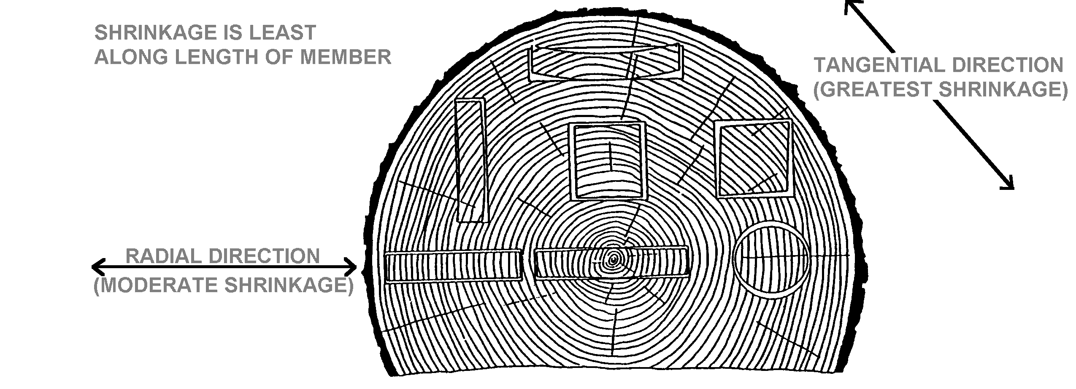
Figure 1-1. Relative shrinkage of wood members due to drying.

Table 1-1. Selection and Properties of Aircraft Wood. (See notes following table.)
Species of Wood | Strength properties as compared to spruce | Maximum  permissible  grain deviation  (slope of grain) | Remarks
1. | 2. | 3. | 4.
Spruce(Picea) Sitka (P. Sitchensis) Red (P. Rubra) White (P. Glauca). | 100% | 1:15 | Excellent for all uses. Considered as standard for this table.
Douglas Fir  (Pseudotsuga Taxifolia). | Exceeds spruce. | 1:15 | May be used as substitute for spruce in same sizes or in slightly reduced sizes providing reductions are substantiated. Difficult to work with handtools. Some tendency to split and splinter during fabrication and considerable more care in manufacture is necessary. Large solid pieces should be avoided due to inspection difficulties. Gluing satisfactory.
Noble Fir  (Abies Nobiles). | Slightly exceeds spruce except 8% deficient in shear. | 1:15 | Satisfactory characteristics with respect to workability, warping, and splitting. May be used as direct substitute for spruce in same sizes providing shear does not become critical. Hardness somewhat less than spruce. Gluing satisfactory.
Western Hemlock  (Tsuga Heterpphylla). | Slightly exceeds spruce. | 1:15 | Less uniform in texture than spruce. May be used as direct substitute for spruce. Upland growth superior to lowland growth. Gluing satisfactory.
Pine, Northern White (Pinus Strobus). | Properties between 85 % and 96 % those of spruce. | 1:15 | Excellent working qualities and uniform in properties, but somewhat low in hardness and shock-resisting capacity. Cannot be used as substitute for spruce without increase in sizes to compensate for lesser strength. Gluing satisfactory.
White Cedar, Port Orford (Charaecyparis Lawsoniana). | Exceeds spruce. | 1:15 | May be used as substitute for spruce in same sizes or in slightly reduced sizes providing reductions are substantiated. Easy to work with handtools. Gluing difficult, but satisfactory joints can be obtained if suitable precautions are taken.
Poplar, Yellow (Liriodendrow Tulipifera). | Slightly less than spruce except in compression (crushing) and shear. | 1:15 | Excellent working qualities. Should not be used as a direct substitute for spruce without carefully accounting for slightly reduced strength properties. Somewhat low in shock-resisting capacity. Gluing satisfactory.

Notes for Table 1-1

1. Defects Permitted.
a. Cross grain. Spiral grain, diagonal grain, or a combination of the two is acceptable providing the grain does not diverge from the longitudinal axis of the material more than specified in column 3. A check of all four faces of the board is necessary to determine the amount of divergence. The direction of free-flowing ink will frequently assist in determining grain direction.
b. Wavy, curly, and interlocked grain. Acceptable, if local irregularities do not exceed limitations specified for spiral and diagonal grain.
c. Hard knots. Sound, hard knots up to 3/8 inch in maximum diameter are acceptable providing: (1) they are not projecting portions of I-beams, along the edges of rectangular or beveled unrouted beams, or along the edges of flanges of box beams (except in lowly stressed portions); (2) they do not cause grain divergence at the edges of the board or in the flanges of a beam more than specified in column 3; and (3) they are in the center third of the beam and are not closer than 20 inches to another knot or other defect (pertains to 3/8 inch knots—smaller knots may be proportionately closer). Knots greater than 1/4 inch must be used with caution.
d. Pin knot clusters. Small clusters are acceptable providing they produce only a small effect on grain direction.
e. Pitch pockets. Acceptable in center portion of a beam providing they are at least 14 inches apart when they lie in the same growth ring and do not exceed 1-1/2 inches length by 1/8 inch width by 1/8 inch depth, and providing they are not along the projecting portions of I-beams, along the edges of rectangular or beveled unrouted beams, or along the edges of the flanges of box beams.
f. Mineral streaks. Acceptable, providing careful inspection fails to reveal any decay.
Table 1-1. Selection and Properties of Aircraft Wood. (See notes following table.) (continued)
2. Defects Not Permitted.
a. Cross grain. Not acceptable, unless within limitations noted in 1a.
b. Wavy, curly, and interlocked grain. Not acceptable, unless within limitations noted in 1b.
c. Hard knots. Not acceptable, unless within limitations noted in 1c.
d. Pin knot clusters. Not acceptable, if they produce large effect on grain direction.
e. Spike knots. These are knots running completely through the depth of a beam perpendicular to the annual rings and appear most frequently in quarter-sawed lumber. Reject wood containing this defect.
f. Pitch pockets. Not acceptable, unless within limitations noted in 1e.
g. Mineral streaks. Not acceptable, if accompanied by decay (see 1f).
h. Checks, shakes, and splits. Checks are longitudinal cracks extending, in general, across the annual rings. Shakes are longitudinal cracks usually between two annual rings. Splits are longitudinal cracks induced by artificially induced stress. Reject wood containing these defects.
i. Compression wood. This defect is very detrimental to strength and is difficult to recognize readily. It is characterized by high specific gravity, has the appearance of an excessive growth of summer wood, and in most species shows little contrast in color between spring wood and summer wood. In doubtful cases reject the material, or subject samples to toughness machine test to establish the quality of the wood. Reject all material containing compression wood.
j. Compression failures. This defect is caused from the wood being overstressed in compression due to natural forces during the growth of the tree, felling trees on rough or irregular ground, or rough handling of logs or lumber. Compression failures are characterized by a buckling of the fibers that appear as streaks on the surface of the piece substantially at right angles to the grain, and vary from pronounced failures to very fine hairlines that require close inspection to detect. Reject wood containing obvious failures. In doubtful cases reject the wood, or make a further inspection in the form of microscopic examination or toughness test, the latter means being the more reliable.
k. Decay. Examine all stains and discoloration carefully to determine whether or not they are harmless, or in a stage of preliminary or advanced decay. All pieces must be free from rot, dote, red heart, purple heart, and all other forms of decay.

fittings and wire bracing and checking or splitting of wood members. A few suggestions for minimizing these shrinkage effects are:

Use bushings that are slightly short so that when the wood member shrinks the bushings do not protrude and the fittings may be tightened firmly against the member.

Gradually drop off plywood faceplates by feathering as shown in figure 1-2.

Thoroughly seal all wood surfaces, particularly end grain and bolt holes, with varnish, epoxy, or other acceptable sealer to slow or prevent moisture changes in the member. (See Section 5. Finishing Wood Structures.)

MODIFIED WOOD PRODUCTS. The most common forms of modified woods found in aircraft construction are plywood. Although not a wood product, Phenolic parts are sometimes incorporated into structures. These products are used whenever the manu-

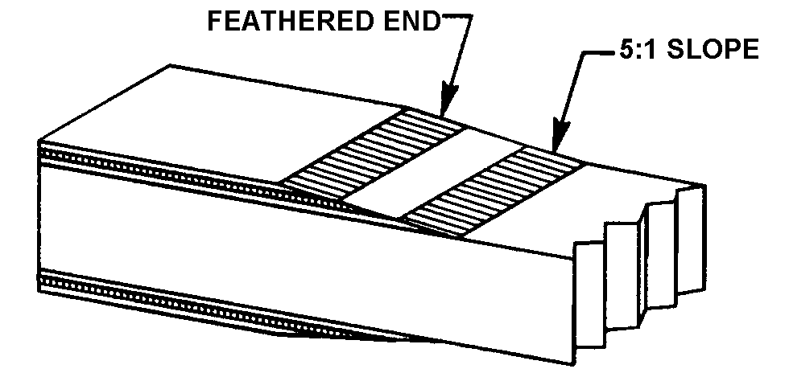
Figure 1-2. Tapering of faceplate.

facturer requires specialized strength or durability characteristics.

ADHESIVES. Because of the critical role played by adhesives in aircraft structure, the mechanic must employ only those types of adhesives that meet all of the performance requirements necessary for use in certificated civil aircraft. Use each product strictly in accordance with the aircraft and adhesive manufacturer’s instructions.

Adhesives acceptable to the FAA can be identified in the following ways:

Refer to the aircraft maintenance or repair manual for specific instructions on acceptable adhesive selection for use on that type aircraft.

Adhesives meeting the requirements of a Military Specification (Mil Spec), Aerospace Material Specification (AMS), or Technical Standard Order (TSO) for wooden aircraft structures are satisfactory providing they are found to be compatible with existing structural materials in the aircraft and the fabrication methods to be used in the repair.

Common types of adhesives that are or have been used in aircraft structure fall into two general groups: casein and synthetic-resins. Adhesive technology continues to evolve, and new types (meeting the requirements of paragraph 1-4a) may become available in the future.

Casein adhesive performance is generally considered inferior to other products available today, modern adhesives should be considered first.

CAUTION: Casein adhesive deteriorates over the years after exposure to moisture in the air and temperature variations. Some modern adhesives are incompatible with casein adhesive. If a joint that has previously been bonded with casein is to be rebonded with another type adhesive, all traces of the casein must be scraped off before the new adhesive is applied. If any casein adhesive is left, residual alkalinity may cause the new adhesive to fail to cure properly.

Synthetic-resin adhesives comprise a broad family which includes plastic resin glue, resorcinol, hot-pressed Phenol, and epoxy.

Plastic resin glue (urea-formalde-hyde resin glue) has been used in wood aircraft for many years. Caution should be used due to possible rapid deterioration (more rapidly than wood) of plastic resin glue in hot, moist environments and under cyclic swell-shrink stress. For these reasons, urea-formaldehyde should be considered obsolete for all repairs. Any proposed use of this type adhesive should be discussed with the appropriate FAA office prior to using on certificated aircraft.

Federal Specification MMM-A-181D and Military Specification MIL-A-22397 both describe a required series of tests that verify the chemical and mechanical properties of resorcinol. Resorcinol is the only known adhesive recommended and approved for use in wooden aircraft structure and fully meets necessary strength and durability requirements. Resorcinol adhesive (resorcinol-formaldehyde resin) is a two-part synthetic resin adhesive consisting of resin and a hardener. The appropriate amount of hardener (per manufacturer’s instruction) is added to the resin, and it is stirred until it is uniformly mixed; the adhesive is now ready for immediate use. Quality of fit and proper clamping pressure are both critical to the achievement of full joint strength. The adhesive bond lines must be very thin and uniform in order to achieve full joint strength.

CAUTION: Read and observe material safety data. Be sure to follow the manufacturer’s instructions regarding mixing, open assembly and close assembly times, and usable temperature ranges.

Phenol-formaldehyde adhesive is commonly used in the manufacturing of aircraft grade plywood. This product is cured at elevated temperature and pressure; therefore, it is not practical for use in structural repair.

Epoxy adhesives are a two-part synthetic resin product, and are acceptable providing they meet the requirements of paragraph 1-4a. Many new epoxy resin systems appear to have excellent working properties. They have been found to be much less critical of joint quality and clamping pressure. They penetrate well into wood and plywood. However, joint durability in the presence of elevated temperature or moisture is inadequate in many epoxies. The epoxy adhesives generally consist of a resin and a hardener that are mixed together in the proportions specified by the manufacturer. Depending on the type of epoxy, pot life may vary from a few minutes to an hour. Cure times vary between products.

CAUTION: Some epoxies may have unacceptable thermal or other hidden characteristics not obvious in a shop test. It is essential that only those products meeting the requirements of paragraph 1-4a be used in aircraft repair. Do not vary the resin-to-hardener ratio in an attempt to alter the cure time. Strength, thermal, and chemical resistance will be adversely affected. Read and observe material safety data. Be sure to follow the adhesive manufacturer’s instructions regarding mixing, open and closed curing time, and usable temperature ranges.

BONDING PRECAUTIONS. Satisfactory bond joints in aircraft will develop the full strength of wood under all conditions of stress. To produce this result, the bonding operation must be carefully controlled to obtain a continuous thin and uniform film of solid adhesive in the joint with adequate adhesion and penetration to both surfaces of the wood. Some of the more important conditions involve:

Properly prepared wood surfaces.

Adhesive of good quality, properly prepared, and properly selected for the task at hand.

Good bonding technique, consistent with the adhesive manufacturer’s instructions for the specific application.

PREPARATION OF WOOD SURFACES FOR BONDING. It is recommended that no more time than necessary be permitted to elapse between final surfacing and bonding. Keep prepared surfaces covered with a clean plastic sheet or other material to maintain cleanliness prior to the bonding operation. The mating surfaces should be machined smooth and true with planers, joiners, or special miter saws. Planer marks, chipped or loosened grain, and other surface irregularities are not permitted. Sandpaper must never be used to smooth softwood surfaces that are to be bonded. Sawn surfaces must approach well-planed surfaces in uniformity, smoothness, and freedom from crushed fibers. It is advisable to clean both joint surfaces with a vacuum cleaner just prior to adhesive application. Wood surfaces ready for bonding must be free from oil, wax, varnish, shellac, lacquer, enamel, dope, sealers, paint, dust, dirt, adhesive, crayon marks, and other extraneous materials.

Roughening smooth, well-planed surfaces of normal wood before bonding is not recommended. Such treatment of well-planed wood surfaces may result in local irregularities and objectionable rounding of edges. When surfaces cannot be freshly machined before bonding, such as plywood or inaccessible members, very slight sanding of the surface with a fine grit such as 220, greatly improves penetration by the adhesive of aged or polished
surfaces. Sanding should never be continued to the extent that it alters the flatness of the surface. Very light sanding may also improve the wetting of the adhesive to very hard or resinous materials.

Wetting tests are useful as a means of detecting the presence of wax, old adhesive, and finish. A drop of water placed on a surface that is difficult to wet and thus difficult to bond will not spread or wet the wood rapidly (in seconds or minutes). The surface may be difficult to wet due to the presence of wax, exposure of the surface to heat and pressure as in the manufacture of hot press bonded plywood, the presence of synthetic resins or wood extractives, or simply chemical or physical changes in the wood surface with time. Good wettability is only an indication that a surface can be bonded satisfactorily. After performing wetting tests, allow adequate time for wood to dry before bonding. Preliminary bonding tests and tests for bond strength are the only positive means of actually determining the bonding characteristics of the adhesive and material combinations. (See paragraph 1-29h.)

APPLYING THE ADHESIVE. To make a satisfactory bonded joint, spread the adhesive in a thin, even layer on both surfaces to be joined. It is recommended that a clean brush be used and care taken to see that all surfaces are covered. Spreading of adhesive on only one of the two surfaces is not recommended. Be sure to read and follow the adhesive manufacturer’s application instructions.

ASSEMBLY TIME IN BONDING.
Resorcinol, epoxy, and other adhesives cure as a result of a chemical reaction. Time is an important consideration in the bonding process. Specific time constraints are as follows:

Pot life is the usable life of the adhesive from the time that it is mixed until it must be

spread onto the wood surface. Once pot life has expired, the remaining adhesive must be discarded. Do not add thinning agents to the adhesive to extend the life of the batch.

Open assembly time is the period from the moment the adhesive is spread until the parts are clamped together. Where surfaces are coated and exposed freely to the air, some adhesives experience a much more rapid change in consistency than when the parts are laid together as soon as the spreading has been completed.

Closed assembly time is the period from the moment that the structure parts are placed together until clamping pressure is applied. The consistency of the adhesive does not change as rapidly when the parts are laid together.

Pressing (or clamping) time is the period during which the parts are pressed tightly together and the adhesive cures. The pressing time must be sufficient to ensure that joint strength is adequate before handling or machining the bonded structure.

NOTE: Follow the adhesive manufacturer’s instructions for all time limits in the bonding process. If the recommended open or closed assembly periods are exceeded, the bond process should not be continued. Discard the parts if feasible. If the parts cannot be discarded, remove the partially cured adhesive and clean the bond line per adhesive manufacturer’s instructions before application of new adhesive.

BONDING TEMPERATURE. Temperature of the bond line affects the cure rate of the adhesive. Some adhesive types, such as resorcinol, require a minimum temperature which must be maintained throughout the
curing process. Each type of adhesive requires a specific temperature during the cure cycle, and the manufacturer’s recommendations should be followed.

CLAMPING PRESSURE.

Use the recommended pressure to squeeze adhesive out into a thin, continuous film between the wood layers. This forces air from the joint and brings the wood surfaces into intimate contact. Pressure should be applied to the joint before the adhesive becomes too thick to flow and is accomplished by means of clamps, presses, or other mechanical devices.

Nonuniform clamping pressure commonly results in weak and strong areas in the same joint. The amount of pressure required to produce strong joints in aircraft assembly operations varies with the type of adhesive used and the type of wood to be bonded. Typical pressures when using resorcinol may vary from 125 to 150 pounds per square inch for softwoods and 150 to 200 pounds per square inch for hardwoods. Insufficient pressure or poorly machined wood surfaces usually result in thick bond lines, which indicate a weak joint, and should be carefully guarded against. Some epoxy adhesives require much less clamping pressure to produce acceptable joint strength. Be sure to read and follow the manufacturer’s instructions in all cases.

METHOD OF APPLYING PRESSURE. The methods of applying pressure to joints in aircraft bonding operations range from the use of brads, nails, small screws, and clamps; to the use of hydraulic and electrical power presses. The selection of appropriate clamping means is important to achieving sound bond joints.

Hand nailing is used rather extensively in the bonding of ribs and in the application of plywood skins to the wing, control surfaces, and fuselage frames. Small brass screws may also be used advantageously when the particular parts to be bonded are relatively small and do not allow application of pressure by means of clamps. Both nails and screws produce adverse after effects. There is considerable risk of splitting small parts when installing nails or screws. Metal fasteners also provide vulnerable points for moisture to enter during service.

On small joints using thin plywood for gussets or where plywood is used as an outer skin, the pressure is usually applied by nailing or stapling. Thin plywood nailing strips are often used to spread the nailing pressure over a larger area and to facilitate removal of the nails after the adhesive has cured.

The size of the nails must vary with the size of the members. If multiple rows of nails are required, the nails should be 1 inch apart in rows spaced 1/2 inch apart. The nails in adjacent rows should be staggered. In no case should the nails in adjacent rows be more than 3/4 inch from the nearest nail. The length of the nails should be such that they penetrate the wood below the joint at least 3/8 inch. In the case of small members, the end of the nail should not protrude through the member below the joint. Hit the nails with several light strokes, just seating the head into the surface of the gusset. Be careful not to crush the wood with a heavy hammer blow.

In some cases the nails are removed after adhesive cure, while in others the nails are left in place. The nails are employed for clamping pressure during adhesive cure and must not be expected to hold members together in service. In deciding whether to re
move nails after assembly, the mechanic should examine adjacent structure to see whether nails remain from original manufacture.

On larger members (spar repairs for example), apply pressure by means of screw clamps, such as a cabinet-maker’s bar or “C-clamps.” Strips or blocks should be used to distribute clamping pressure and protect members from local crushing due to the

limited pressure area of the clamps, especially when one member is thin (such as plywood). The strip or block should be at least twice as thick as the thinner member being bonded.

Immediately after clamping or nailing a member, the mechanic must examine the entire joint to assure uniform part contact and adhesive squeeze-out. Wipe away excess adhesive.

1-12.⎯1-17. [RESERVED.]

