CHAPTER 2. FABRIC COVERING

Section 1. PRACTICES AND PRECAUTIONS

GENERAL. Cotton and Irish linen fabrics were the airframe coverings of choice from WWI through the 1950’s. However, increases in cost and the short lifespan of natural fabrics became the driving factors which resulted in almost 100 percent replacement of original airframe fabrics by man-made, STC-approved, polyester, and glass filament fabric.

PROBLEM AREAS.

Deterioration. Polyester fabric deteriorates only by exposure to ultraviolet radiation as used in an aircraft covering environment. When coatings completely protect the fabric its service life is infinite. Therefore, it is very important to thoroughly protect the structure from deterioration before covering and provide adequate inspection access to all areas of fabric-covered components to allow inspection for corrosion, wood rot, and mice infestation. Multiple drain holes in the lower ends of all fabric-covered sections also provide needed ventilation to remove condensation.

Tension. Polyester fabric obtains maximum tension on an airframe at 350 ºF, and will not be excessive on aircraft originally covered with natural fabric and 12 coats of Nitrate or Butyrate Dope. However, dope applied over full heat-tauted fabric can develop excess tension after aging and damage light aircraft structures. Coatings other than dope will not increase fabric tension after aging. The heat-tauting instructions given in the manual of each STC-approved covering process should be followed.

AIRCRAFT FABRIC-SYNTHETIC.

STC-Approved Covering Materials. There is a wide selection of STC-approved covering materials available which utilize synthetic fabric falling within the generic class “Polyester” and may vary in characteristics. Difference in the fabric may be denier, tenacity, thread count, weight, shrink, tension, and weave style.

Polyester Filaments. Polyester Filaments are manufactured by polymerization of various select acids and alcohols, then extruding the resulting molten polymers through spinnerets to form filaments. The filaments are heat stretched to reduce to the desired denier or size. It is the heat stretching that imparts a memory in the filaments causing them to try and return to their original shorter length when reheated at a controlled temperature. Overheating will cancel the memory and melt the filaments.

Covering Procedures. Coating types, covering accessories, and covering procedures also may vary; therefore, the covering procedures given in the pertinent manuals must be followed to comply with the STC. The FAA STC-approved installation takes precedence over instructions in this advisory circular.

Installation. Initial installation of polyester fabric is similar to natural fabric. The fabric is installed with as little slack as possible, considering fittings and other protrusions. It may be sewn into an envelope, installed as a blanket, or installed by cementing to the airframe with a fabric cement. Each STC may differ in the cement seam overlap, type of sewn seam, heat shrinking procedures, and temperature.

AIRCRAFT FABRIC-NATURAL. Physical specifications and minimum strength requirements for natural fiber fabric, cotton and linen, used to recover or repair components of an aircraft, are listed in table 2-1. Tear resistance is an important factor when considering aircraft fabric. A test method such as ASTM D 1424 is recommended. Technical Standard Order TSO-C15d, entitled Aircraft Fabric, Grade A (AMS 3806D); and TSO-C14b, Aircraft Fabric, Intermediate Grade (AMS 3804C) current edition, respectively, describe the minimum standards that all fabric must meet to qualify as aircraft covering material.

RECOVERING AIRCRAFT. Recover or repair aircraft with a fabric of equal quality and strength to that used by the original aircraft manufacturer. It is recommended that fabric conforming to TSO-C15d or TSO-C14b be used to recover aircraft originally covered with lower strength fabric conforming to AMS 3802, current edition.

NOTE: Recovering or repairing aircraft with any type fabric and/or coating other than the type used by the original aircraft manufacturer is considered a major alteration. Obtain approval from the FAA on fabric and installation data. Cotton and linen rib lacing cord, machine and hand-sewing thread, and finishing tapes should not be used with polyester and glass fabric covering.

Reinforcing tape minimum tensile strength is listed in table 2-2. Reinforcing tape meeting specification MIL-T-5661, Type I, current edition, is acceptable. Reinforcing tape should have a minimum 40 lb. resistance without failure when static tested in shear against a single rib lace, or a pull-through resistance when tested against a single-wire clip, rivet, screw, or any other type of fabric-to-rib

attachment. Reinforcing tape is used over the rib cab on top of the fabric and for inter-rib bracing.

Finishing Tape, sometimes referred to as surface tape, should have the same properties as the fabric used to cover the aircraft.

Lacing Cord shall have a minimum breaking strength of 40 lb. Lacing cord meeting the specifications listed in table 2-2 is acceptable. Rib lace cord should have a microcrystalline fungicidal wax, paraffin-free wax, or beeswax coating, or other approved treatment to prevent wearing and fraying when pulling through the structure.

Machine Thread shall have a minimum breaking strength of 5 lb. Thread meeting the specifications listed in table 2-2 is acceptable.

Hand-Sewing Thread shall have a minimum breaking strength of 14 lb. Thread meeting the specifications listed in table 2-2, is acceptable. When covering with STC-approved fabric covering material, use the type of sewing thread approved by the STC and manufactured under the specific PMA.

Flutter Precautions. When re-covering or repairing control surfaces, especially on high performance airplanes, make sure that dynamic and static balances are not adversely affected. Weight distribution and mass balance must be considered to preclude to possibility of induced flutter.

PREPARATION OF THE STRUCTURE FOR COVERING. One of the most important items when covering aircraft is the proper preparation of the structure. Before covering, the airframe must be inspected and approved by a FAA-certified mechanic or repair station.

Table 2-1. Cotton and linen fabrics.
Materials | Specification | Minimum Tensile Strength New (undoped) | Minimum  Tearing Strength New (undoped) (ASTM D 1424) | Minimum  Tensile Strength  Deteriorated (undoped) | Thread Count Per Inch | Use and  Remarks
Airplane cloth  mercerized cotton  (Grade “A”). | TSO-C15d, as amended,  references  Society  Automotive  Engineers  AMS 3806d,  as amended or MIL-C-5646 | 80 pounds  per inch  warp and fill. | 5 pounds  warp and fill. | 56 pounds  per inch. | 80 min.,  84 max.  warp and fill. | For use on all aircraft.  Required on aircraft with wing loading of 9 p.s.f. or greater or placard never  exceed speed of 160 m.p.h. or greater.
Airplane cloth  mercerized cotton. | TSO-C14b, as amended,  references  Society  Automotive Engineers AMS-3804c,  as amended. | 65 pounds  per inch warp and fill. | 4 pounds warp and fill. | 46 pounds per inch. | 80 min.,  94 max.  warp and fill. | For use on  aircraft with wing loading less than  9 p.s.f. and never exceed speed of less than  160 m.p.h.
Airplane cloth  mercerized cotton. | Society  Automotive  Engineers  AMS 3802, as amended. | 50 pounds per inch warp and fill. | 3 pounds warp and fill. | 35 pounds per inch. | 110 max. warp and fill. | For use on  gliders with wing loading of 8 p.s.f. or less, provided the placarded never-exceed speed is 135 m.p.h. or less.
Aircraft linen. | British 7F1. |  |  |  |  | This material meets the minimum strength  Requirements of TSO-C15.

Battery Box Treatment. An asphaltic, rubber-based acid-proof coating should be applied to the structure in the area of a battery box, by brush, for additional protection from battery acid. Control cables routed in the area of the battery box should be coated with paralketone.

Worn Holes. Oversized screw holes or worn size 4 self-tapping screw holes through ribs and other structures used to attach fabric may be redrilled a minimum 1-1/2 hole diameter distance from the original hole location

with a # 44 (0.086) drill bit. Size 6 screws, drill bit size # 36 (0.1065), may be installed in stripped or worn holes drilled for size 4 screws, usually without redrilling. Worn holes for wire clips and wire barbs should be redrilled a minimum 1-1/2 hole distance from the original locations using a drill jig to ensure correct spacing, with the appropriate size drill bit. Drill bit size # 30 (0.128) may be used to redrill oversize holes for 1/8-inch diameter blind rivets a minimum 1-1/2 hole diameter distance from the original location.

Table 2-2. Cotton and Linen, Tapes and Threads.
Materials | Specification | Yarn Size | Minimum  Tensile Strength | Yards Per Pound | Use and Remarks
Reinforcing tape, cotton. | MIL-T-566 1 E, Type 1  MIL-Y-1140H |  | 150 pounds per 1/2 inch width. |  | Used as reinforcing tape on fabric and under rib lacing cord. Strength of other widths approx. in proportion.
Lacing cord, prewaxed braided cotton. | Federal T-C-57 1F |  | 40 pounds. | 310 minimum. | Lacing fabric to structures. Unless  already waxed, must be lightly waxed before using.
Lacing cord, braided cotton. | MIL-C-5648A |  | 80 pounds. | 170 minimum. | Lacing fabric to structures. Unless  already waxed, must be lightly waxed before using.
Lacing cord thread, high  tenacity cotton. | MIL-T-5660B | Ticket No. 10. | 62 pounds. | 480 minimum. | Lacing fabric to structures. Unless  already waxed, must be lightly waxed before using.
Machine  thread cotton | Federal V-T-276H | 20/4 ply | 5 pounds. | 5,000 nominal. | Use for all machine sewing.
Hand-Sewing thread cotton. | Federal V-T-276H Type III B | 8/4 ply | 14 pounds. | 1,650 nominal. | Use for all hand-sewing.  Use fully waxed thread.
Finishing (Surface) tape cotton. | Same as fabric used. |  | Same as fabric used. |  | Use over seams, leading edges, trailing edges, outer edges and ribs, pinked,  raveled or straight edges.

Fairing Precautions. Aluminum leading edge replacement fairings installed in short sections may telescope during normal spar bending loads or from thermal expansion and contraction. This action may cause a wrinkle to form in the fabric, at the edge of the lap joint. Leading edge fairing sections may be fastened together with rivets or screws to prevent telescoping after installation. Trailing edges should be adequately secured to prevent movement and wrinkles.

Dope Protection. Solvents found in nitrate and butyrate dope will penetrate, wrinkle, lift, or dissolve most one-part wood varnishes and one-part metal primers. All wood surfaces that come in contact with doped fabric should be treated with a protective coating such as aluminum foil, cellulose tape, or dope-proof paint to protect them against the action of the solvents in the dope. This can also be accomplished by recoating with a suitable, solvent resistant two-part epoxy varnish, which will be impervious to solvent penetration and damage after curing. Clad aluminum

and stainless steel parts need not be dope-proofed.

A solvent-sensitive primer on ferrous metal and aluminum alloy components which will be in contact with fabric may be protected from solvent damage by overcoating with a two-part epoxy primer. Epoxy primer meeting MIL-P-53022B is acceptable.

Small metal or wood surfaces, such as rib caps, to which fabric will not be dope bonded as a part of the particular fabric attachment procedure may be protected from dope damage by cellophane tape or aluminum foil.

Chafe Protection. Fabric and finishing tape is often cut through with sandpaper over sharp edges during the coating and finishing procedure and later polishing. All sharp metal edges or protruding screws, nails, rivets, and bolt heads should be covered with an anti-chafe tape to prevent cutting and wearing through the fabric after installation. Use

appropriate non-bleeding cotton adhesive coated tape, finishing tape, or strips of fabric, cut from the fabric being used to cover the aircraft, doped in place.

Small holes cut through the fabric to accommodate flying wires, control cables, and fittings, must be reinforced with finishing tape or fabric patches cut from the same fabric used for the covering.

Areas needing additional chafe protection such as control cables routed firm against the fabric surface should be protected with patches cut from cotton duck, leather, or plastic. These patches may be sewn, doped, or cemented in place, as appropriate.

Any drag and anti-drag wires in the wings should be protected from chafing at cross points.

Inter-Rib Bracing. Use a woven fabric tape of the same quality and width as that used for the rib lace reinforcing, where so incorporated in the wing design by the original aircraft manufacturer. When the original routing for the inter rib bracing is not known, the tape will be routed diagonally, alternating between the top and bottom of each rib cap on each successive rib, if a single pair, half way between the front and rear spars. The number of tape pairs will duplicate the original aircraft manufacturer’s installation. Tapes will be routed continuously from the wing butt to the wingtip bow, with one turn of tape around each intermediate rib cap strip. Care should be given to position the tape so as not to interfere with control cables, bellcranks or push-pull rods.

Preparation of Plywood Surfaces for Covering. Prior to covering plywood surfaces, prepare the surface by sanding, cleaning, and applying sealer and dope. When plywood surfaces are to be covered with light weight

glass fiber deck cloth instead of fabric, no sealer or dope should be applied to the plywood as it would inhibit penetration of epoxy resin.

Sand plywood surfaces as needed to remove old loose dope or varnish residue to provide a clean bonding surface. Remove any oil, grease, or other contamination with a suitable solvent such as naphtha. Small, rough areas and irregularities in the plywood surface and around any plywood repairs may be filled and smoothed with an appropriate commercial grade wood filler. Filling large warp depressions on plywood surfaces with a wood filler for cosmetic purposes is not acceptable.

After cleaning and sanding all plywood surfaces, seal the wood grain with a suitable solvent resistant two-part epoxy varnish. After the varnish has thoroughly dried, apply two brush or spray coats of clear dope, allowing sufficient drying time between coats.

FABRIC SEAMS. Seams parallel to the line of flight are preferable; however, spanwise seams are acceptable.

Sewn Seams.

Machine-sewn seams should be double stitched using any of the styles illustrated in figure 2-1 A, B, C, or D. A machine-sewn seam used to close an envelope at a wingtip, wing trailing edge, empennage and control surface trailing edge, and a fuselage longeron may be made with a single stitch when the seam will be positioned over a structure. (See figure 2-1 E.) The envelope size should accommodate fittings or other small protrusions with minimum excess for installation. Thick or protruding leading edge sewn seams should be avoided on thin airfoils with a sharp leading edge radius because they may act as a stall strip.

Hand sew, with plain overthrow or baseball stitches at a minimum of four stitches per inch, or permanent tacking, to the point where uncut fabric or a machine-sewn seam is reached. Lock hand sewing at a maximum of 10 stitch intervals with a double half hitch, and tie off the end stitch with a double half hitch. At the point where the hand-sewing or permanent tacking is necessary, cut the fabric so that it can be doubled under a minimum of 3/8 inch before sewing or permanent tacking is performed. (See figure 2-2.)

After hand sewing is complete, any temporary tacks used to secure the fabric over wood structures may be removed.

Cover a sewn spanwise seam on a wing’s leading edge with a minimum 4-inch wide pinked-edged surface tape with the tape centered on the seam.

Cover a spanwise-sewn seam at the wing trailing edge with pinked-edge surface tape that is at least 3 inches wide. For aircraft with never-exceed speeds in excess of 200 mph, cut V notches at least 1 inch in depth and 1/4 inch in width in both edges of the surface tape when used to cover spanwise seams on trailing edges of control surfaces. Space notches at intervals not exceeding 6 inches. On tape less than 3 inches wide, the notches should be 1/3 the tape width. In the event the surface tape begins to separate because of poor adhesion or other causes, the tape will tear at a notched section, thus preventing progressive loosening of the entire length of the tape which could seriously affect the controllability of the aircraft. A loose tape acts as a trim tab only on a movable surface. It becomes a spoiler on a fixed surface and has no effect at the trailing edge other than drag.

Make spanwise-sewn seams on the wing’s upper or lower surfaces in a manner

that will minimize any protrusions. Cover the seams with finishing tape at least 3 inches wide, centering the tape on the seam.

Sewn seams parallel to the line of flight (chordwise) may be located over ribs. However, careful attention must be given to avoid damage to the seam threads by rib lace needles, screws, rivets, or wire clips that are used to attach the fabric to the rib. Cover chordwise seams with a finishing tape at least 3 inches wide with the tape centered on the seam.

Doped Seams.

For an overlapped and doped spanwise seam on a wing’s leading edge, overlap the fabric at least 4 inches and cover with finishing tape at least 4 inches wide, with the tape centered at the outside edge of the overlap seam.

For an overlapped and doped spanwise seam at the trailing edge, lap the fabric at least 3 inches and cover with pinked-edge surface tape at least 4 inches wide, with the tape centered on the outside edge of the overlap seam.

For an overlapped and doped seam on wingtips, wing butts, perimeters of wing control surfaces, perimeters of empennage surfaces, and all fuselage areas, overlap the fabric 2 inches and cover with a finishing tape that is at least 3 inches wide, centered on the outside edge of the overlap seam.

For an overlapped and doped seam on a wing’s leading edge, on aircraft with a velocity never exceed (Vne) speed up to and including 150 mph, overlap the fabric 2 inches and cover with a finishing tape that is at least 3 inches wide, with the tape centered on the outside edge of the overlap seam.
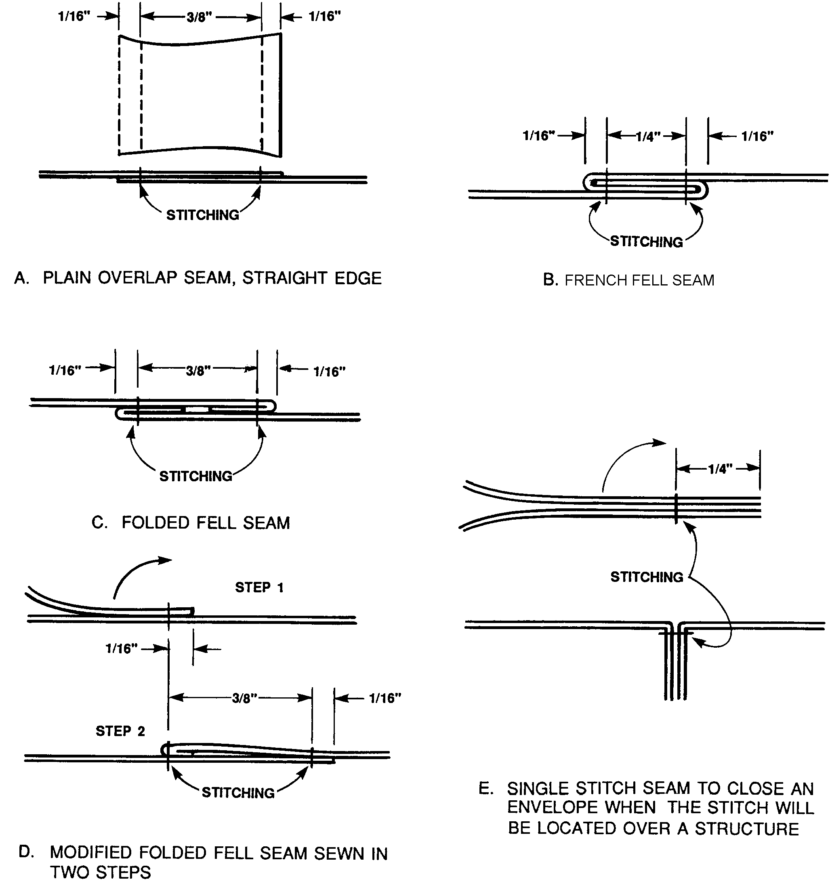
Figure 2-1. Fabric seams.

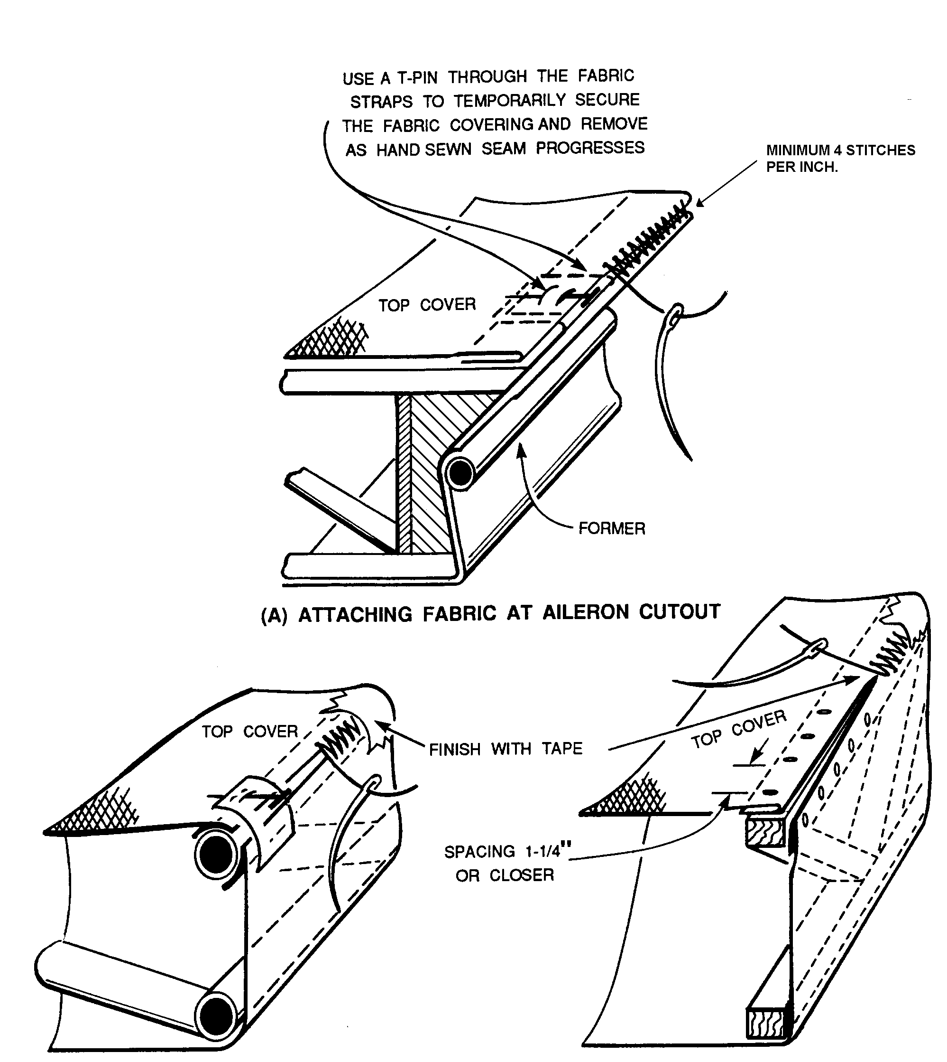

TEMPORARY TACKS MAY BE USED TO SECURE FABRIC IN POSITION FOR HAND-
SEWN SEAMS OVER A WOOD STRUCTURE. PERMANENT TACKS MAY BE USED
TO SECURE FABRIC AT WING BUTT STRUCTURES IN LIEU OF A HAND-SEWN
SEAM AND SHOULD BE OF THE APPROPRIATE LENGTH AND GAUGE, AND MADE
OF CORROSION RESISTANT STEEL OR BRASS.

Figure 2-2. Typical methods of attaching fabric.

For an overlapped and doped seam on the perimeter of a wing (except a leading edge), perimeters of wing control surfaces, perimeters of empennage surfaces, and all areas of a fuselage, on aircraft with a Vne speed up to and including 150 mph, overlap the fabric 1 inch and cover with a finishing tape that is at least 3 inches wide, centered on the outside edge of the overlap seam.

COVERING METHODS. The method of fabric attachment should be identical, as far as strength and reliability are concerned, to the method used by the manufacturer of the airplane being recovered or repaired. Carefully remove the old fabric from the airframe, noting the location of inspection covers, drain grommets, and method of attachment. Cotton or linen fabric may be applied so that either the warp or fill-threads are parallel to the line of flight. Either the envelope method or blanket method of covering is acceptable.

The Envelope Method. A wing envelope may be developed by two methods. Machine sew together, side by side multiple fabric sections, cut to reach chordwise around the wing, starting and ending at the trailing edge with a minimum of 1 inch excess length. The sewn envelope is then positioned around the wing and secured with closely spaced T-Head pins at the wingtip and trailing edge. Excess material may then be trimmed. Carefully remove the envelope and complete by machine sewing at the wingtip and along the trailing edge, except where the geometry of the wing (aileron and flap cut out) would prevent the sewn envelope from being reinstalled. After reinstalling the envelope, the un-sewn sections and butt end are then closed by hand-sewn or overlapped and doped seams in accordance with the aircraft Vne speed. (Refer to paragraph 2-7 b.)

An alternative method, when fabric of sufficient width is available, is to sew together, side-by-side, two sections of fabric, placing the seams spanwise on the leading edge, then fit and sew the wingtip and trailing edge in the same manner as the multiple piece chordwise envelope.

An envelope may be developed for the fuselage in the same manner, with a final closing along a longeron by hand-sewn or overlapped and doped seams in accordance with the aircraft Vne speed.

The Blanket Method. A blanket is developed by sewing together, side-by-side, multiple sections of fabric with the seams chordwise or two wide sections of fabric, side-by-side, placing the seam spanwise on the leading edge, the same as an envelope. Close the three remaining sides with a hand-sewn seam or overlapped and doped seams in accordance with the aircraft Vne speed. Small components may be covered by wrapping one piece of fabric over a straight leading or trailing edge, then closing three sides with hand-stitched or overlapped and doped seams in accordance with the aircraft Vne speed.

NOTE: All overlapped and doped seams will be made only over underlying supporting structures extending the full width of the seam.

Machine-sewn alternate. An alternate to machine-sewn seams on a wing envelope or blanket is to use two sections of wide fabric spanwise. Attach the fabric with overlapped and doped seams at the leading and trailing edge, wingtip and wing butt, in accordance with the aircraft Vne speeds. (Reference paragraph 2-7 b.) Smaller components may be covered in the same manner. The fuselage may be covered with multiple fabric sections with

overlapped and doped seams on the longerons or other wide fabric-forming structures in accordance with the aircraft Vne speed. (Reference paragraph 2-7 b.)

Holes in Fabric. Never cut any holes in the fabric for inspection panels, spar fittings, or drain grommets; or attach the fabric to the airframe with rib lacing screws, rivets, clips, or rib stitch cord until the fabric has been semi-tauted and stabilized with several coats of dope.

REINFORCING TAPE.

Reinforcing tape should be securely bonded to the fabric surface with dope before cord lacing or installation of hardware. Where multiple attachments are in close proximity, such as on a wing rib, continuous reinforcing tape should be installed, extending at least 1 inch past the last attachment at each end. Random or wide spacing, such as on fuselage stringers or empennage surfaces, may be reinforced with 2-inch lengths of reinforcing tape centered on the attachment location.

Reinforcing tapes should be of the appropriate width for hardware attachment such as screws, rivets, wire clips, etc., which pierce the center of the tape. Reinforcing tape under cord lacing should be the same width as the rib to which the fabric is laced and may be comprised of multiple widths positioned side-by-side to achieve the required width.

When the aircraft Vne speed is over 250 mph, anti-tear strips, cut from the same quality fabric used to cover the aircraft, are recommended for use under reinforcing tape on the entire top surface of the wing and on the portion of the wing’s bottom surface in the propeller slipstream. The propeller slipstream is considered to be the propeller diameter plus one outboard rib. The anti-tear strip should be installed completely around the wing, beginning and ending at the trailing edge in the propeller slipstream, and installed from the trailing edge over the leading edge and back under to the front spar on the balance of the ribs. Anti-tear strips should extend 1/2 inch past the wing rib cap edges and be thoroughly bonded to the fabric with dope before the reinforcing tape is installed. (See figure 2-3.)

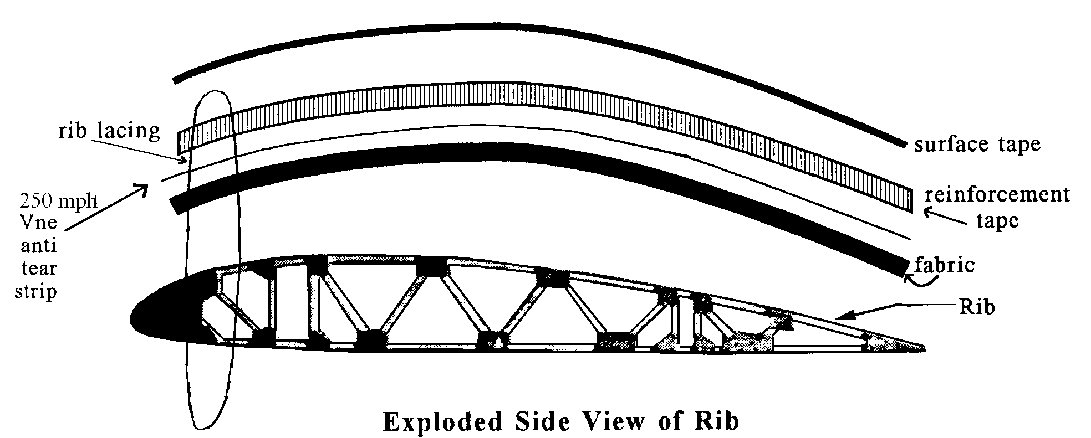

Figure 2-3. Exploded side view of rib.

LACING.

Fabric should be attached to aircraft components to prevent ballooning due to aerodynamic forces, in the identical manner and locations as used by the original aircraft manufacturer. Any deviation from the original method(s) of attachment, such as screws, rivets, wire clips, lacing cord, etc., are considered a major alteration and in conflict with the aircraft type design data. Obtain FAA approval on any deviation.

NOTE: When the type of rib lace knot used by the original aircraft manufacturer is not known, the modified seine knot shown in figure 2-4 through figure 2-9c will be used.

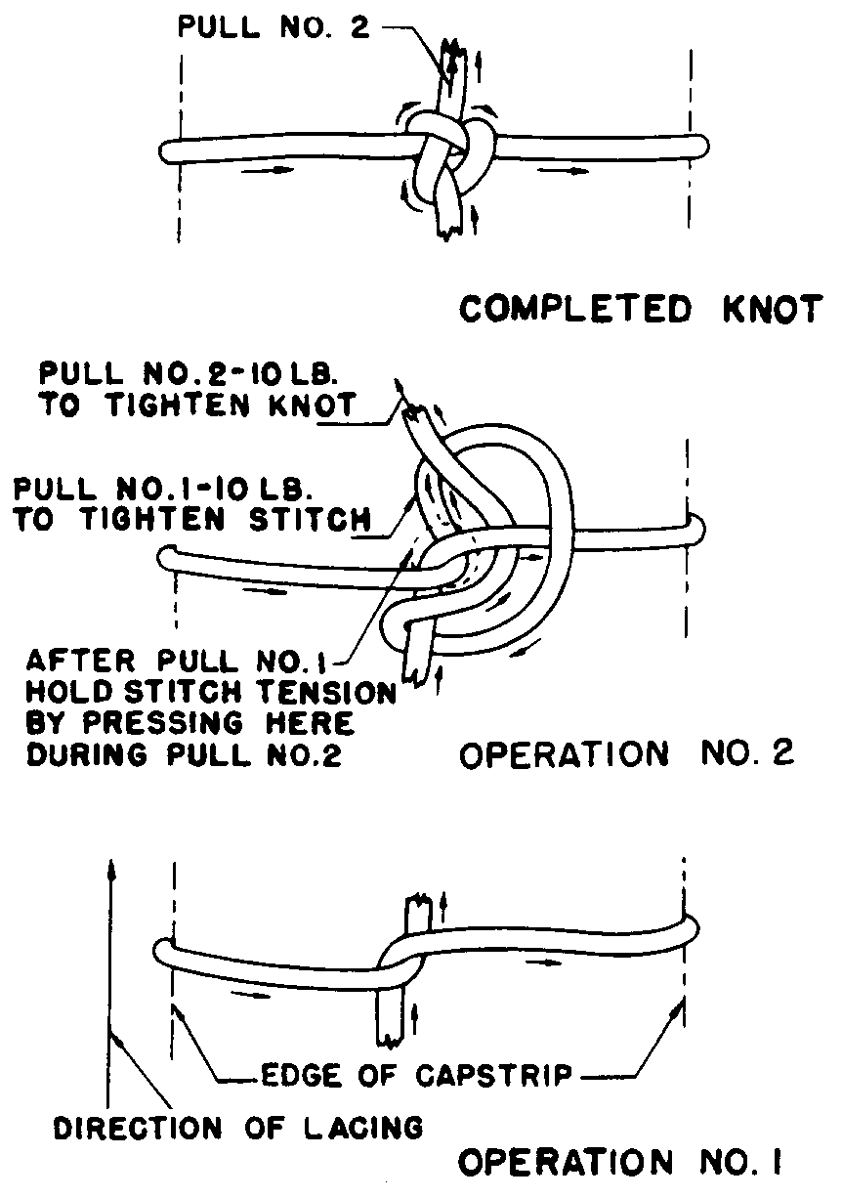

Figure 2-4. Standard external modified seine knot used for single and double rib lacing.

During the installation of lacing cord through a wing or any other component, special attention should be given to avoid interference with the routing of any control cable, bellcrank, or any other movable item. To prevent chafing and cutting of the lacing cord, control cables or any other movable items should be tensioned or positioned to their normal alignment before rib lacing and checked afterwards to ensure adequate clearance. When a lace cord will be chafed by a moving component, a blindstitch may be made around the top and bottom rib caps as illustrated in figure 2-11.

Stationary structures interfering with needle routing may be circumvented by aligning the needle forward or aft adjacent to the rib cap. Pull the needle through the wing and then return through the same hole and exit at the desired adjacent location.

NOTE: The first lace on a wing rib should be spaced from the leading edge fairing no more than 1/2 the required lace spacing for the balance of the rib.

Both surfaces of fabric covering on wings and control surfaces must be securely fastened to the ribs by lacing cord or any other method originally approved for the aircraft. Care must be taken to insure that all sharp edges against which the lacing cord may bear are protected by tape in order to prevent abrasion of the cord. Separate lengths of lacing cord may be joined by the splice knot shown in figure 2-10 or tied off. The first loop is tied with a square knot as illustrated in figure 2-5 and figure 2-9a, and the knot secured with a half hitch on each side after the lacing is pulled tight around the rib. The needle is then routed through the wing and around the rib cap at the
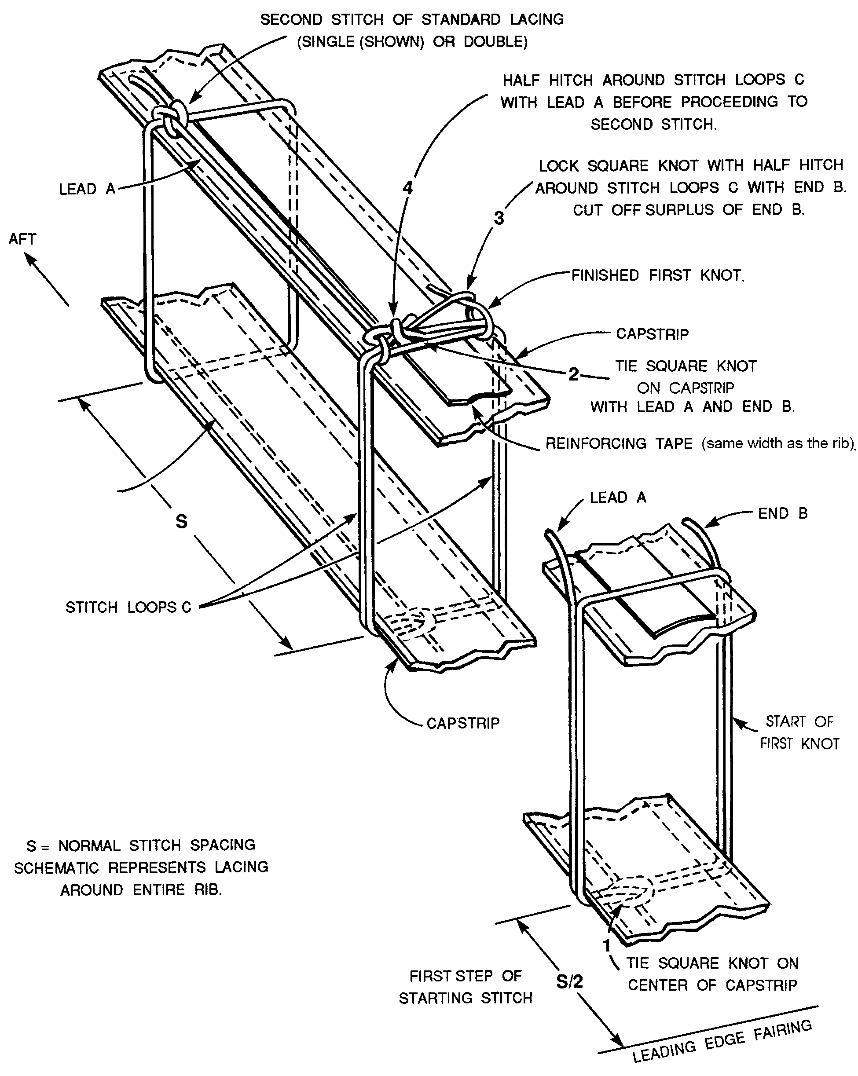
Figure 2-5. Starting stitch for rib lacing.
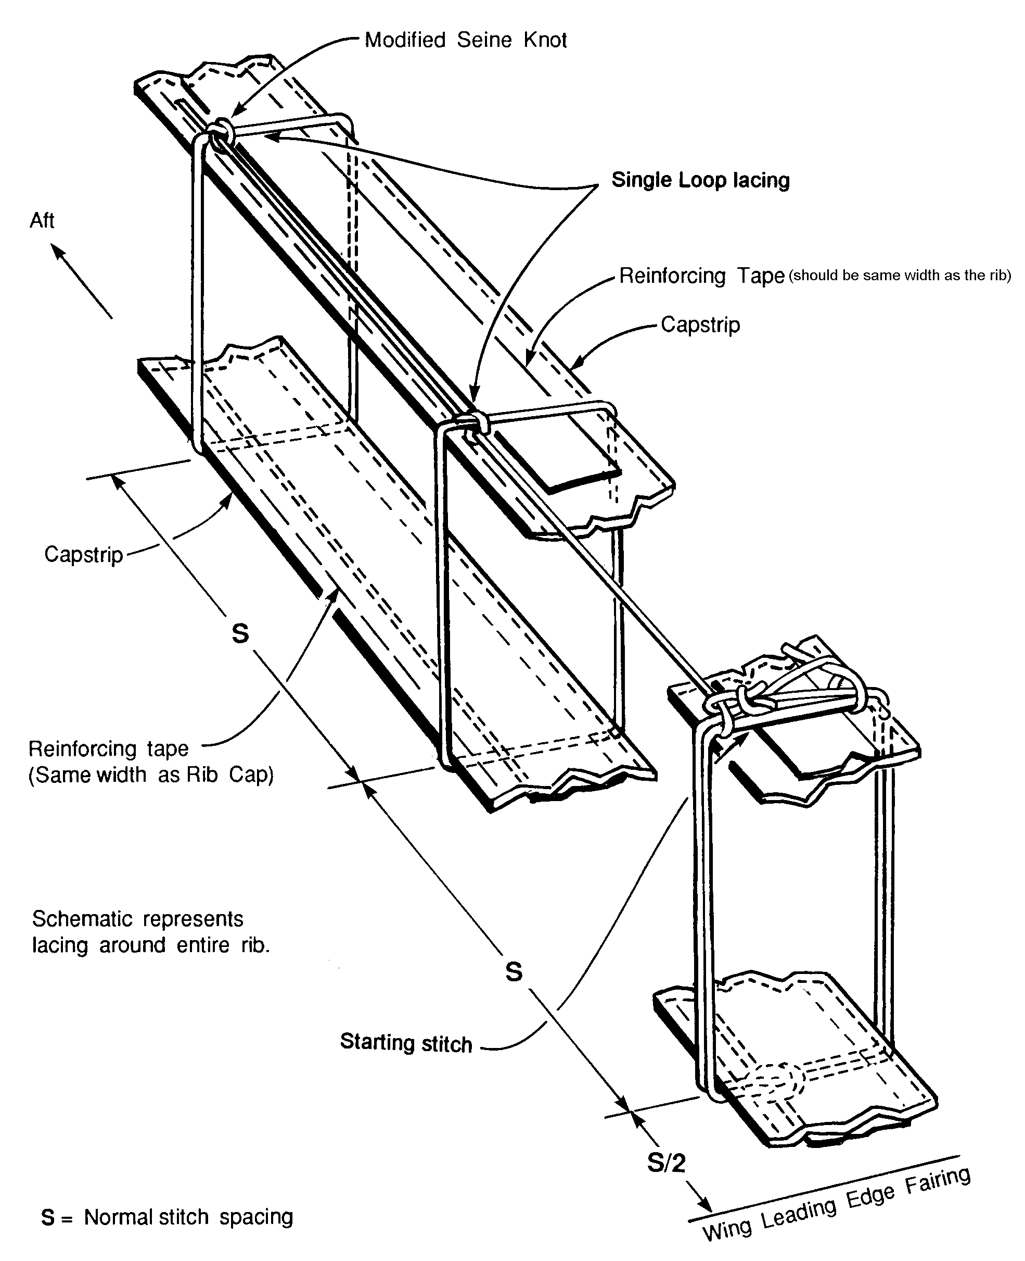
Figure 2-6. Standard single-loop lacing.
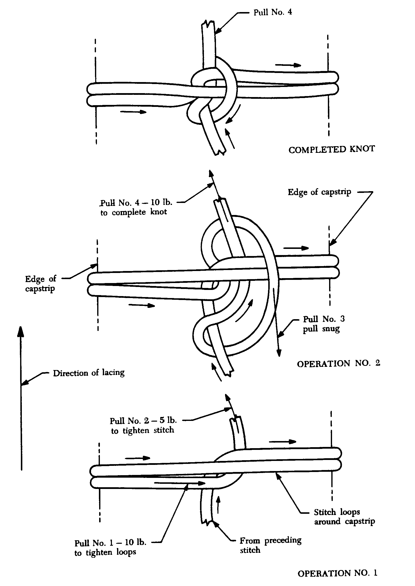
Figure 2-7. Standard knot for double-loop lacing.
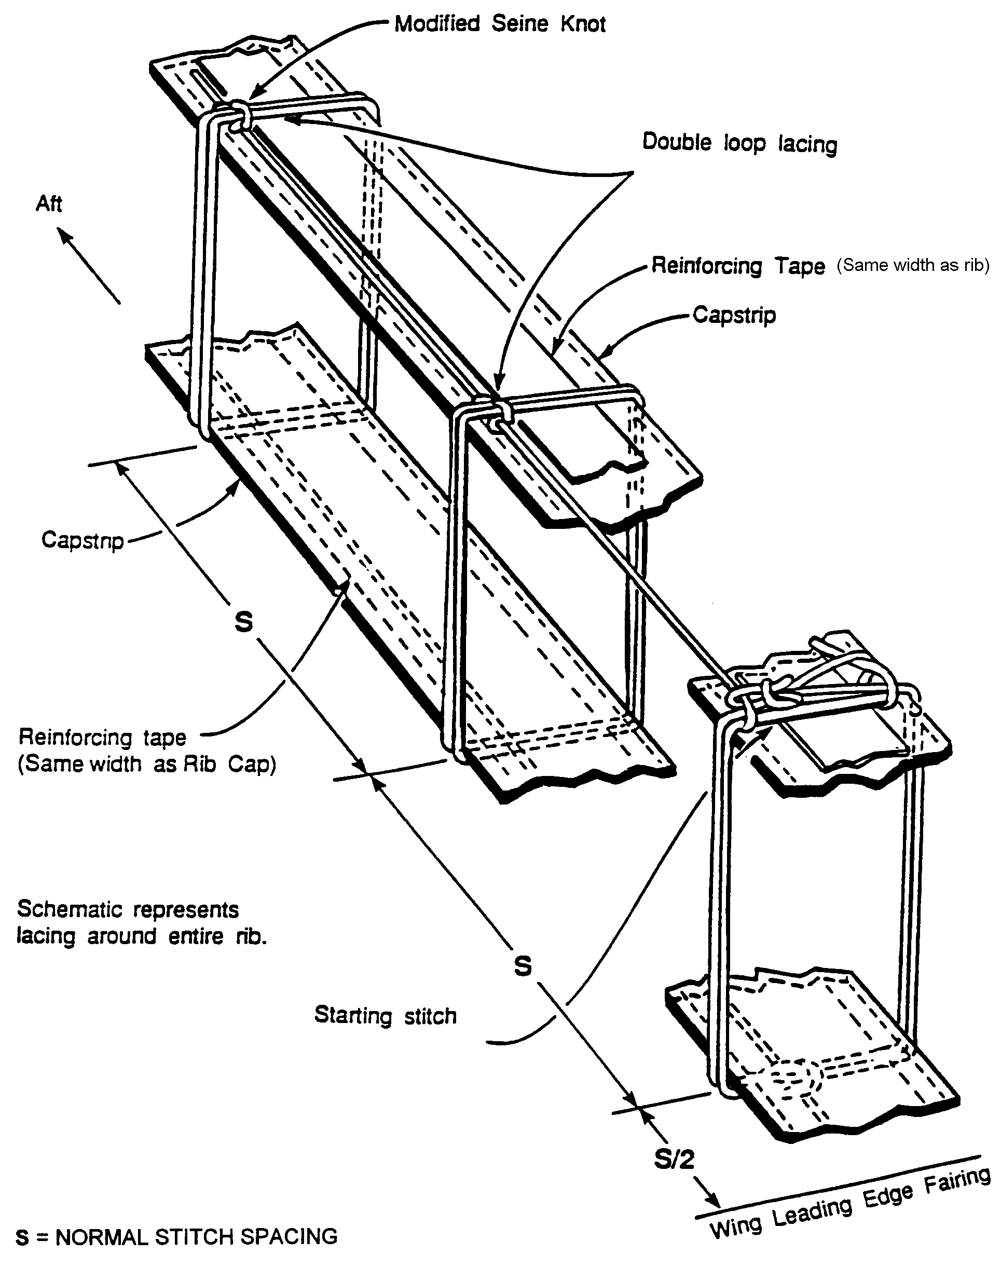
Figure 2-8. Standard double-loop lacing (optional).
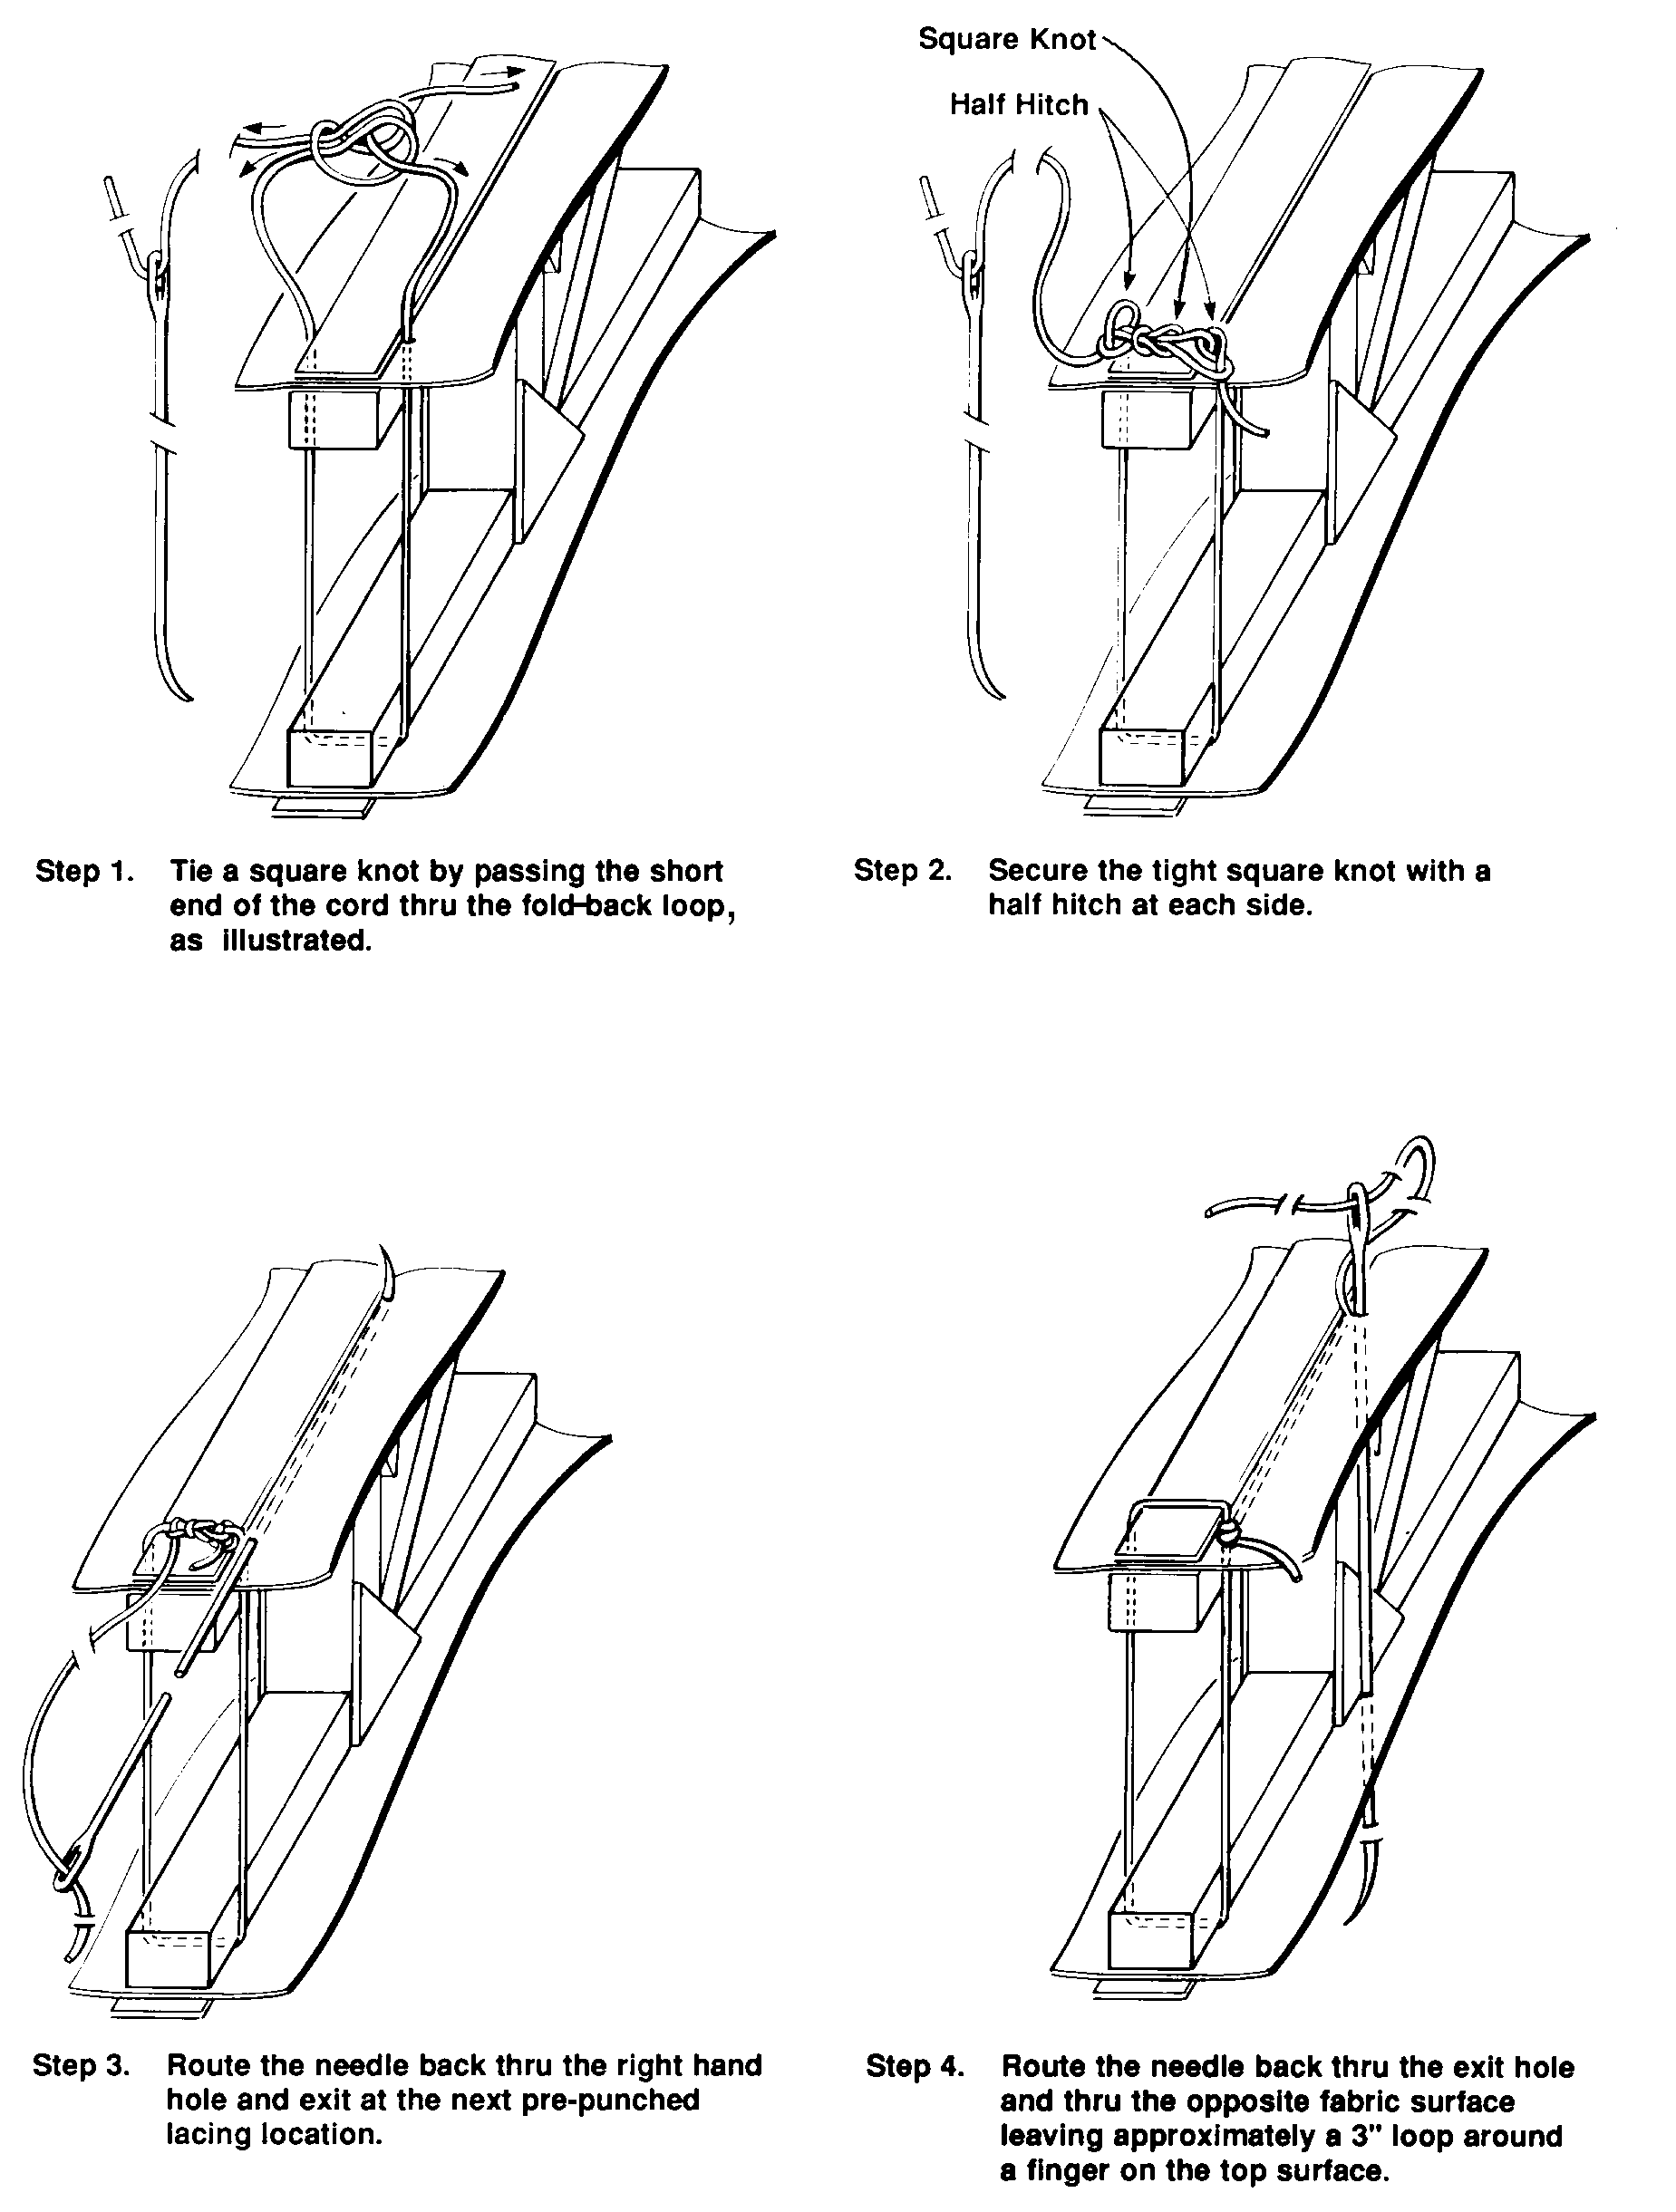

Figure 2-9a. Alternate sequence to tie a modified seine knot for rib lacing.
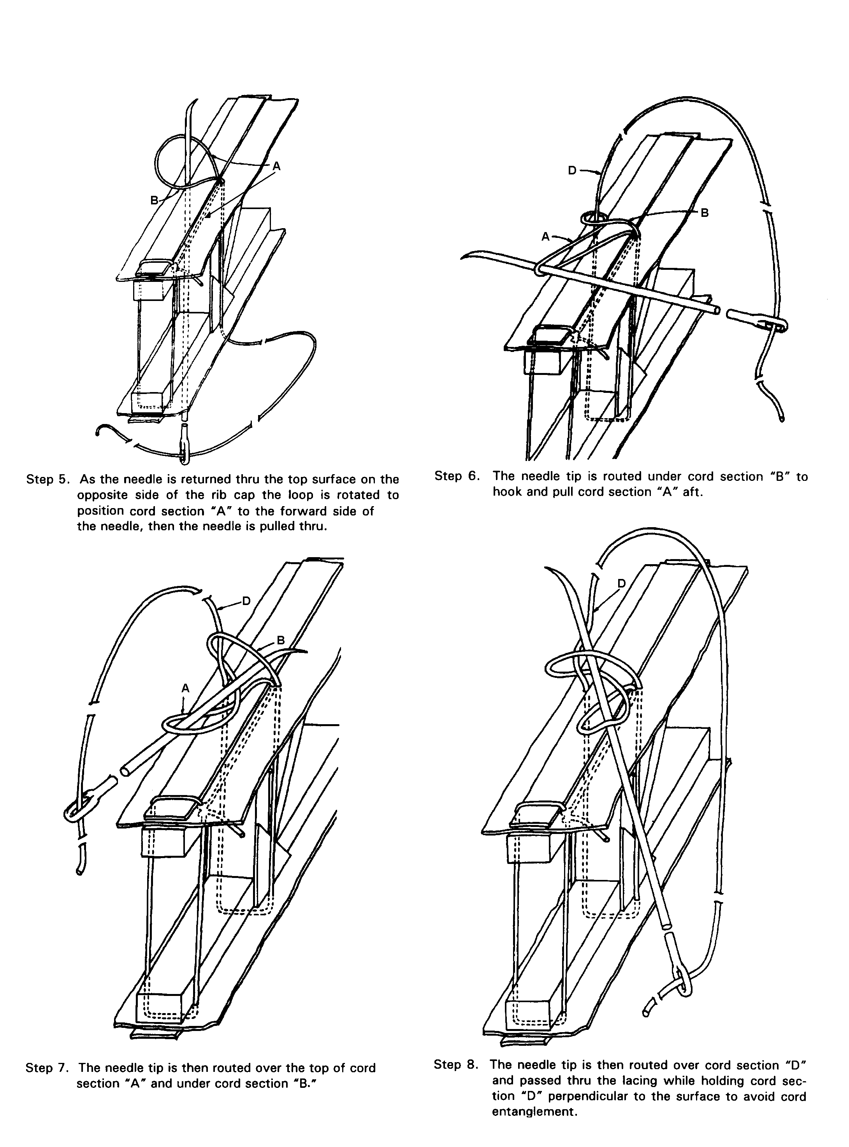

Figure 2-9b. Alternate sequence to tie a modified seine knot for rib lacing.

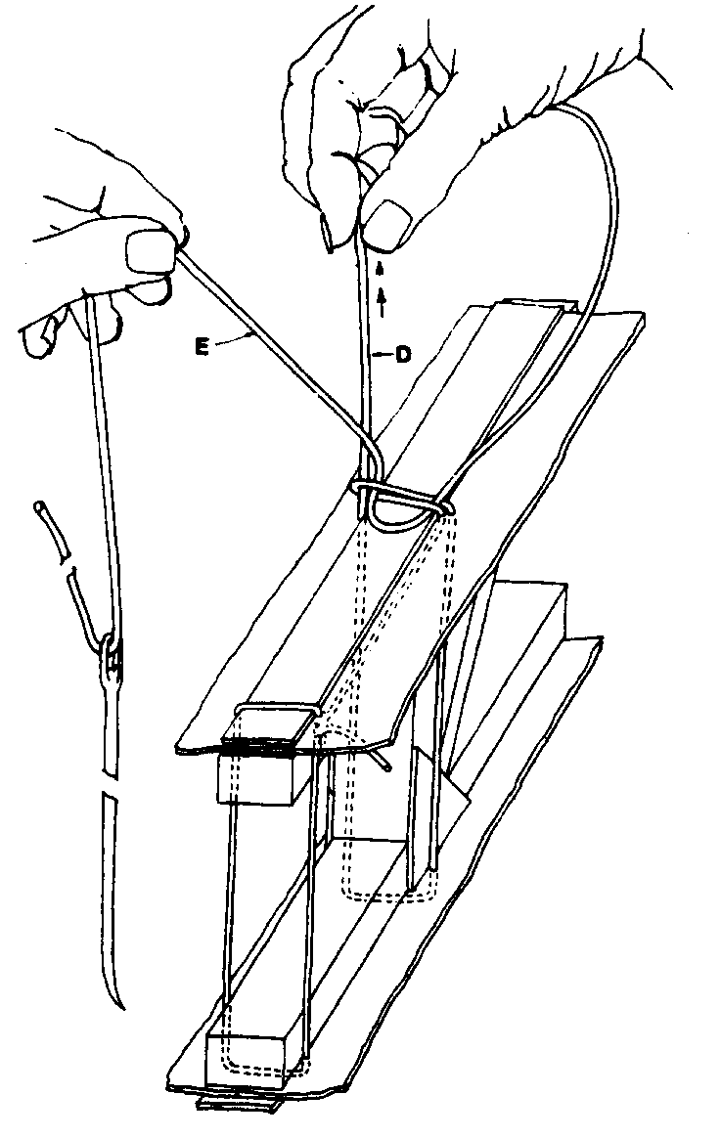
Step 9. Pull cord section “D” perpendicular to the fabric surface to remove all slack in the cord back to the last rib lacing knot while working the loose knot to the right side. Do not pull cord section “E.”

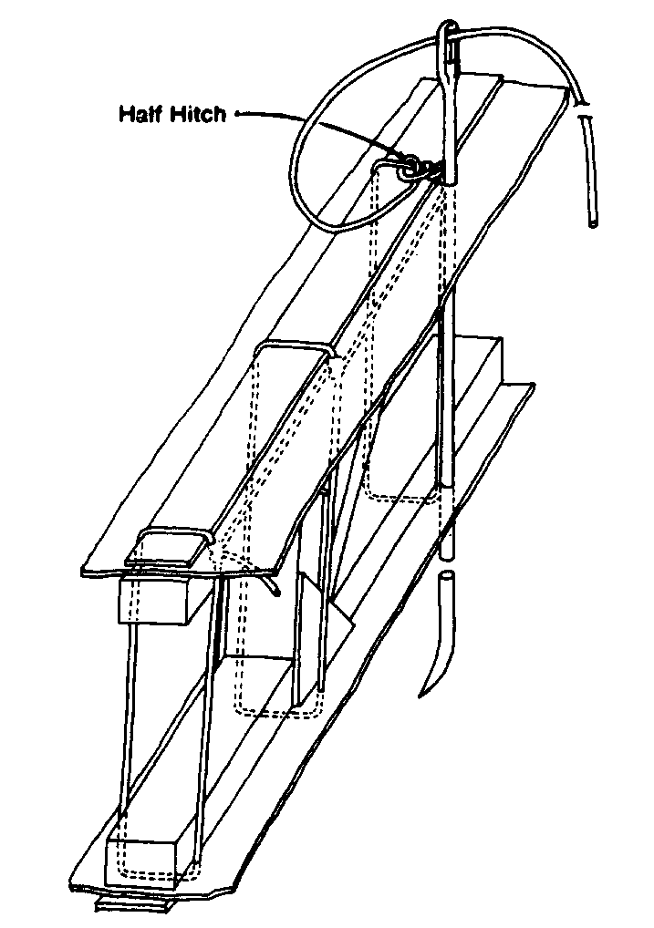

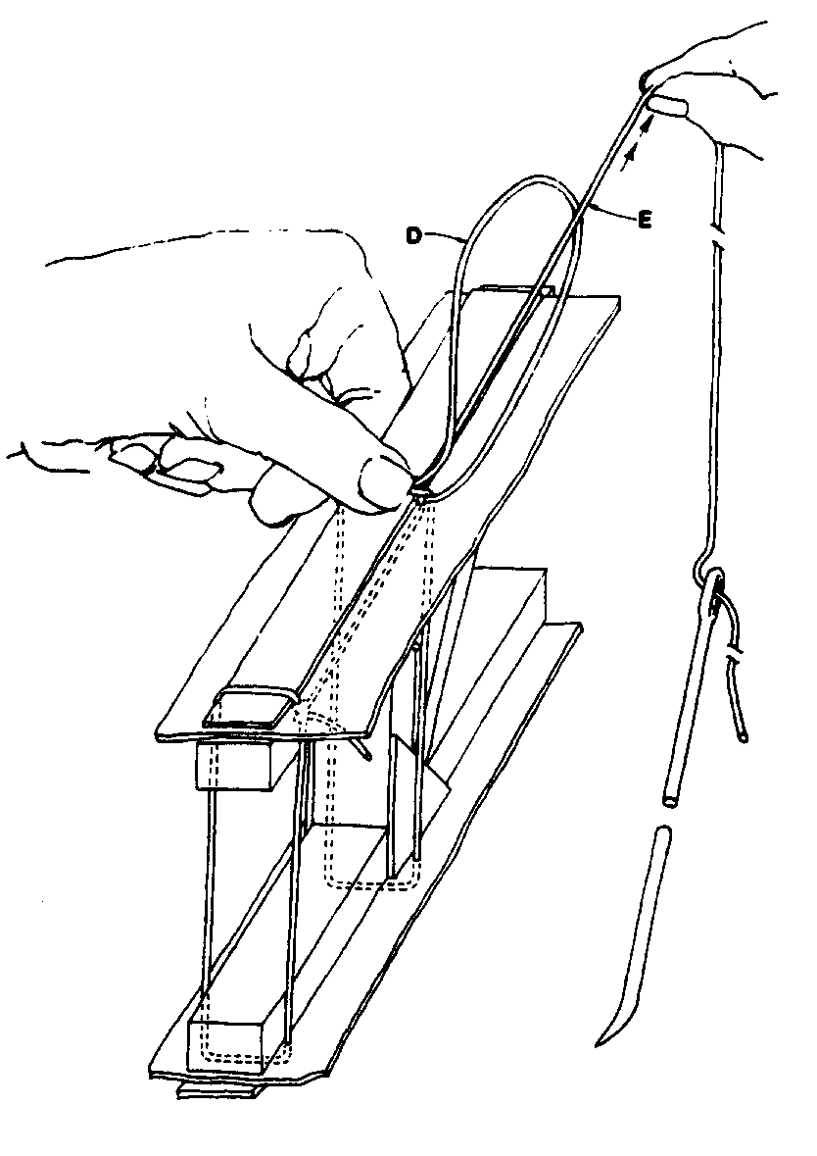
Step 10. After all slack is removed by pulling cord section “D,” switch hands and place a thumbnail on the loose knot formed on the right-hand side, then secure the knot by pulling firmly perpendicular to the fabric surface on cord section “E.”

Step 11. After completing all lacing in the same sequence, the end is secured with a half hitch after the modified seine knot. The knot is pulled to the inside by routing the needle thru the wing before cutting the cord to leave the end inside.

Figure 2-9c. Alternate sequence to tie a modified seine knot for rib lacing.

next rib lace location with the cord and knot remaining on top of the fabric surface as illustrated in figure 2-5, figure 2-6, and figure 2-8. An alternate method is to route the needle under the fabric and out through the next lace location, then back down through the wing as illustrated in figure 2-9a through figure 2-9c. A modified seine knot is then tied as illustrated in figure 2-4 through figure 2-9c.

Rotate each lace loop to place the knot at the side of the rib cap to reduce the protrusion and aerodynamic interference before moving to the next lace location, or the cord routed under the fabric to the next lace location as illustrated in figure 2-9a through figure 2-9c. The end cord is then cut off leaving a minimum of 1/4 inch stub. Lacing tension should be uniform.

Repeated pulling of long lengths of lacing cord may remove wax coating from the cord and cause fraying. Convenient lengths of rib lacing cord may be used to lace long or thick ribs. The end of each length is tied off with a half hitch as illustrated in figure 2-9c, or if needed, separate lengths of lacing cord may be joined by using the splice knot illustrated in figure 2-10.

Lacing is installed through other components, where applicable, in the same manner as a wing. Single, wide space lace attachments, usually used on empennage surfaces, are tied with a square knot and half hitch on each side, the same as a starting wing rib lace illustrated in figure 2-9a, steps 1 and 2. The lace may be rotated to place the knot under the fabric before cutting the cord.

Blind lacing on a fuselage, wing rib caps above and below a fuel tank, and any other component, when used by the original

aircraft manufacturer, should be reinstalled in the same location and spacing as installed by the original aircraft manufacturer. The lace cord is routed around the stringer, rib cap, or other structure using an appropriate length, single or double pointed, curved needle as illustrated in figure 2-11. Blind laces are tied with a square knot, then pulled tight and secured with a half hitch at each side. The lace may be rotated to place the knot under the fabric surface before cutting the cord.

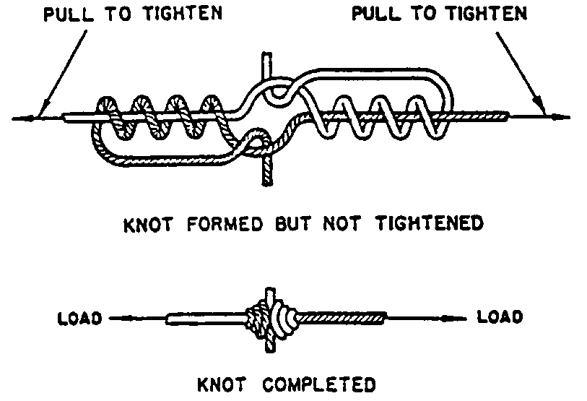

The splice knot is made by crossing the ends of the cord, and making four complete wraps with the small end of the free piece around the end of the standing piece. The end is then doubled back through the formed loop. The other free end is wrapped and doubled back. The long ends of the cords are then pulled until the knot is tight. The short ends are cut close to the knot. This finishes the splice knot.

Figure 2-10. Splice knot.

STITCH SPACING.

Rib lace spacing on wings, formerly referred to as stitch spacing, should be no greater than the spacing used by the original aircraft manufacturer. When the original spacing cannot be determined the maximum spacing illustrated in figure 2-12 should be used on the wings and wing control surfaces.

Figure 2-11. Blindstitch lacing - square knot secured with half hitches.
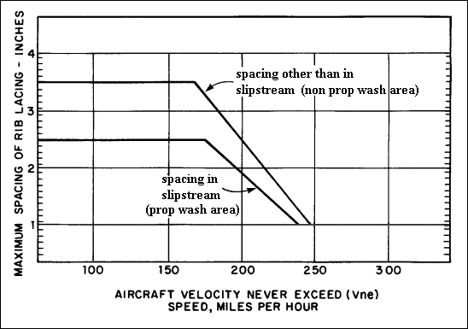
Figure 2-12. Fabric attachment spacing

When the original lace spacing on the empennage surfaces and fuselage, is not known, a maximum spacing of two times the spacing shown in figure 2-12 for the slipstream area (prop wash) on the wings may be used.

The installations of fabric attachments such as screws, rivets, wire clips, and rib lacing should be delayed until the fabric is stabilized and pulled taut with dope. This action is delayed to avoid pulling wing ribs and other structures out of alignment or tearing the fabric at attachment points as the fabric becomes taut. All lacing should be installed adjacent to the structure to which the fabric is being laced, to avoid tearing the fabric and/or creating slack in the cord loop when a load is applied. Where plastic washers were used by the aircraft manufacturer to provide increased pull-through resistance, under the heads of rivets or screws, the same diameter aluminum washer may be used as replacement. Aluminum washers are used because they are not
affected by solvents found in adhesives or dopes, nor do they become brittle because of age or cold weather.

FASTENERS. Several light aircraft designs employ screws, rivets, or single-wire metal clips to secure the fabric to the wing.

Screws holding the old fabric can be removed after spinning a small sharpened tube around each screw or using a razor blade to cut and peel away the finishing tape. Care must be taken not to mark or scribe the underlying metal or wood structure. Blind rivets through ribs can be removed by drilling in the center to undercut the head.

Single-wire clips may be removed without damage to the rib by inserting a wide, thin screwdriver blade under the clip and carefully twisting. Apply a lifting force at the clip end to pull it up through the hole.

NOTE: It is important that any damage found to ribs, such as oversize rivet or screw holes, and cracks or breaks in the rib cap, should be tagged immediately for easy location and repair later.

When repairs are made to fabric surfaces attached by special mechanical methods, duplicate the original type of fastener. When self-tapping screws are used for the attachment of fabric to the rib structure, observe the following procedure:

Redrill the holes where necessary due to wear, distortion, etc., and in such cases, use a screw one size larger as a replacement.

Extend the length of the screw beyond the rib capstrip at least two threads.

Install a thin washer, preferably aluminum, under the heads of screws and dope pinked-edge tape over each screw head.

FINISHING TAPE.

Finishing tape (surface tape) is installed after the fabric has been pulled taut with the initial dope application. This procedure is performed to prevent ripples from forming in fabric panels adjacent to newly applied tapes. Ripple formation is caused by the inability of the combined tape and fabric to tighten uniformly with adjacent fabric when additional dope is applied.

In addition to the tape widths required to be installed over fabric seams specified in paragraph 2-7, finishing tape should be installed as weather protection over all rib lacing, screws, rivets, wire clips, or other devices used to secure fabric. This includes wings, control surface ribs, empennage surface ribs, and fuselage stringers, where so installed by the original aircraft manufacturer. Tape

width should be sufficient to bond the fabric a minimum of 3/8 inch on each side of all fabric attachments. Two inch width tape is normally used. Tapes over wing rib lacing should extend a minimum of 1/2 inch past each end of any reinforcing tapes. Random or widely-spaced attachments may be covered by individual sections of fabric or finishing tape.

Installation of finishing tapes for additional wear resistance is recommended over the edges of all fabric-forming structures. This includes fuselage stringers, longerons, leading and trailing edges, false or nose ribs, control surfaces, and empennage ribs not already covered and protected by a finishing tape that is required to be on a fabric seam or fabric attached to the structure. Compound surfaces, such as wingtip bow and empennage surfaces, are more conveniently taped using bias cut finishing tape, which easily conforms to the compound contour, rather than notching linear cut tape to fit the surface. Bias cut tape will be reduced to approximately two thirds the original cut width when pulled tight around a wingtip bow and should be considered when selecting the width of tape for the various locations.

Finishing tapes are applied by coating the fabric surface over which the tape will be applied with dope, applying the tape over the wet dope film, then brushing the tape firmly onto the fabric surface. This action will assure a good bond by thoroughly saturating and wetting the finishing tape.

INSPECTION RINGS AND DRAIN GROMMETS.

Inspection Rings. Inspection access is provided adjacent to or over every control bellcrank, drag-wire junction, cable guide, pulley, wing fitting, or any other component throughout the aircraft which will be inspected or serviced annually. They are installed only
on the bottom side of the wings except where installed on the top surface by the original manufacturer.

Cutting the holes may be delayed until needed; however, all covers should be finished in matching colors with any trim lines and stored until needed. Spraying matching colors a year later is expensive and time consuming.

The 3-9/16 inch inside diameter cellulose acetate butyrate (CAB) plastic inspection access rings have become popular and bond satisfactorily with Nitrate Dope or Fabric Cement. Any metal inspection hole reinforcements of a particular shape or special design or size, installed by the original manufacturer, should be reinstalled after cleaning.

Tapes or patches over aluminum reinforcements are optional, but recommended in the prop-wash areas on the wings and forward fuselage bottom.

Fabric patches over plastic rings are strongly recommended because plastic is not a stable material, becomes brittle at low temperatures, and fatigues and cracks from prop blast vibration. Plastic rings are often cracked during removal and installation of spring, clip-held covers. Patches with a minimum 1-inch overlap, should be installed with dope.

Drain Grommets. Atmospheric temperature changes cause the humidity in the air to condense on the inside of aircraft surfaces and pool in all low areas. Rainwater enters

through openings in the sides and top, and when flying, everywhere throughout the structure. Taxiing on wet runways also splashes water up through any bottom holes. Therefore, provisions must be made to drain water from the lowest point in each fabric panel or plywood component throughout the airframe while in a stored attitude. Drain holes also provide needed ventilation.

Install drain grommets on the under side of all components, at the lowest point in each fabric panel, when the aircraft is in stored attitude. Seaplane grommets, which feature a protruding lip to prevent water splashes through the drain hole, are recommended over drain holes subject to water splashing on land planes as well as seaplanes. The appropriate-size holes must be cut through the fabric before installing seaplane grommets. Plastic drain grommets may be doped directly to the fabric surface or mounted on fabric patches then doped to the covering. Installing a small fabric patch over flat grommets to ensure security is optional. Alternate brass grommets are mounted on fabric patches, then doped to the fabric.

After all coating applications and sanding are completed, open all holes through flat drain grommets by cutting through the fabric with a small-blade knife. Do not attempt to open drain holes by punching with a sharp object because the drain hole will not remain open.

2-15.⎯2-19. [RESERVED.]

