Section 4. REPAIRS TO FABRIC COVERING

GENERAL. All materials used to make repairs to fabric covering must be of a quality at least equal to the original materials. Workmanship and repair methods must be made in a manner that will return the fabric covering to its original airworthy condition.

Any combination of seams hand-sewn and overlapped and doped may be used to make repairs and install new fabric sections. (See paragraph 2-7.)

All pigmented dope coats, including aluminum-pigmented coats, should be removed to the clear dope preliminary coats before installing a new fabric section or finishing tape on the old fabric. The appropriate dope thinner (see paragraph 2-20) may be applied with a brush to soften the old dope. The softened coats can then be removed down to the clear dope coats by scraping with a dull-bladed knife while supporting the fabric from the back side. Removing the old dope by sanding is optional.

Avoid allowing dope to run down the back side of the fabric or drip through the wing onto the back side of the opposite surface, which will cause cosmetic damage and will show in a high gloss finish.

Repairing a new fabric section over two adjacent wing ribs is considered a major repair. A log book entry and an FAA Form 337 must be processed accordingly.

All fabric patch edges not covered with a finishing tape should have a pinked edge or a 1/4-inch raveled edge.

Where the edge of a new fabric section will be located within 1 inch of a structural member to which the fabric is attached by

rib lacing or other methods, the new fabric section should be extended 3 inches past the structural member.

NOTE: Before installing new finishing tape, duplicate the original rib lacing or other attachments without removing the original rib lacing or attachment. Removing the original finishing tape is optional.

When installing large sections of fabric on a wing or other components, all machine-sewn and/or overlapped and doped seams should be made in accordance with the guidelines specified in paragraphs 2-7 and 2-8.

When repairing a covering material other than cotton or linen, which was approved with the manufacturer’s type certificate (TC), or approved under the authority of an STC, follow the repair instructions furnished by the aircraft manufacturer or supplier of the STC-approved covering materials.

REPAIR OF TEARS AND ACCESS OPENINGS. When all the original fabric is intact, an opening may be repaired by sewing the two sides together with a curved needle as illustrated in figures 2-13 and 2-14. The fabric edges should be pulled together uniformly with no wrinkles. Before sewing, remove the old dope coats down to the clear dope coats a distance of 2 inches on each side of the opening. The hand-sewn thread quality should be at least equal to that specified in table 2-2 and treated with wax (paraffin-free or beeswax) to prevent fraying, or use the proper thread on the STC application. After sewing, apply a coat of clear dope over the cleaned area and install a 3-inch wide finishing tape, centered over the stitches.

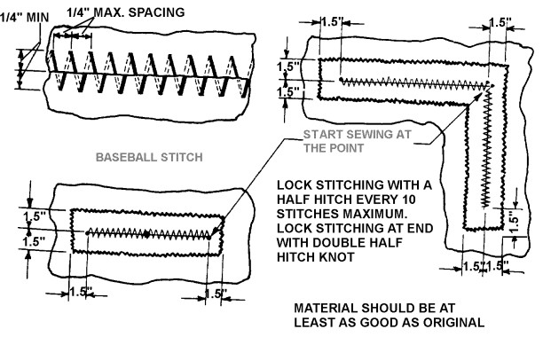
Figure 2-13. Repair of tears in fabric.

Finishing tapes should be well saturated with dope and smoothed out with no voids or wrinkles during installation. After drying for 1 hour at 70 °F, additional coats of clear dope followed with pigmented dope are applied as detailed in paragraph 2-21.

If the opening is more than 8 inches long but less than 16 inches long in any direction, the finishing tape width should be increased to 4 inches.

The finishing tape width should be increased to 6 inches if the opening is more than 16 inches long in any direction, is located on a wing top surface, or the aircraft Vne speed is greater than 150 mph.

SEWN-PATCH REPAIR. Openings that cannot be repaired by closing with stitches may be repaired by sewing in a new fabric section. The edges of the fabric around the

opening should be trimmed straight on four sides to facilitate the installation of straight sections of finishing tape over the stitches.

After cutting out the damaged section and removing the coatings as detailed in paragraph 2-42, the new fabric section should be sized to allow folding both edges of the fabric back 1/2-inch to increase the stitch tear resistance. Temporarily attach the four corners in position with thread. Start with a double thread with a square knot at the end (see figure 2-14) and continue stitching in the manner described in figures 2-13 and 2-14. When the stitching is complete, wet the new fabric section as described in paragraph 2-21 to remove any creases. After drying, apply one coat of clear dope on the new fabric, as described in paragraph 2-21. When the first coat of dope has dried 1 hour at 70 °F, apply a 3-inch wide finishing tape, centered over the stitches. The finishing tape should be well saturated with

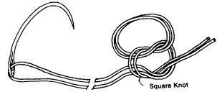
Step 1. Tie the thread ends together with a square knot.
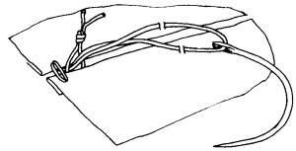
Step 2. Start the stitch by routing through the loop, positioning the square knot on the inside.
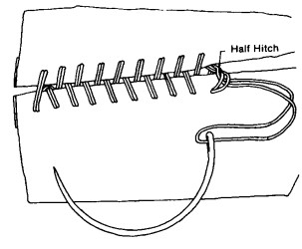
Step 3. Complete the hand-stitch and secure the stitching with a half hitch at a maximum each 10 stitches.
Figure 2-14. Hand-stitch detail.

dope and smoothed out with no voids or wrinkles. Additional coats of clear dope and pigmented dope are then applied to obtain the desired tautness and finish, as described in paragraph 2-21.

If the opening is more than 8 inches but less than 16 inches long in any direction, the finishing tape should be 4 inches wide.

The finishing tape width should be 6 inches wide if the opening is over 16 inches long in any direction, is located on a wing top surface, or the aircraft Vne speed is greater than 150 mph.

DOPED-ON PATCH REPAIR. An opening not over 8 inches in length in any direction, on an aircraft with a Vne speed less than 150 mph, may be repaired with a 2-inch overlapped and doped patch. The opening should be trimmed to eliminate any irregular edges and old pigmented dope coats removed as described in paragraph 2-42.

When installing a fabric patch over a small opening, the loose edge of the fabric around the opening may be secured by extending a series of small threads, from the edge across the opening, to the opposite side. After the patch is completed, the threads may be clipped and removed through an access port or left in place.

The fabric patch is installed by applying a coat of clear dope around the opening, then positioning the patch over the opening. Brush out any void or wrinkles while saturating only the fabric overlap area. After the first coat of clear dope around the edge has dried 1 hour at 70 °F, wet the fabric patch to remove any creases as described in paragraph 2-21. After drying, apply additional coats of clear dope and pigmented dope over the entire patch as described in paragraph 2-21.

If the opening is less than 8 inches in length in any direction and the aircraft Vne speed is greater than 150 mph, a 2-inch wide finishing tape should be installed on all sides, centered on the edge of the 2-inch overlap patch.

If the opening is more than 8 inches but less than 16 inches in length, in any direction on an aircraft with a Vne speed less than
150 mph, it may be repaired with a doped patch, which is overlapped 1/4 of the opening maximum dimension. The maximum overlap should not exceed 4 inches.

If the opening is more than 8 inches but less than 16 inches in length in any direction, the repair is located on a wing top surface, and the aircraft Vne speed is greater than 150 mph, the patch overlap should be 4 inches and a 2-inch wide finishing tape installed on all sides, centered on the edge of the patch.

If the opening is more than 16 inches in length in any direction and the Vne speed is less than 150 mph, the patch overlap should be 4 inches and the finishing tape should be 4 inches in width, centered on the edge of the patch.

If the opening is more than 16 inches in length in any direction and the Vne speed is greater than 150 mph, the patch overlap should be 4 inches and the finishing tape should be 6 inches in width, centered on the edge of the patch.

2-46.⎯2-51. [RESERVED.]

