CHAPTER 3. FIBERGLASS AND PLASTICS

Section 1. REPAIR OF LIGHT LOAD LAMINATE STRUCTURES

GENERAL. There is a wide variation in the composition and structural application of laminates, and it is essential that these factors be given major consideration when any restoration activities are undertaken. To a similar extent, there also exist many types of laminate structure repairs that may or may not be suitable for a given condition. For this reason, it is important that the aircraft or component manufacturer’s repair data be reviewed when determining what specific type of repair is permissible and appropriate for the damage at hand.

NOTE: Review Material Safety Data Sheets for material to be used. When handling materials, prepreg fabrics, or parts with prepared surfaces, observe shelf life. Latex gloves and approved masks must be worn.

The materials used in the repair of laminate structures must preserve the strength, weight, aerodynamic characteristics, or electrical properties of the original part or assembly. Preservation is best accomplished by replacing damaged material with material of identical chemical composition or a substitute approved by the manufacturer.

To eliminate dangerous stress concentrations, avoid abrupt changes in cross-sectional areas. When possible, for scarf joints and facings, make small patches round or oval-shaped, and round the corners of large repairs. Smooth and properly contour aerodynamic surfaces.

Test specimens should be prepared during the actual repair. These can then be subjected to a destructive test to establish the quality of the adhesive bond in the repaired

part. To make this determination valid, the specimens must be assembled with the same adhesive batch mixture and subjected to curing pressure, temperature, and time identical to those in the actual repair.

FIBERGLASS LAMINATE REPAIRS. The following repairs are applicable to fiberglass laminate used for non-structural fairing, covers, cowlings, honeycomb panel facings, etc. Prior to undertaking the repair, remove any paint by using normal dry sanding methods. Bead blasting may be used but caution must be exercised not to abrade the surfaces excessively.

NOTE: Chemical paint strippers must not be used.

NOTE: These repairs are not to be used on radomes or advanced composite components, such as graphite (carbon fiber) or Kevlar.

CAUTION: Sanding fiberglass laminates gives off a fine dust that may cause skin and/or respiratory irritation unless suitable skin and respiration protection is used. Sanding also creates static charges that attract dirt or other contaminants.

Check for voids and delamination by tap testing. (See chapter 5.) When the surface of a fiberglass laminated structure is scratched, pitted, or eroded; first wash with detergent and water to remove all of the dirt, wax, or oxide film. Then scrub the surface with an acceptable cleaner. After the surface is thoroughly cleaned, sand it with 280-grit sandpaper, and again use an acceptable cleanser to remove any sanding residue and moisture. This is

essential, as any moisture remaining on the surface will inhibit the cure of the resin. Dry the fiberglass laminate thoroughly prior to bonding repair. Mix enough resin, using the manufacturer’s instructions, to completely cover the damaged area, and apply one or two coats. Cover the resin with a peel ply to exclude all air from the resin while it is curing. After the resin has cured, remove the film and file or sand the surface to conform to the original shape of the part. Ensure that all edges of the laminate part are sealed to prevent water absorption. Then refinish it to match the rest of the structure.

Superficial scars, scratches, surface abrasion, or rain erosion can generally be repaired by applying one or more coats of a suitable low temperature resin, catalyzed to cure at room temperature, to the abraded surface. The number of coats required will depend upon the type of resin and the severity of the damage.

Damage not exceeding the first layer or ply of fiberglass laminate can be repaired by filling with a putty consisting of a compatible room-temperature-setting resin and clean short glass fibers. Before the resin sets, apply a sheet of peel ply over the repair area and work out any bubbles and excess resin. After the resin has cured, sand off any excess and prepare the area for refinishing.

Damage deep enough to seriously affect the strength of the laminate (usually more than the first ply or layer of fabric) may be repaired as illustrated in figure 3-1. Coat the sanded area with room-temperature-setting resin and apply contoured pieces of glass fabric soaked in resin. Apply a peel ply sheet over the repair and work out any bubbles and excess resin. After the resin has cured, scrape off the excess resin and sand the surface of the repair to the original contour.

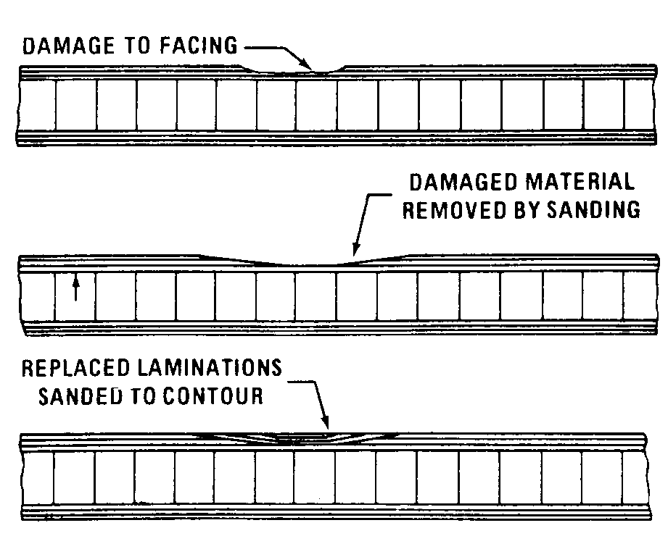
Figure 3-1. Typical laminate (facing) repair.

Damage that extends completely through one facing and into the core requires the replacement of the damaged core and facing. A method for accomplishing this type of repair is shown in figure 3-2. An alternate method for repairing the facing is shown in figure 3-3. The damaged portion is carefully trimmed out to a circular or oval shape and the core material is removed completely to the opposite facing. Exercise caution so as not to damage the opposite facing or to start delamination between the facings and the core around the damage.

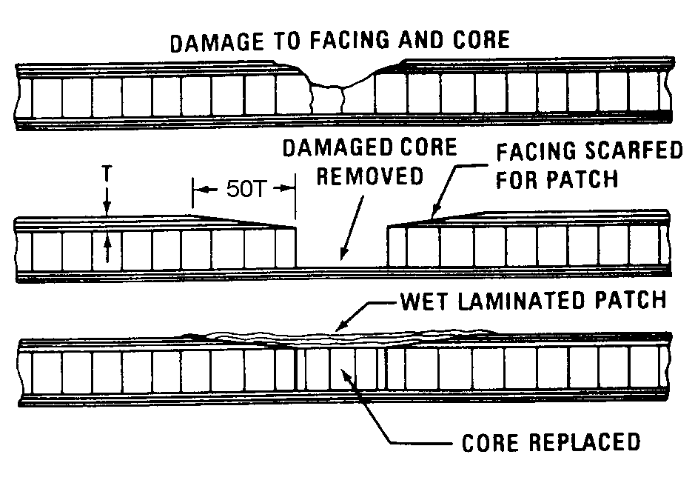
Figure 3-2. Typical core and facing repair.

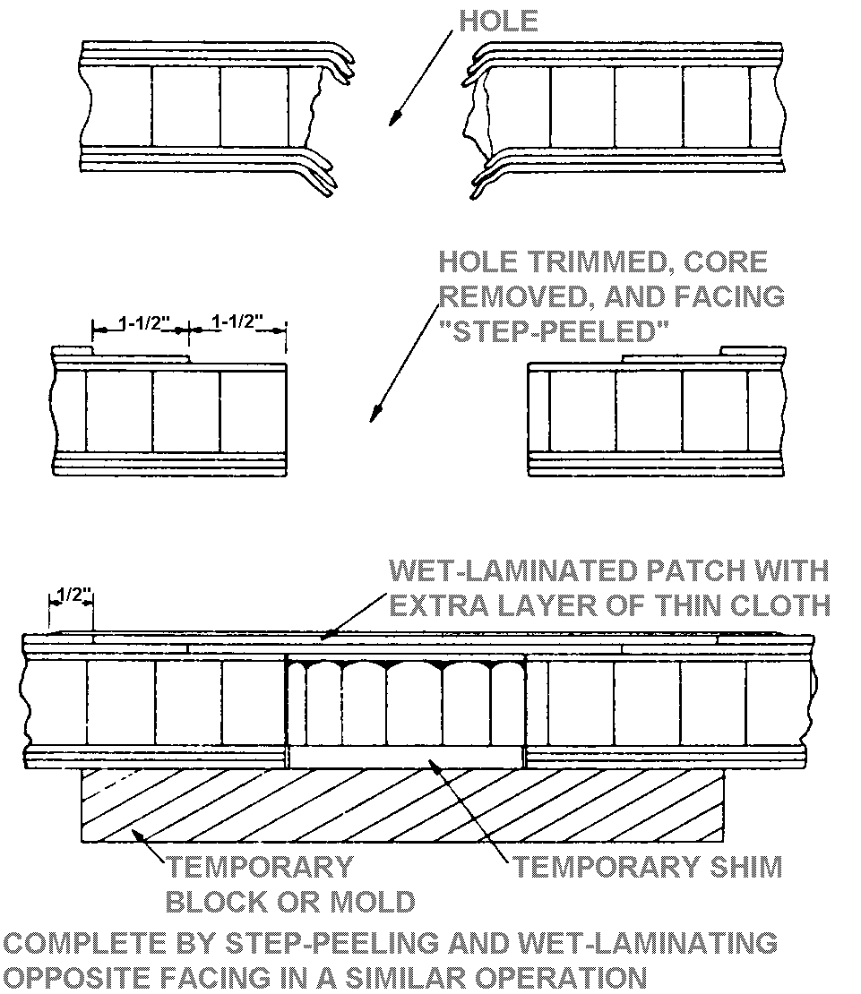
Figure 3-3. Typical stepped joint repair.

Use replacement core stock of the same material and density as the original (or an acceptable substitute) and cut it to fit snugly in the trimmed hole. Observe the direction of the original core. When all of the pieces of replacement facing laminations are cut and soaked in resin, coat all surfaces of the hole and the scarfed area with resin. Then coat all surfaces of the core replacement with resin and insert it into the hole. After all of the pieces of resin-impregnated glass-fabric facing are in place and lined up with the original fiber-orientation, cover the entire area with a piece of peel ply and carefully work down the layers of fabric to remove any air bubbles and excess resin. Apply light pressure by means of sand bags or a vacuum bag. When the resin has cured, sand the repair to match the original contour and refinish the surface.

REPAIRING HOLES.

Scarf Method. If the damaged area is less than 3 inches in diameter, the damage may

be removed by either sanding with a power sander or hand sanding with 180-grit
sandpaper.

Scarf back the edges of the hole about 50 times the thickness of the face ply. Thoroughly clean out all of the sanding residue with a cloth wet with an acceptable cleanser.

Prepare the patches by (see figure 3-4) laying the proper weight fiberglass cloth impregnated with resin on a piece of peel ply. A weight of resin equal to the weight of the patch provides a 50-percent ratio.

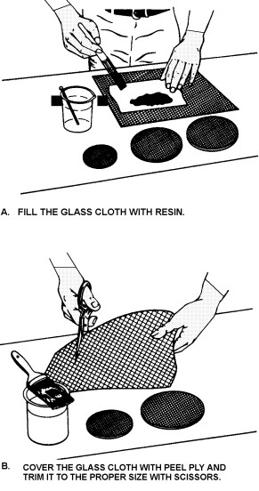
Figure 3-4. Preparing the fiberglass sandwich.

Make a sandwich by laying a second layer of peel ply over the patch before cutting it to the required size and shape. Sandwiching will prevent the patch from raveling when cut. Brush a good coat of resin over the scarfed area. Remove one piece of peel ply from the first patch and lay the patch in place. Work all of the air out of the resin and remove the top peel ply. Cut the next larger patch so it will overlap the first patch by at least one-half inch. Remove one piece of peel ply from this patch and center the patch over the first one. Work all of the air out of the resin. Continue laying in patches, each overlapping the one below it by at least one-half inch, until you have the required number of layers (see figures 3-5 and 3-6) plus an extra ply to restore original strength to the repaired area.

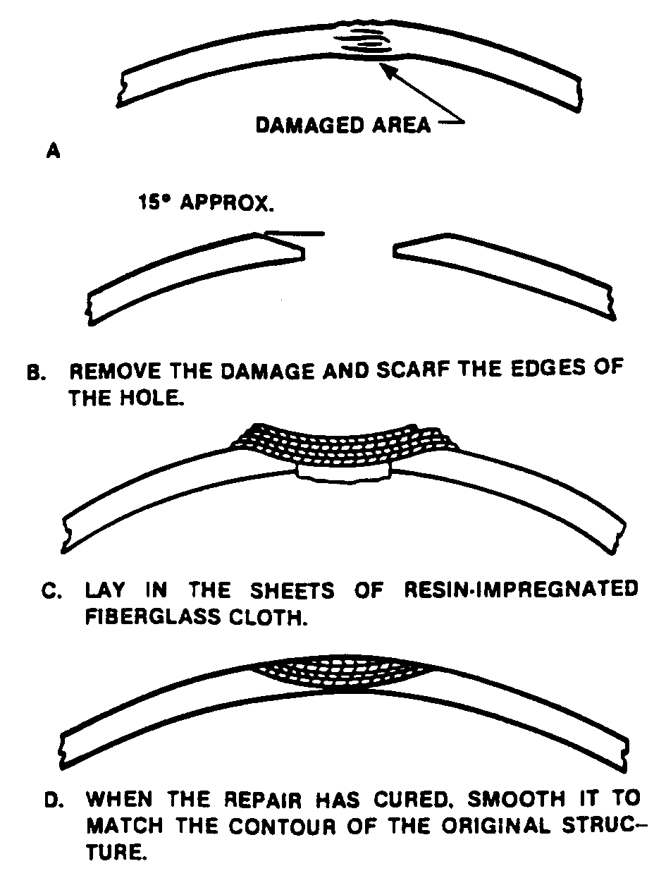
Figure 3-5. Scarfed repair to a nonstructural laminated fiberglass component.

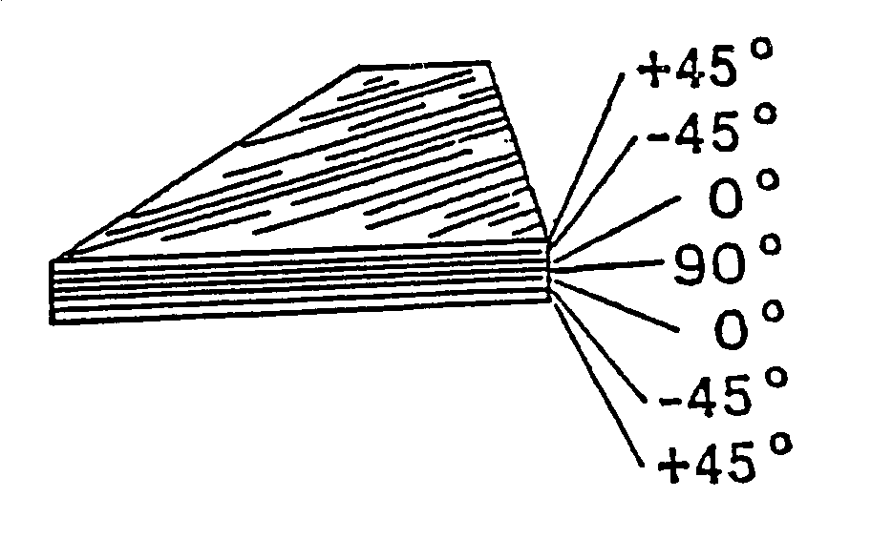
Figure 3-6. Symmetrical layup same as original number of plies, plus one extra ply.

Cover the entire repair with peel ply and carefully work out all of the air bubbles from the resin. Apply pressure over the repair with tape or sandbags and allow it to cure. After the repair has cured, remove the excess resin by filing or sanding the surface to the contour of the original part. Smooth the surface with fine sandpaper and refinish it to match the original part.

An alternate layup method that works equally well is to place the larger patch over the scarfed area first, and then each subsequent smaller patch over this. Both types of repair are finished in exactly the same way.

The scarfed joint method (see figure 3-7) is normally used on small punctures up to 3 or 4 inches in maximum dimension and in facings that are made of thin fabric that is difficult to peel.

Step-Joint Method. The scarf method of repairing a laminated fiberglass face sheet of a honeycomb structure is the easiest method to use. In this type of repair, the damage is outlined with a compass. If a square or rectangular repair is more appropriate then the damage is outlined using a straight-edge and a compass to round out the corners.

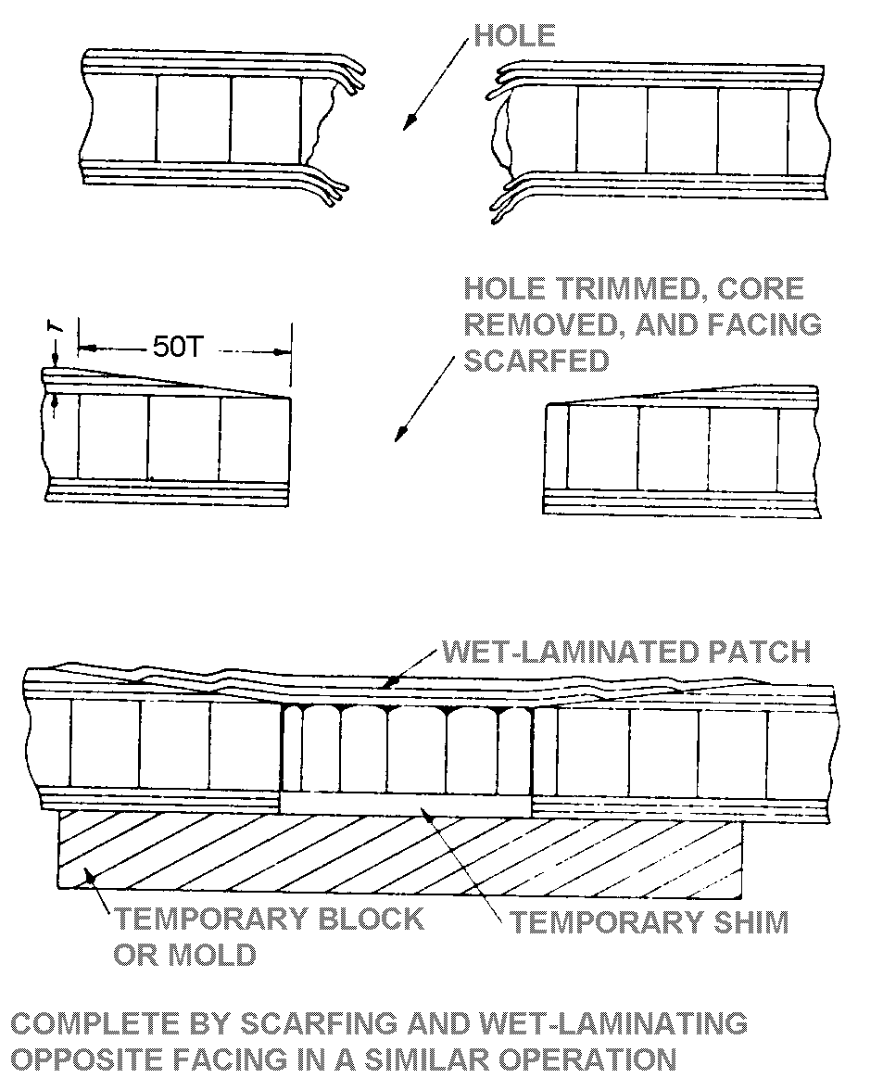
Figure 3-7. Typical scarf joint repair.

The configuration of the repair should be that which will remove the least amount of sound material. Extend the cleaned-out area for a distance equal to the number of plies to be removed, less 1 inch. For example, if you must remove three plies, extend the repair for 2 inches beyond the cleaned-out area. Each layer should be 1 inch beyond the layer below. Use a sharp knife or other type of cutter to cut through the top layer, being careful not to damage the underneath layer. Use several passes with the knife rather than one deep cut. (See figure 3-8.)

Begin with one corner of the patch and carefully pry it loose and peel it up until all of the layer is removed. Next, mark the exposed layer 1/2 inch inside the opening and carefully cut and remove it. Continue until you have removed all of the damaged or delaminated layers.

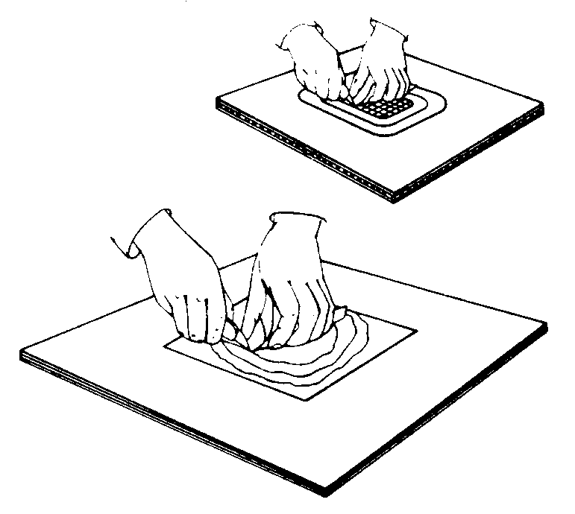
Figure 3-8. Carefully cut through each layer of fiberglass cloth and remove it from the damaged area.

Lightly sand, then scrub the entire area with an acceptable cleanser. Prepare the patches exactly as you did for the scarf method, cutting each layer to exactly the size of the material removed. Brush in a coat of resin, lay in the patch of the smallest size, and carefully work out all of the air bubbles from the resin. Now, lay in the next larger size patch to lock the first layer of fiberglass cloth into place. Repeat the process until the damage area is filled.

Butt the top layer of cloth to the opening in the face ply and cover the entire repair with peel ply. Carefully work all of the air bubbles out of the resin and put pressure on the repair with either sandbags, or another appropriate method, such as vacuum bagging. (See figure 3-9.) After the top repair has hardened, repeat the process on the bottom.

SAMPLE BAGGING AND CURING PROCESS. Figure 3-9 shows a typical bagging arrangement for a localized repair in which patch plies of prepreg are cured with a layer of adhesive, and a heating blanket is used to supply heat.

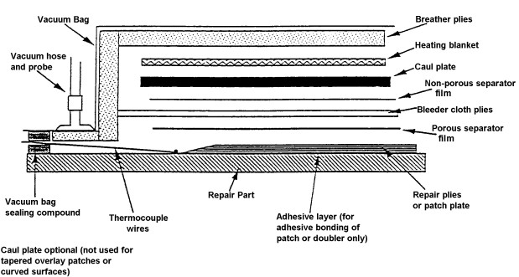
Figure 3-9. Sample bagging layup cross section.

The materials used for most bonded repairs require elevated temperatures and pressure, during their cure, to develop full strength. The following paragraphs describe the operations required to enclose the repair in a vacuum bag. When the part to be cured can be placed in an autoclave, additional pressure and heat can be applied. For cured-in-place parts, vacuum pressure and portable heat blankets usually suffice.

When selecting materials, especially the parting agent film, the temperature at which the repair is to be cured must be known. Polyvinyl alcohol (PVA) film is ideal when the bonding temperature does not exceed 250 °F. PVA film has very high tear resistance and may be heat-sealed effectively. When the bond temperature is not above 180 °F, polyvinyl chloride film can be used. For temperatures up to 450 °F, a polyvinyl fluoride film is used. These three types of films are available in a variety of weights and widths. Most nylon bagging films are used for temperatures up to 400 °F.

When all repair details are in place and ready to be cured, they are enclosed in a bag of plastic film or thin rubber. Air is removed from the bag by a vacuum source so that atmospheric pressure exerts a pressure on the repair as it is cured.

To provide a path to draw off the air initially inside the bag, layers of fiberglass cloth or similar noncontaminating materials, known as breather plies, are placed inside the bag. When prepreg is being cured as part of the repair, it is sometimes necessary to bleed off excess resin. To do this, layers of fiberglass cloth or similar materials known as bleeder plies are placed over the prepreg. Some repairs have been made with a net resin prepreg that does not require bleeding, and therefore does not require bleeder plies. Porous separator plies or film are used between the prepreg and the bleeder and nonporous separator plies or film are used between the bleeder and breather plies to control the flow of resin.

Small parts may be envelope bagged (i.e., enclosing the entire part in the bag). Larger parts with localized repairs can be bagged by sealing the surface completely around the repair areas with sealing tape and applying the bagging material to the sealing tape.

CAUTION: The whole panel must be vacuum bagged to prevent delamination in sandwich skins when using an oven or autoclave. Contoured parts must be restrained with tooling to prevent warpage.

When the heat for curing the repair is provided by a heat blanket, the blanket can be either inside or outside the vacuum bag. However, the blanket should be covered to minimize heat loss, and the blanket should be separated from direct contact with most bagging materials by layers of fiberglass cloth.

This will prevent localized overheating that could damage the bag. It is sometimes helpful to place a thin aluminum sheet under the heating blanket to minimize localized heating. A thin rubber blanket can help smooth the surface of the material being cured. A pressure plate should be used when two or more heat blankets are applied to the same repair.

NOTE: Understanding that various resins behave differently during cure, the choice of bagging arrangements will often vary with the material being cured.

The procedure for the bagging arrangement is as follows:

Place a peel ply over the patch material to provide a surface finish for subsequent bonding or painting if not previously accomplished. Place a layer of porous separator

cloth over the patch, extending beyond the prepreg and the adhesive. Smooth to avoid wrinkles.

With the patch material in place, place the end of the thermocouple wire next to the edge of the prepreg. Tape the wire to the structure inside the bag with heat-resistant tape. The tape should not be in contact with the prepreg or the adhesive.

Place bleeder plies as shown, extending 2 to 3 inches beyond the patch. The number of bleeder plies needed will vary with the type of resin and the resin content required.

Place a layer of nonporous parting film over the bleeder plies, cut 1 inch smaller than the bleeder plies. This layer is intended to stop resin flow from bleeder plies into breather plies while still providing an airflow path when vacuum is applied.

If a pressure plate is used, place it over the previous separator ply. The plate is frequently perforated with small holes to permit airflow to the breather plies. Bleeder plies may be necessary when using a pressure plate.

NOTE: Pressure on the repair will be reduced if the pressure plate does not conform to the repair.

Place the heat blanket over the assembly, making sure it extends 3 to 4 inches beyond the material to be cured.

One or more thermocouples should be in contact with the heat blanket to monitor its temperature. Additional thermocouples should be placed near the curing repair to monitor the temperature of the curing resin.

When using a heat blanket as the heat source, four to six layers of fiberglass surface breather or the equivalent should be
used over the heat blanket. This will insulate and prevent damage to the nylon bagging film. Ensure that the breather plies are in contact with the bleeder plies so that an air passage exists.

Place a bead of sealing tape against the parent material around the edge of the breather plies. Seal the thermocouple wires to prevent vacuum leakage.

NOTE: Two layers of sealing tape may be required in order to provide a good seal.

Cover with a suitable vacuum bag, smoothed to minimize wrinkles. Press the bag firmly onto the sealing tape to obtain an air-tight seal. Place pleats in vacuum bag to allow the bag material to stretch.

Install two vacuum probes or sniffers through openings cut in the bag. One will be used for the vacuum gauge and the

other will be connected to the vacuum source. The vacuum probe must sit on the breather plies, but must not touch the patch or adhesive.

NOTE: Place the vacuum gauge on the opposite side of the vacuum port, where applicable. Do not place vacuum probes near repair area.

Connect the vacuum source and smooth the bag by hand pressure as the air is removed. Check for leaks and reseal as necessary. A minimum vacuum of 22 inches of mercury is required.

Place insulating material over the vacuum bag to prevent heat loss.

Apply power to the heat blanket and control its temperature as specified for the material being cured.

Observe cure time requirements established by the product manufacturer.

3-5.⎯3-9. [RESERVED.]

