SECTION 3. TRANSPARENT PLASTICS

GENERAL. Plastics cover a broad field of organic synthetic resin and may be divided into two main classifications – thermoplastics and thermosetting plastics.

Thermoplastics. Thermoplastics may be softened by heat and can be dissolved in various organic solvents. Two kinds of transparent thermoplastic materials are commonly employed in windows, canopies, etc. These materials are known as acrylic plastics and cellulose acetate plastics.

Cellulose acetate was used in the past but since it is dimensionally unstable and turns yellow after it has been installed for a time, it has just about passed from the scene and is not considered an acceptable substitute for acrylic.

Acrylic plastics are known by the trade names of Lucite or Plexiglas and by the British as Perspex and meet the military specifications of MIL-P-5425 for regular acrylic, MIL-P-8184 for craze-resistant acrylic.

Thermosetting Plastics. These plastics do not soften appreciably under heat but may char and blister at temperatures of 240 to 260 °C (400 to 500 °F). Most of the molded products of synthetic resin composition, such as phenolic, urea-formaldehyde, and melamine formaldehyde resins, belong to the thermosetting group. Once the plastic becomes hard, additional heat will not change it back into a liquid as it would with a thermoplastic.

STORAGE AND HANDLING. Because transparent thermoplastic sheets soften and deform when they are heated, they must be stored where the temperature will never become excessive. Store them in a cool, dry

location away from heating coils, radiators, or steam pipes, and away from such fumes as are found in paint spray booths or paint storage areas.

Paper-masked transparent sheets must be kept out of the direct rays of the sun, because sunlight will accelerate deterioration of the adhesive, causing it to bond to the plastic and making it difficult to remove.

Plastic sheets should be stored with the masking paper in place, in bins that are tilted at a ten-degree angle from the vertical. This will prevent their buckling. If the sheets are stored horizontally, take care to avoid getting dirt and chips between them. Stacks of sheets must never be over 18 inches high, with the smallest sheets stacked on top of the larger ones so there will be no unsupported overhang. Leave the masking paper on the sheets as long as possible, and take care not to scratch or gouge the sheets by sliding them against each other or across rough or dirty tables.

Formed sections should be stored with ample support so they will not lose their shape. Vertical nesting should be avoided. Protect formed parts from temperatures higher than 120 °F (49 °C), and leave their protective coating in place until they are installed on the aircraft.

FORMING PROCEDURES AND TECHNIQUES. Transparent acrylic plastics get soft and pliable when they are heated to their forming temperatures and can be formed to almost any shape. When they cool, they retain the shape to which they were formed. Acrylic plastic may be cold-bent into a single curvature if the material is thin and the bending radius is at least 180 times the thickness of the sheet. Cold bending beyond these limits

will impose so much stress on the surface of the plastic that tiny fissures or cracks, called crazing, will form.

HEATING. Before heating any transparent plastic material, remove all of the masking paper and adhesive from the sheet. If the sheet is dusty or dirty, wash it with clean water and rinse it well. Dry the sheet thoroughly by blotting it with soft absorbent paper towels.

NOTE: Wear cotton gloves when handling the plastic to eliminate finger marks on the soft surface.

For the best results when hot-forming acrylics, use the temperatures recommended by the manufacturer. A forced-air oven should be used−one that is capable of operating over a temperature range of 120 to 374 °F (49 to 190 °C). If the part gets too hot during the forming process, bubbles may form on the surface and impair the optical qualities of the sheet.

For uniform heating, it is best to hang the sheets vertically by grasping them by their edges with spring clips and suspending the clips in a rack. (See figure 3-17.) If the piece is too small to hold with clips, or if there is not enough trim area, lay the sheets on shelves or racks covered with soft felt or flannel. Be sure there is enough open space to allow the air to circulate around the sheet and heat it evenly.

Small forming jobs, such as landing light covers, may be heated in a kitchen baking oven. Infrared heat lamps may be used if they are arranged on 7-or 8-inch centers and enough of them are used in a bank to heat the sheet evenly. Place the lamps about 18 inches from the material.
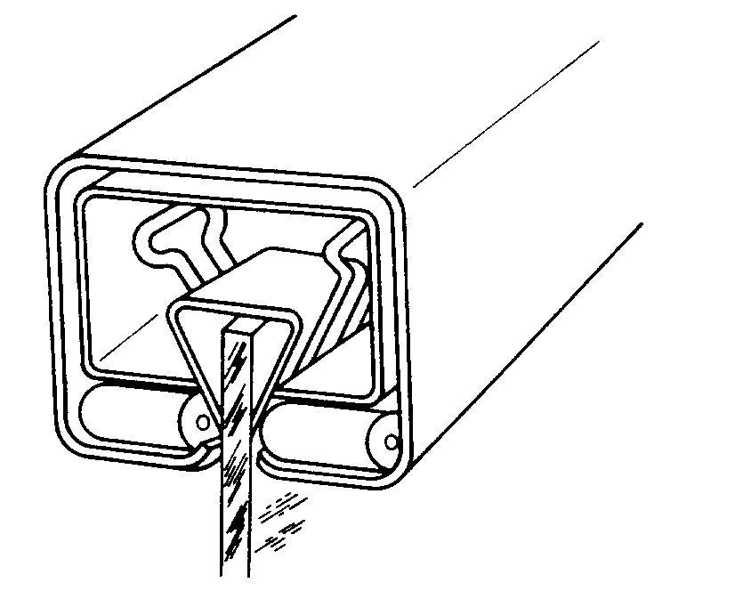
Figure 3-17. Hanging of acrylic sheets.

Never use hot water or steam directly on the plastic to heat it, because this will likely cause the acrylic to become milky or cloudy.

FORMS. Heated acrylic plastic will mold with almost no pressure, so the forms used can be of very simple construction. Forms made of pressed wood, plywood, or plaster are adequate to form simple curves, but reinforced plastic or plaster may be needed to shape complex or compound curves.

Since hot plastic conforms to any waviness or unevenness, the form used must be completely smooth. To ensure this, sand the form and cover it with soft cloth such as outing flannel or billiard felt.

The mold should be large enough to extend beyond the trim line of the part, and provisions should be made for holding the hot plastic snug against the mold as it cools.

A mold can be made for a complex part by using the damaged part itself. If the part is broken, tape the pieces together, wax or grease the inside so the plaster will not stick to it, and support the entire part in sand. Fill the part with plaster and allow it to harden, and

then remove it from the mold. Smooth out any roughness and cover it with soft cloth. It is now ready to use to form the new part.

FORMING METHODS. (See table 3-1.)

Simple Curve Forming. Heat the plastic material to the recommended temperature, remove it from the heat source, and carefully drape it over the prepared form. Carefully press the hot plastic to the form and either hold or clamp the sheet in place until it cools. This process may take from ten minutes to one-half hour. Do not force-cool it.

Compound-Curve Forming. This type of forming is normally used for such parts as canopies or complex wingtip light covers, and it requires a great deal of specialized equipment. There are four commonly used methods, each having its advantages and disadvantages.

Stretch Forming. Preheated acrylic sheets are stretched mechanically over the form in much the same way as is done with the simple curved piece. Special care must be taken to preserve uniform thickness of the material, since some parts will have to stretch more than others.

Male And Female Die Forming. This requires expensive matching male and female dies. The heated plastic sheet is placed between the dies which are then mated. When the plastic cools, the dies are opened.

Vacuum-Forming Without Forms. Many aircraft canopies are formed by this method. In this process a clamp with an opening of the desired shape is placed over a vacuum box and the heated sheet of plastic is clamped in place. When the air in the box is evacuated, the outside air pressure will force the hot plastic through the opening and form the concave canopy. It is the surface tension of the plastic that shapes the canopy.

Vacuum-Forming With A Female Form. If the shape needed is other than that which would be formed by surface tension, a female mold, or form must be used. It is placed below the plastic sheet and the vacuum pump is connected. When air from the form is evacuated, the outside air pressure will force the hot plastic sheet into the mold and fill it.

Sawing And Drilling.

Several types of saws can be used with transparent plastics, however circular saws are the best for straight cuts. The blades

Table 3-1. Typical temperatures for forming acrylic sheets.
Thickness of sheet (in.) | 0.125 |  | 0.250 |  | 0.125 |  | 0.250
Type of forming | Regular acrylic plastic.  MIL-P-6886 |  |  |  | Heat-resistant acrylic plastic,  MIL-P-5425, and craze-resistant acrylic plastic, MIL-P-8184
 | °C | °F | °C | °F | °C | °F | °C | °F
Simple curve | 113 | 235 | 110 | 230 | 135 | 275 | 135 | 275
Stretch forming  (dry mold cover) | 140 | 284 | 135 | 275 | 160 | 320 | 150 | 302
Male and female forming | 140 | 284 | 135 | 275 | 180 | 356 | 170 | 338
Vacuum forming without  form | 140 | 284 | 135 | 275 | 150 | 302 | 145 | 293
Vacuum forming with  female form | 145 | 293 | 140 | 284 | 180 | 356 | 170 | 338

should be hollow-ground or have some set to prevent binding. After the teeth are set, they should be side-dressed to produce a smooth edge on the cut. Band saws are recommended for cutting flat acrylic sheets when the cuts must be curved or where the sheet is cut to a rough dimension to be trimmed later. Close control of size and shape may be obtained by band sawing a piece to within 1/16 inch of the desired size, as marked by a scribed line on the plastic, and then sanding it to the correct size with a drum or belt sander.

Unlike soft metal, acrylic plastic is a very poor conductor of heat. Make provisions for removing the heat when drilling. Deep holes need cooling, and a water-soluble cutting oil is a satisfactory coolant since it has no tendency to attack the plastic.

The drill used on acrylics must be carefully ground and free from nicks and burrs that would affect the surface finish. Grind the drill with a greater included angle than would be used for soft metal. The rake angle should be zero in order to scrape, not cut. (See figure 3-18.)

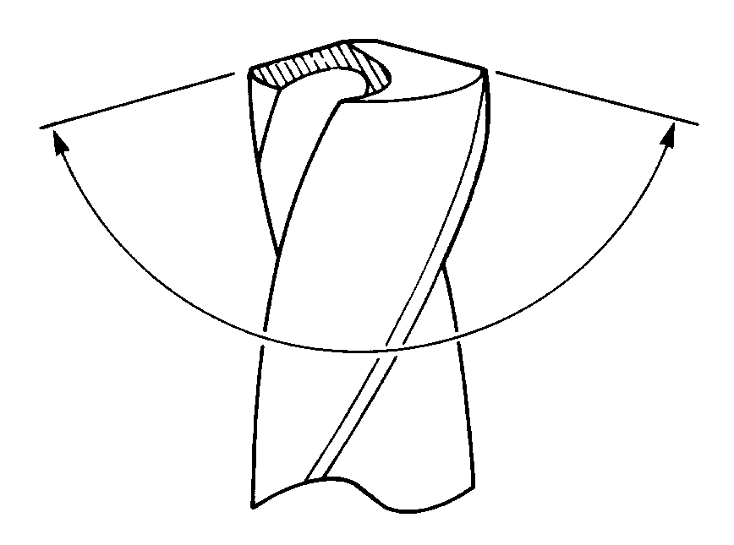
Figure 3-18. Drill having an included angle of
approximately 150°, used to drill acrylic plastics.

The patented Unibit (see figure 3-19) is good for drilling small holes in aircraft windshields and windows. It can cut holes from 1/8-to 1/2−inch in 1/32−inch increments and produces good smooth holes with no stress cracks around their edges.
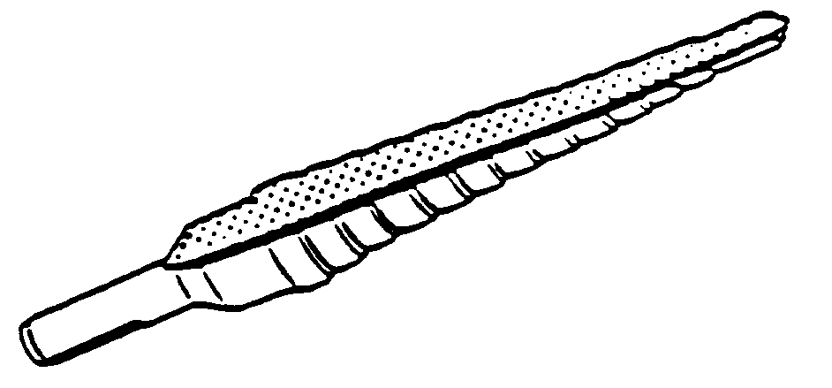
Figure 3-19. Unibit drill for drilling acrylic plastics.

Polymerizable Cements. Polymerizable cements are those in which a catalyst is added to an already thick monomerpolymer syrup to promote rapid hardening. Cement PS-30 and Weld-On 40 are polymerizable cements of this type. They are suitable for cementing all types of PLEXIGLAS acrylic cast sheet and parts molded from PLEXIGLAS molding pellets. At room temperature, the cements harden (polymerize) in the container in about 45 minutes after mixing the components. They will harden more rapidly at higher temperatures. The cement joints are usually hard enough for handling within 4 hours after assembly. The joints may be machined within 4 hours after assembly, but it is better to wait 24 hours.

PS-30 and Weld-On 40 joints retain excellent appearance and color stability after outdoor exposure. These cements produce clear, transparent joints and should be used when the color and appearance of the joints are important.

PS-30 and Weld-On 40 should be used at temperatures no lower than 65 °F. If cementing is done in a room cooler than 65 °F, it will require a longer time to harden and the joint strength will be reduced.

The cement should be prepared with the correct proportions of components as given in the manufacturer’s instructions and thoroughly mixed, making sure neither the mixing container nor mixing paddle adds color or affects the hardening of the cement.
Clean glass or polyethylene mixing containers are preferred.

Because of their short pot life (approximately 45 minutes) Cement PS-30 and Weld-On 40 must be used quickly once the components are mixed. Time consumed in preparation shortens the effective working time, making it necessary to have everything ready to be cemented before the cements are mixed. For better handling pour cement within 20 minutes of mixing.

For maximum joint strength, the final cement joint should be free of bubbles. It will usually be sufficient to allow the mixed cement to stand for 10 minutes before cementing to allow bubbles to rise to the surface. (See figure 3-20.)

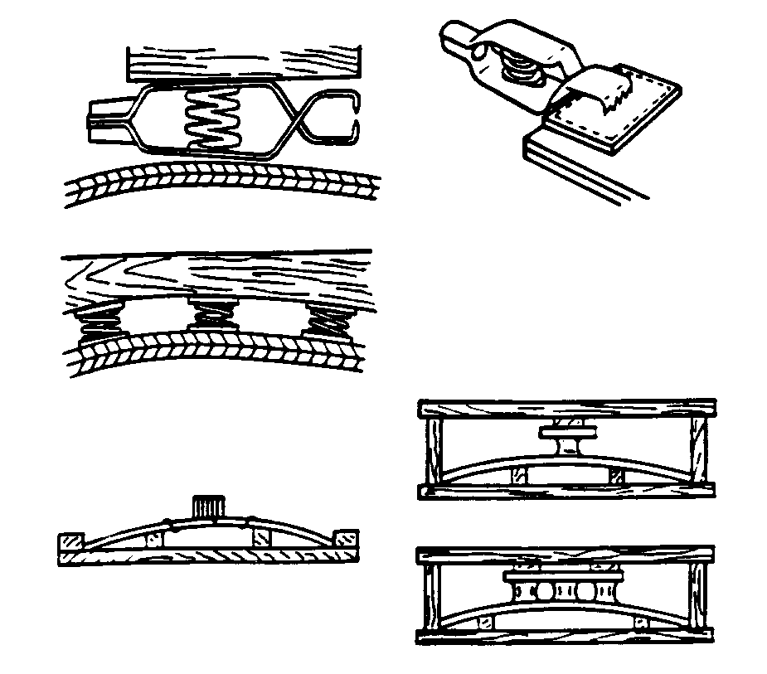
Figure 3-20. Applying pressure to acrylic plastics.

The gap joint technique can only be used with colorless PLEXIGLAS acrylic or in cases in which joints will be hidden. If inconspicuous joints in colored PLEXIGLAS acrylic are needed, the parts must be fitted closely, using closed V groove, butt, or arc joints.

Cement forms or dams may be made with masking tape as long as the adhesive surface does not contact the cement. This

is easily done with a strip of cellophane tape placed over the masking tape adhesive. The tape must be chosen carefully. The adhesive on ordinary cellophane tape prevents the cure of PS-30 and Weld-On 40. Before actual fabrication of parts, sample joints should be tried to ensure that the tape system used will not harm the cement. Since it is important for all of the cement to remain in the gap, only contact pressure should be used.

Bubbles will tend to float to the top of the cement bead in a gap joint after the cement is poured. These cause no problem if the bead is machined off. A small wire (not copper), or similar objects may be used to lift some bubbles out of the joint; however, the cement joint should be disturbed as little as possible.

Polymerizable cements shrink as the cement hardens. Therefore, the freshly poured cement bead should be left above the surfaces being cemented to compensate for the shrinkage. If it is necessary for appearances, the bead may be machined off after the cement has set.

REPAIR OF PLASTICS. Replace, rather than repair extensively damaged transparent plastic, whenever possible, since even a carefully patched part is not the equal of a new section, either optically or structurally. At the first sign of crack development, drill a small hole with a # 30 or a 1/8-inch drill at the extreme ends of the cracks as shown in figure 3-21. This serves to localize the cracks and to prevent further splitting by distributing the strain over a large area. If the cracks are small, stopping them with drilled holes will usually suffice until replacement or more permanent repairs can be made. The following repairs are permissible; however, they are not to be located in the pilot’s line of vision during landing or normal flight.

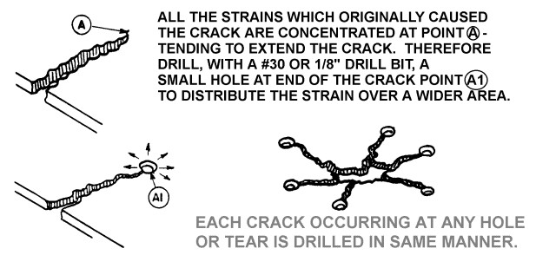
Figure 3-21. Stop-drilling cracks.

Surface Patch. If a surface patch is to be installed, trim away the damaged area and round all corners. Cut a piece of plastic of sufficient size to cover the damaged area and extend at least 3/4 inch on each side of the crack or hole. Bevel the edges as shown in figure 3-22. If the section to be repaired is curved, shape the patch to the same contour by heating it in an oil bath at a temperature of 248 to 302 °F, or it may be heated on a hot-plate until soft. Boiling water should not be used for heating. Coat the patch evenly with plastic solvent adhesive and immediately place it over the hole. Maintain a uniform pressure of 5 to 10 psi on the patch for a minimum of 3 hours. Allow the patch to dry 24 to 36 hours before sanding or polishing.

Plug Patch. When using inserted patches to repair holes in plastic structures, trim the holes to a perfect circle or oval and bevel the edges slightly. Make the patch slightly thicker than the material being

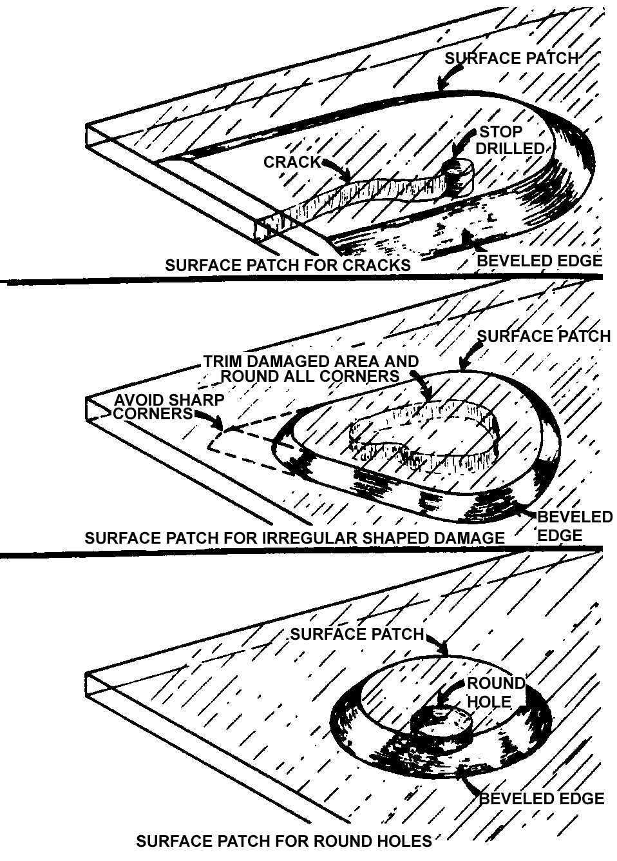
Figure 3-22. Surface patches.

repaired and similarly bevel its edges. Install patches in accordance with figure 3-23. Heat the plug until soft and press it into the hole without cement and allow to cool to make a perfect fit. Remove the plug, coat the edges with adhesive, and then reinsert in the hole. Maintain a firm light pressure until the cement has set. Sand or file the edges level with the surface, then buff and polish.

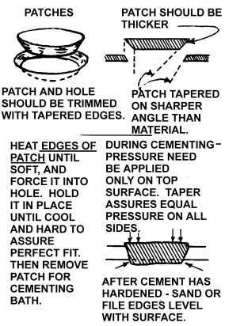
Figure 3-23. Plug patch repair.

CLEANING AND POLISHING TRANSPARENT PLASTIC. Plastics have many advantages over glass for aircraft use, but they lack the surface hardness of glass and care must be exercised while servicing the aircraft to avoid scratching or otherwise damaging the surface.

Clean the plastic by washing it with plenty of water and mild soap, using a clean, soft, grit-free cloth, sponge, or bare hands. Do not use gasoline, alcohol, benzene, acetone, carbon tetrachloride, fire extinguisher or deicing fluids, lacquer thinners, or window cleaning sprays. These will soften the plastic and cause crazing.

Plastics should not be rubbed with a dry cloth since this is likely to cause scratches, and also to build up an electrostatic charge that attracts dust particles to the surface. If after removing dirt and grease, no great amount of scratching is visible, finish the plastic with a good grade of commercial wax. Apply the wax in a thin even coat and bring to a high polish by rubbing lightly with a soft cloth.

Do not attempt hand polishing or buffing until the surface is clean. A soft, open-type cotton or flannel buffing wheel is suggested. Minor scratches may be removed by vigorously rubbing the affected area by hand, using a soft clean cloth dampened with a mixture of turpentine and chalk, or by applying automobile cleanser with a damp cloth. Remove the cleaner and polish with a soft, dry cloth. Acrylic and cellulose acetate plastics are thermoplastic. Friction created by buffing or polishing too long in one spot can generate sufficient heat to soften the surface. This condition will produce visual distortion and should be avoided.

REPLACEMENT PANELS. Use material equivalent to that originally used by the manufacturer of the aircraft for replacement panels. There are many types of transparent plastics on the market. Their properties vary greatly, particularly in regard to expansion characteristics, brittleness under low
temperatures, resistance to discoloration when exposed to sunlight, surface checking, etc. Information on these properties is in MIL-HDBK-17A, Plastics for Flight Vehicles, Part II⎯Transparent Glazing Materials, available from the Government Printing Office (GPO). These properties are considered by aircraft manufacturers in selecting materials to be used in their designs and the use of substitutes having different characteristics may result in subsequent difficulties.

INSTALLATION PROCEDURES. When installing a replacement panel, use the same mounting method employed by the manufacturer of the aircraft. While the actual installation will vary from one type of aircraft to another, consider the following major principles when installing any replacement panel.

Never force a plastic panel out of shape to make it fit a frame. If a replacement panel does not fit easily into the mounting, obtain a new replacement or heat the whole panel and reform. When possible, cut and fit a new panel at ordinary room temperature.

In clamping or bolting plastic panels into their mountings, do not place the plastic under excessive compressive stress. It is easy to develop more than 1,000 psi on the plastic by over-torquing a nut and bolt. Tighten each nut to a firm fit, then back the nut off one full turn (until they are snug and can still be rotated with the fingers).

In bolted installations, use spacers, collars, shoulders, or stop-nuts to prevent tightening the bolt excessively. Whenever such devices are used by the aircraft manufacturer, retain them in the replacement installation. It is important that the original number of bolts, complete with washers, spacers, etc., be used. When rivets are used, provide adequate spacers or other satisfactory means to prevent excessive tightening of the frame to the plastic.

Mount plastic panels between rubber, cork, or other gasket material to make the installation waterproof, to reduce vibration, and to help to distribute compressive stresses on the plastic.

Plastics expand and contract considerably more than the metal channels in which they are mounted. Mount windshield panels to a sufficient depth in the channel to prevent it from falling out when the panel contracts at low temperatures or deforms under load. When the manufacturer’s original design permits, mount panels to a minimum depth of 1-1/8 inch, and with a clearance of 1/8 inch between the plastic and bottom of the channel.

In installations involving bolts or rivets, make the holes through the plastic oversize by 1/8-inch diameter and center so that the plastic will not bind or crack at the edge of the holes. The use of slotted holes is also recommended.

3-28.⎯3-39. [RESERVED.]

