Section 4. METAL REPAIR PROCEDURES

GENERAL. The airframe of a fixed-wing aircraft is generally considered to consist of five principal units; the fuselage, wings, stabilizers, flight control surfaces, and landing gear.

Aircraft principal structural elements (pse) and joints are designed to carry loads by distributing them as stresses. The elements and joints as originally fabricated are strong enough to resist these stresses, and must remain so after any repairs. Long, thin elements are called members. Some examples of members are the metal tubes that form engine mount and fuselage trusses and frames, beams used as wing spars, and longerons and stringers of metal-skinned fuselages and wings. Longerons and stringers are designed to carry principally axial loads, but are sometimes required to carry side loads and bending moments, as when they frame cutouts in metal-skinned structures. Truss members are designed to carry axial (tension and compression) loads applied to their ends only. Frame members are designed to carry side loads and bending moments in addition to axial loads. Beam members are designed to carry side loads and bending moments that are usually large compared to their axial loads. Beams that must resist large axial loads, particularly compression loads, in combination with side loads and bending moments are called beam-columns. Other structural elements such as metal skins, plates, shells, wing ribs, bulkheads, ring frames, intercostal members, gussets, and other reinforcements, and fittings are designed to resist complex stresses, sometimes in three dimensions.

Any repair made on an aircraft structure must allow all of the stresses to enter, sustain these stresses, and then allow them to return into the structure. The repair must be equal to the original structure, but not stronger

or stiffer, which will cause stress concentrations or alter the resonant frequency of the structure.

All-metal aircraft are made of very thin sheet metal, and it is possible to restore the strength of the skin without restoring its rigidity. All repairs should be made using the same type and thickness of material that was used in the original structure. If the original skin had corrugations or flanges for rigidity, these must be preserved and strengthened. If a flange or corrugation is dented or cracked, the material loses much of its rigidity; and it must be repaired in such a way that will restore its rigidity, stiffness, and strength.

RIVETED (OR BOLTED) STEEL TRUSS-TYPE STRUCTURES. Repairs to riveted structures may be made employing the general principles outlined in the following paragraphs on aluminum alloy structures. Repair methods may also be found in text books on metal structures. Methods for repair of the major structural members must be specifically approved by the Federal Aviation Administration (FAA).

ALUMINUM ALLOY STRUCTURES. Extensive repairs to damaged stressed skin on monocoque-types of aluminum alloy structures must be made in accordance with FAA-approved manufacturer’s instructions or other FAA-approved source.

Rivet Holes. Rivet holes are slightly larger than the diameter of the rivet. When driven, solid rivets expand to fill the hole. The strength of a riveted joint is based upon the expanded diameter of the rivet. Therefore, it is important that the proper drill size be used for each rivet diameter.

The acceptable drill size for rivets may be found in Metallic Materials and Elements for Flight Vehicle Structure (MIL-HDBK-5).

Avoid drilling oversized holes or otherwise decreasing the effective tensile areas of wing-spar capstrips, wing, fuselage, fin-longitudinal stringers, or highly-stressed tensile members. Make all repairs, or reinforcements, to such members in accordance with factory recommendations or with the specific approval of an FAA representative.

Disassembly Prior to Repairing. If the parts to be removed are essential to the rigidity of the complete structure, support the structure prior to disassembly in such a manner as to prevent distortion and permanent damage to the remainder of the structure. When rivets are removed, undercut rivet heads by drilling. Use a drill of the same size as the diameter of the rivet. Drilling must be exactly centered and to the base of the head only. After drilling, break off the head with a pin punch and carefully drive out the shank. On thin or unsupported metal skin, support the sheet metal on the inside with a bucking bar. Removal of rivet heads with a cold chisel and hammer is not recommended because skin damage and distorted rivet holes will probably result. Inspect rivet joints adjacent to damaged structure for partial failure by removing one or more rivets to see if holes are elongated or the rivets have started to shear.

Effective Tools. Care must also be taken whenever screws must be removed to avoid damage to adjoining structure. When properly used, impact wrenches can be effective tools for removal of screws; however, damage to adjoining structure may result from excessive vertical loads applied through the screw axis. Excessive loads are usually related to improperly adjusted impact tools or attempting to remove screws that have seized

from corrosion. Remove seized screws by drilling and use of a screw extractor. Once the screw has been removed, check for structural cracks that may appear in the adjoining skin doubler, or in the nut or anchor plate.

SELECTION OF ALUMINUM FOR REPLACEMENT PARTS. All aluminum replacement sheet metal must be identical to the original or properly altered skin. If another alloy is being considered, refer to the information on the comparative strength properties of aluminum alloys contained in MIL-HDBK-5.

Temper. The choice of temper depends upon the severity of the subsequent forming operations. Parts having single curvature and straight bend lines with a large bend radius may be advantageously formed from heat-treated material; while a part, such as a fuselage frame, would have to be formed from a soft, annealed sheet, and heat-treated after forming. Make sure sheet metal parts which are to be left unpainted are made of clad (aluminum coated) material. Make sure all sheet material and finished parts are free from cracks, scratches, kinks, tool marks, corrosion pits, and other defects which may be factors in subsequent failure.

Use of Annealed Alloys for Structural Parts. The use of annealed aluminum alloys for structural repair of an aircraft is not recommended. An equivalent strength repair using annealed aluminum will weigh more than a repair using heat-treated aluminum
alloy.

HEAT TREATMENT OF ALUMINUM ALLOY PARTS. All structural aluminum alloy parts are to be heat-treated in accordance with the heat-treatment instruction issued by the manufacturers of the part. In the case of a specified temper, the sequence of heat-treating operations set forth in
MIL-HDBK-5 and corresponding specifications. If the heat-treatment produces warping, straighten the parts immediately after quenching. Heat-treat riveted parts before riveting, to preclude warping and corrosion.

Quenching. Quench material from the solution heat-treating temperature as rapidly as possible after removal from the furnace. Quenching in cold water is preferred, although less drastic chilling (hot or boiling water, or airblast) is sometimes employed for bulk sections, such as forgings, to minimize quenching stresses.

Reheating at Temperatures Above Boiling Water. Reheating of 2017 and 2024 alloys above 212 °F tend to impair the original heat treatment. Therefore, reheating above 212 °F, including the baking of primers, is not acceptable without subsequent complete and correct heat treatment.

BENDING METAL. When describing a bend in aviation, the term “bend radii” is used to refer to the inside radius. Requirements for bending the metal to various shapes are frequently encountered. When a metal is bent, it is subjected to changes in its grain structure, causing an increase in its hardness.

The minimum radius is determined by the composition of the metal, its temper, and thickness. Table 4-6 shows the recommended radius for different types of aluminum. Note that the smaller the thickness of the material, the smaller the recommended minimum bend radius, and that as the material increases in hardness, the recommended bend radii increases.

When using layout techniques, the mechanic must be able to calculate exactly how much material will be required for the bend. It is easier to lay out the part on a flat

sheet before the bending or shaping is performed. Before bending, smooth all rough edges, remove burrs, and drill relief holes at the ends of bend lines and at corners; to prevent cracks from starting. Bend lines should preferably be made to lie at an angle to the grain of the metal (preferably 90 degrees).

Bend radii (BR) in inches for a specific metal composition (alloy) and temper is determined from table 4-6. For example, the minimum bend radii for 0.016 thick 2024-T6 (alloy and temper) is found is found to be 2 to 4 times the material thickness or 0.032 to 0.064.

Setback.

Setback is a measurement used in sheet metal layout. It is the distance the jaws of a brake must be setback from the mold line to form a bend. For a 90 degree bend, the point is back from the mold line to a distance equal to the bend radius plus the metal thickness. The mold line is an extension of the flat side of a part beyond the radius. The mold line dimension of a part, is the dimension made to the intersection of mold lines, and is the dimension the part would have if its corners had no radius. (See figure 4-2.)

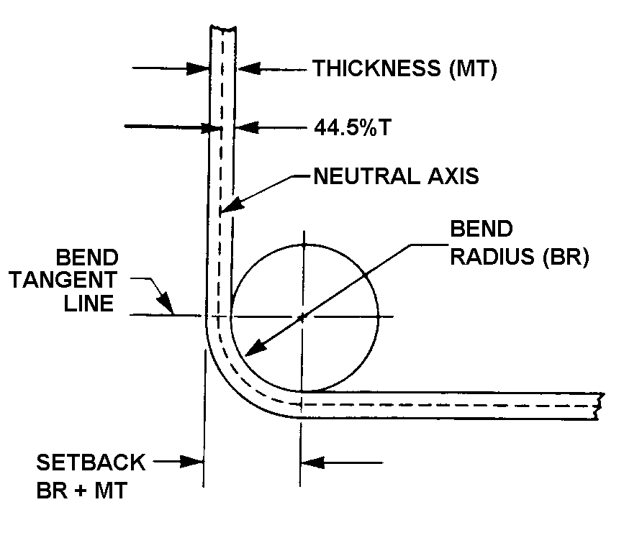
Figure 4-2. Setback for a 90-degree bend.
Table 4-6. Recommended radii for 90-degree bends in aluminum alloys.
Alloy and | Approximate sheet thickness (t) (inch)
temper | 0.016 | 0.032 | 0.064 | 0.128 | 0.182 | 0.258
2024-0¹ | 0 | 0-1t | 0-1t | 0-1t | 0-1t0-1t | 0-1t
2024-T3^{1, 2} | 1½t-3t | 2t-4t | 3t-5t | 4t-6t | 4t-6t | 5t-7t
2024-T6¹ | 2t-4t | 3t-5t | 3t-5t | 4t-6t | 5t-7t | 6t-10t
5052-0 | 0 | 0 | 0-1t | 0-1t | 0-1t | 0-1t
5052-H32 | 0 | 0 | ½t-1t | ½t-1½t | ½t-1½t | ½t-1½t
5052-H34 | 0 | 0 | ½t-1½t | 1½t-2½t | 1½t-2½t | 2t-3t
5052-H36 | 0-1t | ½t-1½t | 1t-2t | 1½t-3t | 2t-4t | 2t-4t
5052-H38 | ½t-1½t | 1t-2t | 1½t-3t | 2t-4t | 3t-5t | 4t-6t
6061-0 | 0 | 0-1t | 0-1t | 0-1t | 0-1t | 0-1t
6061-T4 | 0-1t | 0-1t | ½t-1½t | 1t-2t | 1½t-3t | 2½t-4t
6061-T6 | 0-1t | ½t-1½t | 1t-2t | 1½t-3t | 2t-4t | 3t-4t
7075-0 | 0 | 0-1t | 0-1t | ½t-1½t | 1t-2t | 1½t-3t
7075-T6¹ | 2t-4t | 3t-5t | 4t-6t | 5t-7t | 5t-7t | 6t-10t
¹ Alclad sheet may be bent over slightly smaller radii than the corresponding tempers of uncoated alloy.
² Immediately after quenching, this alloy may be formed over appreciably smaller radii.

To determine setback for a bend of more or less than 90 degrees, a correction known as a K-factor must be applied to find the setback.

Table 4-7 shows a chart of K-factors. To find the setback for any degree of bend, multiply the sum of the bend radius and metal thickness by the K-value for the angle through which the metal is bent.

Figure 4-3 shows an example of a piece of 0.064 inch sheet metal bent through 45 degrees to form an open angle of 135 degrees. For 45 degrees, the K-factor is 0.41421. The setback, or the distance from the mold point to the bend tangent line, is:

Setback = K(BR + MT)
= 0.41421 (0.25 + 0.064)
= 0.130 inches

If a closed angle of 45 degrees is formed, the metal must be bent through 135 degrees. The K-factor for 135 de-grees is 2.4142, so the setback, or distance from the mold point to the bend tangent line, is 0.758 inch.

RIVETING.

The two major types of rivets used in aircraft are the common solid shank rivet, which must be driven using an air-driven rivet gun and bucking bar; and special (blind) rivets, which are installed with special installation tools. Design allowables for riveted assemblies are specified in MIL-HDBK-5.

Solid shank rivets are used widely during assembly and repair work. They are identified by the material of which they are made, the head type, size of shank, and temper condition.

Table 4-7. K-chart for determining setback for bends other than 90 degrees.
Deg. | K | Deg. |  | K |  | Deg. |  | K |  | Deg. |  | K |  | Deg: |  | K
1 | 0.0087 |  | 37 |  | 0.3346 |  | 73 |  | 0.7399 |  | 109 |  | 1.401 |  | 145 |  | 3.171
2 | 0.0174 |  | 38 |  | 0.3443 |  | 74 |  | 0.7535 |  | 110 |  | 1,428 |  | 146 |  | 3.270
3 | 0.0261 |  | 39 |  | 0.3541 |  | 75 |  | 0.7673 |  | 111 |  | 1.455 |  | 147 |  | 3.375
4 | 0.0349 |  | 40 |  | 0.3639 |  | 76 |  | 0.7812 |  | 112 |  | 1.482 |  | 148 |  | 3.487
5 | 0.0436 |  | 41 |  | 0.3738 |  | 77 |  | 0.7954 |  | 113 |  | 1.510 |  | 149 |  | 3.605
6 | 0.0524 |  | 42 |  | 0.3838 |  | 78 |  | 0.8097 |  | 114 |  | 1.539 |  | 150 |  | 3.732
7 | 0.0611 |  | 43 |  | 0.3939 |  | 79 |  | 0.8243 |  | 115 |  | 1.569 |  | 151 |  | 3.866
8 | 0.0699 |  | 44 |  | 0.4040 |  | 80 |  | 0.8391 |  | 116 |  | 1.600 |  | 152 |  | 4.010
9 | 0.0787 |  | 45 |  | 0.4142 |  | 81 |  | 0.8540 |  | 117 |  | 1.631 |  | 153 |  | 4.165
10 | 0.0874 |  | 46 |  | 0.4244 |  | 82 |  | 0.8692 |  | 118 |  | 1.664 |  | 154 |  | 4.331
11 | 0.0963 |  | 47 |  | 0.4348 |  | 83 |  | 0.8847 |  | 119 |  | 1.697 |  | 155 |  | 4.510
12 | 0.1051 |  | 48 |  | 0.4452 |  | 84 |  | 0.9004 |  | 120 |  | 1.732 |  | 156 |  | 4.704
13 | 0.1139 |  | 49 |  | 0.4557 |  | 85 |  | 0.9163 |  | 121 |  | 1.767 |  | 157 |  | 4.915
14 | 0.1228 |  | 50 |  | 0.4663 |  | 86 |  | 0.9324 |  | 122 |  | 1.804 |  | 158 |  | 5.144
15 | 0.1316 |  | 51 |  | 0.4769 |  | 87 |  | 0.9489 |  | 123 |  | 1.841 |  | 159 |  | 5.399
16 | 0.1405 |  | 52 |  | 0.4877 |  | 88 |  | 0.9656 |  | 124 |  | 1.880 |  | 160 |  | 5.671
17 | 0.1494 |  | 53 |  | 0.4985 |  | 89 |  | 0.9827 |  | 125 |  | 1.921 |  | 161 |  | 5.975
18 | 0.1583 |  | 54 |  | 0.5095 |  | 90 |  | 1.000 |  | 126 |  | 1.962 |  | 162 |  | 6.313
19 | 0.1673 |  | 55 |  | 0.5205 |  | 91 |  | 1.017 |  | 127 |  | 2.005 |  | 163 |  | 6.691
20 | 0.1763 |  | 56 |  | 0.5317 |  | 92 |  | 1.035 |  | 128 |  | 2.050 |  | 164 |  | 7.115
21 | 0.1853 |  | 57 |  | 0.5429 |  | 93 |  | 1.053 |  | 129 |  | 2.096 |  | 165 |  | 7.595
22 | 0.1943 |  | 58 |  | 0.5543 |  | 94 |  | 1.072 |  | 130 |  | 2.144 |  | 166 |  | 8.144
23 | 0.2034 |  | 59 |  | 0.5657 |  | 95 |  | 1.091 |  | 131 |  | 2.194 |  | 167 |  | 8.776
24 | 0.2125 |  | 60 |  | 0.5773 |  | 96 |  | 1.110 |  | 132 |  | 2.246 |  | 168 |  | 9.514
25 | 0.2216 |  | 61 |  | 0.5890 |  | 97 |  | 1-130 |  | 133 |  | 2.299 |  | 169 |  | 10.38
26 | 0.2308 |  | 62 |  | 0.6008 |  | 98 |  | 1.150 |  | 134 |  | 2.355 |  | 170 |  | 11.43
27 | 0.2400 |  | 63 |  | 0.6128 |  | 99 |  | 1.170 |  | 135 |  | 2.414 |  | 171 |  | 12.70
28 | 0.2493 |  | 64 |  | 0.6248 |  | 100 |  | 1.191 |  | 136 |  | 2.475 |  | 172 |  | 14.30
29 | 0.2586 |  | 65 |  | 0.6370 |  | 101 |  | 1.213 |  | 137 |  | 2.538 |  | 173 |  | 16.35
30 | 0.2679 |  | 66 |  | 0.6494 |  | 102 |  | 1.234 |  | 138 |  | 2.605 |  | 174 |  | 19.08
31 | 0.2773 |  | 67 |  | 0.6618 |  | 103 |  | 1.257 |  | 139 |  | 2.674 |  | 175 |  | 22.90
32 | 0.2867 |  | 68 |  | 0.6745 |  | 104 |  | 1.279 |  | 140 |  | 2.747 |  | 176 |  | 26.63
33 | 0.2962 |  | 69 |  | 0.6872 |  | 105 |  | 1.303 |  | 141 |  | 2.823 |  | 177 |  | 38.18
34 | 0.3057 |  | 70 |  | 0.7002 |  | 106 |  | 1.327 |  | 142 |  | 2.904 |  | 178 |  | 57.29
35 | 0.3153 |  | 71 |  | 0.7132 |  | 107 |  | 1.351 |  | 143 |  | 2.988 |  | 179 |  | 114.59
36 | 0.3249 |  | 72 |  | 0.7265 |  | 108 |  | 1.376 |  | 144 |  | 3.077 |  | 180 |  | Inf.

The material used for the majority of solid shank rivets is aluminum alloy. The strength and temper conditions of aluminum alloy rivets are identified by digits and letters similar to those used to identify sheet stock. The 1100, 2017-T, 2024-T, 2117-T, and 5056 rivets are the six grades usually available. AN-type aircraft solid rivets can be identified by code markings on the rivet heads. A rivet made of 1100 material is designated as an “A” rivet, and has no head marking. The 2017-T alloy rivet is designated as a “D” rivet and has a raised teat on the head. Two dashes on a rivet head indicate a 2024-T alloy designated as a “DD” rivet. The 2117-T rivet is designated as an “AD” rivet, and has a dimple on the head. A “B” designation is given to a rivet of 5056 material and is marked with a raised cross on the rivet head. Each type of rivet is identified by a part number to allow the user to select the correct rivet. The numbers are in series and each series represents a particular type of head. (See figure 4-4 and table 4-8.)

An example of identification marking of rivet follows.

MS 20470AD3-5 | Complete part number
MS | Military standard number
20470 | Universal head rivet
AD | 2117-T aluminum alloy
3 | 3/32nds in diameter
5 | 5/16ths in length

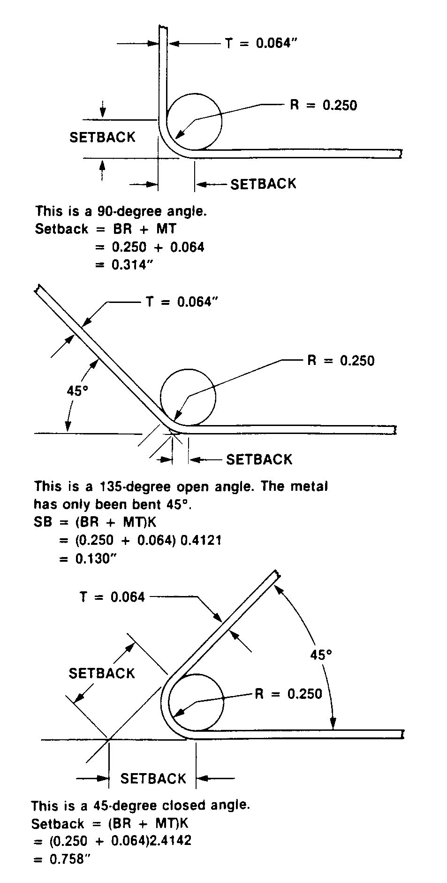
Figure 4-3. Methods of determining setback for bends other than 90 degree.

Countersunk head rivets (MS20426 supersedes AN426 100-degree) are used where a smooth finish is desired. The 100-degree countersunk head has been adopted as the standard in the United States. The universal head rivet (AN470 superseded by MS20470) has been adopted as the standard for protruding-head rivets, and may be used as a replacement for the roundhead, flathead, and brazier head rivet. These rivets can also be purchased in half sizes by designating a “0.5” after the main length (i.e., MS20470 AD4-3.5).
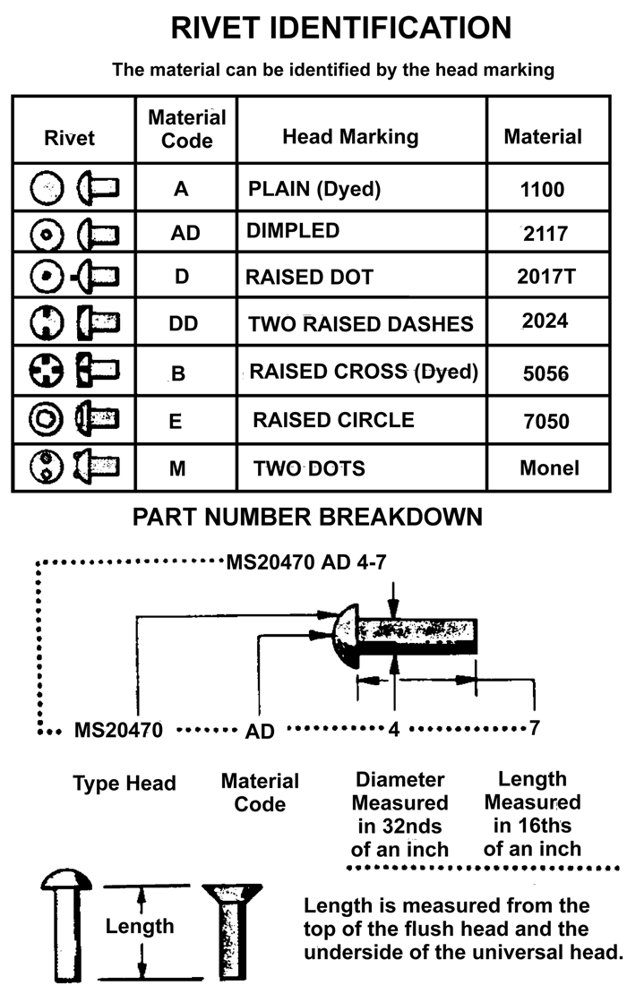

Figure 4-4. Rivet identification and part number breakdown.

Replace rivets with those of the same size and strength whenever possible. If the rivet hole becomes enlarged, deformed, or otherwise damaged; drill or ream the hole for the next larger size rivet. However, make sure that the edge distance and spacing is not less than minimums listed in the next paragraph. Rivets may not be replaced by a type having lower strength properties, unless the lower strength is adequately compensated by an increase in size or a greater number of rivets. It is acceptable to replace 2017 rivets of 3/16 inch diameter or less, and 2024 rivets of 5/32 inch diameter or less with 2117 rivets for general repairs, provided the replacement rivets are 1/32 inch greater in diameter than the rivets they replace.

Table 4-8. Aircraft rivet identification.
 | Material | 1100 | 2117T | 2017T | 2017T-HD | 2024T | 5056T | 7075-T73
 | Head Marking | Plain | Dimpled | Raised Dot | Raised Dot | Raised Double Dash | Raised Cross | Three Raised Dashes
 |  |  |  |  |  |  |  | 
 | AN  Material Code | A | AD | D | D | DD | B
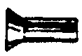 | AN425  78▪  Counter-Sunk Head | X | X | X | X | X |  | X
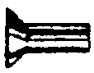 | AN426 100▪ Counter-Sunk Head  MS20426 | X | X | X | X | X | X | X
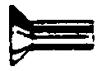 | AN427 100▪ Counter-Sunk Head  MS20427
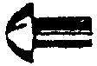 | AN430 Round Head  MS20470 | X | X | X | X | X | X | X
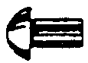 | AN435 Round Head  MS20613  MS20615
 | AN 441  Flat Head
 | AN 442  Flat Head  MS20470 | X | X | X | X | X | X | X
 | AN 455  Brazier Head  MS20470 | X | X | X | X | X | X | X
 | AN 456  Brazier Head  MS20470 | X | X | X | X | X | X | X
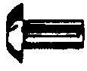 | AN 470  Universal Head  MS20470 | X | X | X | X | X | X | X
 | Heat Treat Before Using | No | No | Yes | No | Yes | No | No
 | Shear Strength psi | 10000 | 30000 | 34000 | 38000 | 41000 | 27000
 | Bearing Strength psi | 25000 | 100000 | 113000 | 126000 | 136000 | 90000

Table 4-8. Aircraft rivet identification. (continued)
 | Material | Carbon Steel | Corrosion-Resistant Steel | Copper | Monel | Monel Nickel-Copper Alloy | Brass | Titanium
 | Head Marking | Recessed Triangle | Recessed Dash | Plain | Plain | Recessed Double Dots | Plain | Recessed Large and Small Dot
 |  |  |  |  |  |  |  | 
 | AN  Material Code |  | F | C | M | C
AN425
78▪
Counter-Sunk Head
 | AN426 100▪ Counter-Sunk Head  MS20426 |  |  |  |  |  |  | MS 20426
 | AN427 100▪ Counter-Sunk Head  MS20427 | X | X | X | X
AN430 Round Head
MS20470
 | AN435 Round Head  MS20613  MS20615 | X  MS20613 | X  MS20613 | X |  | X  MS20615 | X  MS20615
 | AN 441  Flat Head | X |  | X | X |  |  | X
AN 442
Flat Head
MS20470
AN 455
Brazier Head
MS20470
AN 456
Brazier Head
MS20470
AN 470
Universal Head
MS20470
 | Heat Treat Before Using | No | No | No | No | No | No | No
 | Shear Strength  psi | 35000 | 65000 | 23000 | 49000 | 49000 |  | 95000
 | Bearing Strength  psi | 90000 | 90000

Rivet edge distance is defined as the distance from the center of the rivet hole to the nearest edge of the sheet. Rivet spacing is the distance from the center of the rivet hole to the center of the adjacent rivet hole. Unless structural deficiencies are suspected, the rivet spacing and edge distance should duplicate those of the original aircraft structure. If structural deficiencies are suspected, the following may be used in determining minimum edge distance and rivet spacing.

For single row rivets, the edge distance should not be less than 2 times the diameter of the rivet and spacing should not be less than 3 times the diameter of the rivet.

For double row rivets, the edge distance and spacing should not be less than the minimums shown in figure 4-5.

For triple or multiple row rivets, the edge distance and spacing should not be less than the minimums shown in figure 4-5.

The 2117 rivets may be driven in the condition received, but 2017 rivets above 3/16 inch in diameter and all 2024 rivets are to be kept packed in dry ice or refrigerated in the “quenched” condition until driven, or be reheat treated just prior to driving, as they would otherwise be too hard for satisfactory riveting. Dimensions for formed rivet heads are shown in figure 4-6(a), together with commonly found rivet imperfections.

When solid shank rivets are impractical to use, then special fasteners are used. Special fastening systems used for aircraft construction and repair are divided into two types, special and blind fasteners. Special fasteners are sometimes designed for a specific purpose in an aircraft structure. The name “special fasteners” refers to its job requirement and the tooling needed for installation. Use of special fasteners may require an FAA field approval.

Blind rivets are used under certain conditions when there is access to only one side of the structure. Typically, the locking characteristics of a blind rivet are not as good as a driven rivet. Therefore, blind rivets are usually not used when driven rivets can be installed.

Blind rivets shall not be used:

in fluid-tight areas;

on aircraft in air intake areas where rivet parts may be ingested by the engine, on aircraft control surfaces, hinges, hinge brackets, flight control actuating systems, wing attachment fittings, landing gear fittings, on floats or amphibian hulls below the water level, or other heavily-stressed locations on the aircraft;

CAUTION: For metal repairs to the airframe, the use of blind rivets must be specifically authorized by the airframe manufacturer or approved by a representative of the FAA.

Self plugging friction-lock cherry rivets. This patented rivet may be installed when there is access to only one side of the structure. The blind head is formed by pulling the tapered stem into the hollow shank. This swells the shank and clamps the skins tightly together. When the shank is fully upset, the stem pulls in two. The stem does not fracture flush with the rivet head and must be trimmed and filed flush for the installation to be complete. Because of the friction-locking stem, these rivets are very sensitive to vibrations. Inspection is visual, with a loose rivet standing out in the standard “smoking rivet” pattern. Removal consists of punching out the friction-

locked stem and then treating it like any other rivet. (See figure 4-7.)

Mechanical-lock rivets have a device on the puller or rivet head which locks the center stem into place when installed. Many friction-lock rivet center stems fall out due to vibrations; this in turn, greatly reduces its shear strength. The mechanical-lock rivet was developed to prevent that problem. Various manufacturers make mechanical-lock fasterners such as: Bulbed Cherrylock, CherryMax, Olympic-Loks, and Huck-Loks.

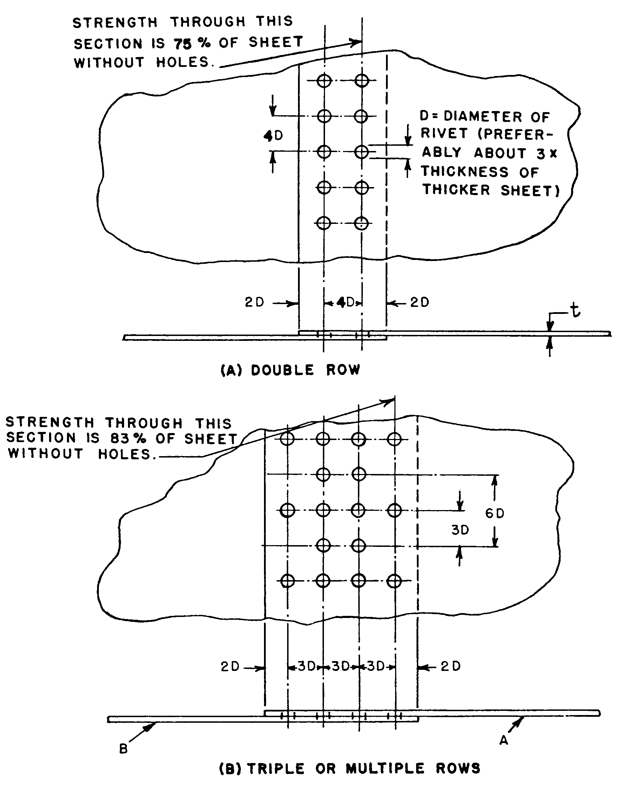
Figure 4-5. Rivet hole spacing and edge distance for single-lap sheet splices.

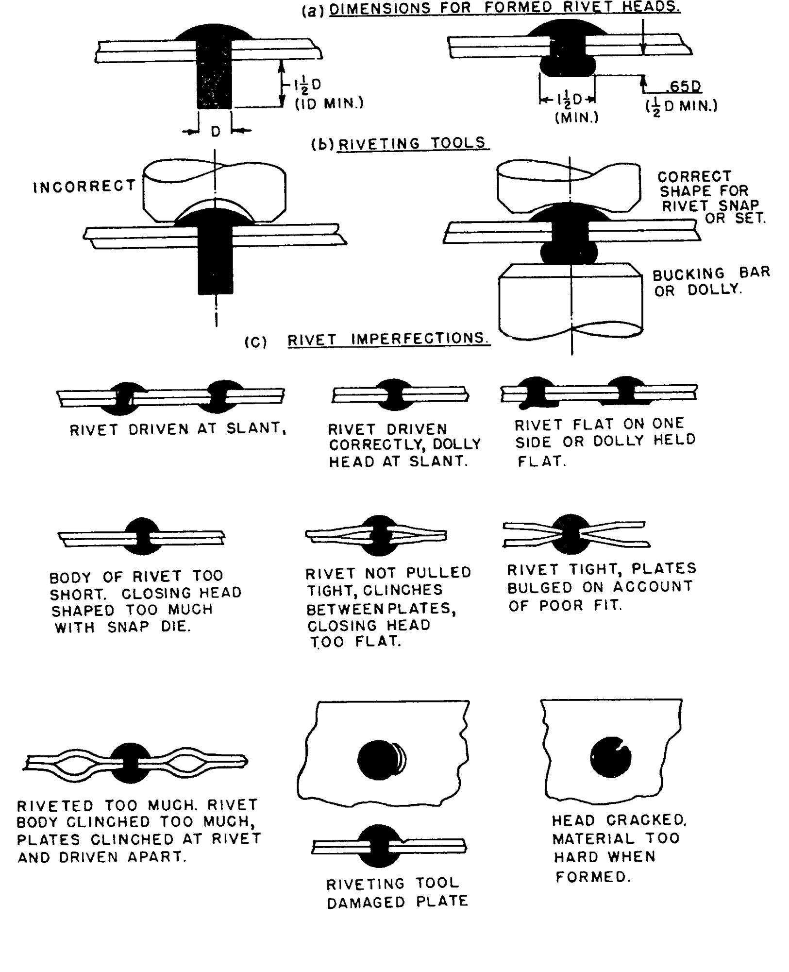
Figure 4-6. Riveting practice and rivet imperfections.

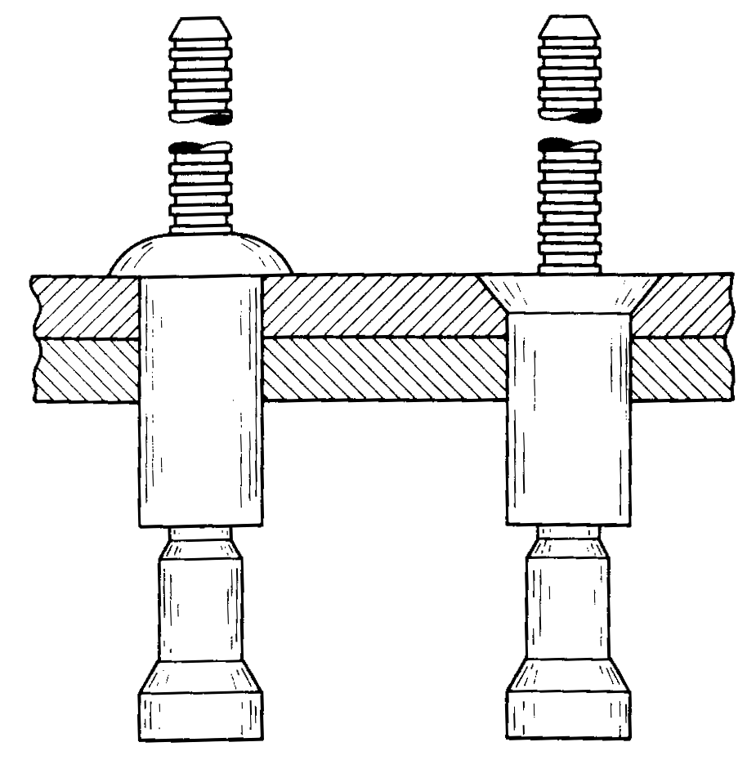
Figure 4-7. Self plugging friction-lock Cherry rivets.

Bulbed Cherrylock Rivets. One of the earlier types of mechanical-lock rivets developed were Bulbed Cherrylock blind rivets. These blind rivets have as their main advantage the ability to replace a solid shank rivet size for size. (See figure 4-8.)

A Bulbed Cherrylock consists of three parts; a rivet shell, a puller, and a lockring. The puller or stem has five features which are activated during installation; a header, shank expanding section, lockring indent, weak or stem fracture point, and a serrated pulling stem. Carried on the pulling stem, near the manufactured head, is the stem lockring. When the rivet is pulled the action of the moving stem clamps together the sheets of metal and swells the shank to fill the drilled hole. When the stem reaches its preset limit of travel, the upper stem breaks away (just above the lockring) as the lockring snaps into the recess on the locking stem. The rough end of the retained stem in the center on the manufactured head must never be filed smooth, because it will weaken the strength of the lockring and the center stem could fall out. (See figure 4-8.)

The Bulbed Cherrylock rivets are available in two head styles: universal and 100° countersunk. Their lengths are measured in increments of 1/16 inch. It is important to select a rivet with a length related to the grip length of the metal being joined.

The Bulbed Cherrylock rivet can be installed using a G35 cherry rivet hand puller or a pneumatic Bulbed Cherrylock pulling tool.

The CherryMax (see figure 4-9) rivet uses one tool to install three standard rivet diameters and their oversize counterparts. This makes the use of CherryMax rivets very popular with many small general aviation repair shops. CherryMax rivets are available in four nominal diameters 1/8, 5/32, 3/16, and 1/4 inch and three oversized diameters. CherryMax rivets are manufactured with two head styles, universal and countersunk. The CherryMax rivets consists of five parts; bulbed blind header, hollow rivet shell, locking (foil) collar, driving anvil, and pulling stem. The blind bulbed header takes up the extended shank and forms the bucktail on a CherryMax rivet stem. Rivet sleeves are made from 5056 aluminum, monel, and INCO 600. The stems are made from alloy steel, CRES, and INCO X-750 stem. CherryMax rivets have an ultimate shear strength ranging from 50 KSI to 75 KSI.

An Olympic-Lok (see figure 4-10) rivet is a light three-piece mechanically locked, spindle-type blind rivet. It carries its stem lock integral to the manufactured head. While installing, the lockring is pressed into a groove on the pulling stem just as the rivet completes drawing the metal together. After installation is completed, never file the stem of an Olympic-Lok rivet, because it will weaken the lockring attachment. The Olympic-Lok fastener is available in three head styles:
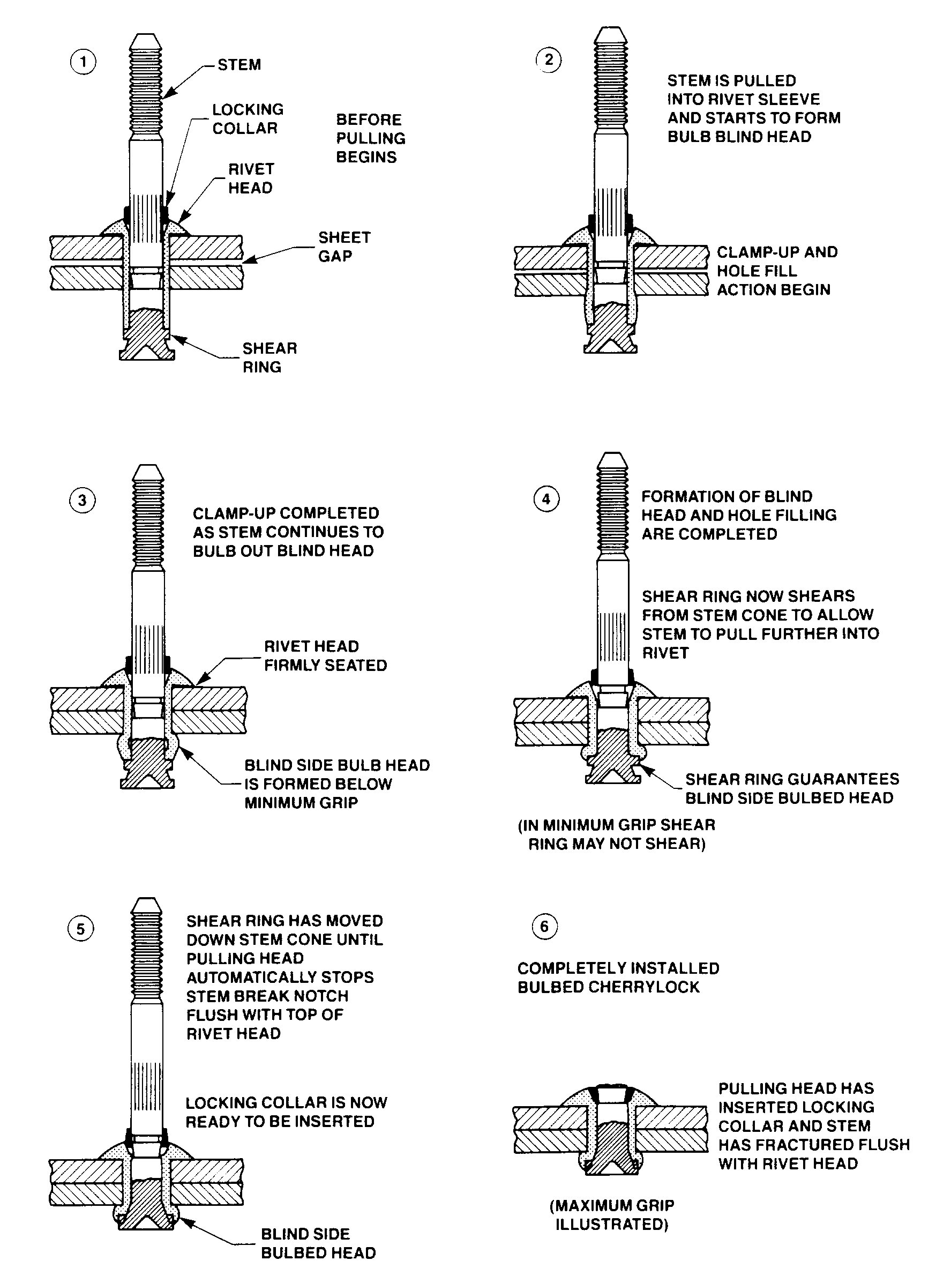
Figure 4-8. Mechanical-lock (Bulbed Cherrylock) Cherry rivet.

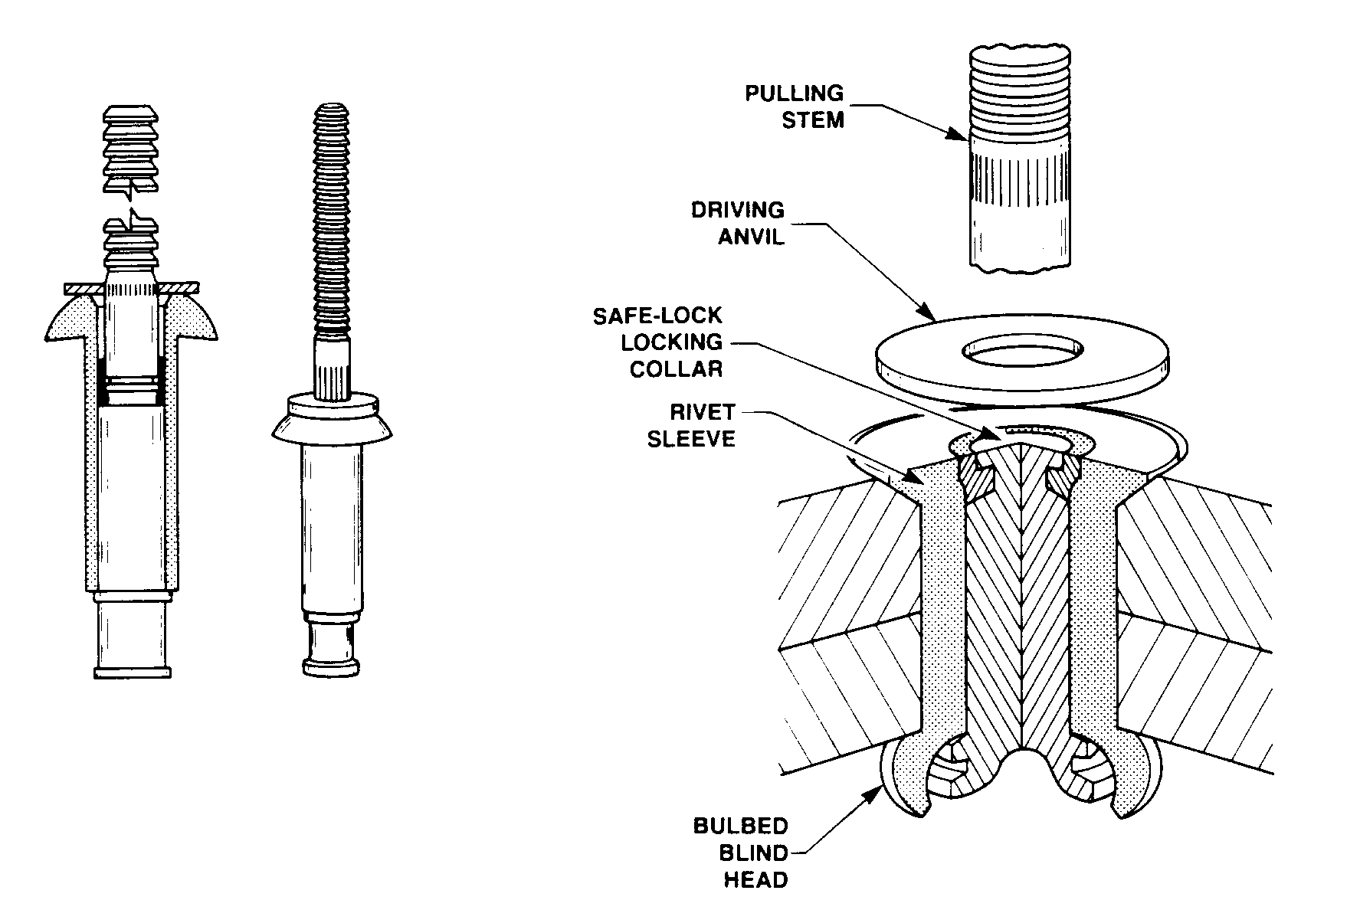
Figure 4-9. CherryMax rivet.

universal protruding, 100-degree flush countersink, and 100-degree flush shear; and three diameters 1/8, 5/32, and 3/16 inch. The three diameters are available in eight different alloy combinations of 2017-T4, A-286, 5056, and monel. Olympic-Lok lock spindles are made from the same material as the sleeves.

Huck rivets (see figure 4-11) are available in two head styles, protruding and flush. They are available in four diameters 1/8, 5/32, 3/16, and 1/4 inch. Their diameters are measured in increments of 1/32 inch and lengths are measured in 1/16 inch increments. They are manufactured in three different combinations of alloys: 5056 aluminum sleeve with 2024 aluminum alloy pin, A-286 corrosion-resistant steel sleeve with an A-286 pin, and a monel 400 sleeve with an A-286 pin. The Huck fastener has the ability to tightly draw-up two or more sheets of metal together while being installed. After the take-up of the Huck fastener is completed, the lockring is squeezed into a groove on the pulling stem. The anvil or footer (of the installation tool) packs the ring into the groove of the pulling stem by bearing against the lockring.

Common pull-type Pop rivets, produced for nonaircraft related applications, are not approved for use on certificated aircraft structures or components.

Design a new or revised rivet pattern for strength required in accordance with one of the following:

The aircraft manufacturer’s maintenance manuals.

The techniques found in structural text books and using the mechanical properties found in MIL-HDBK-5.

The specific instructions in paragraphs 4-58g through 4-58n. When following the instruction in paragraphs 4-58g through 4-58n, the general rule for the diameter of the rivets used to join aluminum sheets is to use a diameter approximately three times the thickness of the thicker sheet. Do not use rivets where they would be placed in tension, tending to pull the heads off; and backup a lap joint of thin sheets with a stiffener section.

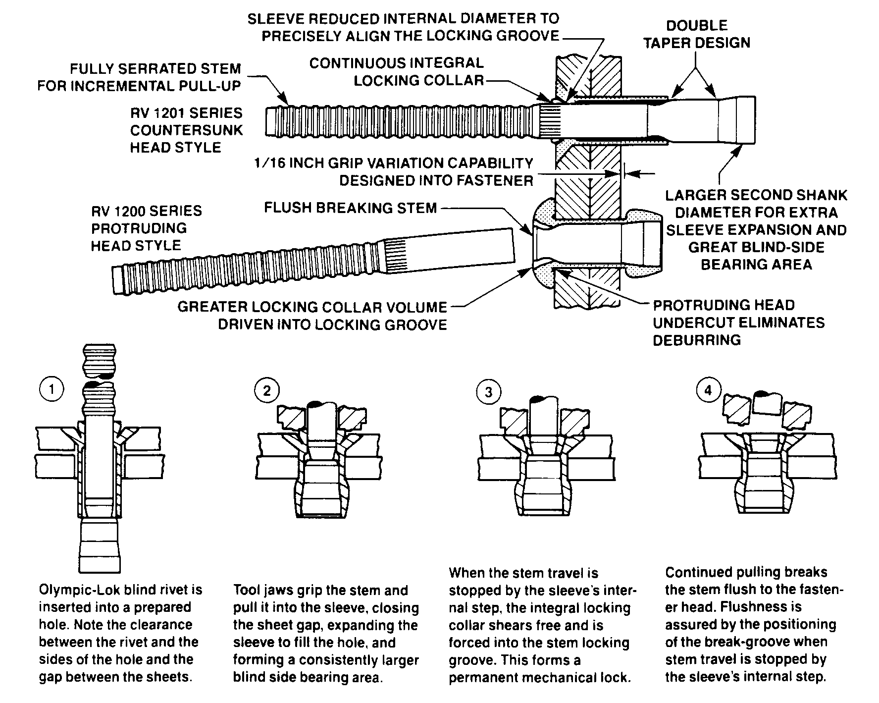
Figure 4-10. Olympic-Lok rivet.

REPAIR METHODS AND PRECAUTIONS FOR ALUMINUM STRUCTURE. Carefully examine all adjacent rivets outside of the repair area to ascertain that they have not been harmed by operations in adjacent areas. Drill rivet holes round, straight, and free from cracks. Deburr the hole with an oversize drill or deburring tool. The rivet-set used in driving the rivets must be cupped slightly flatter than the rivet head. (See figure 4-6.) Rivets are to be driven straight and tight, but not overdriven or driven while too hard, since the finished rivet must be free from cracks. Information on special methods of riveting, such as flush riveting, usually may be obtained from manufacturer’s service manuals.

Splicing of Tubes. Round or streamline aluminum alloy tubular members may be repaired by splicing. (See figure 4-12.) Splices in struts that overlap fittings are not acceptable. When solid rivets go completely through hollow tubes, their diameter must be at least one-eighth of the outside diameter of the outer tube. Rivets which are loaded in shear should be hammered only enough to form a small head and no attempt made to form the standard roundhead. The amount of hammering required to form the standard roundhead often causes the rivet to buckle inside the tube. (Correct and incorrect examples of this type of rivet application are incorporated in figure 4-12.)
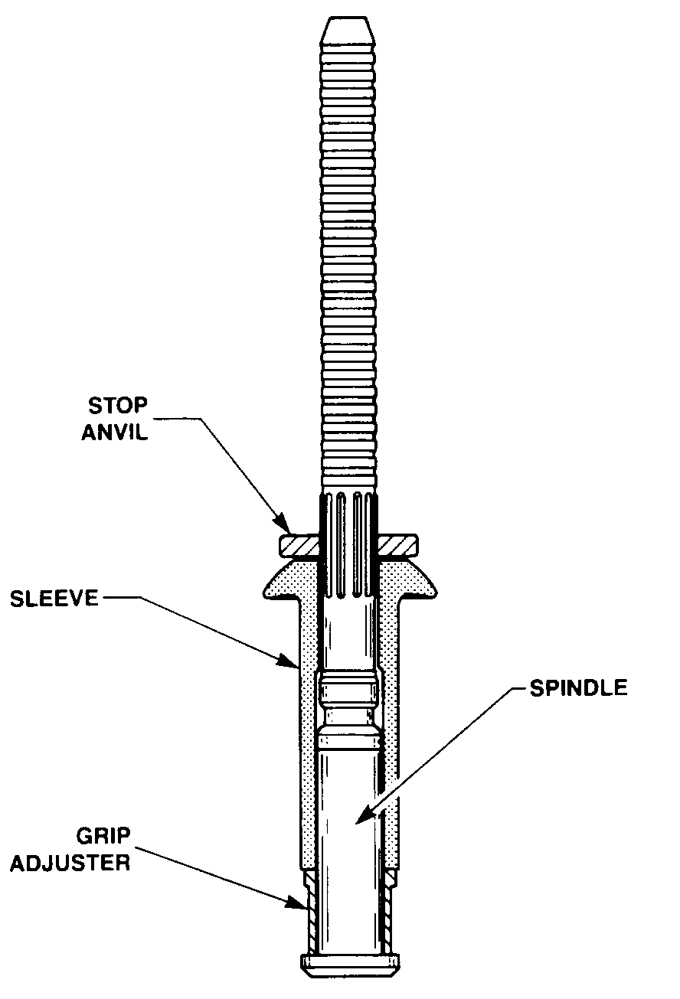
Figure 4-11. Huck rivet.

Repairs to Aluminum Alloy Members. Make repairs to aluminum alloy members with the same material or with suitable material of higher strength. The 7075 alloy has greater tensile strength than other commonly used aluminum alloys such as 2014 and 2024, but is subject to somewhat greater notch sensitivity. In order to take advantage of its strength characteristics, pay particular attention to design of parts to avoid notches, small radii, and large or rapid changes in cross-sectional areas. In fabrication, exercise caution to avoid processing and handling defects, such as machine marks, nicks, dents, burrs, scratches, and forming cracks. Cold straightening or forming of 7075-T6 can cause cracking; therefore, it may be advisable to limit this processing to minor cold straightening.

Wing and Tail Surface Ribs. Damaged aluminum alloy ribs either of the stamped sheet-metal type or the built-up type employing special sections, square or round tubing, may be repaired by the addition of suitable reinforcement. (Acceptable methods of repair are shown in figures 4-13 and 4-14.) These examples deal with types of ribs commonly found in small and medium size aircraft. Repair schemes developed by the aircraft manufacturer are acceptable, but any other methods of reinforcement are major repairs and require approved data.

Trailing and Leading Edges and Tip Strips. Repairs to wing, control surface trailing edges, leading edges, and tip strips should be made by properly executed and reinforced splices. Acceptable methods of trailing edge repairs are shown in figure 4-15.

Repair of Damaged Skin. In cases where metal skin is damaged extensively, repair by replacing an entire sheet panel from one structural member to the next. The repair seams are to lie along stiffening members, bulkheads, etc.; and each seam must be made exactly the same in regard to rivet size, splicing, and rivet pattern as the manufactured seams at the edges of the original sheet. If the two manufactured seams are different, the stronger one will be copied. (See figure 4-16 for typical acceptable methods of repairs.)

Patching of Small Holes. Small holes in skin panels which do not involve damage to the stiffening members may be patched by covering the hole with a patch plate in the manner shown in figure 4-16. Flush patches also may be installed in stressed-skin type construction. An acceptable and easy flush patch may be made by trimming out the damaged area and then installing a conventional patch on the underneath side or back of the sheet being repaired. A plug patch plate of the same size and skin thickness as the opening may then be inserted and riveted to the patch plate. Other types of flush patches similar to those used for patching plywood may be used. The rivet pattern used, however, must follow standard practice to maintain satisfactory strength in the sheet.

Splicing of Sheets. The method of copying the seams at the edges of a sheet may not always be satisfactory. For example, when the sheet has cutouts, or doubler plates at an edge seam, or when other members transmit loads into the sheet, the splice must be designed as illustrated in the following examples.

Material: Clad 2024 sheet, 0.032 inch thickness. Width of sheet (i.e., length at splice) = “W” = 10 inches.

Determine rivet size and pattern for a single-lap joint similar to figure 4-5.

Use rivet diameter of approximately three times the sheet thickness,
3 x 0.032 = 0.096-inch. Use 1/8-inch 2117-T4 (AD) rivets (5/32-inch 2117-T4 (AD) would be satisfactory).

Use the number of rivets required per inch of width “W” from table 4-10. (Number per inch 4.9 x .75 = 3.7 or the total number of rivets required = 10 x 3.7 or 37 rivets.) See notes in table.

Lay out rivet pattern with spacing not less than shown in figure 4-5. Referring to figure 4-5(A), it seems that a double row pattern with the minimum spacing will give a total of 40 rivets. However, as only 37 rivets are required, two rows of 19 rivets each equally spaced over the10 inches will result in a satisfactory splice.

Straightening of Stringers or Intermediate Frames. Members which are slightly bent may be straightened cold and examined with a magnifying glass for cracks or tears to

the material. Reinforce the straightened part to its original shape, depending upon the condition of the material and the magnitude of any remaining kinks or buckles. If any strain cracks are apparent, make complete reinforcement in sound metal beyond the damaged portion.

Local Heating. Do not apply local heating to facilitate bending, swaging, flattening, or expanding operations of heat-treated aluminum alloy members, as it is difficult to control the temperatures closely enough to prevent possible damage to the metal, and it may impair its corrosion resistance.

Splicing of Stringers and Flanges. It is recommended that all splices be made in accordance with the manufacturer’s recommendations. If the manufacturer’s recommendations are not available, the typical splices for various shapes of sections are shown in figures 4-17 through 4-19. Design splices to carry both tension and compression, and use the splice shown in figure 4-18 as an example illustrating the following principles.

To avoid eccentric loading and consequent buckling in compression, place splicing or reinforcing parts as symmetrically as possible about the centerline of the member, and attach to as many elements as necessary to prevent bending in any direction.

To avoid reducing the strength in tension of the original bulb angle, the rivet holes at the ends of the splice are made small (no larger than the original skin attaching rivets), and the second row of holes (those through the bulbed leg) are staggered back from the ends. In general, arrange the rivets in the splice so that the design tensile load for the member and splice plate can be carried into the splice without failing the member at the outermost rivet holes.

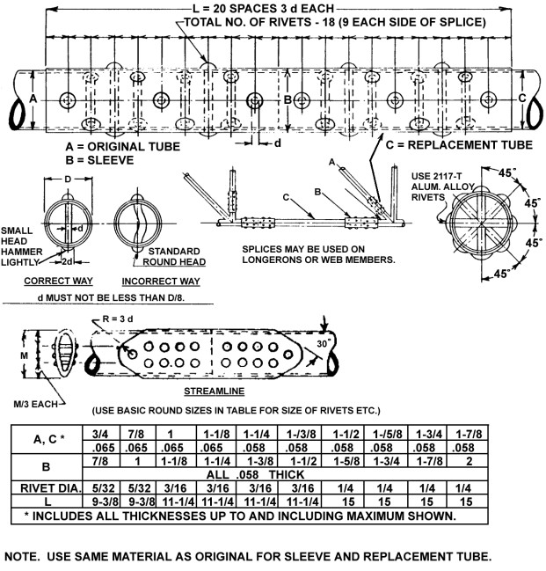
Figure 4-12. Typical repair method for tubular members of aluminum alloy.

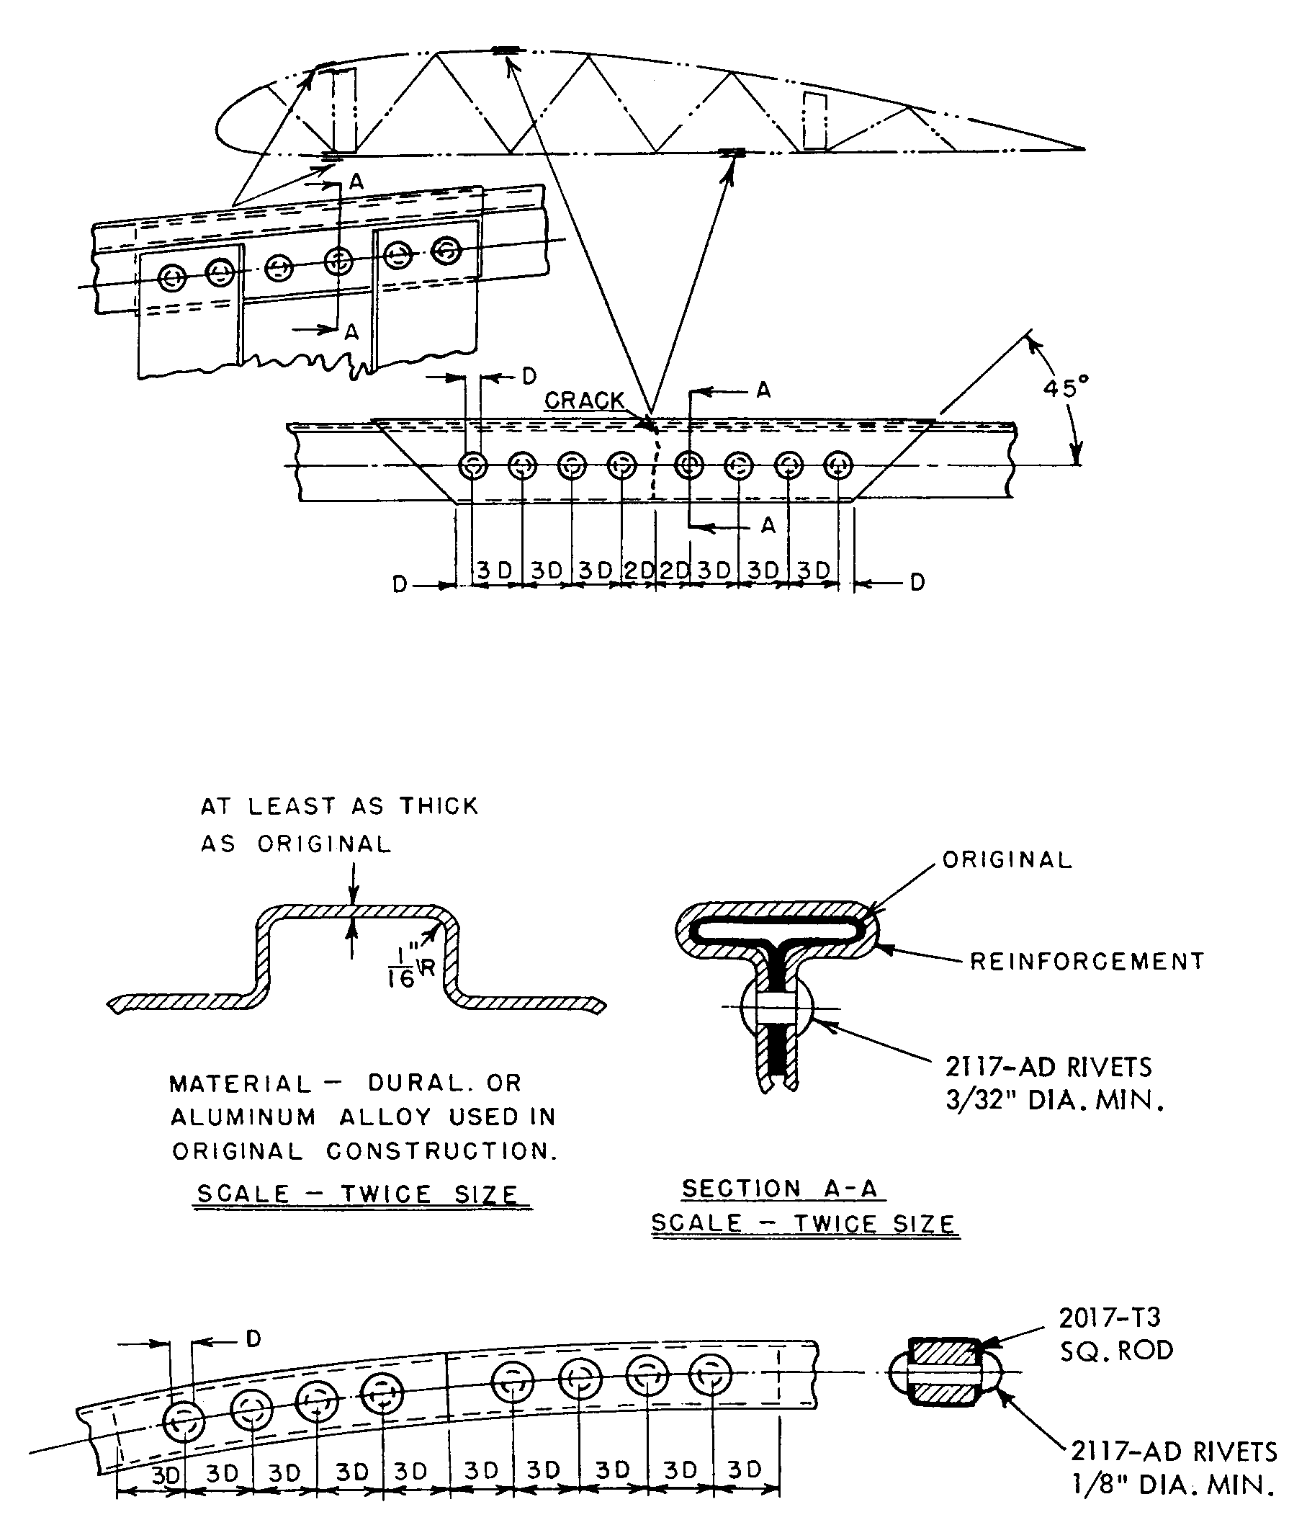

NOTE: FOR MINIMUM NUMBER OF RIVETS REQUIRED, SEE PARAGRAPH 4-58g AND SUBSEQUENT.

Figure 4-13. Typical repair for buckled or cracked metal wing rib capstrips.

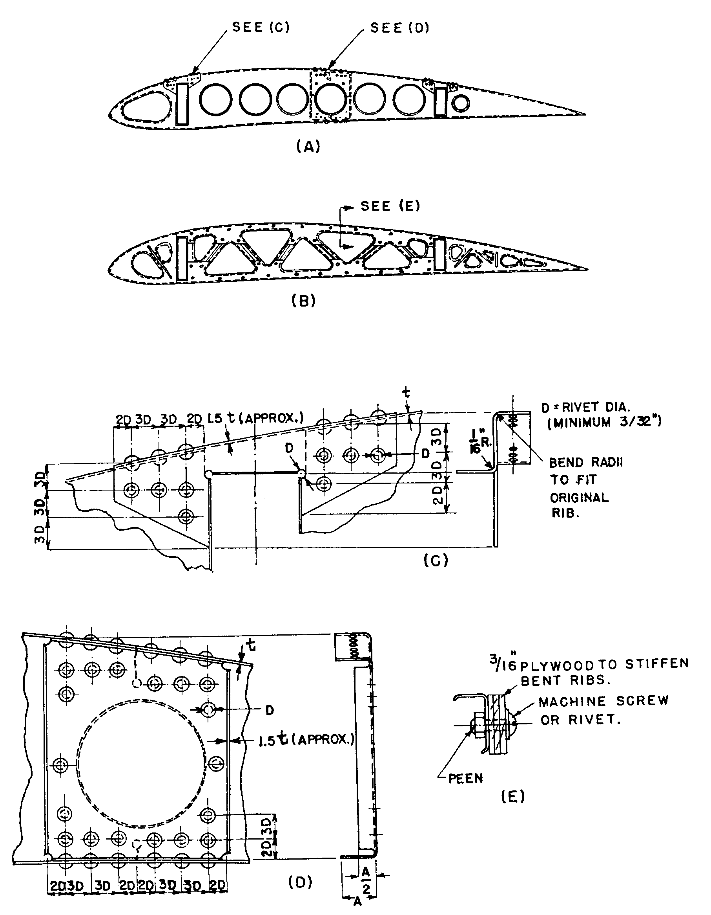

NOTE: FOR MINIMUM NUMBER OF RIVETS REQUIRED, SEE PARAGRAPH 4-58g AND SUBSEQUENT.

Figure 4-14. Typical metal rib repairs (usually found on small and medium-size aircraft).

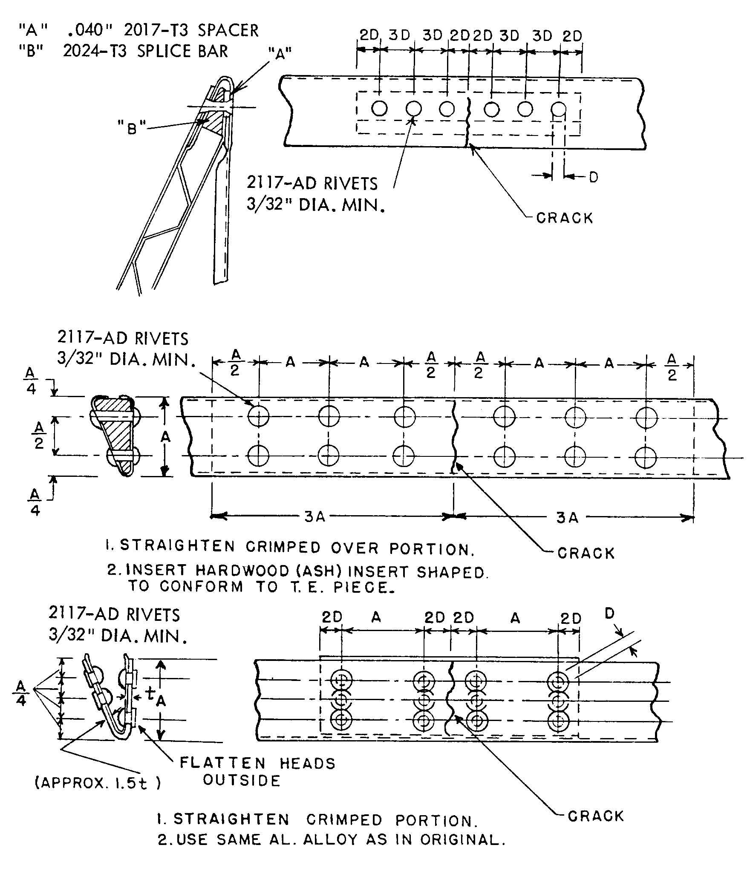

NOTE: FOR MINIMUM NUMBER OF RIVETS REQUIRED, SEE PARAGRAPH 4-58g AND SUBSEQUENT.

Figure 4-15. Typical repairs of trailing edges.

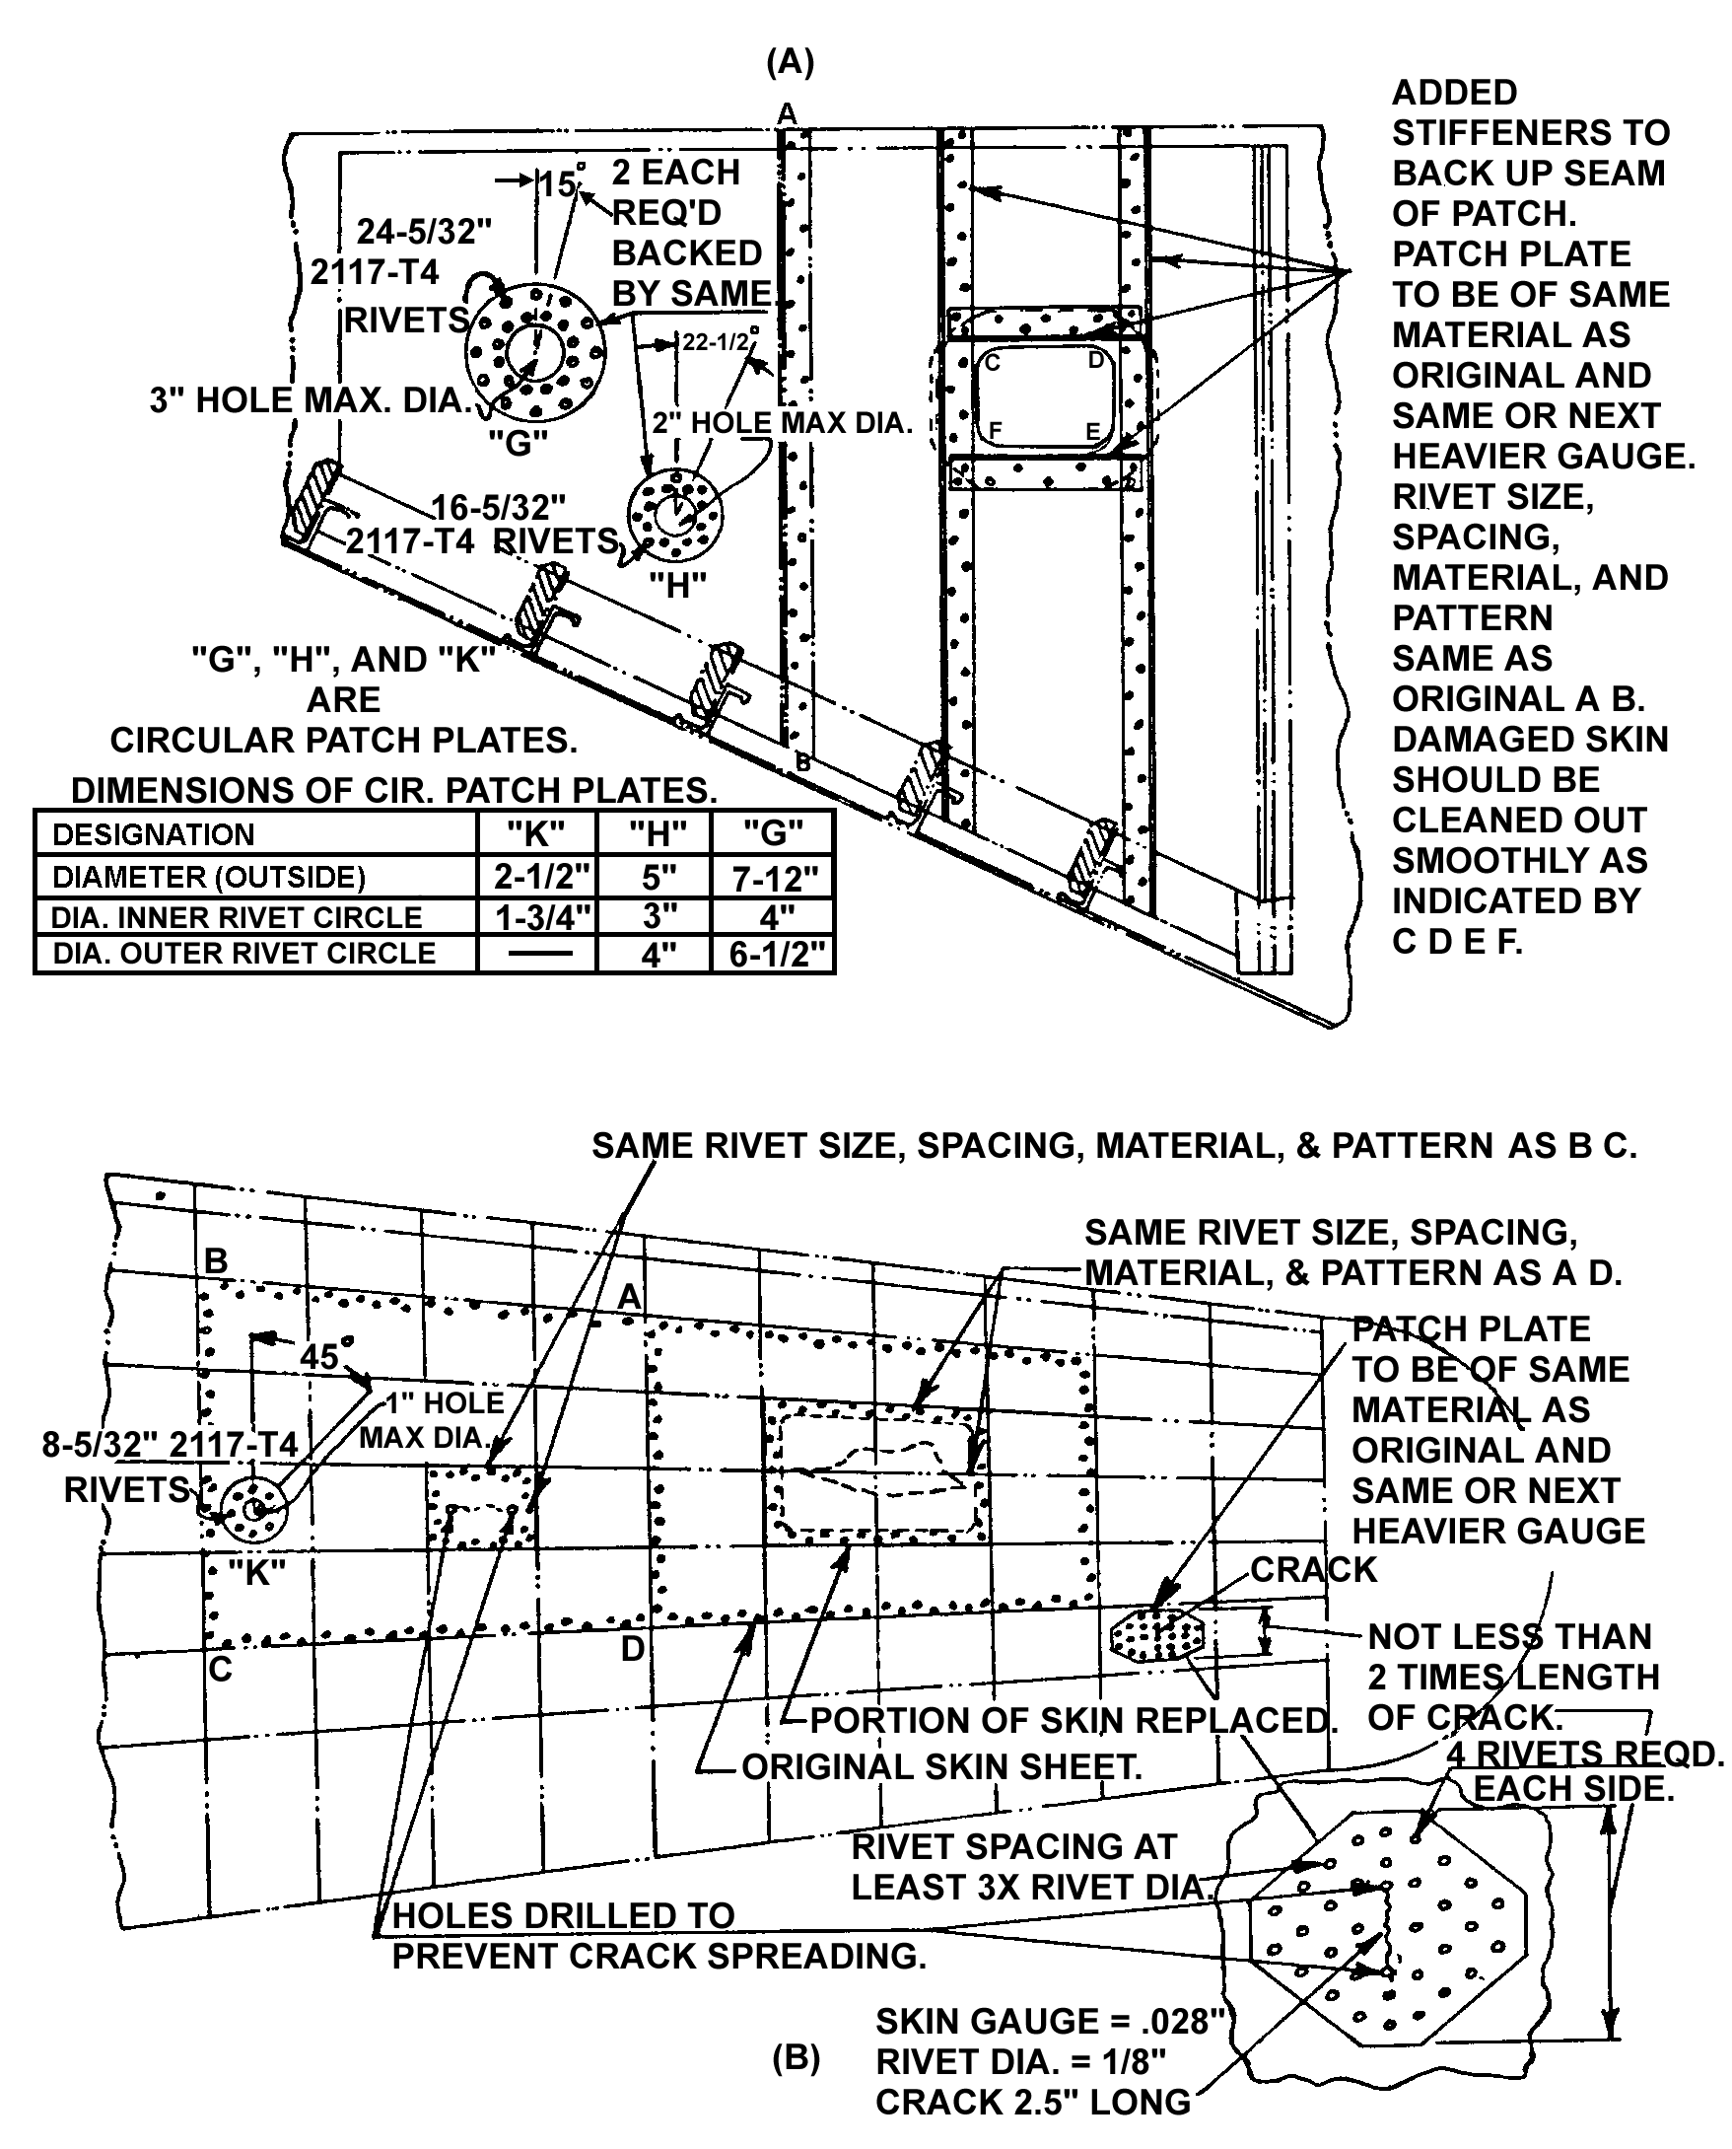
Figure 4-16. Typical repairs of stressed sheet metal coverings. (Refer to tables 4-9, 4-10, and 4-11 to calculate number of rivets to be used.)
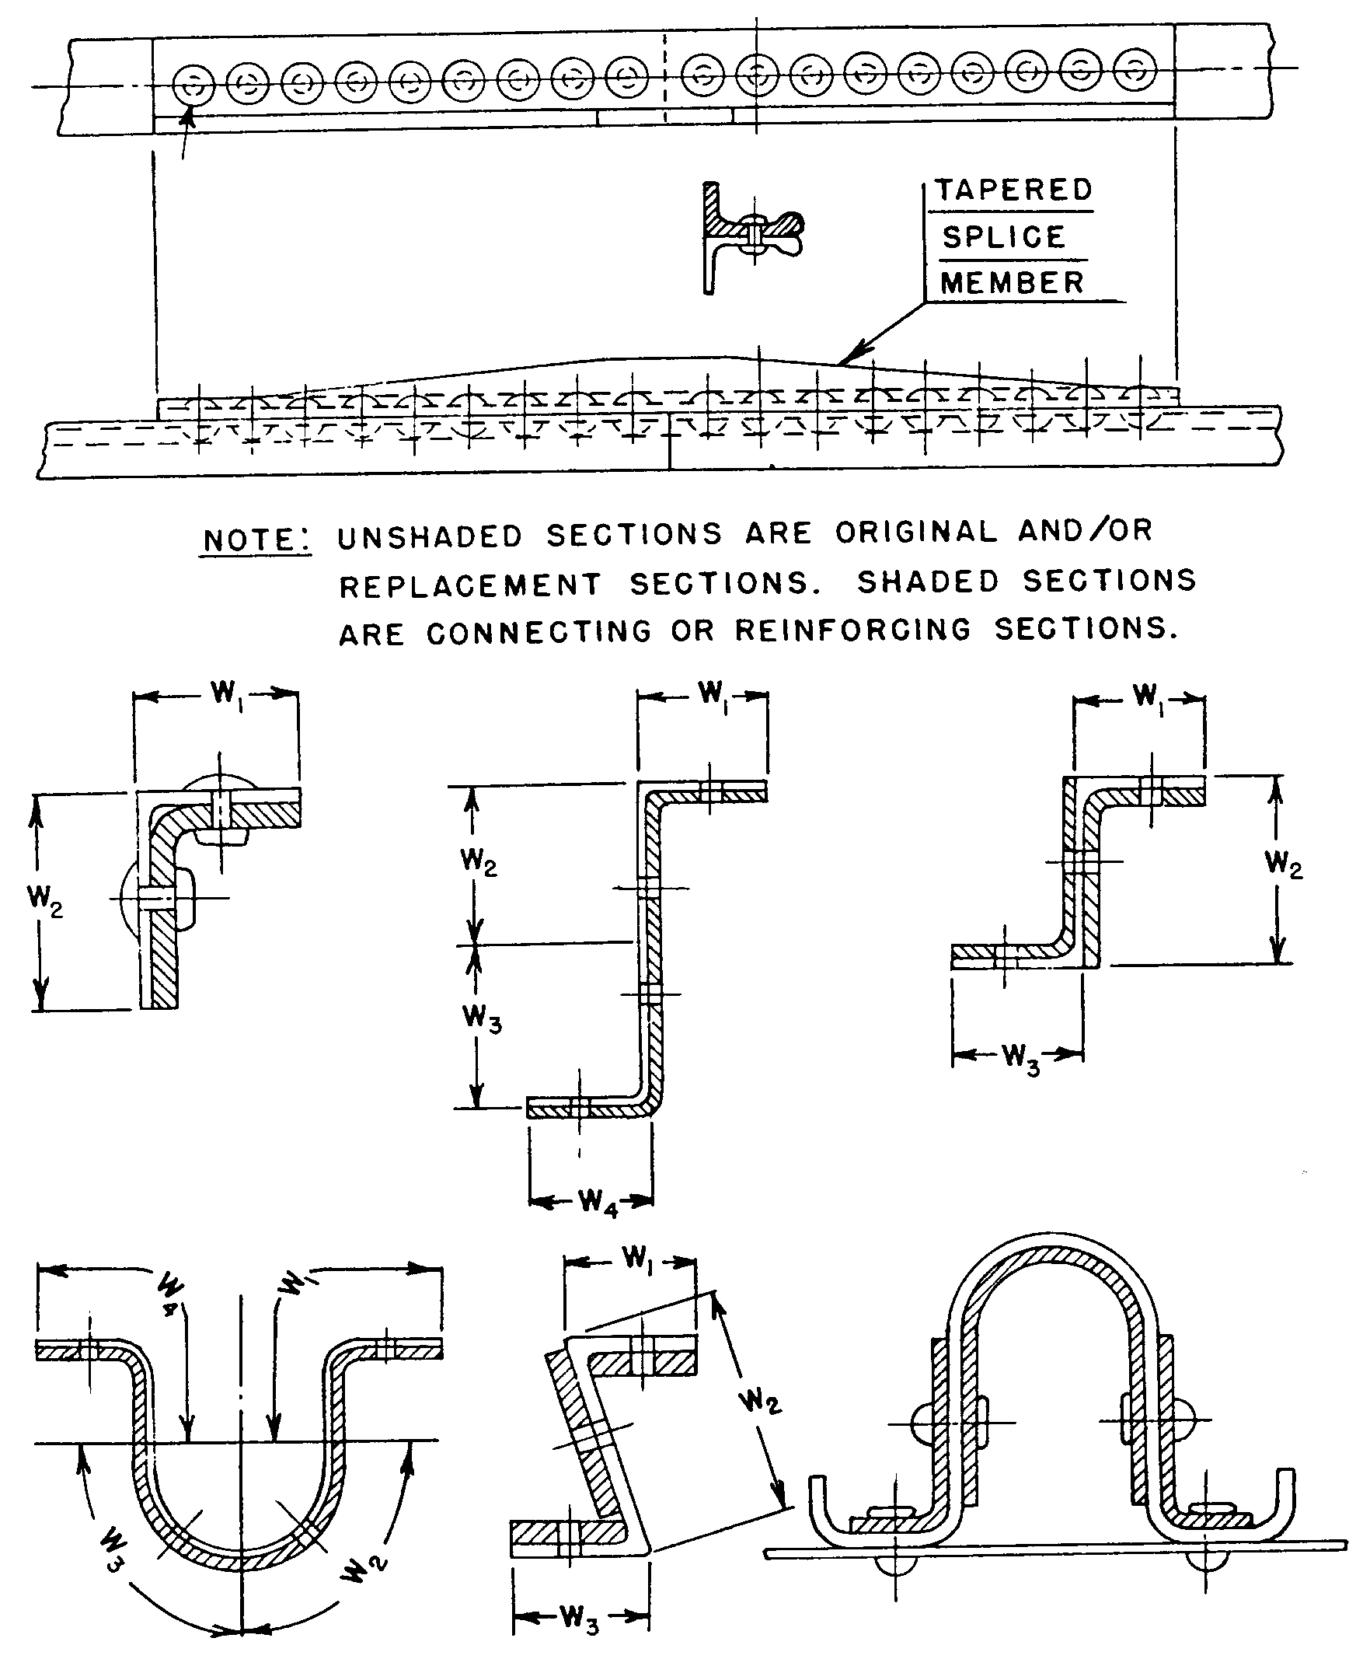
NOTE: FOR MINIMUM NUMBER OF RIVETS REQUIRED, SEE PARAGRAPH 4-58g AND SUBSEQUENT.
Figure 4-17. Typical stringer and flange splices.

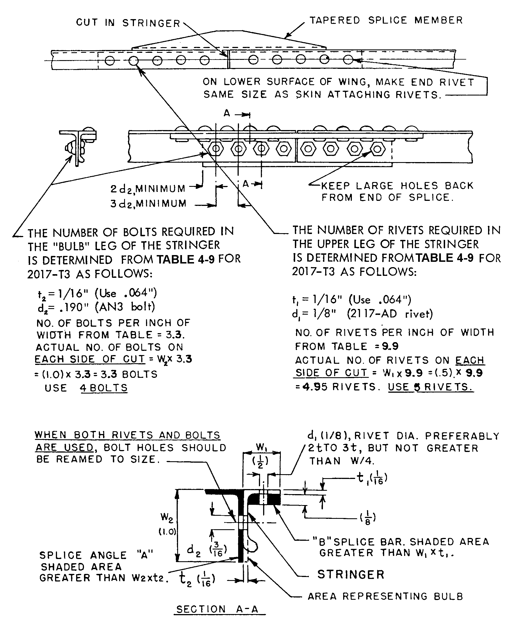

Figure 4-18. Example of stringer splice (material-2017 alloy).

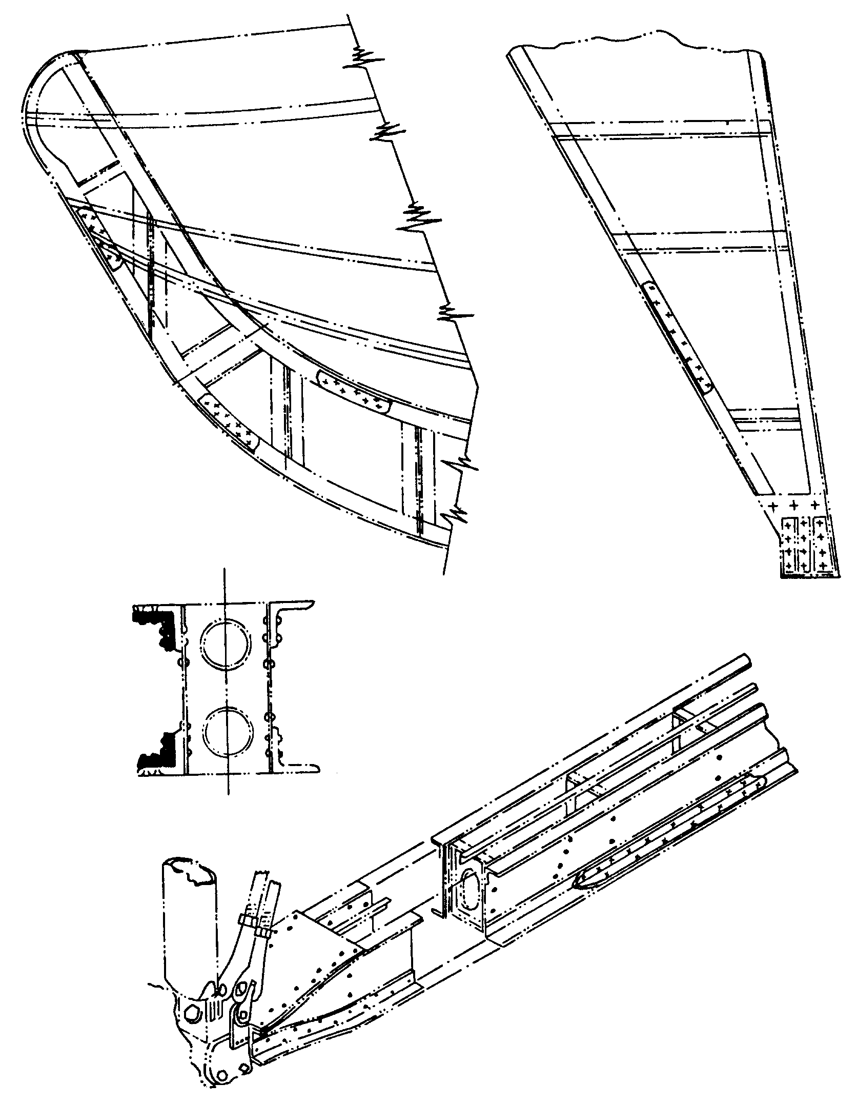
NOTE: FOR MINIMUM NUMBER OF RIVETS REQUIRED, SEE PARAGRAPH 4-58g AND SUBSEQUENT.

NOTE: STRENGTH INVESTIGATION IS USUALLY REQUIRED FOR THIS TYPE OF REPAIR.

Figure 4-19. Application of typical flange splices and reinforcement.

To avoid concentration of load on the end rivet and consequent tendency toward progressive rivet failure, the splice is tapered at the ends by tapering the backing angle and by making it shorter than the splice bar. (See figure 4-18.)

The preceding principles are especially important in splicing stringers on the lower surface of stressed skin wings, where high-tension stresses may exist. When several adjacent stringers are spliced, stagger the splices if possible.

Size of Splicing Members. When the same material is used for the splicing members as for the original member, the cross-section area (i.e., the shaded areas in figure 4-17), of the splice material will be greater than the area of the section element which it splices. The area of a section element (e.g., each leg of an angle or channel) is equal to the width multiplied by the thickness. For example, the bar “B” in figure 4-18 is assumed to splice the upper leg of the stringer, and the angle “A” is assumed to splice the bulbed leg of the stringer. Since the splice bar “B” is not as wide as the adjacent leg, its thickness must be increased such that the area of bar “B” is at least equal to the area of the upper leg of the stringer.

The Diameter of Rivets in Stringers. The diameter of rivets in stringers might preferably be between two and three times the thickness “t” of the leg, but must not be more than 1/4th the width “W” of the leg. Thus, 1/8-inch rivets are chosen in the example, figure 4-18. If the splices were in the lower surface of a wing, the end rivets would be made the same size as the skin-attaching rivets, or 3/32 inch.

The Number of Rivets. The number of rivets required on each side of the cut in a stringer or flange may be determined from standard text books on aircraft structures, or may be found in tables 4-9 through 4-11.

In determining the number of rivets required in the example, figure 4-18, for attaching the splice bar “B” to the upper leg, the thickness “t” of the element of area being spliced is 1/16 inch (use 0.064), the rivet size is 1/8 inch, and table 4-9 shows that 9.9 rivets are required per inch of width. Since the width “W” is 1/2 inch, the actual number of rivets required to attach the splice bar to the upper leg on each side of the cut is 9.9 (rivets per inch) x 0.5 (inch width) = 4.95 (use 5 rivets).

For the bulbed leg of the stringer “t” = 1/16 inch (use 0.064); AN-3 bolts are chosen, and the number of bolts required per inch of width = 3.3. The width “W” for this leg, however, is 1 inch; and the actual number of bolts required on each side of the cut is 1 x 3.3 = 3.3 (use 4 bolts). When both rivets and bolts are used in the same splice, the bolt holes must be accurately reamed to size. It is preferable to use only one type of attachment, but in the above example, the dimensions of the legs of the bulb angle indicated rivets for the upper leg and bolts for the bulb leg.

Splicing of Intermediate Frames. The same principles used for stringer splicing may be applied to intermediate frames when the following point is considered. Conventional frames of channel or Z sections are relatively deep and thin compared to stringers, and usually fail by twisting or by buckling of the free flange. Reinforce the splice joint against this type of failure by using a splice plate heavier than the frame and by splicing the free flange of the frame with a flange of the splice plate. (See figure 4-20.) Since a frame is likely to be subjected to bending loads, make the length of splice plate “L” more than twice the width “W2,” and the rivets spread out to cover the plate.

Table 4-9. Number of rivets required for splices (single-lap joint) in bare 2014-T6, 2024-T3, 2024-T36, and 7075-T6 sheet, clad 2014-T6, 2024-T3, 2024-T36, and 7075-T6 sheet, 2024-T4, and 7075-T6 plate, bar, rod, tube, and extrusions, 2014-T6 extrusions.
Thickness “t” in  inches | No. of 2117-T4 (AD) protruding head rivets required  per inch of width “W”  Rivet size |  |  |  |  | No. of Bolts
 | 3/32 | 1/8 | 5/32 | 3/16 | 1/4 | AN-3
.016 | 6.5 | 4.9 | - - | - - | - - | - -
.020 | 6.9 | 4.9 | 3.9 | - - | - - | - -
.025 | 8.6 | 4.9 | 3.9 | - - | - - | - -
.032 | 11.1 | 6.2 | 3.9 | 3.3 | - - | - -
.036 | 12.5 | 7.0 | 4.5 | 3.3 | 2.4 | - -
.040 | 13.8 | 7.7 | 5.0 | 3.5 | 2.4 | 3.3
.051 | - - | 9.8 | 6.4 | 4.5 | 2.5 | 3.3
.064 | - - | 12.3 | 8.1 | 5.6 | 3.1 | 3.3
.081 | - - | - - | 10.2 | 7.1 | 3.9 | 3.3
.091 | - - | - - | 11.4 | 7.9 | 4.4 | 3.3
.102 | - - | - - | 12.8 | 8.9 | 4.9 | 3.4
.128 | - - | - - | - - | 11.2 | 6.2 | 3.2
NOTES:

a. For stringers in the upper surface of a wing, or in a fuselage, 80 percent of the number of rivets shown in the table may be used.

b. For intermediate frames, 60 percent of the number shown may be used.

c. For single lap sheet joints, 75 percent of the number shown may be used.

ENGINEERING NOTES:

a. The load per inch of width of material was calculated by assuming a strip 1 inch wide in tension.

b. Number of rivets required was calculated for 2117-T4 (AD) rivets, based on a rivet allowable shear stress equal to 40 percent of the sheet allowable tensile stress, and a sheet allowable bearing stress equal to 160 percent of the sheet allowable tensile stress, using nominal bolt diameters for rivets.

c. Combinations of sheet thickness and rivet size above the underlined numbers are critical in (i.e., will fail by) bearing on the sheet; those below are critical in shearing of the rivets.

d. The number of AN-3 bolts required below the underlined number was calculated based on a sheet allowable tensile stress of 70,000 psi and a bolt allowable single shear load of 2,126 pounds.

Table 4-10. Number of rivets required for splices (single-lap joint) in 2017, 1017 ALCLAD, 2024-T3 ALCLAD sheet, plate, bar, rod, tube, and extrusions.
Thickness  “t” in  inches | No. of 2117-T4 (AD) protruding head rivets required  per inch of width “W”  Rivet size |  |  |  |  | No. of  Bolts
 | 3/32 | 1/8 | 5/32 | 3/16 | 1/4 | AN-3
.016 | 6.5 | 4.9 | - - | - - | - - | - -
.020 | 6.5 | 4.9 | 3.9 | - - | - - | - -
.025 | 6.9 | 4.9 | 3.9 | - - | - - | - -
.032 | 8.9 | 4.9 | 3.9 | 3.3 | - - | - -
.036 | 10.0 | 5.6 | 3.9 | 3.3 | 2.4 | - -
.040 | 11.1 | 6.2 | 4.0 | 3.3 | 2.4 | - -
.051 | - - | 7.9 | 5.1 | 3.6 | 2.4 | 3.3
.064 | - - | 9.9 | 6.5 | 4.5 | 2.5 | 3.3
.081 | - - | 12.5 | 8.1 | 5.7 | 3.1 | 3.3
.091 | - - | - - | 9.1 | 6.3 | 3.5 | 3.3
.102 | - - | - - | 10.3 | 7.1 | 3.9 | 3.3
.128 | - - | - - | 12.9 | 8.9 | 4.9 | 3.3
NOTES:

a. For stringers in the upper surface of a wing, or in a fuselage, 80 percent of the number of rivets shown in the table may be used.

b. For intermediate frames, 60 percent of the number shown may be used.

c. For single lap sheet joints, 75 percent of the number shown may be used.

ENGINEERING NOTES:

a. The load per inch of width of material was calculated by assuming a strip 1 inch wide in tension.

b. Number of rivets required was calculated for 2117-T4 (AD) rivets, based on a rivet allowable shear stress equal to percent of the sheet allowable tensile stress, and a sheet allowable bearing stress equal to 160 percent of the sheet allowable tensile stress, using nominal hole diameters for rivets.

c. Combinations of sheet thickness and rivet size above the underlined numbers are critical in (i.e., will fail by) bearing on the sheet; those below are critical in shearing of the rivets.

d. The number of AN-3 bolts required below the underlined number was calculated based on a sheet allowable tensile stress of 55,000 psi and a bolt allowable single shear load of 2,126 pounds.

Table 4-11. Number of rivets required for splices (single-lap joint) in 5052 (all hardnesses) sheet.
Thickness  “t” in  inches | No. of 2117-T4 (AD) protruding head rivets required  per inch of width “W”  Rivet size |  |  |  |  | No. of  Bolts
 | 3/32 | 1/8 | 5/32 | 3/16 | 1/4 | AN-3
.016 | 6.3 | 4.7 |  | - - | - - | - -
.020 | 6.3 | 4.7 | 3.8 | - - | - - | - -
.025 | 6.3 | 4.7 | 3.8 | - - | - - | - -
.032 | 6.3 | 4.7 | 3.8 | 3.2 | - - | - -
.036 | 7.1 | 4.7 | 3.8 | 3.2 | 2.4 | - -
.040 | 7.9 | 4.7 | 3.8 | 3.2 | 2.4 | - -
.051 | 10.1 | 5.6 | 3.8 | 3.2 | 2.4 | - -
.064 | 12.7 | 7.0 | 4.6 | 3.2 | 2.4 | - -
.081 | - - | 8.9 | 5.8 | 4.0 | 2.4 | 3.2
.091 | - - | 10.0 | 6.5 | 4.5 | 2.5 | 3.2
.102 | - - | 11.2 | 7.3 | 5.1 | 2.8 | 3.2
.128 | - - | - - | 9.2 | 6.4 | 3.5 | 3.2
NOTES:

a. For stringers in the upper surface of a wing, or in a fuselage, 80 percent of the number of rivets shown in the table may be used.

b. For intermediate frames, 60 percent of the number shown may be used.

c. For single lap sheet joints, 75 percent of the number shown may be used.

ENGINEERING NOTES:

a. The load per inch of width of material was calculated by assuming a strip 1 inch wide in tension.

b. Number of rivets required was calculated for 2117-T4 (AD) rivets, based on a rivet allowable shear stress equal to 70 percent of the sheet allowable tensile stress, and a sheet allowable bearing stress equal to 160 percent of the sheet allowable tensile stress, using nominal hole diameters for rivets.

c. Combinations of sheet thickness and rivet size above the underlined numbers are critical in (i.e., will fail by) bearing on the sheet, those below are critical in shearing of the rivets.

REPAIRING CRACKED MEMBERS. Acceptable methods of repairing various types of cracks in structural elements are shown in figures 4-21 through 4-24. The following general procedures apply in repairing such defects.

Drill small holes 3/32 inch (or 1/8 inch) at the extreme ends of the cracks to minimize the possibility of their spreading further.

Add reinforcement to carry the stresses across the damaged portion and to stiffen the joints. (See figures 4-14 through 4-17.) The condition causing cracks to develop at a particular point is stress concentration at that point in conjunction with repetition of stress, such as produced by vibration of the structure. The stress concentration may be due to the design or to defects such as nicks, scratches, tool marks, and initial stresses or cracks from forming or heat-treating operations. It should be noted, that an increase in sheet thickness alone is usually beneficial but does not necessarily remedy the conditions leading to cracking.

STEEL AND ALUMINUM FITTINGS.

Steel Fittings. Inspect for the following defects.

Fittings are to be free from scratches, vise and nibbler marks, and sharp bends or edges. A careful examination of the fitting with a medium power (at least 10 power) magnifying glass is acceptable as an inspection.

When repairing aircraft after an accident or in the course of a major overhaul, inspect all highly-stressed main fittings, as set forth in the manufacturer’s instruction manual.

Replace torn, kinked, or cracked fittings.

Elongated or worn bolt holes in fittings, which were designed without bushings, are not to be reamed oversize. Replace such fittings, unless the method of repair is approved by the FAA. Do not fill holes with welding rod. Acceptable methods of repairing elongated or worn bolt holes in landing gear, stabilizer, interplane, or cabane-strut ends are shown in figure 4-25.

Aluminum and Aluminum Alloy Fittings.

Replace damaged fittings with new parts that have the same material specifications.

Repairs may be made in accordance with data furnished by the aircraft manufacturer, or data substantiating the method of repair may be submitted to the FAA for approval.

CASTINGS. Damaged castings are to be replaced and not repaired unless the method of repair is specifically approved by the aircraft manufacturer or substantiating data for the repair has been reviewed by the FAA for approval.

SELECTIVE PLATING IN AIRCRAFT MAINTENANCE. Selective plating is a method of depositing metal from an electrolyte to the selected area. The electrolyte is held in an absorbent material attached to an inert anode. Plating contact is made by brushing or swabbing the part (cathode) with the electrolyte-bearing anode.

Selective Plating Uses. This process can be utilized for any of the following reasons.

THE NUMBER OF RIVETS REQUIRED IN EACH LEG ON EACH SIDE OF THE CUT IS DETERMINED BY THE WIDTH “W,” THE THICKNESS OF THE FRAME “t,” AND THE RIVET DIAMETER “d” USING TABLE 4-10 IN A MANNER SIMILAR TO THAT FOR STRINGERS IN FIGURE 4-20.

NOTE b. IN TABLE 4-10 INDICATES THAT ONLY 60 PERCENT OF THE NUMBER OF RIVETS SO CALCULATED NEED BE USED IN SPLICES IN INTERMEDIATE.

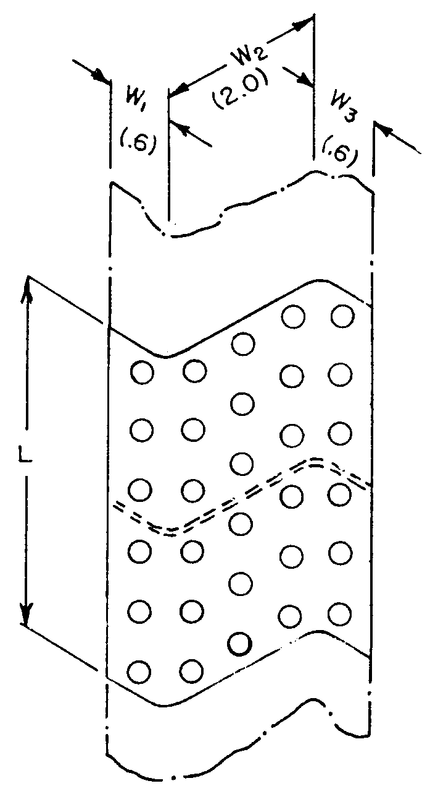
EXAMPLE: (FOR 2017-T3 aluminum alloy frame)

FLANGE LEG

t = .040”
d = 1/8” 2117-T4 (AD)
W₁ & W ₃ = .6 inch

NO. OF RIVETS PER INCH OF WIDTH
FROM TABLE 4-10 = 6.2

No. of rivets required = W x 6.2 =
.6 x 6.2 = 3.72 or 4 rivets.
60 percent of 4 rivets = 2.4 rivets.
USE 3 RIVETS ON EACH SIDE OF THE
CUT IN EACH FLANGE LEG.

WEB OF ZEE (OR CHANNEL)

t = .040”
d = 1/8” 2117-T4 (AD) rivet
W = 2.0 inches

No. of rivets per inch of width
from table 4-10 = 6.2

No. of rivets required = W x 6.2 =
2.0 x 6.2 = 12.4 or 13 rivets.
60 percent of 13 rivets = 7.8 rivets.
USE 8 RIVETS ON EACH SIDE OF CUT
IN THE WEB OF ZEE (OR CHANNEL).

“L” SHOULD BE MORE THAN TWICE W₂
Thickness of splice plate to be greater than that of the frame to be spliced.

Figure 4-20. Example of intermediate frame stringer splice (material 2017-T3 AL alloy).

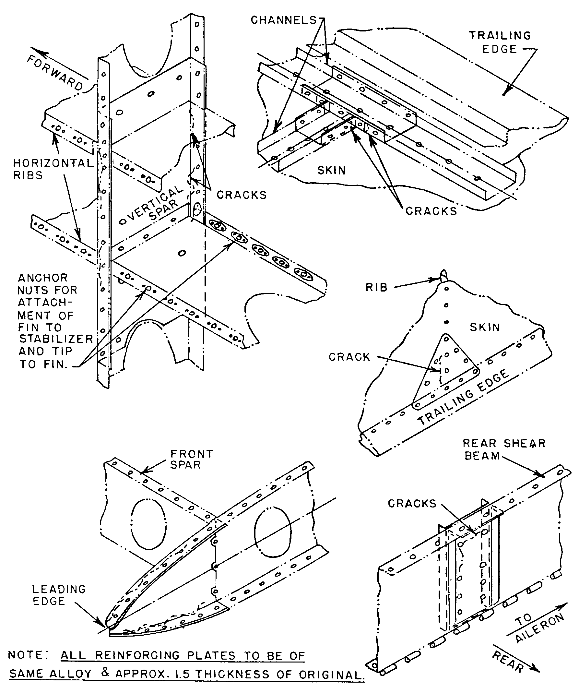

Figure 4-21. Typical methods of repairing cracked leading and trailing edges and rib intersections.

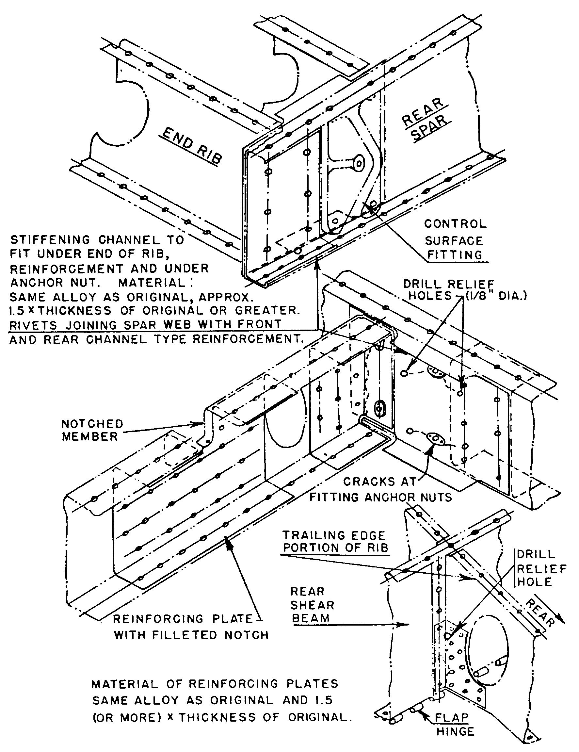
Figure 4-22. Typical methods of replacing cracked members at fittings.

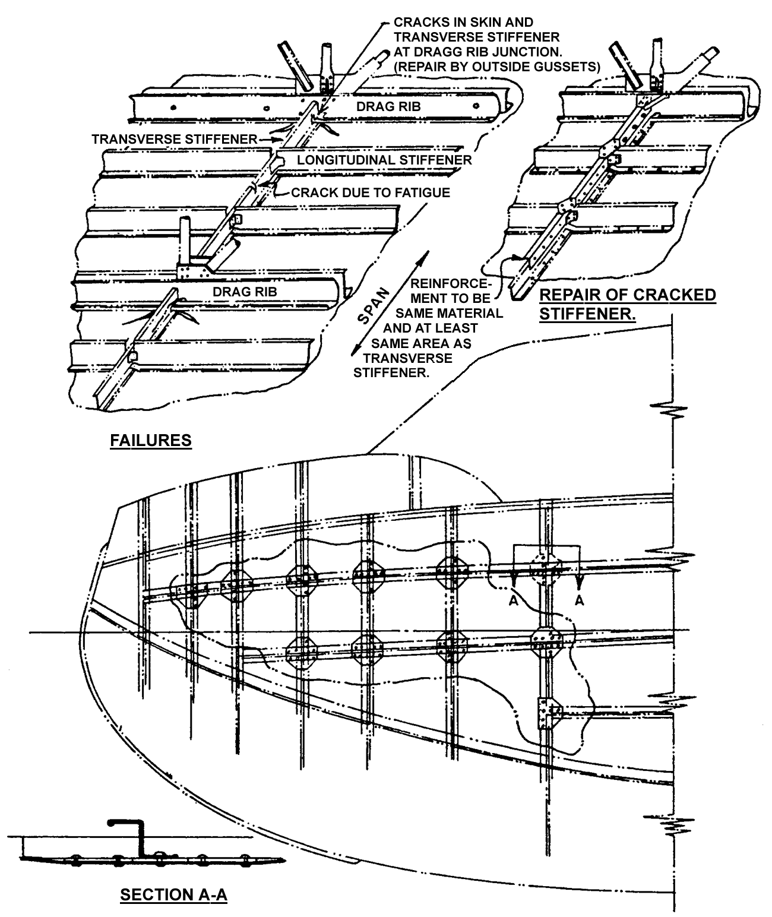
Figure 4-23. Typical methods of repairing cracked frame and stiffener combination.

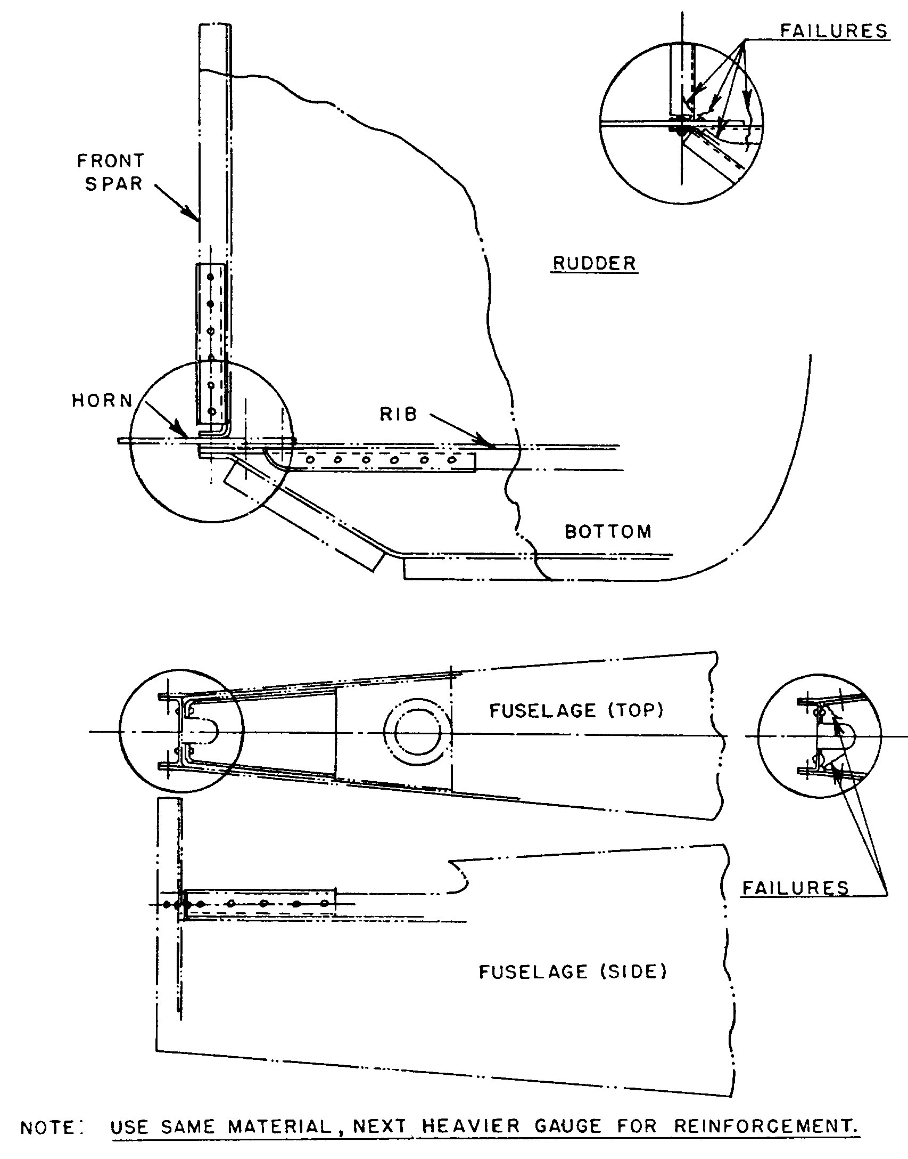

Figure 4-24. Typical repairs to rudder and to fuselage at tail post.

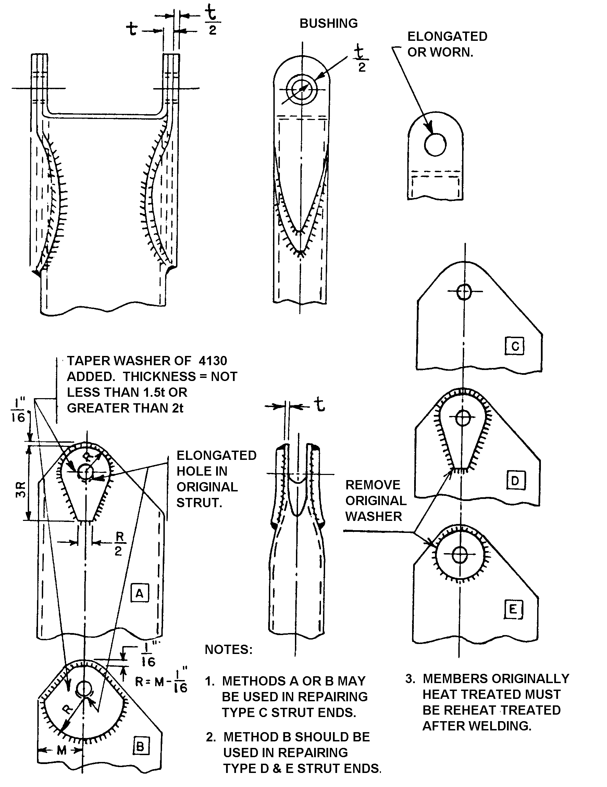
Figure 4-25. Typical methods of repairing elongated or worn bolt holes.

To prevent or minimize disassembly, or reassembly.

Resizing worn components (plate to size).

Filling in damaged or corroded areas.

To plate small areas of extremely large parts.

To plate electrical contacts.

To plate parts too large for existing baths.

To supplement conventional plating.

To plate components which become contaminated if immersed in a plating bath.

To cadmium-plate ultrahigh strength steels without hydrogen embrittlement.

On-site plating.

Reverse current applications (e.g., stain removal, deburring, etching, and dynamic balancing).

Specifications. Selective plating (electrodepositions), when properly applied, will meet the following specifications and standards.

QQ-C-320, Chromium Plating.

QQ-N-290, Nickel Plating.

QQ-P-416, Cadmium Plating.

QQ-S-365, Silver Plating.

QQ-Z-325, Zinc Plating.

MIL-T-10727, Tin Plating.

MIL-C-14550, Copper Plating.

MIL-G-45204, Gold Plating.

General Requirements.

Areas to be repaired by this process should be limited to small areas of large parts, particularly electrical or electronic parts.

All solutions should be kept clean and free from contamination. Care should be taken to insure that the solutions are not contaminated by used anodes or other plating solutions. Brush-plating solutions are not designed to remove large amounts of scale, oil, or grease. Mechanical or chemical methods should be used to remove large amounts of scale or oxide. Use solvents to remove grease or oil.

Brush-plating solutions are five to fifty times as concentrated as tank solutions. The current densities used range from 500 to 4,000 amps/feet². The voltages listed on the solution bottles have been precalculated to give proper current densities. Too high a current density burns the plating, while too low a current density produces stressed deposits and low efficiencies. Agitation is provided by anode/cathode motion. Too fast a motion results in low efficiencies and stressed deposits, and too slow a motion causes burning. A dry tool results in burnt plate, coarse grain structure, and unsound deposits. The tool cannot be too wet. Solution temperatures of 110 °F to 120 °F are reached during operation.

Materials such as stainless steel, aluminum, chromium, and nickel (which have a passive surface) will require an activating operation to remove the passive surface. During the activating process, do not use solutions
that have been previously used with reverse current (because of solution contamination).

Equipment. The power source should operate on either 110 or 220-volt alternating current (AC), 60 Hertz, single-phase input. It should have a capability to produce direct current (DC) having smooth characteristics with controlled ripple and be able to output a current of at least 25 amperes at 0 to 25 volts. Minimum instrumentation of the power source should include a voltmeter, ammeter, and ampere-hour meter.

The ammeter should provide a full-scale reading equal to the maximum capacity of the power source, and with an accuracy of ±5 percent of the current being measured.

The voltmeter should have sufficient capacity to provide a full-scale reading equal to the maximum capacity of the power source and an accuracy of ±1.0 volt.

An ampere-hour meter should be readable to 0.001 ampere-hour and have an accuracy of ±0.01 ampere-hour.

The stylus should be designed for rapid cooling and to hold anodes of various sizes and configurations. For safety, the anode holder should be insulated.

The containers for holding and catching runoff solutions should be designed to the proper configuration and be inert to the specific solution.

The mechanical cleaning equipment and materials should be designed and selected to prevent contamination of the parts to be cleaned.

Materials. The anodes should be of high-purity dense graphite or platinum-iridium alloys. Do not mix solutions from different suppliers. This could result in contamination.

Detail Requirements. On large parts, no area greater than approximately 10 percent of the total area of the part should be plated by this selective plating process. Small parts may be partially or completely plated. Special cases exceeding these limitations should be coordinated with the manufacturer of the plating equipment being used and their recommendations should be followed.

Anode Selection. As a general guide, the contact area of the anode should be approximately one-third the size of the area to be plated. When selecting the anode, the configuration of the part will dictate the shape of the anode.

Required Ampere-Hour Calculation. The selected plating solution has a factor which is equal to the ampere-hours required to deposit 0.0001 inch on 1 square inch of surface. Determine the thickness of plating desired on a certain area, and multiply the solution factor times the plating thickness times the area in square inches to determine the ampere-hours required. This factor may vary because of temperature, current density, etc.

Cleaning. Remove corrosion, scale, oxide, and unacceptable plating prior to processing. Use a suitable solvent or cleaner to remove grease or oil.

Plating on Aluminum and Aluminum Base Alloys.

Electroclean the area using direct current until water does not break on the surface. This electroclean process should be accomplished at 10 to 15 volts, using the appropriate electroclean solution.

Rinse the area in cold, clean tap water.

Activate the area with reverse current, 7 to 10 volts, in conjunction with the proper activating solution until a uniform, gray-to-black surface is obtained.

Rinse thoroughly in cold, clean tap water.

Immediately electroplate to color while the area is still wet, using the appropriate nickel solution.

Rinse thoroughly.

Immediately continue plating with any other solution to desired thickness.

Rinse and dry.

Plating on Copper and Copper Base Alloys.

Electroclean the area using direct current until water does not break on the surface. The electroclean process should be accomplished at 8 to 12 volts using the appropriate electroclean solution.

Rinse the area in cold, clean tap water.

Immediately electroplate the area with any of the plating solutions, except silver. Silver requires an undercoat.

Rinse and dry.

Plating on 300 and 400 Series Stainless Steels, Nickel Base Alloys, Chrome Base Alloys, High Nickel Ferrous Alloys, Cobalt Base Alloys, Nickel Plate, and Chrome Plate.

Electroclean the area using direct current until water does not break on the surface. This electroclean process should be accomplished at 12 to 20 volts using the appropriate electrocleaning solution.

Rinse the area in cold, clean tap water.

Activate the surface using direct current for 1 to 2 minutes, using the activating solution, and accomplish at 6 to 20 volts.

Do not rinse.

Immediately nickel-flash the surface to a thickness of 0.00005 to 0.0001 inch, using the appropriate nickel solution.

Rinse thoroughly.

Immediately continue plating with any other solution to desired thickness.

Rinse and dry.

Plating on Low-Carbon Steels (Heat Treated to 180,000 psi).

Electroclean the area using direct current until water does not break on the surface. This electroclean process should be accomplished at 12 to 20 volts, using the appropriate electrocleaning solution.

Rinse the area in cold, clean tap water.

Reverse-current etch at 8 to 10 volts, using the appropriate activating solution, until a uniform gray surface is obtained.

Rinse thoroughly.

Immediately electroplate the part using any solutions, except copper or silver. Both of these require undercoats.

Rinse and dry.

Plating on Cast Iron and High-Carbon Steels (Steels Heat Treated to 180,000 psi).

Electroclean the area using direct current until water does not break on the surface. This electroclean process should be accomplished at 12 to 20 volts, using the appropriate electrocleaning solution.

Rinse the area thoroughly in cold, clean tap water.

Reverse-current etch at 8 to 10 volts, using the appropriate etching solution, until a uniform gray is obtained.

Rinse thoroughly.

Remove surface smut with 15 to 25 volts using the appropriate activating solution.

Rinse thoroughly.

Electroplate immediately, using any of the solutions, except copper or silver (both of these require undercoats).

Rinse and dry.

Plating on Ultrahigh Strength Steels (Heat Treated Above 180,000 psi).

Electroclean the area using reverse current until water does not break on the surface. This electroclean process should be accomplished at 8 to 12 volts using the appropriate electroclean solution.

Rinse the area thoroughly in cold, clean tap water.

Immediately electroplate the part, using either nickel, chromium, gold, or cadmium. Other metals require an undercoat of one of the above. Plate initially at the highest voltage recommended for the solution so as to develop an initial barrier layer. Then reduce to standard voltage.

Rinse and dry.

Bake the part for 4 hours at 375 °F
± 25 °F.

NOTE: Where the solution vendor provides substantiating data that hydrogen embrittlement will not result from plating with a particular solution, then a postbake is not required. This substantiating data can be in the form of aircraft industry manufacturer’s process specifications, military specifications, or other suitable data.

NOTE: Acid etching should be avoided, if possible. Where etching is absolutely necessary, it should always be done with reverse current. Use alkaline solutions for initial deposits.

Dissimilar Metals and Changing Base. As a general rule, when plating two dissimilar metals, follow the plating procedure for the one with the most steps or activation. If activating steps have to be mixed, use reverse-current activation steps prior to direct-current activation steps.

Plating Solution Selection.

Alkaline and neutral solutions are to be used on porous base metals, white metals, high-strength steel, and for improved coating
ability. Acid solutions are to be used for rapid buildup and as a laminating structure material in conjunction with alkaline-type solutions.

Chrome brush-plating solutions do not yield as hard a deposit as bath-plating solutions. The hardness is about 600 Brinell as compared to 1,000 Brinell for hard chrome deposited from a tank.

Silver-immersion deposits will form with no current flowing on most base metals from the silver brush-plating solutions. Such deposits have poor adhesion to the base metal. Consequently, a flash of a more noble metal should be deposited prior to silver plating to develop a good bond.

In general, brush plating gives less hydrogen embrittlement and a lower fatigue strength loss than does equivalent tank deposits. However, all brush-plated, ultrahigh strength steel parts (heat treated above 180,000 psi) should be baked, as mentioned, unless it is specifically known that embrittlement is not a factor.

Qualification Tests. All brush-plated surfaces should be tested for adhesion of the electrodeposit. Apply a 1-inch wide strip of Minnesota Mining and Manufacturing tape code 250, or an approved equal, with the adhesive side to the freshly plated surface. Apply the tape with heavy hand pressure and remove it with one quick motion perpendicular to the plated surface. Any plating adhering to the tape should be cause for rejection.

Personnel Training for Quality Control. Manufacturers of selective-plating equipment provide training in application techniques at their facilities. Personnel performing selective plating must have adequate knowledge of the methods, techniques, and practices involved. These personnel should be certified as qualified operators by the manufacturers of the products used.

4-63.⎯4-73. [RESERVED.]

