Section 5. Welding and Brazing

GENERAL. This section covers weld repairs to aircraft and component parts only. Observe the following procedures when using such equipment as gas tungsten arc welding (GTAW), gas metal arc welding (GMAW), plasma arc welding, and oxyacetylene gas welding. When repairs of any of these flight-critical parts are required, it is extremely important to make the weld repairs equal to the original weld. Identifying the kind of metal to be welded, identifying the kind of welding process used in building the part originally, and determining the best way to make welded repairs are of utmost importance.

Welding is one of the three commonly used methods of joining metals without the use of fasteners. Welding is done by melting the edges of two pieces of metal to be joined and allowing the molten material to flow together so the two pieces will become one.

Brazing is similar to welding in that heat is used to join the material; but rather than melting, the metal is heated only enough to melt a brazing rod having a much lower melting point. When this brazing rod melts, it wets the surfaces to be joined, and when it cools and solidifies, it bonds the pieces together.

Soldering is similar to brazing except that brazing materials normally melt at temperatures above 425 °C (800 °F), while solders melt at temperatures considerably lower.

The next step in making airworthy weld repairs is to decide the best process to use, considering the available state-of-the-art welding equipment, and then deciding the correct weld-filler material to use. Before any weld repairs can be made, the metal parts to be welded must be cleaned properly, fitted and jigged properly, and all defective welds must be removed to prepare for an aircraft quality weld
repair.

Finally, after the weld is completed, the weld must be inspected for defects. All these things are necessary in order to make an airworthy weld repair.

Aircraft welding Qualifications. Four groups of metals a person can be certified and qualified to use are:

Group 1, 4130 Steel.

Group 2, Stainless Steel.

Group 3, Aluminum

Group 4, Titanium.

For other group listing of metal the welder may qualify, refer to Mil-Std-1595A.

Most large business or agencies conduct their own certification tests, or they have an outside testing lab validate the certification tests.

EQUIPMENT SELECTION. Use the welding equipment manufacturer’s information to determine if the equipment will satisfy the requirements for the type of welding operation being undertaken. Disregarding such detailed operating instructions may cause substandard welds. For example, when using GTAW equipment, a weld can be contaminated with tungsten if the proper size electrode is not used when welding with direct current reverse polarity. Another example, the depletion of the inert gas supply below the critical level causes a reduction in the gas flow and will increase the danger of atmospheric contamination.

Electric welding equipment versatility requires careful selection of the type current and polarity to b used. Since the composition and thickness of metals are deciding

factors, the selection may vary with each specific application. Metals having refractory surface oxide films (i.e., magnesium alloys and aluminum and its alloys), are generally welded with alternating current (ac), while direct current (dc) is used for carbon, low alloy, noncorrodible, and heat-resisting steels. General recommendations covering current and polarity are shown in table 4-12.

Oxyacetylene gas equipment is suitable for welding most metals. It is not, however, the best method to use on such materials as stainless steel, magnesium, and aluminum alloys; because of base metal oxidization, distortion, and loss of ductility.

NOTE: If oxyacetylene is used for welding stainless steel or aluminum, all flux must be removed, as it may cause corrosion.

ACCURATELY IDENTIFY THE TYPE OF MATERIAL TO BE REPAIRED. If positive identification of the material is not possible, contact the aircraft manufacturer or subject the item to a metallurgical laboratory analysis. Before any welding is attempted, carefully consider the weldability of the alloy, since all alloys are not readily weldable. The following steels are readily weldable; plain carbon (of the 1000 series), nickel steel (of the Society of Automotive Engineers (SAE) 2300 series), chrome-nickel alloys (of the SAE 3100 series), chrome-molybdenum steels (of the SAE 4100 series), and low nickel-chrome-molybdenum steel (of the SAE 8600 series).

PREPARATION FOR WELDING.

Hold elements to be welded in a welding jig or fixture which is sufficiently rigid to prevent misalignment due to expansion and contraction of the heated material and which positively and accurately positions the
pieces to be welded.

Clean parts to be welded with a wire brush or other suitable method prior to welding. Do not use a brush of dissimilar metal, such as brass or bronze on steel. The small deposit left by a brass or bronze brush will materially weaken the weld, and may cause cracking or subsequent failure of the weld. If the members are metallized, the surface metal may be removed by careful sandblasting followed by a light buffing with emery cloth.

INSPECTION OF A COMPLETED WELD. Visually inspect the completed weld for the following:

The weld has a smooth seam and uniform thickness. Visual inspection shall be made of the completed weld to check for undercut and/or smooth blending of the weld contour into the base metal.

The weld is tapered smoothly into the base metal.

No oxide has formed on the base metal more than 1/2 inch from the weld.

There are no signs of blowholes, porosity, or projecting globules. Many military specifications, as well as American Society of Testing Materials (ASTM) codes, specify acceptable limits of porosity and other types of defects that are acceptable.

The base metal shows no signs of pitting, burning, cracking, or distortion.

The depth of penetration insures fusion of base metal and filler rod.

The welding scale is removed. The welding scale can be removed using a wire brush or by sandblasting. Remove any roll over, cold lab, or unfued weld metal. Check underside of welded joint for defects.

Table 4-12. Current and polarity selection for inert gas welding.
 | ALTERNATING  CURRENT | DIRECT  CURRENT
MATERIAL | With High-Frequency  Stabilization | STRAIGHT  Polarity
Magnesium up to ¹/8 in. thick | 1 | N.R.
Magnesium above ³/16 in. thick | 1 | N.R.
Magnesium Castings | 1 | N.R.
Aluminum up to ³/32 in. thick | 1 | N.R.
Aluminum over ³/32 in. thick | 1 | N.R.
Aluminum Castings | 1 | N.R.
Stainless Steel |  | 1
Low Carbon Steel, 0.015 to 0.030 in. |  | 1
Low Carbon Steel, 0.030 to 0.125 in. | N.R. | 1
1 Recommended N.R. Not Recommended

MICROFISSURES Cracks in parts and materials can vary from tiny microfissures, that are visible only with magnification, to those easily identified by unaided eyes. Microfissures are the worst type of defect for two reasons; they are often hard to detect, and they produce the worst form of notch effect/stress concentration. Once they form, they propagate with repeated applications of stress and lead to early failures. Every possible means should be used to detect the presence of cracks, and ensure their complete removal before welding operations proceed. (See figure 4-26.)

NONDESTRUCTIVE TESTING or evaluation is advisable in critical applications. Nondestructive testing methods such as; magnetic particle, liquid penetrant, radiography, ultrasonic, eddy current, and acoustic emission can be used; however, they require trained and qualified people to apply them.

PRACTICES TO GUARD AGAINST Do not file or grind welds in an effort to create a smooth appearance, as such treatment causes a loss of strength. Do not fill welds with solder, brazing metal, or any other filler. When it is necessary to weld a

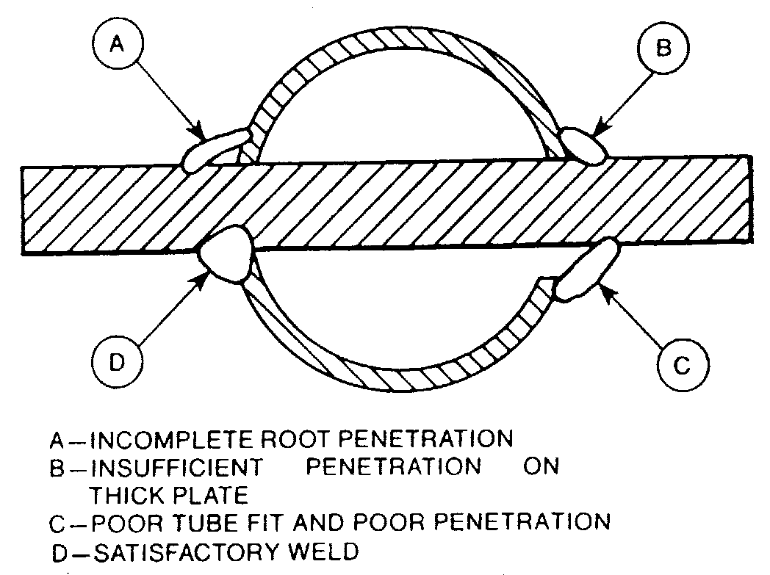
Figure 4-26. Common defects to avoid when fitting and welding aircraft certification cluster.

joint which was previously welded, remove all of the old weld material before rewelding. Avoid welding over a weld, because reheating may cause the material to lose its strength and become brittle. Never weld a joint which has been previously brazed.

TORCH SIZE (Oxyacetylene welding). When using oxyacetylene welding, the torch tip size depends upon the thickness of the material to be welded. Commonly used sizes, proven satisfactory by experience, are shown in table 4-13.

Table 4-13. Torch tip sizes.
Thickness of steel  (in inches) | Diameter of  hole in tip | Drill size
0.015 to 0.031  0.031 to 0.065  0.065 to 0.125  0.125 to 0.188  0.188 to 0.250  0.250 to 0.375 | 0.026  .031  .037  .042  .055  .067 | 71  68  63  58  54  51

WELDING RODS AND ELECTRODES Use welding rods and electrodes that are compatible with the materials to be welded. Welding rods and electrodes for various applications have special properties suitable for the application intended.

Lap welds are used in shear applications. The weld throat of the fillet weld is considered the plane 45 degrees to the surface plane of the sheet being welded and is equal to 0.707 times the thickness of the sheet stock. (See figure 4-27.)

P_{WS} = 0.707xtx1xFwsu
where: P_{WS} = the allowable tensile
strength of the joint.
t = the thickness of the sheet stock (the throat of the weld joint.
l = the length of the weld joint.
Fwsu = the shear strength of the filled rod material.
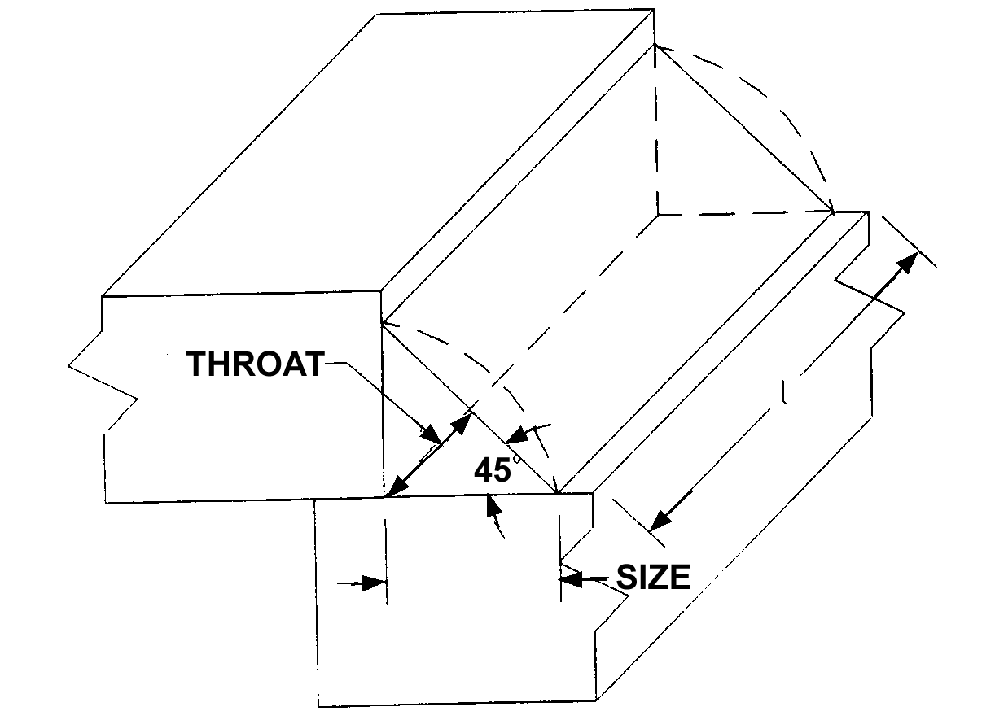
FIGURE 4-27. Lap Weld Strength Calculation

ROSETTE WELDS are generally employed to fuse an inner reinforcing tube (liner) with the outer member. Where a rosette weld is used, drill a hole, (in the outside tube only) of sufficient size to insure fusion of the inner tube. A hole diameter of approximately one-fourth the tube diameter of the outer tube serves adequately for this purpose. In cases of tight-fitting sleeves or inner liners, the rosettes may be omitted. Rosette weld edge distance is 1/2 the diameter of the tube, as measured from the edge of the rosette hole to the end of the inside and outside tube. Rosettes shall not be considered when determining the strength of a welded form. Drill an 1/8-inch hole in the lower tube in the center of the intended rosette weld so the heat does not burn away the outer tube. This small hole tends to bleed off the heat from the torch and keeps the size of the rosette small.

HEAT-TREATED MEMBERS Certain structural parts may be heat treated and, therefore, could require special handling. In general, the more responsive an alloy steel is to heat treatment, the less suitable it is for welding because of its tendency to become brittle and lose its ductility in the welded area. Weld the members which depend on heat treatment for their original physical properties by using a welding rod suitable for producing heat-treated values comparable to those of the original members. (See paragraph 4-74.) After welding, heat treat the affected members to the manufacturer’s specifications.

TYPES OF WELDING.

Gas Welding. A fuel gas such as acetylene or hydrogen is mixed inside a welding torch with oxygen to produce a flame with a temperature of around 6,300 °F (3,482 ºC). This flame is used to melt the materials to be welded. A filler rod is melted into the puddle of molten metal to reinforce the weld. When highly-reactive metals such as aluminum are gas welded, they must be covered with flux to exclude oxygen from the molten metal and keep oxides from forming which would decrease the strength of the weld. (An illustration of a carburizing flame, a neutral flame, and an oxidizing flame is shown in figure 4-28.)

Shielded Metal Arc Welding (SMAW). This method is the most familiar and common type and is known in the trade as stick welding. A metal wire rod coated with a welding flux is clamped in an electrode holder connected to the power supply with a heavy electrical cable. The metal to be welded is also attached to the power supply. The electrical power is supplied to the work at a low voltage

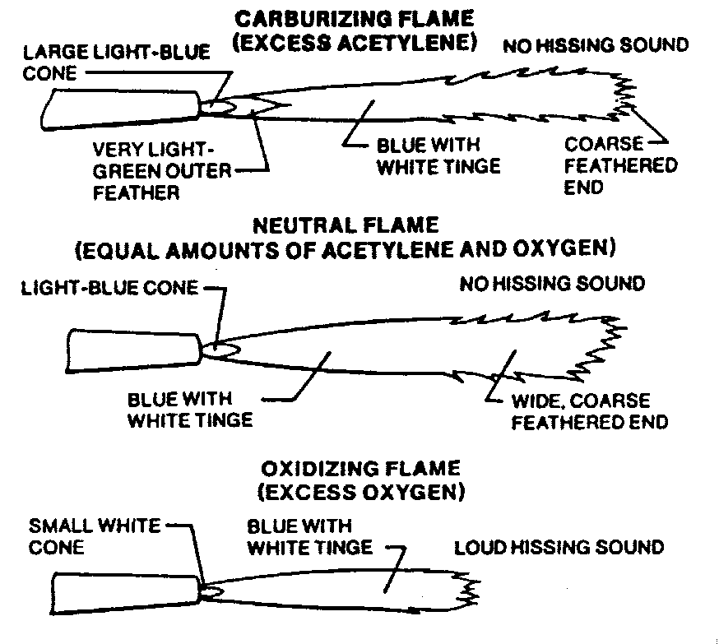
Figure 4-28. Basic gas-welding flames: Each has distinctive shape, color and sound. Neutral flame is the most used.

and high current and may be either AC or DC, depending upon the type of welding being done. An arc is struck between the rod and the work and produces heat in excess of 10,000 °F, which melts both the material and

the rod. As the flux melts, it releases an inert gas which shields the molten puddle from oxygen in the air and prevents oxidation. The molten flux covers the weld and hardens to an airtight slag cover that protects the weld bead as it cools. This slag must be chipped off to examine the weld.

Gas Metal Arc Welding (GMAW). This method of welding was formerly called Metal Inert Gas (MIG) welding and is an improvement over stick welding because an uncoated wire electrode is fed into the torch and an inert gas such as argon, helium, or carbon dioxide flows out around the wire to protect the puddle from oxygen. The power supply connects between the torch and the work, and the arc produces the intense heat needed to melt the work and the electrode. Low-voltage high-current DC is used almost exclusively with GMAW welding. GMAW is used more for large-volume production work than for aircraft repair.

Gas Tungsten Arc Welding (GTAW). This is the form of electric arc welding that fills most of the needs in aircraft maintenance. It is more commonly known as Tungsten Inert Gas (TIG) welding and by the trade names of Heliarc or Heliweld. These trade names were derived from the fact that the inert gas originally used was helium.

Rather than using a consumable electrode such as is used in both of the other two methods we have discussed, the electrode in TIG welding is a tungsten rod. (In earlier procedures using this form of welding, a carbon electrode was used, but it has been replaced almost exclusively with tungsten.)

The 250+ amp arc between the electrode and the work melts the metal at 5,432 ºF, and a filler rod is manually fed into the molten puddle. A stream of inert gas such as argon or helium flows out of the torch and envelopes the arc, thereby preventing the formation of oxides in the puddle.

The versatility of TIG welding is increased by the power supply that is used. Direct current of either polarity or alternating current may be used. (See figures 4-29 and 4-30.)

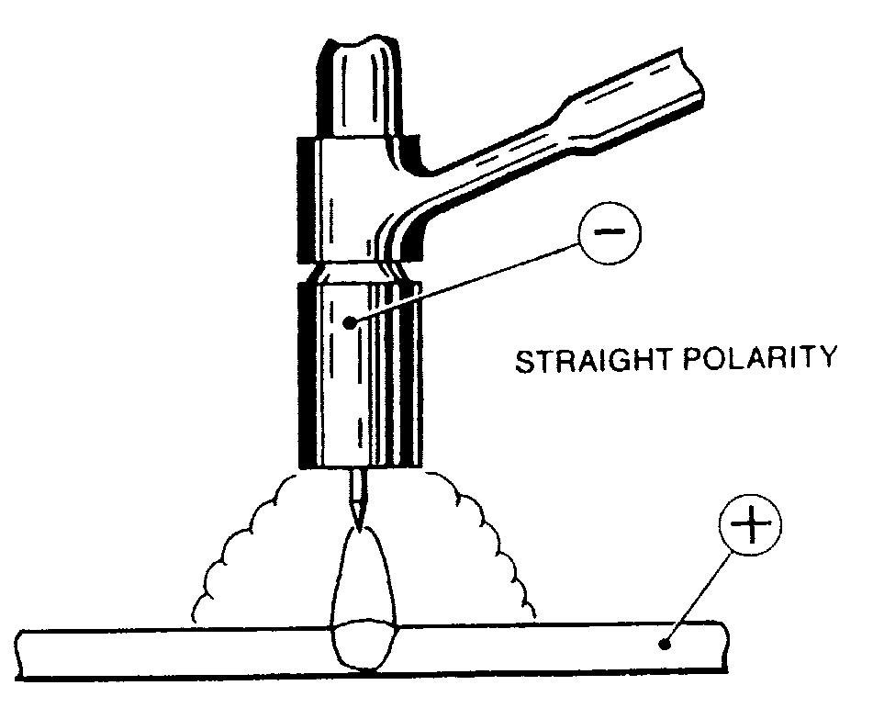
Figure 4-29. Set TIG welder to dc current, straight polarity for welding mild steel, stainless steel and titanium
Figure 4-30. Set TIG to ac current for welding
aluminum and magnesium.

ELECTRIC-RESISTANCE WELDING. Many thin sheet metal parts for aircraft, especially stainless steel parts, are joined by one of the forms of electric resistance welding, either spot welding or seam welding.

Spot Welding. Two copper electrodes are held in the jaws of the spot welding machine, and the material to be welded is clamped between them. Pressure is applied to hold the electrodes tightly together, and electrical current flows through the electrodes and the material. The resistance of the material being welded is so much higher than that of the copper electrodes that enough heat is generated to melt the metal. The pressure on the electrodes forces the molten spots in the two pieces of metal to unite, and this pressure is held after the current stops flowing long enough for the metal to solidify. Refer to MIL HDBK-5 for joint construction and strength data. The amount of current, pressure, and dwell time are all carefully controlled and matched to the type of material and the thickness to produce the correct spot welds. (See figure 4-31.)

Seam Welding. Rather than having to release the electrodes and move the material to form a series of overlapping spot welds, a seam-welding machine is used to manufacture 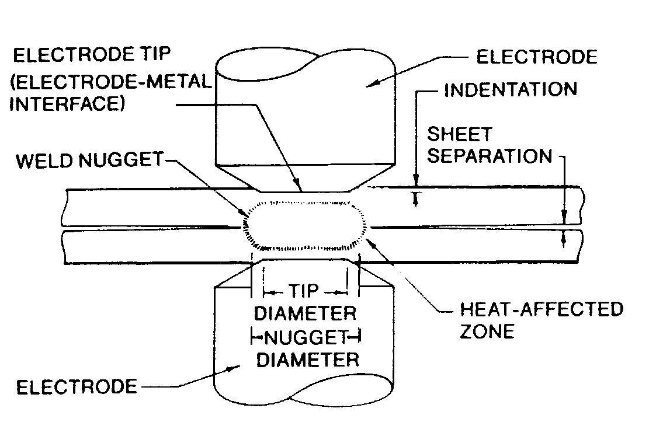
Figure 4-31. In spot welding, heat is produced by electrical resistance between copper electrodes. Pressure is simultaneously applied to electrode tips to force metal together to complete fusing process. Spot-weld-nugget size is directly related to tip size.

fuel tanks and other components where a continuous weld is needed. Two copper wheels

replace the bar-shaped electrodes. The metal to be welded is moved between them, and electric pulses create spots of molten metal that overlap to form the continuous seam.

BRAZING. Brazing refers to a group of metal-joining processes in which the bonding material is a nonferrous metal or alloy with a melting point higher than 425 C (800 F), but lower than that of the metals being joined. Brazing includes silver brazing (erroneously called silver soldering or hard soldering), copper brazing, and aluminum brazing.

NOTE: Never weld over a previously brazed joint.

Brazing requires less heat than welding and can be used to join metals that are damaged by high heat. However, because the strength of brazed joints is not as great as welded joints, brazing is not used for structural repairs on aircraft. In deciding whether brazing of a joint is justified, it should be remembered that a metal, which will be subjected to a sustained high temperature in use, should not be brazed.

A brazing flux is necessary to obtain a good union between the clean base metal and the filler metal. There are a number of readily available manufactured fluxes conforming to AWS and AMT specifications.

The base metal should be preheated slowly with a mild flame. When it reaches a dull-red heat (in the case of steel), the rod should be heated to a dark (or purple) color and dipped into the flux. Since enough flux adheres to the rod, it is not necessary to spread it over the surface of the metal.

A neutral flame is used in most brazing applications. However, a slightly oxidizing flame should be used when copper-zinc, copper-zinc-silicon, or copper-zinc-nickel-silicon filler alloys are used. When brazing aluminum and its alloys, a neutral flame is preferred, but if difficulties are encountered, a slightly reduced flame is preferred to an oxidizing flame.

The filler rod can now be brought near the tip of the torch, causing the molten bronze to flow over a small area of the seam. The base metal must be at the flowing temperature of the filler metal before it will flow into the joint. The brazing metal melts when applied to the steel and runs into the joint by capillary attraction. In braze welding, the rod should continue to be added, as the brazing progresses, with a rhythmic dipping action; so that the bead will be built to a uniform width and height. The job should be completed rapidly and with as few passes of the rod and torch as possible.

When the job is finished, the metal should be allowed to cool slowly. After cooling, remove the flux from the parts by immersing them for 30 minutes in a lye solution.

Copper brazing of steel is normally done in a special furnace having a controlled atmosphere, and at a temperature so high that field repairs are seldom feasible. If copper brazing is attempted without a controlled atmosphere, the copper will probably not completely wet and fill the joint. Therefore, copper brazing in any conditions other than appropriately controlled conditions is not recommended.

The allowable shear strength for copper brazing of steel alloys should be 15 thousand pounds per square inch (kpsi), for all conditions of heat treatment.

The effect of the brazing process on the strength of the parent or base metal of steel alloys should be considered in the structural design. Where copper furnace brazing is employed, the calculated allowable strength of

the base metal, which is subjected to the temperatures of the brazing process, should be in accordance with table 4-14.

Table 4-14. Calculated allowable strength of base metal.
Material | Allowable Strength
Heat-treated material (including normalized) used in “as-brazed”  condition | Mechanical properties of normalized material
Heat-treated material (including normalized) reheat-treated during or after brazing | Mechanical properties corresponding to heat treatment performed

Alloys commonly referred to as silver solders melt above 425 °C (800 °F), and when using them the process should be called silver brazing.

The principal use of silver brazing in aircraft work is in the fabrication of high-pressure oxygen lines and other parts which must withstand vibration and high temperatures. Silver brazing is used extensively to join copper (and its alloys), nickel, silver, various combinations of these metals, and thin steel parts. Silver brazing produces joints of higher strength than those produced by other brazing processes.

It is necessary to use flux in all silver-brazing operations, because of the necessity for having the base metal chemically clean, (without the slightest film of oxide to prevent the silver-brazing alloy from coming into intimate contact with the base metal).

The joint must be physically and chemically clean, which means it must be free of all dirt, grease, oil, and paint. After removing the dirt, grease, and paint, any oxide should be removed by grinding or filing the piece until bright metal can be seen. During the soldering operation, the flux continues the process of keeping oxide away from the metal and aids the flow of solder.

In figure 4-32, three types of joints for silver brazing are shown; flanged butt, lap, and edge joints. If a lap joint is used, the amount of lap should be determined according to the strength needed in the joint. For strength equal to that of the base metal in the heated zone, the amount of lap should be four to six times the metal thickness.

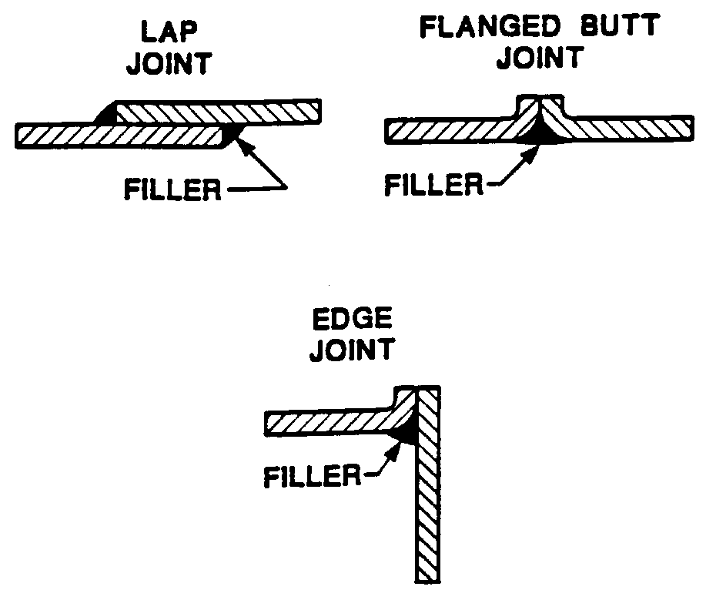
Figure 4-32. Silver brazing joints.

The oxyacetylene flame for silver brazing should be neutral, but may have a slight excess of acetylene. It must be soft, not harsh. During both preheating and application of the solder, the tip of the inner cone of the flame should be held about 1/2 inch from the work. The flame should be kept moving so that the metal will not become overheated.

When both parts of the base metal are at the right temperature (indicated by the flow of flux), brazing alloy can be applied to the surface of the under or inner part at the edge of the seam. It is necessary to simultaneously direct the flame over the seam, and keep moving it so that the base metal remains at an even temperature.

The torch can be shut off simply by closing the acetylene off first and allowing the gas remaining in the torch tip to burn out. Then turn off the oxygen valve. If the torch is not to be used again for a long period, the pressure should be turned off at the cylinder. The hose lines should then be relieved of pressure by opening the torch needle valves and the working pressure regulator, one at a time, allowing the gas to escape. Again, it is a good practice to relieve the oxygen pressure and then the acetylene pressure. The hose should then be coiled or hung carefully to prevent damage or kinking.

Soft soldering is used chiefly for copper, brass, and coated iron in combination with mechanical seams; that is, seams that are riveted, bolted, or folded. It is also used where a leak-proof joint is desired, and sometimes for fitting joints to promote rigidity and prevent corrosion. Soft soldering is generally performed only in very minor repair jobs. This process is used to join electrical connections because it forms a strong union with low electrical resistance.

Soft solder gradually yields under a steadily applied load and should not be used unless the transmitted loads are very low. It should never be used as a means of joining structural members.

A soldering iron is the tool used in soldering. Its purpose is to act as a source of heat for the soldering operation. The bit, or working face, is made from copper since this metal will readily absorb heat and transmit it to the work. Figure 4-33 shows a wedge-shaped bit.

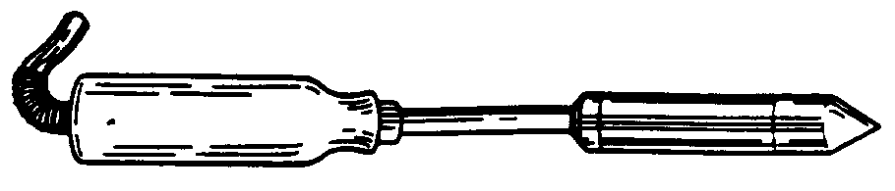
Figure 4-33. Electric soldering iron.

To tin the soldering iron, it is first heated to a bright red, and then the point is cleaned (by filing) until it is smooth and bright. No dirt or pits should remain on its surface. After the soldering iron has been mechanically cleaned, it should be reheated sufficiently to melt solder and chemically cleaned by rubbing it firmly on a block of sal ammoniac (ammonium chloride). Rosin flux paste may also be used. Solder is then applied to the point and wiped with a clean cloth.

A properly tinned copper iron has a thin unbroken film of solder over the entire surface of its point.

Soft solders are chiefly alloys of tin and lead. The percentages of tin and lead vary considerably in various solder, with a corresponding change in their melting points, ranging from 145-311 °C (293-592 °F). Half-and-half (50/50) solder is a general purpose solder and is most frequently used. It contains equal proportions of tin and lead, and it melts at approximately 182 °C (360 °F).

The application of the melted solder requires somewhat more care than is apparent. The parts to be soldered should be locked together or held mechanically or manually while tacking. To tack the seam, the hot copper iron is touched to a bar of solder, then the drops of solder adhering to the copper iron are used to tack the seam at a number of points. The film of solder between the surfaces of a joint must be kept thin to make the strongest joint.

A hot, well-tinned soldering copper iron should be held so that its point lies flat on the metal (at the seam), while the back of the copper iron extends over the seam proper at a 45-degree angle, and a bar of solder is touched to the point. As the solder

melts, the copper iron is drawn slowly along the seam. As much solder as necessary is added without raising the soldering copper iron from the job. The melted solder should run between the surfaces of the two sheets and cover the full width of the seam. Work should progress along the seam only as fast as the solder will flow into the joint.

AIRCRAFT PARTS NOT TO BE WELDED.

Brace Wires and Cables. Do not weld aircraft parts whose proper function depends upon strength properties developed by cold-working. Among parts in this classification are streamlined wire and cables.

Brazed and Soldered Parts. Do not weld brazed or soldered parts as the brazing mixture or solder will penetrate and weaken the hot steel.

Alloy Steel Parts. Do not weld alloy steel parts such as aircraft bolts, turnbuckle ends, etc., which have been heat treated to improve their mechanical properties.

Nos. 2024 and 7075 Aluminum. Do not weld these two aluminum alloys (that are often used in aircraft construction) because the heat from the welding process will cause severe cracking. The 2024 aluminum is most often used in wing skins, fuselage skins, and in most structured airframe parts. The 7075 aluminum is most often used in machined fittings such as wing-spar attachments, landing-gear attachments, and other structural parts.

WELDING ROD SELECTION. Most aircraft repair shops that are prepared to make weld repairs should have the basic selection of welding rods available. The best rods to stock, the metals they weld, and the AWS specification number are shown in table 4-15.

REPAIR OF TUBULAR MEMBERS.

Inspection. Prior to repairing tubular members, carefully examine the structure surrounding any visible damage to insure that no secondary damage remains undetected. Secondary damage may be produced in some structure, remote from the location of the primary damage, by the transmission of the damaging load along the tube. Damage of this nature usually occurs where the most abrupt change in direction of load travel is experienced. If this damage remains undetected, subsequent normal loads may cause failure of the part.

Location and Alignment of Welds. Unless otherwise noted, welded steel tubing may be spliced or repaired at any location along the length of the tube. To avoid distortion, pay particular attention to the proper fit and alignment.

Members Dented at a Cluster. Repair dents at a steel-tube cluster joint by welding a specially formed steel patch plate over the dented area and surrounding tubes. (See figure 4-34.) To prepare the patch plate, cut a section of steel sheet of the same material and thickness as the heaviest tube damaged. Trim the reinforcement plate so that the fingers extend over the tubes a minimum of 1.5 times the respective tube diameter. (See figure 4-34.) Remove all the existing finish on the damaged cluster-joint area to be covered by the reinforcement plate. The reinforcement plate may be formed before any welding is attempted, or it may be cut and tack-welded to one or more of the tubes in the cluster joint, then heated and formed around the joint to produce a smooth contour. Apply sufficient heat to the plate while forming so that there is generally a gap of no more than 1/16 inch from the contour of the joint to the plate. In this operation avoid unnecessary heating, and exercise care to prevent damage at the point of the angle
formed by any two adjacent fingers of the plate. After the plate is formed and tack welded to the cluster joint, weld all the plate edges to the cluster joint.

Table 4-15. Chart showing Welding Filler Rod selection.
Welding Rod # | AMS Spec. | AWS Spec. | Welds these Metals
4130 | AMS 6457 | AWS A5.18 | Mild Steel, 4130 steel
4140 | AMS 6452 | AWS A5.28 | 4140 Steel
4043 | AMS 4190 | AWS A5.10 | Most weldable Aluminum
308L | AMS 5692 | AWS A5.9 | 304 Stainless steel
316L | AMS 5692 | AWS A5.9 | 316 Stainless steel
AZ61A | AMS 4350 | AWS A5.19 | AZ61A Magnesium
ERTi-5 | AMS 4954 | AWS A5-16 | Titanium
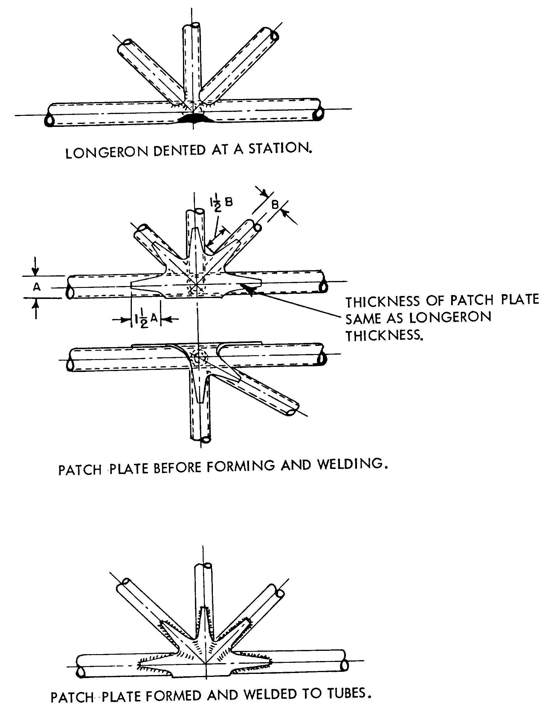
Figure 4-34. Finger patch repairs for members dented at a cluster.

Members Dented in a Bay. Repair dented, bent, cracked, or otherwise damaged tubular members by using a split-sleeve reinforcement. Carefully straighten the damaged member, and in the case of cracks, drill No. 40 (0.098) inch stop holes at the ends of the crack.

REPAIR BY WELDED SLEEVE. This repair is outlined in figure 4-35. Select a length of steel tube sleeve having an inside diameter approximately equal to the outside diameter of the damaged tube and of the same material, and at least the same wall thickness. Diagonally cut the sleeve reinforcement at a 30-degree angle on both ends so that the minimum distance of the sleeve from the edge of the crack or dent is not less than 1-1/2 times the diameter of the damaged tube. Cut through the entire length of the reinforcement sleeve, and separate the half-sections of the sleeve. Clamp the two sleeve sections to the proper positions on the affected areas of the original tube. Weld the reinforcement sleeve along the length of the two sides, and weld both ends of the sleeve to the damaged tube. (See figure 4-35.) The filling of dents or cracks with welding rod in lieu of reinforcing the member is not acceptable.

REPAIR BY BOLTED SLEEVE. Do not use bolted-sleeve repairs on welded steel-tube structure unless specifically authorized by the manufacturer or the FAA. The tube area removed by the bolt holes, in this type of repair, may prove critical.

WELDED-PATCH REPAIR. Dents or holes in tubing may be repaired by using a patch of the same material, one gauge thicker. (See figure 4-36.)

Dented Tubing.

Dents are not deeper than 1/10 of

tube diameter, do not involve more than 1/4 of the tube circumference, and are not longer than tube diameter.

Dents are free from cracks, abrasions, and sharp corners.

The dented tubing can be substantially reformed, without cracking, before application of the patch.

Punctured Tubing. Holes are not longer than tube diameter and involve not more than 1/4 of tube circumference.

SPLICING TUBING BY INNER-SLEEVE METHOD. If the damage to a structural tube is such that a partial replacement of the tube is necessary, the inner-sleeve splice is recommended; especially where a smooth tube surface is desired. (See figure 4-37.)

Make a diagonal cut when removing the damaged portion of the tube, and remove the burr from the edges of the cut by filing or similar means. Diagonally cut a replacement steel tube of the same material and diameter, and at least the same wall thickness, to match the length of the removed portion of the damaged tube. At each end of the replacement tube allow a 1/8-inch gap from the diagonal cuts to the stubs of the original tube. Select a length of steel tubing of the same material, and at least the same wall thickness, and of an outside diameter equal to the inside diameter of the damaged tube. Fit this inner-sleeve tube material snugly within the original tube, with a maximum diameter difference of 1/16 inch. From this inner-sleeve tube material cut two sections of tubing, each of such a length that the ends of the inner sleeve will be a minimum distance of 1-1/2-tube diameters from the nearest end of the diagonal cut.

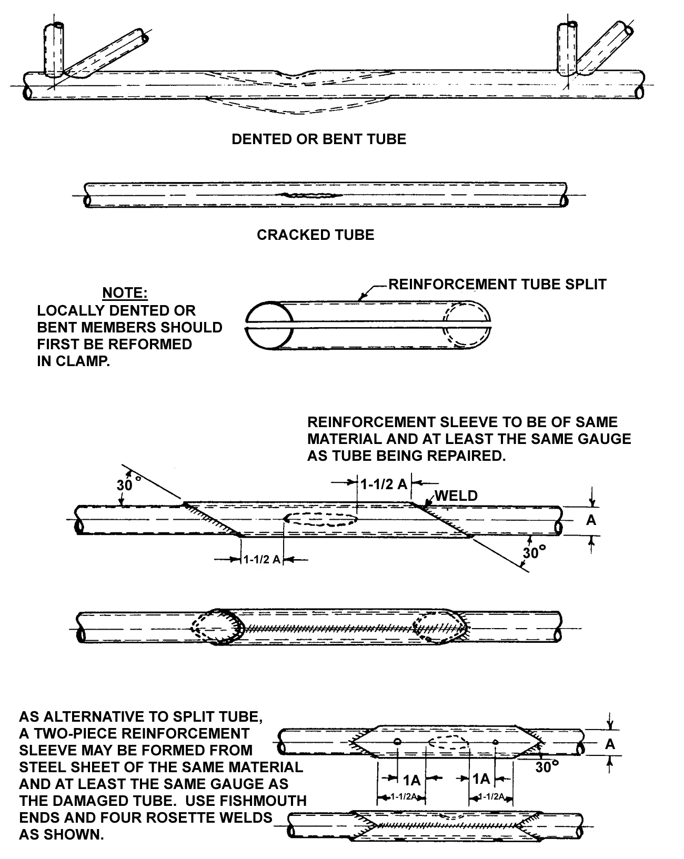
Figure 4-35. Members dented in a bay (repairs by welded sleeve).

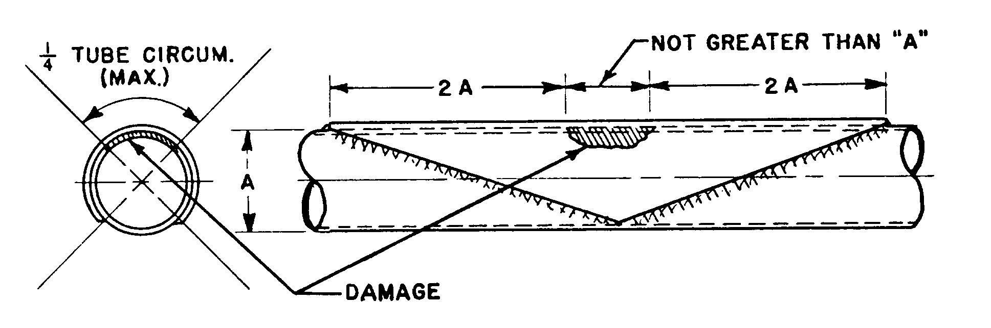Figure 4-36. Welded patch repair.

If the inner sleeve fits very tightly in the replacement tube, chill the sleeve with dry ice or cold water. If this is insufficient, polish down the diameter of the sleeve with emery cloth. Tack the outer and inner replacement tubes using rosette welds. Weld the inner sleeve to the tube stubs through the 1/8-inch gap, forming a weld bead over the gap.

SPLICING TUBING BY OUTER-SLEEVE METHOD. If partial replacement of a tube is necessary, make the outer-sleeve splice using a replacement tube of the same diameter. Since the outer-sleeve splice requires the greatest amount of welding, it should be used only when the other splicing methods are not suitable. Information on the replacement by use of the outer-sleeve method is given in figure 4-38 and figure 4-39.

Remove the damaged section of a tube utilizing a 90-degree cut. Cut a replacement steel tube of the same material, diameter, and at least the same wall thickness to match the length of the removed portion of the damaged tube. This replacement tube must bear against the stubs of the original tube with a total tolerance not to exceed 1/32 inch. The outer-sleeve tube material selected must be of the same material and at least the same wall thickness as

the original tube. The clearance between inside diameter of the sleeve and the outside diameter of the original tube may not exceed 1/16 inch.

From this outer-sleeve tube material, cut diagonally (or fishmouth) two sections of tubing, each of such length that the nearest end of the outer sleeve is a minimum distance of 1-1/2-tube diameters from the end of the cut on the original tube. Use a fishmouth sleeve wherever possible. Deburr the edges of the sleeves, replacement tube, and the original tube stubs.

Slip the two sleeves over the replacement tube, align the replacement tube with the original tube stubs, and slip the sleeves over the center of each joint. Adjust the sleeves to suit the area and provide maximum
reinforcement.

Tack weld the two sleeves to the replacement tube in two places before welding. Apply a uniform weld around both ends of one of the reinforcement sleeves and allow the weld to cool; then, weld around both ends of the remaining reinforcement tube. Allow one sleeve weld to cool before welding the remaining tube to prevent undue warping.

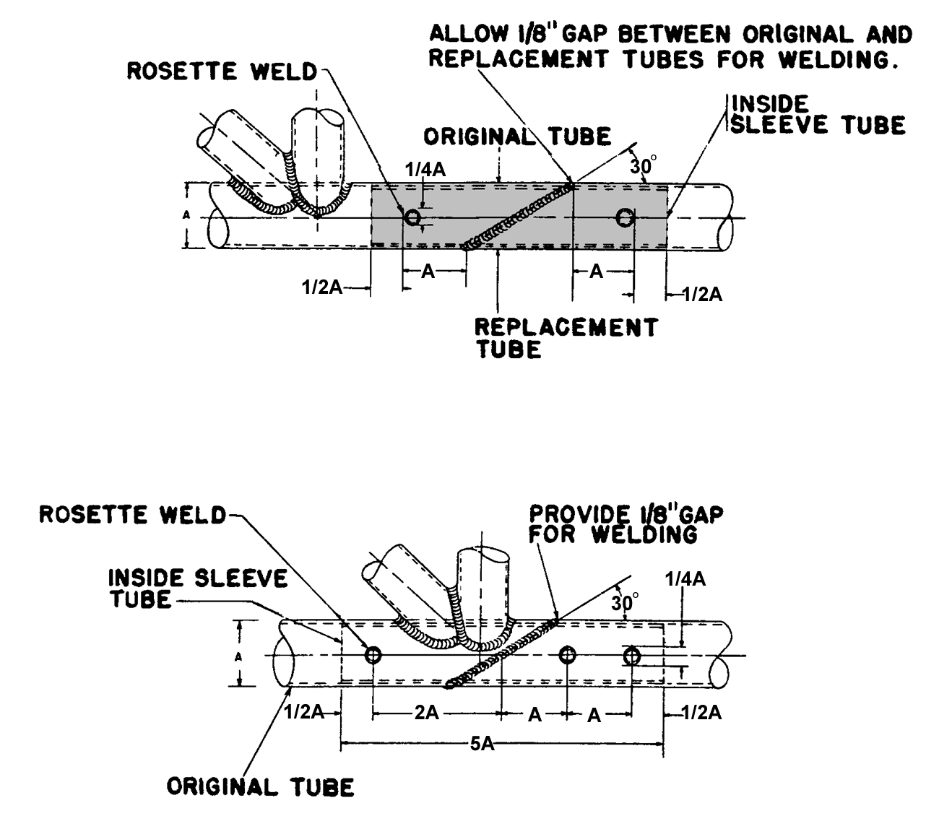
Figure 4-37. Splicing by inner-sleeve method.

SPLICING USING LARGER DIAMETER REPLACEMENT TUBES. The method of splicing structural tubes, as shown in figure 4-40, requires the least amount of cutting and welding. However, this splicing method cannot be used where the damaged tube is cut too near the adjacent cluster joints, or where bracket-mounting provisions make it necessary to maintain the same replacement tube diameter as the original. As an aid to installing the replacement tube, squarely cut the original damaged tube leaving a minimum short stub equal to 2-1/2-tube diameters on one end and a minimum long stub equal to 4-1/2-tube diameters on the other end. Select a length of steel tube of the same material and at least the same wall thickness, having an inside diameter approximately equal to the outside diameter of the damaged tube. Fit this replacement tube material snugly around the original tube with a maximum diameter difference of 1/16 inch. From this replacement tube material, cut a section of tubing diagonally (or fishmouth) of such a length that each end of the tube is a minimum distance of 1-1/2-tube diameters from the end of the cut on the original tube. Use a fishmouth cut replacement tube wherever possible. Deburr the edges of the replacement tube and original tube stubs. If a fishmouth cut is used, file out the sharp radius of the cut with a small round file.

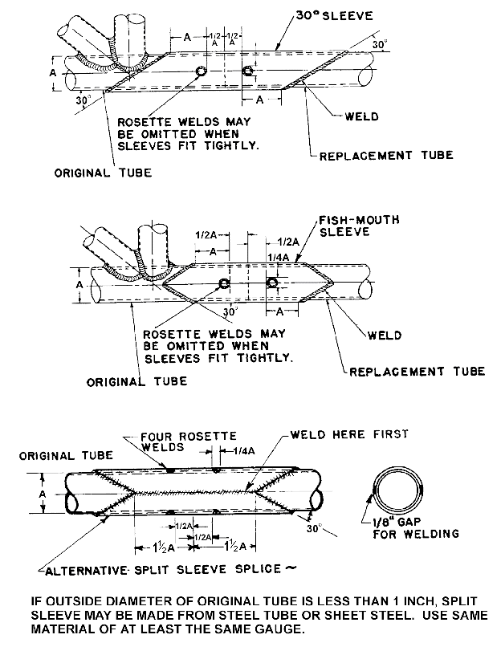
Figure 4-38. Splicing by outer-sleeve method (replacement by welded outside sleeve).

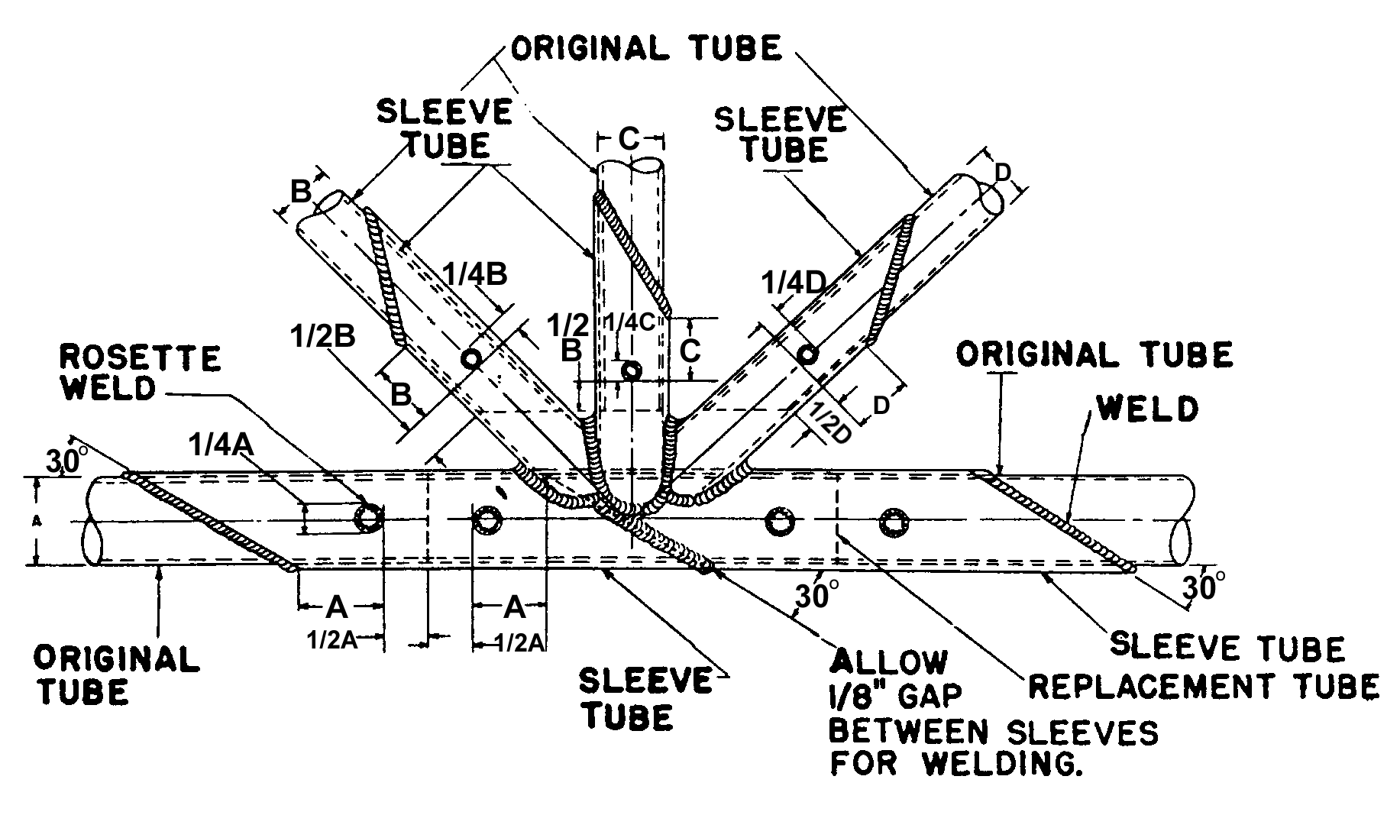
Figure 4-39. Tube replacement at a station by welded outer sleeves.

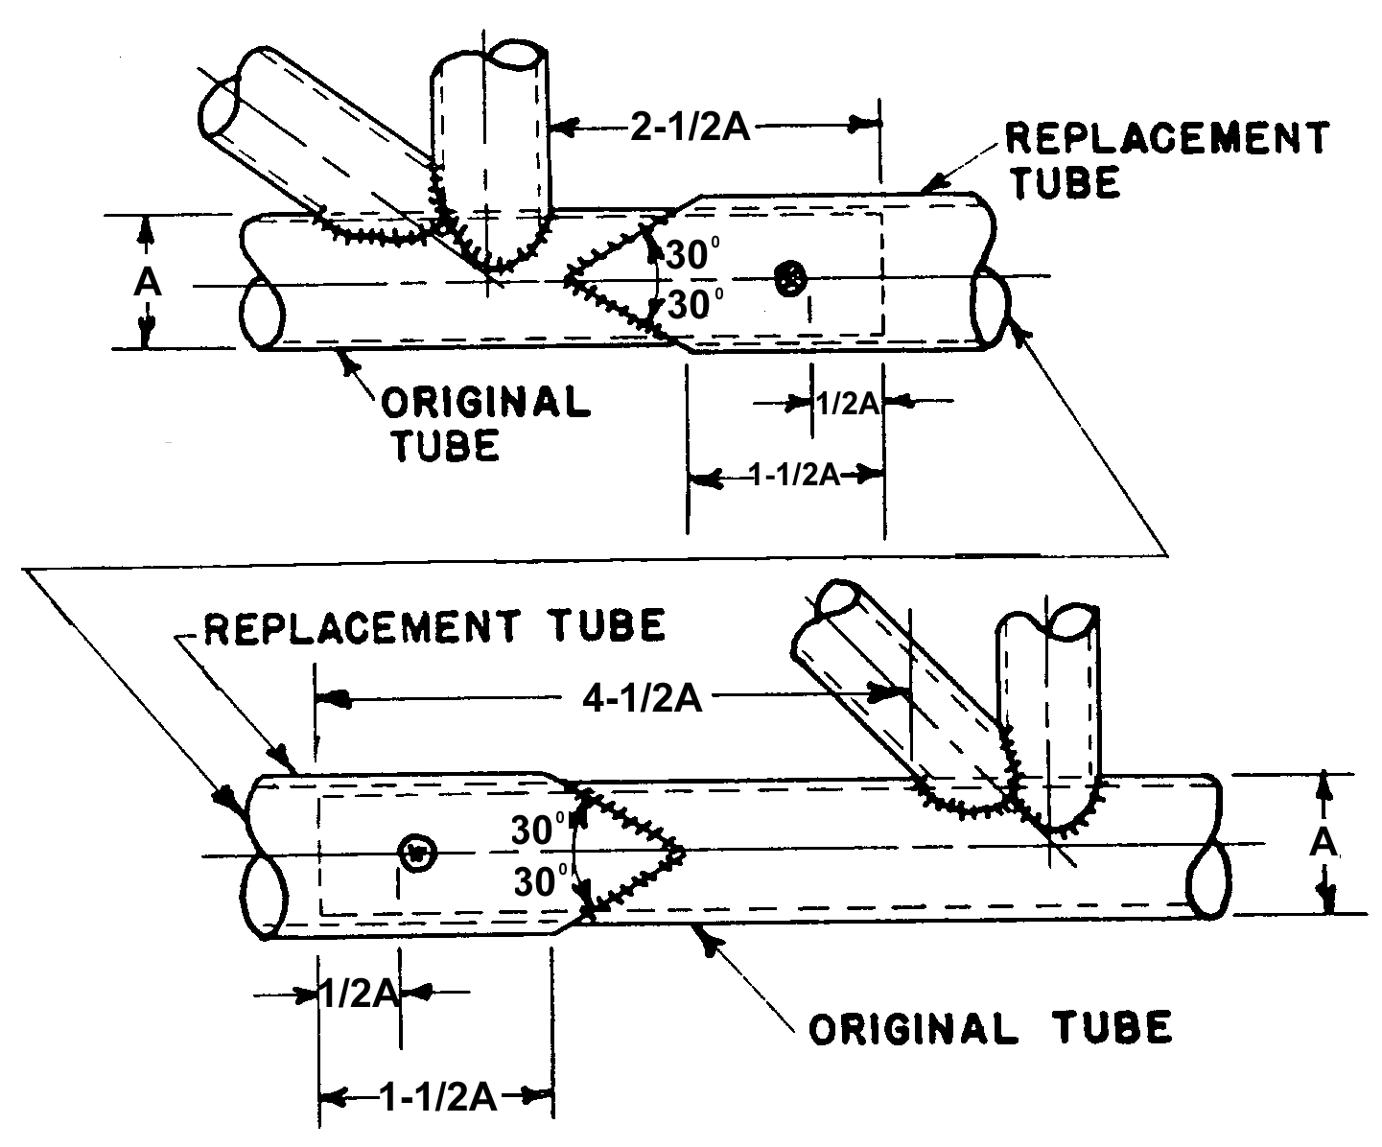
Figure 4-40. Splicing using larger diameter replacement tube.

Spring the long stub of the original tube from the normal position, slip the replacement tube over the long stub, and then back over the short stub. Center the replacement tube between the stubs of the original tube. Tack weld one end of the replacement tube in several places, then weld completely around the end. In order to prevent distortion, allow the weld to cool completely, then weld the remaining end of the replacement tube to the original tube.

REPAIRS AT BUILT-IN FUSELAGE FITTINGS. Make splices in accordance with the methods described in paragraphs 4-86 through 4-92. Repair built-in fuselage fittings in the manner shown in figure 4-41. The following paragraphs outline the different methods as shown in figure 4-41.

Tube of Larger Diameter Than Original. A tube (sleeve) of larger diameter than the original is used in the method shown in figure 4-41 (A). The forward splice is a 30-degree scarf splice. Cut the rear longeron (right) approximately 4 inches from the centerline of the joint and fit a 1 inch long spacer over the longeron, and edge weld this spacer and longeron. Make a tapered “V” cut approximately 2 inches long in the aft end of the outer sleeve, and swage the end of the outer sleeve to fit the longeron and weld.

Tube of Same Diameter as Original. In the method shown in figure 4-41 (B) the new section is the same size as the longeron
forward (left) of the fitting. The rear end (right) of the tube is cut at 30 degrees and forms the outside sleeve of the scarf splice. A sleeve is centered over the forward joint as indicated.

Simple Sleeve. In figure 4-41 (C), it is assumed the longeron is the same size on each side of the fitting. It is repaired by a sleeve of larger diameter than the longeron.

Large Difference in Longeron Diameter Each Side of Fitting. Figure 4-41 (D) assumes that there is 1/4-inch difference in the diameter of the longeron on the two sides of the fitting. The section of longeron forward (left) of the fitting is cut at 30 degrees, and a section of tubing of the same size as the tube and of such length as to extend well to the rear (right) of the fitting is slipped through it. One end is cut at 30 degrees to fit the 30-degree scarf at left, and the other end fishmouthed. This makes it possible to insert a tube of proper diameter to form an inside sleeve for the tube on the left of the fitting and an outside sleeve for the tube on the right of the fitting.

ENGINE-MOUNT REPAIRS. All welding on an engine mount must be of the highest quality, since vibration tends to accentuate any minor defect. Engine-mount members should preferably be repaired by using a larger diameter replacement tube, telescoped over the stub of the original member, and using fishmouth and rosette welds. However, 30-degree scarf welds in place of the fishmouth welds will be considered acceptable for engine-mount repair work.

Repaired engine mounts must be checked for accurate alignment. When tubes are used to replace bent or damaged ones, the original alignment of the structure must be maintained. When drawings are not available, this can be done by measuring the distance between points of corresponding members that have not been distorted.

Grind out all cracked welds.

Use only high-grade metallurgically controlled (mc) welding rods for engine-mount repairs.

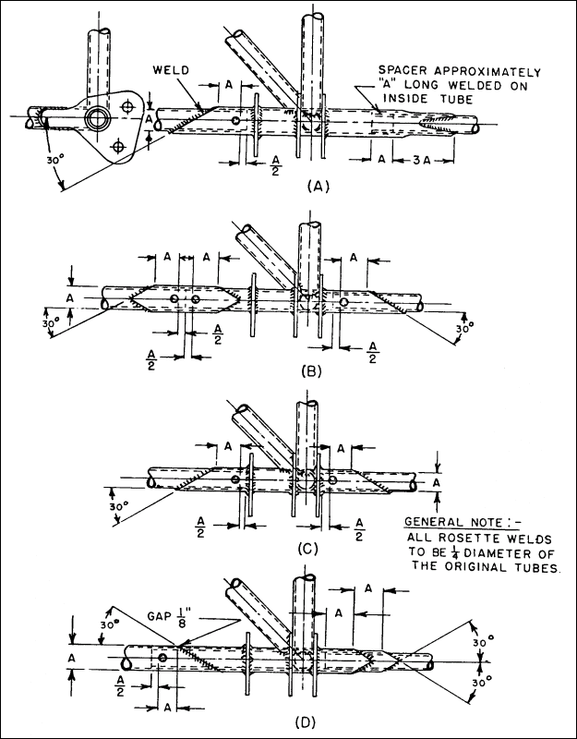
Figure 4-41. Repairs at built-in fuselage fittings.

If all members are out of alignment, reject the engine mount and replace with one supplied by the manufacturer or one which was built to conform to the manufacturer’s drawings. The method of checking the alignment of the fuselage or nacelle points should be requested from the manufacturer.

Repair minor damage, such as a crack adjacent to an engine-attachment lug, by rewelding the ring and extending a gusset or a mounting lug past the damaged area. Engine-mount rings which are extensively damaged must not be repaired, unless the method of repair is specifically approved by the FAA, or the repair is accomplished in accordance with FAA-approved instructions.

If the manufacturer stress relieved the engine mount after welding it, the engine mount should be re-stress relieved after the weld repairs are made.

BUILT-UP TUBULAR WING OR TAIL-SPARS. Repair built-up tubular wing or tail-spars by using any of the applicable splices and methods of repair shown in figure 4-35 through figure 4-45, provided the spars are not heat treated. In the case of heat-treated spars, the entire spar assembly would have to be reheat treated to the manufacturer’s specifications after completion of the repair. In general, this will be found less practicable than replacing the spar with one furnished by the manufacturer or holder of the PMA for the part.

WING-BRACE STRUTS AND TAIL-BRACE STRUTS. In general, it will be found advantageous to replace damaged wing-brace struts made either from rounded or streamlined tubing with new members purchased from the original manufacturer. However, there is no objection, from an airworthiness point of view, to repairing such members in a proper manner. An acceptable method of repair, if streamlined tubing is used, will be found in figure 4-43. Repair similar members made of round tubes using a standard splice, as shown in figure 4-35, figure 4-37, or figure 4-38.

Location of Splices. Steel-brace struts may be spliced at any point along the length of the strut provided the splice does not overlap part of an end fitting. The jury-strut attachment is not considered an end fitting; therefore, a splice may be made at this point. The repair procedure and workmanship minimize distortion due to welding and the necessity for subsequent straightening operations. Observe every repaired strut carefully during initial flights to ascertain that the vibration characteristics of the strut and attaching components are not adversely affected by the repair. A wide range of speed and engine-power combination must be covered during this check.

Fit and Alignment. When making repairs to wing and tail surface brace members, ensure to proper fit and alignment to avoid distortion.

LANDING GEAR REPAIR.

Round Tube Construction. Repair landing gears made of round tubing using standard repairs and splices as shown in figure 4-35 and figure 4-41.

Streamline Tube Construction. Repair landing gears made of streamlined tubing by either one of the methods shown in figure 4-42, figure 4-44, or figure 4-45.

Axle Assemblies. Representative types of repairable and nonrepairable landing gear axle assemblies are shown in figures 4-46 and 4-47. The types as shown in A, B, and C of this figure are formed from steel tubing and may be repaired by the applicable method

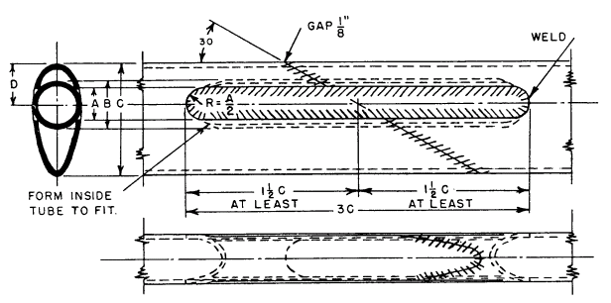
A- Slot Width (Original Tube).
B- Outside Diameter (Insert Tube).
C- Streamline Tube Length of Major Axis.
 | S.L. Size | A | B | C | D
 | 1” | .375 | .563 | 1.340 | .496
 | 1-¼ | .375 | .688 | 1.670 | .619
 | 1-½ | .500 | .875 | 2.005 | .743
 | 1-¾ | .500 | 1.000` | 2.339 | .867
 | 2 | .500 | 1.125 | 2.670 | .991
 | 2-¼ | .500 | 1.250 | 3.008 | 1.115
 | 2-½ | .500 | 1.375 | 3.342 | 1.239
ROUND INSERT TUBE (B) SHOULD BE AT LEAST OF SAME MATERIAL AND ONE GAUGE THICKER THAN ORIGINAL STREAMLINE TUBE (C).
Figure 4-42. Streamline tube splice using round tube (applicable to landing gear).

shown in figure 4-35 through figure 4-45. However, it will always be necessary to ascertain whether or not the members are heat treated. The axle assembly as shown in figure 4-47 is, in general, of a nonrepairable type for the following reasons.

The axle stub is usually made from a highly heat-treated nickel alloy steel and carefully machined to close tolerances. These stubs are usually replaceable and must be replaced if damaged.

The oleo portion of the structure is generally heat treated after welding, and is perfectly machined to ensure proper functioning of the shock absorber. These parts would be distorted by welding after machining.

REPAIRS TO WELDED assemblies. These repairs may be made by the following methods.

A welded joint may be repaired by cutting out the welded joint and replacing it with one properly gusseted. Standard splicing procedures should be followed.

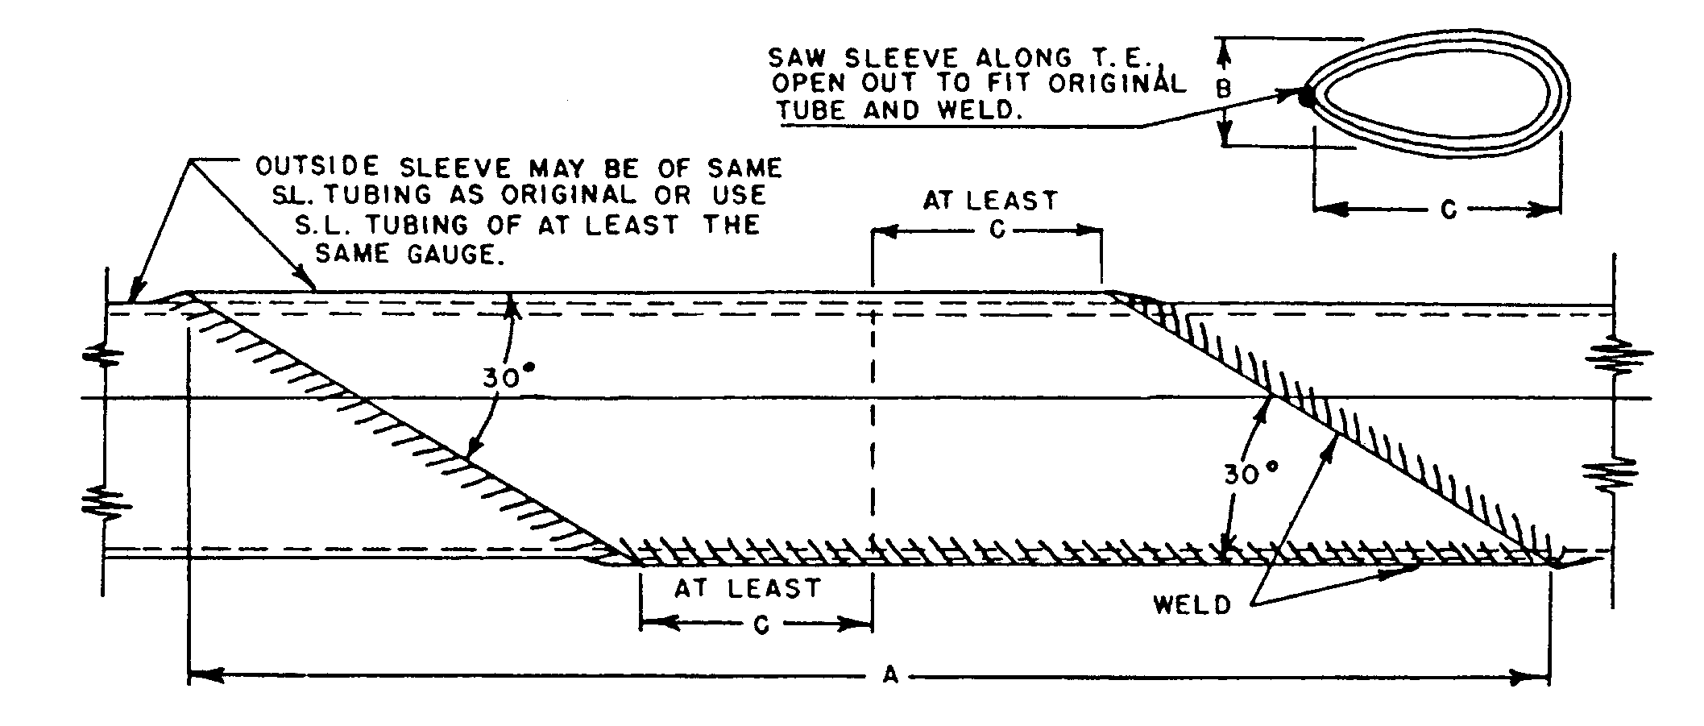

A- Minimum Length of Sleeve.
B- Streamline Tube Length of Minor Axis.
C- Streamline Tube Length of Major Axis.
 | S.L. Size | A | B | C
 | 1” | 7.324 | .572 | 1.340
 | 1-¼ | 9.128 | .714 | 1.670
 | 1-½ | 10.960 | .858 | 2.005
 | 1-¾ | 12.784 | 1.000 | 2.339
 | 2 | 14.594 | 1.144 | 2.670
 | 2-¼ | 16.442 | 1.286 | 3.008
 | 2-½ | 18.268 | 1.430 | 3.342
Figure 4-43. Streamline tube splice using split sleeve (applicable to wing and tail surface brace struts and other members).

Replacing weld deposit by chipping out the metal deposited by the welding process and rewelding after properly reinforcing the joint by means of inserts or external gussets.

STAINLESS STEEL STRUCTURE. Repair structural components made from stainless steel, particularly the “18-8” variety (18 percent chromium, 8 percent nickel), joined by spot welding, in accordance with the instructions furnished by the manufacturer, DER, or FAA. Substitution of bolted or riveted connections for spot-welded joints are to

be specifically approved by a DER or the FAA. Repair secondary structural and nonstructural elements such as tip bows or leading and trailing edge tip strips of wing and control surfaces by soldering with a 50-50 lead-tin solder or a 60-40 lead-tin solder. For best results, use a flux of phosphoric acid (syrup). Since the purpose of flux is to attack the metal so that the soldering will be effective, remove excess flux by washing the joint. Due to the high-heat conductivity of the stainless steel, use a soldering iron large enough to do the work properly.

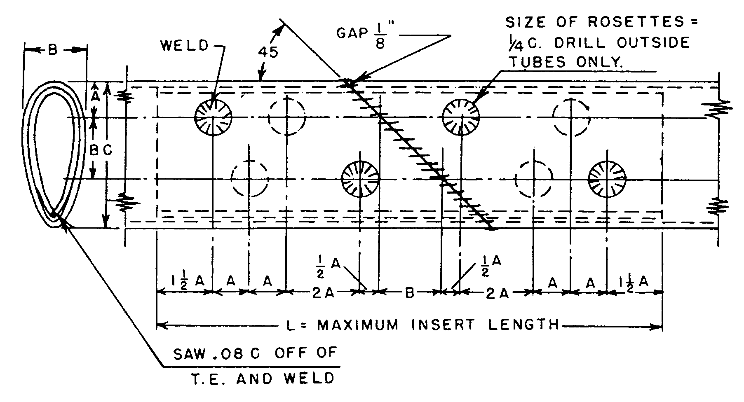
INSERT TUBE IS OF SAME STREAMLINE TUBING AS ORIGINAL.

A- Is ²/³ B.
B- Is Minor Axis Length of Original Streamline Tube.
C- Is Major Axis Length of Original Streamline Tube.
 | S.L. Size | A | B | C | L
 | 1” | .382 | .572 | 1.340 | 5.160
 | 1-¼ | .476 | .714 | 1.670 | 6.430
 | 1-½ | .572 | .858 | 2.005 | 7.720
 | 1-¾ | .667 | 1.000 | 2.339 | 9.000
 | 2 | .763 | 1.144 | 2.670 | 10.300
 | 2-¼ | .858 | 1.286 | 3.008 | 11.580
 | 2-½ | .954 | 1.430 | 3.342 | 12.880
Figure 4-44. Streamline tube splice using split insert (applicable to landing gear).

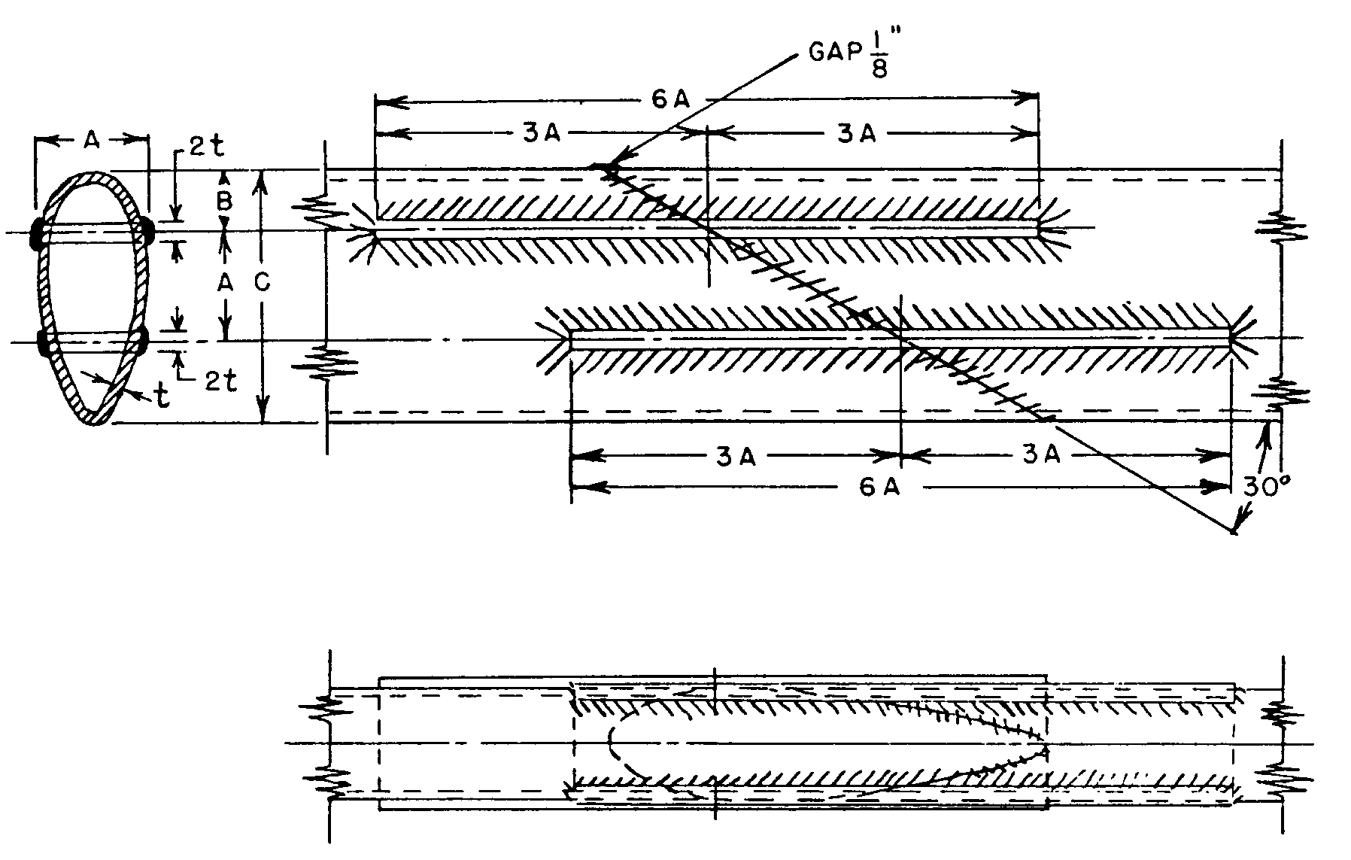
A- Streamline Tube Length of Minor Axis, Plate Widths.
B- Distance of First Plate From Leading Edge, ²/³ A.
C- Streamline Tube Length of Major Axis.
 | S.L. Size | A | B | C | 6A
 | 1” | .572 | .382 | 1.340 | 3.430
 | 1-¼ | .714 | .476 | 1.670 | 4.280
 | 1-½ | .858 | .572 | 2.005 | 5.150
 | 1-¾ | 1.000 | .667 | 2.339 | 6.000
 | 2 | 1.144 | .762 | 2.670 | 6.860
 | 2-¼ | 1.286 | .858 | 3.008 | 7.720
 | 2-½ | 1.430 | .954 | 3.342 | 8.580
Figure 4-45. Streamline tube splice using plates (applicable to landing gear).

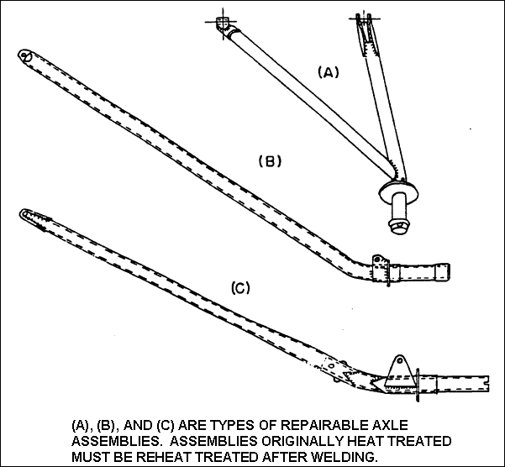
Figure 4-46. Representative types of repairable axle assemblies.

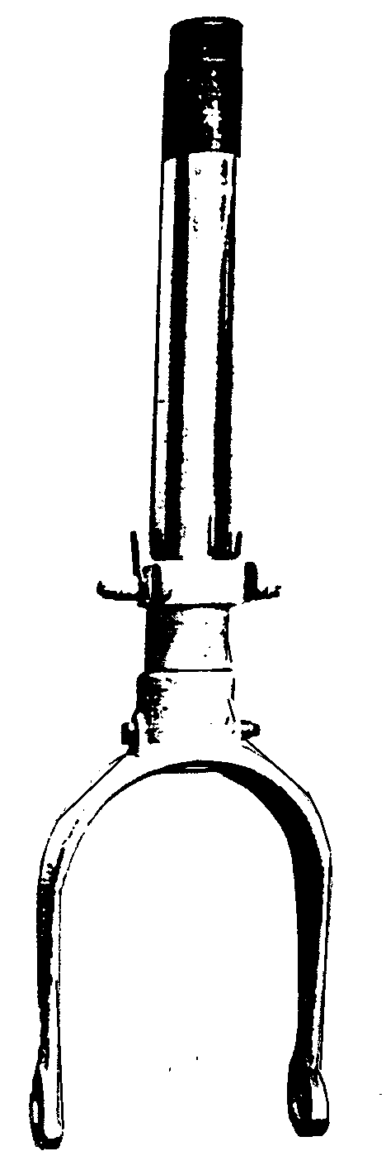

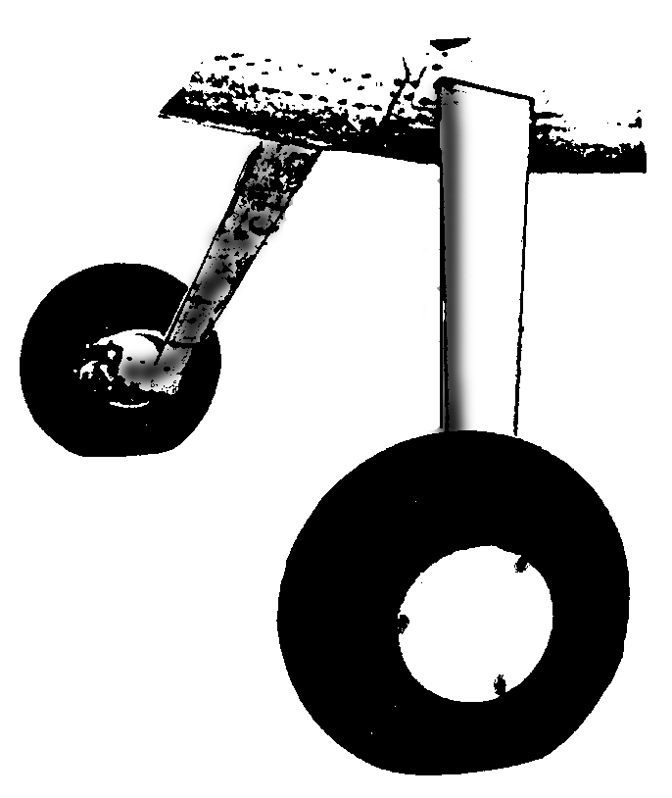
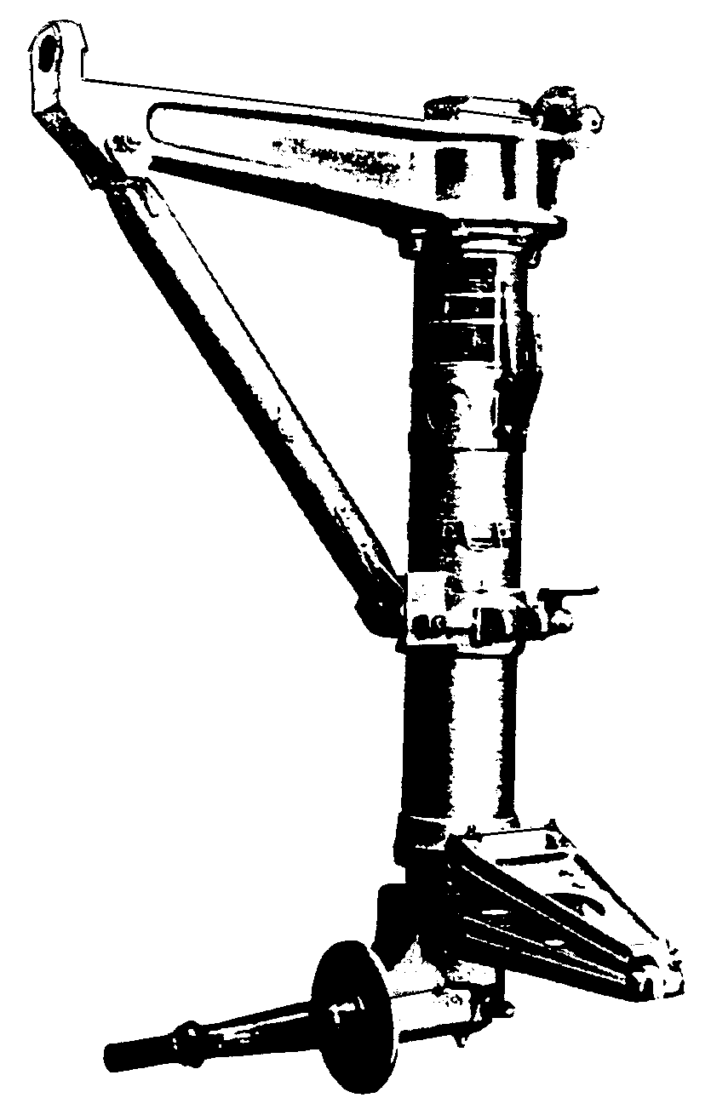

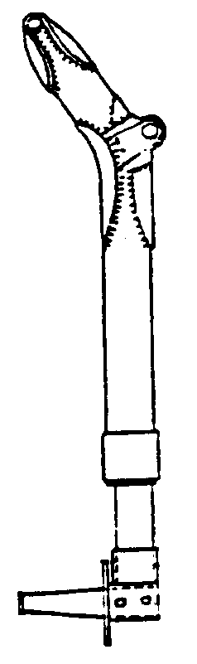

Figure 4-47. Landing gear assemblies that cannot be repaired by welding.

4-105.⎯4-110. [RESERVED.]

