Section 2. VISUAL INSPECTION

GENERAL. Visual inspection is the oldest and most common form of NDI for aircraft. Approximately 80 percent of all NDI procedures are accomplished by the direct visual methods. This inspection procedure may be greatly enhanced by the use of appropriate combinations of magnifying instruments, borescopes, light sources, video scanners, and other devices discussed in this AC. Visual inspection provides a means of detecting and examining a wide variety of component and material surface discontinuities, such as cracks, corrosion, contamination, surface finish, weld joints, solder connections, and adhesive disbonds. Visual inspection is widely used for detecting and examining aircraft surface cracks, which are particularly important because of their relationship to structural failures. Visual inspection is frequently used to provide verification when defects are found initially using other NDI techniques. The use of optical aids for visual inspection is beneficial and recommended. Optical aids magnify defects that cannot be seen by the unaided eye and also permit visual inspection in inaccessible areas.

SIMPLE VISUAL INSPECTION AIDS. It should be emphasized that the eye-mirror-flashlight is a critical visual inspection process. Aircraft structure and components that must be routinely inspected are frequently located beneath skin, cables, tubing, control rods, pumps, actuators, etc. Visual inspection aids such as a powerful flashlight, a mirror with a ball joint, and a 2 to 10 power magnifying glass are essential in the inspection process.

Flashlights. Flashlights used for aircraft inspection should be suitable for industrial use and, where applicable, safety approved by the Underwriters Laboratory or

equivalent agency as suitable for use in hazardous atmospheres such as aircraft fuel tanks. Military Specification MIL-F-3747E, flashlights: plastic case, tubular (regular, explosion-proof, explosion-proof heat resistant, traffic directing, and inspection-light), provides requirements for flashlights suitable for use in aircraft inspection. However, at the present time, the flashlights covered by this specification use standard incandescent lamps and there are no standardized performance tests for flashlights with the brighter bulbs: Krypton, Halogen, and Xenon. Each flashlight manufacturer currently develops its tests and provides information on its products in its advertising literature. Therefore, when selecting a flashlight for use in visual inspection, it is sometimes difficult to directly compare products. The following characteristics should be considered when selecting a flashlight: foot-candle rating; explosive atmosphere rating; beam spread (adjustable, spot, or flood); efficiency (battery usage rate); brightness after extended use; and rechargeable or standard batteries. (If rechargeable, how many hours of continuous use and how long is required for recharging?) If possible, it would be best to take it apart and inspect for quality of construction and to actually use the flashlight like it would be used in the field. Inspection flashlights are available in several different bulb brightness levels:

Standard incandescent (for long-battery life).

Krypton (for 70 percent more light than standard bulbs).

Halogen (for up to 100 percent more light than standard bulbs).

Xenon (for over 100 percent more light than standard bulbs).

Inspection Mirrors. An inspection mirror is used to view an area that is not in the normal line of sight. The mirror should be of the appropriate size to easily view the component, with the reflecting surface free of dirt, cracks, worn coating, etc., and a swivel joint tight enough to maintain its setting.

Simple Magnifiers. A single converging lens, the simplest form of a microscope, is often referred to as a simple magnifier. Magnification of a single lens is determined by the equation M = 10/f. In this equation, “M” is the magnification, “f” is the focal length of the lens in inches, and “10” is a constant that represents the average minimum distance at which objects can be distinctly seen by the unaided eye. Using the equation, a lens with a focal length of 5 inches has a magnification of 2, or is said to be a two-power lens.

BORESCOPES. These instruments are long, tubular, precision optical instruments with built-in illumination, designed to allow remote visual inspection of internal surfaces or otherwise inaccessible areas. The tube, which can be rigid or flexible with a wide variety of lengths and diameters, provides the necessary optical connection between the viewing end and an objective lens at the distant, or distal tip of the borescope. Rigid and flexible borescopes are available in different designs for a variety of standard applications and manufacturers also provide custom designs for specialized applications. Figure 5-1 shows three typical designs of borescopes.

Borescopes Uses. Borescopes are used in aircraft and engine maintenance programs to reduce or eliminate the need for costly tear-downs. Aircraft turbine engines have access ports that are specifically designed for borescopes. Borescopes are also used extensively in a variety of aviation maintenance programs to determine the airworthiness of difficult-to-reach components. Borescopes

typically are used to inspect interiors of hydraulic cylinders and valves for pitting, scoring, porosity, and tool marks; inspect for cracked cylinders in aircraft reciprocating engines; inspect turbojet engine turbine blades and combustion cans; verify the proper placement and fit of seals, bonds, gaskets, and sub-assemblies in difficult to reach areas; and assess Foreign Object Damage (FOD) in aircraft, airframe, and powerplants. Borescopes may also be used to locate and retrieve foreign objects in engines and airframes.

Optical Designs. Typical designs for the optical connection between the borescope viewing end and the distal tip are:

A rigid tube with a series of relay lenses;

A flexible or rigid tube with a bundle of optical fibers; and

A flexible or rigid tube with wiring that carries the image signal from a Charge Couple Device (CCD) imaging sensor at the distal tip.

These designs can have either fixed or adjustable focusing of the objective lens at the distal tip. The distal tip may also have prisms and mirrors that define the direction and field of view. A fiber optic light guide with white light is generally used in the illumination system, but ultraviolet light can also be used to inspect surfaces treated with liquid fluorescent penetrant or to inspect for contaminants that fluoresce. Some borescopes with long working lengths use light-emitting diodes at the distal tip for illumination.

VISUAL INSPECTION PROCEDURES. Corrosion can be an extremely critical defect. Therefore, NDI personnel should be familiar with the appearance of common types of corrosion and have training and

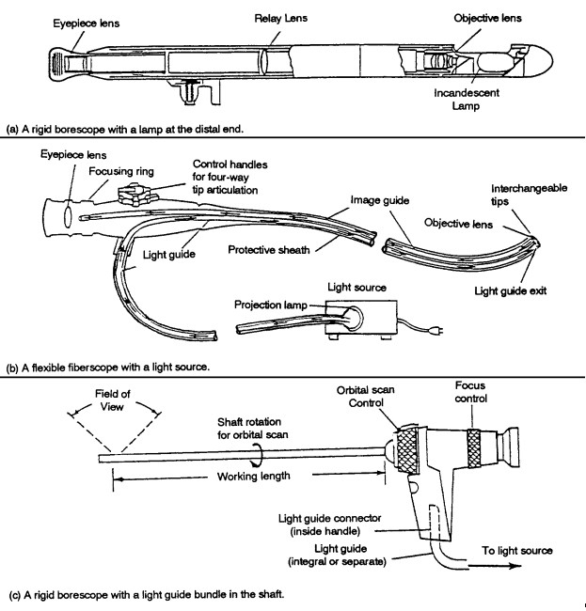
Figure 5-1. Typical borescope designs.

experience on corrosion detection on aircraft structure and engine materials. (Reference: AC 43-4A, Corrosion Control for Aircraft, for additional information on corrosion.

Preliminary Inspection. Perform a preliminary inspection of the overall general area for cleanliness, presence of foreign objects, deformed or missing fasteners, security

of parts, corrosion, and damage. If the configuration or location of the part conceals the area to be inspected, use visual aids such as a mirror or borescope.

Corrosion Treatment. Treat any corrosion found during preliminary inspection after completing a visual inspection of any selected part or area.

NOTE: Eddy current, radiography, or ultrasonic inspection can determine the loss of metal to corrosion.

Lighting. Provide adequate lighting to illuminate the selected part or area.

Personal Comfort. Personal comfort (temperature, wind, rain, etc.) of the inspector can be a factor in visual inspection reliability.

Noise. Noise levels while conducting a visual inspection are important. Excessive noise reduces concentration, creates tension, and prevents effective communication. All these factors will increase the likelihood of errors.

Inspection Area Access. Ease of access to the inspection area has been found to be of major importance in obtaining reliable visual inspection results. Access consists of the act of getting into an inspection position (primary access) and doing the visual inspection (secondary access). Poor access can affect the inspector’s interpretation of discontinuities, decision making, motivation, and attitude.

Precleaning. Clean the areas or surface of the parts to be inspected. Remove any contaminates that might hinder the discovery of existing surface indications. Do not remove the protective finish from the part or area prior to inspection. Removal of the finish may be required at a later time if other NDI techniques are required to verify any visual indications of flaws that are found.

Inspection. Carefully inspect the area for discontinuities, using optical aids as

required. An inspector normally should have available suitable measuring devices, a flashlight, and a mirror.

Surface cracks. When searching for surface cracks with a flashlight, direct the light beam at a 5 to 45 degree angle to the inspection surface, towards the face. (See figure 5-2.) Do not direct the light beam at such an angle that the reflected light beam shines directly into the eyes. Keep the eyes above the reflected light beam during the inspection. Determine the extent of any cracks found by directing the light beam at right angles to the crack and tracing its length. Use a 10-power magnifying glass to confirm the existence of a suspected crack. If this is not adequate, use other NDI techniques, such as penetrant, magnetic particle, or eddy current to verify cracks.

Other surface discontinuities. Inspect for other surface discontinuities, such as: discoloration from overheating; buckled, bulging, or dented skin; cracked, chafed, split, or dented tubing; chafed electrical wiring; de-laminations of composites; and damaged protective finishes.

Recordkeeping. Document all discrepancies by written report, photograph, and/or video recording for appropriate evaluation. The full value of visual inspection can be realized only if records are kept of the discrepancies found on parts inspected. The size and shape of the discontinuity and its location on the part should be recorded along with other pertinent information, such as rework performed or disposition. The inclusion on a report of some visible record of the discontinuity makes the report more complete.
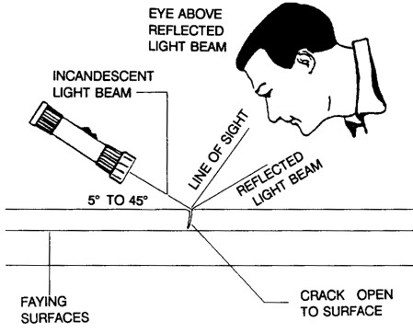
Figure 5-2. Using a flashlight to inspect for cracks.

5-19.⎯5-24. [RESERVED.]

