Section 4. MAGNETIC PARTICLE INSPECTION

GENERAL. Magnetic particle inspection is a method for detecting cracks, laps, seams, voids, pits, subsurface holes, and other surface, or slightly subsurface, discontinuities in ferro-magnetic materials. Magnetic particle inspection can be used only on ferro-magnetic materials (iron and steel). It can be performed on raw material, billets, finished and semi-finished materials, welds, and in-service assembled or disassembled parts. Magnetic particles are applied over a surface either dry, as a powder, or wet, as particles in a liquid carrier such as oil or water.

Common uses for magnetic particle inspection are; final inspection, receiving inspection, in-process inspection; and quality control, maintenance, and overhaul.

PRINCIPLES OF OPERATION. Magnetic particle inspection uses the tendency of magnetic lines of force, or flux, of an applied field to pass through the metal rather than through the air. A defect at or near the metal’s surface distorts the distribution of the magnetic flux and some of the flux is forced to pass out through the surface. (See figure 5-9.) The field strength is increased in the area of the defect and opposite magnetic poles form on either side of the defect. Fine magnetic particles applied to the part are attracted to these regions and form a pattern around the defect. The pattern of particles provides a visual indication of a defect. (See figure 5-10.)

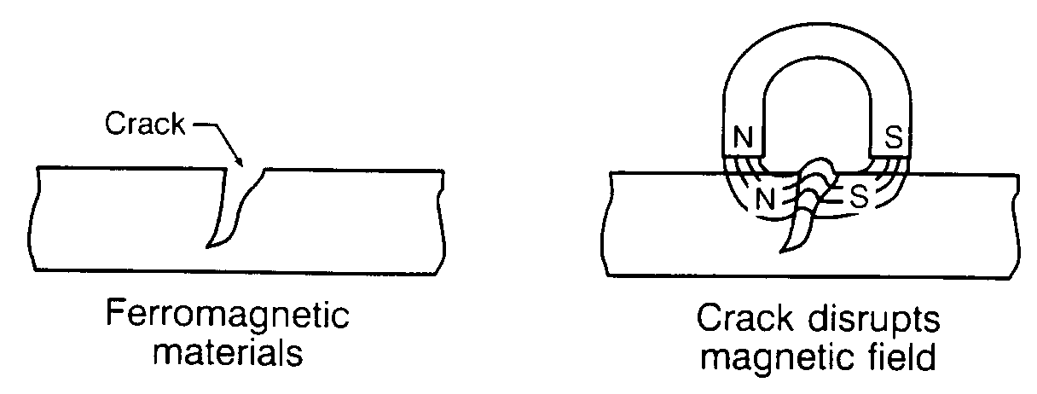
Figure 5-9. Magnetic field disrupted.
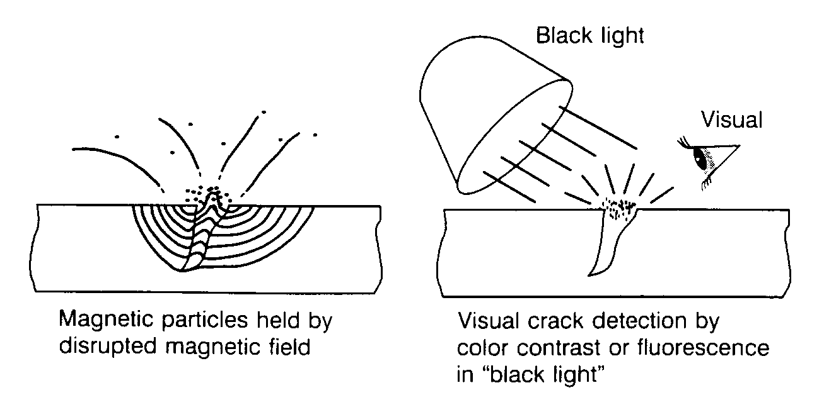
Figure 5-10. Crack detection by magnetic particle inspection.

To locate a defect, it is necessary to control the direction of magnetization, and flux lines must be perpendicular to the longitudinal axes of expected defects. Examination of critical areas for defects may require complete disassembly. Two methods of magnetization, circular and longitudinal, are used to magnetize the part and induce perpendicular flux paths. Parts of complex configuration may require local magnetization to ensure proper magnetic field direction and adequate removal of surface coatings, sealants, and other similar compounds. Possible adverse influence of the applied or residual magnetic fields on delicate parts such as instruments, bearings, and mechanisms may require removal of these parts before performing the inspection.

Certain characteristics inherent in the magnetic particle method may introduce errors in examination results. Nonrelevant errors are caused by magnetic field distortions due to intentional design features, such as:

Sharp radii, less than 0.10 inch radius, in fillets;

Thread roots, keyways, and drilled holes; and

Abrupt changes in geometry or in magnetic properties within the part.

Operators must understand nonrelevant error indications and recognize them during examination. Proper analysis of indications in these regions will require considerable skill and experience, and supplemental methods may be required before a final evaluation can be made. Special techniques for examination of these areas are given in subsequent paragraphs.

APPLICATIONS. Use magnetic particle inspection on any well-cleaned surface that is accessible for close visual examination. Typical parts deserving magnetic particle examination are: steel fasteners and pins; critical structural elements; linkages; landing gear components; splice and attach fittings; and actuating mechanisms.

During field repair operations, disassembly is often not necessary, except when the parts have critical areas or delicate installed components. However, for overhaul operations, a more thorough and critical examination may be obtained with stationary equipment in a shop environment with completely disassembled, and thoroughly cleaned and stripped parts.

Magnetic rubber examination material is useful for in-field service examinations of fastener holes in areas where the accessibility is limited or restricted, where particle suspensions may cause unwanted contamination, when a permanent record is desired, and when the examination area cannot be observed visually.

ELECTRICAL MAGNETIZING EQUIPMENT. Stationary equipment in the range of 100 to 6000 amperes is normal for use within the aerospace industry for overhaul operations. Mobile equipment with similar amperage outputs is available for field examination of heavy structures, such as landing gear cylinders and axles. Small parts and local

areas of large components can be adequately checked with the use of small, inexpensive permanent magnets or electromagnetic yokes. In procuring magnetizing equipment, the maximum rated output should be greater than the required examination amperage. Actual current flow through a complex part may be reduced as much as 20 percent by the resistance load of the rated output.

MATERIALS USED IN MAGNETIC PARTICLE INSPECTION. The particles used in magnetic particle inspection are finely divided ferro-magnetic materials that have been treated with color or fluorescent dyes to improve visibility against the various surface backgrounds of the parts under inspection. Magnetic particles, particle-suspension vehicles, and cleaners are required for conducting magnetic particle inspection. Requirements for magnetic particle inspection materials, other than cleaners, are contained
in the aerospace industry standard, ASTM-E1444, Inspection, Magnetic Particle (as revised). A certification statement which will certify that the material meets applicable specification requirements will generally be received when a magnetic particle inspection material is purchased. Magnetic particle inspection materials for use on a specific part or component will generally be specified by the aircraft or component manufacturer or the FAA in documents such as; maintenance or overhaul manuals, AD’s, SSID’s, or manufacturer’s SB’s. However, if the magnetic particle inspection materials are not specified for the specific part or component to be inspected, it is recommended that personnel use materials meeting the aircraft or component manufacturers’ specifications or materials meeting the requirements of ASTM-E1444. Other FAA engineering-approved materials may also be used. Table 5-2 provides a partial listing of commonly accepted standards and specifications for magnetic particle inspection.

Table 5-2. Listing of commonly accepted standards and specifications for magnetic particle inspection.
NUMBER | TITLE
ASTM STANDARDS  ASTM A275/A275 M-96  ASTM A456/A456 M Rev. A.  ASTM D96  ASTM E125-63 (1993)  ASTM E1316-95C | Standard Test Method for Magnetic Particle Examination of Steel Forgings. 1995  Standard Specification for Magnetic Particle Examination of Large Crankshaft Forgings. 1995  Standard Test Methods for Water and Sediment in Crude Oils by Centrifuge Method (Field Procedure). 1988  Standard Reference Photographs for Magnetic Particle Indications on Ferrous Castings. (Revised 1993) 1963  Standard Terminology for Nondestructive Examination. 1995 (Replaces ASTM E269).
SAE-AMS  SPECIFICATIONS  AMS 2300G  MAM 2300A  AMS 2303C  MAM 2303A  AMS 2641  AMS 3040B  AMS 3041B  AMS 3042B  AMS 3043A  AMS 3044C  AMS 3045B  AMS 3046B | Premium Aircraft-Quality Steel Cleanliness Magnetic Particle Inspection Procedure. 1991 (Revised 1995)  Premium Aircraft Quality Steel Cleanliness Magnetic Particle Inspection Procedure Metric (SI) Measurement. 1992  Aircraft Quality Steel Cleanliness Martensitic Corrosion Resistant Steels Magnetic Particle Inspection Procedure. 1993  Aircraft Quality Steel Cleanliness Martensitic Corrosion Resistant Steels Magnetic Particle Inspection Procedure Metric (SI) Measurement. 1993  Vehicle, Magnetic Particle Inspection Petroleum Base. 1988  Magnetic Particles, Nonfluorescent, Dry Method. 1995  Magnetic Particles, Nonfluorescent, Wet Method, Oil Vehicle, Ready-To-Use. 1988  Magnetic Particles, Nonfluorescent, Wet Method, Dry Powder. 1988  Magnetic Particles, Nonfluorescent, Wet Method, Oil Vehicle, Aerosol Packaged. 1988  Magnetic Particles, Fluorescent, Wet Method, Dry Powder. 1989  Magnetic Particles, Fluorescent, Wet Method, Oil Vehicle Ready-to-Use. 1989  Magnetic Particles, Fluorescent, Wet Method, Oil Vehicle, Aerosol Packaged. 1989
U.S. GOVERNMENT  SPECIFICATIONS  DOD-F-87935  Mil-Std-271F  Mil-Std-410E  MIL-HDBK-728/1  MIL-HDBK-728/4A | Fluid, Magnetic Particle Inspection, Suspension. 1993  Requirements for Nondestructive Testing Methods. 1993  Nondestructive Testing Personnel Qualifications and Certifications. 1991  Nondestructive Testing. 1985  Magnetic Particle Testing. 1993
OTHER PUBLICATIONS  SNT-TC-1A  ATA No. 105  ASM Handbook,  Volume 17 | American Society for Nondestructive Testing. Recommended Practice . 1992 (Personnel Qualification and Certification in Nondestructive Testing and Recommended Training Courses) Note: Updated every 4 years - 1996 edition due in early 1997.  Air Transport Association of America. Guidelines for Training and Qualifying Personnel in Nondestructive Testing Methods, (Revision 4 1993)  Nondestructive Evaluation and Quality Control. 1989

PREPARATION OF SURFACE.

Remove protective coatings according to the manufacturer’s instructions if necessary. Unless otherwise specified, magnetic particle examination should not be performed with coatings in place that could prevent the detection of surface defects in the ferro-magnetic substrate. Such coatings include paint or chromeplate thicker than 0.003 inch, or ferro-magnetic coatings such as electroplated nickel thicker than 0.001 inch.

Parts should be free of grease, oil, rust, scale, or other substances which will interfere with the examination process. If required, clean by vapor degrease, solvent, or abrasive means per the manufacturer’s instructions. Use abrasive cleaning only as necessary to completely remove scale or rust. Excessive blasting of parts can affect examination results.

Exercise extreme care to prevent any cleaning material or magnetic particles from becoming entrapped where they cannot be removed. This may require extracting components such as bushings, bearings, or inserts from assemblies before cleaning and magnetic particle examination.

A water-break-free surface is required for parts to be examined by water suspension methods. If the suspension completely wets the surface, this requirement is met.

Magnetic particle examination of assembled bearings is not recommended because the bearings are difficult to demagnetize. If a bearing cannot be removed, it should be protected from the magnetic particle examination materials and locally magnetized with a magnetic yoke to limit the magnetic field across the bearing.

METHODS OF EXAMINATION. Magnetic particle examination generally consists of: the application of magnetic particles; magnetization; determination of field strength; special examination techniques; and demagnetization and post-examination cleaning. Each of these steps will be described in the following paragraphs.

APPLICATION OF MAGNETIC PARTICLES. The magnetic particles used can be nonfluorescent or fluorescent (dependent on the examination required) and are applied suspended in a suitable substance. Fluorescent particles are preferred due to their higher sensitivity.

Wet Continuous Method. Unless otherwise specified, use only the wet continuous method. In the wet continuous method, the particle suspension is liberally applied to wet all surfaces of the part. The magnetizing current is applied at the instant the suspension is diverted from the part. Apply two shots of magnetizing current, each at least 1/2 second long.

Wet suspensions of fluorescent particles, either in water or oil, should be used for most overhaul and in-service examinations except where the material, size, or shape of the part prohibits its use.

Water, with a suitable rust inhibitor and wetting agent, may be used as a liquid vehicle, provided that magnetic examination equipment is designed for use or is satisfactorily converted for use with water.

Dry Continuous Method. This method is not recommended for use on aerospace components because of its lower sensitivity level.

Residual Magnetization Method. In this method, the part is magnetized and the magnetizing current is then cut off. If the amperage has been correctly calculated and quality indicator has verified the technique, then one shot will correctly magnetize the part. The magnetic particles are applied to the part after the magnetization. This method is dependent upon the retentiveness of the part, the strength of the applied field, the direction of magnetization, and the shape of the part.

MAGNETIZATION.

Circular. Circular magnetization is induced in the part by the central-conductor method or the direct-contact method. (See figure 5-11.)

Indirect Induction (central-conduc-tor method). Pass the current through a central conductor that passes through the part. When several small parts are examined at one time, provide sufficient space between each

piece to permit satisfactory coverage (with particles), magnetization, and examination.

Direct Induction (contact method). Pass current through the part mounted horizontally between contact plates. As an example, circular magnetization of a round steel bar would be produced by placing the ends of the steel bar between the heads of the magnetic inspection machine and passing a current through the bars. Magnetic particles applied either during or after passage of the current, or after passage of the current in magnetically-retentive steels, would disclose discontinuities parallel to the axis of the bar.

NOTE: Exercise extreme caution to prevent burning of the part at the electrode contact areas. Some causes of overheating and arcing are: insufficient contact area, insufficient contact pressure, dirty or coated contact areas, electrode removal during current flow, and too high an amperage setting.

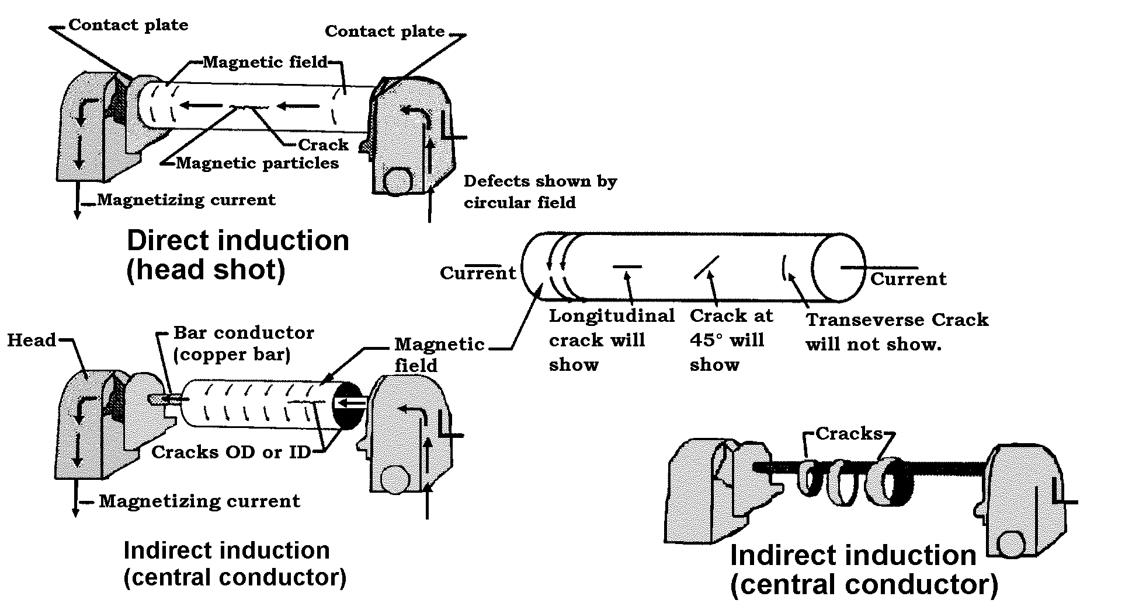
Figure 5-11. Circular magnetization.

Longitudinal. Longitudinal magnetization is induced in a part by placing the part in a strong magnetic field, such as the center of a coil or between the poles of an electromagnetic yoke. (See figure 5-12.) When using a coil, optimum results are obtained when the following conditions are met.

The part to be examined is at least twice as long as it is wide.

The long axis of the part is parallel to the axis of the coil opening.

The area of the coil opening is at least 10 times the cross-sectional areas of the part.

The part is positioned against the inner wall of the coil.

Three to five turns are employed for hand-held coils formed with cables.

For the 10-to-1 fill factor, the effective region of inspection is 1 coil radius on either side of the coil with 10 percent overlap. (Refer to ASTME-1444.)

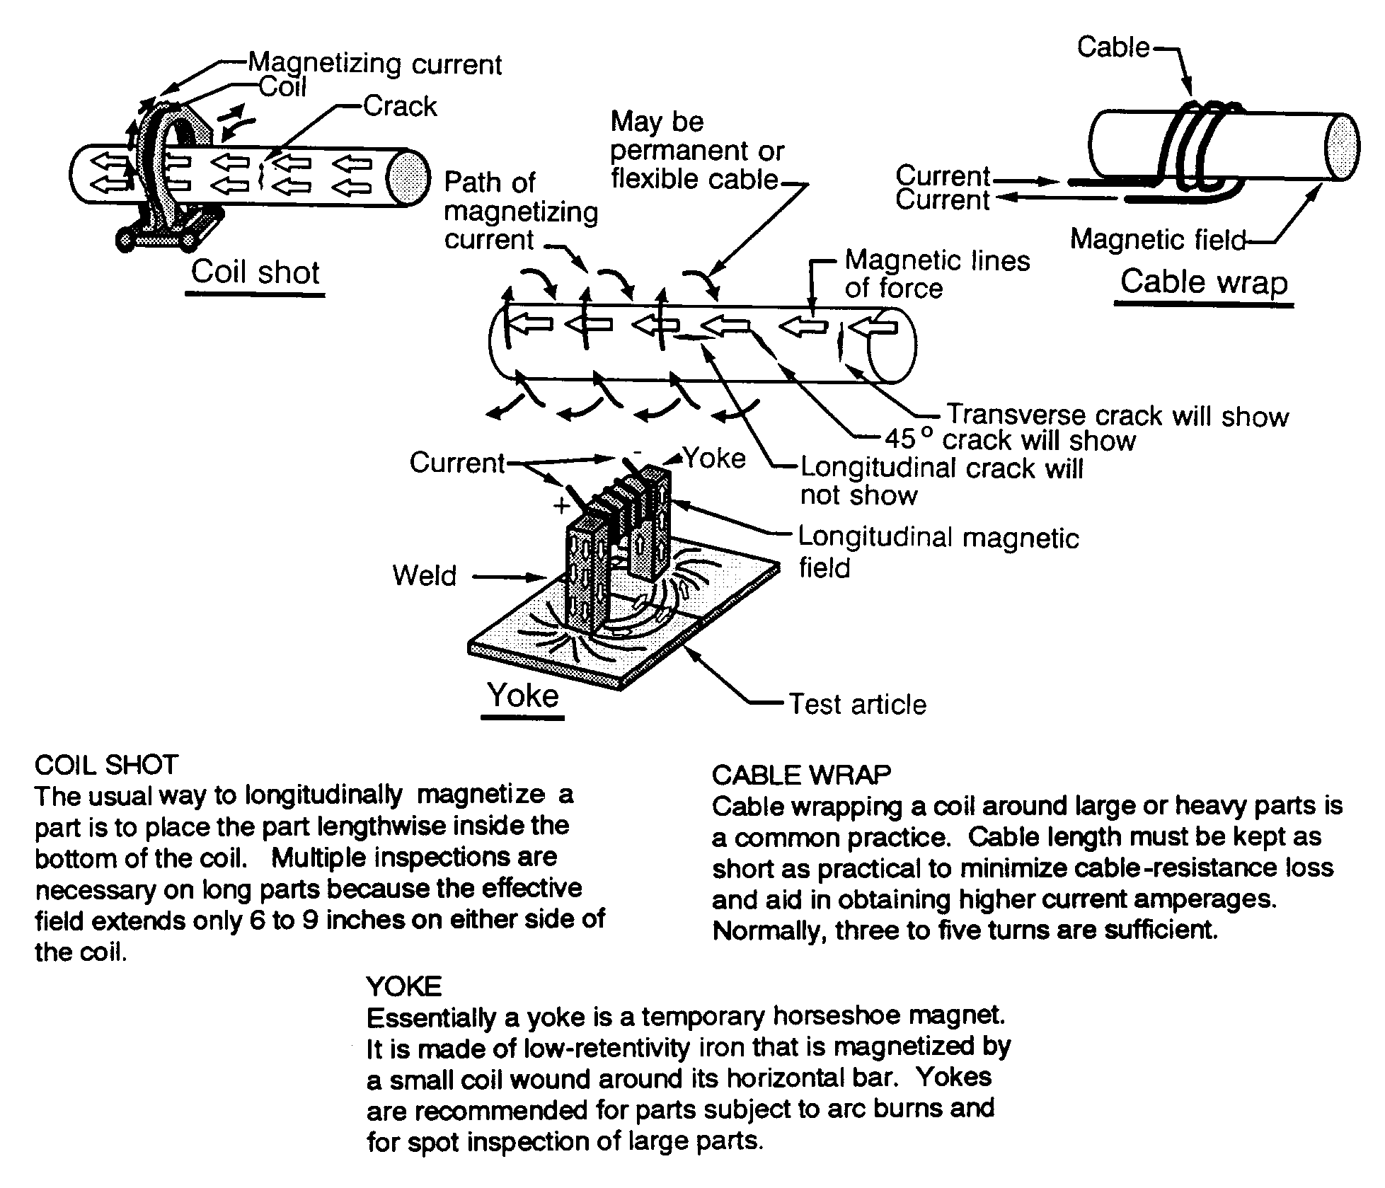
Figure 5-12. Longitudinal magnetization.

The intensity of the longitudinal shots is kept just below the level at which leakage fields develop across sharp changes of section, such as radii under bolt heads, threads,
and other sharp angles in parts. This does not apply when checking chrome-plated parts for grinding cracks.

For example, longitudinal magnetization of a round steel bar would be produced by placing the DC coil around the bar. After application of the magnetic particles, either during or subsequent to magnetization, discontinuities perpendicular to the longitudinal axis of the bar would be disclosed.

When a yoke is used, the portion of the part between the ends of the yoke completes the path of the magnetic lines of force. This results in a magnetic field between the points of contact.

Permanent Magnets and Electromagnetic Yoke. The stability of the magnetic field generated by permanent magnets requires some agitation of the oxide particles within the field. The wet method is considered most satisfactory. Use a well-agitated plastic squirt bottle for the most effective application of the magnetic particle suspension. When the direction of possible cracks in a suspect area is not known, or would not necessarily be normal to the lines of force between the poles of the magnet, reposition the magnet to the best advantage and recheck. Usually, two shots, 90 degrees apart are required. The part must be demagnetized between each magnetization when the field direction is changed unless the next shot is at least 10 percent stronger than the previous shot, if this is the case demagnetization is not necessary.

DETERMINATION OF FIELD STRENGTH. Factors such as part size, shape, magnetic properties of the material, and the method of magnetization will affect the

field strength induced within a part by a given applied magnetizing force. The factors vary considerably, making it difficult to establish rules for magnetizing during examination. Technique requirements are best determined on actual parts having known defects.

A magnetization indicator, such as a Quantitative Quality Indicator (QQI), should be used to verify that adequate magnetic flux strength is being used. It effectively indicates the internally-induced field, the field direction, and the quality of particle suspension during magnetization.

The level of magnetization required for detection of service-related defects in most cases can be lower than that required for material and manufacturing control. Contact the manufacturer for correct specifications.

NOTE: If the examination must be performed with less current than is desired because of part size or equipment limitations, the lower field strength can be partially accommodated by reducing the area of examination for each magnetization, or the examination can be supplemented by using electromagnetic yokes. Examine only 4 inches on either side of a coil instead of 6, or apply additional magnetization around the periphery of a hollow cylinder when using an internal conductor.

SPECIAL EXAMINATION TECHNIQUES.

Magnetic Rubber. Magnetic rubber formulations using finely divided magnetic particles in a silicone rubber base are used for the inspection of screw, bolt, or other bore holes, which are not easily accessible. The liquid silicone rubber mixture is poured into holes in magnetic parts to be inspected.

Curing time for silicone rubbers varies from about 30 minutes and up depending upon the particular silicone rubber, the catalyst, and the amount of catalyst used to produce the curing reaction.

Curing. While curing is taking place, the insides of the hole must be maintained in the required magnetized state. This can be accomplished using a permanent magnet, a DC yoke, an electromagnet, or some other suitable means. Whatever method of magnetization is used, the leakage fields at any discontinuities inside the holes must be maintained long enough to attract and hold in position the magnetic particles until a partial cure takes place. A two-step magnetizing procedure has been developed.

The first magnetization is accomplished for a short time in one direction followed by a second at 90 degrees to the first for the same length of time. This procedure must be repeated for whatever period of time is needed until the cure prevents particle mobility. Magnetization in two directions 90 degrees apart ensures formation of indications at discontinuities in all directions inside the holes.

After curing, the rubber plugs, which are exact replicas of the holes, are removed and visibly examined for indications which will appear as colored lines against the lighter colored background of the silicone rubber. Location of any discontinuities or other surface imperfections in the holes can be determined from the location of the indications on the plugs. The magnetic rubber inspection method is covered in detail in Air Force Technical Order 33B-1-1, section XI.

Critical Examination for Sharp Radii Parts. A critical examination is required for cracks in sharp radii; such as threaded parts, splines, gear teeth roots, and abrupt changes in

sections, that cause obscuring and nonrelevant indications during normal examination practices. The procedure provided herein is the most sensitive method for detecting the early beginnings of in-service fatigue cracks in the sharp, internal radii of ferro-magnetic parts. Magnetic particle examination equipment may be used; however, alternating fields are not reliable to provide the necessary high level of residual magnetism. Optical aids are necessary to realize the maximum sensitivity provided by this magnetic particle procedure. Low-power (10x-30x) binocular microscopes are recommended. As a minimum, pocket magnifiers of 7 to 10 power may be used with the following procedure.

Thoroughly clean the part at the sharp radii and fillets where soils, greases, and other contaminants tend to accumulate and at other places where they might be overlooked during a casual or hasty examination.

The residual method should be used as an aid in particular problem areas, even though it is not considered the best practice in most of the instances. The conventional wet continuous methods should be used initially for overall examination and the residual technique should be applied only for supplemental, local examination of the sharp radii. It should not be applied except in those cases where nonrelevant indications have proven to be a problem in the initial examination.

Methods of magnetization should be done according to standard procedures; however, alternating fields should not be used, and the level of magnetizing force imposed should usually be increased above the normal levels to ensure a higher residual field within the part.

Following magnetization, apply particles in liquid suspension. The application should be liberal and in a manner to cause maximum particle buildup. Immersion of
small parts such as rod end fittings in a container of suspension, which has just been stirred for about 30 seconds, is an excellent method.

Check for the presence of particle accumulation in the sharp radii. It is necessary that the level of magnetization and the particle application result in the formation of nonrelevant indications. Lack of indications will require remagnetization to a higher level, more care in applying the particles, or both.

Wash the parts in a clean suspension vehicle only enough to remove the weakly-held particle accumulations causing the nonrelevant indications. Particles at true cracks will be more strongly held and will persist if the washing is gently done. This can be accomplished by flowing or directing a stream of liquid vehicle over the part, or for a small component, by gently stirring in a container of the vehicle. Closely observe the removal of the nonrelevant particle accumulations in the region to be examined to avoid excessive washing. If washing is prolonged beyond the minimum needed to remove the nonrelevant indications, the small defect indications may also be washed away. A few trials will help to develop the best method and time required for washing.

Check for crack indications with optical magnification and ample lighting. The smaller indications that are attainable by this procedure cannot be reliably seen or evaluated with the unaided eye.

DEMAGNETIZATION AND POST-EXAMINATION CLEANING. Parts should be magnetized longitudinally last before demagnetizing.

NOTE: Circular magnetism cannot be read with a field meter since it is an internal magnetic field. However, if the last shot, was a coil shot the meter can read it if a magnetic field is present.

Demagnetization. Demagnetize between successive magnetization of the same part, to allow finding defects in all directions, and whenever the residual magnetism interferes with the interpretation of the indications. Also, demagnetize all parts and materials after completion of magnetic particle examination. Test all parts at several locations and parts for residual magnetism of complex configuration at all significant changes in geometry. Repeat demagnetization if there is any appreciable deflection of the field indicator needle.

AC method. Hold the part in the AC demagnetizing coils and then move the part slowly and steadily through the coils and approximately 3 to 4 feet past the coils. Repeat this process until the part loses its residual magnetism. Rotate and tumble parts of complex configuration as they are passed through the coils.

DC method. Place the part in the same relative position as when magnetized and apply reversing DC current. Gradually reduce the current to zero and repeat the process until the residual magnetic field is depleted.

Post-Examination Cleaning.

When oil suspensions are used, solvent clean or remove the part until all magnetic particles and traces of oil are removed.

When parts or materials have been examined using water suspension methods, completely remove the water by any suitable means, such as an air blast, to ensure that the parts are dried immediately after cleaning. Thoroughly rinse the part with a detergent-base cleaner until all magnetic particles are removed. Then rinse in a solution of water and rust inhibitor.

For cadmium-plated parts an air-water vapor blast may be used to remove any remaining magnetic particle residue.

After final cleaning and drying, use temporary protective coatings, when necessary, to prevent corrosion.

After magnetic particle examination has been completed, restore any removed finishes according to the manufacturer’s repair manual.

NOTE: Visible penetrant is often used interchangeably by NDI personnel with fluorescent penetrant. However, the chemical within most common red dye penetrants will neutralize the fluorescence of the chemicals used in that method. Therefore, a thorough cleaning of all magnetic particles is mandatory.

5-52.⎯5-59. [RESERVED.]

