Section 5. PENETRANT INSPECTION

GENERAL. Penetrant inspection is used on nonporous metal and nonmetal components to find material discontinuities that are open to the surface and may not be evident to normal visual inspection. The part must be clean before performing a penetrant inspection. The basic purpose of penetrant inspection is to increase the visible contrast between a discontinuity and its background. This is accomplished by applying a liquid of high penetrating power that enters the surface opening of a discontinuity. Excess penetrant is removed and a developer material is then applied that draws the liquid from the suspected defect to reveal the discontinuity. The visual evidence of the suspected defect can then be seen either by a color contrast in normal visible white light or by fluorescence under black ultraviolet light. (See figure 5-13.)

The penetrant method does not depend upon ferro-magnetism like magnetic particle inspection, and the arrangement of the discontinuities is not a factor. The penetrant method is effective for detecting surface defects in nonmagnetic metals and in a variety of nonmetallic materials. Penetrant inspection is also used to inspect items made from ferromagnetic steels and its sensitivity is generally greater than that of magnetic particle inspection. Penetrant inspection is superior to visual inspection but not as sensitive as other advanced forms of tests for detection of in-service surface cracks.

The major limitations of the penetrant inspection is that it can detect only those discontinuities that are open to the surface; some other method must be used for detecting subsurface defects. Surface roughness or porosity can limit the use of liquid penetrants. Such

surfaces can produce excessive background indications and interfere with the inspection. Penetrant inspection can be used on most airframe parts and assemblies accessible to its application. The basic steps to perform penetrant inspections are briefly described in the following paragraphs.

Equipment used in the penetrant inspection process. Equipment varies from simple aerosol cans used in portable systems to fully automated computer-controlled systems. Whether fluorescent or visible penetrants are used, different penetrant bases are available but may require different cleaning methods. Water-washable penetrants can often be removed by a simple water washing process, whereas oil-base penetrants may require special solvents for removal. Some oil-base penetrants have emulsifiers, either added to the penetrant before it is applied or added afterwards, that allow water washing to be used. Developers used, can be applied either by a wet or dry bath. Therefore, each penetrant inspection process may require different cleaning facilities and procedures. (See table 5-3.)

BASIC STEPS TO PERFORM PENETRATION INSPECTION. Table 5-4 shows a general process, in the procedures flow sheet, for commonly used penetrant inspection processes. It is important to ensure that parts are thoroughly cleaned and dried before doing penetrant inspection. All surfaces to be inspected should be free of contaminants, paint, and other coatings that could prevent penetrant from entering discontinuities. Table 5-5 shows applications of various methods of precleaning for penetrant inspection.

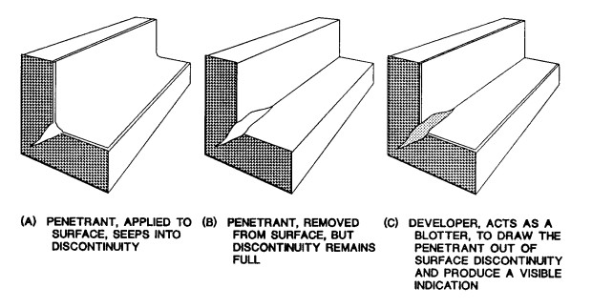
Figure 5-13. Penetrant and developer action.

Table 5-3. Classification of penetrant inspection materials covered by MIL-I-25135E.
PENETRANT SYSTEMS |  |  |  |  | DEVELOPERS |  |  | SOLVENT REMOVERS
Type I  Type II  Type III | Fluorescent Dye  Visible Dye  Visible and Fluorescent Dye  (dual mode) |  |  | Form a  Form b  Form c  Form d  Form e | Dry Powder  Water Soluble  Water Suspendible  Nonaqueous  Specific Application | Class (1)  Class (2)  Class (3) | Halogenated  (chlorinated)  Nonhalogenated  (nonchlorinated)  Specific Application
Method A  Method B  Method C  Method D | Water Washable  Post emulsifiable,  Lipophilic  Solvent Removable  Post Emulsifiable,  Hydrophilic
Sensitivity Level 1/2  Sensitivity Level 1  Sensitivity Level 2  Sensitivity Level 3  Sensitivity Level 4 |  |  | Ultralow  Low  Medium  High  Ultrahigh

Table 5-4. Fluorescent and visible penetrant inspection general processing procedures flowsheet.
Penetrant Inspection-General Processing
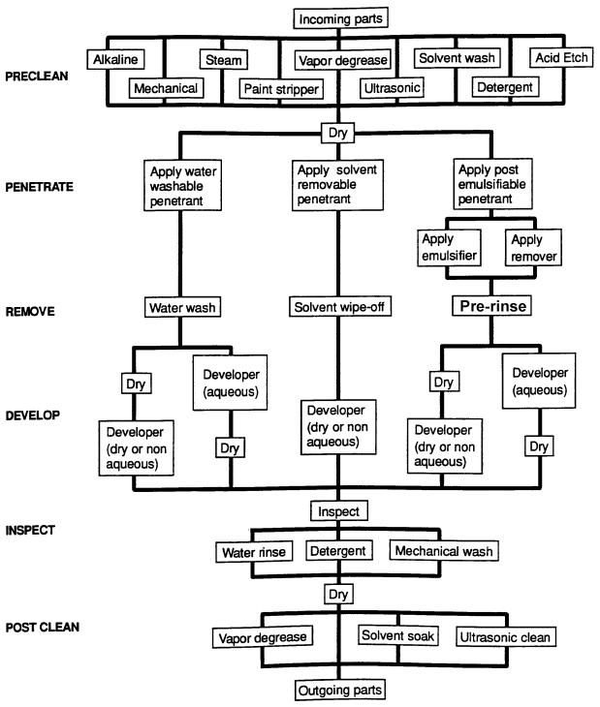

Table 5-5. Pre-cleaning methods for penetrant inspection.
METHOD | USE
Mechanical Methods  Abrasive tumbling | Removing light scale, burrs, welding flux, braze stopoff, rust, casting mold, and core material; should not be used on soft metals such as aluminum, magnesium, or titanium.
Dry abrasive grit blasting | Removing light or heavy scale, flux, stopoff, rust, casting mold and core material, sprayed coatings, carbon deposits: In general, any brittle deposit. Can be fixed or portable (may peen metal over defect).
Wet abrasive grit blast | Same as dry except, where deposits are light, better surface and better control of dimensions are required.
Wire brushing | Removing light deposits of scale, flux, and stopoff (may mask defect by displacing metal).
High pressure water and steam | Ordinarily used with an alkaline cleaner or detergent; removing typical machine shop contamination, such as cutting oils, polishing compounds, grease, chips, and deposits from electrical discharge machining; used when surface finish must be maintained.
Ultrasonic cleaning | Ordinarily used with detergent and water or with a solvent; removing adhering shop contamination from large quantities of small parts.
Chemical Methods  Alkaline cleaning | Removing braze stopoff, rust, scale, oils, greases, polishing material, and carbon deposits; ordinarily used on large articles where hand methods are too laborious; also used on aluminum for gross metal removal.
Acid cleaning | Strong solutions for removing heavy scale; mild solutions for light scale; weak (etching) solutions for removing lightly smeared metal.
Molten salt bath cleaning | Conditioning and removing heavy scale; not suitable for aluminum, magnesium, or titanium.
Solvent Methods

Solvent wiping | Same as for vapor degreasing except a hand operation; may employ nonhalogenated (nonchlorinated) solvents; used for localized low-volume cleaning.

CAUTION: Improper cleaning methods can cause severe damage or degradation of the item being cleaned. Personnel must select and apply cleaning processes in accordance with aircraft, engine, propeller, or appliance manufacturer’s recommendations.

CLEANERS AND APPLICATIONS. Use a cleaner to remove contaminants from parts prior to the application of penetrant inspection materials. After the inspection is completed, penetrant inspection material residues are removed. The following cleaners are commonly used during the penetrant inspection process.

Detergents. Detergent cleaners are water-based chemicals called surfactants, which surround and attach themselves to particles of contaminants allowing them to be washed away.

Solvents. Solvents dissolve contaminants such as oils, greases, waxes, sealants, paints, and general organic matter so they can easily be wiped away or absorbed on a cloth. They are also used to remove Method C penetrant material prior to developer application.

Alkalies. Alkaline cleaners are water solutions of chemicals that remove contaminants by chemical action or displacement rather than dissolving the contaminant.

Paint Removers. The general types of removers used for conventional paint coatings are solvent, bond release, and disintegrating.

Salt Baths. Molten salt baths are used in removing heavy, tightly-held scale and oxide from low alloy steels, nickel, and cobalt-base alloys, and some types of stainless steel. They cannot be used on aluminum, magnesium, or titanium alloys.

Acids. Solutions of acids or their salts are used to remove rust, scale, corrosion products, and dry shop contamination. The type of acid used and its concentration depends on the part material and contaminants to be removed.

Etching Chemicals. Etching chemicals contain a mixture of acids or alkalies plus inhibitors. They are used to remove a thin layer of surface material, usually caused by a mechanical process, that may seal or reduce the opening of any discontinuities. The type of etching solution used depends on the part material and condition.

Penetrant Application. Apply the penetrant by spraying, brushing, or by completely submerging the part in a container of penetrant. Wait the recommended amount of time after the penetrant has been applied to allow it to enter any discontinuities

Removal of Excess Penetrant. Excess penetrant must be removed from the part’s surface to prevent a loss of contrast between indications of discontinuities and the background during the inspection. Removal may require actually washing or spraying the part with a cleansing liquid, or may simply require wiping the part clean with a solvent-moistened cloth. The removal method is determined by the type of penetrant used.

Drying. If removal of the excess penetrant involves water or other cleaning liquids, drying of the part may be required prior to developer application. When drying is required, the time can be decreased by using ovens or ventilation systems.

Developer Application. Apply developer after excess penetrant is removed and, where required, the surface is dried. Apply the developer in a thin uniform layer over the surface to be inspected. Developer acts like a

blotter to assist the natural capillary action bleed-out of the penetrant from discontinuities and to spread the penetrant at discontinuity surface edges to enhance bleed-out indications. After the developer is applied, allow sufficient time for the penetrant to be drawn out of any discontinuities. Follow the manufacturer’s recommendations.

Inspection for Discontinuities. After the penetrant has sufficiently developed, visually inspect the surface for indications from discontinuities. Evaluate each indication observed to determine if it is within acceptable limits. Visible penetrant inspection is performed in normal visible white light, whereas fluorescent penetrant inspection is performed in black (ultraviolet) light.

Post-Cleaning. Remove inspection material residues from parts after completion

of penetrant inspection. This residue could interfere with subsequent part processing, or if left on some alloys, it could increase their susceptibility to hydrogen embrittlement, intergranular corrosion, and stress corrosion during service.

TECHNICAL STANDARDS. Two of the more generally accepted aerospace industry standards are the MIL-I-25135E, Inspection Materials, Penetrants (see table 5-6) and ASTM-E-1417. The penetrant materials specification (MIL-I-25135E) is used to procure penetrant materials and the process control specification (MIL-STD-6866) is used to establish minimum requirements for conducting a penetrant inspection. Table 5-6 provides a partial listing of commonly-accepted standards and specifications for penetrant inspection.

Table 5-6. Listing of commonly accepted standards and specifications for penetrant inspection.
NUMBER | TITLE
ASTM STANDARDS
ASTM-E-165 | Standard Practice for Liquid Penetrant Inspection Method
ASTM -E-270 | Standard Definitions of Terms Relating to Liquid Penetrant Inspection
ASTM -E-1135 | Standard Method for Comparing the Brightness of Fluorescent Penetrants
ASTM -E-1208 | Standard Method for Fluorescent Liquid Penetrant Examination Using the Lipophilic Post-Emulsification  Process
ASTM -E-1209 | Standard Method for Fluorescent Penetrant Examination Using the Water Washable Process
ASTM -E-1210 | Standard Method for Fluorescent Penetrant Examination Using the Hydrophilic Post-Emulsification Process
ASTM -E-1219 | Standard Method for Fluorescent Penetrant Examination Using the Solvent Removable Process
ASTM -E-1220 | Standard Method for Visible Penetrant Examination Using the Solvent Removable Method
ASTM -E-2512 | Compatibility of Materials with Liquid Oxygen (Impact-Sensitivity Threshold Technique)
SAE-AMS
SPECIFICATIONS
AMS-2647 | Fluorescent Penetrant Inspection - Aircraft and Engine Component Maintenance
US GOVERNMENT
SPECIFICATIONS
MIL-STD-271 | Requirements for Nondestructive Testing
MIL-STD-410 | Nondestructive Testing Personnel Qualifications and Certifications
MIL-STD-1907 | Inspection, Liquid Penetrant and Magnetic Particle, Soundness Requirements for Materials, Parts and Welds
MIL-STD-6866 | Inspection, Liquid Penetrant
MIL-STD-728/1 | Nondestructive Testing
MIL-STD-728/3 | Liquid Penetrant Testing
MIL-STD-25135E | Inspection Materials, Penetrants
QPL-25135 | Qualified Products List of Materials Qualified Under MIL-I-25135
T.O. 33B-1-1 | U.S. Air Force/Navy Technical Manual, Nondestructive Testing Methods
OTHER
PUBLICATIONS
SNT-TC-1A | Personnel Qualification and Certification in Nondestructive Testing and Recommended Training Courses
ATA No. 105  Metals Handbook,  Ninth Edition,  Volume 17 | Guidelines for Training and Qualifying Personnel in Nondestructive Methods,  Nondestructive Evaluation, and Quality Control

5-65.⎯5-72. [RESERVED.]

