Section 7. ULTRASONIC INSPECTION

GENERAL. Ultrasonic inspection is an NDI technique that uses sound energy moving through the test specimen to detect flaws. The sound energy passing through the specimen will be displayed on a Cathode Ray Tube (CRT), a Liquid Crystal Display (LCD) computer data program, or video/camera medium. Indications of the front and back surface and internal/external conditions will appear as vertical signals on the CRT screen or nodes of data in the computer test program. There are three types of display patterns; “A” scan, “B” scan, and “C” scan. Each scan provides a different picture or view of the specimen being tested. (See figure 5-15.)

SOUND REFLECTION. The amount of reflection that occurs when a sound wave strikes an interface depends largely on the physical state of the materials forming the interface and to a lesser extent on the specific physical properties of the material. For example: sound waves are almost completely reflected at metal/gas interfaces; and partial reflection occurs at metal/liquid or metal/solid interfaces.

ULTRASONIC INSPECTION TECHNIQUES. Two basic ultrasonic inspection techniques are employed: pulse-echo and through-transmission. (See figure 5-16.)

Pulse-Echo Inspection. This process uses a transducer to both transmit and receive the ultrasonic pulse. The received ultrasonic pulses are separated by the time it takes the sound to reach the different surfaces from which it is reflected. The size (amplitude) of a reflection is related to the size of the reflecting surface. The pulse-echo ultrasonic response pattern is analyzed on the basis of signal amplitude and separation.

Through-Transmission Inspection. This inspection employs two transducers, one to generate and a second to receive the ultrasound. A defect in the sound path between the two transducers will interrupt the sound transmission. The magnitude (the change in the sound pulse amplitude) of the interruption is used to evaluate test results. Through-transmission inspection is less sensitive to small defects than is pulse-echo inspection.

FLAW DETECTION. Ultrasonic inspection can easily detect flaws that produce reflective interfaces. Ultrasonic inspection is used to detect surface and subsurface discontinuities, such as: cracks, shrinkage cavities, bursts, flakes, pores, delaminations, and porosity. It is also used to measure material thickness and to inspect bonded structure for bonding voids. Ultrasonic inspection can be performed on raw material, billets, finished, and semi-finished materials, welds, and in-service assembled or disassembled parts. Inclusions and other nonhomogeneous areas can also be detected if they cause partial reflection or scattering of the ultrasonic sound waves or produce some other detectable effect on the ultrasonic sound waves. Ultrasonic inspection is one of the more widely-used methods of NDI.

BASIC EQUIPMENT. Most ultrasonic inspection systems include the following basic equipment; portable instruments (frequency range 0.5 to 15 MHz), transducers (longitudinal and shear wave), positioners, reference standards, and couplant.

Ultrasonic Instruments. A portable, battery-powered ultrasonic instrument is used for field inspection of airplane structure. (See figure 5-17.) The instrument generates an

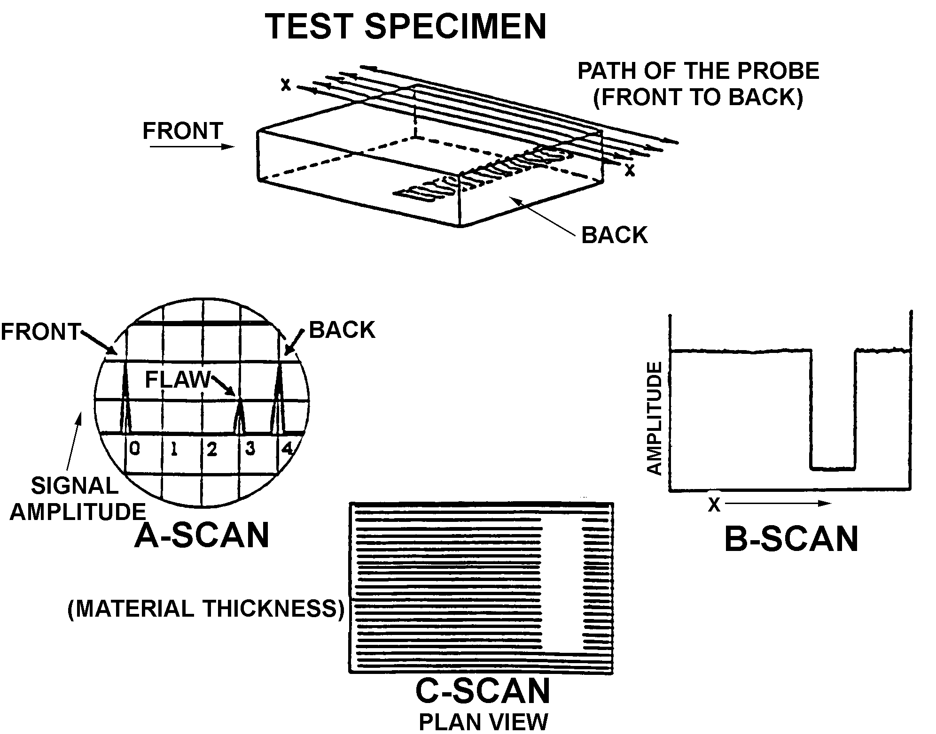

Figure 5-15. Ultrasound.

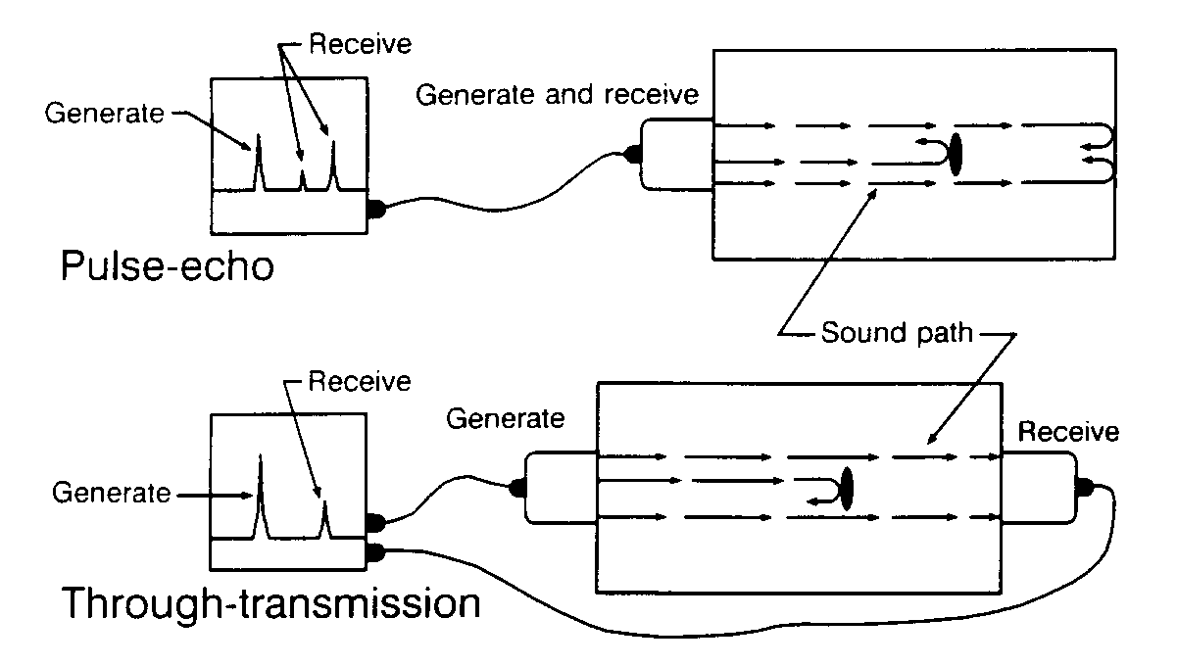
Figure 5-16. Pulse-echo and through-transmission ultrasonic inspection techniques.

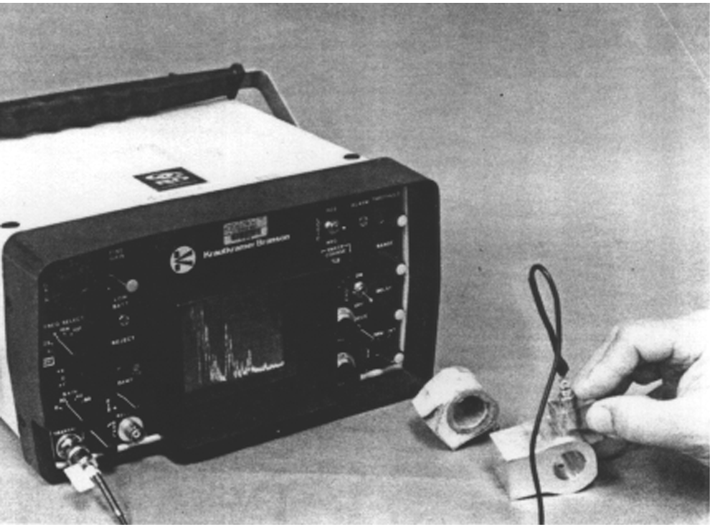
Figure 5-17. Typical portable ultrasonic inspection instrument.

ultrasonic pulse, detects and amplifies the returning echo, and displays the detected signal on a cathode ray tube or similar display. Piezoelectric transducers produce longitudinal or shear waves, which are the most commonly used wave forms for aircraft structural inspection.

Positioning Fixtures. To direct ultrasound at a particular angle, or to couple it into an irregular surface, transducer positioning fixtures and sound-coupling shoes are employed. (See figure 5-18.) Shoes are made of a plastic material that has the necessary sound- transmitting characteristics. Positioning fixtures are used to locate the transducer at a prescribed point and can increase the sensitivity of the inspection. (See figure 5-19.) If a transducer shoe or positioning fixture is required, the inspection procedure will give a detailed description of the shoe or fixture.

Reference Standards. Reference standards are used to calibrate the ultrasonic instrument (see figure 5-20), reference standards serve two purposes to provide an ultrasonic response pattern that is related to the part being inspected, and to establish the required inspection sensitivity. To obtain a representative response pattern, the reference standard configuration is the same as that of the test structure,

or is a configuration that provides an ultrasonic response pattern representative of the test structure. The reference standard contains a simulated defect (notch) that is positioned to provide a calibration signal representative of the expected defect. The notch size is chosen to establish inspection sensitivity (response to the expected defect size). The inspection procedure gives a detailed description of the required reference standard.

Couplants. Inspection with ultrasonics is limited to the part in contact with the transducer. A layer of couplant is required to couple the transducer to the test piece because ultrasonic energy will not travel through air. Some typical couplants used are: water, glycerin, motor oils, and grease.

INSPECTION OF BONDED STRUCTURES. Ultrasonic inspection is finding increasing application in aircraft bonded construction and repair. Detailed techniques for specific bonded structures should be obtained from the OEM’s manuals, or FAA requirements. In addition, further information on the operation of specific instruments should be obtained from the applicable equipment manufacturer manuals.

Types of Bonded Structures. Many configurations and types of bonded structures are in use in aircraft. All of these variations complicate the application of ultrasonic inspections. An inspection method that works well on one part or one area of the part may not be applicable for different parts or areas of the same part. Some of the variables in the types of bonded structures are as follows.

Top skin material is made from different materials and thickness.

Different types and thickness of adhesives are used in bonded structures.

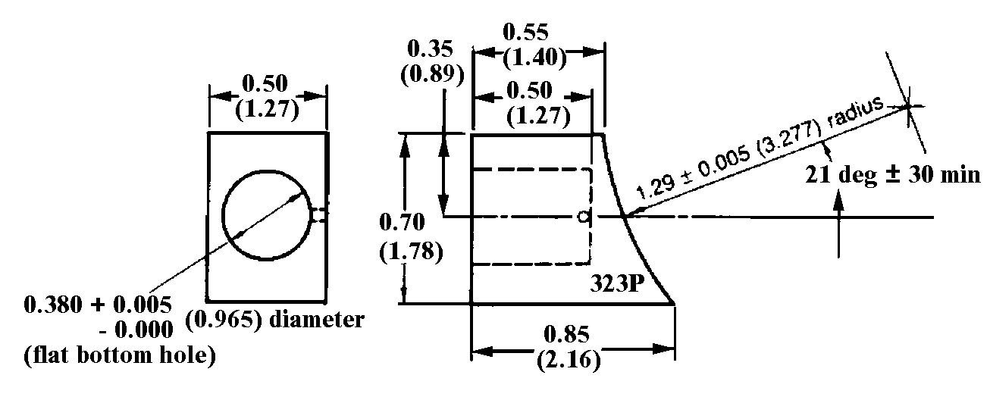
Note:
All dimensions in inches followed by centimeters in parentheses.

Figure 5-18. Example of position fixture and shoe.

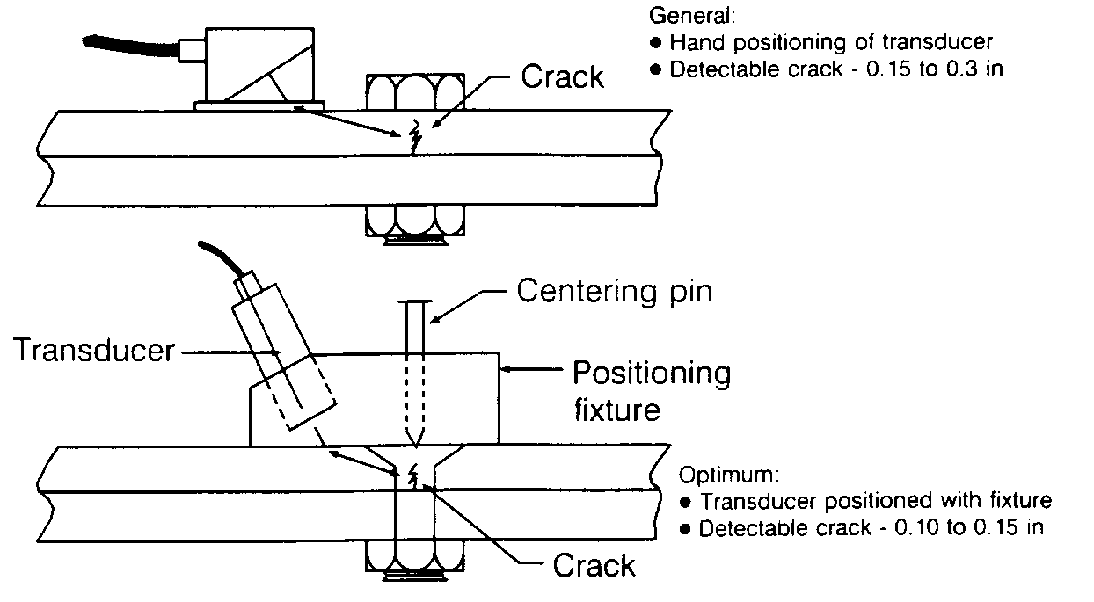
Figure 5-19. Example of the use if a transducer positioning fixture.

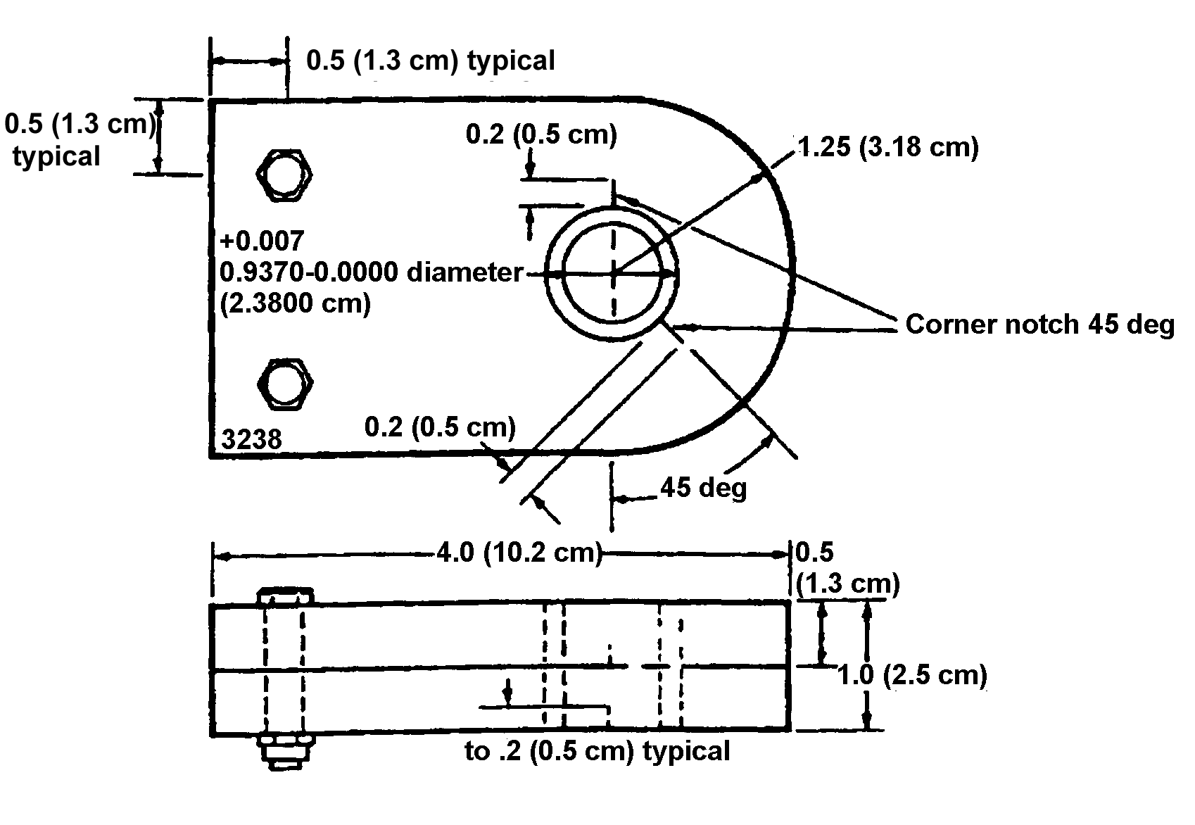
Figure 5-20. Example of a typical reference standard.

Underlying structures contain differences in; core material, cell size, thickness, and height, back skin material and thickness, doublers (material and thickness), closure member attachments, foam adhesive, steps in skins, internal ribs, and laminates (number of layers, layer thickness, and layer material).

The top only or top and bottom skin of a bonded structure may be accessible.

Application of Ultrasonic Inspection. Application to bonded structures must be examined in detail because of the many inspection methods and structural configurations. The advantages and limitations of each inspection method should be considered, and reference standards (representative of the structure to be inspected) should be ultrasonically inspected to verify proposed techniques.

Internal Configuration. Complete information on the internal configuration of the bonded test part must be obtained by the inspector. Drawings should be reviewed, and when necessary, radiographs of the test part should be taken. Knowledge of details such as the location and boundaries of doublers, ribs, etc., is required for valid interpretation of ultrasonic inspection results. The boundaries of internal details should be marked on the test part using a grease pen or other easily removable marking.

Reference Standards. Standards can be a duplicate of the test part except for the controlled areas of unbond. As an option, simple test specimens, which represent the varied areas of the test part and contain controlled areas of unbond, can be used. Reference standards must meet the following requirements.

The reference standard must be similar to the test part regarding material, geometry, and thickness. This includes

containing: closure members, core splices, stepped skins, and internal ribs similar to the test part if bonded areas over or surrounding these details are to be inspected.

The reference standard must contain bonds of good quality except for controlled areas of unbond fabricated as explained below.

The reference standard must be bonded using the adhesive and cure cycle prescribed for the test part.

Types of Defects. Defects can be separated into five general types to represent the various areas of bonded sandwich and laminate structures as follows:

Type I. Unbonds or voids in an outer skin-to-adhesive interface.

Type II. Unbonds or voids at the adhesive-to-core interface.

Type III. Voids between layers of a laminate.

Type IV. Voids in foam adhesive or unbonds between the adhesive and a closure member at core-to-closure member joints.

Type V. Water in the core.

Fabrication of NDI Reference Standards. Every ultrasonic test unit should have sample materials that contain unbonds equal to the sizes of the minimum rejectable unbonds for the test parts. Information on minimum rejectable unbond sizes for test parts should be obtained from the OEM’s manuals, FAA requirements, or the cognizant FAA Aircraft Certification Office (ACO) engineer. One or more of the following techniques can be used in fabricating reference defects; however, since bonding materials vary, some of the methods may not work with certain materials.

Standards for Types I, II, III, and IV unbonds can be prepared by placing discs of 0.006 inch thick (maximum) Teflon sheets over the adhesive in the areas selected for unbonds. For Type II unbonds, the Teflon is placed between the core and adhesive. The components of the standard are assembled and the assembly is then cured.

Types I, II, and III standards can also be produced by cutting flat-bottomed holes of a diameter equal to the diameter of the unbonds to be produced. The holes are cut from the back sides of bonded specimens, and the depths are controlled to produce air gaps at the applicable interfaces. When using this method, patch plates can be bonded to the rear of the reference standard to cover and seal each hole.

Type II standards can be produced by locally undercutting (before assembly) the surface of the core to the desired size unbond. The depth of the undercut should be sufficient to prevent adhesive flow causing bonds between the undercut core and the skin.

Type IV standards can be produced by removing the adhesive in selected areas prior to assembly.

Type V standards can be produced by drilling small holes in the back of the standard and injecting varying amounts of water into the cells with a hypodermic needle. The small holes can then be sealed with a small amount of water-resistant adhesive.

Inspection Coverage. Examples of several different configurations of bonded structure along with suggested inspection coverages with standard ultrasonic test instruments are shown in figure 5-21. In many cases, access limitations will not permit application of the suggested inspections in all of the areas shown. The inspection coverages and

suggested methods contained in figure 5-21 and table 5-7 are for reference only. Details of the inspection coverage and inspections for a particular assembly should be obtained from the OEM’s manuals, or other FAA-approved requirements.

Inspection Methods. Table 5-8 lists the various inspection methods for bonded structures along with advantages and disadvantages of each inspection method.

BOND TESTING INSTRUMENTS. Standard ultrasonic inspection instruments can be used for bond testing as previously noted; however, a wide variety of bond testing instruments are available for adaptation to specific bonded structure inspection problems.

General Principle. Two basic operating principles are used by a variety of bond testers for single-sided bond inspection.

Ultrasonic resonance. Sound waves from a resonant transducer are transmitted into and received from a structure. A disbond in the structure will alter the sound wave characteristics, which in turn affect the transducer impedance.

Mechanical impedance. Low-frequency, pulsed ultrasonic energy is generated into a structure. Through ultrasonic mechanical vibration of the structure, the impedance or stiffness of the structure is measured, analyzed, and displayed by the instrumentation.

Operation. In general, operation of the adhesive bond test instruments noted is similar. The test probe is moved over the surface in smooth overlapping strokes. The direction of the stroke with regard to the surface is generally immaterial; however, when using the Sondicator models, the direction of the stroke becomes critical when the test probe is

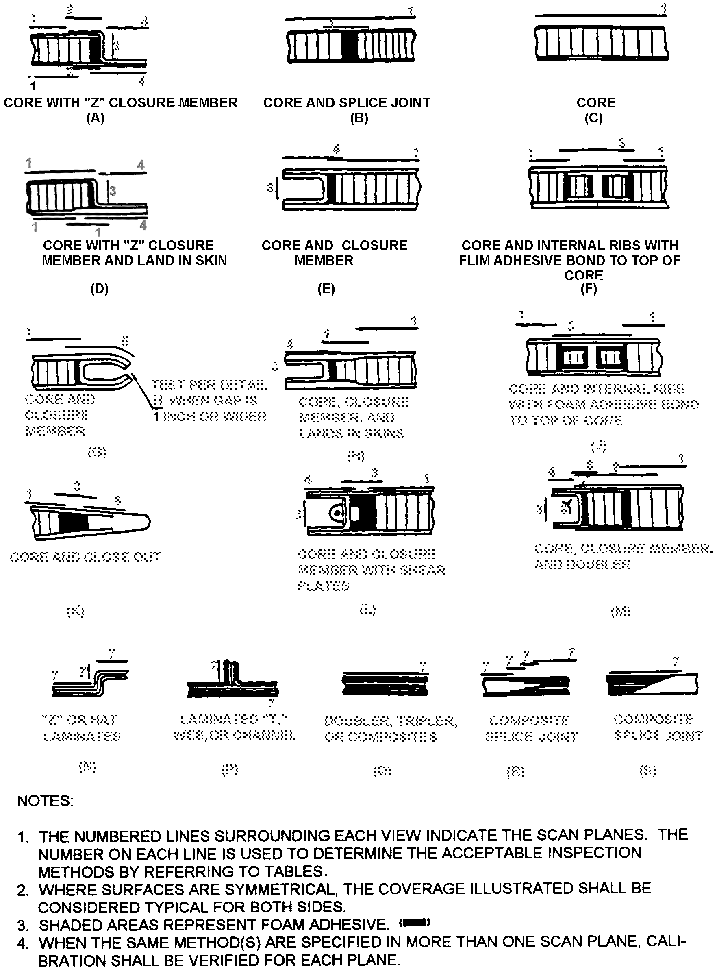

Figure 5-21. Examples of bonded structure configurations and suggested inspection coverage.

Table 5-7. Acceptable ultrasonic inspection methods associated with the example bonded structure configurations shown in figure 5-21.
NUMBER | ACCEPTABLE METHODS
1 | Either  (a) Pulse-echo straight or angle beam, on each side  or  (b) Through-transmission.
2 | Pulse-echo, straight beam, on each skin.
3 | Refer to 1 for methods. If all these methods fail to have sufficient penetration power to detect reference defects in the reference standard, then the ringing method, applied from both sides, should be used. Otherwise, the ringing method is unacceptable.
4 | Either  (a) Ringing, on each skin of the doubler.  or  (b) Through-transmission  or  (c) Damping.
5 | Ringing.
6 | Through-transmission. Dotted Line represents beam direction.
7 | Either  (a) Through-transmission  or  (b) Damping.
NOTE

A variety of ultrasonic testing methods and instruments are available for adaptation to specific inspection problems. Other bond inspection instruments can be used if detailed procedures are developed and proven on the applicable reference standards for each configuration of interest. Some representative instruments, which can be used for the inspection of bonded structures are; the Sondicator, Harmonic Bond Tester, Acoustic Flaw Detector, Audible Bond Tester, Fokker Bond Tester, 210 Bond Tester, and Bondascope 2100.

Table 5-8. Ultrasonic inspection methods for bonded structures.
INSPECTION METHOD
 | THROUGH-TRANSMISSION | PULSE-ECHO | RINGING | DAMPING
Advantages | Applicable to structures with either thick or thin facing sheets.  Applicable to structures with multiple layers bonded over honeycomb core.  Detects unbonds on either side  Detects broken, crushed, and corroded core.  In some cases water in core can be detected. | Applicable to structures with either thick or thin facing sheets.  Determines which side is unbonded.  Detects small unbonds.  Detects broken, crushed, and corroded core.  In some cases water in core can be detected. | Applicable to complex shapes.  Detects small near surface unbonds (larger than diameter of search unit). | Applicable to structures with either thick or thin facing sheets.  Applicable to multiple-layered (more than two layers) structures.  Detects unbonds on either side.  Detects small unbonds (larger than diameter of receiving search unit).
Disadvantages | Access to both sides of part is required.  Does not determine layer position of unbonds.  Alignment of search units is critical.  Couplant is required.  Inspection rate is slow. | Inspection from both sides required, does not detect far side unbonds.  Applicable only to skin-to-honeycomb core structures.  Reduced effectiveness on structures with multiple skins over honeycomb core.  Couplant required. | Applicable only to near surface unbonds, works best on unbonds between top sheet and adhesive, may miss other unbonds.  Reduced effectiveness on thick skins.  Couplant required. | Applicable only to doublers and laminate-type structures.  Access to both sides required.  Does not determine layer positions of unbonds.  Couplant required.

operated near a surface edge. Edge effects on vibration paths give a test reading that may be misinterpreted. To avoid edge effects, the test probe should be moved so that the inspection path follows the surface edge, giving a constant edge for the test probe to inspect. Edge effects are more pronounced in thicker material. To interpret meter readings correctly, the operator should determine whether there are variations in the thickness of the material.

Probe Sending Signal. With the exception of the Sondicator models, the test probes of the testers emit a sending signal that radiates in a full circle. The sending signal of the Sondicator probe travels from one transducer tip to the other. For this reason, the test probe should be held so that the transducer tips are at right angles to the inspection path. When inspecting honeycomb panels with a Sondicator model, the transducer tips should be moved consistently in the direction of the ribbon of the honeycomb or at right angles to the ribbon so that a constant subsurface is presented.

THICKNESS MEASUREMENTS. Ultrasonic inspection methods can be used for measurement of material thickness in aircraft parts and structures.

Applications. Ultrasonic thickness measurements are used for many applications, such as: checking part thickness when access to the back side is not available; checking large panels in interior areas where a conventional micrometer cannot reach; and in maintenance inspections for checking thickness loss due to wear and/or corrosion.

Pulse-Echo Method. The most commonly used ultrasonic thickness measurement method. The ultrasonic instrument measures time between the initial front and back surface signals or subsequent multiple back reflection signals. Since the velocity for a given material

is a constant, the time between these signals is directly proportional to the thickness. Calibration procedures are used to obtain direct readout of test part thickness.

Thickness Measurement Instrument Types. Pulse-echo instruments designed exclusively for thickness measurements are generally used in lieu of conventional pulse-echo instruments; however, some conventional pulse-echo instruments also have direct thickness measurement capabilities. Conventional pulse-echo instruments without direct thickness measuring capabilities can also be used for measuring thickness by using special procedures.

Thickness Measurement Ranges. Dependent upon the instrument used and the material under test, material thickness from 0.005 inches to 20 inches (or more) can be measured with pulse-echo instruments designed specifically for thickness measuring.

LEAK TESTING. The flow of a pressurized gas through a leak produces sound of both sonic and ultrasonic frequencies. If the gas leak is large, the sonic frequency sound it produces can probably be detected with the ear or with such instruments as stethoscopes or microphones; however, the ear and these instruments have limited ability to detect and locate small leaks. Ultrasonic leak detectors are frequently used to detect leaks that cannot be detected by the above methods, because they are very sensitive to ultrasonic energy and, under most conditions, background noise at other frequencies does not affect them.

Standard Method. A standard method of testing for leaks using ultrasonics is provided in ASTM E 1002. The method covers procedures for calibration, location, and estimated measurements of leakage by the ultrasonic technique (sometimes called ultrasonic translation).

Detection Distance. Ultrasonic energy in the relatively low-frequency range of 30-50 KHz travels easily through air; therefore, an ultrasonic leak detector can detect leakage with the probe located away from the leak. The maximum detection distance depends on the leakage rate.

Typical Applications. Some typical applications for the ultrasonic leak detector on aircraft are: fuel system pressurization tests, air ducts and air conditioning systems, emergency evacuation slides, tire pressure retention, electrical discharge, oxygen lines and valves, internal leaks in hydraulic valves and actuators, fuel cell testing, identifying cavitation in hydraulic pumps, arcing in wave guides, cabin and cockpit window and door seals, and cabin pressurization testing.

5-98.⎯5-104. [RESERVED.]

