CHAPTER 6. CORROSION, INSPECTION & PROTECTION

Section 1. GENERAL

GENERAL. The purpose of this chapter is to provide information that will help maintenance personnel prevent, control, identify, and treat various types of corrosion. (Refer to AC 43-4A, Corrosion Control For Aircraft for a more in-depth study on the detection and treatment of corrosion.)

Corrosion is a natural occurrence that attacks metal by chemical or electrochemical action and converts it back to a metallic compound.

Four conditions must exist before electrochemical corrosion can occur. (See figure 6-1.) They are:

A metal subject to corrosion (Anode);

A dissimilar conductive material (Cathode), which has less tendency to corrode;

Presence of a continuous, conductive liquid path (Electrolyte); and

Electrical contact between the anode and the cathode (usually in the form of metal-to-metal contact such as rivets, bolts, and corrosion).

Elimination of any one of these conditions will stop electrochemical corrosion. (See figure 6-2.)

NOTE: Paint can mask the initial stages of corrosion. Since corrosion products occupy more volume than the original metal, painted surfaces should be inspected often for irregularities such as blisters, flakes, chips, and lumps.

FACTORS INFLUENCING CORROSION.

Some factors which influence metal corrosion and the rate of corrosion are:

Type of metal;

Heat treatment and grain direction;

Presence of a dissimilar, less corrodible metal;

Anodic and cathodic surface areas (in galvanic corrosion);

Temperature;

Presence of electrolytes (hard water, salt water, battery fluids, etc.);

Availability of oxygen;

Presence of biological organisms;

Mechanical stress on the corroding metal; and,

Time of exposure to a corrosive environment.

Lead/graphite pencil marks on aircraft surface metals.

Most pure metals are not suitable for aircraft construction and are used only in combination with other metals to form alloys. Most alloys are made up entirely of small crystalline regions, called grains. Corrosion can occur on surfaces of those regions which

are less resistant and also at boundaries between regions, resulting in the formation of pits and intergranular corrosion. Metals have a wide range of corrosion resistance. The most active metals, (those which lose electrons eas-
ily), such as magnesium and aluminum, corrode easily. The most noble metals (those which do not lose electrons easily), such as gold and silver, do not corrode easily.

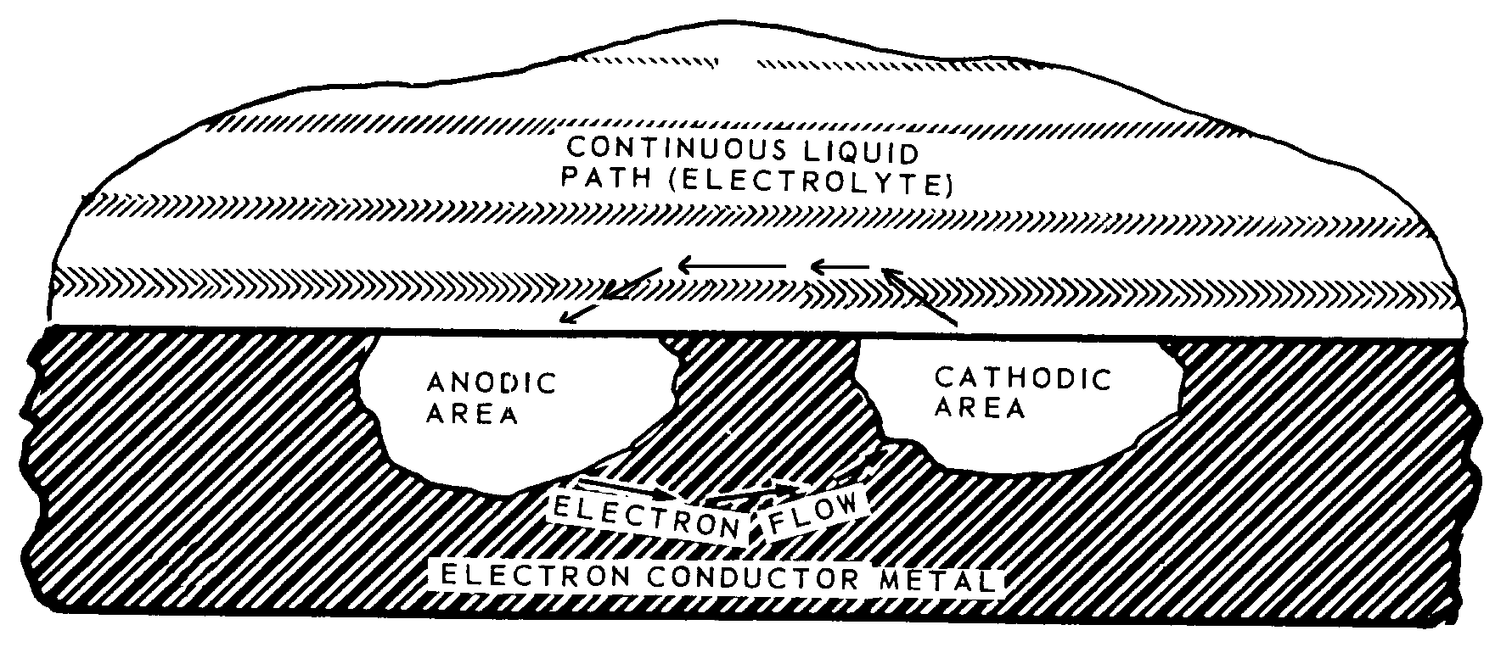
Figure 6-1. Simplified corrosion cell showing conditions which must exist for electrochemical corrosion.

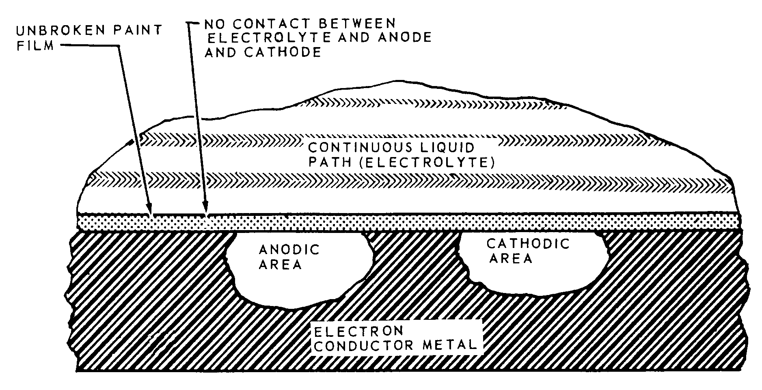
Figure 6-2. Elimination of corrosion by application of an organic film to metal surface.

Corrosion is quickened by high-temperature environments that accelerate chemical reactions and increase the concentration of water vapor in the air.

Electrolytes (electrically-conducting solutions) form on surfaces when condensation, salt spray, rain, or rinse water accumulate. Dirt, salt, acidic gases, and engine exhaust gases can dissolve on wet surfaces, increasing the electrical conductivity of the electrolyte, thereby increasing the rate of corrosion.

When some of the electrolyte on a metal surface is partially confined, (such as between faying surfaces or in a deep crevice) the metal around this area corrodes more rapidly. This type of corrosion is called an oxygen concentration cell. Corrosion occurs more rapidly because the reduced oxygen content of the confined electrolyte causes the adjacent metal to become anodic to other metal surfaces on the same part that are immersed in electrolyte or exposed to air.

Slime, molds, fungi, and other living organisms (some microscopic) can grow on damp surfaces. Once they are established, the area usually remains damp, increasing the possibility of corrosion.

Manufacturing processes such as machining, forming, welding, or heat treatment can leave residual stress in aircraft parts and can cause cracking in a corrosive environment.

COMMON CORROSIVE AGENTS. Substances that cause corrosion are called corrosive agents. The most common corrosive agents are acids, alkalies, and salts. The atmosphere and water, the two most common media for these agents, may also act as corrosive agents.

Any acid will severely corrode most of the alloys used in airframes. The most destructive are sulfuric acid (battery acid), halogen acids (hydrochloric, hydrofluoric, and hydrobromic), nitrous oxide compounds, and organic acids found in the wastes of humans and animals.

Alkalies, as a group, are not as corrosive as acids. Aluminum and magnesium alloys are exceedingly prone to corrosive attack by many alkaline solutions unless the solutions contain a corrosion inhibitor. Substances particularly corrosive to aluminum are washing soda, potash (wood ashes), and lime (cement dust).

The major atmospheric corrosive agents are oxygen and airborne moisture. Corrosion often results from the direct action of atmospheric oxygen and moisture on metal nd the presence of additional moisture often accelerates corrosive attack, particularly on ferrous alloys. The atmosphere may also contain other corrosive gases and contaminants, particularly industrial and marine salt spray.

The corrosiveness of water depends on the type and quantity of dissolved mineral and organic impurities and dissolved gasses (particularly oxygen) in the water. One characteristic of water that makes it corrosive is its conductivity. Physical factors, such as water temperature and velocity also have a direct bearing on its corrosiveness.

MICRO-ORGANISMS.

Bacteria may be either aerobic or anaerobic. Aerobic bacteria require oxygen to live. They accelerate corrosion by oxidizing sulfur to produce sulfuric acid. Bacteria living adjacent to metals may promote corrosion by depleting the oxygen supply or by releasing metabolic products. Anaerobic bacteria, on the other hand, can survive only when free oxygen

is not present. The metabolism of these bacteria requires them to obtain part of their sustenance by oxidizing inorganic compounds, such as iron, sulfur, hydrogen, and carbon monoxide. The resultant chemical reactions cause corrosion.

Fungi are the growths of micro-organisms that feed on organic materials. While low humidity does not kill microbes, it slows their growth and may prevent corrosion damage. Ideal growth conditions for most micro-organisms are temperatures between 68 and 104 °F (20 and 40 °C) and relative humidity between 85 and 100 percent.

Damage resulting from microbial growth can occur when any of three basic mechanisms, or a combination of these, is brought into play. First, fungi have a tendency to hold moisture, which contributes to other forms of corrosion. Second, because fungi are living organisms, they need food to survive.

This food is obtained from the material on which the fungi are growing. Third, these micro-organisms secrete corrosive fluids that attack many materials, including some that are not fungi nutrient.

Microbial growth must be removed completely to avoid corrosion. Microbial growth should be removed by hand with a firm non-metallic bristle brush and water. Removal of microbial growth is easier if the growth is kept wet with water. Microbial growth may also be removed with steam at 100 psi. Protective clothing must be used when using steam for removing microbial growth.

6-5.⎯6-10. [RESERVED.]

