Section 2. TYPES OF CORROSION

GENERAL. All corrosive attacks begin on the surface of the metal making the classification of corrosion by physical appearance a convenient means of identification. (See figure 6-3.)

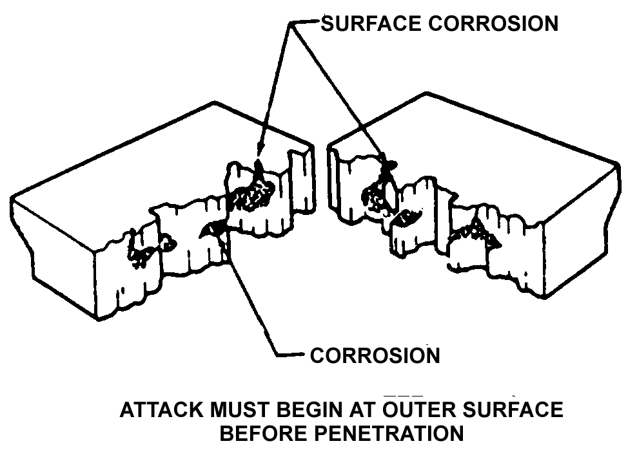
Figure 6-3. Corrosion attack.

GENERAL SURFACE CORROSION. General surface corrosion (also referred to as Uniform Etch or Uniform Attack Corrosion) is the most common form of corrosion and results from a direct chemical attack on a metal surface and involves only the metal surface. (See figure 6-4.) General surface corrosion usually occurs over a wide area and is more or less equal in dispersion. On a polished surface, this type of corrosion is first seen as a general dulling of the surface, and if allowed to continue, the surface becomes rough and possibly frosted in appearance. The discoloration or general dulling of metal created by exposure to elevated temperatures is not to be considered general surface corrosion.

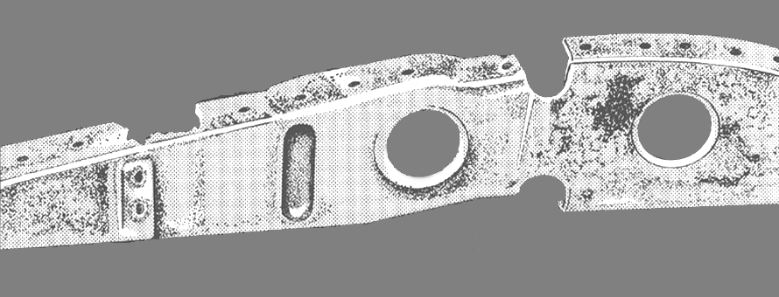
Figure 6-4. General surface corrosion.

PITTING CORROSION. Pitting corrosion is one of the most destructive and intense forms of corrosion. It can occur in any metal but is most common on metals that form protective oxide films, such as aluminum and magnesium alloys. It is first noticeable as a white or gray powdery deposit, similar to dust, which blotches the surface. When the deposit is cleaned away, tiny holes or pits can be seen in the surface. (See figures 6-5(a) and 6-5(b).) These small surface openings may penetrate deeply into structural members and cause damage completely out of proportion to its surface appearance.

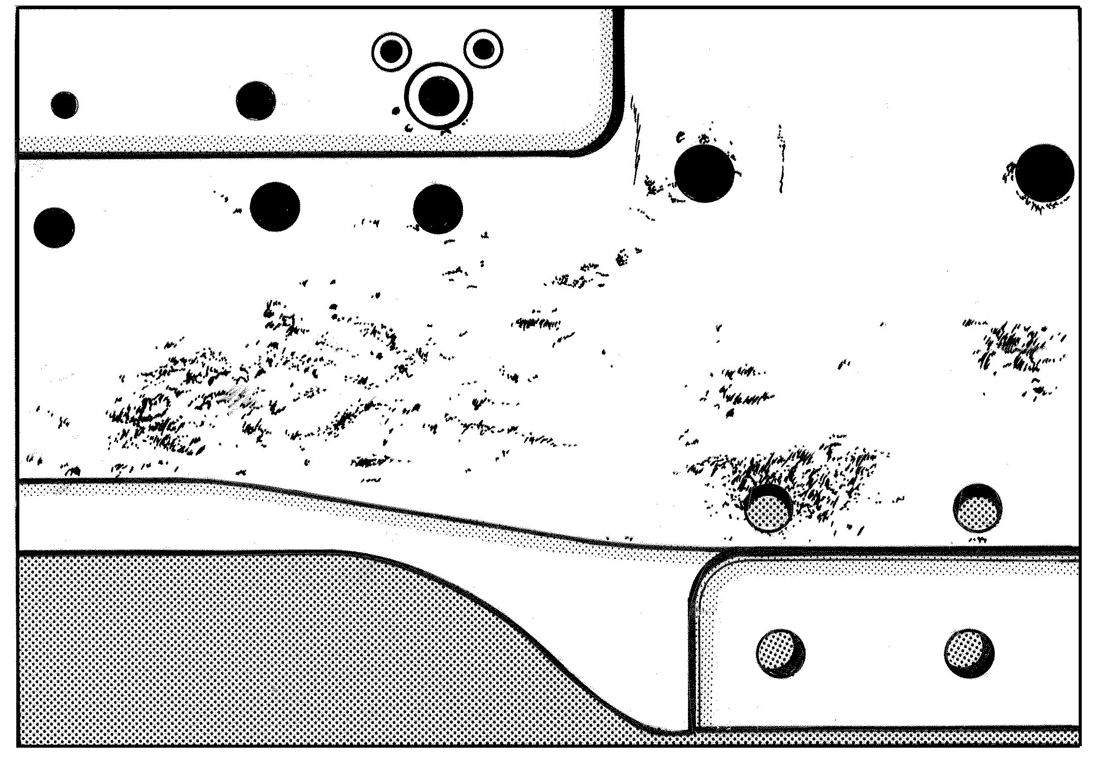
Figure 6-5(a). Pitting corrosion (external view).

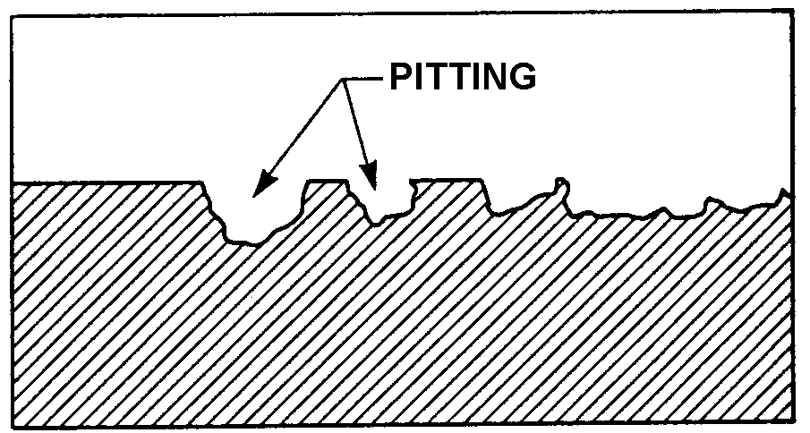
Figure 6-5(b). Pitting corrosion (magnified cross section).

CONCENTRATION CELL CORROSION. Concentration cell corrosion, (also known as Crevice Corrosion) is corrosion of metals in a metal-to-metal joint, corrosion at the edge of a joint even though the joined metals are identical, or corrosion of a spot on the metal surface covered by a foreign material. Metal ion concentration cells and oxygen concentration cells are the two general types of concentration cell corrosion. (See figure 6-6.)

Metal Ion Concentration Cells. The solution may consist of water and ions of the metal which is in contact with water. A high concentration of the metal ions will normally exist under faying surfaces where the solution is stagnant, and a low concentration of metal ions will exist adjacent to the crevice which is created by the faying surface. An electrical potential will exist between the two points; the area of the metal in contact with the low concentration of metal ions will be anodic and corrode, and the area in contact with the high metal ion concentration will be cathodic and not show signs of corrosion.

Oxygen Concentration Cells. The solution in contact with the metal surface will normally contain dissolved oxygen. An oxygen cell can develop at any point where the oxygen in the air is not allowed to diffuse into the solution, thereby creating a difference in oxygen concentration between two points. Typical locations of oxygen concentration

cells are under gaskets, wood, rubber, and other materials in contact with the metal surface. Corrosion will occur at the area of low oxygen concentration (anode). Alloys such as stainless steel are particularly susceptible to this type of crevice corrosion.

ACTIVE-PASSIVE CELLS. Metals which depend on a tightly adhering passive film, usually an oxide, for corrosion protection are prone to rapid corrosive attack by active-passive cells. Active-passive cells are often referred to as a type of concentration cell corrosion. However, the active-passive cell is actually two forms of corrosion working in conjunction. The corrosive action usually starts as an oxygen concentration cell. As an example, salt deposits on the metal surface in the presence of water containing oxygen can create the oxygen cell. The passive film will be broken beneath the salt crystals. Once the passive film is broken, the active metal beneath the film will be exposed to corrosive attack. (See figure 6-7.) Rapid pitting of the active metal will result. This reaction can become locally intense due to several factors. First the reaction is augmented by the affected area, since the proportion of the exposed base metal is small compared to the surrounding non-reactive metal. This effectively concentrates the focal point of the reaction, often resulting in deep pits in a short time and a greater rate of corrosion.

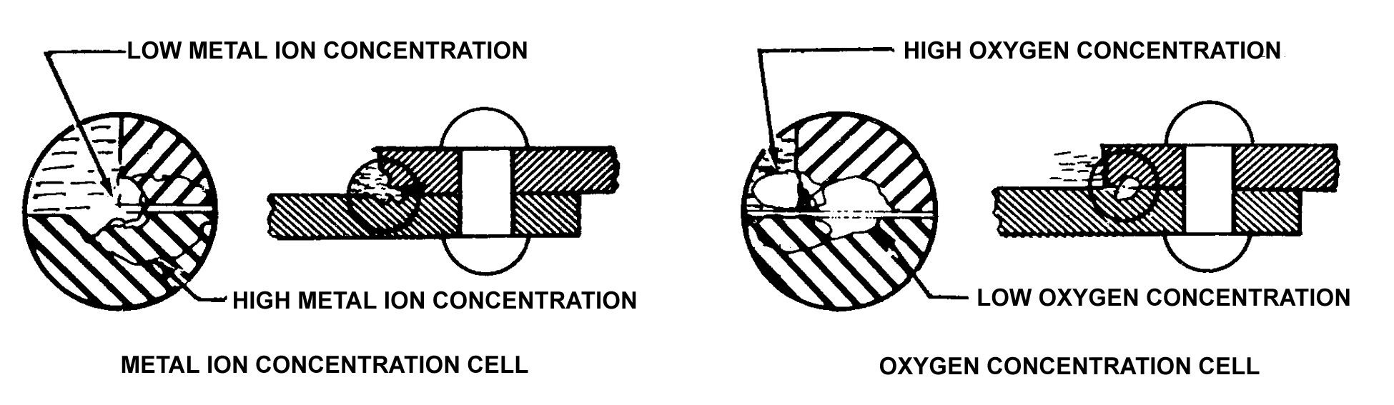
Figure 6-6. Concentration cell corrosion.

FILIFORM CORROSION. Filiform corrosion is a special form of oxygen concentration cell which occurs on metal surfaces having an organic coating system. It is recognized by its characteristic worm-like trace of corrosion products beneath the paint film. (See figure 6-8.) Polyurethane finishes are especially susceptible to filiform corrosion. Filiform occurs when the relative humidity of the air is between 78 and 90 percent and the surface is slightly acidic. This corrosion usually attacks steel and aluminum surfaces. The traces never cross on steel, but they will cross under one another on aluminum which makes the damage deeper and more severe for aluminum. If the corrosion is not removed, the area treated, and a protective finish applied, the corrosion can lead to inter-granular corrosion, especially around fasteners and at seams. Filiform corrosion can be removed using glass bead blasting material with portable abrasive blasting equipment or sanding. Filiform corrosion can be prevented by storing aircraft in an environment with a relative humidity below 70 percent, using coating systems having a low rate of diffusion for oxygen and water vapors, and by washing the aircraft to remove acidic contaminants from the surface.

INTERGRANULAR CORROSION. Inter-granular corrosion is an attack on the grain boundaries of a metal. A highly magnified cross section of any commercial alloy shows the granular structure of the metal. It consists of quantities of individual grains, and each of these tiny grains has a clearly

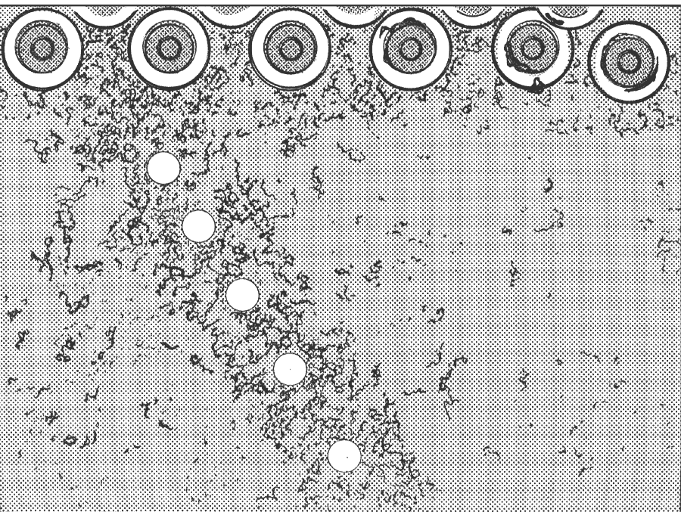
Figure 6-8. Filiform corrosion.

defined boundary which chemically differs from the metal within the grain. The grain boundary and the grain center can react with each other as anode and cathode when in contact with an electrolyte. (See figure 6-9.) Rapid selective corrosion of the grain boundaries can occur. High-strength aluminum alloys such as 2014 and 7075 are more susceptible to inter-granular corrosion if they have been improperly heat-treated and then exposed to a corrosive environment.

EXFOLIATION CORROSION. Exfoliation corrosion is an advanced form of inter-granular corrosion and shows itself by lifting up the surface grains of a metal by the force of expanding corrosion products occurring at the grain boundaries just below the surface. (See figure 6-10.) It is visible evidence of inter-granular corrosion and is most often seen on extruded sections where grain thickness are usually less than in rolled forms.

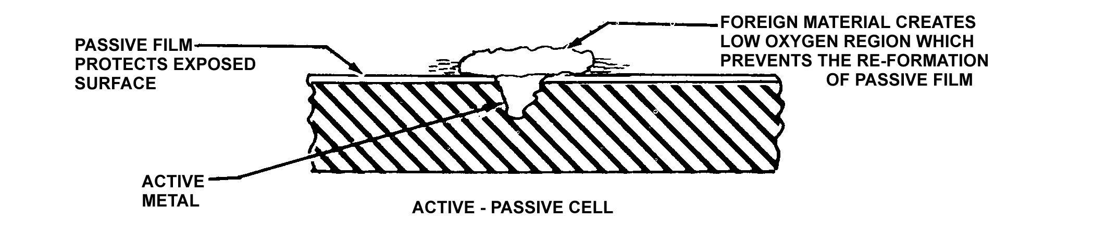
Figure 6-7. Active-passive cell.

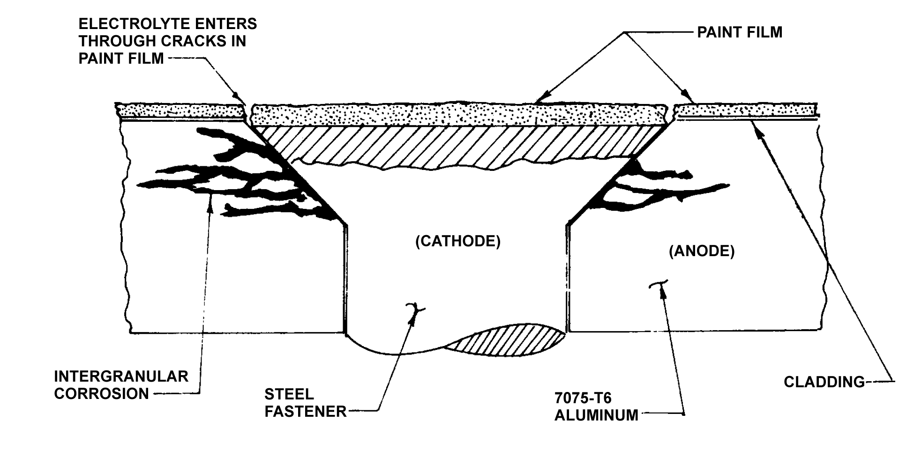
Figure 6-9. Inter-granular Corrosion of 7075-T6 aluminum adjacent to steel fastener.

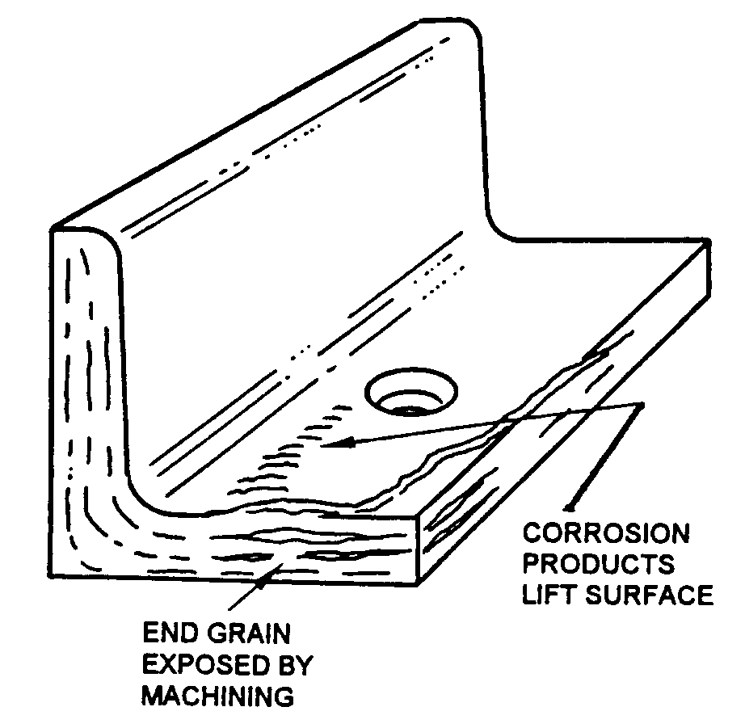
Figure 6-10. Exfoliation corrosion.

GALVANIC CORROSION. Galvanic corrosion occurs when two dissimilar metals make contact in the presence of an electrolyte. (See figure 6-11.) It is usually recognizable by the presence of a build-up of corrosion at the joint between the metals.

STRESS CORROSION CRACKING. This form of corrosion involves a constant or cyclic stress, acting in conjunction

with a damaging chemical environment. The stress may be caused by internal or external loading.

Internal stress may be trapped in a part of structure during manufacturing processes such as cold working or by unequal cooling from high temperatures. Most manufacturers follow up these processes with a stress relief operation. Even so, sometimes stress remains trapped. The stress may be externally introduced in part structure by riveting, welding, bolting, clamping, press fit, etc. If a slight mismatch occurs, or a fastener is over-torque, internal stress will be present.

Internal stress is more important than design stress, because stress corrosion is difficult to recognize before it has overcome the design safety factor. The level of stress varies from point to point within the metal. Stresses near the yield strength are generally necessary to promote stress corrosion cracking. (See figure 6-12.) However, failures may occur at lower stresses. Specific environments have been identified which cause stress corrosion cracking of certain alloys.

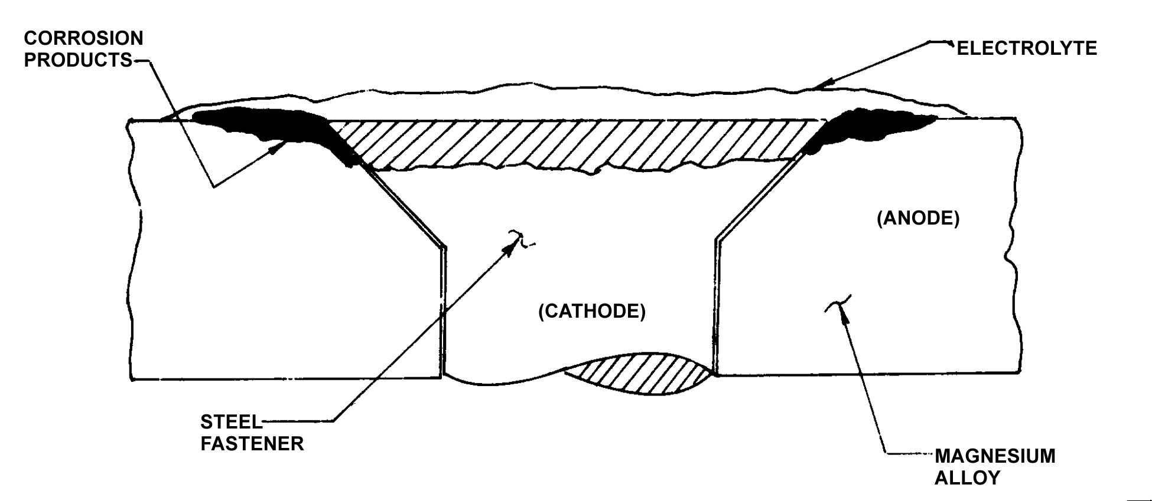
Figure 6-11. Galvanic corrosion of magnesium adjacent to steel fastener.

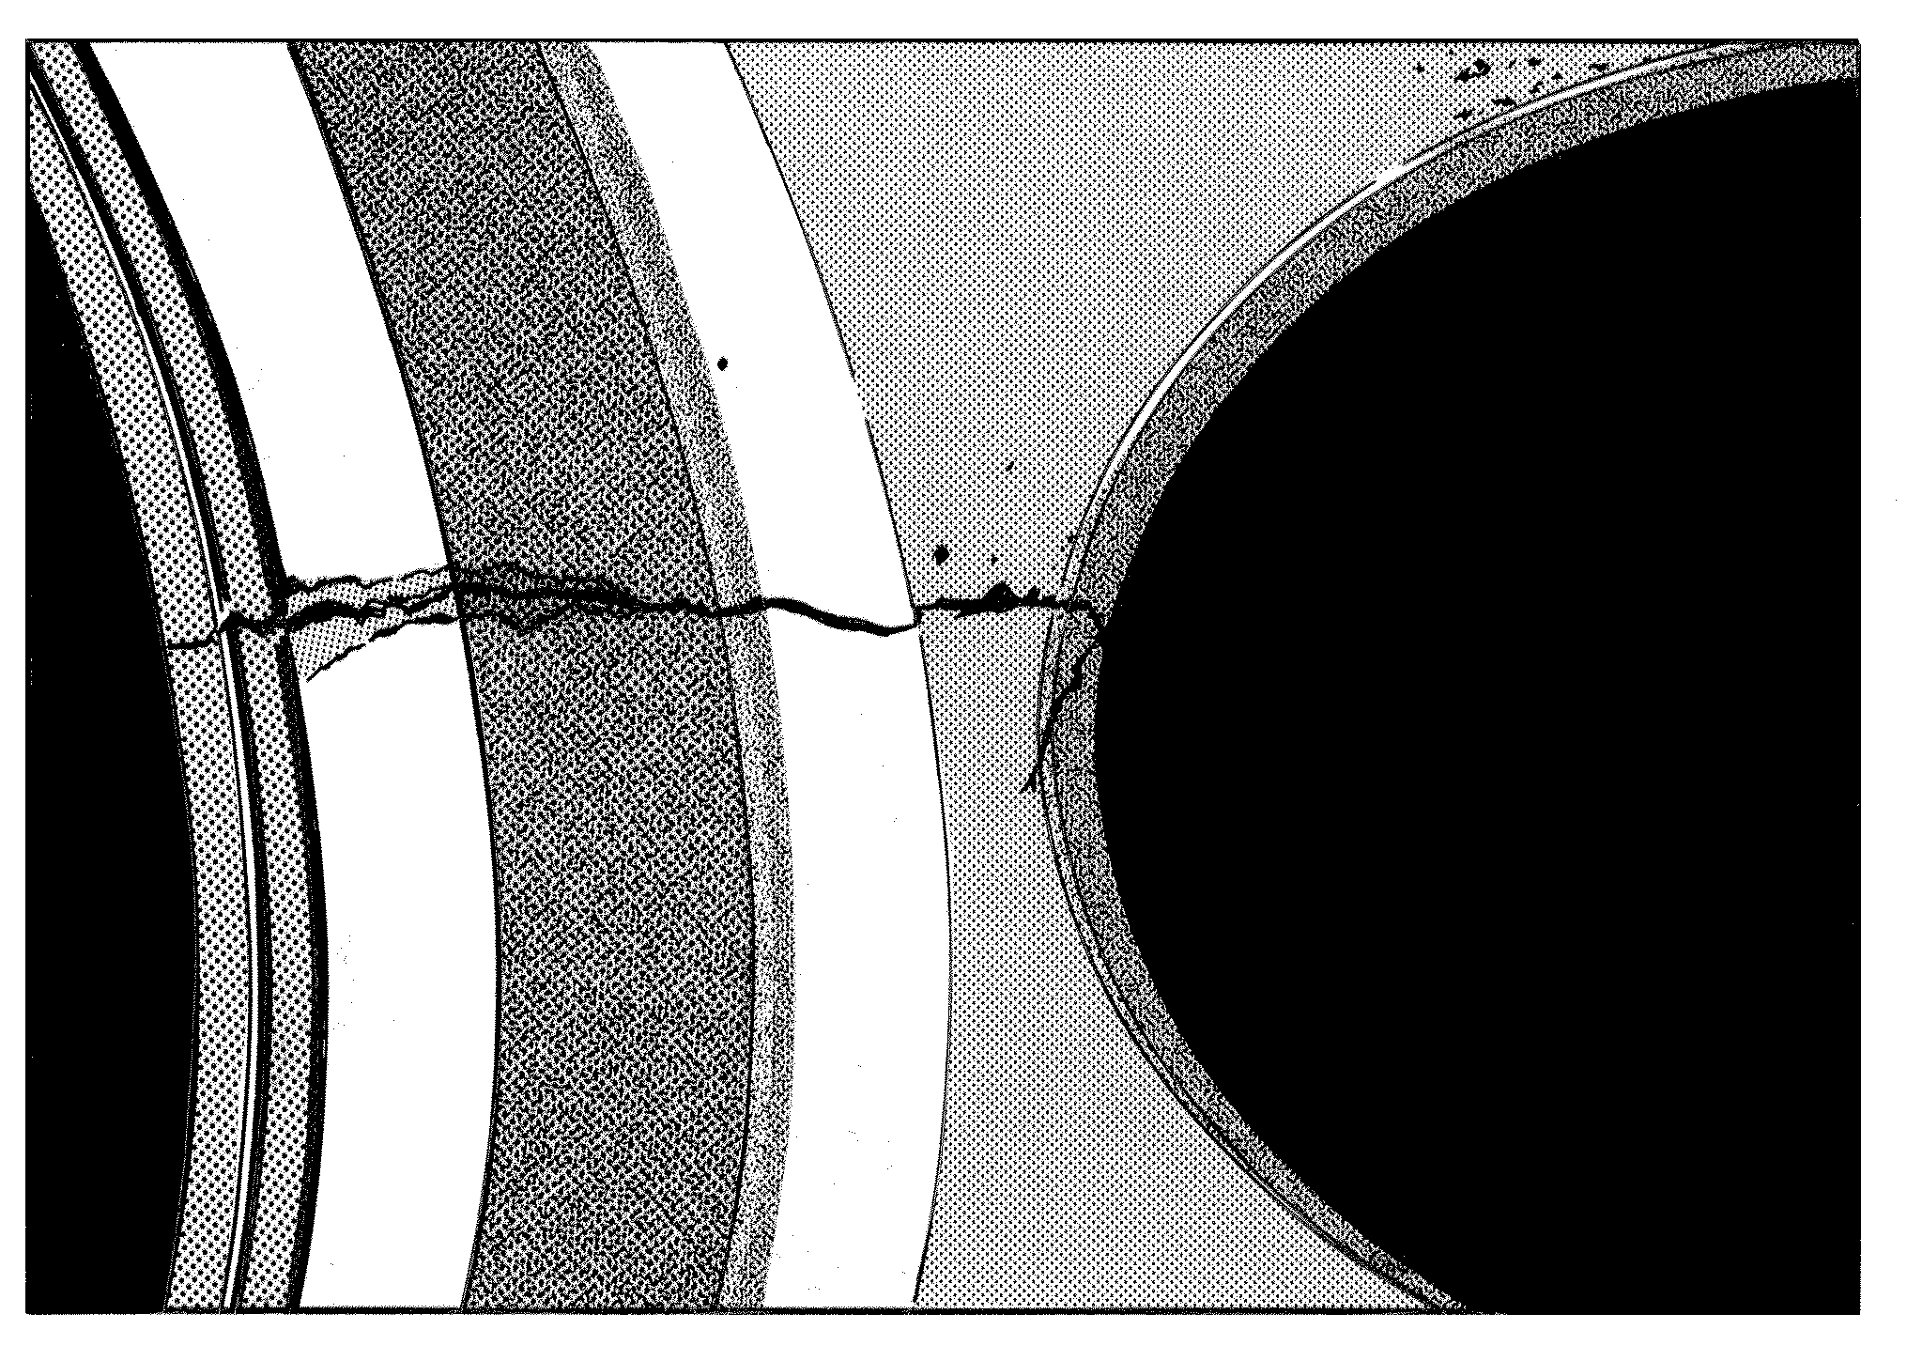
Figure 6-12. Stress corrosion cracking.

Salt solutions and sea water cause stress corrosion cracking of high-strength, heat-treated steel and aluminum alloys.

Methyl alcohol-hydrochloric acid solutions will cause stress corrosion cracking of some titanium alloys.

Magnesium alloys may stress-corrode in moist air.

Stress Corrosion may be reduced by

- applying protective coatings,
- stress relief heat treatments,
- using corrosion inhibitors, or
- controlling the environment.

FATIGUE CORROSION. Fatigue corrosion involves cyclic stress and a corrosive environment. Metals may withstand cyclic stress for an infinite number of cycles so long as the stress is below the endurance limit of the metal. Once the limit has been exceeded, the metal will eventually crack and fail from metal fatigue. However, when the part or structure undergoing cyclic stress is also exposed to a corrosive environment, the stress level for failure may be reduced many times. Thus, failure occurs at stress levels that can be dangerously low depending on the number of cycles assigned to the life-limited part.

Fatigue corrosion failure occurs in two stages. During the first stage the combined action of corrosion and cyclic stress damages the metal by pitting and crack formations to such a degree that fracture by cyclic stress will occur, even if the corrosive environment is completely removed.

The second stage is essentially a fatigue stage in which failure proceeds by propagation of the crack (often from a corrosion pit or pits). It is controlled primarily by stress concentration effects and the physical properties of the metal. Fracture of a metal part due to fatigue corrosion, generally occurs

at a stress level far below the fatigue limit of an uncorroded part, even though the amount of corrosion is relatively small.

FRETTING CORROSION. Fretting corrosion,(also known as wear corrosion or friction oxidation) can occur at the interface of two highly-loaded surfaces which are not supposed to move against each other. However, vibration may cause the surfaces to rub together resulting in an abrasive wear known as fretting. (See figure 6-13.) The protective film on the metallic surfaces is removed by this rubbing action. With continued rubbing, metal particles sheared from the surface of the metal combine with oxygen to form metal oxide. As these oxides accumulate, they cause damage by abrasive action and increased local stress. The most common example of fretting corrosion is the smoking rivet found on engine cowling and wing skins. This is one corrosion reaction that is not driven by an electrolyte, and in fact, moisture may inhibit the reaction.

Application of a lubricant or installation of a fretting-resistant material between the two surfaces can reduce fretting corrosion.

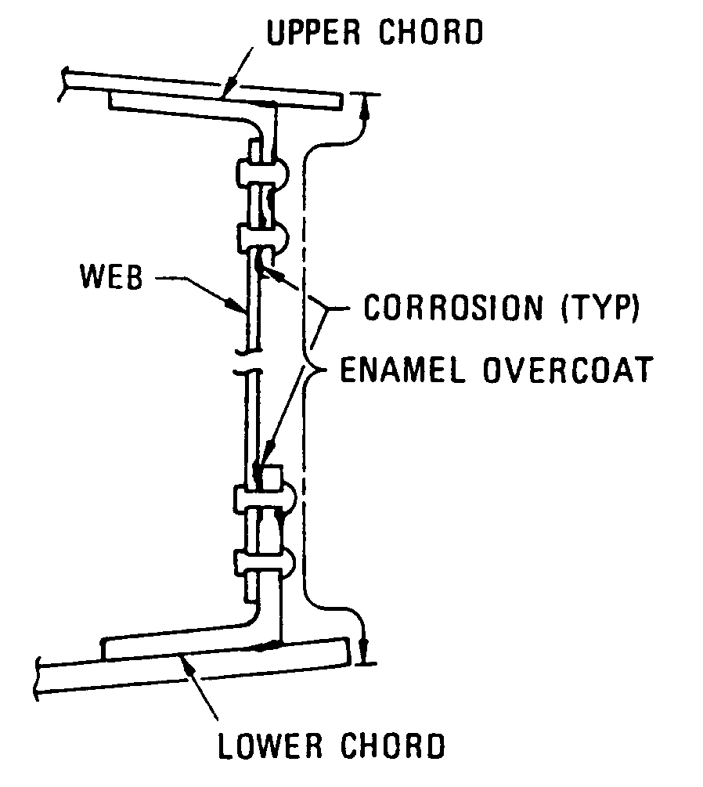
Figure 6-13. Fretting corrosion.

6-23.⎯6-28. [RESERVED.]

