Section 7. SAFETYING

GENERAL. The word safetying is a term universally used in the aircraft industry. Briefly, safetying is defined as: “Securing by various means any nut, bolt, turnbuckle etc., on the aircraft so that vibration will not cause it to loosen during operation.” These practices are not a means of obtaining or maintaining torque, rather a safety device to prevent the disengagement of screws, nuts, bolts, snap rings, oil caps, drain cocks, valves, and parts. Three basic methods are used in safetying; safety-wire, cotter pins, and self-locking nuts. Retainer washers and pal nuts are also sometimes used.

Wire, either soft brass or steel is used on cylinder studs, control cable turnbuckles, and engine accessory attaching bolts.

Cotter pins are used on aircraft and engine controls, landing gear, and tailwheel assemblies, or any other point where a turning or actuating movement takes place.

Self-locking nuts are used in applications where they will not be removed often. Repeated removal and installation will cause the self-locking nut to lose its locking feature. They should be replaced when they are no longer capable of maintaining the minimum prevailing torque. (See table 7-2.)

Pal or speed nuts include designs which force the nut thread against the bolt or screw thread when tightened. These nuts should never be reused and should be replaced with new ones when removed.

SAFETY WIRE. Do not use stainless steel, monel, carbon steel, or aluminum alloy safety wire to secure emergency mechanisms such as switch handles, guards covering handles used on exits, fire extinguishers,

emergency gear releases, or other emergency equipment. Some existing structural equipment or safety-of-flight emergency devices require copper or brass safety wire (.020 inch diameter only). Where successful emergency operation of this equipment is dependent on shearing or breaking of the safety wire, particular care should be used to ensure that safetying does not prevent emergency operation.

There are two methods of safety wiring; the double-twist method that is most commonly used, and the single-wire method used on screws, bolts, and/or nuts in a closely-spaced or closed-geometrical pattern such as a triangle, square, rectangle, or circle. The single-wire method may also be used on parts in electrical systems and in places that are difficult to reach. (See figures 7-3 and 7-3a.)

When using double-twist method of safety wiring, .032 inch minimum diameter wire should be used on parts that have a hole diameter larger than .045 inch. Safety wire of .020 inch diameter (double strand) may be used on parts having a nominal hole diameter between .045 and .062 inch with a spacing between parts of less than 2 inches. When using the single-wire method, the largest size wire that the hole will accommodate should be used. Copper wire (.020 inch diameter), aluminum wire (.031 inch diameter), or other similar wire called for in specific technical orders, should be used as seals on equipment such as first-aid kits, portable fire extinguishers, emergency valves, or oxygen regulators.

CAUTION: Care should be taken not to confuse steel with aluminum wire.

A secure seal indicates that the component has not been opened. Some emergency devices require installation of brass or soft

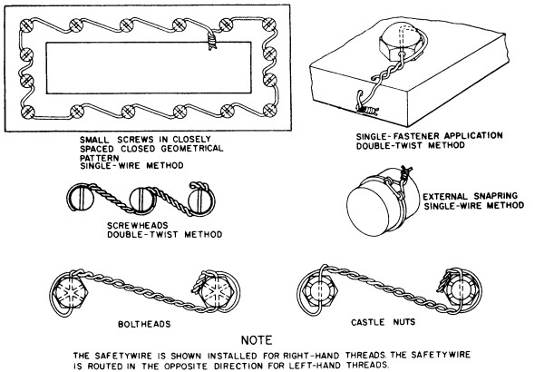

Figure 7-3. Securing screws, nuts, bolts, and snaprings.

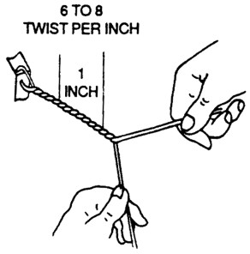
Figure 7-3a. Wire twisting by hand.

copper shear safety wire. Particular care should be exercised to ensure that the use of safety wire will not prevent emergency operation of the devices.

SAFETY-WIRING PROCEDURES. There are many combinations of safety wiring with certain basic rules common to all applications. These rules are as follows.

When bolts, screws, or other parts are closely grouped, it is more convenient to safety wire them in series. The number of bolts, nuts, screws, etc., that may be wired together depends on the application.

Drilled boltheads and screws need not be safety wired if installed with self-locking nuts.

To prevent failure due to rubbing or vibration, safety wire must be tight after installation.

Safety wire must be installed in a manner that will prevent the tendency of the part to loosen.

Safety wire must never be over-stressed. Safety wire will break under vibrations if twisted too tightly. Safety wire must be pulled taut when being twisted, and maintain a light tension when secured. (See figure 7-3a.)

Safety-wire ends must be bent under and inward toward the part to avoid sharp or projecting ends, which might present a safety hazard.

Safety wire inside a duct or tube must not cross over or obstruct a flow passage when an alternate routing can be used.

Check the units to be safety wired to make sure that they have been correctly torqued, and that the wiring holes are properly aligned to each other. When there are two or more units, it is desirable that the holes in the units be aligned to each other. Never overtorque or loosen to obtain proper alignment of the holes. It should be possible to align the wiring holes when the bolts are torqued within the specified limits. Washers may be used (see paragraph 7-37) to establish proper alignment. However, if it is impossible to obtain a proper alignment of the holes without undertorquing or overtorquing, try another bolt which will permit proper alignment within the specified torque limits.

To prevent mutilation of the twisted section of wire, when using pliers, grasp the wires at the ends. Safety wire must not be nicked, kinked, or mutilated. Never twist the wire ends off with pliers; and, when cutting off

ends, leave at least four to six complete turns (1/2 to 5/8 inch long) after the loop. When removing safety wire, never twist the wire off with pliers. Cut the safety wire close to the hole, exercising caution.

Install safety wire where practicable with the wire positioned around the head of the bolt, screw, or nut, and twisted in such a manner that the loop of the wire fits closely to the contour of the unit being safety wired.

TWISTING WITH SPECIAL TOOLS. Twist the wire with a wire twister as follows. (See figure 7-4.)

CAUTION: When using wire twisters, and the wire extends 3 inches beyond the jaws of the twisters, loosely wrap the wire around the pliers to prevent whipping and possible personal injury. Excessive twisting of the wire will weaken the wire.

Grip the wire in the jaws of the wire twister and slide the outer sleeve down with your thumb to lock the handles or lock the spring-loaded pin.

Pull the knob, and the spiral rod spins and twists the wire.

Squeeze handles together to release wire.

SECURING OIL CAPS, DRAIN COCKS, AND VALVES. (See figure 7-4a.) When securing oil caps and drain cocks, the safety wire should be anchored to an adjacent fillister-head screw. This method of safety wiring is applied to wingnuts, filler plugs, single-drilled head bolts, fillister-head screws, etc.; which are safety wired individually. When securing valve handles in the vertical position, the wire is looped around the threads of the pipe leading into one side of the valve,

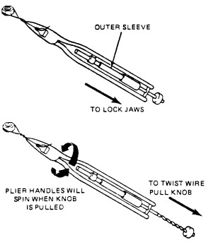
Figure 7-4. Use of a typical wire twister.

double-twisted around the valve handle, and anchored around the threads of the pipe leading into the opposite side of the valve. When castellated nuts are to be secured with safety wire, tighten the nut to the low side of the selected torque range, unless otherwise specified; and, if necessary, continue tightening until a slot lines with the hole. In blind tapped hole applications of bolts or castellated nuts on studs, the safety wiring should be in accordance with the general instructions of this chapter. Hollow-head bolts are safetied in the manner prescribed for regular bolts.

NOTE: Do not loosen or tighten properly tightened nuts to align safety-wire holes.

NOTE: Although there are numerous safety wiring techniques used to secure aircraft hardware, practically all are derived from the basic examples shown in figures 7-5 through 7-5b.

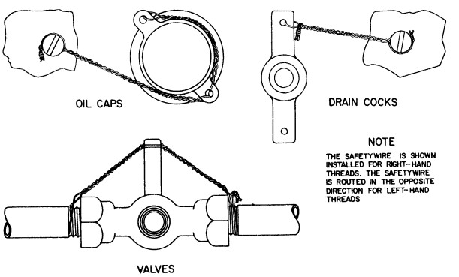
Figure 7-4a. Securing oil caps, drain cocks, and valves.

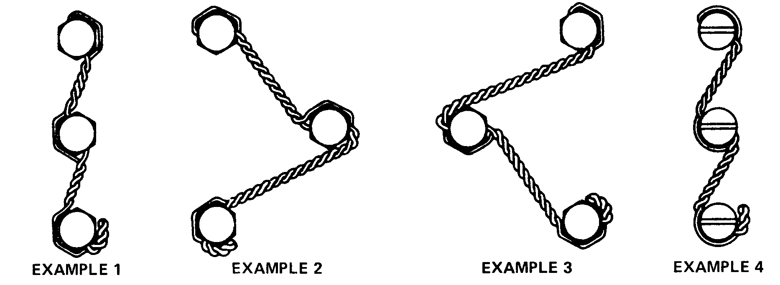
Examples 1, 2, 3, and 4 apply to all types of bolts, fillister-head screws, square-head plugs, and other similar parts which are wired so that the loosening tendency of either part is counteracted by tightening of the other part. The direction of twist from the second to the third unit is counterclockwise in examples 1, 3, and 4 to keep the loop in position against the head of the bolt. The direction of twist from the second to the third unit in example 2 is clockwise to keep the wire in position around the second unit. The wire entering the hole in the third unit will be the lower wire, except example 2, and by making a counterclockwise twist after it leaves the hole, the loop will be secured in place around the head of that bolt.
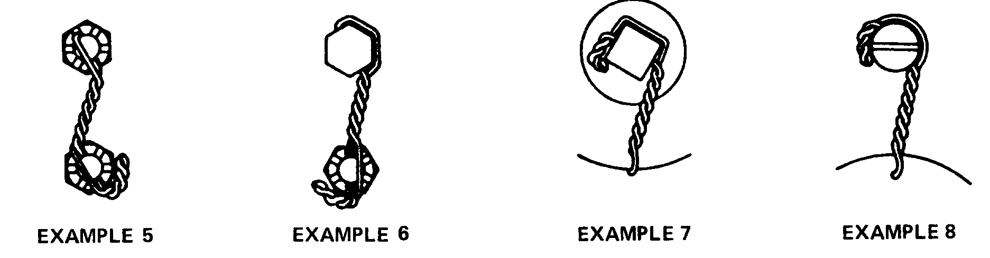
Examples 5, 6, 7, & 8 show methods for wiring various standard items, NOTE: Wire may be wrapped over the unit rather than around it when wiring castellated nuts or on other items when there is a clearance problem.
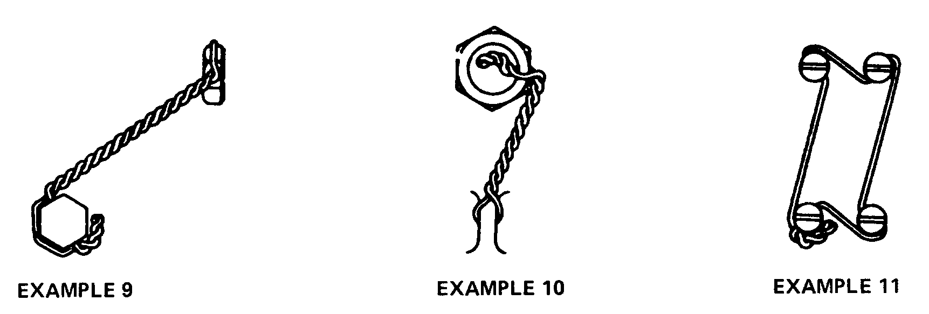

Example 9 shows the method for wiring bolts in different planes. Note that wire should always be applied so that tension is in the tightening direction.
Hollow-head plugs shall be wired as shown with the tab bent inside the hole to avoid snags and possible injury to personnel working on the engine.
Correct application of single wire to closely spaced multiple group.

Figure 7-5. Safety-wiring procedures.
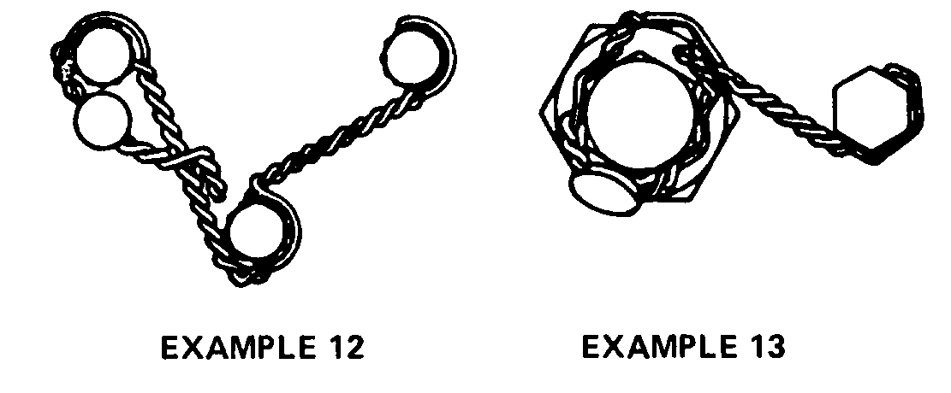
Examples 12 and 13 show methods for attaching lead seal to protect critical adjustments.
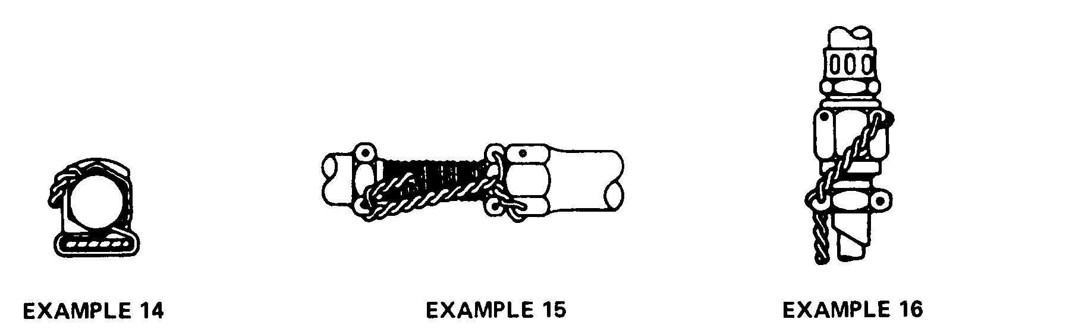

Example 14 shows bolt wired to a right-angle bracket with the wire wrapped around the bracket.
Example 15 shows correct method for wiring adjustable connecting rod.
Example 16 shows correct method for wiring the coupling nut on flexible line to the straight connector brazed on rigid tube.

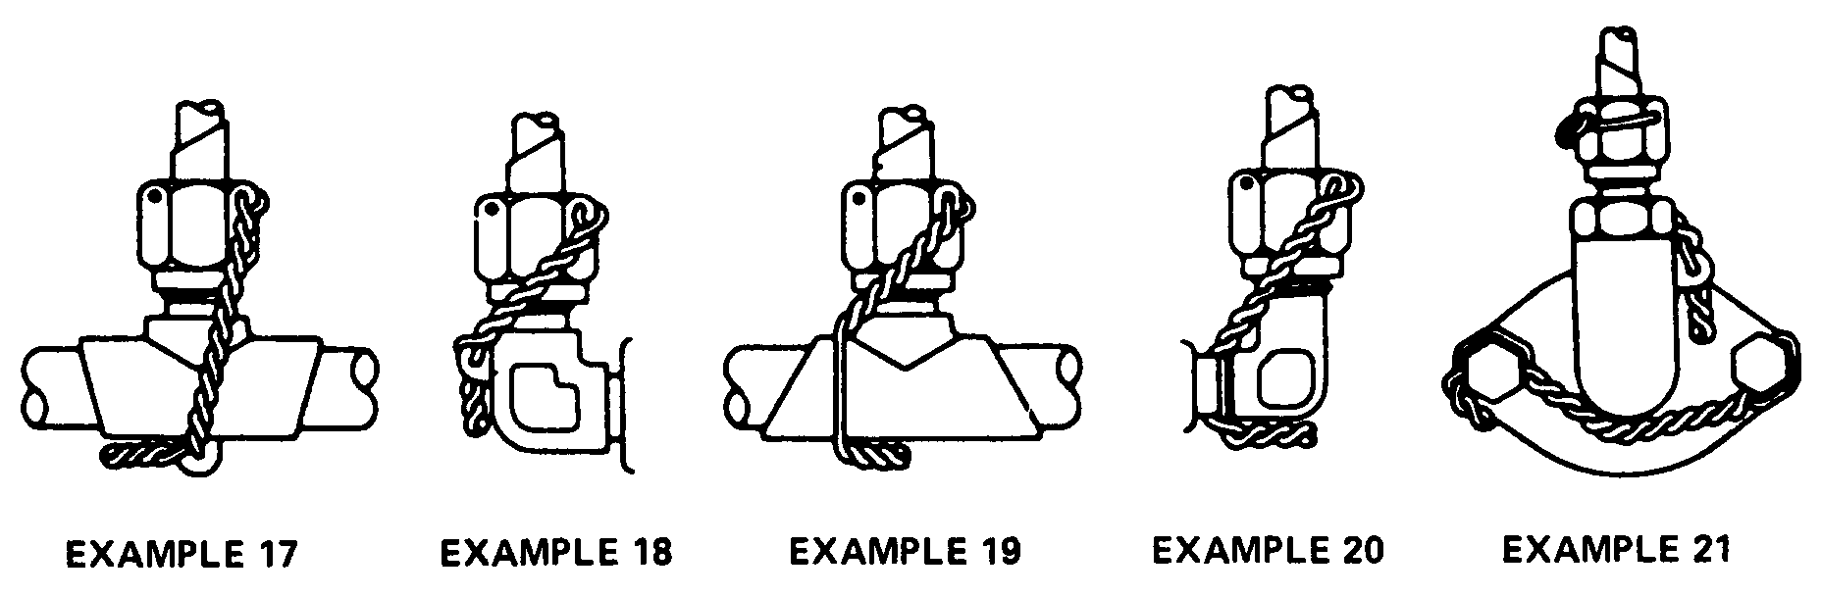

Fittings incorporating wire lugs shall be wired as shown in Examples 17 and 18. Where no lock-wire lug is provided, wire should be applied as shown in examples 19 and 20 with caution being exerted to ensure that wire is wrapped tightly around the fitting.
Small size coupling nuts shall be wired by wrapping the wire around the nut and inserting it through the holes as shown.

Figure 7-5a. Safety-wiring procedures.

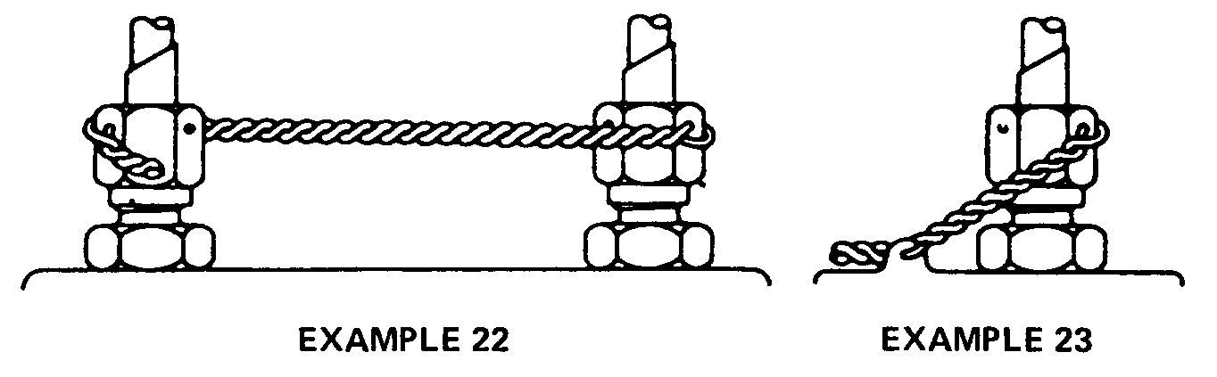
Coupling nuts attached to straight connectors shall be wired as, shown, when hex is an integral part of the connector.
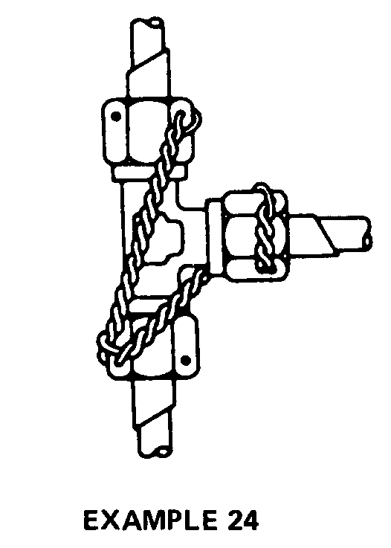
Coupling nuts on a tee shall be wired, as shown above, so that tension is always in the tightening direction.

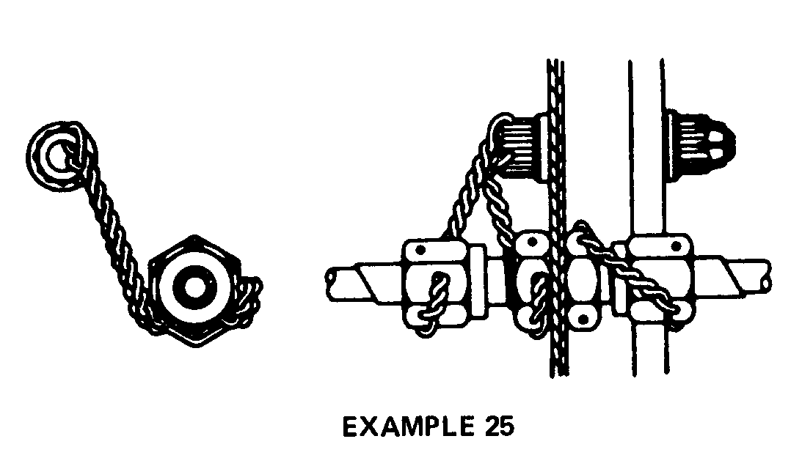
Straight Connector (Bulkhead Type)

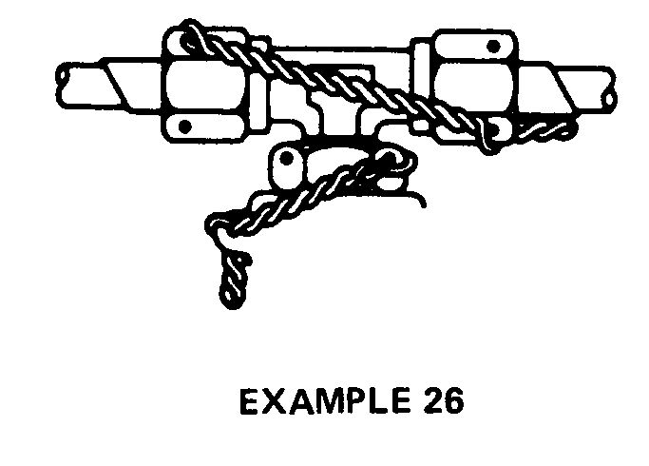

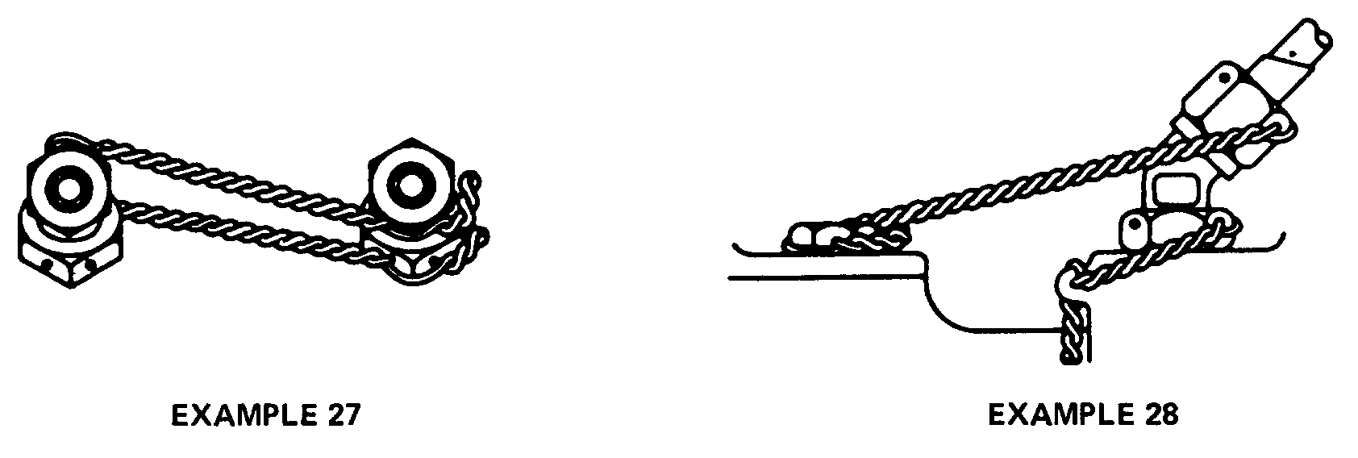
Examples 26, 27, and 28 show the proper method for wiring various standard fittings with checknut wired independently so that it need not be disturbed when removing the coupling nut.

Figure 7-5b. Safety-wiring procedures.

SECURING WITH COTTER PINS.

Cotter pins are used to secure such items as bolts, screws, pins, and shafts. Their use is favored because they can be removed and installed quickly. The diameter of the cotter pins selected for any application should be the largest size that will fit consistent with the diameter of the cotter pin hole and/or the slots in the nut. Cotter pins should not be re-used on aircraft.

To prevent injury during and after pin installation, the end of the cotter pin can be rolled and tucked.

NOTE: In using the method of cotter pin safetying, as shown in figures 7-6 and 7-7, ensure the prong, bent over the bolt, is seated firmly against the bolt shank, and does not exceed bolt diameter. Also, when the prong is bent over the nut, ensure the bent prong is down and firmly flat against the nut and does not contact the surface of the washer.

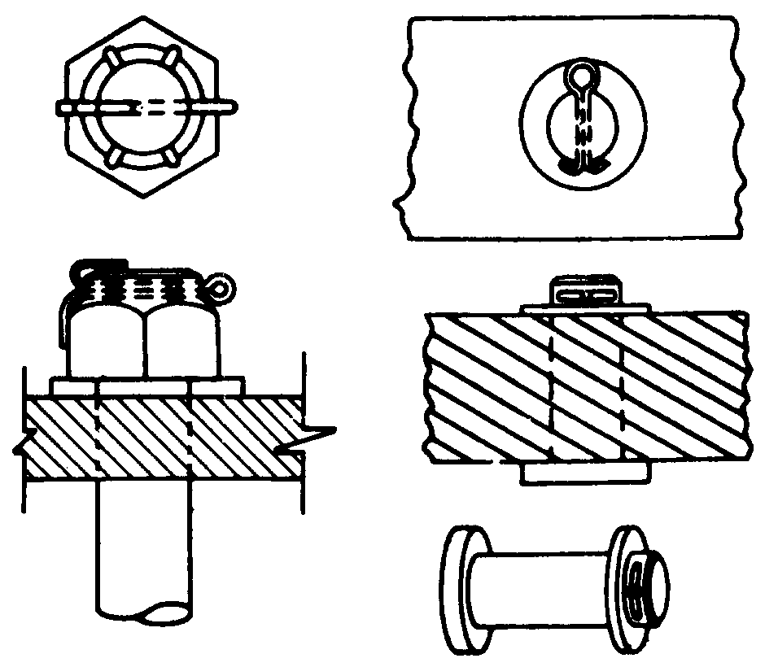
Figure 7-6. Securing with cotter pins.

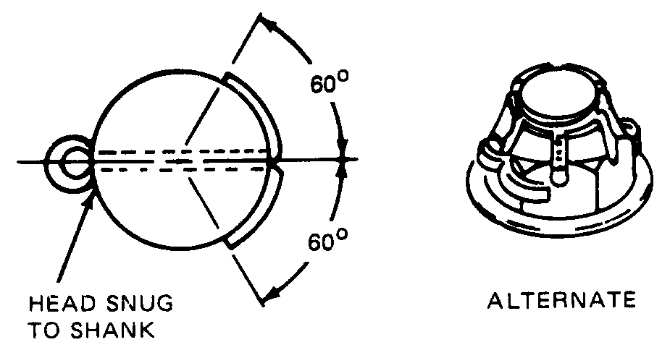
Figure 7-7. Alternate method for securing with cotter pins.

7-128.⎯7-139. [RESERVED.]

