Section 9. TURNBUCKLES

GENERAL. A turnbuckle is a device used in cable systems to provide a means of adjusting tension. Turnbuckles have barrel-shaped sleeves with internal left- and right-hand threads at opposite ends. The cables, with terminals attached, are made to such a length that, when the turnbuckle is adjusted to give the specified cable tension, a sufficient number of threads on the terminal ends are screwed into the barrel to hold the load. The clip-locking turnbuckle and its associated parts are identical to standard AN and MS parts except for a slot grooved on the interior of the barrel and the shanks of the forks, eyes, etc. The clip-locking turnbuckle parts have the following drawing numbers: MS21251, turnbuckle body; MS21252, turnbuckle clevis end; MS21253, turnbuckle clevis end (for bearing); NAS649 and NAS651, turnbuckle clip; MS21254 and NAS648, turnbuckle eye (for pin); MS21255 and NAS647, turnbuckle eye end (for wire rope); NAS645 and NAS646, turnbuckle fork; MS21256, turnbuckle barrel locking clip; AN130-170, turnbuckle assemblies; and, MS21259 and MS21260, terminal, wire rope, stud.

NOTE: Turnbuckles showing signs of thread distortion/bending should be replaced. Turnbuckle ends are designed for providing the specified cable tension on a cable system, and a bent turnbuckle would place undesirable stress on the cable, impairing the function of the turnbuckle.

TURNBUCKLE INSTALLATION. (See figure 7-25.) When installing cable system turnbuckles, it is necessary to screw both threaded terminals into the turnbuckle barrel an equal amount. It is essential that turnbuckle terminals be screwed into the barrel so that not more than three threads on the terminal are exposed. (See figure 7-23A.) On initial installation, the turnbuckle terminals should not be screwed inside the turnbuckle barrel more than four threads. (See figure 7-23B.)

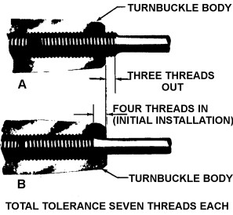
Figure 7-25. Turnbuckle thread tolerance.

WITNESS HOLE. Some manufacturers of turnbuckles incorporate a “witness hole,” in the turnbuckle barrel to ensure that the threaded cable terminals are screwed in far enough into the barrel. The “witness hole” can be inspected visually, or by using a piece of safety wire as a probe.

7-168.⎯7-178. [RESERVED.]

