Section 10. SAFETY METHODS FOR TURNBUCKLES

GENERAL. Safety all turnbuckles with safety wire using either the double or single-wrap method, or with any appropriately approved special safetying device complying with the requirements of FAA Technical Standard Order TSO-C21. The swaged and unswaged turnbuckle assemblies are covered by AN standard drawings. Do not reuse safety wire. Adjust the turnbuckle to the correct cable tension so that no more than three cable threads are exposed on either side of the turnbuckle barrel.

DOUBLE-WRAP METHOD. Of the methods using safety wire for safetying turnbuckles, the method described here is preferred, although either of the other methods described is satisfactory. The method of double-wrap safetying is shown in figure 7-26(A).

Use two separate lengths of wire. Run one end of the wire through the hole in the barrel of the turnbuckle and bend the ends of the wire toward opposite ends of the turnbuckle.

Pass the second length of the wire into the hole in the barrel and bend the ends along the barrel on the side opposite the first. Spiral the two wires in opposite directions around the barrel to cross each other twice between the center hole and the ends.

Then pass the wires at the end of the turnbuckle in opposite directions through the hole in the turnbuckle eyes or between the jaws of the turnbuckle fork, as applicable, laying one wire along the barrel and wrapping the other at least four times around the shank of the turnbuckle and binding the laid wires in place before cutting the wrapped wire off.

Wrap the remaining length of safety wire at least four turns around the shank and cut it off. Repeat the procedure at the opposite end of the turnbuckle.

When a swaged terminal is being safetied, pass the ends of both wires through the hole provided in the terminal for this purpose and wrap both ends around the shank as previously described. If the hole is not large enough to allow passage of both wires, pass the wire through the hole and loop it over the free end of the other wire, and then wrap both ends around the shank as previously described. Another satisfactory double-wrap method is similar to the previous method, except that the spiraling of the wires is omitted as shown in figure 7-26(B).

SINGLE-WRAP METHOD. The single-wrap methods described in the following paragraphs and as illustrated in figure 7-26(C) and (D) are acceptable, but are not the equal of the double-wrap methods.

Pass a single length of wire through the cable eye or fork, or through the hole in the swaged terminal at either end of the turnbuckle assembly. Spiral each of the wire ends in opposite directions around the first half of the turnbuckle barrel, so as to cross each other twice. Thread both wire ends through the hole in the middle of the barrel so that the third crossing of wire ends is in the hole, again, spiral the two wire ends in opposite directions around the remaining half of the turnbuckle, crossing them twice. Then, pass one wire end through the cable eye or fork, or through the hole in the swaged terminals, in the manner previously described. Wrap both wire ends around the shank for at least four turns each, cutting off excess wire. This method is shown in figure 7-26(C).

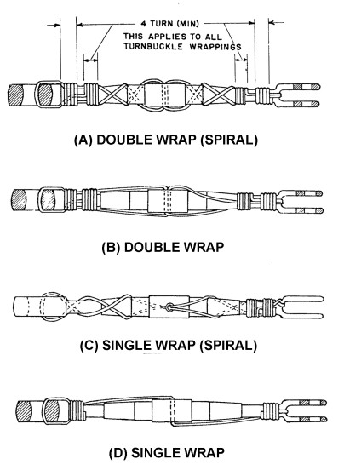
Figure 7-26. Safetying turnbuckles.

For the method shown in figure 7-26D, pass one length of wire through the center hole of the turnbuckle and bend the wire ends toward opposite ends of the turnbuckle. Then pass each wire end through the cable eye or fork, or through the hole in the swaged terminal, and wrap each wire around the shank for at least four turns, cutting off excess wire. After safetying, no more than three threads of the turnbuckle threaded terminal should be exposed.

SAFETY-WIRE SECURED TURNBUCKLES. (See figure 7-27.) Before securing turnbuckles, threaded terminals should be screwed into the turnbuckle barrel until no more than three threads of either terminal are outside the barrel. After the turnbuckle has been adjusted for proper cable tension, two pieces of safety wire are inserted, half the wire length into the hole in the center of the turnbuckle barrel. The safety-wires are bent so that each wire extends half the length of the turnbuckle on top and half on bottom. The ends of the wires are passed through the hole in the turnbuckle eyes or between the jaws of the turnbuckle fork, as applicable. The wires are then bent toward the center of the turnbuckle and each wire is wrapped around the shank four times, binding the wrapping wires in place as shown in figure 7-27.

When a swaged terminal is being secured, one wire is passed through the hole in the terminal and is looped over the free end of the other wire and both ends wrapped around the shank. All lock wire used in the safetying of turnbuckles should be carbon steel, corrosion-resistant steel, nickel-chromium iron alloy (inconel), nickel-copper alloy (monel) or aluminum alloy. For safety cable diameter of safety wire size and material, refer to table 7-8.

Care should be exercised when safety wiring, particularly where corrosion will present a problem, because smaller wire sizes tend to crack when twisted.

Table 7-8. Turnbuckle safetying guide.
Cable Size | Type of Wrap | Diameter of Safety Wire | Material (Annealed  Condition)
1/16 | Single | 0.040 | Copper, brass.¹
3/32 | Single | 0.040 | Copper, brass.¹
1/8 | Single | 0.040 | Stainless steel,  Monel and  “K” Monel.
1/8 | Double | 0.040 | Copper, brass.¹
1/8 | Single | 0.057 min. | Copper, brass.¹
5/32 and greater. | Double | 0.040 | Stainless steel,  Monel and  “K” Monel.¹
5/32 and greater | Single | 0.057 min. | Stainless steel,  Monel or  “K” Monel.¹
5/32 and greater | Double | 0.0512 | Copper, brass.

¹Galvanized or tinned steel, or soft iron wires are also acceptable.

SPECIAL LOCKING DEVICES. Several turnbuckle locking devices are available for securing turnbuckle barrels such as wire-locking clips. Persons intending to use a special device must ensure the turnbuckle assembly has been designed to accommodate such devices. A typical unit is shown in figure 7-28. When special locking devices are not readily available, the use of safety wire is acceptable.

ASSEMBLING AND SECURING CLIP-LOCKING TURNBUCKLES. (See table 7-9 and figure 7-29.) Wire clip-locking turnbuckles are assembled and secured in the following ways.

Engage threads of turnbuckle barrel with threads of cable terminal and turn barrel until proper cable tension is reached.

Align slot in barrel with slot in cable terminal.

Hold lock clip between thumb and forefinger at loop end and insert straight end of clip into opening formed by aligned slots.

Bring hook end of lock clip over hole in center of turnbuckle barrel and seat hook loop into hole.

Apply pressure to hook shoulder to engage hook lip in turnbuckle barrel and to complete safety locking of one end of turnbuckle.

NOTE: Repeat the above steps to safety lock the opposite end of turnbuckle. Both lock clips may be inserted in the same turnbuckle barrel hole or they may be inserted in opposite holes. However, do not reverse wire locking clips

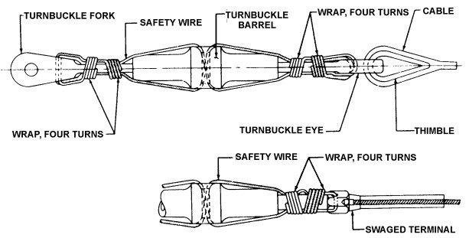
Figure 7-27. Securing turnbuckles.

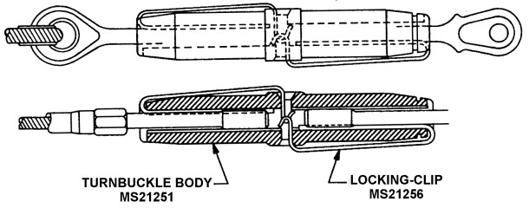

Figure 7-28. Clip-type locking device.

Table 7-9. Locking-clip application.
NOMINAL CABLE DIA. | THREAD UNF-3 | LOCKING CLIP MS21256 | TURNBUCKLE BODY MS21251
1/16 | No. 6-40 | -1 | -2S
3/32 | No. 10-32 |  | -3S
 |  | -2 | -3L
1/8 |  | -1 | -4S
 | 1/4-28 | -2 | -4L
5/32 |  | -1 | -5S
 |  | -2 | -5L
3/16 | 5/16-24 | -1 | -6S
 |  |  | -6L
7/32 | 3/8-24 | -2 | -7L
1/4 |  |  | -8L
9/32 | 7/16-20 | -3 | -9L
5/16 | 1/2-20 |  | -10L

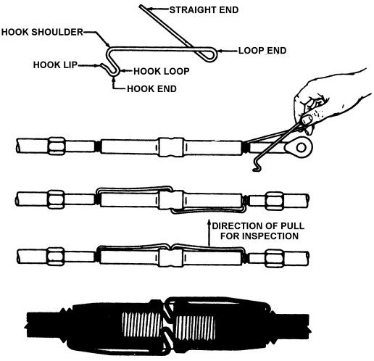

Figure 7-27. Assembling and securing clip-locking turnbuckles

7-185.⎯7-195. [RESERVED.]

