Chapter 8. ENGINES, FUEL, EXHAUST, AND PROPELLERS

Section 1. ENGINES

GENERAL. Consult the manufacturer’s manuals, service bulletins, and instruction books regarding the repair and overhaul, inspection, installation, and maintenance of aircraft engines, for that particular make, model, and type of engine. This section lists acceptable inspection and repair procedures that may be used in the absence of an engine manufacturer’s maintenance information.

SPECIAL INSPECTION. A visual inspection is needed to determine the condition of the engine and its components. An annual or 100-hour inspection should include the engine and nacelle group as follows.

Cold Cylinder Check. If an engine is running rough the cause may be a bad ignition lead, a spark plug not firing, a partially clogged fuel injector, or a bad magneto. The dead cylinder will be colder than the surrounding cylinders and can be quickly determined by using the recommended cold cylinder checks. This should be done using a thermocouple probe which is very sensitive to small differences in temperature, which is the case with a partially-clogged injector. For a carbureted engine, the following check may be helpful:

Using experienced personnel, run the engine on the bad magneto for approximately 30 seconds at 1200 rpm. Without switching the magneto switch back to both shut off the engine. Have another mechanic use a grease pencil (non-carbon), and quickly mark each exhaust stack approximately 1 inch from the flange that holds the exhaust stack to the cylinder. Next, check the exhaust stacks and look for the exhaust stack whose grease

pencil mark has not turned to a grayish-white or ash color. This is the cold cylinder.

The probable cause of the cold cylinder is either a defective spark plug or ignition lead. Switch spark plugs to another cylinder and run the test again. If the problem stays with the original cylinder, the problem is either the ignition lead or the magneto.

Piston Engine Sudden Stoppage Inspection. Sudden stoppage is a very rapid and complete stoppage of the engine. It can be caused by engine seizure or by one or more of the propeller blades striking an object in such a way that rpm goes to zero in less than one complete revolution of the propeller. Sudden stoppage can cause internal damage to constant-speed propellers; reduction drive; gear train damage in the accessory section; crankshaft misalignment; or damage to accessories such as magnetos, generators, vacuum pumps, and tach generators.

Every engine that suffers a sudden stoppage must be inspected in accordance with the manufacturer’s maintenance instructions before being returned to service.

If the engine manufacturer does not provide the required information, then the engine case must be opened and every major component part must be inspected using visual and/or nondestructive inspection (NDI) procedures as applicable.

The sudden-stoppage inspections include: checking for cowling, spinner, and airframe cracks and hidden damage; and alignment of the engine mount to the airframe,

the mounting hardware, isolation mounts, and bushings. The aircraft’s firewall must also be checked for distortion, cracks, and elongated bolt holes. The damaged propeller must be sent to an FAA-certificated repair station for complete NDI and repair.

Engine accessories such as: magnetos, starters, fuel pumps, turbochargers, alternators, or generators must be inspected in accordance with the manufacturer’s maintenance manual on sudden stoppage or overhaul procedures to determine the product’s airworthiness.

Reciprocating Engine (Direct Drive). Preliminary inspection before tear down.

Remove the engine cowling and examine the engine for visible external damage and audible internal damage.

Rotate the propeller shaft to determine any evidence of abnormal grinding or rubbing sounds.

With the propeller removed, inspect the crankshaft flange or splines for signs of twisting, cracks, or other deformation. Remove the thrust-bearing nut and seal and thoroughly inspect the threaded area of the shaft for evidence of cracks.

Rotate the shaft slowly in 90-degree increments while using a dial indicator or an equivalent instrument to check the concentricity of the shaft.

Remove the oil sump drain plug and check for metal chips and foreign material.

Remove the oil screens and inspect for metal particles and contamination.

Visually inspect engine case exterior for signs of oil leaks and cracks. Give

particular attention to the propeller thrust-bearing area of the nose case section.

Inspect cylinders and cylinder hold-down area for cracks and oil leaks. Thoroughly investigate any indication of cracks, oil leaks, or other damage.

Internal Inspection Requirements.

On engines equipped with crankshaft vibration dampers, remove and inspect the cylinders, and inspect the crankshaft dampers in accordance with the engine manufacturer’s inspection and overhaul manual. When engine design permits, remove the damper pins, and examine the pins and damper liners for signs of nicks or brinelling.

After removing the engine-driven accessories, remove the accessory drive case and examine the accessory and supercharger drive gear train, couplings, and drive case for evidence of damage.

Check for cracks in the case in the area of accessory mount pads and gear shaft bosses.

Check the gear train for signs of cracked, broken, or brinelled teeth.

Check the accessory drive shaft couplings for twisted splines, misalignment, and run-out.

Check connecting rods for cracks and straightness.

Reciprocating Engine (Gear-Drive). Inspect the engine, propeller, (refer to section 4 on propeller inspection), and components as described in the preceding paragraphs.

Remove the propeller reduction gear housing and inspect for:

Loose, sheared, or spalled cap screws or bolts.

Cracks in the case.

Disassemble the gear train and inspect the propeller shaft, reduction gears and accessory drive gears for nicks, cracks, or spalling.

Engine-Mount Inspection.

Examine the engine flex mounts when applicable, for looseness of engine to mount, distortion, or signs of wear.

Inspect the engine-mount structure for bent, cracked, or buckled tubes.

Check the adjacent airframe structure firewall for cracks, distortion, or wrinkles.

Remove engine-mount bolts and mount hold-down bolts and replace.

Exhaust-driven Supercharger
(Turbo) Inspection. Sudden stoppage of the
powerplant can cause the heat in turbine parts to heat-soak the turbine seals and bearings. This excessive heat causes carbon to develop in the seal area and varnish to form on the turbine bearings and journals.

Inspect all air ducts and connections for air leaks, warpage, or cracks.

Remove compressor housing and check the turbine wheel for rubbing or binding, and coke or varnish buildup.

NOTE: Turbine turbo supercharger disk seal rubbing is not unusual and may be a normal condition. Consult the engine manufacturer’s inspection procedures and table of limits.

Accessory and Drive Inspection. Check the drive shaft of each accessory, i.e., magnetos, generators, external superchargers, and pumps for evidence of damage.

CRANKSHAFT INSPECTION AND REPAIR REQUIREMENTS. Carefully inspect for misalignment and replace if bent beyond the manufacturer’s permissible service limit. Worn journals may be repaired by regrinding in accordance with manufacturers’ instructions. It is recommended that grinding operations be performed by appropriately-rated repair stations or the original engine manufacturer. Common errors that occur in crankshaft grinding are the removal of nitrided journal surface, improper journal radii, unsatisfactory surfaces, and grinding tool marks on the journals. If the fillets are altered, do not reduce their radii. Polish the reworked surfaces to assure removal of all tool marks. Most opposed engines have nitrided crankshafts, and engine manufacturers specify that these crankshafts must be re-nitrided after grinding.

NOTE: Rapid deceleration or momentary slowing of a propeller may occur due to contact with tall grass, water, or snow. If this occurs, the engine and propeller should be inspected in accordance with the manufacturer’s instruction or service bulletins.

REPLACEMENT PARTS IN CERTIFICATED ENGINES. Engine replacement parts must be approved under Title 14 of the Code of Federal Regulations (14 CFR), part 21. Serviceable parts obtained from the engine manufacturer, authorized service facility, and those which are approved Federal Aviation Administration (FAA)/Parts Manufacture Approval (PMA), or Technical Standard Order (TSO), and meet the requirements of part 21 are acceptable for use as replacement parts. Used engine parts can be installed
if that part either conforms to new part tolerances or meets the manufacturer’s service limits. Ensure that used parts are airworthy and properly identified as a PMA or TSO part.

OIL SYSTEM LINES INSPECTION. The inspection of the plumbing for an oil system is similar to the inspection of any other plumbing system. The tubing, hose, tube fittings, hose fittings, hose clamps, and all other components of the system are inspected for cracks, holes, dents, bulges, and other signs of damage that might restrict the oil flow or cause a leak. All lines are inspected to ensure that they are properly supported and are not rubbing against a structure. Fittings should be checked for signs of improper installation, over-torquing, excessive tension, or other conditions which may lead to failure.

OIL FILTER INSPECTION. The oil filter provides an excellent method for discovering internal engine damage. During the inspection of the engine oil filter, the residue on the screens, disks, or disposable filter cartridge and the residue in the filter housing are carefully examined for metal particles. A new engine or a newly-overhauled engine will often have a small amount of fine metal particles in the screen or filter, but this is not considered abnormal. After the engine has been operated for a time and the oil has been changed one or more times, there should not be an appreciable amount of metal particles in the oil screen. If an unusual residue of metal particles is found in the oil screen, the engine must be taken out of service and disassembled to determine the source of the particles. As an additional precaution, an oil analysis/trend analysis may prevent an engine failure in flight.
At oil changes, oil samples are often taken and sent to laboratories to be analyzed for wear by determining the amount of metal in the sample. Over time, a trend is developed and the engine can be removed from service before failure.

CYLINDER HOLD-DOWN NUTS AND CAP SCREWS. Great care is required in tightening cylinder hold-down nuts and cap screws. They must be tightened to recommended torque limits to prevent improper stressing and to ensure even loading on the cylinder flange. The installation of baffles, brackets, clips, and other extraneous parts under nuts and cap screws is not a good practice and is discouraged. If these baffles, brackets, etc., are not properly fabricated or made of suitable material, they may cause loosening of the nuts or cap screws even though the nuts or cap screws were properly tightened and locked at installation. Improper pre-stressing or loosening of any one of these nuts or cap screws will introduce the danger of progressive stud failure with the possible loss of the engine cylinder in flight.

REUSE OF SAFETYING DEVICES. Do not use cotter pins and safety wire a second time. Flat, steel-type wrist pin retainers and lock washers, likewise, must be replaced at overhaul unless the manufacturer’s recommendations permit their reuse.

SELF-LOCKING NUTS FOR AIRCRAFT ENGINES AND ACCESSORIES. Self-locking nuts may be used on aircraft engines provided the following criteria are met:

When their use is specified by the engine manufacturer in the assembly drawing, parts list, and bills of material.

When the nuts will not fall inside the engine should they loosen and come off.

When there is at least one full thread protruding beyond the nut.

Where the temperature will not exceed the maximum limits established for the self-locking material used in the nut. On many
engines the cylinder baffles, rocker box covers, drive covers and pads, and accessory and supercharger housings are fastened with fiber insert lock nuts which are limited to a maximum temperature of 250 °F. Above this temperature, the fiber insert will usually char and, consequently, lose its locking characteristic. For locations such as the exhaust pipe attachment to the cylinder, a locknut which has good locking features at elevated temperatures will give invaluable service. In a few instances, fiber insert lock nuts have been approved for use on cylinder hold-down studs. This practice is not generally recommended, since especially tight stud fits to the crankcase must be provided, and extremely good cooling must prevail so that low temperatures exist where the nut is installed.

Information concerning approved self-locking nuts and their use on specific engines are usually found in engine manufacturer’s manuals or bulletins. If the desired information is not available, it is suggested that the engine manufacturer be contacted.

Refer to Chapter 7, Aircraft Hardware, Control Cables, and Turnbuckles, for additional information on self-locking nuts.

METALLIZING. Metallizing internal parts of aircraft engines is not acceptable unless it is proven to the FAA that the metallized part will not adversely affect the airworthiness of the engine. Metallizing the finned surfaces of steel cylinder barrels with aluminum is acceptable, since many engines are originally manufactured in this manner.

PLATING. Before restoring the plating on any engine part in accordance with the manufacturer’s instructions, the part should be visually inspected and have an NDI performed before any cylinder reconditioning. In general, chromium plating would not be applied to highly-stressed engine parts. Certain applications of this nature have been found to be satisfactory; however, engineering evaluation of the details for the processes used should be obtained.

Dense chromium plating of the crankpin and main journals of some small engine crankshafts has been found satisfactory, except where the crankshaft is already marginal in strength. Plating to restore worn, low-stress engine parts, such as accessory drive shafts and splines, propeller shaft ends, and seating surfaces of roller and ball-type bearing races is acceptable but requires compliance with FAA-approved data.

Porous chromium-plated walls of cylinder barrels have been found to be satisfactory for practically all types of engines. Dense or smooth chromium plating, without roughened surfaces on the other hand, has not been found to be satisfactory.

Cylinder barrel pre-grinding and chromium plating techniques used by the military are considered acceptable for all engines, and military-approved facilities engaged in doing this work in accordance with military specifications are eligible for approval by the FAA.

Chromium-plated cylinder barrels have been required for some time to be identified in such a manner that the markings are visible with the cylinder installed. Military-processed cylinders are banded with orange enamel above the mounting flange. It has been the practice to etch on either the flange edge or on the barrel skirt the processor’s initials and the cylinder oversize. Most plating facilities use the orange band as well as the permanent identification marks.

A list of engine and maximum permissible cylinder barrel oversize are referenced in table 8-1.
Table 8-1. Current engine and maximum permissible cylinder barrel oversize.
Engine manufacturer | Engine series | Max.  oversize  (in.)
Air Cooled Motors  (Franklin) | No oversize for  sleeved cylinders.  Solid cylinders........... | 0.017
Continental Motors | R-670, W-670, R9A....  GTSIO-520, 550........  All others.................... | 0.010 to  0.020  0.005  0.015
Jacobs | All.............................. | 0.015
Kinner | All.............................. | 0.015
Pigman, LeBlond,  Rearwin, Ken  Royce | All.............................. | 0.025
Lycoming | All.............................. | 0.010 to  0.020
Menasco | All.............................. | 0.010
Pratt & Whitney | R-2800B, C, CA, CB..  *R-959 and R-1830....  All others.................... | 0.025  0.030  0.020
Ranger | 6-410 early cyls.  6-390  6-410 late cyls. 6-440  (L-440) series.. | 0.010  0.120
Warner | All.............................. | 0.015
Wright | All.............................. | 0.020
*(The above oversize limits correspond to the
manufacturer’s requirements, except for P&W R-985
and R-1830 series engines.)
NOTE: ( Check for latest manufacturer specifications.)

Cylinder barrels which have been plated by an agency whose process is approved by the FAA and which have not been worked beyond maximum permissible limits, will be considered acceptable for installation on certificated engines. It will be the responsibility of the owner or the repairing agency to provide this proof. In some cases, it may be necessary to remove cylinders to determine the amount of oversize since this information may be etched on the mating surface of the cylinder base flange.

CORROSION. Accomplish corrosion preventive measures for temporary and long-term storage in accordance with the instructions issued by the pertinent engine manufacturer. Avoid the use of solutions which contain strong caustic compounds and all solutions, polishes, cleaners, abrasives, etc., which

might possibly promote corrosive action. (Refer to Chapter 6, Corrosion, Inspection, and Protection.)

ENGINE RUN-IN. After an aircraft engine has been overhauled, it is recommended that the pertinent aircraft engine manufacturer’s run-in instructions be followed. Observe the manufacturer’s recommendations concerning engine temperatures and other criteria. Repair processes employed during overhaul often necessitate amending the manufacturer’s run-in procedures. Follow the approved amended run-in procedures in such instances.

NOTE: Do not run up engines on the ground for long periods of time with the cowling off. The engine will overheat because cylinder cooling has been disrupted.

COMPRESSION TESTING OF AIRCRAFT ENGINE CYLINDERS. A test to determine the internal condition of the combustion chamber cylinder assembly by ascertaining if any appreciable internal leakage is occurring is compression testing of aircraft engine cylinders. If a cylinder has less than a 60/80 reading on the differential test gauges on a hot engine, and procedures in paragraphs 8-15b(5)(i) and (j) fail to raise the compression reading, the cylinder must be removed and inspected. To determine the cylinder’s problem area, have someone hold the propeller at the weak cylinder’s top dead center and with compressed air still being applied, listen. If air is heard coming out of the exhaust pipe, the cylinder’s exhaust-valve is not seating properly. If air is heard leaking out of the air cleaner/carburetor heat box, the intake valve is leaking. With the oil dipstick removed, and air is rushing out, the piston rings are defective. Remove and repair/overhaul the defective cylinder.

Differential Compression Test. The most common type of compression tester currently in use is the differential pressure-type tester. It provides a cross-reference to validate the readings obtained and tends to assure that the cylinder is defective before it is removed. Before beginning a compression test, consider the following points:

When the spark plugs are removed from the engine, identify them to coincide with the cylinder and location from which they were removed. Close examination of the plugs will reveal the actual operating conditions and aid in diagnosing problems within each individual cylinder.

The operating and maintenance records of the engine should be reviewed. Records of previous compression tests are of assistance in determining progressive wear conditions and help to establish the necessary maintenance corrective actions.

Differential Pressure Compression Test. The differential pressure tester is designed to check the compression of aircraft engines by measuring the leakage through the cylinders caused by worn or damaged components. The operation of the compression tester is based on the principle that, for any given airflow through a fixed orifice, a constant pressure drop across that orifice will result. The restrictor orifice dimensions in the differential pressure tester should be sized for the particular engine as follows:

For an engine cylinder having less than a 5.00-inch bore; 0.040-inch orifice diameter; .250 inch long; and a 60-degree approach angle.

For an engine cylinder with 5.00 inch bore and over: 0.060 inch orifice diameter, .250 inch long, 60 degree approach angle.

A typical schematic diagram of the differential pressure tester is shown in
figure 8-1.

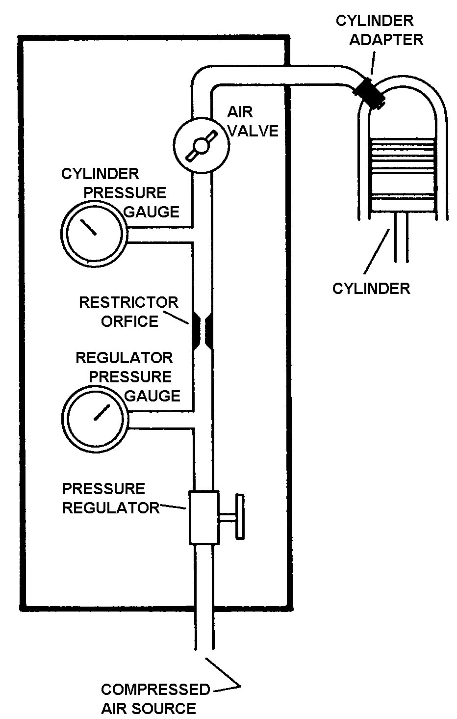
Figure 8-1. Schematic of differential pressure compression tester.

As the regulated air pressure is applied to one side of the restrictor orifice with the air valve closed, there will be no leakage on the other side of the orifice and both pressure gauges will read the same. However, when the air valve is opened and leakage through the cylinder increases, the cylinder pressure gauge will record a proportionally lower reading.

While performing the check the following procedures are listed to outline the principles involved, and are intended to supplement the manufacturer’s instructions for the particular tester being used.

Perform the compression test as soon as possible after the engine is shut down to ensure that the piston rings, cylinder walls, and other engine parts are well-lubricated.

Remove the most accessible spark plug from each cylinder.

With the air valve closed, apply an external source of clean air (approximately 100 to 120 psi) to the tester.

Install an adapter in the spark plug bushing and connect the compression tester to the cylinder.

Adjust the pressure regulator to obtain a reading of 20 psi on the regulator pressure gauge. At this time, the cylinder pressure gauge should also register 20 psi.

Turn the crankshaft, by hand, in the direction of rotation until the piston (in the cylinder being checked) is coming up on its compression stroke. Slowly open the air valve and pressurize the cylinder to 80 psi.

CAUTION: Care must be exercised in opening the air valve since sufficient air pressure will have built up in the cylinder to cause it to rapidly rotate the propeller if the piston is not at top dead center (TDC).

Continue rotating the engine against this pressure until the piston reaches TDC. Reaching TDC is indicated by a flat spot or sudden decrease in force required to turn the crankshaft. If the crankshaft is rotated too far, back up at least one-half revolution and start over again to eliminate the effect of backlash in the valve operating mechanism and to keep piston rings seated on the lower ring lands.

Open the air valve completely. Check the regulated pressure and readjust, if necessary, to read 80 psi.

Observe the pressure indication of the cylinder pressure gauge. The difference between this pressure and the pressure shown by the regulator pressure gauge is the amount of leakage through the cylinder. A loss in excess of 25 percent of the input air pressure is cause to suspect the cylinder of being defective; however, recheck the readings after operating the engine for at least 3 minutes to allow for sealing of the rings with oil.

If leakage is still occurring after a recheck, it may be possible to correct a low reading. This is accomplished by placing a fiber drift on the rocker arm directly over the valve stem and tapping the drift several times with a hammer to dislodge any foreign material between the valve face and seat.

NOTE: When correcting a low reading in this manner, rotate the propeller so the piston will not be at TDC. This is necessary to prevent the valve from striking the top of the piston in some engines. Rotate the engine before rechecking compression to reseat the valves in the normal manner.

SPARK PLUGS. The spark plug provides the high-voltage electrical spark to ignite the fuel/air mixture in the cylinder. The types of spark plugs used in different engines will vary with regard to heat range, reach, thread size, and other characteristics required by the particular installation.

Heat Range. The heat range of a spark plug is the principal factor governing aircraft performance under various service conditions. The term “heat range” refers to the
classification of spark plugs according to their ability to transfer heat from the firing end of the spark plug to the cylinder head.

Spark plugs have been classified as “hot,” “normal,” and “cold.” However, these terms may be misleading because the heat range varies through many degrees of temperature from extremely hot to extremely cold. Thus the words “hot,” “cold,” and “normal” do not necessarily tell the whole story.

Since the insulator is designed to be the hottest part of the spark plug, its temperature can be related to the pre-ignition and fouling regions as shown in figure 8-2. Pre-ignition is likely to occur if surface areas in the combustion chamber exceed critical limits or if the spark plug core nose temperature exceeds 1,630 °F (888 °C). However, fouling or short-circuiting of the plug due to carbon deposits is likely to occur if the insulator tip temperature drops below approximately 800 °F (427 °C). Since spark plugs must operate between fairly well-defined temperature limits, they must be supplied in various heat ranges to meet the requirements of different engines under a variety of operating conditions.

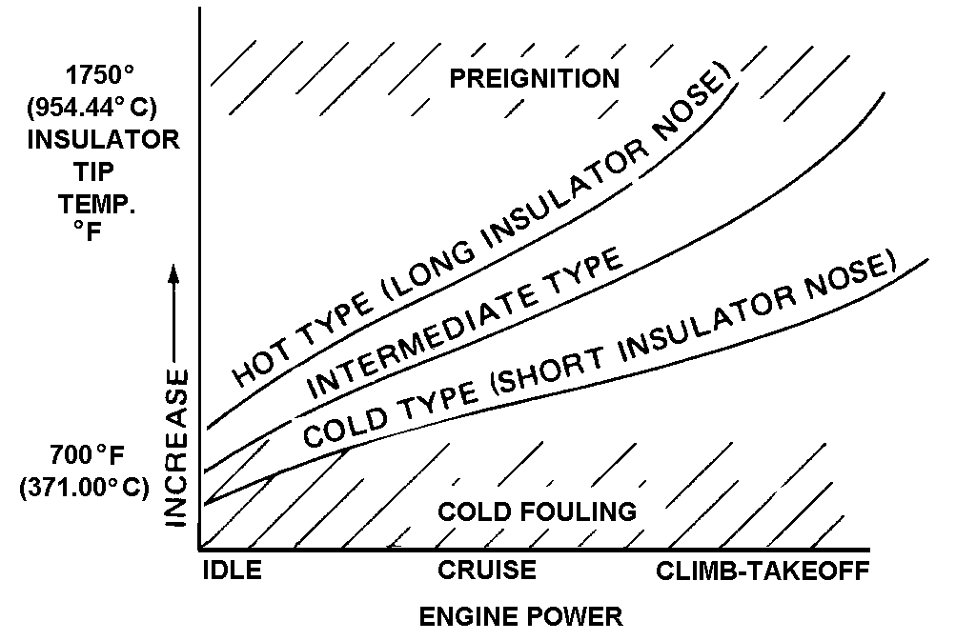
Figure 8-2. Chart of spark plug temperature ranges.

From the engineering standpoint, each individual plug must be designed to offer the widest possible operating range. This means that a given type of spark plug should operate as hot as possible at low speeds and light loads and as cool as possible under cruising and takeoff power. Plug performance, therefore, depends on the operating temperature of the insulator nose, with the most desirable temperature range falling between 1,000 °F and 1,250 °F (538 °C and 677 °C).

Fundamentally, an engine which runs hot requires a relatively cold spark plug, whereas an engine which runs cool requires a relatively hot spark plug. If a hot spark plug is installed in an engine which runs hot, the spark plug tip will be overheated and cause pre-ignition. If a cold spark plug is installed in an engine which runs cool, the tip of the spark plug will collect unburned carbon, causing fouling of the plug. The principal factors governing the heat range of aircraft spark plugs are:

the distance between the copper sleeve around the insulator and the insulator tip;

the thermal conductivity of the insulating material;

the thermal conductivity of the electrode;

the rate of heat transfer between the electrode and the insulator;

the shape of the insulator tip;

the distance between the insulator tip and the shell; and

the type of outside gasket used.

“Hot” plugs have a long insulator nose; thereby, creating a long heat transfer path, whereas “cold” plugs have a relatively short insulator to provide a rapid transfer of heat to the cylinder head. (See figure 8-3.)
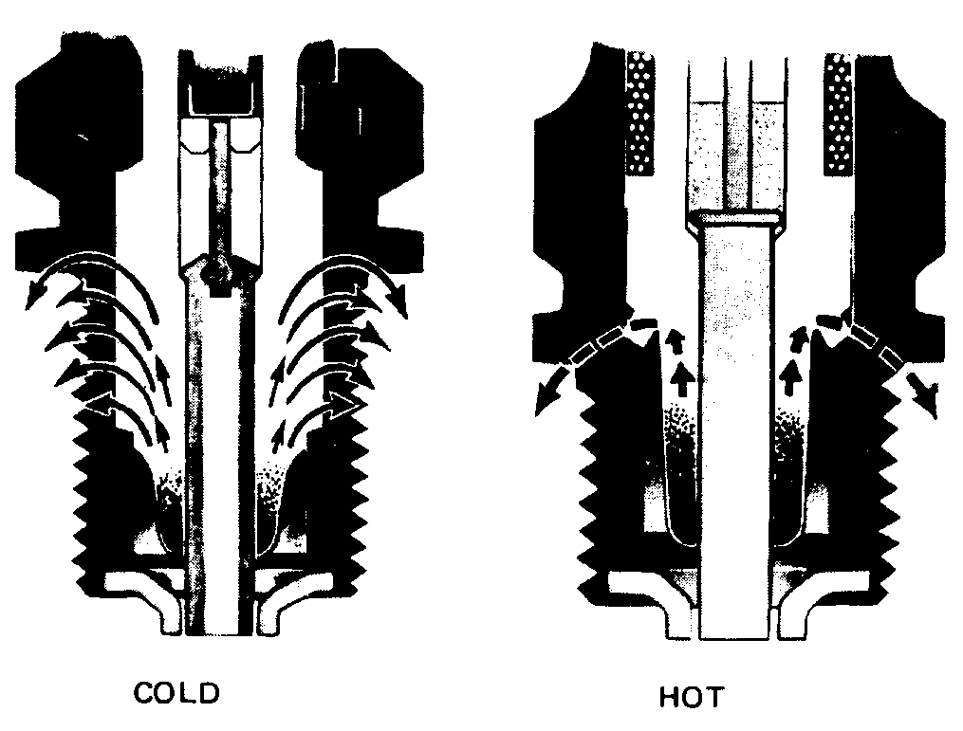
Figure 8-3. Hot and cold spark plugs.

Reach. The spark plug reach (see figure 8-4) is the threaded portion which is inserted into the spark plug bushing of the cylinder. A plug with the proper reach will ensure that the electrode end inside the cylinder is in the best position to achieve ignition. Spark plug seizure or improper combustion within the cylinder will probably occur if a plug with the wrong reach is used. Shell threads of spark plugs are classified as 14- or 18-mm spark plug diameter, long reach or short reach, thus:

Diameter | Long reach | Short reach
14 mm | 1/2 in (12.7 mm) | 3/8 in (9.53 mm)
18 mm | 13/16 in. (20.64 mm) | 1/2 in (12.7 mm)

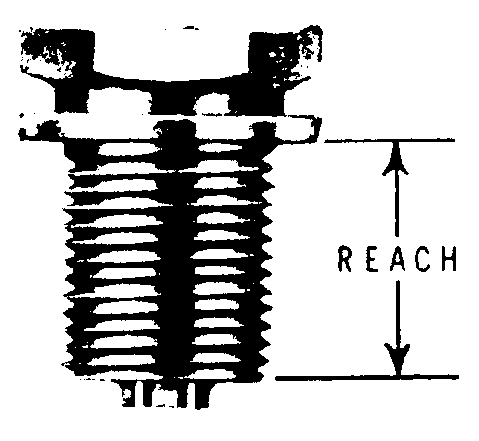
Figure 8-4. Spark plug reach.

Installation Procedures. When installing spark plugs, observe the following procedure.

Visually inspect the plug for cleanliness and condition of the threads, ceramic, and electrodes.

NOTE: Never install a spark plug which has been dropped and always use new gaskets every time you install a spark plug.

Check the plug for the proper gap setting, using a round wire feeler gauge as shown in figure 8-5. In the case of used plugs, procedures for cleaning and regapping are usually contained in the various manufacturers’ manuals.

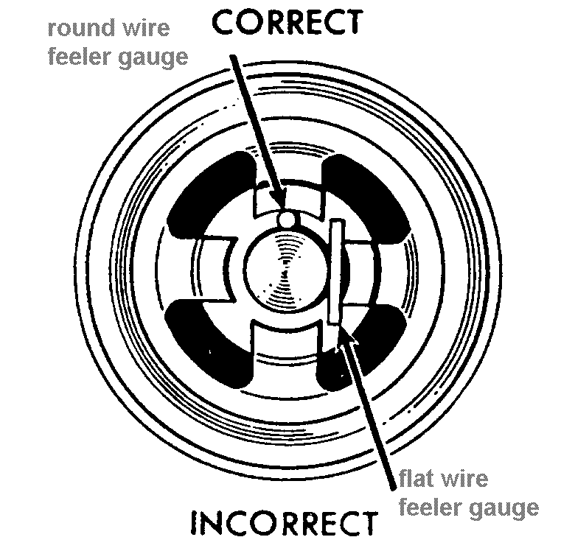
Figure 8-5. Method of checking spark plug gap.

Check the plug and cylinder bushing to ascertain that only one gasket is used per spark plug. When a thermocouple-type gasket is used, no other gasket is required.

Apply anti-seize compound sparingly to the shell threads, but do not allow the compound to contact the electrodes since the material is conductive and will short out the plug. If desired, the use of anti-seize compound may be eliminated on engines equipped with stainless steel spark plug bushings or
inserts.

Screw the plug into the cylinder head as far as possible by hand. If the plug will not turn easily to within two or three threads of the gasket, it may be necessary to clean the threads.

NOTE: Cleaning inserts with a tap is not recommended as permanent damage to the insert may result.

Seat the proper socket securely on the spark plug and tighten to the torque limit specified by the engine manufacturer before proceeding to the next plug.

CAUTION: A loose spark plug will not transfer heat properly, and during engine operation, may overheat to the point the nose ceramic will become a “hot spot” and cause pre-ignition. However, avoid over-tightening as damage to the plug and bushing may result.

Connect the ignition lead after wiping clean with a dry, lint-free cloth. Insert the terminal assembly into the spark plug in a straight line. (Care should be taken as improper techniques can damage the terminal sleeves.) Screw the connector nut into place until finger tight, then tighten an additional one quarter turn while holding the elbow in the proper position.

Perform an engine run-up after installing a new set of spark plugs. When the engine has reached normal operating temperatures, check the magnetos and spark plugs in accordance with the manufacturer’s instructions.

OPERATIONAL PROBLEMS.
Whenever problems develop during engine operation, which appear to be caused by the ignition system, it is recommended that the spark plugs and ignition harnesses be checked first before working on the magnetos. The following are the more common spark plug malfunctions and are relatively easy to identify.

Fouling.

Carbon fouling (see figure 8-6) is identified by the dull black, sooty deposits on the electrode end of the plug. Although the primary causes are excessive ground idling and rich idle mixtures, a cold heat range may also be a contributing factor.

Lead fouling is characterized by hard, dark, cinder-like globules which gradually fill up the electrode cavity and short out the plug. (See figure 8-6a.) The primary cause for this condition is poor fuel vaporization combined with a high tetraethyl-lead content fuel. A cold heat range may also contribute to this condition.

Oil fouling is identified by a wet, black carbon deposit over the entire firing end of the plug as shown in figure 8-6b. This condition is fairly common on the lower plugs in horizontally-opposed engines, and both plugs in the lower cylinders of radial engines. Oil fouling is normally caused by oil drainage past the piston rings after shutdown. However, when both spark plugs removed from the same cylinder are badly fouled with oil and carbon, some form of engine damage should be suspected, and the cylinder more closely inspected. Mild forms of oil fouling can usually be cleared up by slowly increasing power, while running the engine until the deposits are burned off and the misfiring stops.



Figure 8-6. Typical carbon-fouled spark plug.

Fused Electrodes. There are many different types of malfunctions which result in fused spark plug electrodes; however, most are associated with pre-ignition either as the cause or the effect. For this reason, any time a spark plug is found with the following defects, further investigation of the cylinder and piston should be conducted.

Occasionally, the ceramic nose core will crack, break away, and remain trapped behind the ground electrode. This piece of insulation material will then buildup heat to the point it will ignite the fuel/air mixture prematurely. The high temperatures and pressures encountered during this condition can cause damage to the cylinder and piston and ultimately lead to fusing and shorting out of the plug. (See figure 8-6c.)




Figure 8-6a. Typical lead-fouled spark plug.

Corrosive gases formed by combustion and the high voltage spark have eroded the electrodes. Spark plugs in this condition require more voltage to fire—often more than the ignition system can produce. (See figure 8-6d.)

Bridged Electrodes. Occasionally, free combustion chamber particles will settle on the electrodes of a spark plug and gradually bridge the electrode gap, resulting in a shorted plug. Small particles may be dislodged by slowly cycling the engine as described for the oil-fouled condition; however, the only remedy for more advanced cases is removal and replacement of the spark plug. This condition is shown in figure 8-6e.



Figure 8-6b. Typical oil-fouled spark plug.

Metal Deposits. Whenever metal spray is found on the electrodes of a spark plug, it is an indication that a failure of some part of the engine is in progress. The location of the cylinder in which the spray is found is important in diagnosing the problem, as various types of failures will cause the metal spray to appear differently. For example, if the metal spray is located evenly in every cylinder, the problem will be in the induction system, such as an impeller failure. If the metal spray is found only on the spark plugs in one cylinder, the problem is isolated to that cylinder and will generally be a piston failure.

In view of the secondary damage which occurs whenever an engine part fails, any preliminary indication such as metal spray should be thoroughly investigated to establish and correct the cause.
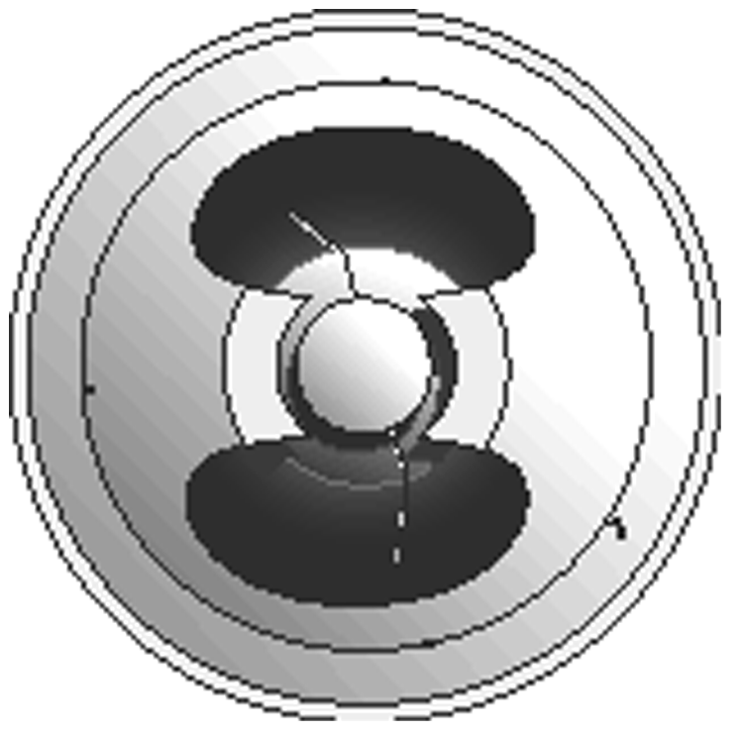


Figure 8-6c. Typical spark plug with cracked
core nose.

Flashover. It is important that spark plug terminal contact springs and moisture seals be checked regularly for condition and cleanliness to prevent “flashover” in the connector well. Foreign matter or moisture in the terminal connector well can reduce the insulation value of the connector to the point the ignition system voltages at higher power settings may flash over the connector well surface to ground and cause the plug to misfire. If moisture is the cause, hard starting can also result. The cutaway spark plug shown in figure 8-7 illustrates this malfunction. Any spark plug found with a dirty connector well may have this condition, and should be reconditioned before reuse.




Figure 8-6d. Typical worn out spark plug.

SPARK PLUG PRE-RECONDI-
TIONING INSPECTION. All spark plugs should be inspected visually before reconditioning to eliminate any plug with obvious defects. A partial checklist of common defects includes:

Chipped or cracked ceramic either at the nose core or in the connector well.

Damaged or badly worn electrodes.

Badly nicked, damaged, or corroded threads on shell or shielding barrel.

Dented, bent, or cracked shielding
barrel.

Connector seat at the top of the shielding barrel badly nicked or corroded.



Figure 8-6e. Typical spark plug with bridged electrodes.

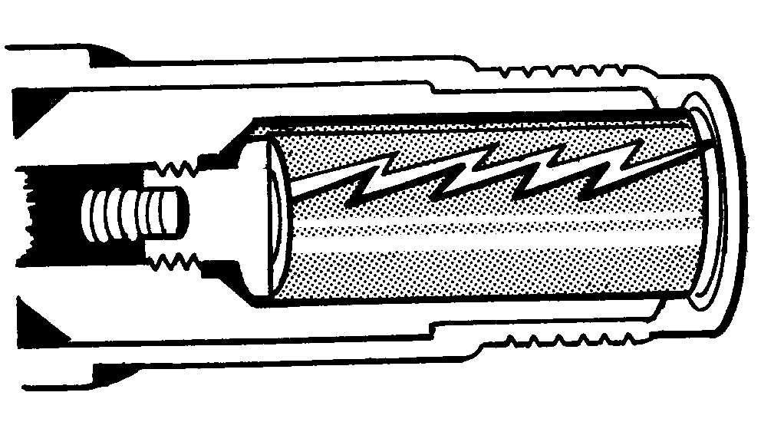
Figure 8-7. Spark plug well flashover.

IGNITION HARNESSES INSPECTION. Aircraft-quality ignition harness is usually made of either medium or high-temperature wire. The type used will depend upon the manufacturing specification for the particular engine. In addition to the applicable manufacturer’s maintenance and repair procedures, the following is a quick-reference checklist for isolating some of the malfunctions inherent to ignition harnesses.

Carefully inspect the lead conduit or shielding. A few broken strands will not affect serviceability, but if the insulation in general looks worn, replace the lead.

When replacing a lead, if the dressing procedure is not accomplished properly, strands of shielding may be forced through the conductor insulation. If this occurs, a short will exist in the conductor; therefore, it is essential this task be performed properly.

The high-temperature coating used on some lightweight harnesses is provided for vibration abrasion resistance and moisture protection. Slight flaking or peeling of this coating is not serious, and a harness assembly need not be removed from service because of this condition.

Check the spark plug contact springs for breaks, corrosion, or deformation. If possible, check the lead continuity from the distributor block to the contact spring.

Check the insulators at the spark plug end of the lead for cracks, breaks, or evidence of old age. Make sure they are clean.

Check to see that the leads are positioned as far away from the exhaust manifold as possible and are supported to prevent any whipping action.

When lightweight harnesses are used and the conduit enters the spark plug at a severe angle, use clamps as shown in figure 8-8 to prevent overstressing the lead.

MAGNETO INSPECTION. Whenever ignition problems develop and it is determined that the magneto is the cause of the difficulty, the following are a few simple inspection procedures which may locate the malfunction quickly. However, conduct any internal inspection or repair of a magneto in accordance with the manufacturer’s maintenance and overhaul manuals.

Inspect the distributor block contact springs. If broken or corroded, replace.

Inspect the felt oil washer, if applicable. It should be saturated with oil. If it is dry, check for a worn bushing.

Inspect the distributor block for cracks or a burned area. The wax coating on the block should not be removed. Do not use any solvents for cleaning.

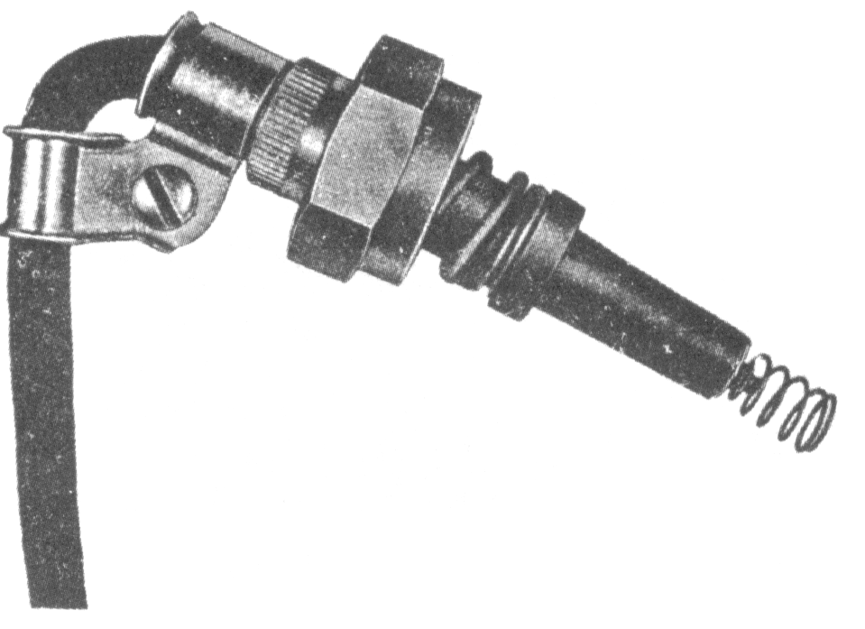
Figure 8-8. Typical method of clamping leads.

Look for excess oil in the breaker compartment. If oil is present, it may indicate a bad oil seal or bushing at the drive end. This condition could require complete overhaul, as too much oil may foul and cause excessive burning of the contact points.

Look for frayed insulation on the leads in the breaker compartment of the magneto. See that all terminals are secure. Be sure that wires are properly positioned.

Inspect the capacitor visually for general condition, and check the mounting bracket for cracks or looseness. If possible, check the capacitor for leakage, capacity, and series resistance.

Examine the points for excessive wear or burning. Discard points which have deep pits or excessively burned areas. Desired contact surfaces have a dull gray, sandblasted (almost rough) or frosted appearance over the area where electrical contact is made. Figure 8-9 shows how the normal contact point will look when surfaces are separated for inspection. Minor irregularities or roughness of point surfaces are not harmful (see figure 8-10), neither are small pits or mounds, if not too pronounced. If there is a possibility of the pit becoming deep enough to penetrate the pad (see figure 8-11), reject the contact assembly.

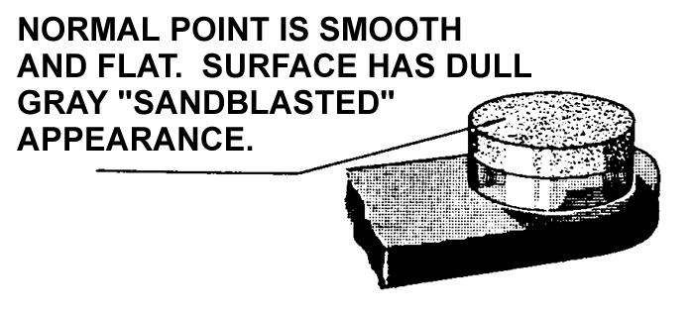
Figure 8-9. Normal contact point.

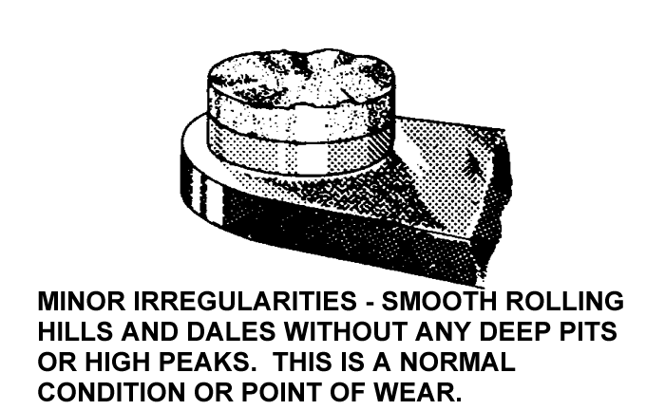
Figure 8-10. Point with minor irregularities.

Generally, no attempt should be made to dress or stone contact point assemblies; however, if provided, procedures and limits contained in the manufacturer’s manuals may be followed.

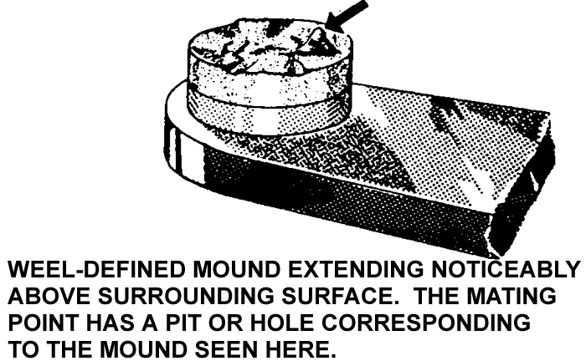
Figure 8-11. Point with well-defined mound.

CAUTION: When inspecting the contact points for condition, do not open further than absolutely necessary. Excess tension on the spring will weaken it and adversely affect the performance of the magneto.

Adjustment of magneto point gaps must be correct for proper internal timing of a magneto. See applicable manufacturer’s publications for internal timing procedures.

Check the breaker cam to assure cleanness and smoothness. Check the cam screw for tightness. If new points have been installed, blot a little oil on the cam. In addition, check contact point assembly to ascertain that the cam follower is securely fastened.

If the impulse coupling is accessible, inspect for excessive wear on the contact edges of the body and flyweights. In addition, check the flyweights for looseness on the axles.

Further examination of the impulse coupling body may disclose cracks caused by exceedingly-tight flyweight axle rivets.

Check the magneto ventilators for proper functioning and obstructions. If drilled plugs are used, they should be in the lowest vent hole of the magneto to serve as a drain for condensation and oil.

MAGNETO-TO-ENGINE TIMING. While the actual process of timing magnetos to an engine is covered in the engine manufacturer’s technical manuals, the following general procedures may be applied.

Before installing a new magneto, the correct “E” gap setting specified by the magneto manufacturer should be verified.

When setting or checking the magneto-to-engine timing, always turn the crankshaft steadily in the normal direction of rotation to eliminate any error caused by gear backlash.

Recheck magneto-to-engine timing after any point-gap adjustment, or after replacement of the breaker points.

Never advance the magneto timing beyond the engine timing specification recommended by the engine manufacturer.

The possibility of a timing error exists if a timing indicator which attaches to the propeller shaft or spinner of geared engines is used. Engine timing specifications are always given in degrees of crankshaft travel and cannot be applied directly to geared propeller shafts because of the gear ratio. Therefore, the correct position of the propeller shaft, if used for timing, must be determined by multiplying the crankshaft timing angle in degrees before top center (BTC) by the propeller gear ratio.

8-21.⎯8-29. [RESERVED.]

