Section 4. REPAIR OF METAL PROPELLERS

GENERAL. Reject damaged blades with model numbers which are on the manufacturer’s list of blades that cannot be repaired. Follow the propeller manufacturer’s recommendations in all cases, and make repairs in accordance with latest techniques and best industry practices.

NOTE: Title 14 of the Code of Federal Regulations, 14 CFR, part 65 does not allow an airframe and power plant mechanic to perform major repairs to propellers.

STEEL BLADES. Due to the critical effects of surface injuries and their repair on the fatigue life of steel blades, all repairs must be made in accordance with the manufacturer’s instructions.

ALUMINUM PROPELLER REPAIRS. Aluminum-alloy propellers and blades with dents, cuts, scars, scratches, nicks, leading-edge pitting, etc., may be repaired, provided the removal or treatment does not materially affect the strength, weight, or performance of the blade. Remove these damages or otherwise treat as explained below, unless it is contrary to the manufacturer’s instructions or recommendations. More than one injury is not sufficient cause alone for rejection of a blade. A reasonable number of repairs per blade may be made and not necessarily result in a dangerous condition, unless their location with respect to each other is such to form a continuous line of repairs that would materially weaken the blade. Suitable sandpaper or fine-cut files may be used for removing the necessary amount of metal. In each case, the area involved will be smoothly finished with #00 sandpaper or crocus cloth, and each blade from which any appreciable amount of metal has been removed will be properly balanced before it is used. Etch all repairs. To avoid

removal of an excessive amount of metal, local etching should be accomplished at intervals during the process of removing suspected scratches. Upon completion of the repair, carefully inspect the entire blade by etching or anodizing. Remove all effects of the etching process with fine emery paper. Blades identified by the manufacturer as being cold-worked (shot-blasted or cold-rolled) may require peening after repair. Accomplish repair and peening operations on this type of blade in accordance with the manufacturer’s instructions. However, it is not permissible in any case to peen down the edges of any injury wherein the operation will lap metal over the injury.

Flaws in Edges. Round out nicks, scars, cuts, etc., occurring on the leading edge of aluminum-alloy blades as shown in figure 8-24 (view B). Blades that have the leading edges pitted from normal wear in service may be reworked by removing sufficient material to eliminate the pitting. In this case, remove the metal by starting a sufficient distance from the edge, as shown in figure 8-25, and working forward over the edge in such a way that the contour will remain substantially the same, avoiding abrupt changes in contour. Trailing edges of blades may be treated in substantially the same manner. On the thrust and camber face of blades, remove the metal around any dents, cuts, scars, scratches, nicks, and pits to form shallow saucer-shaped depressions as shown in figure 8-24 (view C). Exercise care to remove the deepest point of the injury and also remove any raised metal around the edges of the injury as shown in figure 8-24 (view A). When repairing blades, figures 8-26 and 8-27 show the maximum reduction in width and thickness that is allowable below the minimum dimensions required by the blade drawing and blade manufacturing specification. Beyond the 90

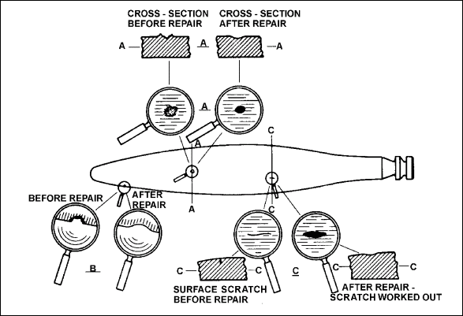
Figure 8-24. Method of repairing surface scratches, nicks, etc., on aluminum-alloy propellers.

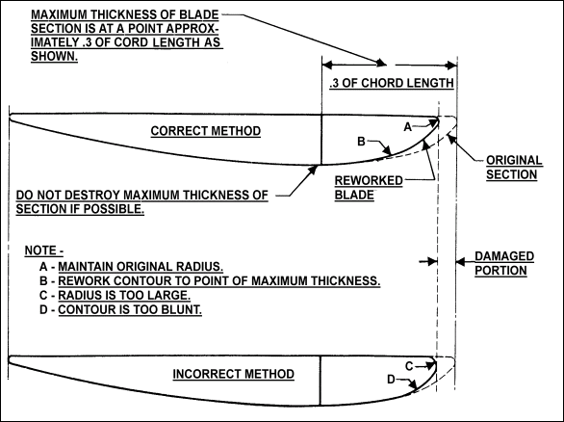
Figure 8-25. Correct and incorrect method of reworking leading edge of aluminum-alloy propellers.

90 percent blade radius point, the blade width and thickness may be modified as per the manufacturer’s instructions.

Shortening Blades. Shortening propeller blades is a major repair. When the removal or treatment of defects on the tip necessitates shortening a blade, shorten each blade used with it and keep such sets of blades together. (See figure 8-26 for acceptable methods.) Mark the shortened blades to correspond with the manufacturer’s system of model designation to indicate propeller diameter. In making the repair, it is not permissible to reduce the propeller diameter below the minimum diameter limit shown on the pertinent specification or type certificate data sheet.

Straighten Propeller Blades. Never straighten a damaged propeller. Even partial

straightening of blades to permit shipment to a certificated propeller repair facility may result in hidden damage not being detected and an unairworthy propeller being returned to service.

REPAIR LIMITS. The following limits are those listed in the blade manufacturing specification for aluminum-alloy blades and govern the width and thickness of new blades. These limits are to be used with the pertinent blade drawing to determine the minimum original blade dimensions to which the reduction of figure 8-27 and figure 8-28. may be applied. When repairs reduce the width or thickness of the blade below these limits, reject the blade. The face alignment or track of the propeller should fall within the limits recommended by the manufacturer for new propellers

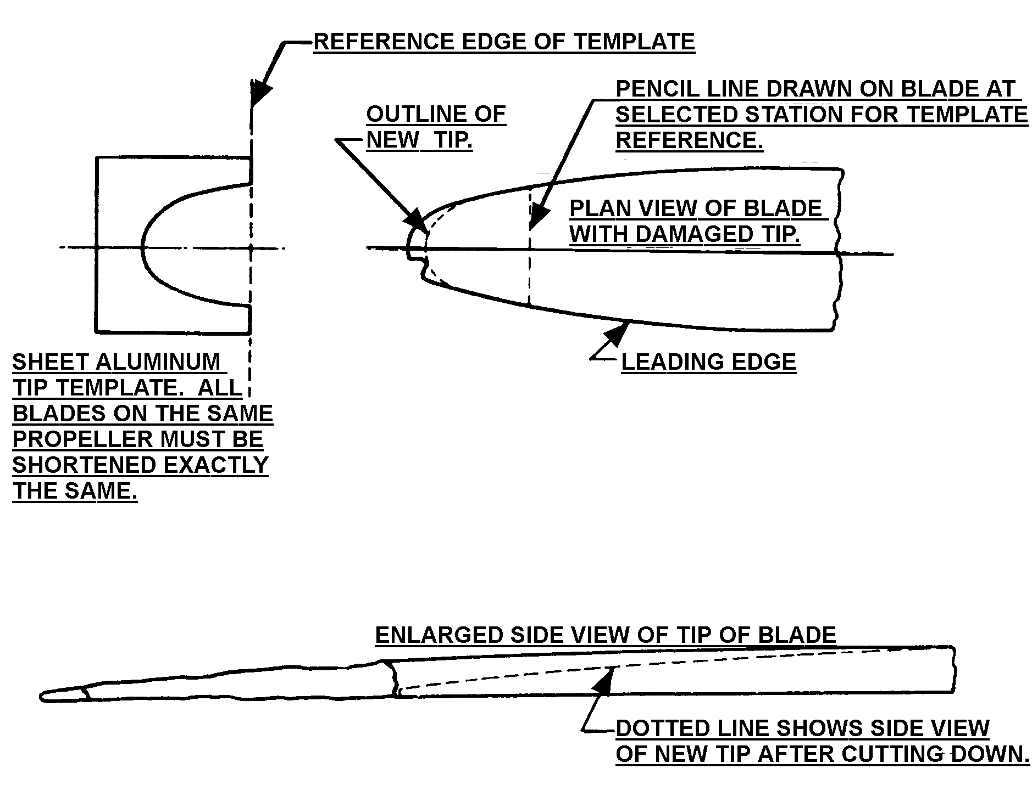
Figure 8-26. Method of repairing damaged tip of aluminum-alloy propellers.

No repairs are permitted to the shanks (roots or hub ends) of aluminum-alloy, adjustable-pitch blades. The shanks must be within manufacturer’s limits.

The following two examples show how to determine the allowable repair limits on aluminum alloy blades.

Example 1. Determine the blade width repair allowable (Δw) and minimum blade width limit, (w₁) for a blade having a diameter (d) of 10 ft. 6 in. The repair location

(r₁) is 24 in. from the shank and the original, as manufactured, blade width (w) at the repair location is 1.88 in.

Step 1. Calculate the blade radius (r)

r = d/2 = (10 ft 6 in)/2 = 126/2 = 63 in.

Step 2. Calculate percent of blade radius to repair (r%)

r% = r₁/r x 100 = (24/63) x 100 = 38

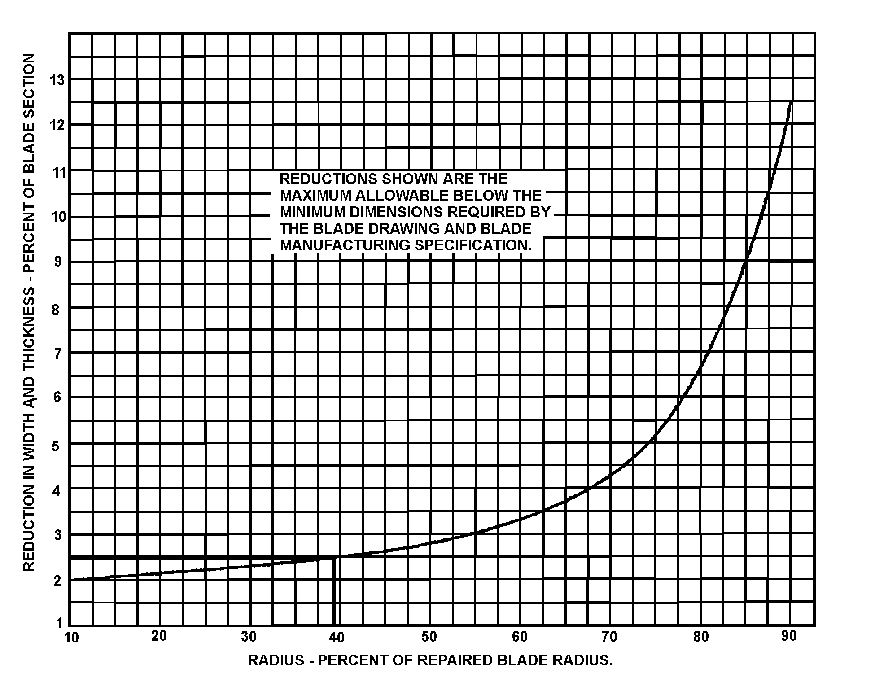

a. Draw a vertical line at the value of r% = 38 on the horizontal axis.
b. Where the vertical line intersects the curve, draw a horizontal line to the right to
intersect the vertical axis.
c. Read the percent reduction in width (Δw%) on the vertical axis at this intersection.
Δw% = 2.5
Figure 8-27. Example 1. Determine the repair width limits.

Step 3. Determine percent reduction in width (Δw%) from figure 8-27.

Step 4. Calculate the blade width repair allowable (Δw)

Δw =(Δw%) x (w) x(0.01) = (2.5) x (1.88) x (0.01) = 0.05 in.

Step 5. Calculate the minimum blade width limit (w₁) at the repair location

w₁ = w - Δw = 1.88 - 0.05 = 1.83 in.

Example 2. Determine the blade thickness repair allowable (Δt) and minimum blade thickness limit (t₁) for a blade having a diameter (d) of 10 ft. 6 in. The repair location (r₁) is 43 in. from the shank and the original, as manufactured, blade thickness (t) at the repair location is 0.07 in.

Step 1. Calculate the blade radius (r)

r = d/2 = (10 ft 6 in)/2 = 126/2 = 63 in.

Step 2. Calculate percent of blade radius to repair (r%)

r% = r/r x 100 = (43/63) x 100 = 68

Step 3. Determine percent reduction in thickness (Δt%) from figure 8-28.

Step 4. Calculate the blade thickness repair allowable (Δt)

Δt = (Δt%) x (t) (0.01) = (4.0) x (0.07) x (0.01) = 0.003 in.

Step 5. Calculate the minimum blade thickness limit (t₁) at the repair location

t₁ = t - Δt = 0.07 - 0.003 = 0.067 in.

STEEL HUBS AND HUB PARTS. Repairs to steel hubs and parts must be accomplished only in accordance with the manufacturer’s recommendations. Welding and remachining is permissible only when covered by manufacturer’s service bulletins (SB).

PROPELLER HUB AND FLANGE REPAIR. When the fixed-pitch propeller bolt holes in a hub or crankshaft become damaged or oversized, it is permissible to make repairs by using methods (A) or (B) in figure 8-29, or by use of aircraft standard bolts 1/16-inch larger than the original bolts. Make the repairs in accordance with the recommendations of the propeller metal hub manufacturer or the engine manufacturer, as applicable. Obtain from the engine or propeller hub manufacturer suitable flange bushings with threaded or smooth bores, as illustrated in methods (A) or (B) of figure 8-29. Drill the flange and insert the bushings as recommended by the propeller to accommodate the bushings, and protect the holes with 2 coats of aluminum paint or other high moisture-resistant coating. Use bolts of the same size as those originally used. Any of the following combinations may be used: (1) drilled head bolt and castellated nut, (2) drilled head bolt and threaded bushing, or (3) undrilled bolt and self-locking nut. Where it is desirable to use oversized bolts, obtain suitable aircraft-standard bolts 1/16-inch larger than the original bolts. Enlarge the crankshaft propeller flange holes and the propeller hub holes sufficiently to accommodate the new bolts without more than 0.005-inch clearance. Such reboring will be permitted only once. Further repairs of bolt holes may be in accordance with the methods listed in (A) or (B) of figure 8-29.

NOTE: Method (A) or (B) is preferred over the oversized bolt method, because a propeller hub flange re-drilled in accordance with this latter

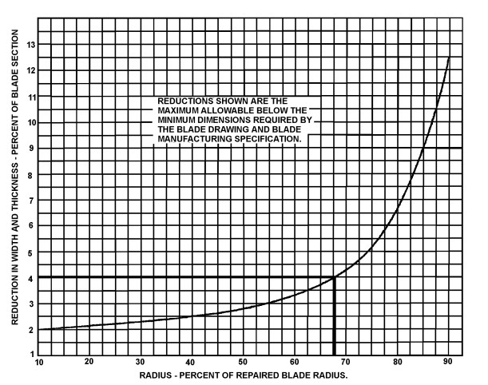

a. Draw a vertical line at the value of r% = 68 on the horizontal axis.
b. Where the vertical line intersects the curve, draw a horizontal line to the right to intersect the vertical axis.
c. Read the percent reduction in thickness (Δt%) on the vertical axis intersection
Δt% = 4.0
Figure 8-28. Example 2. Determine the repair thickness limits.

method will always require the re-drilling of all new propellers subsequently used with the re-drilled flange.

CONTROL SYSTEMS. Components used to control the operation of certificated propellers should be inspected, repaired, assembled, and/or tested in accordance with the manufacturer’s recommendations. Only those repairs which are covered by the manufacturer’s recommendations should be made, and only those replacement parts which are approved under 14 CFR, part 21 should be used.

DEICING SYSTEMS. Components used in propeller deicing systems should be inspected, repaired, assembled, and/or tested in accordance with the manufacturer’s recommendations. Only those repairs which are covered by the manufacturer’s recommendations should be made, and only those replacement parts which are approved under 14 CFR, part 21 should be used.

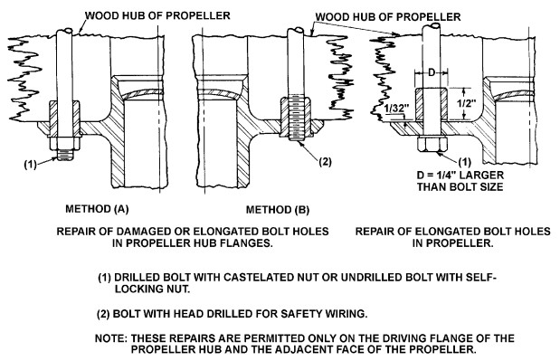
Figure 8-29. Repair of fixed-pitch hub and propeller with elongated or damaged bolt holes.

8-79.⎯8-90. [RESERVED.]

