Section 2. HYDRAULIC SYSTEMS

GENERAL. Hydraulic systems in aircraft provide a means for the operation of aircraft components. The operation of landing gear, flaps, flight control surfaces and brakes is largely accomplished with hydraulic power systems. Hydraulic system complexity varies from small aircraft that require fluid only for manual operation of the wheel brakes to large transport aircraft where the systems are large and complex. To achieve the necessary redundancy and reliability, the system may consist of several subsystems. Each subsystem has a power generating device (pump) reservoir, accumulator, heat exchanger, filtering system, etc. System operating pressure may vary from a couple hundred psi in small aircraft and rotorcraft to several thousand psi in large transports. Generally, the larger the aircraft, the more mechanical work is required to control the aircraft’s various functions. Consequently, the system operating pressure increases accordingly. Primarily, hydraulic power is generated by either engine driven or electric motor driven pumps. The majority of hydraulic pumps are pressure compensated to provide a constant output pressure at a flow-rate demanded by the system. Some constant displacement pumps with a relief valve are used on the smaller aircraft.

PURPOSES OF HYDRAULIC SYSTEMS. Hydraulic systems make possible the transmission of pressure and energy at the best weight per horsepower ratio.

TYPES OF HYDRAULIC FLUID. There are three principal categories of hydraulic fluids; mineral base fluids, polyalphaolefin base, and phosphate ester base fluids. When servicing a hydraulic system, the technician must be certain to use the correct category of replacement fluid. Hydraulic fluids are not necessarily compatible. For example, contamination of the fire-resistant fluid MIL-H-83282 with MIL-H-5606 may render the MIL-H-83282 non fire-resistant.

Mineral-Base Fluids. MIL-H-5606, mineral oil-based hydraulic fluid is the oldest, dating back to the 1940’s. It is used in many systems, especially where the fire hazard is comparatively low. MIL-H-6083 is simply a rust-inhibited version of MIL-H-5606. They are completely interchangeable. Suppliers generally ship hydraulic components with MIL-H-6083.

Polyalphaolefin-Based Fluids. MIL-H-83282, is a fire-resistant hydrogenated polyalphaolefin-based fluid developed in the 1960’s to overcome the flammability characteristics of MIL-H-5606. MIL-H-83282 is significantly more flame resistant than MIL-H-5606, but a disadvantage is the high viscosity at low temperature. It is generally limited to -40 ▪F. However, it can be used in the same system and with the same seals, gaskets, and hoses as MIL-H-5606. MIL-H-46170 is the rust-inhibited version of MIL-H-83282. Small aircraft predominantly use MIL-H-5606 but some have switched to MIL-H-83282, if they can accommodate the high viscosity at low temperature.

Phosphate Ester-Based Fluid (Skydrol/Hyjet). These fluids are used in most commercial transport category aircraft, and are extremely fire-resistant. However, they are not fireproof and under certain conditions, they will burn. The earliest generation of these fluids was developed after World War II as a result of the growing number of aircraft hydraulic brake fires which drew the collective concern of the commercial aviation industry.

Progressive development of these fluids occurred as a result of performance requirements of newer aircraft designs. The

airframe manufacturers dubbed these new generations of hydraulic fluid as “types” based on their performance. Today, types IV and V fluids are used. Two distinct classes of type IV fluids exist based on their density: class I fluids are low density and class II are standard density. The class I fluids provide weight savings advantages versus class II. Monsanto and Exxon are the suppliers of the type IV phosphate ester-based aviation hydraulic fluids.

In addition to the type IV fluids that are currently in use, type V fluids are being developed in response to industry demands for a more thermally stable fluid at higher operating temperatures. Type V fluids will be more resistant to hydrolytic and oxidative degradation at high temperature than the type IV fluids.

Materials of Construction. Hydraulic systems require the use of special accessories that are compatible with the hydraulic fluid. Appropriate seals, gaskets, and hoses must be specifically designated for the type of fluid in use. Care must be taken to ensure that the components installed in the system are compatible with the fluid. When gaskets, seals, and hoses are replaced, positive identification should be made to ensure that they are made of the appropriate material.

Phosphate ester-based hydraulic fluids have good solvency properties and may act as plasticizer for certain polymers. Care should be taken in handling to keep the fluid from spilling on plastic materials and paint finishes.

If a small amount of the fluid is spilled during handling, it must be cleaned up immediately with a dry cloth. When larger quantities are spilled, an absorbent sweeping compound is recommended. A final cleaning with an approved solvent or detergent should remove any traces of fluid.

HANDLING HYDRAULIC FLUID. In addition to any other instructions provided in the aircraft maintenance manual or by the fluid supplier, the following general precautions must be observed in the handling of hydraulic fluids:

Ensure that each aircraft hydraulic system is properly identified to show the kind of fluid to be used in the system. Identification at the filler cap or valve must clearly show the type of fluid to be used or added.

Never allow different categories of hydraulic fluids to become mixed. Chemical reactions may occur, fire resistant fluids may lose their fire resistance, seals may be damaged, etc.

Never, under any circumstances, service an aircraft system with a fluid different from that shown on the instruction plate.

Make certain that hydraulic fluids and fluid containers are protected from contamination of any kind. Dirt particles may cause hydraulic units to become inoperative, cause seal damage, etc. If there is any question regarding the cleanliness of the fluid, do not use it. Containers for hydraulic fluid must never be left open to air longer than necessary.

Do not expose fluids to high temperature or open flames. Mineral-based fluids are highly flammable.

The hydrocarbon-based hydraulic fluids are, in general, safe to handle. To work with these fluids, reasonable handling procedures must always be followed. Take precaution to avoid fluid getting in the eyes. If fluid contacts the eye, wash immediately with water.

When handling Skydrol/Hyjet hydraulic fluids, gloves that are impervious to the fluid must be worn. If skin contact occurs, wash with soap and water.

When handling phosphate ester-based fluid use eye protection. If the eye is exposed to fluid, severe eye pain will occur.

When Skydrol/Hyjet mist or vapor exposure is possible, a respirator capable of removing organic vapors and mists must be worn.

Ingestion of any hydraulic fluid should be avoided. Although small amounts do not appear to be highly hazardous, any significant amount should be tested in accordance with manufacturer’s direction, followed with hospital supervised stomach treatment.

HYDRAULIC SYSTEM MAINTENANCE PRACTICES. The maintenance of hydraulic and pneumatic systems should be performed in accordance with the aircraft manufacturer’s instructions. The following is a summary of general practices followed when dealing with hydraulic and pneumatic systems.

Service. The servicing of hydraulic and pneumatic systems should be performed at the intervals specified by the manufacturer. Some components, such as hydraulic reservoirs, have servicing information adjacent to the component. When servicing a hydraulic reservoir, make certain to use the correct type of fluid. Hydraulic fluid type can be identified by color and smell; however, it is good practice to take fluid from the original marked container and then to check the fluid by color and smell for verification. Fluid containers should always be closed, except when fluid is being removed.

Contamination Control. Contamination, both particulate and chemical, is detrimental to the performance and life of components in the aircraft hydraulic system. Contamination enters the system through normal wear of components, by ingestion through external seals, during servicing, or maintenance when the system is opened to replace/repair components, etc. To control the particulate contamination in the system, filters are installed in the pressure line, in the return line, and in the pump case drain line of each system. The filter rating is given in terms of “micron,” and is an indication of the particle size that will be filtered out. The replacement interval of these filters is established by the manufacturer and is included in the maintenance manual. However, in the absence of specific replacement instructions, a recommended service life of the filter elements is:

Pressure filters⎯3000 hrs.
Return Filters⎯1500 hrs.
Case drain filters⎯600 hrs.

When replacing filter elements, be sure that there is no pressure on the filter bowl. Protective clothing and a face shield must be used to prevent fluid from contacting the eye. Replace the element with one that has the proper rating. After the filter element has been replaced, the system must be pressure tested to ensure that the sealing element in the filter assembly is intact.

In the event of a major component failure, such as a pump, consideration must be given to replacing the system filter elements, as well as the failed component. System filters may also be equipped with differential pressure (ΔP) indicators. These indicators are designed to “pop-up” when the pressure drop across the element reaches a predetermined value caused by contamination held by the element. The indicators are designed to prevent false indications due to cold start, pump ripple, and shock loads. Consequently, a filter whose indicator has been activated must be replaced. In fact, some indicator designs are
such that the indicator cannot be reset, unless the filter bowl is removed and the element replaced.

Flushing a Hydraulic System. When inspection of hydraulic filters or hydraulic fluid evaluation indicates that the fluid is contaminated, flushing the system may be necessary. This must be done according to the manufacturer’s instructions; however, a typical procedure for flushing is as follows:

Connect a ground hydraulic test stand to the inlet and outlet test ports of the system. Verify that the ground unit fluid is clean and contains the same fluid as the aircraft.

Change the system filters.

Pump clean, filtered fluid through the system, and operate all subsystems until no obvious signs of contamination are found during inspection of the filters. Dispose of contaminated fluid and filter. (Note: A visual inspection of hydraulic filters is not always effective.)

Disconnect the test stand and cap the ports.

Ensure that the reservoir is filled to the FULL line or proper service level.

Inspections. Hydraulic and pneumatic systems are inspected for leakage, worn or damaged tubing, worn or damaged hoses, wear of moving parts, security of mounting for all units, safetying, and any other condition specified by the maintenance manual. A complete inspection includes considering the age, cure date, stiffness of the hose, and an operational check of all subsystems.

Leakage from any stationary connection in a system is not permitted, and if found, it should be repaired. A small amount of fluid seepage may be permitted on actuator piston rods and rotating shafts. In a hydraulic system, a thin film of fluid in these areas indicates that the seals are being properly lubricated. When a limited amount of leakage is allowed at any point, it is usually specified in the appropriate manual.

Tubing should not be nicked, cut, dented, collapsed, or twisted beyond approved limits. The identification markings or lines on a flexible hose will show whether the hose has been twisted. (See figure 9.9.)

All connections and fittings associated with moving units must be examined for play evidencing wear. Such units should be in an unpressurized condition when they are checked for wear.

Accumulators must be checked for leakage, air or gas preload, and position. If the accumulator is equipped with a pressure gauge, the preload can be read directly.

An operational check of the system can be performed using the engine-driven pump, an electrically-operated auxiliary pump (if such a pump is included in the system), or a ground test unit. The entire system and each subsystem should be checked for smooth operation, unusual noises, and speed of operation for each unit. The pressure section of the system should be checked with no subsystems to see that pressure holds for the required time without the pump supplying the system. System pressure should be observed during operation of each subsystem to ensure that the engine-driven pump maintains the required pressure.

Troubleshooting. Hydraulic system troubleshooting varies according to the complexity of the system and the components in the system. It is, therefore, important that the
technician refer to the troubleshooting information furnished by the manufacturer.

Lack of pressure in a system can be caused by a sheared pump shaft, defective relief valve, the pressure regulator, an unloading valve stuck in the “kicked-out” position, lack of fluid in the system, the check valve installed backward, or any condition that permits free flow back to the reservoir or overboard. If a system operates satisfactorily with a ground test unit but not with the system pump, the pump should be examined.

If a system fails to hold pressure in the pressure section, the likely cause is the pressure regulator, an unloading valve, a leaking relief valve, or a leaking check valve.

If the pump fails to keep pressure up during operation of the subsystem, the pump may be worn or one of the pressure-control units may be leaking.

High pressure in a system may be caused by a defective or improperly-adjusted pressure regulator, an unloading valve, or by an obstruction in a line or control unit.

Unusual noise in a hydraulic system, such as banging and chattering, may be caused by air or contamination in the system. Such noises can also be caused by a faulty pressure regulator, another pressure-control unit, or a lack of proper accumulator action.

Maintenance of hydraulic system components involves a number of standard practices together with specialized procedures set forth by manufacturers such as the replacement of valves, actuators, and other units, including tubing and hoses. Care should be exercised to prevent system contamination damage to seals, packings, and other parts, and to apply proper torque in connecting fittings. When installing fittings, valves, etc. always lubricate the threads with hydraulic fluid.

Overhaul of hydraulic and pneumatic units is usually accomplished in approved repair facilities; however, replacement of seals and packings may be done from time to time by technicians in the field. When a unit is disassembled, all O-ring and Chevron seals should be removed and replaced with new seals. The new seals must be of the same material as the original and must carry the correct manufacturer’s part number. No seal should be installed unless it is positively identified as the correct part and the shelf life has not expired.

When installing seals, care should be exercised to ensure that the seal is not scratched, cut, or otherwise damaged. When it is necessary to install a seal over sharp edges, the edges must be covered with shim stock, plastic sheet, or electrical tape.

The replacement of hydraulic units and tubing usually involves the spillage of some hydraulic fluid. Care should be taken to ensure that the spillage of fluid is kept to a minimum by closing valves, if available, and by plugging lines immediately after they are disconnected. All openings in hydraulic systems should be capped or plugged to prevent contamination of the system.

The importance of the proper torque applied to all nuts and fittings in a system cannot be over-emphasized. Too much torque will damage metal and seals, and too little torque will result in leaks and loose parts. The proper torque wrenches with the appropriate range should be used in assembling system units.

Disposal of Used Hydraulic Fluids. In the absence of organizational guidelines, the

technician should be guided by local, state, and federal regulations, with regard to means of disposal of used hydraulic fluid. Presently, the most universally accepted procedure for disposal of phosphate ester-based fluid is incineration.

HYDRAULIC LINES AND FITTINGS. Carefully inspect all lines and fittings at regular intervals to ensure airworthiness. Investigate any evidence of fluid loss or leaks. Check metal lines for leaks, loose anchorage, scratches, kinks, or other damage. Inspect fittings and connections for leakage, looseness, cracks, burrs, or other damage. Replace or repair defective elements. Make sure the lines and hoses do not chafe against one another and are correctly secured and clamped.

Replacement of Metal Lines. When inspection shows a line to be damaged or defective, replace the entire line or, if the damaged section is localized, a repair section may be inserted. In replacing lines, always use tubing of the same size and material as the original line. Use the old tubing as a template in bending the new line, unless it is too greatly damaged, in which case a template can be made from soft iron wire. Soft aluminum tubing (1100, 3003, or 5052) under ¼-inch outside diameter may be bent by hand.. For all other tubing use an acceptable hand or power tube-bending tool. Bend tubing carefully to avoid excessive flattening, kinking, or wrinkling. Minimum bend radii values are shown in table 9-2. A small amount of flattening in bends is acceptable, but do not exceed 75 percent of the original outside diameter. Excessive flattening will cause fatigue failure of the tube. When installing the replacement tubing, line it up correctly with the mating part so that it is not forced into alignment by tightening of the coupling nuts.

Tube Connections. Many tube connections are made using flared tube ends with standard connection fittings: AN-818 (MS 20818) nut and AN-819 (MS 20819)
sleeve. In forming flares, cut the tube ends square, file smooth, remove all burrs and sharp edges, and thoroughly clean. The tubing is then flared using the correct 37-degree aviation flare forming tool for the size of tubing and type of fitting. A double flare is used on soft aluminum tubing 3/8-inch outside diameter and under, and a single flare on all other tubing. In making the connections, use hydraulic fluid as a lubricant and then tighten. Over-tightening will damage the tube or fitting, which may cause a failure. Under-tightening may cause leakage which could result in a system failure.

CAUTION: Mistaken use of 45-degree automotive flare forming tools may result in improper tubing flare shape and angle; causing misfit, stress and strain, and probable system failure.

Repair of Metal Tube Lines. Minor dents and scratches in tubing may be repaired. Scratches or nicks not deeper than 10 percent of the wall thickness in aluminum alloy tubing, that are not in the heel of a bend, may be repaired by burnishing with hand tools. Replace lines with severe die marks, seams, or splits in the tube. Any crack or deformity in a flare is unacceptable and cause for rejection. A dent less than 20 percent of the tube diameter is not objectionable unless it is in the heel of a bend. A severely-damaged line should be replaced; however, it may be repaired by cutting out the damaged section and inserting a tube section of the same size and material. Flare both ends of the undamaged and replacement tube sections and make the connection by using standard unions, sleeves, and tube nuts. If the damaged portion is short enough, omit the insert tube and repair by using one union and two sets of connection fittings.
Table 9-2. Tube data.
 |  | Wrench torque for tightening AN-818 Nut (pound inch) |  |  |  |  |  | Minimum bend radii
Dash Nos. | Tubing OD | Aluminum-alloy tubing |  | Steel tubing |  | Aluminum-alloy tubing |  |  | measured to tubing
Ref. | inches | Minimum | Maximum | Minimum | Maximum | (Flare MS33583) for use on oxygen lines only |  |  | centerline. Dimension in inches.
 |  |  |  |  |  | Minimum | Maximum |  | Alum.  Alloy | Steel
-2  -3  -4  -5  -6  -8  -10  -12  -16  -20  -24  -28  -32 | 1/8  3/16  1/4  5/16  3/8  1/2  5/8  3/4  1  1-1/4  1-1/2  1-3/4  2 | 20  25  50  70  110  230  330  460  500  800  800  --  1800 | 30  35  65  90  130  260  360  500  700  900  900  --  2000 | 75  95  135  170  270  450  650  900  1200  1520  1900  --  2660 | 85  105  150  200  300  500  700  1000  1400  1680  2100  --  2940 | --  --  --  100  200  300  --  --  --  --  --  --  -- | --  --  --  125  250  400  --  --  --  --  --  --  -- |  | 3/8  7/16  9/16  3/4  15/16  1-1/4  1-1/2  1-3/4  3  3-3/4  5  --  8 | --  21/32  7/8  1-1/8  1-5/16  1-3/4  2-3/16  2-5/8  3-1/2  4-3/8  5-1/4  --  7

Replacement of Flexible Lines. When replacement of a flexible line is necessary, use the same type, size, part number, and length of hose as the line to be replaced. Check TSO requirements. If the replacement of a hose with a swaged-end type fitting is necessary, obtain a new hose assembly of the correct size and composition. Certain synthetic oils require a specially compounded synthetic rubber hose, which is compatible. Refer to the aircraft manufacturer’s service information for the correct part number for the replacement hose. If the fittings on each end are of the correct type or sleeve type, a replacement may be fabricated as shown in figure 9-8. Before cutting new flexible wire braided hose to the proper size, tape the hose tightly with masking tape and cut in the center of the masking tape to prevent fraying. The use of a mandrel will prevent cutting the inside of the hose when inserting the fittings. Typical aircraft hose specifications and their uses are shown in table 9-3. Install hose assemblies without twisting. (See figure 9-9.) A hose should not be stretched tight between two fittings as this will result in overstressing and eventual failure. The length of hose should be sufficient to provide about 5 to 8 percent slack. Avoid tight bends in flex lines as they may result in

failure. Never exceed the minimum bend radii as indicated in figure 9-10.

Teflon hose is used in many aircraft systems because it has superior qualities for certain applications. Teflon is compounded from tetrafluoroethylene resin which is unaffected by fluids normally used in aircraft. It has an operating range of -65°F to 450 °F. For these reasons, Teflon is used in hydraulic and engine lubricating systems where temperatures and pressures preclude the use of rubber hose. Although Teflon hose has excellent performance qualities, it also has peculiar characteristics that require extra care in handling. It tends to assume a permanent set when exposed to high pressure or temperature. Do not attempt to straighten a hose that has been in service. Any excessive bending or twisting may cause kinking or weakening of the tubing wall. Replace any hose that shows signs of leakage, abrasion, or kinking. Any hose suspected of kinking may be checked with a steel ball of proper size. Table 9-4 shows hose and ball sizes. The ball will not pass through if the hose is distorted beyond limits.

If the hose fittings are of the reusable type, a replacement hose may be

fabricated as described in figure 9-8. Refer to figure 9-10 for minimum bend radii. When a hose assembly is removed, the ends should be tied as shown in figure 9-11, so that the preformed shape will be maintained. Refer to figure 9-12 for minimum bend radii for teflon hose.

All flexible hose installations should be supported at least every 24 inches. Closer supports are preferred. They should be carefully routed and securely clamped to avoid abrasion, kinking, or excessive flexing. Excessive flexing may cause weakening of the hose or loosening at the fittings.

O-Ring Seals. An understanding of O-ring seal applications is necessary to determine when replacement should be made. The simplest application is where the O-ring merely serves as a gasket when it is compressed within a recessed area by applying pressure with a packing nut or screw cap. Leakage is not normally acceptable in this type of installation. In other installations, the O-ring seals depend primarily upon their resiliency to accomplish their sealing action. When moving parts are involved, minor seepage may be normal and acceptable. A moist surface found on moving parts of hydraulic units is an indication the seal is being properly lubricated. In pneumatic systems, seal lubrication is provided by the installation of a grease-impregnated felt wiper ring. When systems are static, seepage past the seals is not normally acceptable.

Storage of replacement seals.

Store O-ring seals where temperature does not exceed 120° F.

Keep seals packaged to avoid exposure to ambient air and light, particularly sunlight.

During inspection, consider the following to determine whether seal replacement is necessary.

How much fluid is permitted to seep past the seals? In some installations minor seepage is normal. Refer to the manufacturer’s maintenance information.

What effect does the leak have on the operation of the system? Know the system.

Does the leak of fluid create a hazard or affect surrounding installations? A check of the system fluid and a knowledge of previous fluid replenishment is helpful.

Will the system function safely without depleting the reservoirs until the next inspection?

Do’s and Don’ts that apply to O-ring seals.

Correct all leaks from static seal installations.

Don’t retighten packing gland nuts; retightening will, in most cases, increase rather than decrease the leak.

Never reuse O-ring seals because they tend to swell from exposure to fluids, and become set from being under pressure. They may have minor cuts or abrasions that are not readily discernible by visual inspection.

Avoid using tools that might damage the seal or the sealing surface.

Do not depend upon color-coding. Coding may vary with manufacturer

Be sure that part number is correct

Retain replacement seals in their package until ready for use. This provides proper identification and protects the seal from damage and contamination.

Assure that the sealing surfaces are clean and free of nicks or scratches before installing seal.

Protect the seal from any sharp surfaces that it may pass over during installation. Use an installation bullet or cover the sharp surfaces with tape.

Lubricate the seal so it will slide into place smoothly.

Be sure the seal has not twisted during installation.

Hydraulic System Pressure Test. When a flexible hose has been repaired or overhauled using existing hardware and new hose material, before the hose is installed on the aircraft it is recommended that the hose is tested to at least 1.5 system pressure. A new hose can be operationally checked after it is installed in the aircraft using system pressure.

Hydraulic Components. Hydraulic components such as pumps, actuating cylinders, selector valves, relief valves, etc., should be repaired or adjusted following the airplane and component manufacturer’s instructions. Inspect hydraulic filter elements at frequent intervals and replace as necessary.

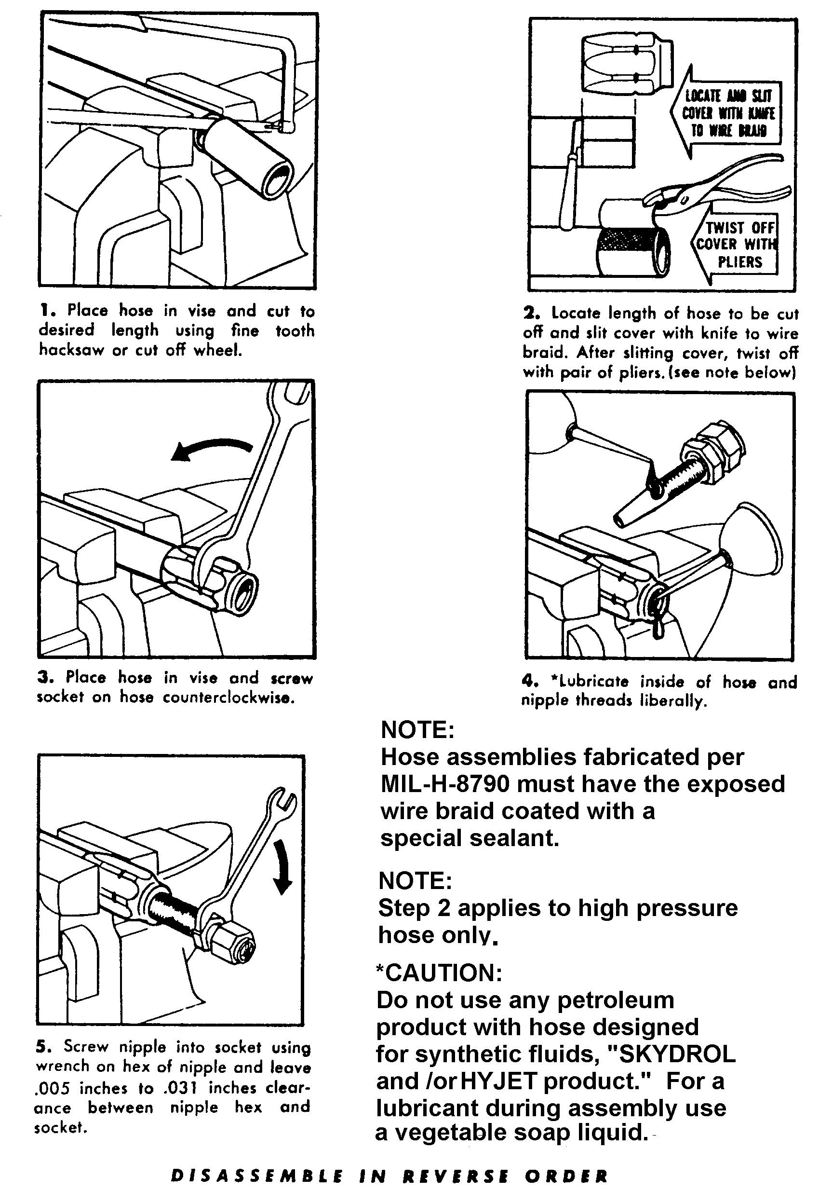

Figure 9-8. Hose assembly instructions (can be used for low pressure hydraulic fluid, and oil line
applications).
Table 9-3. Aircraft hose specifications.
SINGLE WIRE BRAID FABRIC COVERED
 | MIL.  PART NO. | TUBE  SIZE  O.D. | HOSE SIZE  I.D. | HOSE  SIZE  O.D. |  | RECOMM.  OPER.  PRESS. |  |  |  | MIN.  BURST  PRESS. | MAX.  PROOF  PRESS. | MIN  BEND  RADIUS
 | MIL-H-8794- 3-L  MIL-H-8794- 4-L  MIL-H-8794- 5-L  MIL-H-8794- 6-L  MIL-H-8794- 8-L  MIL-H-8794-10-L  MIL-H-8794-12-L  MIL-H-8794-16-L  MIL-H-8794-20-L  MIL-H-8794-24-L  MIL-H-8794-32-L  MIL-H-8794-40-L  MIL-H-8794-48-L | 3/16  1/4  5/16  38  1/2  5/8  3/4  1  1 1/4  1 1/2  2  2 1/2  3 | 1/8  3/16  1/4  5/16  13/32  1/2  5/8  7/8  1 1/8  1 3/8  1 13/16  2 3/8  3 | .45  .52  .58  .67  .77  .92  1.08  1.23  1.50  1.75  2.22  2.88  3.56 |  | 3,000  3,000  3,000  2,000  2,000  1,750  1,750  800  600  500  350  200  200 |  |  |  | 12,000  12,000  10,000  9,000  8,000  7,000  6,000  3,200  2,500  2,000  1,400  1,000  800 | 6,000  6,000  5,000  4,500  4,000  3,500  3,000  1,600  1,250  1,000  700  300  300 | 3.00  3.00  3.38  4.00  4.63  5.50  6.50  7.38  9.00  11.00  13.25  24.00  33.00
 | Construction: Seamless synthetic rubber inner tube reinforced with one fiber braid, one braid of high tensile steel wire and covered with an oil resistant rubber impregnated fiber braid.  Identification: Hose is identified by specification number, size number, quarter year and year, hose manufacturer’s identification. |  |  |  |  |  |  | Uses: Hose is approved for use in aircraft  hydraulic, pneumatic, coolant, fuel and oil  systems.  Operating Temperatures:  Sizes-3 through 12: Minus  65 °F. to plus 250 °F.  Sizes - 16 through 48: Minus  40 °F. to plus 275 °F.  Note: Maximum temperatures and pressures should not be used simultaneously.
 | MULTIPLE WIRE BRAID RUBBER COVERED
 | MIL  PAR NO. | TUBE  SIZE  O.D. | HOSE  SIZE  I.D. | HOSE  SIZE  O.D. |  | RECOMM.  OPER.  PRESS. |  |  |  | MIN.  BURST  PRESS. | MIN.  PROOF  PRESS. | MIN.  BEND  RADIUS
 | MIL-H-8788- 4-L  MIL-H-8788- 5-L  MIL-H-8788- 6-L  MIL-H-8788- 8-L  MIL-H-8788-10-L  MIL-H-8788-12-L  MIL-H-8788-16-L | 1/4  5/16  3/8  1/2  5/8  3/4  1 | 7/32  9/32  11/32  7/16  9/16  11/16  7/8 | 0.63  0.70  0.77  0.86  1.03  1.22  1.50 |  | 3,000  3,000  3,000  3,000  3,000  3,000  3,000 |  |  |  | 16,000  14,000  14,000  14,000  12,000  12,000  10,000 | 8,000  7,000  7,000  7,000  6,000  6,000  5,000 | 3.00  3.38  5.00  5.75  6.50  7.75  9.63
 | Hose Construction: Seamless synthetic rubber inner tube reinforced with one fabric braid, two or more steel wire braids, and covered with a synthetic rubber cover (for gas applications request perforated cover).  Identification: Hose is identified by specification number, size number, quarter year and year, hose manufacturer’s identification. |  |  |  |  |  |  |  | Uses: High pressure hydraulic, pneumatic, coolant, fuel and oil.  Operating Temperatures:  Minus 65 °F. to plus 200 °F.

RIGHT WAY | WRONG WAY
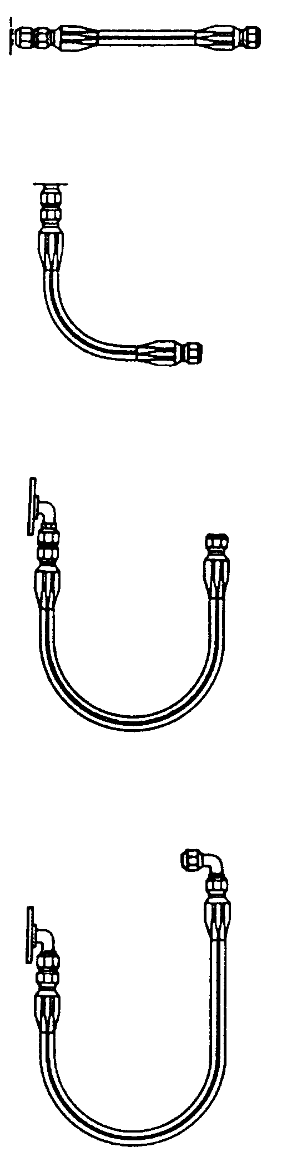 | 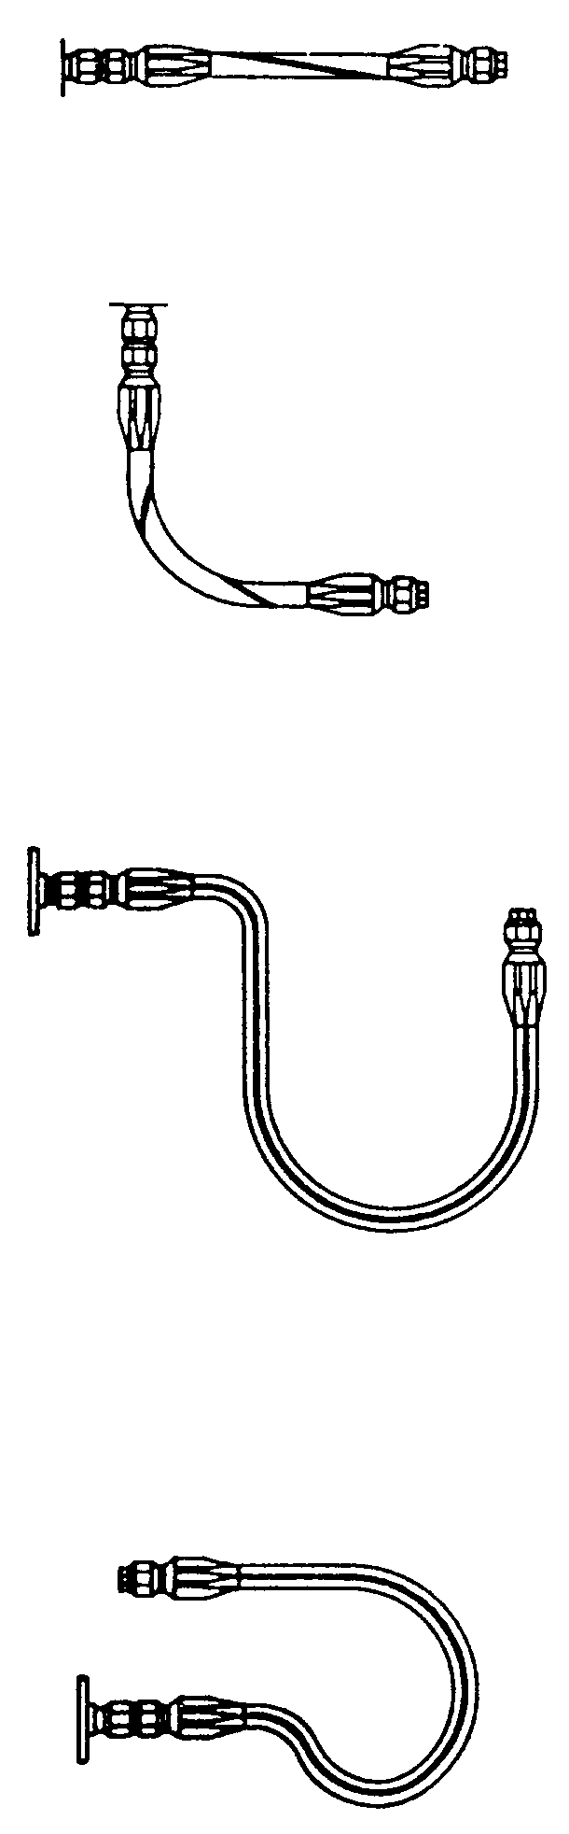 | Do not bend or twist the hose as illustrated.  Allow enough slack in the hose line to provide for changes in length when pressure is applied. The hose will change in length from  + 2% to – 4%.  Metal end fittings cannot be considered as part of the flexible portion of the assembly.  The use of elbows and adapters will ensure easier installation and in many installations will remove the strain from the hose line and greatly increase service life.  At all times keep the minimum bend radii of the hose as large as possible to avoid tube collapsing.
Figure 9-9. Proper hose installations.

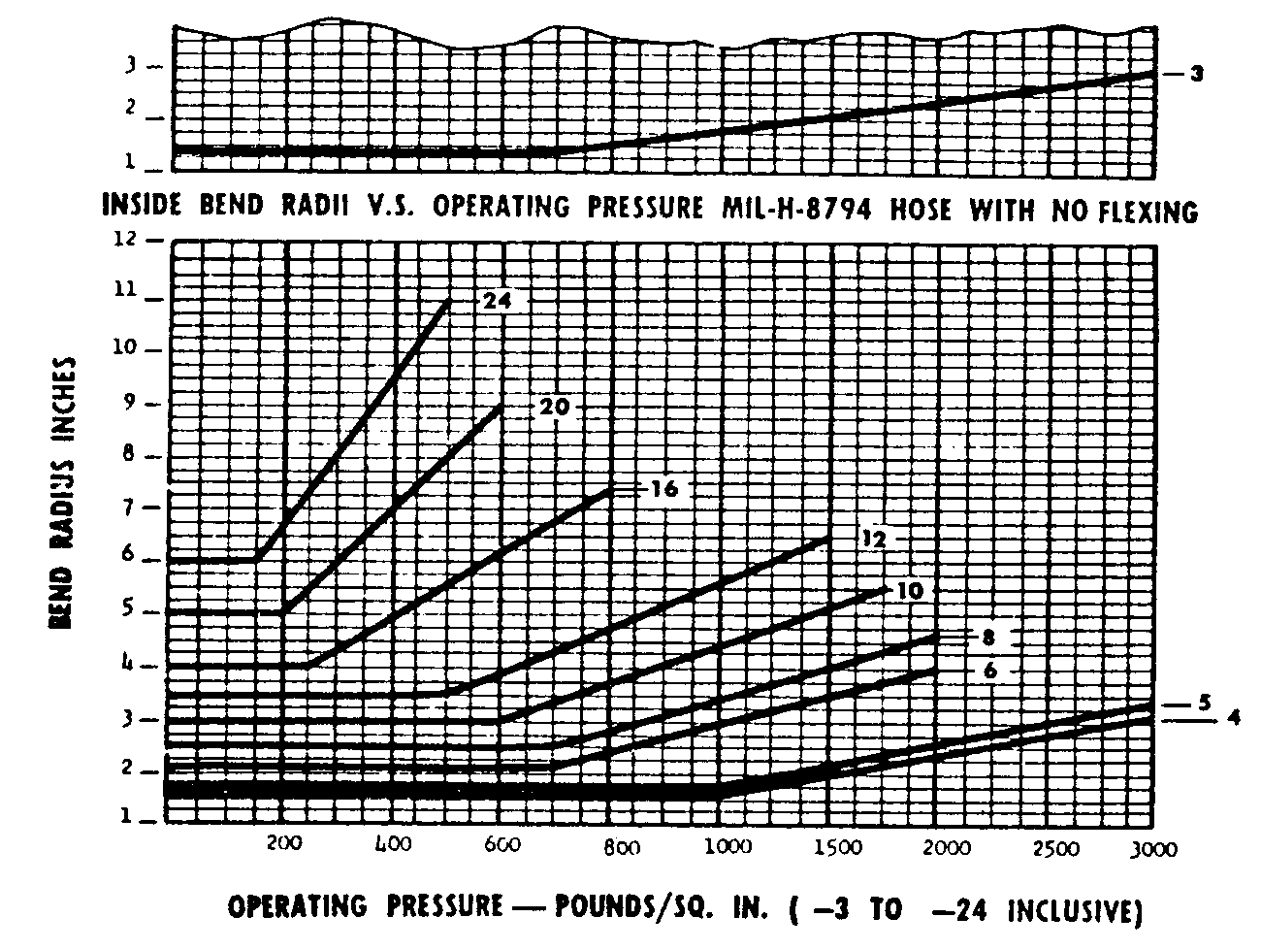
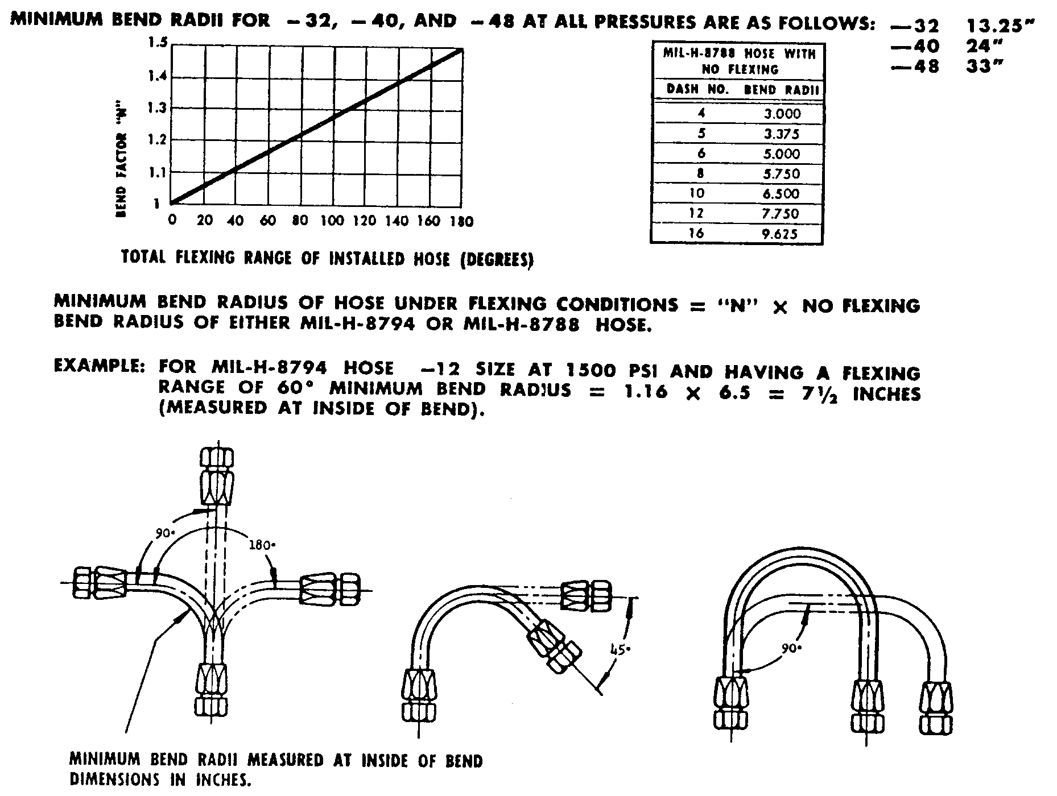
Figure 9-10. Minimum bend radii.

Table 9-4. Ball diameters for testing hose restrictions
or kinking.
HOSE SIZE  -4  -5  -6  -8  -10  -12  -16  -20 | BALL SIZE  5/64  9/64  13/64  9/32  3/8  1/2  47/64  61/64

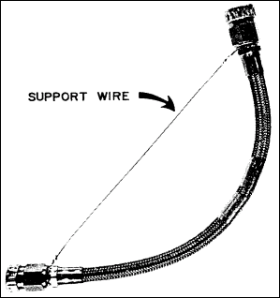
Figure 9-11. Suggested handling of preformed hose.

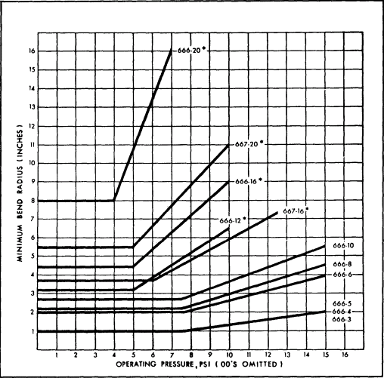
Figure 9-12. Minimum bend radii–Teflon hose.

9.31.⎯9.36 [RESERVED.]

