Section 3. EMERGENCY EQUIPMENT

LIFE RAFTS. Inflatable life rafts are subject to general deterioration due to aging. Experience has indicated that such equipment may be in need of replacement at the end of 5 years due to porosity of the rubber-coated material. Wear of such equipment is accelerated when stowed on board aircraft because of vibration which causes chafing of the rubberized fabric. This ultimately results in localized leakage. Leakage is also likely to occur where the fabric is folded because sharp corners are formed. When these corners are in contact with the carrying cases or with adjacent parts of the rubberized fabric, they tend to wear through due to vibration (Ref: TSO-C70a).

When accomplishing maintenance, repair, and inspection of unpacked rafts, personnel should not step on any part of the raft or flotation tubes while wearing shoes. Rafts should not be thrown or dropped, since damage to the raft or accessories may result. Particular care should be exercised at all times to prevent snagging, cutting, and contact with gasoline, acids, oils, and grease. High standards of performance for proper maintenance, inspection, and repair cannot be overemphasized, since the lives of passengers could be involved.

Inspection and inflation tests, when applicable, will be accomplished during storage and after installation in an aircraft in accordance with the manufacturer’s specifications and/or FAA-approved procedures. Accessory items will be installed during these inspections. A raft knife will be attached by a 24-inch nylon lanyard to the mooring eye located above the CO₂ cylinder case to enable rapid cutting of the mooring line.

Life raft inspections. Inspection of life rafts should be performed in accordance with the manufacturer’s

specifications. General inspection procedures to be performed on most life rafts are as follows.

CAUTION: Areas where life rafts are inspected or tested must be smooth, free of splinters, sharp projections, and oil stains. Floors with abrasive characteristics, such as concrete or rough wood, will be covered with untreated tarpaulins or heavy clean paper.

Inspect life rafts for cuts, tears, or other damage to the rubberized material. If the raft is found to be in good condition, remove the CO₂ bottle(s) and inflate the raft with air to a pressure of 2 psi. The air should be introduced at the fitting normally connected to the CO₂ bottle(s). After at least 1 hour, to allow for the air within the raft to adjust itself to the ambient temperature, check pressure and adjust, if necessary, to 2 psi and allow the raft to stand for 24 hours. If, after 24 hours, the pressure is less than 1 psi, examine the raft for leakage by using soapy water. In order to eliminate pressure variations due to temperature differences at the time the initial and final reading are taken, test the raft in a room where the temperature is fairly constant. If the pressure drop is satisfactory, the raft should be considered as being in an airworthy condition and returned to service after being fitted with correctly charged CO₂ bottles as determined by weighing them. Rafts more than 5 years old are likely to be unairworthy due to deterioration. It is suggested that serviceable rafts be marked to indicate the date of inspection and that soapstone be used when folding them preparatory to insertion into the carrying case. Take care to see that all of the raft’s required equipment is on board and properly stowed. If the raft lanyard, used to prevent the raft from floating away from the airplane, is in need of

replacement, use a lanyard not less than 20 feet long and having a breaking strength of about 75 pounds.

It is recommended that the aforementioned procedure be repeated every 18 months using the CO₂ bottle(s) for inflation. If a single bottle is used for inflating both compartments, it should be noted whether the inflation is proceeding equally to both compartments. Occasionally, the formation of “carbon-dioxide snow” may occur in one passage of the distribution manifold and divert a larger volume of gas to one compartment, which may burst if the mattress valve is not open to relieve the pressure. If the pressure is satisfactory, return the raft to service in accordance with the procedure outlined.

Inspect the CO₂ cylinder for evidence of cross-threading or stripping.

Inspect the CO₂ bottle inflation valve cable rigging as follows.

Remove the screws that attach the cover plate to the valve and remove the cover plate.

Inspect the firing line cable ball swage for engagement in the correct recess for either “Upward Pull” or “Downward Pull.” The cable will be wrapped around the sheave approximately 270 degrees.

Reposition the cable ball swage as required. (See figure 9-12.)

Replace the cover plate. The green dot on the sheave should be visible through the window in the cover plate, indicating a charged cylinder.

Check the CO₂ cylinder release cable and housing for condition and security.

Make sure the safety deflector is removed from the cylinder outlet before connecting the cylinder to the raft. (See
figure 9-12.)

Stencil the life raft’s inspection date on the raft.

Survival kit inspection.

Survival Kit Contents. Each raft accommodating passengers or crew members should contain, as a minimum, the following:

Hand Pump (if required)
Desalting Kit, First-Aid Kit
Mirror/Reflector
Emergency Rations
Tarpaulins
Fishing Kit
Raft Knife
Compass
Protective Ointment (Sunburn)
Oars
Emergency Water Containers
Repair Kits
Signal Flares
Carrying Case
Locator Beacon and Battery
Lines and Anchor
Police Whistle
Flashlight
Thermal Protective Aid
Light-sticks
Solar Still Kit
Survival Manual
Duct Tape
Plastic Trash Bags
Accessory Containers
- Bailing Bucket
- Sponge
Dye Marker

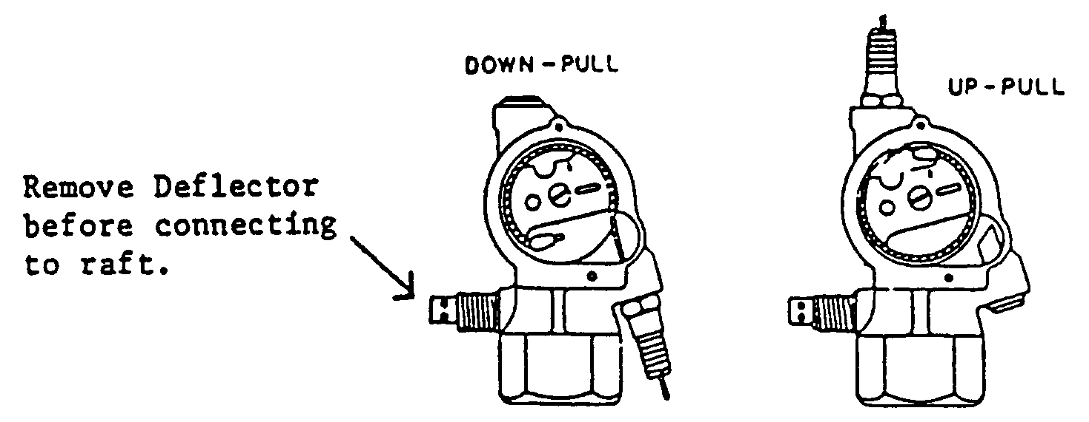
Figure 9-12. Inflation valve.

Exposure Suits. Quick-donning exposure suits should be provided in sufficient quantity to accommodate the passengers and crew on extended over-water missions whenever any of the following conditions exist.

The water temperature is 59 ▪F or below, or

The Outside Air Temperature (OAT) is 32 ▪F or below.

Physical Inspection. Make a physical inspection of the life raft’s accessories and/or contents, in accordance with manufacturer’s specifications, to ascertain that all items required are in a serviceable condition.

Pumps and Hoses.

Check the air pump for condition and security.

Check the air pump hose and hose fittings for ease of attachment to the pump and mattress valves.

Operate the pump to ensure that it delivers air.

Close the outlet and check the seal of the piston.

Blow into the outlet to determine if the pump check valve will seal.

Desalting Kit.

Check the desalting kit expiration date, if applicable.

Replace the severely dented or punctured cans.

NOTE: Type MK-2 desalter kits have an indefinite shelf and service life and do not have to be age-controlled.

First-Aid Kit. Inspect each kit prior to flight to ensure that the seal is intact; the kits have not been tampered with or opened; and check the date when the kit contents should be inspected (120-day interval), and containing the following:

1 Case First-Aid Kit, empty;
1 Bottle Benzalkonium Chloride Zinc;
Tinted, 1:1000 2cc
1 Package Sodium Chloride;
(Sodium Bicarbonate Mix) 4.5 gm;
1 Bandage each, Gauze, & Compress
(2 inches x 6 yd);
2 Dressings, First-Aid, 4 inches x 7 inches;
1 Package Bandages; Absorbent &
Adhesive, 3/4-inch x 3 inches;
3 Bottles, Snap-On Cap, Plastic Tablet
and Capsule, Round, (issued empty; to be used as needed by user);
1 Tube Lipstick, Anti-Chap; and
1 bottle Water Purification Tablets,
Iodine 8 mg (50).

If the seal is found to be broken, or there is evidence of tampering, the kit should be opened and inspected to ensure that all components are included and undamaged. After such inspection, the kit should be resealed.

To reseal the kit, use a wire and lead seal according to the manufacturer’s specifications. Pass the wire through grommets or opposite flaps, bend the wire back and force each end through the middle of the lacing cord on each side of the square knot. Pass the ends of the wire through the holes in the lead seal, draw the wire taut, and compress the seal.

Mirror/Reflector. Check the reflector for defective reflection surface and the reflector lanyard for defective conditions and security of attachment.

Emergency Rations. Check the food ration cans for obvious damage, severe dents, and an expiration date. Replace items when severely damaged, dented, or when the date is expired. Ensure that the opening key is attached.

Tarpaulins. Spread out and check for tears, mildew, corroded grommets, and general condition.

Fishing Kit. Check for damaged container or for tampering. Replace if damaged or incomplete.

Raft Knife. Check for corrosion and ease of opening and security of the knife lanyard to the raft.

Compass. Check for proper operation and condition.

Protective Ointment (Sunburn).

Check the sunburn ointment containers for cracks or crushed condition.

Install the ointment in a 6 inch mailing tube and tape the ends to prevent crushing. Stow it where it will be subjected to the least amount of pressure in the kit.

Oars.

Check for serviceability.

Wrap the oars separately in craft paper and seal with tape.

Stencil inspected in letters not less than 1/2-inch high on each package.

Emergency Water Containers. Check for open seams, holes, etc. Replace defective containers.

Repair Kit. Check for proper wrapping and missing items. Four plugs are wrapped in a single container. This container and the pliers are wrapped in waterproof paper and sealed with waterproof tape. The package is stenciled repair plugs and pliers with letters not less than 1/2-inch high.

Signal Flares. Check the flares for obvious damage and suspended lot numbers. Replace if lot number is over-age or obvious damage exists.

Carrying Case. Check for snags, abrasions, and defective snaps. Repair or replace as necessary.

Locator Beacon and Battery.

Check for corrosion and obvious damage per the manufacturer’s manual.

Assemble as an operating unit. Perform an operational test, prepare the beacon for water activation by pulling out the battery switch plug from the end of the transmitter section, and package as instructed on the container.

Lines and Anchor. Check all lines and sea anchors for conditions and security.

Police Whistle. Inspect and test.

Flashlight. Test the flashlight switch for operation; remove old batteries and inspect the case for corrosion and condition; and install new batteries and test momentarily for operation.

Space Blankets. Check space blankets (if required) for rips, tears, and obvious damage.

Light-sticks. Inspect light-sticks for condition and check expiration date.

Solar Still Kit. Check the solar still kit for condition.

Survival Manual. Inspect the survival manual for condition and completeness.

Duct Tape. Check the duct tape for deterioration.

Plastic Trash Bags. Assure that three (each) plastic trash bags are serviceable.

Accessory Containers.

Check the containers for condition and security.

Repack the accessories, secure, and record the inspection data on data cards. Record the Inspection date.

Dye Marker. Check for dents and overall condition.

Shark Chaser. Check for dents and overall condition.

After Inspection. Replace accessories in the container, close, and tie securely with tying tapes. Draw a 25-pound breaking strength cord tightly around the center and one approximately 5 inches from each end of the container, tie with square knots, and seal with a lead seal.

Folding Life Rafts. Fold the life rafts per the manufacturer’s folding diagram using soapstone and secure the raft in its container. Check the container for obvious damage.

Special inspections. Life rafts in storage or in service shall be unpacked and thoroughly inspected for mildew whenever weather or other conditions warrant. The extent of a special inspection will be determined by the inspector or maintenance chief following a review of the circumstances or conditions to which the life rafts have been subjected. The inspector or maintenance chief may direct a complete overall inspection and inflation test
of the life rafts, regardless of the last date of inspection, if it is considered that another inspection is warranted.

Inspection record. The date the inspection was completed will be stenciled on the flotation tube at the left of the cylinder. The size of lettering will not be less than 1/4-inch or greater than 1/2-inch in height. Previous inspection dates will not be removed or obliterated, but will be arranged in columnar form with the latest date at the top. After the inspection is completed, fill out the raft’s inspection record in accordance with part 43 section 43.9, and attach the parts tag to the survival equipment. The date on the tag will reflect the same date as stenciled on the flotation tube and will be used to determine the next due date of inspection and test.

Raft repairs.

Repairs. The service life for flotation equipment will be determined by condition rather than age. Equipment passing tests and inspections may remain in service indefinitely since the inflation tests and material inspections will identify and condemn equipment having more than minor installation defects. However, the service life for life rafts operating under normal usage and environmental conditions is anticipated by the manufacturers to be 8 to 10 years, and it is appropriate to base life raft’s parts replacement programs upon this estimate. It is not considered advisable or economical to perform major repairs on life rafts.

Life Rafts. Life rafts with any of the following conditions should be condemned rather than repaired:

Life rafts over 3-1/2 years of age and requiring major repair or more than two minor repairs.

A rip or tear across an air retaining seam.

Rafts on which oil, grease, or any other foreign substance has caused a deterioration of the rubberized fabric.

Rafts on which a heavy mildew condition has caused deterioration of the rubberized fabric.

Rafts on which porous flotation tubes allow diffusion of air. A porous area is located by a soap test on the inflated raft. Higher diffusion is indicated by the excessive loss of pressure after a soap test has failed to locate a specific area of injury on the raft.

Rafts requiring internal repair or opening of air retaining seams for repair.

Rafts with an excessive number of injuries that would not, in the judgment of competent inspectors, justify repair.

Patches. Holes or abrasions which are 2 inches or less, in diameter (in air retaining chambers) will be repaired by the application of an outside patch. Holes exceeding 2 inches in length or diameter, will require an inside patch as well as an outside patch. Inside and outside patches should be round or rectangular and manufactured of fabric (specification MIL-C-6819). Cement should conform to Class 1 of specification MIL-C-5539. Patch as follows:

Outside patches.

With a rubber solvent thoroughly clean the area to be patched.

From the material referenced, fabricate a patch as shown in figure 9-13.

When two fabric surfaces are to be bonded, apply two coats of extra light cement, two coats of light cement, and three coats of heavy cement to each surface. Rubber-coated tape and seam crossover patches with protective backing do not require cement. Each coat of cement should be thoroughly dry to the touch before the next coat is applied. Start the bonding of fabric surfaces while the last coat of cement is slightly tacky. To ensure proper adhesion when bonding two cemented surfaces, the areas to be bonded should remain tacky during application. This is accomplished by brushing the cemented area with a cloth moistened with solvent.

NOTE: If difficulty in the drying of heavy cement is encountered due to atmospheric conditions, six additional coats of light cement may be substituted for the three coats of heavy cement.

After applying the patch, thoroughly roll it with a hand roller, rolling from the center to the outer edge, to ensure that all air pockets are removed and a firm bond is secured.

Thoroughly dust with talc. Allow to cure for 60 hours before performing leak tests and storing.

Inside Patches.

Cut a rectangular patch as shown in figure 9-13, allowing at least 1-1/2 inches to extend beyond the edge of the injury in all directions.

Mark the center line on the side of the patch that is to be attached to the raft. Mark cross lines on each end of the patch 1-1/2 inches from the ends. When the patch is applied to the injury on the inside, the longitudinal edges of the injury will coincide with the

center line, and cross lines on the ends of the patch will coincide with the ends of the injury.

To ensure that the inside surface of the raft is properly powdered in the area of repair, pass a small handful of talc through the opening in the raft and place it approximately 12 inches from the injury. This should be accomplished before the inside area is cemented, exercising care to prevent distribution of the talc prior to completion of the repair.

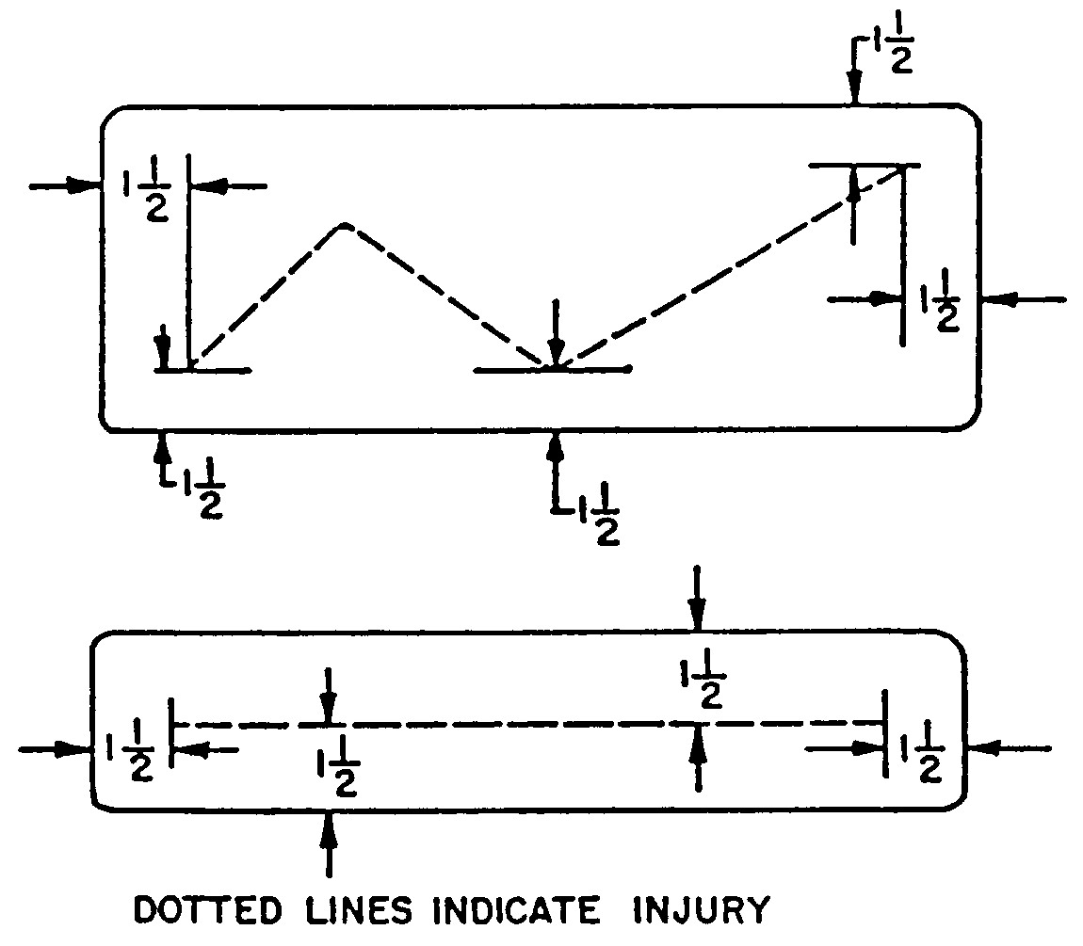
Figure 9-13. Repair dimensions.

Using cleaning solvent, cleanse an area on the inside surface of the fabric slightly larger than the patch to be applied. Ensure that the repaired area is thoroughly dry, both inside and outside; apply two coats of extra light cement, two coats of light cement, and three coats of heavy cement (or six additional coats of light cement in lieu of the heavy cement) to the cleansed area, allowing each coat to dry thoroughly before applying successive coats.

NOTE: Since it is impossible for the repairman to visually observe the cementing that is being accomplished on the inside of the raft, exercise care to ensure that each coat of cement completely covers the area to be repaired.

The inside patch should be cemented simultaneously with the application of cement to the inside of the raft. Apply the same number of coats as directed in paragraph 9 42b(2)(d) to the side of the patch that is applied to the injured fabric of the raft. Ensure that each coat is thoroughly dry before applying the next coat.

To aid in adhesion, prior to applying the patch, the inside area to be repaired and cemented surface of the patch should be cleaned with a cloth moistened with rubber solvent. The cement will then become tacky.

Apply the patch. Fold the patch lengthwise in the shape of the letter “U” and insert the patch between the torn edges of the injury on the life rafts. Position the patch so that the fabric at the end of the tear will coincide with a cross line and the center line on the patch follows one edge of the torn fabric. Attach one edge of the torn fabric along the center line on the patch.

Inspect the repair for wrinkles. Working from the attached edge of the fabric to the edge of the patch, remove the wrinkles with a stitcher. Lay the opposite edge of the torn fabric on the patch so that it butts the edge of the torn fabric that has already been applied to the patch. Remove the wrinkles. Thoroughly roll the patch with a 2 inch rubber roller.

NOTE: The surface under the patch should be as smooth as possible so that the torn edge of the fabric may be attached to the patch instead of attempting to attach the patch to the fabric.

Scatter the handful of talc that was placed inside the tube by grasping the sides of the flotation tube and pulling them apart.

Prepare and attach the outside patch as outlined in “Outside Patches,” sub-paragraphs 9-42b(1)(a)-(e).

Allow to cure for at least 60 hours before performing leak tests and storing.

Seams and Tapes.

Remove all old or dead cement from the area that will require recementing. Dampen the repair area with a solvent-moistened cloth; then roll or rub off the old cement.

Apply cement to the surface as outlined in “Outside Patches,” sub-paragraph 9-42b(1)(a)-(e).

Roll thoroughly with a roller to ensure that all air pockets are removed and a firm bond is secured.

Allow to dry and apply talc over the seam as previously outlined.

Allow to cure for at least 60 hours before performing leak tests and storing.

LIFE PRESERVERS. Inflatable life preservers are subject to general deterioration due to aging. Experience has indicated that such equipment may be in need of replacement at the end of 5 years due to porosity of the rubber-coated material. Wear of such equipment is accelerated when stowed on board aircraft because of vibration which causes chafing of the rubberized fabric. This ultimately results in localized leakage. Leakage is also likely to occur where the fabric is folded because sharp corners are formed. When these corners are in contact with the carrying cases, or with adjacent parts of the rubberized fabric, they tend to wear through due to vibration.
Life preservers should be inspected in accordance with the manufacturer’s specification, unless climate, storage, or operational conditions indicate the need for more frequent inspections (Ref: TSO-C13).

Life preserver inspection. Life preservers should be inspected at 12-month intervals for cuts, tears, or other damage to the rubberized material. Check the mouth valves and tubing for leakage, corrosion, and deterioration. Remove the CO₂ cylinder and check the discharge mechanism by operating the lever to ascertain that the pin operates freely. Check the gaskets and valve cores of the cylinder container and the pull cord for deterioration. If no defects are found, inflate the preserver with air to a 2 psi pressure and allow to stand for 12 hours. If the preserver still has adequate rigidity at the end of that time, deflate and fit with CO₂ cylinders having weights not less than that indicated on them by the manufacturer. All cylinders made in accordance with joint Army/Navy Specification MIL-C-00601D are so stamped and have a minimum permissible weight stamped on them. The use of such CO₂ cylinders is recommended. Having fitted the preserver with an adequately-charged cylinder, mark the preserver to indicate the date of inspection and patch it to the container. It is recommended that the aforementioned procedure be repeated every 12-month period, utilizing the CO₂ cartridge for inflation. Carbon dioxide permeates the rubberized fabric at a faster rate than air and will indicate if the porosity of the material is excessive. The following checks and inspections should be completed:

Check for abrasions, chafing, and soiling across folded cell areas and around metal parts. Condemn the life preserver when unsuitable conditions are found.

Check for separation of cell fabric and loose attachments along the edges of patches and sealing tapes. Repair if practicable.

Check for deterioration in areas where oil and grease are noted. Condemn deteriorated cells. If deterioration is not noted, clean the areas with mild soap and water and rinse with clear water.

Inspect the snaps and/or buckles to ensure proper operation.

Inspect the instruction panel for readability.

Inspect all stitching for gaps, pulls, and tears.

Visually inspect the cell containers for snags, cuts, loose stitching, and oil and grease spots. Repair or replace as necessary.

Inspect the hardware for rusted or broken parts and cotter pins for damage. Ensure that pins are smooth and free of burrs.

Check the inflator discharge lever for proper operation. Move the inflator discharge lever slowly through a normal cycle of operation to ensure freedom of operation and to make certain that the piercing pin has sufficient movement to discharge the CO₂ cylinder. The point of the pin should move past the surface of the gasket in the inflator. In the unoperated position, the end point should be slightly below the gasket surface.

Check the installation of the inflator stem gaskets and check the stem caps for tightness. Ensure that the inflator is centered on the stem.

Check rescue light. Inspect and test.

Replace the battery if it shows any signs of encrustation.

Inspect for proper installation and physical condition of the lamp, wire, and battery.

Check the light assembly for proper operation and water insulation and flotation.

Pull the sealing plug (where applicable) from the battery. Let water flow through the open ports. Make sure the battery is activated and power is supplied to the light.

Fill out the inspection record and serviceable parts tag. Attach to the vest.

Deflate the life preserver and repack in container and secure.

The accessories listed below will be required for all life preservers:

One Recognition Light: Remove when returning to serviceable or reparable storage. Remove for replacement of defective light, repair, or salvage of preserver.

One Recognition Light Battery: Remove when returning to serviceable or reparable storage.

Record the inspection data on data cards.

Life preserver inspected and found sea worthy. Include the inspector’s signature.

Inspection record. Upon completion of 12-month inspection and tests, each flotation cell will be marked to indicate the date the inspection was accomplished. The inspection stencil will consist of 1/8-inch letters and numerals and will be applied to the patches on the cells (example: 4/3/97). To facilitate

determination of the next 12-month inspection period, enter the date it is due in the blank beside the word inspect on the inspection data card provided in the inspection data pocket on the cell container. Repack, close, and seal the container.

Repair of life preservers. Leaks may be disclosed by immersion in soapy water. Repair leaks by the use of patches in accordance with the recommendations of the manufacturer. Clean corroded metal parts and replace missing or weakened lanyards. Life preservers which do not retain sufficient rigidity after the 12-hour period, because of general deterioration and porosity of the fabric, are beyond economical repair and should be replaced.

MISCELLANEOUS EQUIPMENT.

Parachutes. With reasonable care, parachutes can remain in service indefinitely. They should not be carelessly tossed about, left in aircraft to become wet, or left where someone may tamper with them. They should not be placed where they may fall on oily floors or be subject to acid fumes from adjacent battery chargers.

When repacking is scheduled, to comply with the 120-day requirement in Title 14 of the Code of Federal Regulation (14 CFR) part 105 section 105.43 a careful inspection of the parachute shall be made by a qualified parachute technician (rigger). If repairs or replacements of parts are necessary to maintain the airworthiness of the parachute assembly, such work must be done by the original parachute manufacturer or by a qualified parachute rigger, certificated in accordance with 14 CFR, part 65.

The lead seal should be inspected periodically to ensure the thread has not been broken. If broken, or broken and retied or

appears to have been tampered with, the parachute must be repacked by a properly certified rigger.

Safety Belts shall be of an approved type. All seat belts and restraint systems must conform to standards established by the FAA. These standards are contained in Technical Standard Order TSO C22 for seat belts and TSO C114 for restraint systems.

Safety belts eligible for installation in aircraft must be identified by the proper TSO markings on the belt. Each safety belt must be equipped with an approved metal to metal latching device. Airworthy type-certificated safety belts currently in aircraft may be removed for cleaning and reinstalled. However, when a TSO safety belt is found unairworthy, replacement with a new TSO-approved belt or harness is required.

The webbing of safety belts, even when mildew-proofed, is subject to deterioration due to constant use, cleaning, and the effects of aging. Fraying of belts is an indication of wear, and such belts are likely to be unairworthy because they can no longer hold the minimum required tensile load.

Safety belts shall be repaired in accordance with specifications approved by the responsible FAA ACO.

OXYGEN SYSTEMS. The following instructions are to serve as a guide for the inspection and maintenance of aircraft oxygen systems. The information is applicable to both portable and permanently-installed equipment.

Aircraft Gaseous Oxygen Systems. The oxygen in gaseous systems is supplied from one or more high- or low-pressure oxygen cylinders. Since the oxygen is compressed within the cylinder, the amount of pressure indicated on the system gauge bears a direct relationship to the amount of oxygen contained in the cylinder. The pressure-indicating line connection is normally located between the cylinder and a pressure-reducing valve.

NOTE: Some of the gaseous oxygen systems do not use pressure-reducing valves. The high pressure is reduced to a useable pressure by a regulator. This regulator is located between the high- and low-pressure system.

CAUTION: Oxygen rich environments are dangerous.

Portable Oxygen Systems. The three basic types of portable oxygen systems are: demand, pressure demand, and continuous flow. The components of these systems are identical to those of a permanent installation with the exception that some parts are miniaturized as necessary. This is done in order that they may be contained in a case or strapped around a person’s shoulder. It is for this portability reason that special attention be given to assuring that any storage or security provision for portable oxygen equipment in the aircraft is adequate, in good condition, and accessible to the user.

NOTE: Check portable equipment including its security provisions frequently, since it is more susceptible to personnel abuse than a permanently-installed system.

INSPECTION. Hands, clothing, and tools must be free of oil, grease, and dirt when working with oxygen equipment. Traces of these organic materials near compressed oxygen may result in spontaneous combustion, explosions, and/or fire.

Oxygen Tanks and Cylinders. Inspect the entire exterior surface of the cylinder for indication of abuse, dents, bulges, and strap
chafing.

Examine the neck of cylinder for cracks, distortion, or damaged threads.

Check the cylinder to determine if the markings are legible.

Check the date of the last hydrostatic test. If the periodic retest date is past, do not return the cylinder to service until the test has been accomplished.

Inspect the cylinder mounting bracket, bracket hold-down bolts, and cylinder-holding straps for cracks, deformation, cleanliness, and security of attachment.

In the immediate area where the cylinder is stored or secured, check for evidence of any types of interference, chafing, deformation, or deterioration.

Lines and Fittings.

Inspect oxygen lines for chafing, corrosion, flat spots and irregularities, i.e., sharp bends, kinks, and inadequate security.

Check fittings for corrosion around the threaded area where lines are joined. Pressurize the system and check for leaks. (See paragraph 9-49b(2)(d).)

CAUTION: In pressurizing the system, actuate the valve slowly to avoid surging which could rupture the line.

Regulators, Valves, and Gauges.

Examine all parts for cracks, nicks, damaged threads or other apparent damage.

Actuate the regulator controls and the valve to check for ease of operation.

Determine if the gauge is functioning properly by observing the pressure build-up and the return to zero when the system oxygen is bled off.

Masks and Hoses.

Check the oxygen mask for fabric cracks and rough face seals. If the mask is a full-face model, inspect the glass or plastic for cleanliness and state of repair.

When appropriate, with due regard to hygienic considerations, the sealing qualities of an oxygen mask may be tested by placing a thumb over the connection at the end of the mask tube and inhaling very lightly. Remove the thumb from the disconnect after each continuous inhalation. If there is no leakage, the mask will adhere tightly to the face during inhalation, and definite resistance to inhalation will be noticeable.

Flex the mask hose gently over its entirety and check for evidence of deterioration or dirt.

Examine the mask and hose storage compartment for cleanliness and general condition.

If the mask and hose storage compartment is provided with a cover or release mechanism, thoroughly check the operation of the mechanism.

MAINTENANCE.

Oxygen Tanks, Cylinders, and Hold-Down Brackets.

Remove from service any cylinders that show signs of abuse, dents, bulges, cracks, distortion, damaged thread, or defects which might render them unsafe. Typical examples

of oxygen cylinder damage are shown in figure 9-14.

When replacing an oxygen cylinder, be certain that the replacement cylinder is of the same size and weight as the one removed.

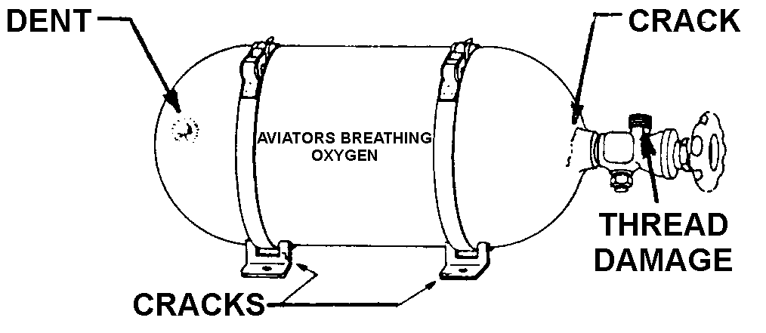
Figure 9-14. Oxygen cylinder damage.

NOTE: Cylinders having greater weight or size will require strengthened cylinder mounting brackets and a reevaluation to determine that the larger or heavier cylinder will not interfere with adjacent systems, components, or structural members, and that the strength of attaching structure is adequate and any additional weight will be computed into the aircraft’s weight and balance report.

Replace or repair any cylinder mounting brackets that show signs of wear. Visible cracks may be welded in accordance

with manufacturer’s standards. Replace the cylinder straps or clamps that show wear or abuse. For typical mounting bracket cracks and failure, see figure 9-15.

Lines and Fittings.

Replace any oxygen line that is chafed, rusted, corroded, dented, cracked, or kinked.

Clean oxygen system fittings showing signs of rusting or corrosion in the threaded area. To accomplish this, use a cleaner recommended by manufacturers of oxygen equipment. Replace lines and fittings that cannot be cleaned.

The high-pressure lines which are located between the oxygen bottle (outside the oxygen service filler) and the regulator are normally fabricated from stainless steel or thick-wall, seamless copper alloy tubing. The fittings on high-pressure lines are normally silver brazed.

NOTE: Use silver alloys free of cadmium when silver brazing. The use of silver brazing alloys, which contain cadmium, will emit a poisonous gas when heated to a molten state. This gas is extremely hazardous to health if inhaled.

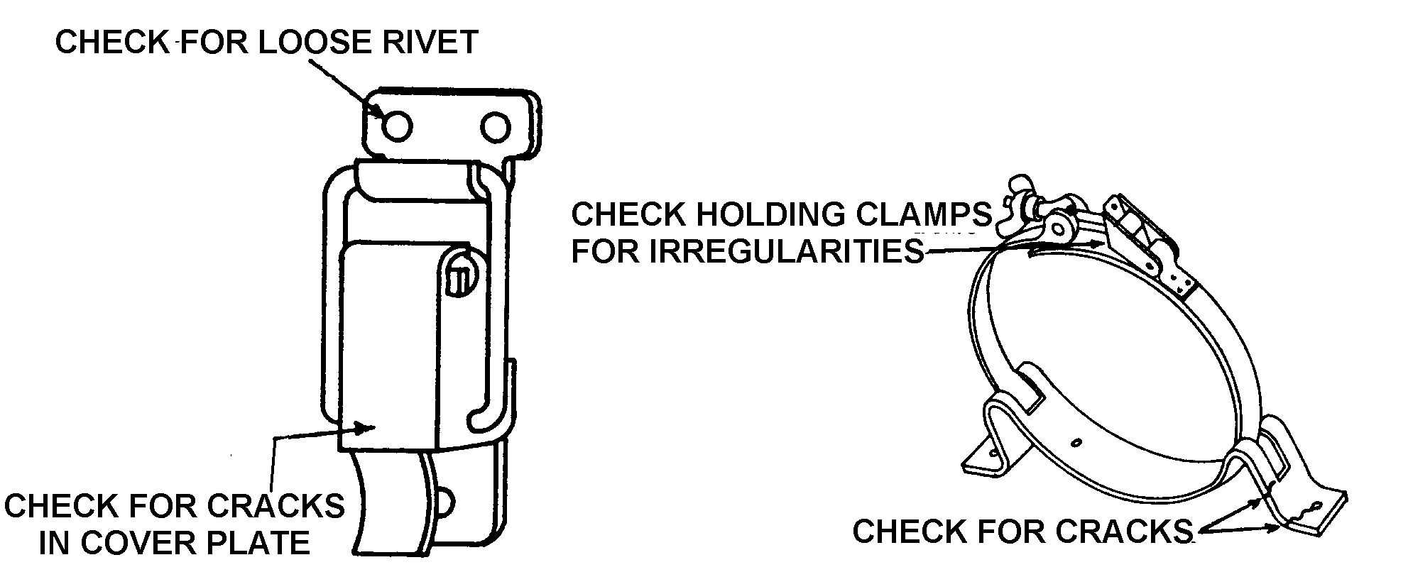
Figure 9-15. Cylinder brackets and clamps.

The low-pressure lines extend from the pressure regulator to each passenger and crew oxygen outlet. These lines are fabricated from seamless aluminum alloy, copper, or flexible hose. Normally, flare- or flange-type connections are used.

CAUTION: Do not allow oil, grease, flammable solvent, or other combustibles such as lint or dust to come in contact with threads or any parts that will be exposed to pressurized oxygen.

It is advisable to purge the oxygen system any time work has been accomplished on any of the lines and fittings. Use dry nitrogen or dry air for purging the system. All open lines should be capped immediately after purging.

When oxygen is being lost from a system through leakage, a sequence of steps may be necessary to locate the opening. Leakage may often be detected by listening for the distinct hissing sound of escaping gas. If this check proves negative, it will be necessary to soap-test all lines and connections with a castile soap and water solution or specially compounded leak-test material. Make the solution thick enough to adhere to the contours of the fittings. At the completion of the leakage test, remove all traces of the soap and water.

CAUTION: Do not attempt to tighten any connections while the system is charged.

Regulators, Valves, and Gauges. Line maintenance of oxygen regulators, valves, and gauges does not include major repair. These components are precision made and their repair usually requires the attention of a repair station or the manufacturer. Care must be taken when reinstalling these components to

ascertain if the threaded area is free of nicks, burrs, and contaminants that would prevent the connections from sealing properly.

CAUTION: Do not use petroleum lubricants on these components.

Masks and Hoses.

Troubleshooting. If a mask assembly is defective (leaks, does not allow breathing, or contains a defective microphone), it is advisable to return the mask assembly to the manufacturer or a repair station.

Maintenance Practice and Cleaning.

Clean and disinfect the mask assemblies after use, as appropriate.

NOTE: Use care to avoid damaging the microphone assembly while cleaning and sterilizing.

Wash the mask with a mild soap solution and rinse it with clear water.

To sterilize, swab the mask thoroughly with a gauze or sponge soaked in a water merthiolate solution. This solution should contain 1/5-teaspoon of merthiolate per 1 quart of water. Wipe the mask with a clean cloth and air dry.

Replace the hose if it shows evidence of deterioration.

Hoses may be cleaned in the same manner as the mask.

Observe that each mask breathing tube end is free of nicks, and that the tube end will slip into the cabin oxygen receptacle with ease and not leak.

FUNCTIONAL TESTING AFTER REPAIR. Following repair, and before inspection plates, cover plates, or upholstering are replaced, test the entire system.

Open the cylinder valve slowly and observe the pressure gauge on a high-pressure system. A pressure of approximately 1,800 psi (at 70 °F) should be indicated on the gauge. (Cylinder pressure will vary considerably with radical temperature changes.)

Check the system by installing one of the mask hose fittings (minus the mask) in each of the cabin wall outlets to determine whether there is a flow. If a demand mask is used, check by breathing through the mask and, if appropriate, clean the mask according to paragraph 9-49d.

Check the complete system for leaks in accordance with the procedure outlined in paragraph 9-49b(2)(d).

If leaks are found, close the cylinder valve and open an outlet to reduce the pressure in the system to zero.

The following checks may be made for a pressure drop check of the system.

Open the cylinder valve and pressurize the system. Observe the pressure gauge (a pressure of approximately 1,800 psi at 70 °F should be indicated). For the light weight ICC 3HT 1850 cylinders, pressurize the system to approximately 1,850 psi at 70 °F.

Close the cylinder valve and wait approximately 5 minutes for temperatures to stabilize.

Record the pressure gauge reading and temperature and after 1 hour, record the pressure gauge reading and temperature again.

A maximum pressure drop of 100 psi is permissible.

NOTE: Conduct the above tests in an area where changes of temperature will be less than 10 °F. If a leak occurs during the 1-hour period, suitable corrections would be required, or reconduct the test under conditions of unvarying temperatures.

SERVICE OXYGEN CYLINDERS. REQUIREMENTS (Ref 49 CFR 173.34 e, 16). Standard-weight cylinders must be hydrostatic tested at the end of each 5-year period (10 years if it meets the requirements in 49 CFR 173.34 e, 16). This is a Department of Transportation (DOT) requirement. Thesecylinders carry an ICC or DOT 3AA 1800 classification and are suitable for the use intended.

Lightweight cylinders must be hydrostatic tested every 3 years, and must be retired from service after 24 years or 4,380 pressurizations, whichever occurs first. These cylinders carry an ICC or DOT 3 HT 1850 classification and must be stamped with the approval after being inspected. (Ref. 49 CFR 173.34 e, 15).

CAUTION: Use only aviation breathing oxygen when having the oxygen bottle charged.

Charging High-Pressure Oxygen Cylinders. The following are recommended procedures for charging high-pressure oxygen cylinders from a manifold system, either permanently-installed or trailer-mounted.

CAUTION: Never attempt to charge a low-pressure cylinder directly from a high-pressure manifold system or cylinder.

Inspection. Do not attempt to charge oxygen cylinders if any of the following discrepancies exist:

Inspect for contaminated fittings on the manifold, cylinder, or outside filler valve. If cleaning is needed, wipe with stabilized trichlorethylene and let air dry. Do not permit the solvent to enter any internal parts.

Check the hydrostatic test date of the cylinder. DOT regulations require ICC or DOT 3AA 1800 designation cylinders to be hydrostatic tested to 5/3 their working pressure, every 5 years (10 years if they meet the requirements in 49 CFR 173.34,e, 16).

Cylinders bearing designation ICC or DOT 3HT 1850 (Ref. 49 CFR 173.34,e, 15) must be hydrostatic tested to 5/3 their working pressure every 3 years, and retired from service 24 years or 4,380 filling cycles after the date of manufacture, whichever occurs first.

If the cylinder is completely empty, do not charge. An empty cylinder must be removed, inspected, and cleaned before charging.

Charging.

Connect the cylinder valve outlet or the outside filler valve to the manifold.

Slowly open the valve of the cylinder to be charged and observe the pressure on the gauge of the manifold system.

Slowly open the valve of the cylinder on the manifold system having the lowest pressure and allow the pressure to equalize.

Close the cylinder valve on the manifold system and slowly open the valve of the cylinder having the next highest pressure. Continue this procedure until the cylinder has been charged in accordance with table 9-5.

Close all valves on the manifold system.

Close the valve on the filled cylinder and remove the cylinder from the manifold.

Using a leak detector, test for leakage around the cylinder valve threaded connections. (If leakage is present, discharge the oxygen and return the cylinder to the facility for repair.)

Let the cylinder stabilize for a period of at least 1 hour, and then recheck the pressure.

Make any necessary adjustments in the pressure.

Charging of Low-Pressure Oxygen Systems and Portables. For recharging a low-pressure aircraft oxygen system, or portable cylinders, it is essential that the oxygen trailer or cart have a pressure-reducing regulator. Military types E-2 or C-1 reducing regulators are satisfactory. These types of regulators reduce the large cylinder pressure from 2,000 psi to a line pressure of 450 psi. (A welding pressure-reducing regulator is not satisfactory.)

CAUTION: When refilling the low-pressure system or portable cylinders, open the oxygen filler tank valve slowly to allow the system or portable cylinders to be filled at a slow rate. After the refilling operation is completed, check for leaks with a leak detector. If a leak is detected, paragraph 9-49b(2)(d) should be referred to for corrective action.
Table 9-5. Table of filling pressures.
Initial Temp  (° F) | Filling Pressure  (psi)
0 | 1,650
10 | 1,700
20 | 1,725
30 | 1,775
40 | 1,825
50 | 1,875
60 | 1,925
70 | 1,975
80 | 2,000
90 | 2,050
100 | 2,100
110 | 2,150
120 | 2,200
130 | 2,250
Initial Temperature-Refers to the ambient temperature in the filling room.

Filling Pressure-Refers to the pressure to which aircraft cylinders should be filled. This table gives approximations only, and assumes a rise in temperature of approximately 25 °F. due to the heat of compression. This table also assumes the aircraft cylinders will be filled as quickly as possible and that they will only be cooled by ambient air, with no water bath or other means of cooling being used.

Example: If ambient temperature is 70 °F, fill aircraft cylinders to approximately 1,975 psi-as close to this pressure as the gauge may be read. Upon cooling, cylinders should have approximately 1,850 psi pressure

9-52.⎯9-59. [RESERVED.]

