CHAPTER 10. WEIGHT AND BALANCE

Section 1 TERMINOLOGY

GENERAL. The removal or addition of equipment results in changes to the center of gravity (c.g.). The empty weight of the aircraft, and the permissible useful load are affected accordingly. Investigate the effects of these changes, since the aircraft flight characteristics may be adversely affected. Information on which to base the record of weight and balance changes to the aircraft may be obtained from the pertinent Aircraft Specifications, Type Certificate Data Sheet (TCDS), prescribed aircraft operating limitations, aircraft flight manual, aircraft weight and balance report, and maintenance manual. Removal of standard parts with negligible weight or addition of minor items of equipment such as nuts, bolts, rivets, washers, and similar standard parts of negligible weight on fixed-wing aircraft do not require a weight and balance check. Rotorcraft are, in general, more critical with respect to control with changes in the c.g. position. Refer to the procedures and instructions in that particular model’s maintenance or flight manual.

TERMINOLOGY. The following terminology is used in the practical application of weight and balance control.

Maximum Weight. The maximum weight is the maximum authorized weight of the aircraft and its contents as listed in the specifications.

Empty Weight. The empty weight of an aircraft includes all operating equipment that has a fixed location and is actually installed in the aircraft. It includes the weight of the airframe, powerplant, required equipment, optional and special equipment, fixed ballast, full engine coolant, hydraulic fluid, residual fuel, and oil. Additional information regarding fluids that may be contained in the aircraft systems and must be included in the empty weight will be indicated in the pertinent Aircraft Specifications or TCDS.

Negligible Weight Change is any change of one pound or less for aircraft whose weight empty is less than 5,000 pounds; two pounds or less for aircraft whose weight empty is more than 5,000 and 50,000 pounds; and five pounds or less for aircraft whose weight empty is more than 50,000 pounds. Negligible c. g. change is any change of less than 0.05% MAC for fixed wing aircraft, 0.2 percent of the maximum allowable c. g. range for rotary wing aircraft.

Useful Load. The useful load is the empty weight subtracted from the maximum weight of the aircraft. This load consists of the pilot, crew (if applicable), maximum oil, fuel, passengers, and baggage unless otherwise noted.

Weight Check. The weight check consists of checking the sum of the weights of all items of useful load against the authorized useful load (maximum weight less empty weight) of the aircraft.

Datum. The datum is an imaginary vertical plane from which all horizontal measurements are taken for balance purposes with the aircraft in level flight attitude. The datum is indicated in most Aircraft Specifications or TCDS. On some of the older aircraft, when the datum is not indicated, any convenient datum may be selected. Once the datum is selected, all moment arms and the location of the permissible c.g. range must be taken with reference to it. Examples of typical locations of the datum are shown in figure 10-1.

Arm (or Moment Arm). The arm (or moment arm) is the horizontal distance in inches from the datum to the c.g. of an item. The algebraic sign is plus ( + ) if measured aft

of the datum, and minus ( - ) if measured forward of the datum. Examples of plus and minus arms are shown in figure 10-2.

Figure 10-1. Typical datum locations.

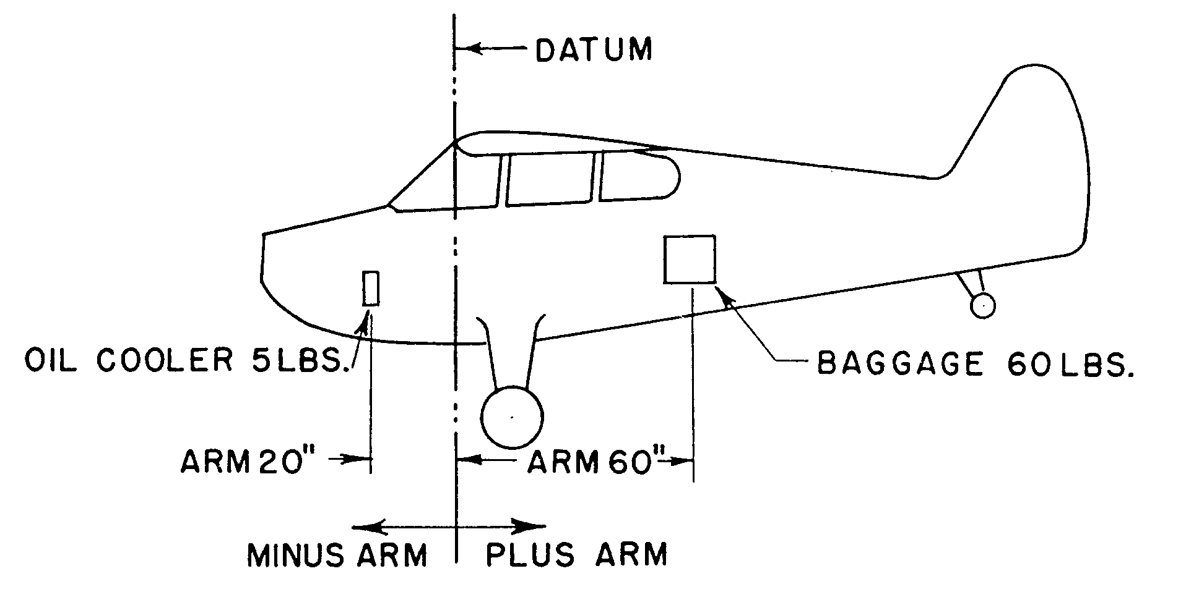
Figure 10-2. Illustration of arm (or moment arm).

Moment. The moment is the product of a weight multiplied by its arm. The moment of an item about the datum is obtained by multiplying the weight of the item by its horizontal distance from the datum. A typical moment calculation is given in figure 10-3.

Center of Gravity. The c.g. is a point about which the nose-heavy and tail-heavy moments are exactly equal in magnitude. If the aircraft is suspended from the c.g., it will not have a tendency to pitch in either direction (nose up or down). The weight of the aircraft (or any object) may be assumed to be concentrated at its c.g. (See figure 10-3.)

Empty Weight Center of Gravity. The empty weight c.g. is the c.g. of an aircraft in its empty weight condition, and is an essential part of the weight and balance record. Formulas for determining the c.g. for tail and nosewheel type aircraft are given in figure 10-4. Typical examples of computing the empty weight and empty weight c.g. for aircraft are shown in figures 10-5 and 10-6.

Empty Weight Center of Gravity Range. The empty weight c.g. range is determined so that the empty weight c.g. limits will not be exceeded under standard specifications loading arrangements. Calculations as outlined in paragraph 10-16 should be completed when it is possible to load an aircraft in a manner not covered in the Aircraft Specifications or TCDS (extra tanks, extra seats, etc.). The empty weight c.g. range, when applicable, is listed in the Aircraft Specifications or TCDS. Calculation of empty weight c.g. is shown in figures 10-5 and 10-6.

Operating Center of Gravity Range. The operating c.g. range is the distance between the forward and rearward c.g. limits indicated in the pertinent Aircraft Specifications or TCDS. These limits are determined for the most forward and most rearward loaded c.g. positions at which the aircraft meets the requirements of Title 14 of the Code of Federal Regulation (14 CFR). The limits are indicated in the specifications in either percent of mean aerodynamic chord (MAC) or inches from the

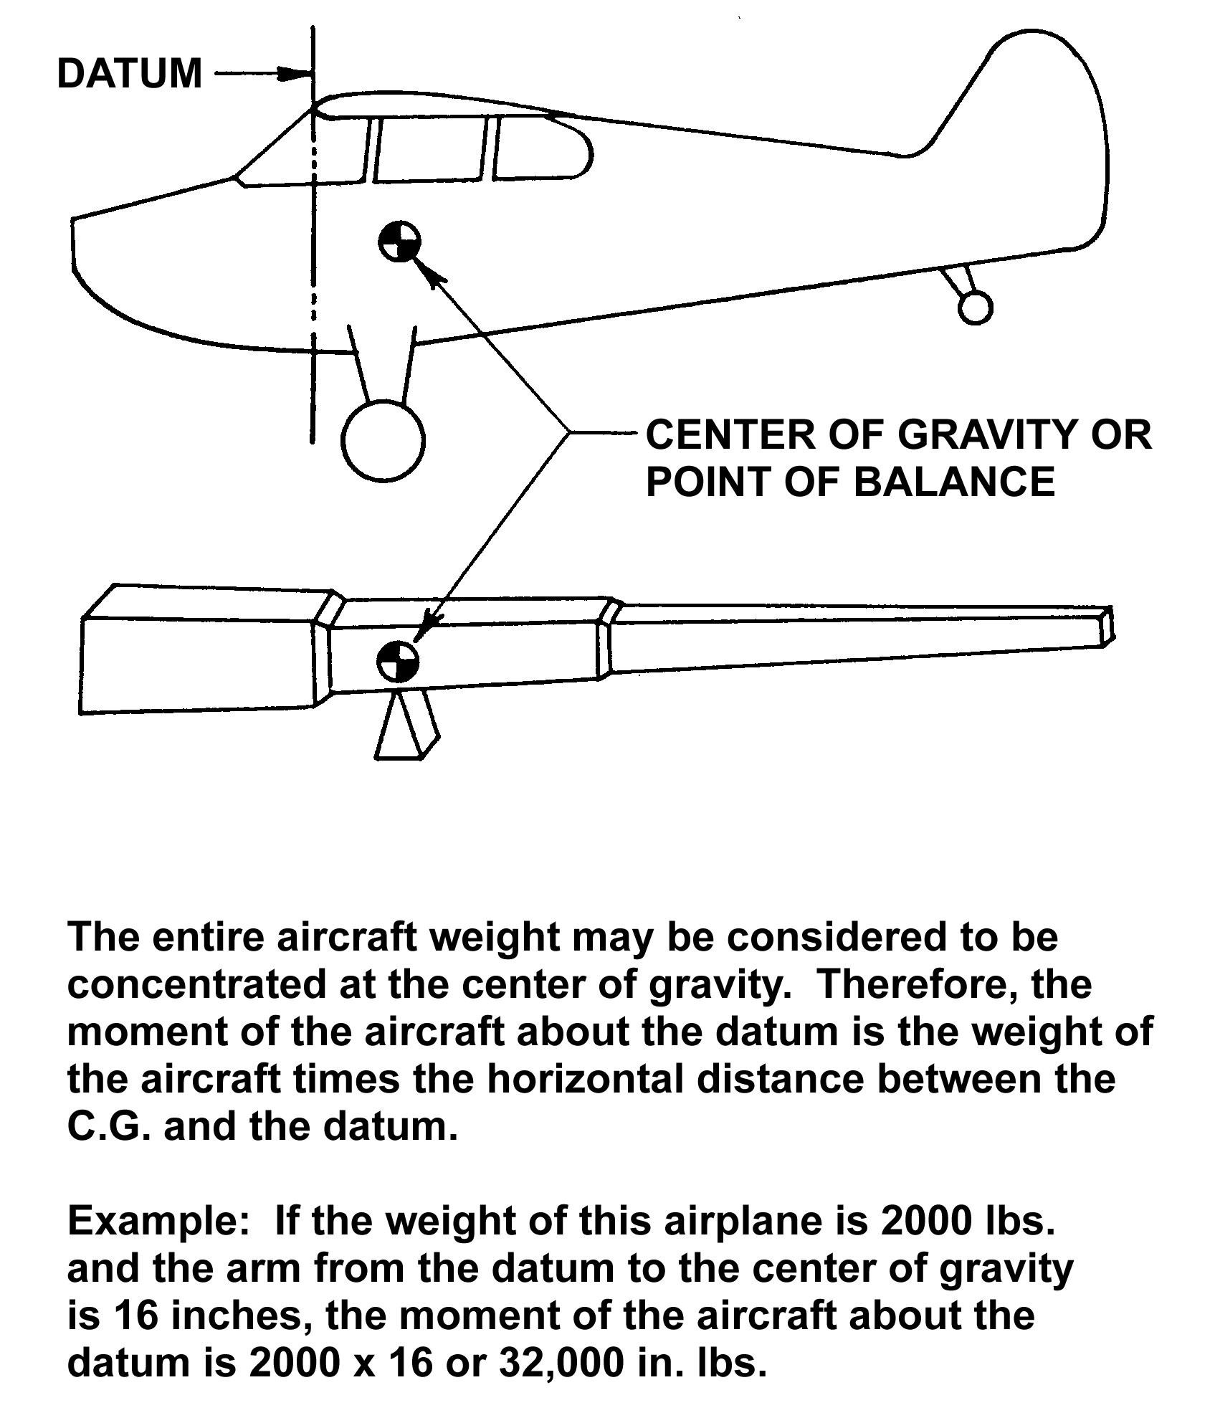
Figure 10-3. Example of moment computation.

datum. The c.g. of the loaded aircraft must be within these limits at all times as illustrated in figure 10-7.

Mean Aerodynamic Chord (MAC). The MAC is established by the manufacturer who defines its leading edge and its trailing edge in terms of inches from the datum. The c.g. location and various limits are then expressed in percentages of the chord. The

location and dimensions of the MAC can be found in the Aircraft Specifications, the TCDS, the aircraft flight manual, or the aircraft weight and balance report.

Weighing Point. If the c.g. location is determined by weighing, it is necessary to obtain horizontal measurements between the points on the scale at which the aircraft’s weight is concentrated. If weighed using

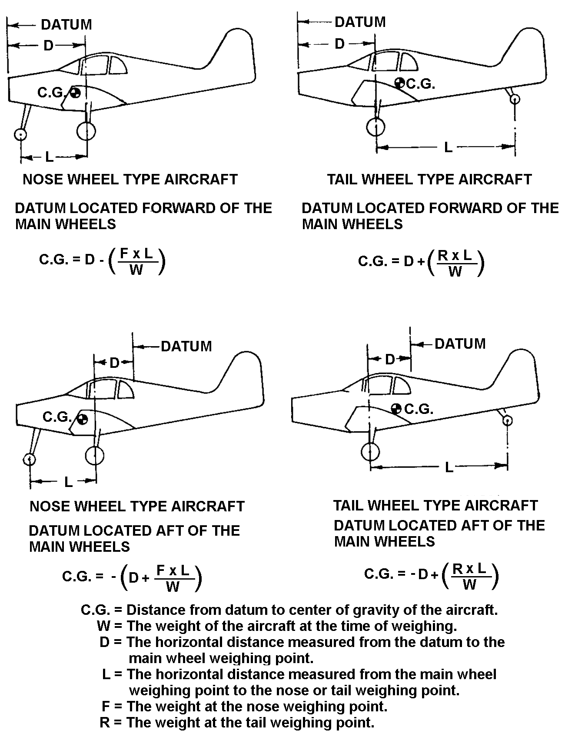
Figure 10-4. Empty weight center of gravity formulas.

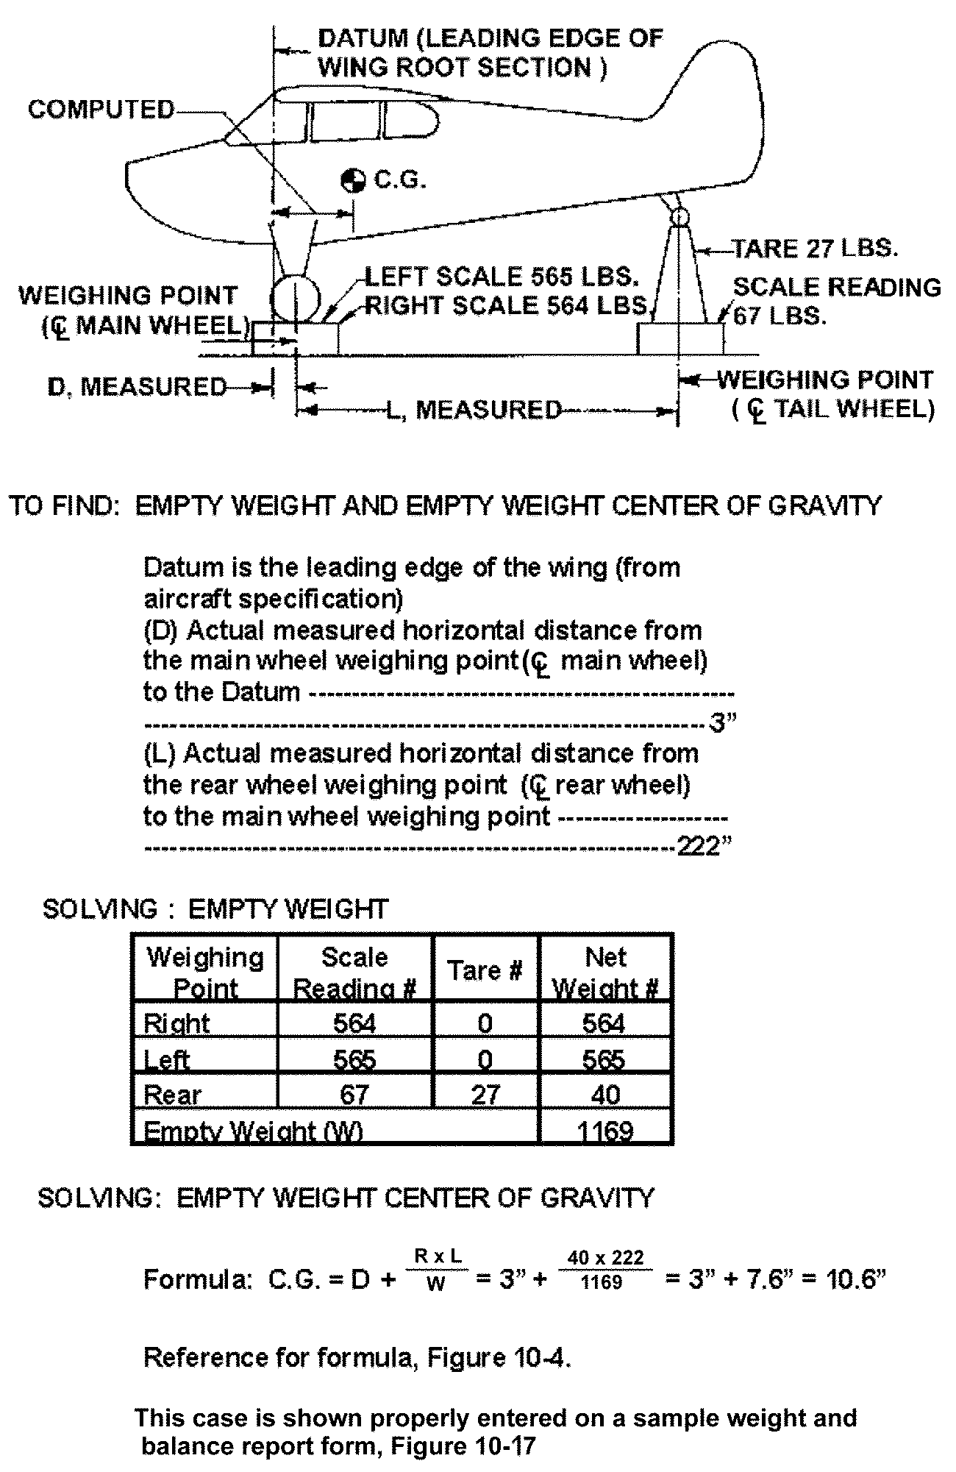
Figure 10-5. Empty weight and empty center of gravity - tail-wheel type aircraft.
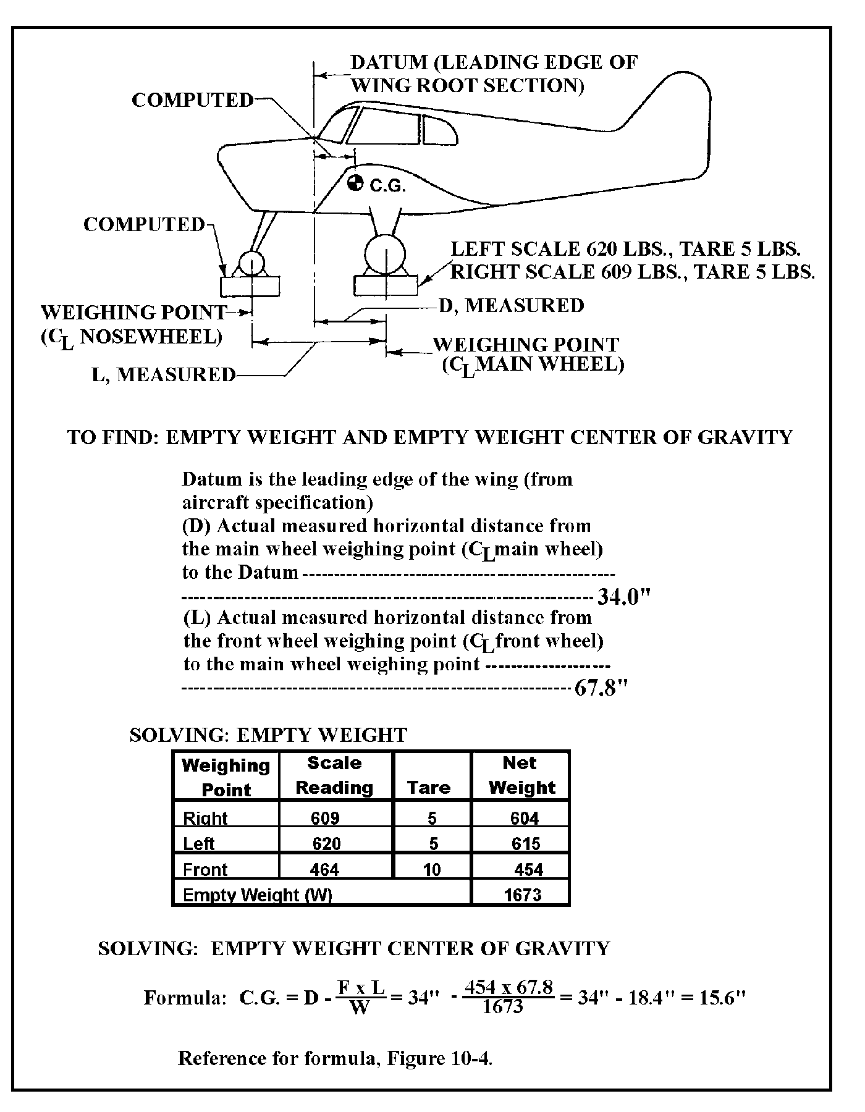
Figure 10-6. Empty weight and empty weight center of gravity - nosewheel-type aircraft.
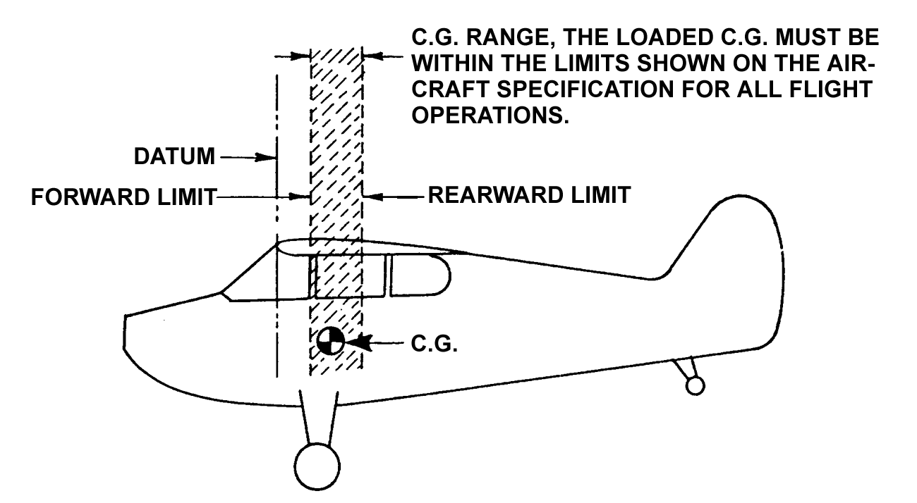
Figure 10-7. Operating center of gravity range.

scales under the landing gear tires, a vertical line passing through the centerline of the axle will locate the point on the scale at which the weight is concentrated. This point is called the “weighing point.” Other structural locations capable of supporting the aircraft, such as jack pads on the main spar, may also be used if the aircraft weight is resting on the jack pads. Indicate these points clearly in the weight and balance report when used instead of the landing gear. Typical locations of the weighing points are shown in figure 10-8.

Zero Fuel Weight. The maximum permissible weight of a loaded aircraft (passengers, crew, cargo, etc.) less its fuel is zero fuel weight. All weights in excess of maximum zero fuel weight must consist of usable fuel.

Minimum Fuel. The minimum fuel for balance purposes is 1/12 gallon per maximum-

except-take-off horsepower (METO). Minimum fuel is the maximum amount of fuel which can be used in weight and balance computations when low fuel might adversely affect the most critical balance conditions. To determine the weight of fuel in pounds divide the METO horsepower by two.

Full Oil. The full oil is the quantity of oil shown in the Aircraft Specifications or TCDS as oil capacity. Use full oil as the quantity of oil when making the loaded weight and balance computations.

Tare. The weight of chocks, blocks, stands, etc., used when weighing aircraft is called tare and is included in the scale readings. Tare is deducted from the scale reading at each respective weighing point when tare is involved, to obtain the actual aircraft weight.

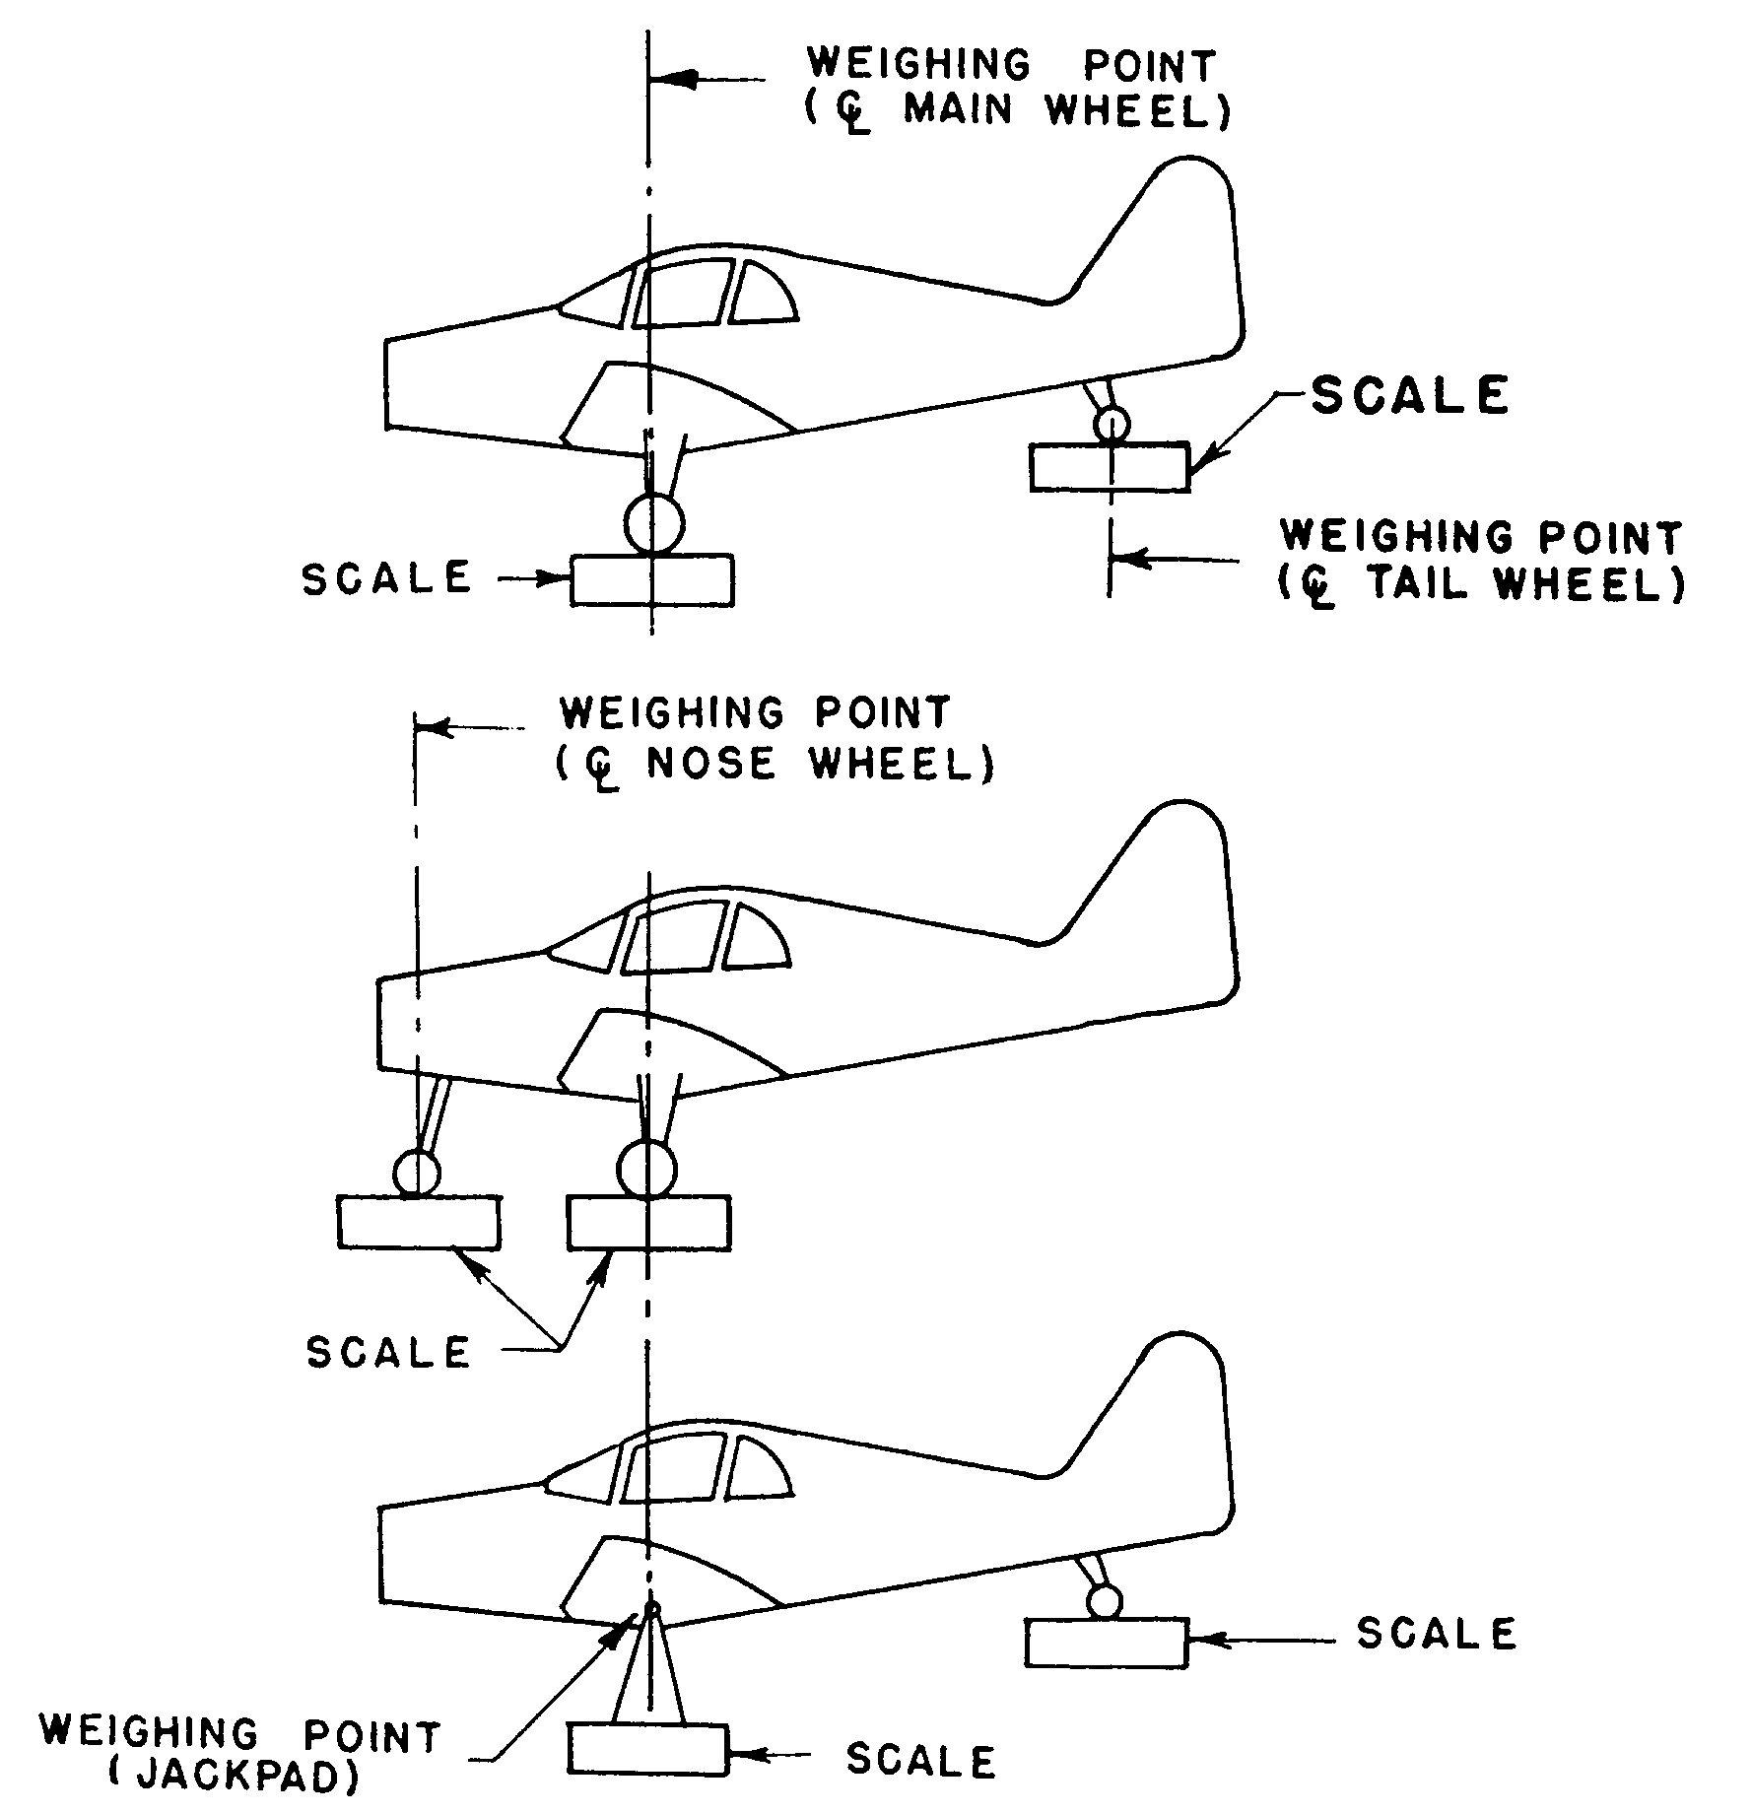

Figure 10-8. Weighing point centerline.

10-3.⎯10-13. [RESERVED.]

