Section 2 WEIGHING PROCEDURES

GENERAL. Weighing procedures may vary with the aircraft and the type of weighing equipment employed. The weighing procedures contained in the manufacturer’s maintenance manual should be followed for each particular aircraft.

PROCEDURES. Accepted procedures when weighing an aircraft are:

Remove excessive dirt, grease, moisture, etc., from the aircraft before weighing.

Weigh the aircraft inside a closed building to prevent error in scale reading due to wind.

Determine the empty weight c. g. by placing the aircraft in a level flight attitude.

Have all items of equipment that are included in the certificated empty weight report installed in the aircraft when weighing. These items of equipment are a part of the current weight and balance report.

The scales should have a current calibration before weighing begins. Zero and use the scales in accordance with the scale manufacturer’s instructions. Platform scales and suitable support for the aircraft, if necessary, are usually placed under the wheels of a landplane, the keel of a seaplane float, or the skis of a skiplane. Other structural locations capable of supporting the aircraft, such as jack pads, may be used. Clearly indicate these points and the alternate equipment used in the weight and balance report.

Drain the fuel system until the quantity indicator reads zero or until the tanks are empty with the aircraft in level flight attitude, unless otherwise noted in the TCDS or Aircraft Specifications. The amount of fuel remaining in the tank, lines, and engine is termed residual fuel and is to be included in the empty weight. In special cases, the aircraft may be weighed with full fuel in tanks provided a definite means of determining the exact weight of the fuel is available.

The oil system should be filled to the quantity noted in the TCDS or Aircraft Specifications.

NOTE: On Civil Aeronautics Regulations (CAR-3) Certified Aircraft, the weight of the oil was subtracted mathematically to get the empty weight. In 14 CFR, part 23 aircraft, the weight of the oil is included in the empty weight.

When weighed with full oil, actual empty weight equals the actual recorded weight less the weight of the oil in the oil tank( oil weight = oil capacity in gallons x 7.5 pounds). Indicate on all weight and balance reports whether weights include full oil or oil drained. (See figure 10-9.)

Do not set brakes while taking scale reading.

Note any tare reading when the aircraft is removed from the scales.

10-15a. REPAIRS AND ALTERATIONS are the major sources of weight changes, and it is the responsibility of the aircraft mechanic making any repairs or alteration to know the weight and location of these changes, and to compute the new CG and record the new empty (EW) weight and EWCG data in the aircraft flight manual.

10-15b. ANNUAL OR 100-HOUR INSPECTION. After conducting an annual or 100-hour inspection, the aircraft mechanic

must ensure the weight and balance data in the aircraft records is current and accurate.

WEIGHT AND BALANCE COMPUTATIONS. It is often necessary after completing an extensive alteration to establish
by computation that the authorized weight and c.g. limits as shown in the TCDS and Aircraft Specifications are not exceeded. Paragraph b(2) explains the significance of algebraic signs used in balance computations.

 | 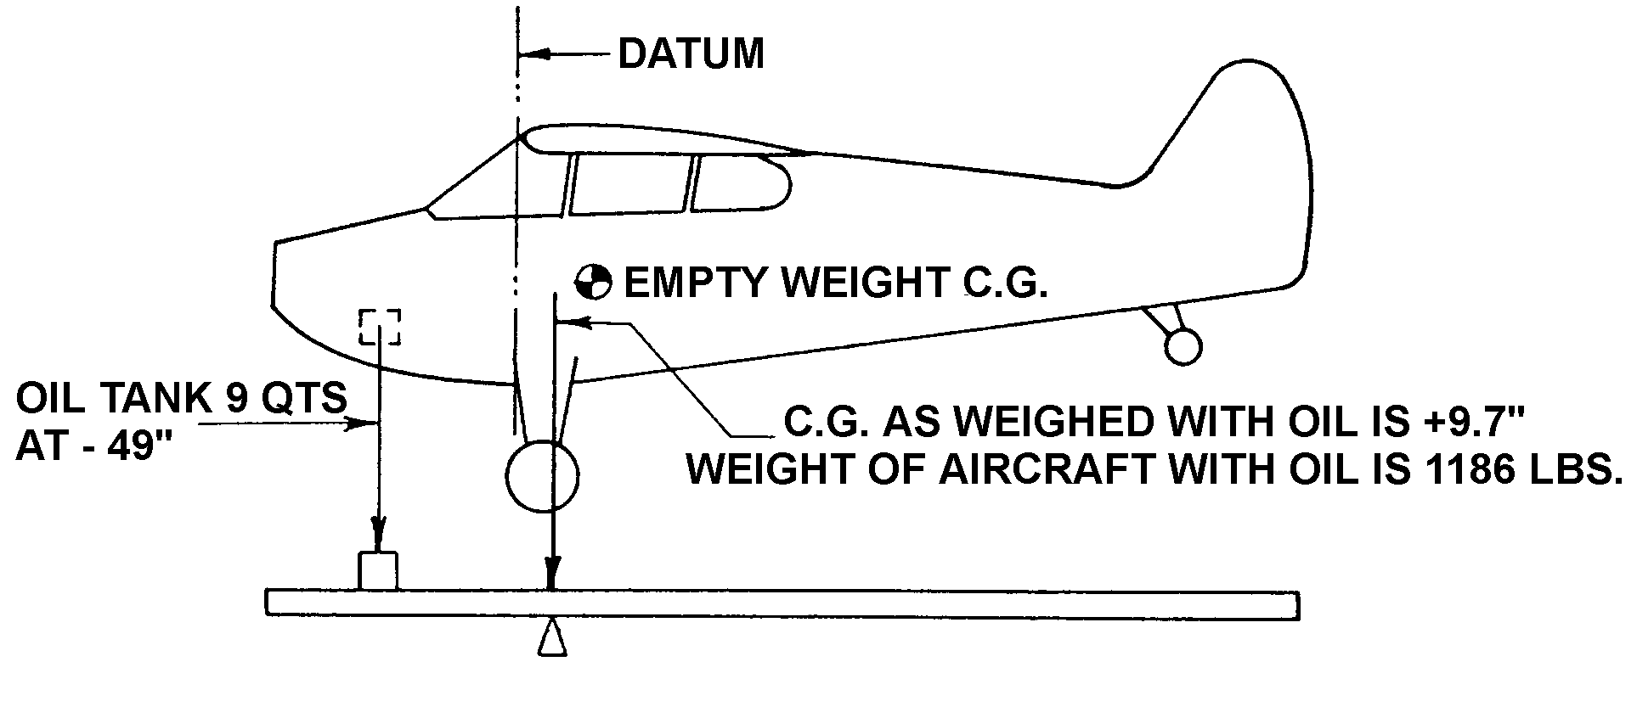
EMPTY WEIGHT AND EMPTY WEIGHT CENTER OF GRAVITY
(when aircraft is weighed with oil)
GIVEN:
Aircraft as weighed with full oil 1186 lbs.
Center of gravity 9.7”
Full oil capacity 9 qts. 17 lbs.

SOLVING:
 |  | Weight # x Arm” = Moment “#
 | Aircraft as weighed | + 1186 |  |  |  |  |  | + 9.7 |  |  | + 11504
 | Less oil | - 17 |  |  |  |  |  | - 49.0 |  |  | + 833
 | Total | + 1169(A) |  |  |  |  |  |  |  |  | + 12337(B)
 | Empty Weight (A) = 1169 pounds
 | Empty Weight Center of Gravity |  |  | B | = | 12337 |  |  |  | = + 10.6”
 |  |  |  | A |  |  | 1169
Figure 10-9. Empty weight and empty weight center of gravity when aircraft is weighed with oil.

The TCDS or Aircraft Specifications contain the following information relating to the subject:

Center of gravity range.

Empty weight c.g. range when applicable.

Leveling means.

Datum.

Maximum weights.

Number of seats and arm.

Maximum baggage and arm.

Fuel capacity and arm.

Oil capacity and arm.

Equipment items and arm.

The TCDS do not list the basic required equipment prescribed by the applicable airworthiness regulations for certification. Refer to the manufacturer’s equipment list for such information.

Unit weight for weight and balance purposes.

Gasoline ----------- 6 pounds per U.S. gal.
Turbine Fuel ------ 6.7 pounds per U.S. gal.
Lubricating oil ---- 7.5 pounds per U.S. gal.
Crew and
passengers ----- 170 pounds per person.

It is important to retain the proper algebraic sign (+ or -) through all balance computations. For the sake of uniformity in these computations, visualize the aircraft with the nose to the left. In this position any arm to the left (forward) of the datum is “minus” and any arm to the right (rearward) of the datum is “plus.” Any item of weight added to the aircraft either side of the datum is plus weight, any weight item removed is a minus weight. When multiplying weights by arms, the answer is plus if the signs are the same, and minus if the signs are different. The following combinations are possible:

Items added forward of the datum-
( + ) weight x ( - ) arm = ( - ) moment.
Items added to the rear of the datum-
( + ) weight x ( + ) arm = ( + ) moment.
Items removed forward of the datum-
( - ) weight x ( - ) arm = ( + ) moment.
Items removed rear of the datum-
( - ) weight x ( + ) arm = ( - ) moment.

The total weight of the airplane is equal to the weight of the empty aircraft plus the weight of the items added minus the weight of the items removed.

The total moment of the aircraft is the algebraic sum of the empty weight moment of the aircraft and all of the individual moments of the items added and/or removed.

WEIGHT AND BALANCE EXTREME CONDITIONS. The weight and balance extreme conditions represent the maximum forward and rearward c.g. position for the aircraft. Include the weight and balance data information showing that the c.g. of the aircraft (usually in the fully loaded condition) falls between the extreme conditions.

Forward Weight and Balance Check. When a forward weight and balance check is made, establish that neither the maximum weight nor the forward c.g. limit listed in the TCDS and Aircraft Specifications are exceeded. To make this check, the following information is needed:

The weights, arms, and moment of the empty aircraft.

The maximum weights, arms, and moments of the items of useful load that are located ahead of the forward c.g. limit.

The minimum weights, arms, and moments of the items of useful load that are located aft of the forward c.g. limit. A typical example of the computation necessary to make this check, using this data, is shown in figure 10-10.

Rearward Weight and Balance Check. When a rearward weight and balance check is made, establish that neither the maximum weight nor the rearward c.g. limit listed in the TCDS and Aircraft Specifications are exceeded. To make this check, the following information is needed:

The weight, arms, and moments of the empty aircraft.

The maximum weights, arms, and moments of the items of useful load that are located aft of the rearward c.g. limit.

 | 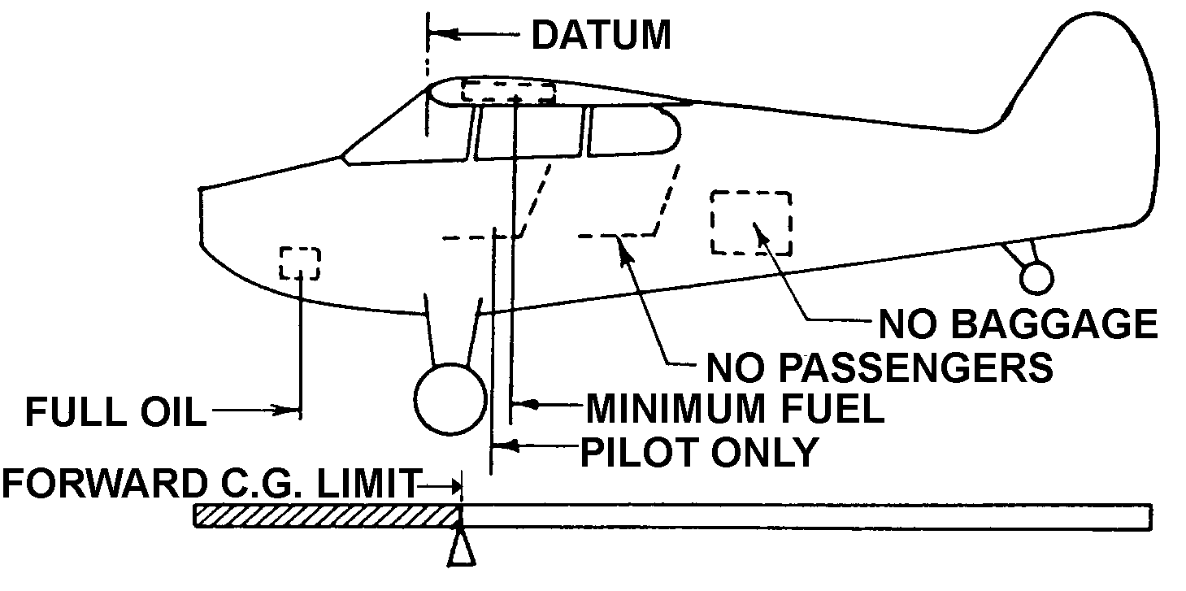
 | TO CHECK: MOST FORWARD WEIGHT AND BALANCE EXTREME.
GIVEN:
Actual empty weight of the aircraft 1169#
Empty weight center of gravity + 10.6”
*Maximum weight 2100#
*Forward C.G.. limit + 8.5”
*Oil capacity, 9 qts. 17# at -49”
*Pilot in farthest forward seat equipped with
controls (unless otherwise placarded) 170# at +16”
*Since the fuel tank is located to the rear of the
forward C.G. limit, minimum fuel should be included.
METO HP = 165 = 13.75 gal. x 6# 83# at +22”
12 12
* Information should be obtained from the aircraft specification.
Note: Any items or passengers must be used if they are located ahead of the forward C.G. limit.
Full fuel must be used if the tank is located ahead of the forward C.G. limit.

CHECK OF FORWARD WEIGHT AND BALANCE EXTREME
 |  |  |  |  |  |  | Weight (#) x Arm (“) = Moment (“#)
 |  |  | Aircraft empty |  |  |  | + 1169 | + 10.6 | + 12391
 |  |  | Oil |  |  |  | + 17 | - 49 | - 833
 |  |  | Pilot |  |  |  | + 170 | + 16 | + 2720
 |  |  | Fuel |  |  |  | + 83 | + 22 | + 1826
 |  |  | Total |  |  |  | + 1439 (TW) |  | + 16104 (TM)
 |  | Divide the TM (total moment) by the TW (total weight) to obtain the forward weight and balance extreme.
 |  |  | TM | = | 16104 | = + 11.2”
 |  |  | TW |  | 1439
Since the forward C.G. limit and the maximum weight are not exceeded, the forward weight and balance
extreme condition is satisfactory.

Figure 10-10. Example of check of most forward weight and balance extreme.

The minimum weights, arms, and moments of the items of useful load that are located ahead of the rearward c.g. limit. A typical example of the computation necessary to make this check, using this data, is shown in figure 10-11.

LOADING CONDITIONS
AND/OR PLACARDS. If the following items have not been covered in the weight and balance extreme condition checks and are not covered by suitable placards in the aircraft, additional computations are necessary. These computations should indicate the permissible distribution of fuel, passengers, and baggage that may be carried in the aircraft at any one time without exceeding either the maximum weight or c.g. range. The conditions to check are:

With full fuel, determine the number of passengers and baggage permissible.

With maximum passengers, determine the fuel and baggage permissible.

With maximum baggage, determine the fuel and the number and location of passengers.

Examples of the computations for the above items are given in figures 10-12, 10-13, and 10-14 respectively. The above cases are mainly applicable to the lighter type personal aircraft. In the case of the larger type transport aircraft, a variety of loading conditions is possible and it is necessary to have a loading schedule.

EQUIPMENT LIST. A list of the equipment included in the certificated empty weight may be found in either the approved aircraft flight manual or the weight and balance report. Enter into the weight and balance

report all required, optional, and special equipment installed in the aircraft at time of weighing and/or subsequent equipment changes.

Required equipment items are listed in the pertinent Aircraft Specifications.

Optional equipment items are listed in the pertinent Aircraft Specifications and may be installed in the aircraft at the option of the owner.

Special equipment is any item not corresponding exactly to the descriptive information in the Aircraft Specifications. This includes items such as emergency locator transmitter (ELT), tail or logo lights, instruments, ashtrays, radios, navigation lights, and carpets.

Required and optional equipment may be shown on the equipment list with reference to the pertinent item number listed in the applicable specifications only when they are identical to that number item with reference to description, weight, and arm given in the specifications. Show all special equipment items with reference to the item by name, make, model, weight, and arm. When the arm for such an item is not available, determine by actual measurement.

EQUIPMENT CHANGE. The person making an equipment change is obligated to make an entry on the equipment list indicating items added, removed, or relocated with the date accomplished, and identify himself by name and certificate number in the aircraft records. Examples of items so affected are the installation of extra fuel tanks, seats, and baggage compartments. Figure 10-15 illustrates the effect on balance when equipment items are added within the acceptable c.g. limits and fore and aft of the established c.g. limits.
 | 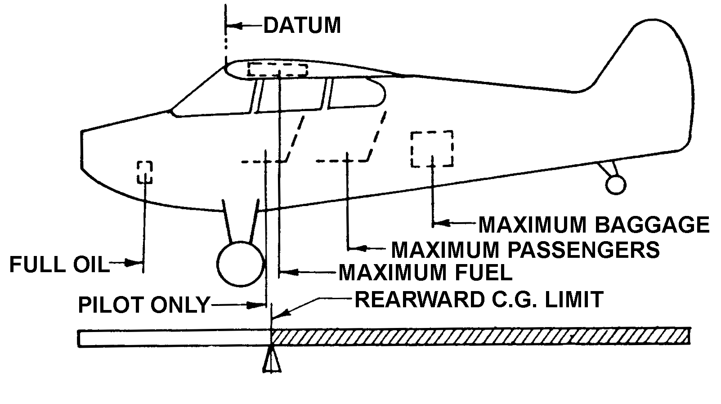
 | TO CHECK: MOST REARWARD WEIGHT AND BALANCE EXTREME.
GIVEN:
Actual empty weight of the aircraft 1169#
Empty weight center of gravity 10.6”
*Maximum weight 2100#
*Rearward C.G.. limit 21.9”
*Oil capacity, 9 qts. 17# at -49”
*Baggage, placarded do not exceed 100 lbs 100# at +75.5”
*Two passengers in rear seat, 170# x 2 340# at +48”
*Pilot in most rearward seat equipped with
controls (unless otherwise placarded) 170# at +16”
*Since the fuel tank is located aft of the
rearward C.G. limit full fuel must be used 240# at +22”

* Information should be obtained from the aircraft specification.
Note: If fuel tanks are located ahead of the rearward C.G. limit minimum fuel should be used.
CHECK OF REARWARD WEIGHT AND BALANCE EXTREME
 |  |  |  |  |  |  | Weight (#) x Arm (“) = Moment (“#)
 |  |  | Aircraft empty |  |  |  | + 1169 | + 10.6 | + 12391
 |  |  | Oil |  |  |  | + 17 | - 49 | - 833
 |  |  | Pilot (1) |  |  |  | + 170 | + 16 | + 2720
 |  |  | Passenger (2) |  |  |  | + 340 | + 48 | + 16320
 |  |  | Fuel (40 gals.) |  |  |  | + 240 | + 22 | + 5280
 |  |  | Baggage |  |  |  | + 100 | + 75.5 | + 7550
 |  |  | Total |  |  |  | + 2036 (TW) |  | + 43428 (TM)
 |  | Divide the TM (total moment) by the TW (total weight) to obtain the rearward weight and balance extreme.
 |  |  | TM | = | 43428 | = + 21.3”
 |  |  | TW |  | 2036
 |  | Since the rearward C.G. limit and the maximum weight are not exceeded, the rearward weight and balance extreme condition is satisfactory.
Figure 10-11. Example of check of most rearward weight and balance extreme.

EXAMPLE OF THE DETERMINATION OF THE NUMBER OF PASSENGERS AND BAGGAGE
PERMISSIBLE WITH FULL FUEL
GIVEN:
Actual empty weight of the aircraft 1169#
Empty weight center of gravity 10.6”
Maximum weight 2100#
Datum is leading edge of the wing
Forward center of gravity limit 8.5”
Rearward center of gravity limit 21.9”
Oil capacity, 9 qts.; show full capacity 17# at -49”
Baggage, maximum 100# at +75.5”
Two passengers in rear seat, 170# x 2 340# at +48”
Pilot in most rearward seat equipped with
controls (unless otherwise placarded) 170# at +16”
Full fuel, 40 gals. x 6# 240# at +22”

 |  |  |  |  |  |  |  | Weight (#) x Arm (“) = Moment (“#)
 |  | Aircraft empty |  |  |  |  |  | + 1169 |  | + 10.6 |  |  | + 12391
 |  | Oil |  |  |  |  |  | + 17 |  | - 49 |  |  | - 833
 |  | Full Fuel |  |  |  |  |  | + 240 |  | + 22 |  |  | + 5280
 |  | Passengers 2 rear |  |  |  |  |  | + 340* |  | + 48 |  |  | +16320
 |  | Pilot |  |  |  |  |  | + 170 |  | + 16 |  |  | + 2720
 |  | Baggage |  |  |  |  |  | + 100 |  | + 75.5 |  |  | + 7550
 |  | Total |  |  |  |  |  | + 2036 (TW) |  |  |  |  | + 43428 (TM)
 |  | Divide the TM (total moment) by the TW (total weight) to obtain the loaded center of gravity.
 |  | TM | = | 43428 | = + 21.3”
 |  | TW |  | 2036
The above computations show that with full fuel, 100 pounds of baggage and two passengers in the rear seat may be carried in this aircraft without exceeding either the maximum weight or the approved C. G. range.

This condition may be entered in the loading schedule as follows:

 |  | GALLONS OF FUEL |  |  |  |  | NUMBER OF PASSENGERS |  |  |  | POUNDS OF BAGGAGE
 |  | Full |  |  |  |  | 2 Rear |  |  |  | 100
* Only two passengers are listed to prevent the maximum weight of 2100 lbs. from
being exceeded.

Figure 10-12. Loading conditions: determination of the number of passengers and baggage permissible
with full fuel.

 | EXAMPLE OF THE DETERMINATION OF THE POUNDS OF FUEL AND BAGGAGE PERMISSIBLE WITH MAXIMUM PASSENGERS
 |  |  |  |  |  |  |  |  | Weight (#) x Arm (“) = Moment (“#)
 |  | Aircraft empty |  |  |  |  |  |  | + 1169 |  | + 10.6 |  |  | + 12391
 |  | Oil |  |  |  |  |  |  | + 17 |  | - 49 |  |  | - 833
 |  | Pilot |  |  |  |  |  |  | + 170 |  | + 16 |  |  | + 2720
 |  | Passenger (1) front |  |  |  |  |  |  | + 170 |  | + 16 |  |  | + 2720
 |  | Passenger (2) rear |  |  |  |  |  |  | + 340 |  | + 48 |  |  | +16320
 |  | Fuel (39 gals.) |  |  |  |  |  |  | + 234 |  | + 22 |  |  | + 5148
 |  | Baggage |  |  |  |  |  |  | ---- |  | ---- |  |  | ----
 |  | Total |  |  |  |  |  |  | + 2100 |  |  |  |  | + 38466
 |  | Divide the TM (total moment) by the TW (total weight) to obtain the loaded center of gravity.
 |  | TM | = |  | 38466 | = + 18.6”
 |  | TW |  |  | 2100
The above computations show that with the maximum number of passengers, 39 gallons of fuel and zero pounds of baggage may be carried in this aircraft without exceeding either the maximum weight or the approved C. G. range.

This condition may be entered in the loading schedule as follows:

 |  | GALLONS OF FUEL |  |  |  |  |  | NUMBER OF PASSENGERS |  |  |  | POUNDS OF BAGGAGE
 |  | *Full |  |  |  |  |  | *2 Rear |  |  |  | * 100
 |  | 39 |  |  |  |  |  | 1(F) 2(R) |  |  |  | None
* Conditions as entered from Figure 10-12
(F) Front seat
(R) Rear seat

Figure 10-13. Loading conditions: determination of the fuel and baggage permissible with maximum passengers.

 | EXAMPLE OF THE DETERMINATION OF THE FUEL AND THE NUMBER AND LOCATION OF PASSENGERS PERMISSIBLE WITH MAXIMUM BAGGAGE
 |  |  |  |  |  |  |  |  | Weight (#) x Arm (“) = Moment (“#)
 |  | Aircraft empty |  |  |  |  |  |  | + 1169 |  | + 10.6 |  |  | + 12391
 |  | Oil |  |  |  |  |  |  | + 17 |  | - 49 |  |  | - 833
 |  | Pilot |  |  |  |  |  |  | + 170 |  | + 16 |  |  | + 2720
 |  | Passenger (1) rear |  |  |  |  |  |  | + 170 |  | + 48 |  |  | + 8160
 |  | Passenger (1) front |  |  |  |  |  |  | + 170 |  | + 16 |  |  | + 2720
 |  | Fuel (40 gals.) |  |  |  |  |  |  | + 240 |  | + 22 |  |  | + 5280
 |  | Baggage |  |  |  |  |  |  | + 100 |  | + 75.5 |  |  | + 7550
 |  | Total |  |  |  |  |  |  | + 2036 |  |  |  |  | + 37988
 |  | Divide the TM (total moment) by the TW (total weight) to obtain the loaded center of gravity.
 |  | TM | = |  | 37988 | = + 18.7
 |  | TW |  |  | 20366
The above computations show that with maximum baggage, full fuel and 2 passengers (1 in the front seat and 1 in the rear seat) may be carried in this aircraft without exceeding either the maximum weight or the approved C. G. range.

This condition may be entered in the loading schedule as follows:

 |  | GALLONS OF FUEL |  |  |  |  |  | NUMBER OF PASSENGERS |  |  |  | POUNDS OF BAGGAGE
 |  | *Full |  |  |  |  |  | *2 Rear |  |  |  | * 100
 |  | ** 39 |  |  |  |  |  | *1(F) 2(R) |  |  |  | **None
 |  | Full |  |  |  |  |  | 1(F) 1(R) |  |  |  | Full
* Conditions as entered from Figure 10-12
** Conditions as entered from Figure 10-13
(F) Front seat
(R) Rear seat

Figure 10-14. Loading conditions: determination of the fuel and the number and location of passengers
permissible with maximum baggage.

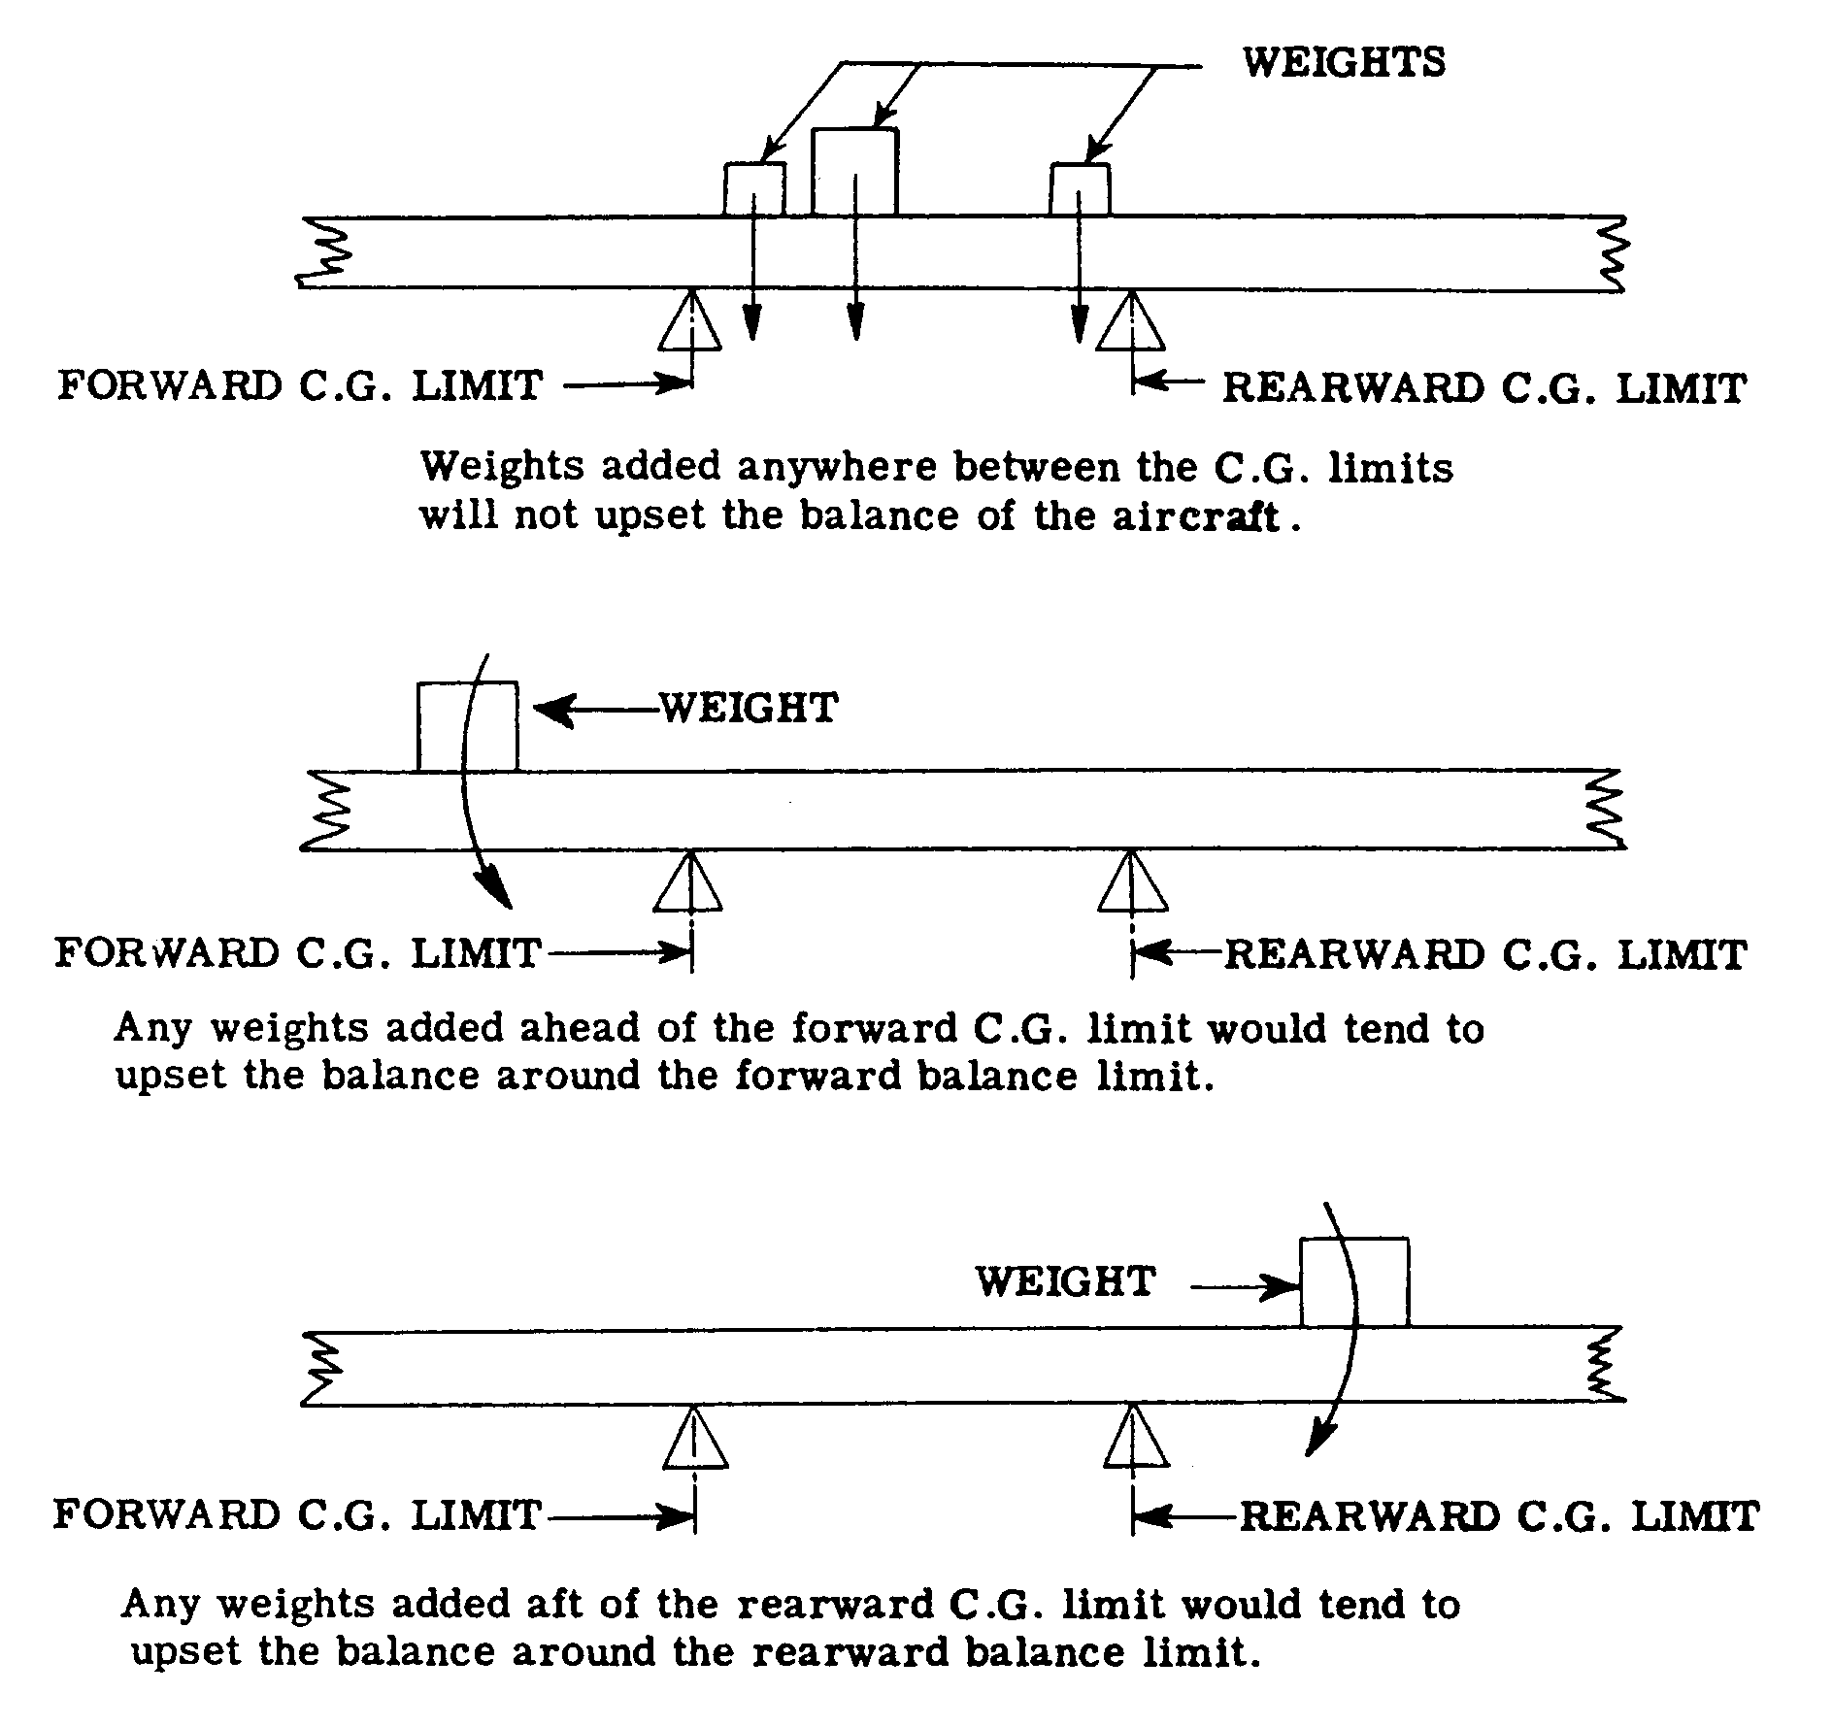
Figure 10-15. Effects of the addition of equipment items on balance.

Moment computations for typical equipment changes are given in figure 10-16 and are also included in the sample weight and balance sheet in figure 10-18.

SAMPLE WEIGHT AND BALANCE REPORT. Suggested methods of tabulating the various data and computations for determining the c.g., both in the empty weight condition and the fully loaded condition, are given in figures 10-17 and 10-18, respectively, and represent a suggested means of recording this information. The data presented in figure 10-17 have previously been computed in figures 10-10 and 10-11 for the extreme load conditions and figure 10-16 for equipment change, and represents suggested means of recording this information.

INSTALLATION OF BALLAST. Ballast is sometimes permanently installed for c.g. balance purposes as a result of installation or removal of equipment items and is not used to correct a nose-up or nose-down tendency of an aircraft. It is usually located as far aft or as far forward as possible in order to bring the

c.g. position within acceptable limits with a minimum of weight increase. Permanent ballast is often lead plate wrapped around and bolted to the fuselage primary structure (e.i., tail-post, longerons, or bulkhead members). Permanent ballast invariably constitutes a concentrated load; therefore, the strength of the local structure and the attachment of the ballast thereto should be investigated for the design loading conditions pertinent to that particular aircraft. Placard permanent ballast with Permanent ballast - do not remove. It is not
desirable to install permanent ballast by pouring melted lead into the tail-post or longerons due to difficulties that may be encountered in subsequent welding repair operations. It should be noted that the installation of permanent ballast results in an increase of aircraft empty weight. See figure 10-19 for ballast computation. The local strength of the compartment in which the ballast is carried and the effect of the ballast on aircraft weight and balance should be investigated when disposable ballast is carried.

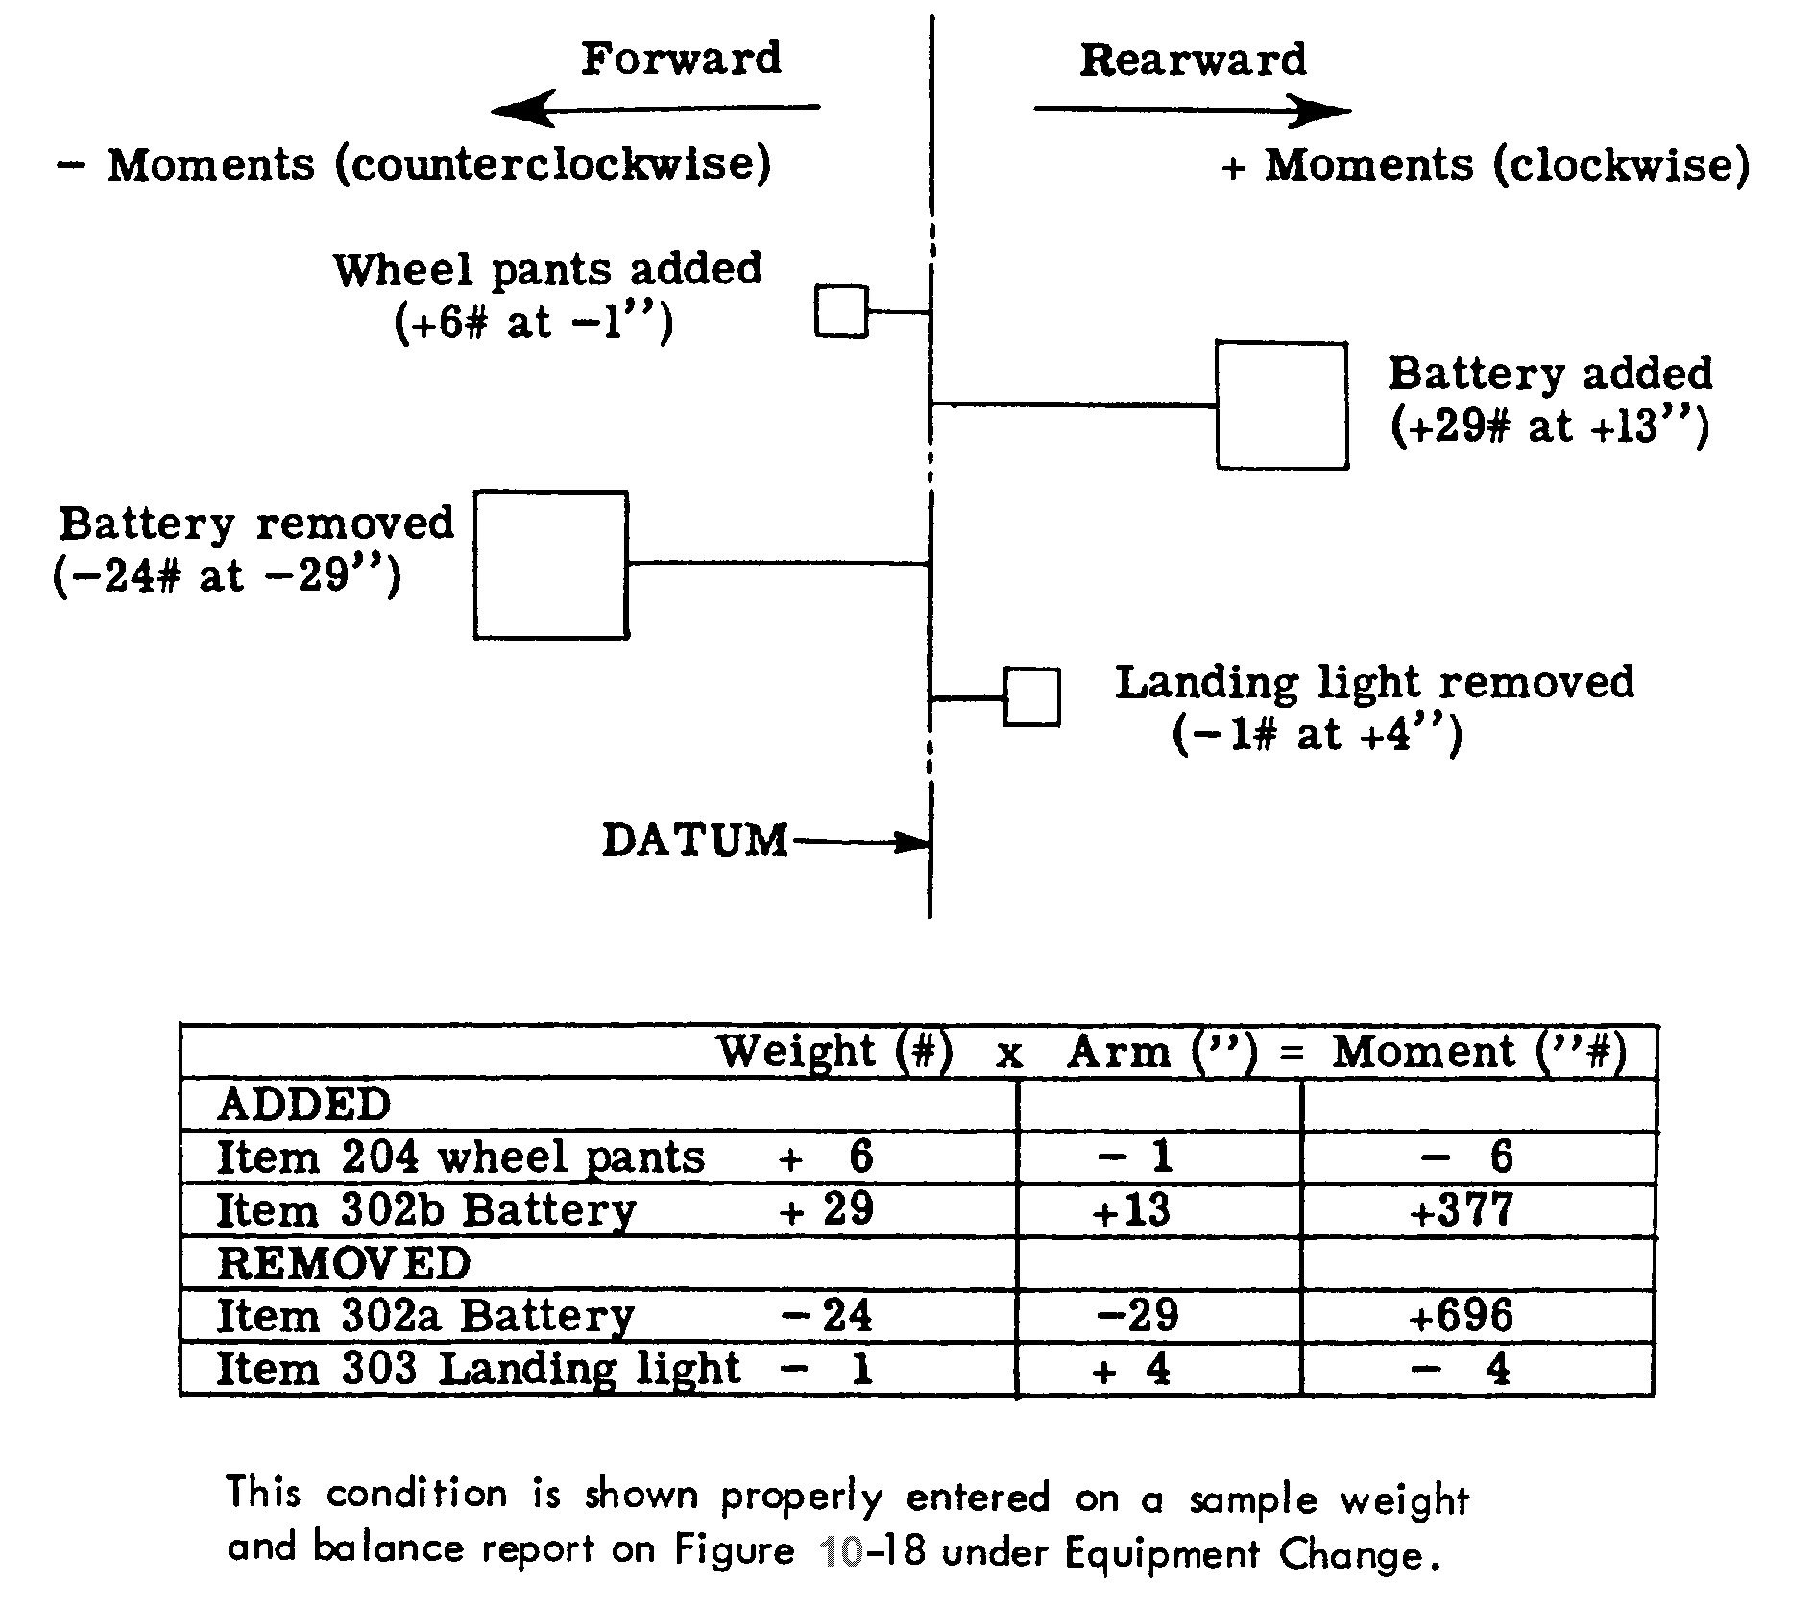
Figure 10-16. Example of moment and weight changes resulting from equipment changes.

MAKE MA-700 MODEL A SERIAL # 0000 REGISTRATION # N1234 .
DATUM IS leading edge of wing .

COMPUTE AS FOLLOWS IF AIRCRAFT WEIGHED

 | 1. Leveling means: |  | level top longeron between front and rear seats.
2. Main wheel weighing point is located ( “FORWARD) (+ 3 “ AFT) of datum.
3. Actual measured distance from the main weight point centerline to the tail (or nose) point
centerline 222 “.
4. Oil over and above “ZERO” tank reading = (a. ---- Gals.) (b. ---- Lbs.) (c. ---- In.)

ACTUAL EMPTY WEIGHT
 | Weight Point |  |  | Scale Reading - Tare = Net Weight
 | 5. Right |  |  | 564 |  |  |  |  |  |  |  |  |  | 0 |  |  |  |  |  |  | 564
 | 6. Left |  |  | 565 |  |  |  |  |  |  |  |  |  | 0 |  |  |  |  |  |  | 565
 | 7. Tail |  |  | 67 |  |  |  |  |  |  |  |  |  | 27 |  |  |  |  |  |  | 40
 | 8. Nose |  |  | ---- |  |  |  |  |  |  |  |  |  | ---- |  |  |  |  |  |  | -----
 | 9. Total Net Weight |  |  | X |  |  |  |  |  |  |  |  |  | X |  |  |  |  |  |  | 1169
 | CENTER OF GRAVITY AS WEIGHED
 | 10. | C.G. relative to main wheel weighing point:
 | (a) Tail wheel airc. |  |  |  |  | (Item 3, 222) x (Item 7, 40 ) |  |  |  |  |  |  |  |  |  |  |  | = + |  |  |  | 7.6 |  |  | = C.G.
 |  |  |  |  |  |  |  |  |  | (Item 9, 1169)
 | (b) Nose wheel airc. |  |  |  |  | (Item 3 ----) x (Item 8 ---- ) |  |  |  |  |  |  |  |  |  |  |  | = |  |  |  |  |  |  | = C.G.
 |  |  |  |  |  |  |  |  | (Item 9 ---- )
 | 11. | C.G. relative to datum:
 | (a) Tail wheel airc. |  |  |  |  | (Item 10a, + 7.6) |  |  |  |  | added to |  |  |  |  | (Item 2, + 3) |  |  |  |  |  |  |  | = |  | +10.6” |  | = C.G.
 | (b) Nose wheel airc. |  |  |  |  | (Item 10b, ) |  |  |  |  | added to |  |  |  |  | (Item 2, ) |  |  |  |  |  |  |  | = |  |  |  | = C.G.
 | COMPUTE IF AIRCRAFT WEIGHED WITH OIL (Item 4)
 |  |  |  |  |  |  | Weight x Arm = Moment
 | Aircraft  Less Oil |  |  |  |  |  | (9)  (4b) |  |  |  |  |  |  | (11)  (4c)
 | Empty Totals |  |  |  |  |  | (a) |  |  |  |  |  |  | X |  |  |  |  |  |  | (b)
 | (b) ------------------- = (c) ------------------“ = Empty weight C.G.
 | 12. (a)
 | REPAIR AGENCY |  |  |  |  |  |  |  |  |  |  |  |  |  |  |  |  |  |  |  |  |  | DATE
 |  |  | Name |  |  |  |  |  |  |  |  |  |  | Number
Figure 10-17. Sample weight and balance report to determine empty weight center of gravity.

EQUIPMENT LIST
 | *Required or Optional Item Numbers as Shown in Aircraft Specification
 | 1 |  | 2 |  | 101 |  | 102 |  |  | 103 |  | 104 |  | 105
 | 106 |  | 201 |  | 202 |  | 203 |  |  | 301 |  | 302(a) |  | 303
 | 401(a) |  | 402 |  | ---- |  | ---- |  |  | ---- |  | ---- |  | ----
 | Special Equipment
 | Item |  |  |  | Make |  |  |  |  | Model |  | Weight |  | Arm
 | 3 Flares 1-1/2 Min. |  |  |  | XYZ |  |  |  |  | 03 |  | 25# |  | 105”
 | Enter above those items included in the empty weight.
WEIGHT AND BALANCE EXTREME CONDITIONS
 | Approved fwd limit 8.5” Approved max. weight 2100# Approved aft limit 21.9”
 | Item | FORWARD CHECK |  |  |  |  |  |  | REARWARD CHECK
 |  | Weight X Arm = Moment |  |  |  |  |  |  | Weight X Arm = Moment
 | Airo. Empty | + 1169  (9 or 12a) |  | + 10.6  (11 or 12c) |  | + 12391 |  |  | + 1169  (9 or 12a) |  |  | + 10.6  (11 or 12c) |  | + 12391
 | Oil | + 17 |  | - 49 |  | - 833 |  |  | + 17 |  |  | - 49 |  | - 833
 | Pilot | + 170 |  | + 16 |  | + 2720 |  |  | + 170 |  |  | + 16 |  | + 2720
 | Fuel | + 83 |  | + 22 |  | + 1826 |  |  | + 240 |  |  | + 22 |  | + 5280
 | Passenger (s) |  |  |  |  |  |  |  | + 340 |  |  | + 48 |  | + 16320
 | Baggage |  |  |  |  |  |  |  | + 100 |  |  | + 75.5 |  | + 7550
 | TOTAL | + 1439 = TW |  | x |  | + 16104 = TM |  |  | + 2036 = TW |  |  | x |  | +43428=TM
 |  |  | TM = 16104 |  | = +11.2” = |  |  | TM = 43428 |  |  |  | = +21.3” =
 |  |  | TW 1439 |  |  |  |  | TW 2036
 |  |  | Most Forward C.G. location |  |  |  |  |  |  |  | Most Rearward C.G. location
LOADING SCHEDULE
 |  |  |  |  | Gallons  of Fuel |  | Number of  Passengers |  |  | Pounds of  Baggage
 |  |  |  |  | 40 |  | 2(R) |  |  | 100
 |  |  |  |  | The above includes pilot and capacity oil.
EQUIPMENT CHANGE
 | Computing New C.G.
 | Item, Make, and Model* |  |  |  | Weight X Arm Moment
 | Airc. Empty |  |  |  | + 1169  (9 or 12a) |  |  |  |  | + 10.6  (11 or 12c) |  |  | + 12391
 | 204 added |  |  |  | + 6 |  |  |  |  | - 1 |  |  | - 6
 | 302(b) added |  |  |  | + 29 |  |  |  |  | + 13 |  |  | + 377
 | 302(a) removed |  |  |  | - 24 |  |  |  |  | + 29 |  |  | + 696
 | 303 removed |  |  |  | - 1 |  |  |  |  | + 4 |  |  | - 4
 | NET TOTALS |  |  |  | - 1179 = NW |  |  |  |  | x |  |  | + 13454 = NM
 |  |  | NM = 13454= +11.4” = New C.G.
 |  |  | NW 1179
*ITEM NUMBERS WHEN LISTED IN PERTINENT AIRCRAFT SPECIFICATION MAY BE USED
IN LIEU OF “ITEM, MAKE, AND MODEL”.
 | PREPARED BY________________________________ |  |  |  |  |  |  |  |  | DATE________________________
Figure 10-18. Sample weight and balance report including an equipment change for aircraft fully loaded.
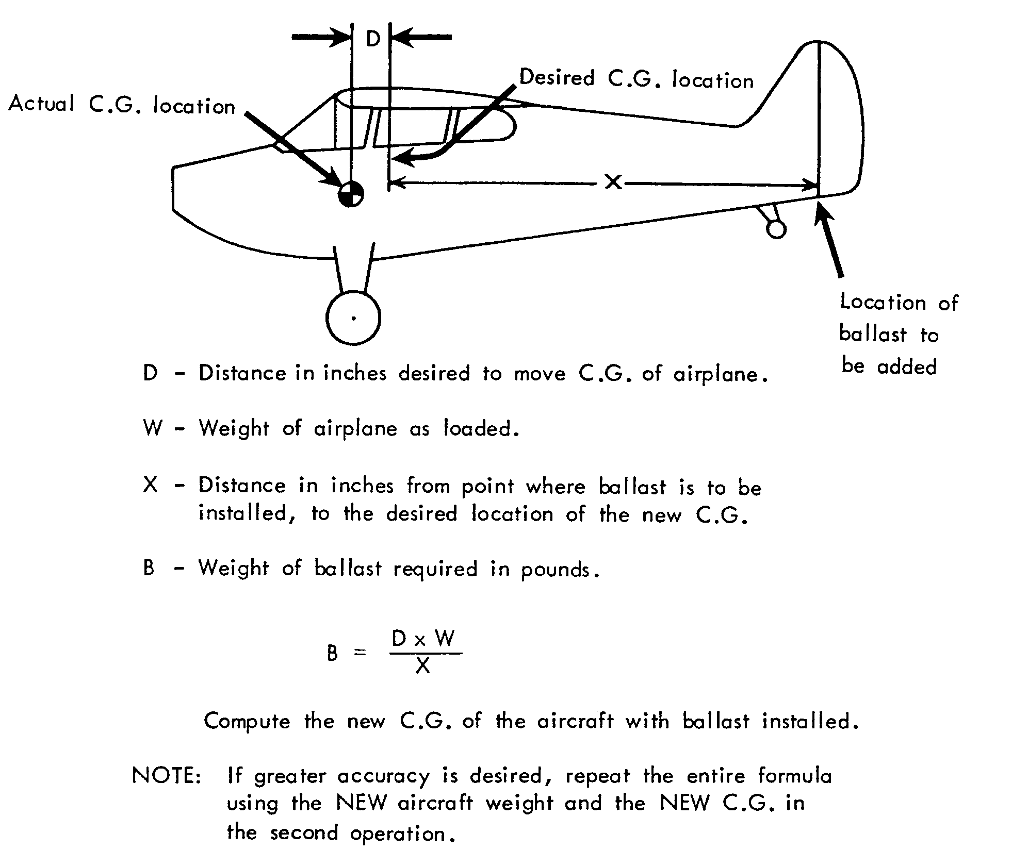
Figure 10-19. Permanent ballast computation formula.

LOADING SCHEDULE. The loading schedule should be kept with the aircraft and form a part of the aircraft flight manual. It includes instructions on the proper load distribution such as filling of fuel and oil tanks, passenger seating, restrictions of passenger movement, and distribution of cargo.

Other means of determining safe loading conditions such as the use of a graphical index and load adjuster are

acceptable and may be used in lieu of the information in paragraph 10-18.

Compute a separate loading condition when the aircraft is to be loaded in other than the specified conditions shown in the loading schedule.

10-24.⎯10-34. [RESERVED.]

