Section 4. INSPECTION OF CIRCUIT-PROTECTION DEVICES

GENERAL. All electrical wires must be provided with some means of circuit protection. Electrical wire should be protected with circuit breakers or fuses located as close as possible to the electrical power source bus. Normally, the manufacturer of electrical equipment will specify the fuse or breaker to be used when installing the respective equipment, or SAE publication, ARP 1199, may be referred to for recommended practices.

DETERMINATION OF CIRCUIT BREAKER RATINGS. Circuit protection devices must be sized to supply open circuit capability. A circuit breaker must be rated so that it will open before the current rating of the wire attached to it is exceeded, or before the cumulative rating of all loads connected to it are exceeded, whichever is lowest. A circuit breaker must always open before any component downstream can overheat and generate smoke or fire. Wires must be sized to carry continuous current in excess of the circuit protective device rating, including its time-current characteristics, and to avoid excessive voltage drop. Refer to section 5 for wire rating methods.

DC Circuit Protector Chart. Table 11-3 may be used as a guide for the selection of circuit breaker and fuse rating to protect copper conductor wire. This chart was prepared for the conditions specified. If actual conditions deviate materially from those stated, ratings above or below the values recommended may be justified. For example, a wire run individually in the open air may possibly be protected by the circuit breaker of the next higher rating to that shown on the chart. In general, the chart is conservative for all ordinary aircraft electrical installations.

Table 11-3. DC wire and circuit protector chart.
Wire AN gauge copper | Circuit breaker amp. | Fuse amp.
22  20  18  16  14  12  10  8  6  4  2  1  0 | 5  7.5  10  15  20  30  40  50  80  100  125 | 5  5  10  10  15  20  30  50  70  70  100  150  150
Basis of chart:
(1) Wire bundles in 135 °F. ambient and altitudes up to 30,000 feet.
(2) Wire bundles of 15 or more wires, with wires carrying no more than 20 percent of the total current carrying capacity of the bundle as given in Specification MIL-W-5088 (ASG).
(3) Protectors in 75 to 85 °F. ambient.
(4) Copper wire Specification MIL-W-5088.
(5) Circuit breakers to Specification MIL-C-5809 or equivalent.
(6) Fuses to Specification MIL-F-15160 or equivalent.

ResetTable Circuit Protection Devices.

All resettable type circuit breakers must open the circuit irrespective of the position of the operating control when an overload or circuit fault exists. Such circuit breakers are referred to as “trip free.”

Automatic reset circuit breakers, that automatically reset themselves periodically, are not recommended as circuit protection devices for aircraft.

Circuit Breaker Usage. Circuit breakers are designed as circuit protection for the wire (see paragraph 11-48 and 11-49), not for protection of black boxes

or components. Use of a circuit breaker as a switch is not recommended. Use of a circuit breaker as a switch will decrease the life of the circuit breaker.

Circuit Breaker Maintenance. Circuit breakers should be periodically cycled with no load to enhance contact performance by cleaning contaminants from the contact surfaces.

SWITCHES. In all circuits where a switch malfunction can be hazardous, a switch specifically designed for aircraft service should be used. These switches are of rugged construction and have sufficient contact capacity to break, make, and continuously carry the connected load current. The position of the switch should be checked with an electrical meter.

Electrical Switch Inspection. Special attention should be given to electrical circuit switches, especially the spring-loaded type, during the course of normal airworthiness inspection. An internal failure of the spring-loaded type may allow the switch to remain closed even though the toggle or button returns to the “off” position. During inspection, attention should also be given to the possibility that improper switch substitution may have been made.

With the power off suspect aircraft electrical switches should be checked in the ON position for opens (high resistance) and in The OFF position for shorts (low resistance), with an ohmmeter.

Any abnormal side to side movement of the switch should be an alert to imminent failure even if the switch tested was shown to be acceptable with an ohmmeter.

Electromechanical Switches. Switches have electrical contacts and various types of switch actuators (i.e., toggle, plunger, push-button, knob, rocker).

Contacts designed for high-level loads must not be subsequently used for low-level applications, unless testing has been performed to establish this capability.

Switches are specifically selected based on the design for the aircraft service current ratings for lamp loads, inductive loads, and motor loads and must be replaced with identical make and model switches.

Proximity Switches. These switches are usually solid-state devices that detect the presence of a predetermined target without physical contact and are usually rated 0.5 amps or less.

Switch Rating. The nominal current rating of the conventional aircraft switch is usually stamped on the switch housing and represents the continuous current rating with the contacts closed. Switches should be derated from their nominal current rating for the following types of circuits:

Circuits containing incandescent lamps can draw an initial current that is 15 times greater than the continuous current. Contact burning or welding may occur when the switch is closed.

Inductive circuits have magnetic energy stored in solenoid or relay coils that is released when the control switch is opened and may appear as an arc.

Direct-current motors will draw several times their rated current during starting, and magnetic energy stored in their
armature and field coils is released when the control switch is opened.

Switch Selection. Switches for aircraft use should be selected with extreme caution. The contact ratings should be adequate for all load conditions and applicable voltages, at both sea level and the operational altitude. Consideration should be given to the variation in the electrical power characteristics, using MIL-STD-704 as a guide.

Derating Factors. Table 11-4 provides an approximate method for derating nominal ratings to obtain reasonable switch efficiency and service life under reactive load conditions.

WARNING: Do not use AC derated switches in DC circuits. AC switches will not carry the same amperage as a DC switch.

Table 11-4. Switch derating factors.
Nominal  System  Voltage | Type of Load | Derating  Factor
28 VDC | Lamp | 8
28 VDC | Inductive (relay-solenoid) | 4
28 VDC | Resistive (Heater) | 2
28 VDC | Motor | 3
12 VDC | Lamp | 5
12 VDC | Inductive (relay-solenoid) | 2
12 VDC | Resistive (Heater) | 1
12 VDC | Motor | 2
NOTES:

1. To find the nominal rating of a switch required to operate
a given device, multiply the continuous current rating
of the device by the derating factor corresponding
to the voltage and type of load.

2. To find the continuous rating that a switch of a
given nominal rating will handle efficiently,
divide the switch nominal rating by the derating
factor corresponding to the voltage and type of load.

Low Energy Loads. Switches rated for use at 28 VDC or more, and at 1.0 amp or more, generally have silver contacts. In general, silver contacts should not be used to control devices which have either a voltage less than 8 volts or a continuous current less than 0.5 amps unless the switch is specifically rated for use with low-energy loads. Table 11-5 provides general guidelines for selecting contact materials for low-energy loads, but is not applicable to hermetically sealed switches.

Typical logic load devices have a voltage of 0.5 volts to 28 volts and a continuous current of less than 0.5 amps. A suitable method of rating switches for use on logic load devices is specified in ANSI/EIA 5200000. (General specification for special use electromechanical switches of certified quality.)

Table 11-5. Selection of contact material.
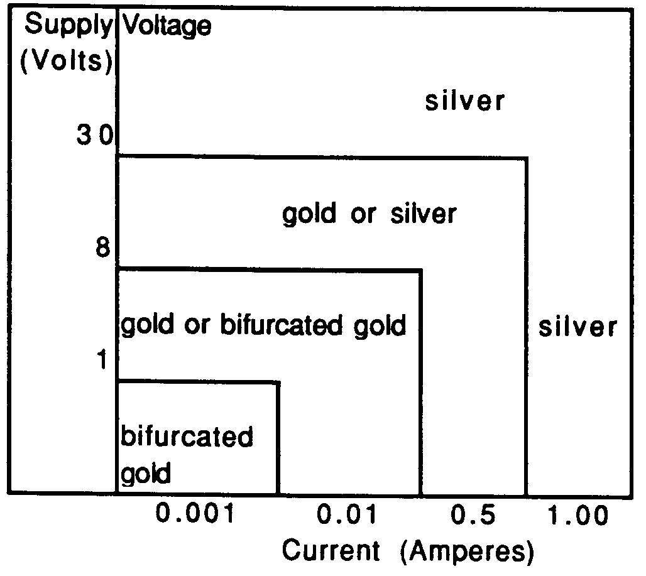
NOTES:
1. If sulfide, moisture, or any form of contamination is present, a sealed switch should be used. The degree of sealing required (environmental or hermetic) is dependent upon the environment in which the switch is intended to be operated.

2. If particle contamination in any form is likely to reach the contacts, bifurcated contacts should be used.

3. Low-voltage high-current loads are difficult to predict and may result in a combined tendency of noncontact, sticking, and material transfer.

4. High-voltage high-current applications may require the use of Silver Nickel contacts.

Typical low-level load devices have a voltage of less than 0.5 volts and a continuous current of less than 0.5 amps. A suitable method of rating switches for use on logic load devices is specified in ANSI/EIA 5200000.

Shock and Vibration.

Electromechanical switches (toggle switches) are most susceptible to shock and vibration in the plane that is parallel to contact motion. Under these conditions the switch contacts may momentarily separate. ANSI/EIA 5200000 specifies that contact separations greater than 10 microseconds and that closing of open contacts in excess of 1 microsecond are failures. Repeated contact separations during high levels of vibration or shock may cause excessive electrical degradation of the contacts. These separations can also cause false signals to be registered by electronic data processors without proper buffering.

Although proximity switches do not have moving parts, the reliability of the internal electronic parts of the switch may be reduced. Reliability and mean time between-failure (MTBF) calculations should reflect the applicable environment. Note that the mounting of both the proximity sensor and its target must be rigid enough to withstand shock or vibration to avoid creating false responses.

Electromagnetic/Radio Frequency Interference (EMI/RFI).

DC operated electromechanical switches are usually not susceptible to EMI/RFI. Proximity switches are susceptible to an EMI/RFI environment and must be evaluated in the application. Twisting lead wires, metal overbraids, lead wire routing, and the design of the proximity switch can minimize susceptibility.

The arcing of electromechanical switch contacts generates short duration EMI/RFI when controlling highly inductive electrical loads. Twisting lead wires, metal overbraids, and lead wire routing can reduce or eliminate generation problems when dealing with arcing loads. Proximity sensors generally use a relatively low-energy electromagnetic field to sense the target. Adequate spacing is required to prevent interference between adjacent proximity sensors or other devices susceptible to EMI/RFI. Refer to manufacturer’s instructions.

Temperature.

Electromechanical switches can withstand wide temperature ranges and rapid gradient shifts without damage. Most aircraft switches operate between -55 °C and 85 °C with designs available from -185 °C to 260 °C or more. Higher temperatures require more exotic materials, which can increase costs and limit life. It should be noted that o-ring seals and elastomer boot seals tend to stiffen in extreme cold. This can increase operating forces and reduce release forces or stop the switch from releasing.

Proximity sensors are normally designed for environments from -55 °C to 125 °C. During temperature excursions, the operating and release points may shift from 5 percent to 10 percent. Reliability of the proximity sensor will typically be highest at room temperature. The reliability and MTBF estimates should be reduced for use under high temperatures or high thermal gradients.

Sealing.

NOTE: The materials used for sealing (o-rings, potting materials, etc.) should be compatible with any aircraft fluids to which the switch may be exposed.

Electromechanical switches range in sealing from partially sealed to hermetically sealed. Use a sealed switch when the switch will be exposed to a dirty environment during storage, assembly, or operation. Use a higher level of sealing when the switch will not have an arcing load to self-clean the contacts. Low-energy loads tend to be more susceptible to contamination.

Proximity switches for aircraft applications typically have a metal face and potting material surrounding any electronics and lead wire exits. The potting material should be compatible with the fluids the switch will be exposed to in the environment. The plastic sensing face of some proximity switches may be subject to absorption of water that may cause the operating point to shift should be protected.

Switch Installation. Hazardous errors in switch operation may be avoided by logical and consistent installation. “On-off” two-position switches should be mounted so that the “on” position is reached by an upward or forward movement of the toggle. When the switch controls movable aircraft elements, such as landing gear or flaps, the toggle should move in the same direction as the desired motion. Inadvertent operation of switches can be prevented by mounting suitable guards over the switches.

RELAYS. A relay is an electrically controlled device that opens and closes electrical contacts to effect the operation of other devices in the same or in another electrical circuit. The relay converts electrical energy into mechanical energy through various means, and through mechanical linkages, actuates electrical conductors (contacts) that control electrical circuits. Solid-state relays may also be used in electrical switching applications.

Use of Relays. Most relays are used as a switching device where a weight reduction can be achieved, or to simplify electrical controls. It should be remembered that the relay is an electrically operated switch, and therefore subject to dropout under low system voltage conditions.

Types of Connections. Relays are manufactured with various connective means from mechanical to plug-in devices. Installation procedures vary by the type of connection and should be followed to ensure proper operation of the relay.

Repair. Relays are complicated electromechanical assemblies and most are not repairable.

Relay Selection.

Contact ratings, as described on the relay case, describe the make, carry, and break capability for resistive currents only. Consult the appropriate specification to determine the derating factor to use for other types of current loads. (Ref. MIL-PRF-39016, MIL-PRF-5757, MIL-PRF-6016, MIL-PRF-835836.)

Operating a relay at less than nominal coil voltage may compromise its performance and should never be done without written manufacturer approval.

Relay Installation and Maintenance. For installation and maintenance, care should be taken to ensure proper placement of hardware, especially at electrical connections. The use of properly calibrated torque wrenches and following the manufacturer’s installation procedures is strongly recommended. This is especially important with hermetically sealed relays, since the glass-to-metal seal (used for

insulation of the electrically “live” components) is especially vulnerable to catastrophic failure as a result of overtorquing.

When replacing relays in alternating current (ac) applications, it is essential to maintain proper phase sequencing. For any application involving plug-in relays, proper engagement of their retaining mechanism is vital.

The proximity of certain magnetically permanent, magnet assisted, coil operated relays may cause them to have an impact on each other. Any manufacturer’s recommendations or precautions must be closely followed.

LOAD CONSIDERATIONS.
When switches or relays are to be used in applications where current or voltage is substantially lower than rated conditions, additional intermediate testing should be performed to ensure reliable operation. Contact the manufacturer on applications different from the rated conditions.

OPERATING CONDITIONS FOR SWITCHES AND RELAYS. Switches and relays should be compared to their specification rating to ensure that all contacts are made properly under all conditions of operation, including vibration equivalent to that in the area of the aircraft in which the switch or relay is to be installed.

11-57.⎯11-65. [RESERVED.]

