Section 5. ELECTRICAL WIRE RATING

GENERAL. Wires must be sized so that they: have sufficient mechanical strength to allow for service conditions; do not exceed allowable voltage drop levels; are protected by system circuit protection devices; and meet circuit current carrying requirements.

Mechanical Strength of Wires. If it is desirable to use wire sizes smaller than #20, particular attention should be given to the mechanical strength and installation handling of these wires, e.g., vibration, flexing, and termination. Wire containing less than 19 strands must not be used. Consideration should be given to the use of high-strength alloy conductors in small gauge wires to increase mechanical strength. As a general practice, wires smaller than size #20 should be provided with additional clamps and be grouped with at least three other wires. They should also have additional support at terminations, such as connector grommets, strain relief clamps, shrinkable sleeving, or telescoping bushings. They should not be used in applications where they will be subjected to excessive vibration, repeated bending, or frequent disconnection from screw termination.

Voltage Drop in Wires. The voltage drop in the main power wires from the generation source or the battery to the bus should not exceed 2 percent of the regulated voltage when the generator is carrying rated current or the battery is being discharged at the 5-minute rate. The tabulation shown in table 11-6 defines the maximum acceptable voltage drop in the load circuits between the bus and the utilization equipment ground.

Resistance. The resistance of the current return path through the aircraft structure is generally considered negligible. However, this is based on the assumption that adequate

Table 11-6. Tabulation chart (allowable voltage drop between bus and utilization equipment ground).
Nominal  system  voltage | Allowable voltage  drop continuous  operation | Intermittent operation
14  28  115  200 | 0.5  1  4  7 | 1  2  8  14

bonding to the structure or a special electric current return path has been provided that is capable of carrying the required electric current with a negligible voltage drop. To determine circuit resistance check the voltage drop across the circuit. If the voltage drop does not exceed the limit established by the aircraft or product manufacturer, the resistance value for the circuit may be considered satisfactory. When checking a circuit, the input voltage should be maintained at a constant value. Tables 11-7 and 11-8 show formulas that may be used to determine electrical resistance in wires and some typical examples.

Resistance Calculation Methods. Figures 11-2 and 11-3 provide a convenient means of calculating maximum wire length for the given circuit current.

Values in tables 11-7 and 11-8 are for tin-plated copper conductor wires. Because the resistance of tin-plated wire is slightly higher than that of nickel or silver-plated wire, maximum run lengths determined from these charts will be slightly less than the allowable limits for nickel or silver-plated copper wire and are therefore safe to use. Figures 11-2 and 11-3 can be used to derive slightly longer maximum run lengths for silver or nickel-plated wires by multiplying the maximum run length by the ratio of resistance of tin-plated wire, divided by the resistance of silver or nickel-plated wire.

TABLE 11-7. Examples of determining required tin-plated copper wire size and checking voltage drop using figure 11-2
Voltage  drop | Run Lengths  (Feet) | Circuit Current  (Amps) | Wire Size From Chart | Check-calculated voltage drop (VD)= (Resistance/Ft) (Length) (Current)
1 | 107 | 20 | No. 6 | VD= (.00044 ohms/ft) (107)(20)= 0.942
0.5 | 90 | 20 | No. 4 | VD= (.00028 ohms/ft) (90)(20)= 0.504
4 | 88 | 20 | No. 12 | VD= (.00202 ohms/ft) (88)(20)= 3.60
7 | 100 | 20 | No. 14 | VD= (.00306 ohms/ft) (100)(20)= 6.12

TABLE 11-8. Examples of determining maximum tin-plated copper wire length and checking voltage drop using figure 11-2.

Maximum  Voltage  drop | Wire  Size | Circuit Current  (Amps) | Maximum Wire Run Length  (Feet) | Check-calculated voltage drop (VD)= (Resistance/Ft) (Length) (Current)
1 | No. 10 | 20 | 39 | VD= (.00126 ohms/ft) (39)(20)= .98
0.5 | ---- |  | 19.5 | VD= (.00126 ohms/ft) (19.5)(20)= .366
4 | ---- |  | 156 | VD= (.00126 ohms/ft) (156)(20)= 3.93
7 | ---- |  | 273 | VD= (.00126 ohms/ft) (273)(20)= 6.88

As an alternative method or a means of checking results from figure 11-2, continuous flow resistance for a given wire size can be read from table 11-9 and multiplied by the wire run length and the circuit current. For intermittent flow, use figure 11-3.

Voltage drop calculations for aluminum wires can be accomplished by multiplying the resistance for a given wire size, defined in table 11-10, by the wire run length and circuit current.

When the estimated or measured conductor temperature (T2) exceeds 20 °C, such as in areas having elevated ambient temperatures or in fully loaded power-feed wires, the maximum allowable run length (L2), must be shortened from L1 (the 20 °C value) using the following formula for copper conductor wire:

$$L2=\frac{(\text{254}\text{.}5 °C)(L1)}{(\text{234}\text{.}5 °C)+)(T2)}$$

For aluminum conductor wire, the formula is:

$$L2=\frac{(\text{258}\text{.}1 °C)(L1)}{(\text{238}\text{.}1 °C)+(T2)}$$

These formulas use the reciprocal of each material’s resistively temperature coefficient to take into account increased conductor resistance resulting from operation at elevated temperatures.

To determine T2 for wires carrying a high percentage of their current carrying capability at elevated temperatures, laboratory testing using a load bank and a high-temperature chamber is recommended. Such tests should be run at anticipated worse case ambient temperature and maximum current-loading combinations.

Approximate T2 can be estimated using the following formula:

Where:
T₁ = Ambient Temperature
T₂ = Estimated Conductor Temperature
T_{R} = Conductor Temperature Rating
I₂ = Circuit Current (A=Amps)
I_{max} = Maximum Allowable Current (A=Amps) at T_{R}
This formula is quite conservative and will typically yield somewhat higher estimated temperatures than are likely to be encountered under actual operating conditions.

Note: Aluminum wire-From Table 11-9 and 11-10 note that the conductor resistance of aluminum wire and that of copper wire (two numbers higher) are similar. Accordingly, the electric wire current in Table 11-9 can be used when it is desired to substitute aluminum wire and the proper size can be selected by reducing the copper wire size by two numbers and referring to Table 11-10. The use of aluminum wire size smaller than No. 8 is not recommended.

Table 11-9. Current carrying capacity and resistance of copper wire.
Wire Size | Continuous duty current (amps)-Wires in bundles, groups, harnesses, or conduits. (See Note #1) |  |  |  |  |  | Max. resistance  ohms/1000ft@20 °C |  | Nominal  conductor
 | Wire Conductor Temperature Rating |  |  |  |  |  | tin plated conductor |  | area -
 | 105 °C |  | 150 °C |  | 200 °C |  | (See Note #2) |  | circ.mils
24  22  20  18  16  14  12  10  8  6  4  2  1  0  00  000  0000 | 2.5  3  4  6  7  10  13  17  38  50  68  95  113  128  147  172  204 |  | 4  5  7  9  11  14  19  26  57  76  103  141  166  192  222  262  310 |  | 5  6  9  12  14  18  25  32  71  97  133  179  210  243  285  335  395 |  | 28.40  16.20  9.88  6.23  4.81  3.06  2.02  1.26  0.70  0.44  0.28  0.18  0.15  0.12  0.09  0.07  0.06 |  | 475  755  1,216  1,900  2,426  3,831  5,874  9,354  16,983  26,818  42,615  66,500  81,700  104,500  133,000  166,500  210,900
Note #1: Rating is for 70°C ambient, 33 or more wires in the bundle for sizes 24 through 10, and 9 wires for size 8 and larger, with no more than 20 percent of harness current carrying capacity being used, at an operating altitude of 60,000 feet. For rating of wires under other conditions or configurations see paragraph 11-69.
Note #2: For resistance of silver or nickel-plated conductors see wire specifications.

Table 11-10. Current carrying capacity and resistance of aluminum wire.
Wire Size |  | Continuous duty current (amps)  Wires in bundles, groups or harnesses or conduits (See table 11-9 Note #1) |  |  |  | Max. resistance  ohms/1000ft
 |  | Wire conductor temperature rating |  |  |  | @ 20 °C
 |  | 105 °C |  | 150 °C
8  6  4  2  1  0  00  000  0000 |  | 30  40  54  76  90  102  117  138  163 |  | 45  61  82  113  133  153  178  209  248 |  | 1.093  0.641  0.427  0.268  0.214  0.169  0.133  0.109  0.085
Note: Observe design practices described in paragraph 11-67 for aluminum conductor

METHODS FOR DETERMINING CURRENT CARRYING CAPACITY OF WIRES. This paragraph contains methods for determining the current carrying capacity of electrical wire, both as a single wire in free air and when bundled into a harness. It presents derating factors for altitude correction and examples showing how to use the graphical and tabular data provided for this purpose. In some instances, the wire may be capable of carrying more current than is recommended for the contacts of the related connector. In this instance, it is the contact rating that dictates the maximum current to be carried by a wire. Wires of larger gauge may need to be used to fit within the crimp range of connector contacts that are adequately rated for the current being carried. Figure 11-5 gives a family of curves whereby the bundle derating factor may be obtained.

Effects of Heat Aging on Wire Insulation. Since electrical wire may be installed in areas where inspection is infrequent over extended periods of time, it is necessary to give special consideration to heat-aging characteristics in the selection of wire. Resistance to heat is of primary importance in the selection of wire for aircraft use, as it is the basic factor in wire rating. Where wire may be required to operate at higher temperatures due either to high ambient temperatures, high-current loading, or a combination of the two, selection should be made on the basis of satisfactory performance under the most severe operating conditions.

Maximum Operating Temperature. The current that causes a temperature steady state condition equal to the rated temperature of the wire should not be exceeded. Rated temperature of the wire may be based upon the ability of either the conductor or the insulation to withstand continuous operation without degradation.

Single Wire in Free Air. Determining a wiring system’s current carrying capacity begins with determining the maximum current that a given-sized wire can carry without exceeding the allowable temperature difference (wire rating minus ambient °C). The curves are based upon a single copper wire in free air. (See figures 11-4a and 11-4b.)

Wires in a Harness. When wires are bundled into harnesses, the current derived for a single wire must be reduced as shown in figure 11-5. The amount of current derating is a function of the number of wires in the bundle and the percentage of the total wire bundle capacity that is being used.

Harness at Altitude. Since heat loss from the bundle is reduced with increased altitude, the amount of current should be de-rated. Figure 11-6 gives a curve whereby the altitude-derating factor may be obtained.

Aluminum Conductor Wire. When aluminum conductor wire is used, sizes should be selected on the basis of current ratings shown in table 11-10. The use of sizes smaller than #8 is discouraged (Ref. AS50881A). Aluminum wire should not be attached to engine mounted accessories or used in areas having corrosive fumes, severe vibration, mechanical stresses, or where there is a need for frequent disconnection. Use of aluminum wire is also discouraged for runs of less than 3 feet (AS50991A). Termination hardware should be of the type specifically designed for use with aluminum conductor wiring.

INSTRUCTIONS FOR USE OF ELECTRICAL WIRE CHART.

Correct Size. To select the correct size of electrical wire, two major requirements must be met:

The wire size should be sufficient to prevent an excessive voltage drop while carrying the required current over the required distance. (See table 11-6, Tabulation Chart, for allowable voltage drops.)

The size should be sufficient to prevent overheating of the wire carrying the required current. (See paragraph 11-69 for allowable current carrying calculation methods.)

Two Requirements. To meet the two requirements (see paragraph 11-66b) in selecting the correct wire size using figure 11-2 or figure 11-3, the following must be known:

The wire length in feet.

The number of amperes of current to be carried.

The allowable voltage drop
permitted.

The required continuous or intermittent current.

The estimated or measured conductor temperature.

Is the wire to be installed in conduit and/or bundle?

Is the wire to be installed as a single wire in free air?

Example No. 1. Find the wire size in figure 11-2 using the following known information:

The wire run is 50 feet long, including the ground wire.

Current load is 20 amps.

The voltage source is 28 volts from bus to equipment.

The circuit has continuous operation.

Estimated conductor temperature is 20 °C or less.

The scale on the left of the chart represents maximum wire length in feet to prevent an excessive voltage drop for a specified voltage source system (e.g., 14V, 28V, 115V, 200V). This voltage is identified at the top of scale and the corresponding voltage drop limit for continuous operation at the bottom. The scale (slant lines) on top of the chart represents amperes. The scale at the bottom of the chart represents wire gauge.

STEP 1: From the left scale find the wire length, 50 feet under the 28V source column.

STEP 2: Follow the corresponding horizontal line to the right until it intersects the slanted line for the 20-amp load.

STEP 3: At this point, drop vertically to the bottom of the chart. The value falls between No. 8 and No. 10. Select the next larger size wire to the right, in this case No. 8. This is the smallest size wire that can be used without exceeding the voltage drop limit expressed at the bottom of the left scale. This example is plotted on the wire chart, figure 11-2. Use figure 11-2 for continuous flow and figure 11-3 for intermittent flow.

Procedures in Example No. 1 paragraph 11-68c, can be used to find the wire size for any continuous or intermittent operation (maximum two minutes). Voltage (e.g. 14 volts, 28 volts, 115 volts, 200 volts) as indicated on the left scale of the wire chart in figure 11-2 and 11-3.

Example No. 2. Using figure 11-2, find the wire size required to meet the allowable voltage drop in table 11-6 for a wire carrying current at an elevated conductor temperature using the following information:

The wire run is 15.5 feet long, including the ground wire.

Circuit current (I2) is 20 amps,
continuous.

The voltage source is 28 volts.

The wire type used has a 200 °C conductor rating and it is intended to use this thermal rating to minimize the wire gauge. Assume that the method described in paragraph 11-66d(6) was used and the minimum wire size to carry the required current is #14.

Ambient temperature is 50 °C under hottest operating conditions.

Procedures in example No. 2.

STEP 1: Assuming that the recommended load bank testing described in paragraph 11-66d(5) is unable to be conducted, then the estimated calculation methods outlined in paragraph 11-66d(6) may be used to determine the estimated maximum current (Imax). The #14 gauge wire mentioned above can carry the required current at 50 °C ambient (allowing for altitude and bundle derating).

Use figure 11-4a to calculate the Imax a #14 gauge wire can carry.

Where:

T₂ = estimated conductor temperature

T₁ = 50 °C ambient temperature

T_{R} = 200 °C maximum conductor rated
temperature

Find the temperature differences (TR-T1) = (200 °C-50 °C) = 150 °C.

Follow the 150 °C corresponding horizontal line to intersect with #14 wire size, drop vertically and read 47 Amps at bottom of chart (current amperes).

Use figure 11-5, left side of chart reads 0.91 for 20,000 feet, multiple 0.91 x 47 Amps = 42.77 Amps.

Use figure 11-6, find the derate factor for 8 wires in a bundle at 60 percent. First find the number of wires in the bundle (8) at bottom of graph and intersect with the 60 percent curve meet. Read derating factor, (left side of graph) which is 0.6. Multiply 0.6 x 42.77 Amps = 26 Amps.

I_{max} = 26 amps (this is the maximum current the #14 gauge wire could carry at 50°C ambient

L₁=15.5 feet maximum run length for size #14 wire carrying 20 amps from figure 11-2

STEP 2: From paragraph 11-66d (5) and (6), determine the T₂ and the resultant maximum wire length when the increased resistance of the higher temperature conductor is taken into account.

$$T_{2}=T_{1}+\left(T_{R}−T_{1}\right)\left(\sqrt{{I_{2}}/{I_{\text{max}}}}\right)$$

$$T_{2}=\text{50} ^{°}C+(\text{200} ^{∘}C−\text{50} ^{∘}C)(\sqrt{\text{20}A/{\text{26}}A}$$
= 50 °C+(150 °C)(.877)
T₂ = 182 °C

$L2=\frac{(\text{254}\text{.}5 °C)(L1)}{(\text{234}\text{.}5 °C)+(T2)}=$
L₂ = $\frac{(\text{254}\text{.}5 °C)(\text{15}\text{.}\text{5Ft})}{(\text{234}\text{.}5 °C)+(\text{182} °C)}$
L₂ = 9.5 ft

The size #14 wire selected using the methods outlined in paragraph 11-66d is too small to meet the voltage drop limits from figure 11-2 for a 15.5 feet long wire run.

STEP 3: Select the next larger wire (size #12) and repeat the calculations as follows:
L₁=24 feet maximum run length for 12 gauge wire carrying 20 amps from figure 11-2.

I_{max} = 37 amps (this is the maximum current the size #12 wire can carry at 50 °C ambient. Use calculation methods outlined in paragraph 11-69 and figure 11-4a.

$$\begin{aligned}T_{2}=\text{50} ^{o}\text{C+}(\text{200} ^{o}\text{C-50} ^{o}C)(\sqrt{\text{20}A/{\text{37}}A}= \\ \text{50} ^{o}\text{C+}(\text{150} ^{o}C)(\text{-540}){\text{=131 }}^{o}C \\ L_{2}=\frac{\text{254}\text{.}5 ^{o}C(L_{1})}{\text{234}\text{.}5 ^{o}\text{C+}(T_{2})} \\ L_{2}=\frac{(\text{254}\text{.}5 ^{o}C)(\text{24ft})}{(\text{234}\text{.}5 ^{o}C)+(\text{131} ^{o}C)}=\frac{\text{6108}}{\text{366}} \\ L_{2}=\frac{(\text{254}\text{.}5 ^{o}C)(\text{24ft})}{\text{366}}=\text{16}\text{.}7\text{ ft}\end{aligned}$$
The resultant maximum wire length, after adjusting downward for the added resistance associated with running the wire at a higher temperature, is 15.4 feet, which will meet the original 15.5 foot wire run length requirement without exceeding the voltage drop limit expressed in figure 11-2.

COMPUTING CURRENT CARRY- ING CAPACITY.

Example 1. Assume a harness (open or braided), consisting of 10 wires, size #20, 200 °C rated copper and 25 wires, size #22, 200 °C rated copper, will be installed in an area where the ambient temperature is 60 °C and the vehicle is capable of operating at a 60,000-foot altitude. Circuit analysis reveals that 7 of the 35 wires in the bundle (7/35 = 20 percent) will be carrying power currents nearly at or up to capacity.

STEP 1: Refer to the “single wire in free air” curves in figure 11-4a. Determine the change of temperature of the wire to determine free air ratings. Since the wire will be in an ambient of 60 ºC and rated at 200° C, the change of to temperature is 200 °C - 60 °C = 140 °C. Follow the 140 °C temperature difference horizontally until it intersects with wire size line on figure 11-4a. The free air rating for size #20 is 21.5 amps, and the free air rating for size #22 is 16.2 amps.

STEP 2: Refer to the “bundle derating curves” in figure 11-5, the 20 percent curve is selected since circuit analysis indicate that 20 percent or less of the wire in the harness would be carrying power currents and less than 20 percent of the bundle capacity would be used. Find 35 (on the abscissa) since there are 35 wires in the bundle and determine a derating factor of 0.52 (on the ordinate) from the 20 percent curve.

STEP 3: Derate the size #22 free air rating by multiplying 16.2 by 0.52 to get 8.4 amps in-harness rating. Derate the size #20 free airrating by multiplying 21.5 by 0.52 to get 11.2 amps in-harness rating.

STEP 4: Refer to the “altitude derating curve” of figure 11-6, look for 60,000 feet (on the abscissa) since that is the altitude at which the vehicle will be operating. Note that the wire must be derated by a factor of 0.79 (found on the ordinate). Derate the size
#22 harness rating by multiplying 8.4 amps by 0.79 to get 6.6 amps. Derate the size #20 harness rating by multiplying 11.2 amps by 0.79 to get 8.8 amps.

STEP 5: To find the total harness capacity, multiply the total number of size #22 wires by the derated capacity (25 x 6.6 = 165.0 amps) and add to that the number of size #20 wires multiplied by the derated capacity (10 x 8.8 = 88 amps) and multiply the sum by the 20 percent harness capacity factor. Thus, the total harness capacity is (165.0 + 88.0) x 0.20 = 50.6 amps. It has been determined that the total harness current should not exceed 50.6 A, size #22 wire should not carry more than 6.6 amps and size #20 wire should not carry more than 8.8 amps.

STEP 6: Determine the actual circuit current for each wire in the bundle and for the whole bundle. If the values calculated in step #5 are exceeded, select the next larger size wire and repeat the calculations.

Example 2. Assume a harness (open or braided), consisting of 12, size #12, 200 °C rated copper wires, will be operated in an ambient of 25 °C at sea level and 60 °C at a 20,000-foot altitude. All 12 wires will be operated at or near their maximum capacity.

STEP 1: Refer to the “single wire in free air” curve in figure 11-4a, determine the temperature difference of the wire to determine free air ratings. Since the wire will be in ambient of 25 °C and 60 °C and is rated at 200 °C, the temperature differences are 200 °C-25 °C = 175 °C and 200 °C-60 °C = 140 °C respectively. Follow the 175 °C and the 140 °C temperature difference lines on figure 11-4a until each intersects wire size line, the free air ratings of size #12 are 68 amps and 61 amps, respectively.

STEP 2: Refer to the “bundling derating curves” in figure 11-5, the 100 percent curve is selected because we know all 12 wires will be carrying full load. Find 12 (on the abscissa) since there are 12 wires in the bundle and determine a derating factor of 0.43 (on the ordinate) from the 100 percent curve.

STEP 3: Derate the size #12 free air ratings by multiplying 68 amps and 61 amps by 0.43 to get 29.2 amps and 26.2 amps, respectively.

STEP 4: Refer to the “altitude derating curve” of figure 11-6, look for sea level and 20,000 feet (on the abscissa) since these are the conditions at which the load will be carried. The wire must be derated by a factor of 1.0 and 0.91, respectively.

STEP 5: Derate the size #12 in a bundle ratings by multiplying 29.2 amps at sea level and 26.6 amps at 20,000 feet by 1.0 and 0.91, respectively, to obtained 29.2 amps and 23.8 amps. The total bundle capacity at sea level and 25 °C ambient is 29.2x12=350.4 amps. At 20,000 feet and 60 °C ambient the bundle capacity is 23.8x12=285.6 amps. Each size #12 wire can carry 29.2 amps at sea level, 25 °C ambient or 23.8 amps at 20,000 feet, and 60 °C ambient.

STEP 6: Determine the actual circuit current for each wire in the bundle and for the bundle. If the values calculated in Step #5 are exceeded, select the next larger size wire and repeat the calculations.

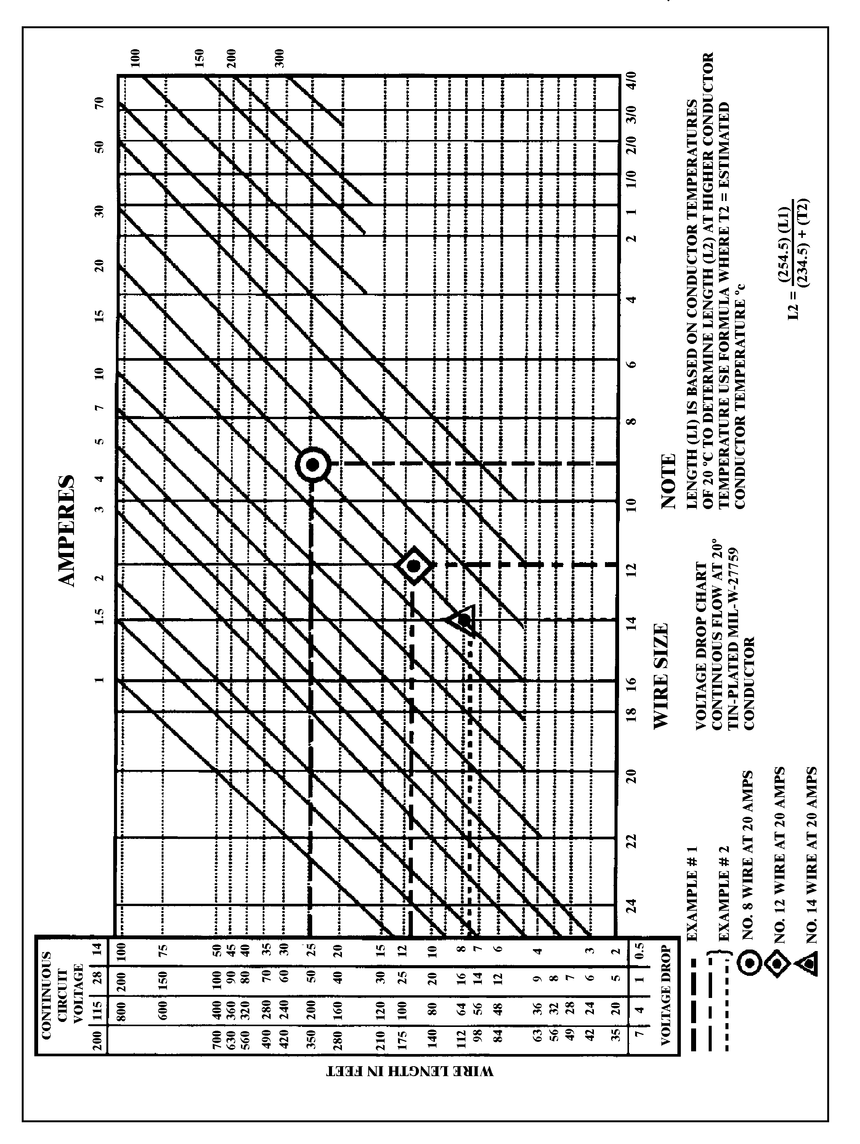
Figure 11-2. Conductor chart, continuous flow.

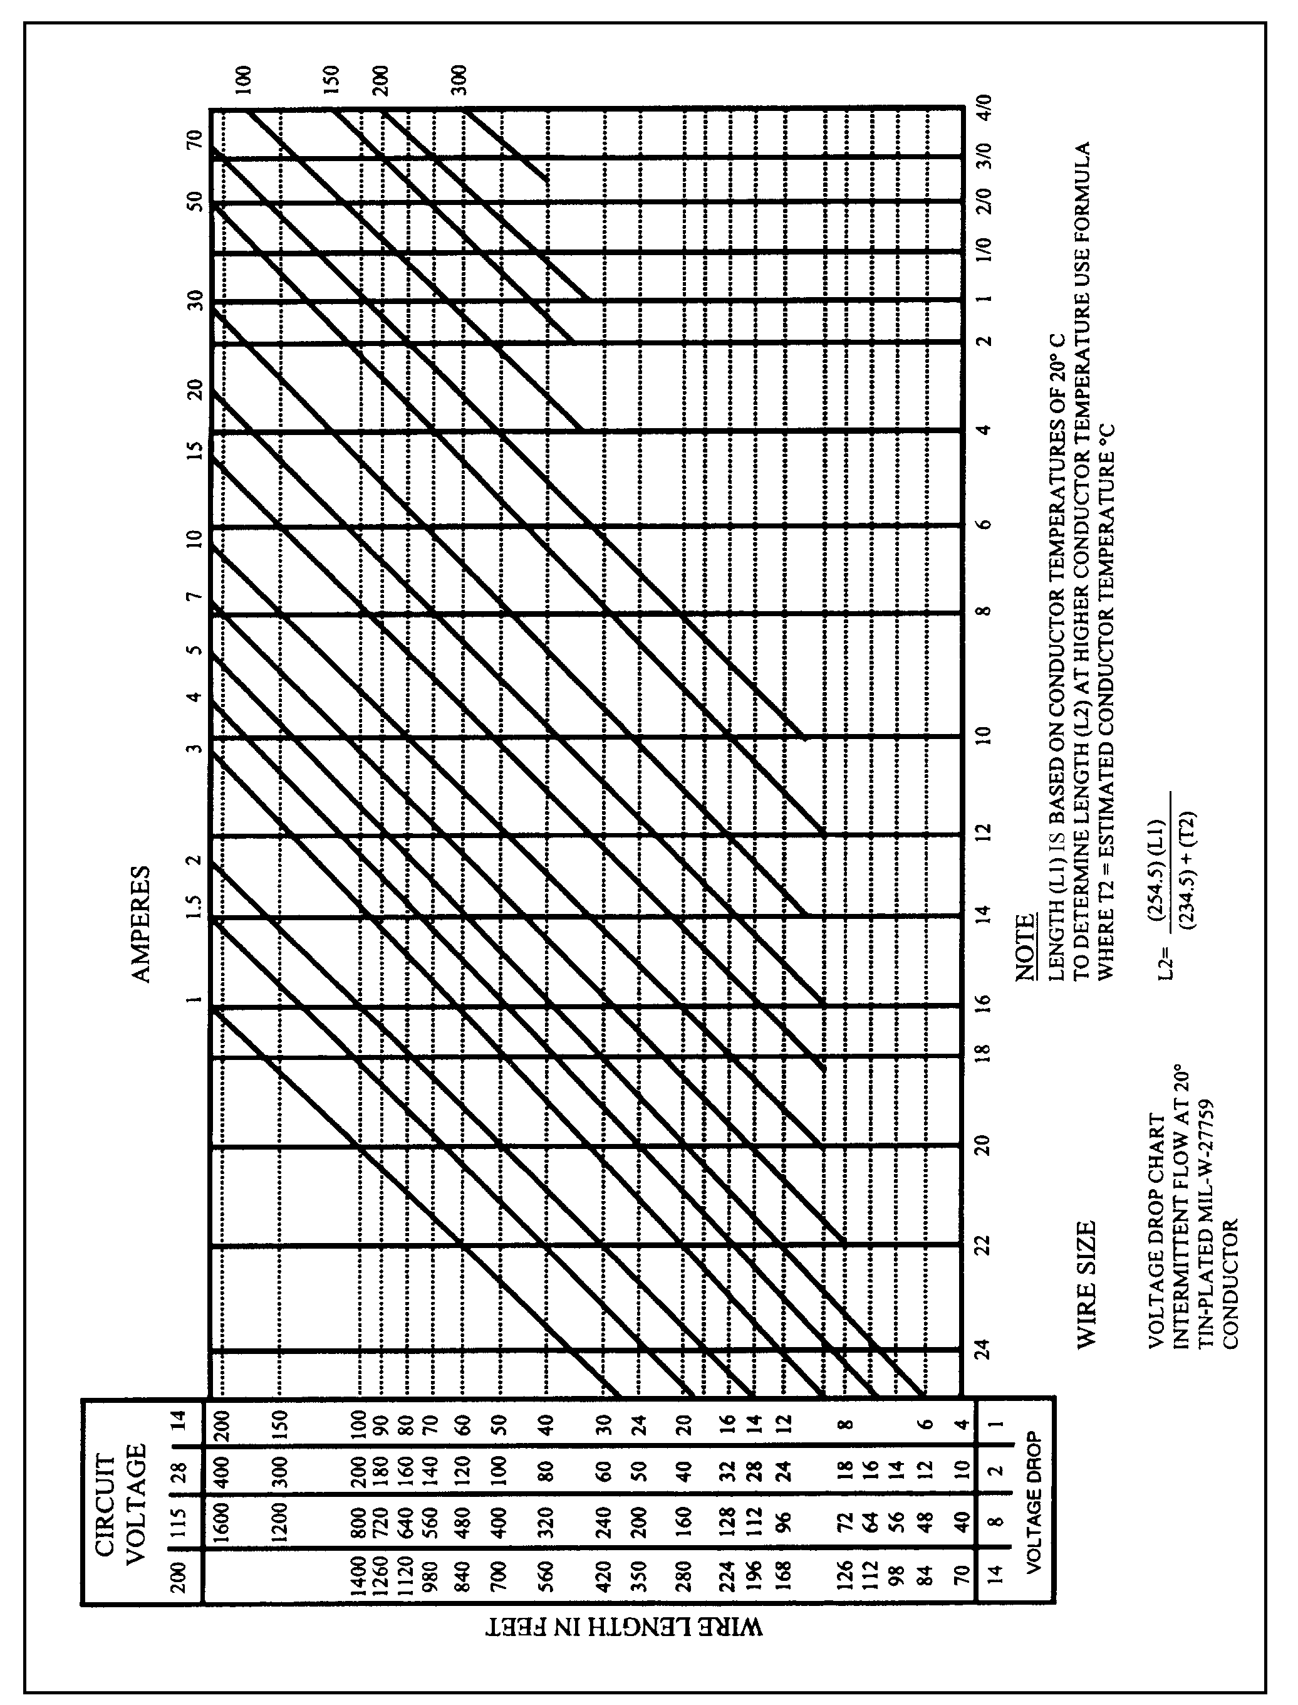
Figure 11-3. Conductor chart, intermittent flow.

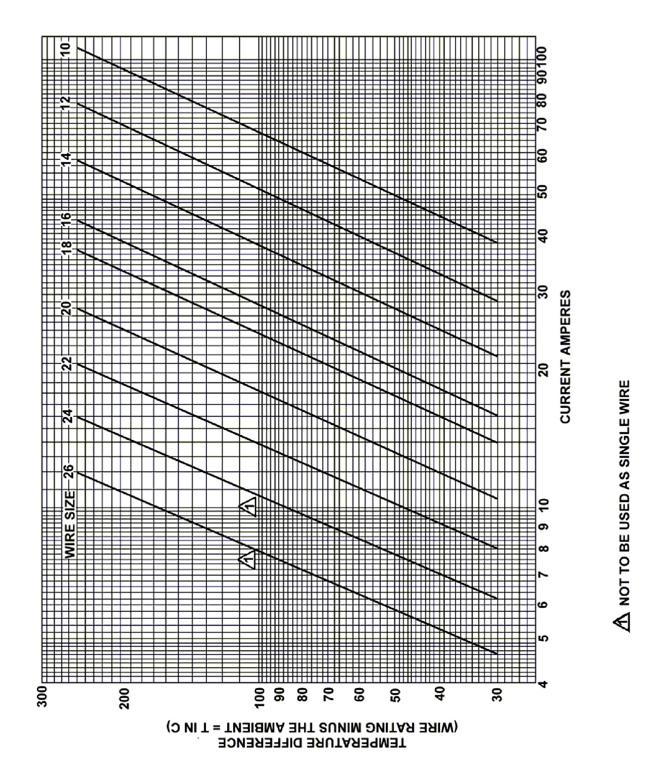
Figure 11-4a. Single copper wire in free air.

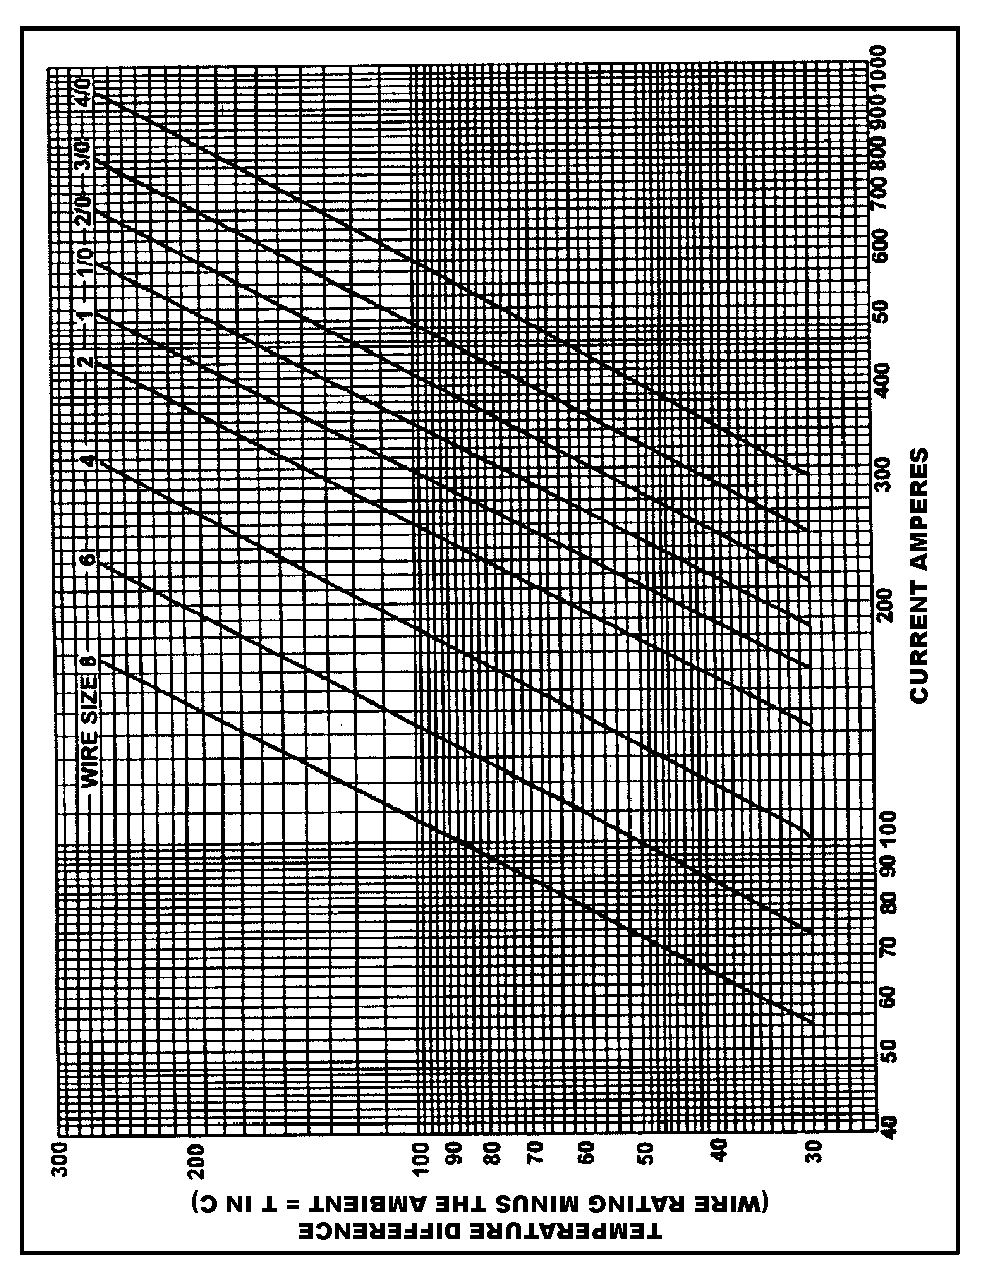
Figure 11-4b. Single copper wire in free air.

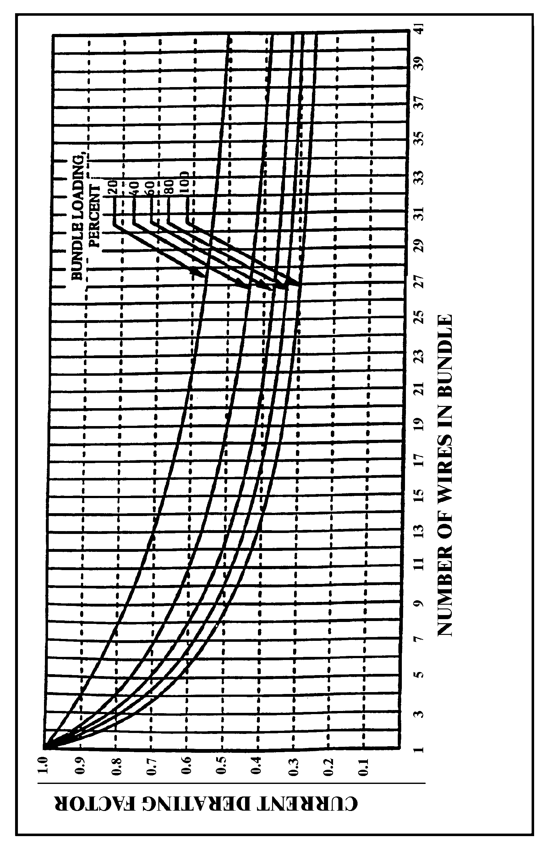
Figure 11-5. Bundle derating curves.

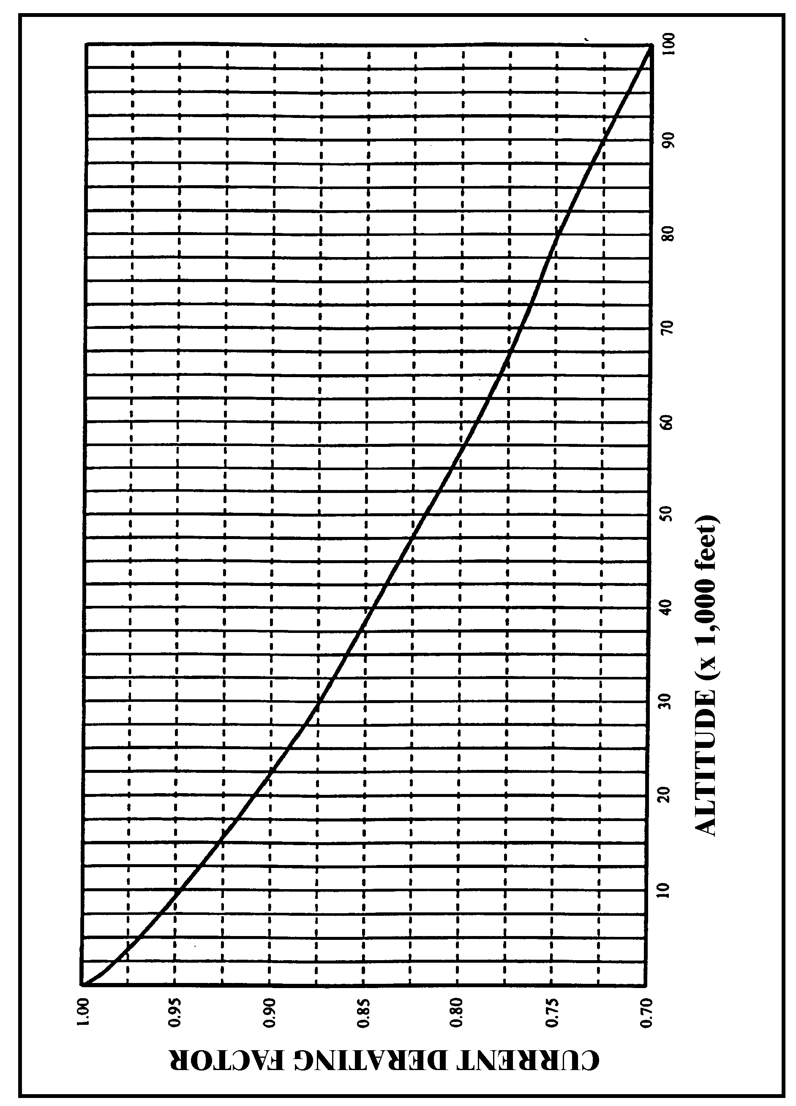
Figure 11-6. Altitude derating curve.

11-70. – 11-75. [RESERVED.]

