Section 9. ENVIRONMENTAL PROTECTION AND INSPECTION

MAINTENANCE AND OPERATIONS. Wire bundles must be routed in accessible areas that are protected from damage from personnel, cargo, and maintenance activity. They should not be routed in areas in where they are likely to be used as handholds or as support for personal equipment or where they could become damaged during removal of aircraft equipment. Wiring must be clamped so that contact with equipment and structure is avoided. Where this cannot be accomplished, extra protection, in the form of grommets, chafe strips, etc., should be provided. Protective grommets must be used, wherever wires cannot be clamped, in a way that ensures at least a 3/8-inch clearance from structure at penetrations. Wire must not have a preload against the corners or edges of chafing strips or grommets. Wiring must be routed away from high-temperature equipment and lines to prevent deterioration of insulation. Protective flexible conduits should be made of a material and design that eliminates the potential of chafing between their internal wiring and the conduit internal walls. Wiring that must be routed across hinged panels, must be routed and clamped so that the bundle will twist, rather than bend, when the panel is moved.

Group and Bundle Ties. A wire bundle consists of a quantity of wires fastened or secured together and all traveling in the same direction. Wire bundles may consist of two or more groups of wires. It is often advantageous to have a number of wire groups individually tied within the wire bundle for ease of identification at a later date. (See figure 11-7.) Comb the wire groups and bundles so that the wires will lie parallel to each other and minimize the possibility of insulation abrasion. A combing tool, similar to that shown in figure 11-8, may be made from any suitable insulating material, taking care to

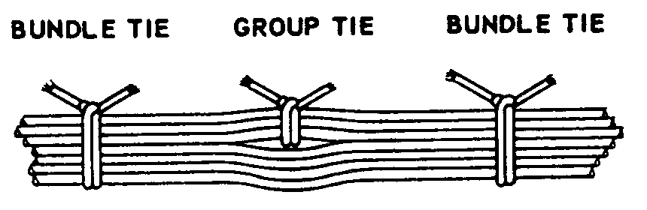
Figure 11-7. Group and bundle ties.

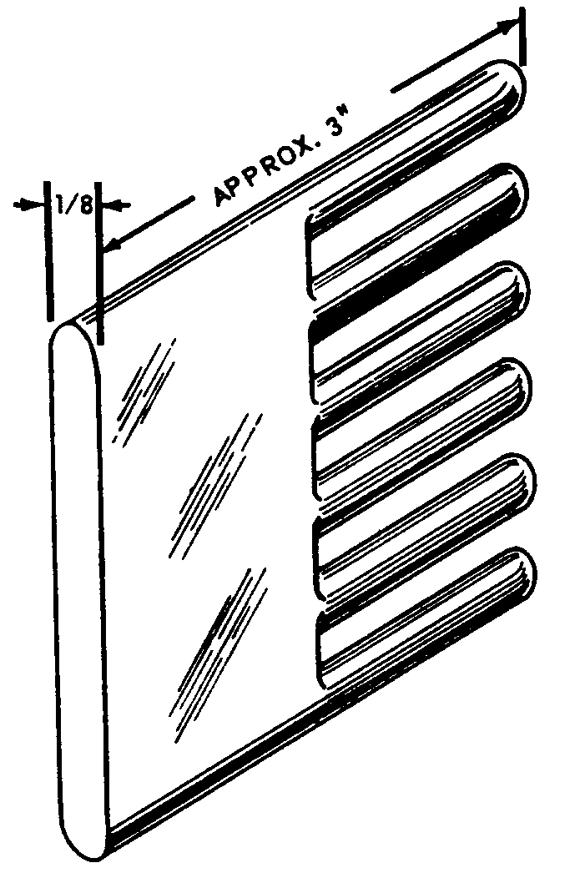
Figure 11-8. Comb for straightening wires in bundles.

ensure all edges are rounded to protect the wire insulation.

Minimum Wire Bend Radii. The minimum radii for bends in wire groups or bundles must not be less than 10 times the outside diameter of their largest wire. They may be bent at six times their outside diameters at breakouts or six times the diameter where they must reverse direction in a bundle, provided that they are suitably supported.

RF cables should not bend on a radius of less than six times the outside diameter of the cable.

Care should be taken to avoid sharp bends in wires that have been marked with the hot stamping process.

SLACK. Wiring should be installed with sufficient slack so that bundles and individual wires are not under tension. Wires connected to movable or shock-mounted equipment should have sufficient length to allow full travel without tension on the bundle. Wiring at terminal lugs or connectors should have sufficient slack to allow two reterminations without replacement of wires. This slack should be in addition to the drip loop and the allowance for movable equipment. Normally, wire groups or bundles should not exceed 1/2-inch deflection between support points, as shown in figure 11-9a. This measurement may be exceeded provided there is no possibility of the wire group or bundle touching a surface that may cause abrasion. Sufficient slack should be provided at each end to:

Permit replacement of terminals.

Prevent mechanical strain on wires.

Permit shifting of equipment for maintenance purposes.

11-118A. DRIP LOOP IN WIRE BUNDLE. A drip loop is an area where wire is dressed downward to a connector, terminal block, panel, or junction bo. In additional to the service termination and strain relief, a trap or drip loop shall be provided in the wiring to prevent fluid or condensate from running into the above devices. (see Figure 11-9b) Wires or groups of wires should enter a junction box or piece of equipment in an upward direction where practicable. Where wires must be routed downwards to a junction box or unit of electric equipment, the entry should be sealed or adequate slack should be provided to form a trap or drip loop to prevent liquid from
running down the wires in the box or electric unit.

POWER FEEDERS. The power feeder wires should be routed so that they can be easily inspected or replaced. They must be given special protection to prevent potential chafing against other wiring, aircraft structure, or components.

RF CABLE. All wiring needs to be protected from damage. However, coaxial and triaxial cables are particularly vulnerable to certain types of damage. Personnel should exercise care while handling or working around coaxial. Coaxial damage can occur when clamped too tightly, or when they are bent sharply (normally at or near connectors). Damage can also be incurred during unrelated maintenance actions around the coaxial cable. Coaxial can be severely damaged on the inside without any evidence of damage on the outside. Coaxial cables with solid center conductors should not be used. Stranded center coaxial cables can be used as a direct replacement for solid center coaxial.

PRECAUTIONS.

Never kink coaxial cable.

Never drop anything on coaxial cable.

Never step on coaxial cable.

Never bend coaxial cable sharply.

Never loop coaxial cable tighter than the allowable bend radius.

Never pull on coaxial cable except in a straight line.

Never use coaxial cable for a handle, lean on it, or hang things on it (or any other wire).

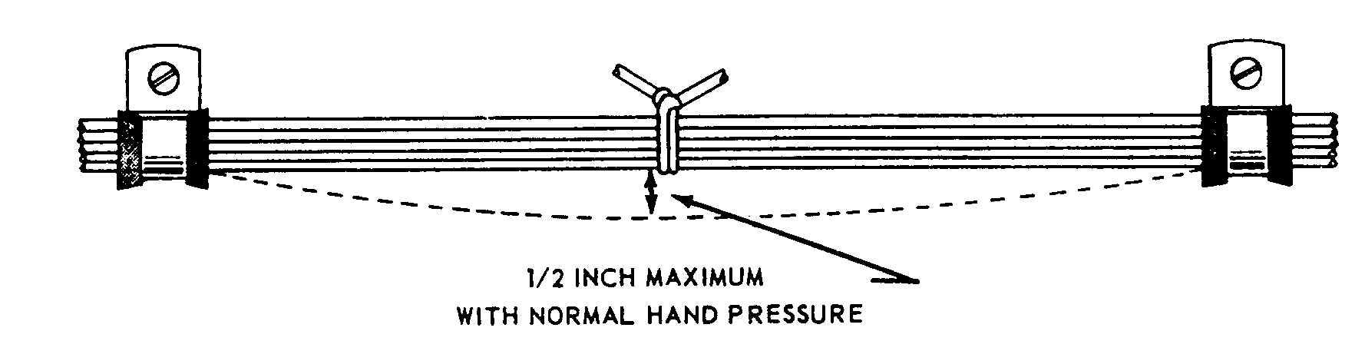

Figure 11-9a. Slack between supports

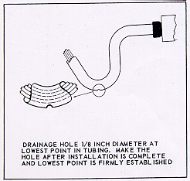
FIGURE 11-9b. Drainage hole in low point of tubing.

MOISTURE PROTECTION, WHEEL WELLS, AND LANDING GEAR AREAS.

Wires located on landing gear and in the wheel well area can be exposed to many hazardous conditions if not suitably protected. Where wire bundles pass flex points, there must not be any strain on attachments or excessive slack when parts are fully extended or retracted. The wiring and protective tubing must be inspected frequently and replaced at the first sign of wear.

Wires should be routed so that fluids drain away from the connectors. When this is not practicable, connectors must be potted. Wiring which must be routed in wheel wells or other external areas must be given extra protection in the form of harness jacketing and connector strain relief. Conduits or flexible sleeving used to protect wiring must be equipped with drain holes to prevent entrapment of moisture.

PROTECTION AGAINST PERSONNEL AND CARGO. Wiring must be installed so the structure affords protection against its use as a handhold and damage from cargo. Where the structure does not afford adequate protection, conduit must be used, or a suitable mechanical guard must be provided.

HEAT PRECAUTIONS. Wiring must be routed away from high-temperature equipment and lines to prevent deterioration of insulation. Wires must be rated (reference paragraph 11-66 and 11-67) so that the conductor temperature remains within the wire specification maximum when the ambient temperature, and heat rise, related to current carrying capacity are taken into account. The residual heating effects caused by exposure to

sunlight when aircraft are parked for extended periods should also be taken into account. Wires such as in fire detection, fire extinguishing, fuel shutoff, and fly-by-wire flight control systems that must operate during and after a fire, must be selected from types that are qualified to provide circuit integrity after exposure to fire for a specified period. Wire insulation deteriorates rapidly when subjected to high temperatures. Do not use wire with soft polyethylene insulation in areas subject to high temperatures. Use only wires or cables with heat resistance shielding or insulation.

Movable Controls Wiring Precautions. Clamping of wires routed near movable flight controls must be attached with steel hardware and must be spaced so that failure of a single attachment point can not result in interference with controls. The minimum separation between wiring and movable controls must be at least 1/2 inch when the bundle is displaced by light hand pressure in the direction of the controls.

FLAMMABLE FLUIDS AND GASES. An arcing fault between an electrical wire and a metallic flammable fluid line may puncture the line and result in a fire. Every effort must be made to avoid this hazard by physical separation of the wire from lines and equipment containing oxygen, oil, fuel, hydraulic fluid, or alcohol. Wiring must be routed above these lines and equipment with a minimum separation of 6 inches or more whenever possible. When such an arrangement is not practicable, wiring must be routed so that it does not run parallel to the fluid lines. A minimum of 2 inches must be maintained between wiring and such lines and equipment, except when the wiring is positively clamped to maintain at least 1/2-inch separation, or when it must be connected

directly to the fluid-carrying equipment. Install clamps as shown in figure 11-10. These clamps should not be used as a means of supporting the wire bundle. Additional clamps should be installed to support the wire bundle and the clamps fastened to the same structure used to support the fluid line(s) to prevent relative motion.

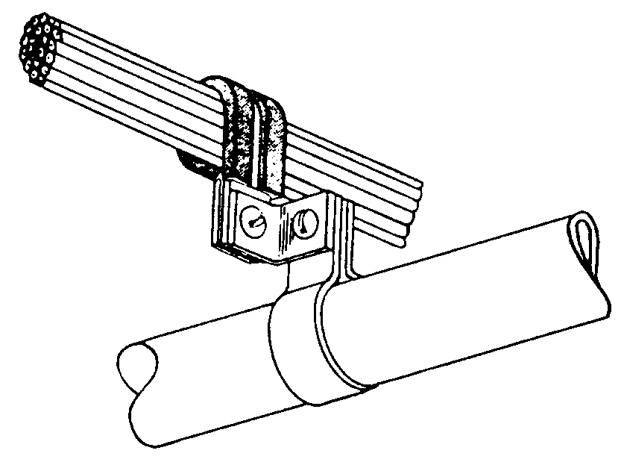
Figure 11-10. Separation of wires from plumbing lines.

11-127.⎯11-134. [RESERVED.]

