Section 11. CLAMPING

GENERAL. Wires and wire bundles must be supported by using clamps meeting Specification MS-21919, or plastic cable straps in accessible areas if correctly applied within the restrictions of paragraph 11-158. Clamps and other primary support devices must be constructed of materials that are compatible with their installation and environment, in terms of temperature, fluid resistance, exposure to ultraviolet (UV) light, and wire bundle mechanical loads. They should be spaced at intervals not exceeding 24 inches. Clamps on wire bundles should be selected so that they have a snug fit without pinching wires, as shown in figure 11-11 through figure 11-13.

CAUTION: The use of metal clamps on coaxial RF cables may cause problems if clamp fit is such that RF cable’s original cross-section is distorted.

Clamps on wire bundles should not allow the bundle to move through the clamp when a slight axial pull is applied. Clamps on RF cables must fit without crushing and must be snug enough to prevent the cable from moving freely through the clamp, but may allow the cable to slide through the clamp when a light axial pull is applied. The cable or wire bundle may be wrapped with one or more turns of electrical tape when required to achieve this fit. Plastic clamps or cable ties must not be used where their failure could result in interference with movable controls, wire bundle contact with movable equipment, or chafing damage to essential or unprotected wiring. They must not be used on vertical runs where inadvertent slack migration could result in chafing or other damage. Clamps must be installed with their attachment hardware positioned above them, wherever practicable, so

that they are unlikely to rotate as the result of wire bundle weight or wire bundle chafing. (See figure 11-11.).

Clamps lined with nonmetallic material should be used to support the wire bundle along the run. Tying may be used between clamps, but should not be considered as a substitute for adequate clamping. Adhesive tapes are subject to age deterioration and, therefore, are not acceptable as a clamping means.

The back of the clamp, whenever practical, should be rested against a structural member. Stand-offs should be used to maintain clearance between the wires and the structure. Clamps must be installed in such a manner that the electrical wires do not come in contact with other parts of the aircraft when subjected to vibration. Sufficient slack should be left between the last clamp and the electrical equipment to prevent strain at the terminal and to minimize adverse effects on shock-mounted equipment. Where wires or wire bundles pass through bulkheads or other structural members, a grommet or suitable clamp should be provided to prevent abrasion.

When wire bundle is clamped into position, if there is less than 3/8-inch clearance between the bulkhead cutout and the wire bundle, a suitable grommet should be installed as indicated in figure 11-14. The grommet may be cut at a 45 degree angle to facilitate installation, provided it is cemented in place and the slot is located at the top of the cutout.

WIRE AND CABLE CLAMPS INSPECTION. Inspect wire and cable clamps for proper tightness. Where cables pass through structure or bulkheads, inspect for proper clamping and grommets. Inspect for sufficient slack between the last clamp and

the electronic equipment to prevent strain at the cable terminals and to minimize adverse effects on shock-mounted equipment.

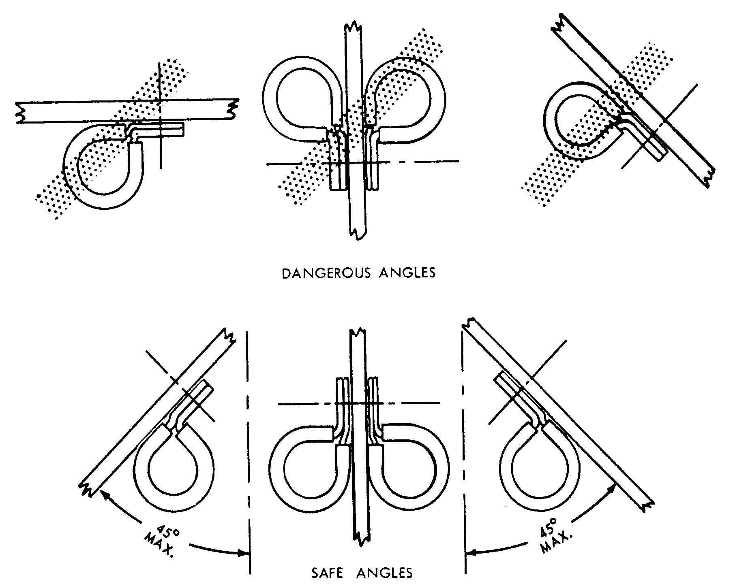
Figure 11-11. Safe angle for cable clamps.

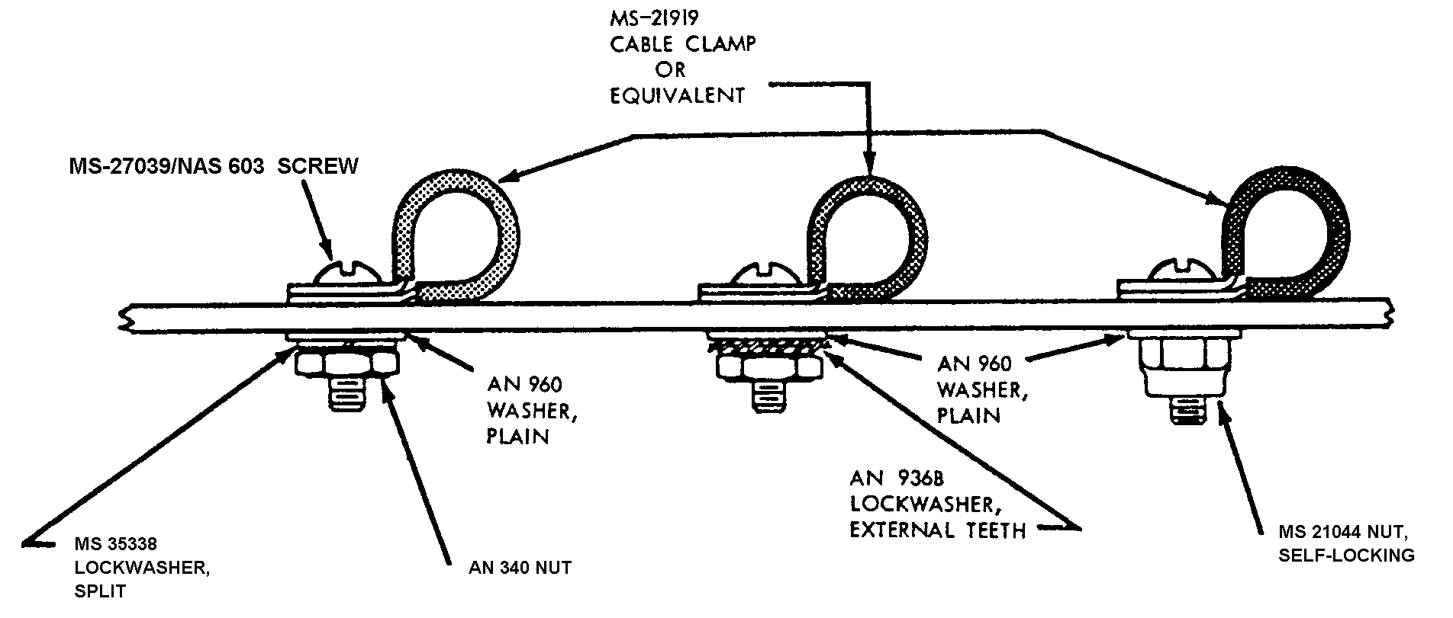
Figure 11-12. Typical mounting hardware for MS-21919 cable clamps.

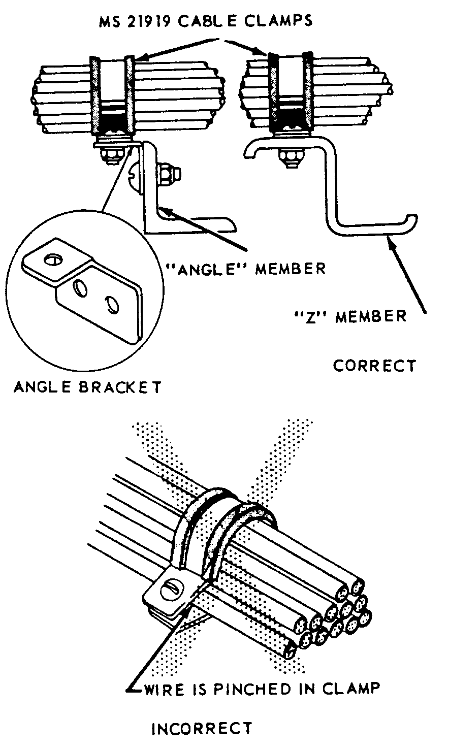
Figure 11-13. Installing cable clamp to structure.

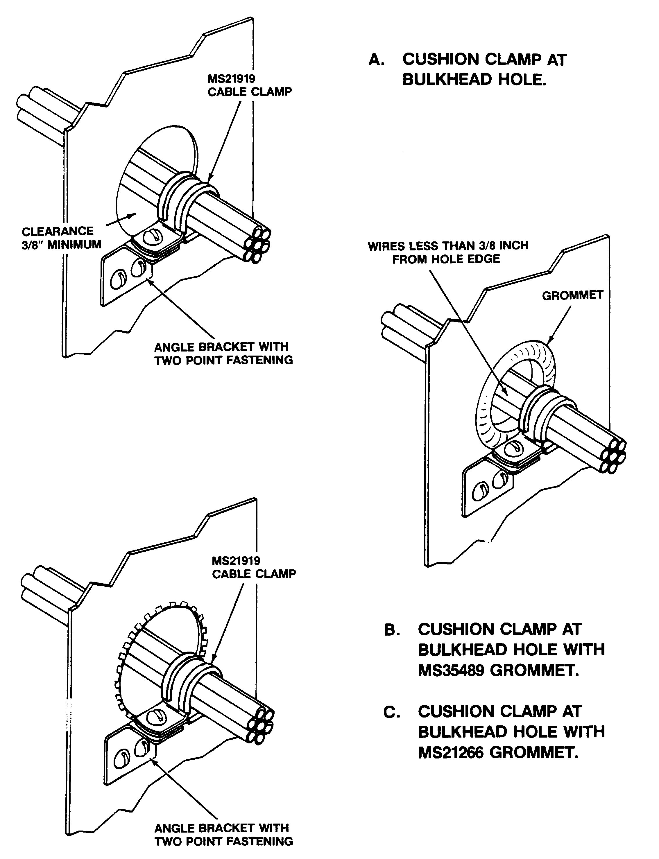
Figure 11-14. Clamping at a bulkhead hole.

11-148.⎯11-154. [RESERVED.]

