Section 12. WIRE INSULATION AND LACING STRING TIE

GENERAL. Insulation of wires should be appropriately chosen in accordance with the environmental characteristics of wire routing areas. Routing of wires with dissimilar insulation, within the same bundle, is not recommended, particularly when relative motion and abrasion between wires having dissimilar insulation can occur. Soft insulating tubing (spaghetti) cannot be considered as mechanical protection against external abrasion of wire; since at best, it provides only a delaying action. Conduit or ducting should be used when mechanical protection is needed.

INSULATION MATERIALS. Insulating materials should be selected for the best combination of characteristics in the following categories:

Abrasion resistance.

Arc resistance (noncarbon tracking).

Corrosion resistance.

Cut-through strength.

Dielectric strength.

Flame resistance.

Heat distortion temperature.

Impact strength.

Mechanical strength.

Resistance to fluids.

Resistance to notch propagation.

Smoke emission.

Special properties unique to the
aircraft.

For a more complete selection of insulated wires refer to SAE AS 4372 Aerospace Wire Performance Requirement and SAE AS 4373 Test Methods for Aerospace Wire.

STRIPPING INSULATION.
Attachment of wire, to connectors or terminals, requires the removal of insulation to expose the conductors. This practice is commonly known as stripping. Stripping may be accomplished in many ways; however, the following basic principles should be practiced.

Make sure all cutting tools used for stripping are sharp.

When using special wire stripping tools, adjust the tool to avoid nicking, cutting,
or otherwise damaging the strands.

Damage to wires should not exceed the limits specified in table 11-13.

When performing the stripping operation, remove no more insulation than is necessary.

LACING AND TIES. Ties, lacing, and straps are used to secure wire groups or bundles to provide ease of maintenance, inspection, and installation. Braided lacing tape per MIL-T-43435 is suitable for lacing and tying wires. In lieu of applying ties, straps meeting Specification MS17821 or MS17822 may be used in areas where the temperature does not exceed 120 ▪C. Straps may not be used in areas of SWAMP such as wheel wells, near wing flaps or wing folds. They may not be used in high vibration areas, where failure

Table 11-13. Allowable nicked or broken strands.
Maximum allowable nicked and broken strands
Wire Size | Conductor material | Number of strands per conductor | Total allowable nicked and  broken strands
24-14  12-10  8-4  2-1  0-00  000  0000  8-000 | Copper  or  Copper Alloy  Aluminum | 19  37  133  665-817  1,045-1,330  1,665-  2,109-  All numbers of strands | 2 nicked, none broken  4 nicked, none broken  6 nicked, 6 broken  6 nicked, 6 broken  6 nicked, 6 broken  6 nicked, 6 broken  6 nicked, 6 broken  None, None

of the strap would permit wiring to move against parts which could damage the insulation and foul mechanical linkages or other moving mechanical parts. They also may not be used where they could be exposed to UV light, unless the straps are resistant to such exposure.

Lacing. Lace wire groups or bundles inside junction boxes or other enclosures. Single cord-lacing method, shown in figure 11-15, and tying tape, meeting specification MIL-T-43435, may be used for wire groups of bundles 1-inch in diameter or less. The recommended knot for starting the single cord-lacing method is a clove hitch secured by a double-looped overhand knot as shown in figure 11-15, step a. Use the double cord-lacing method on wire bundles 1-inch in diameter or larger as shown in figure 11-16. When using the double cord-lacing method, employ a bowline on a bight as the starting knot.

Tying. Use wire group or bundle ties where the supports for the wire are more than

12 inches apart. A tie consists of a clove hitch, around the wire group or bundle, secured by a square knot as shown in figure 11-17.

Plastic Ties. Refer to Paragraph 11-220 and table 11-21.

INSULATION TAPE. Insulation tape should be of a type suitable for the application, or as specified for that particular use. Insulation tape should be used primarily as a filler under clamps and as secondary support. Nonadhesive tape may be used to wrap around wiring for additional protection, such as in wheel wells. All tape should have the ends tied or otherwise suitably secured to prevent unwinding. Tape used for protection should be applied so that overlapping layers shed liquids. Drainage holes should be provided at all trap points and at each low point between clamps. Plastic tapes, that absorb moisture or have volatile plasticizers that produce chemical reactions with other wiring, should not be used. (Reference MIL-W-5088.)

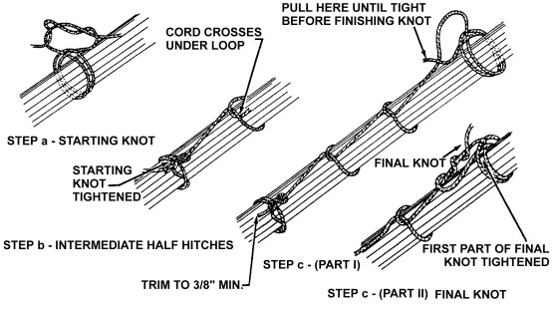
Figure 11-15. Single cord lacing.

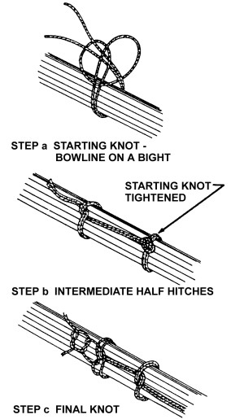
Figure 11-16. Double cord lacing.
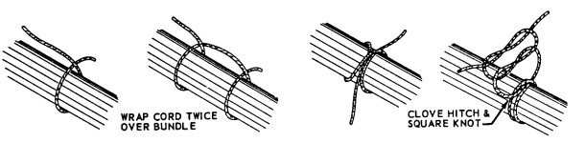
Figure 11-17. Making ties.

11-160.⎯11-166. [RESERVED.]

