Section 16. WIRE MARKING

GENERAL. The proper identification of electrical wires and cables with their circuits and voltages is necessary to provide safety of operation, safety to maintenance personnel, and ease of maintenance.

Each wire and cable should be marked with a part number. It is common practice for wire manufacturers to follow the wire material part number with the five digit/letter C.A.G.E. code identifying the wire manufacturer. Existing installed wire that needs replacement can thereby be identified as to its performance capabilities, and the inadvertent use of a lower performance and unsuitable replacement wire avoided.

The method of identification should not impair the characteristics of the wiring.

Caution: Do not use metallic bands in place of insulating sleeves. Exercise care when marking coaxial or data bus cable, as deforming the cable may change its electrical characteristics.

WIRE IDENTIFICATION. To facilitate installation and maintenance, original wire-marking identification is to be retained. The wire identification marks should consist of a combination of letters and numbers that identify the wire, the circuit it belongs to, its gauge size, and any other information to relate the wire to a wiring diagram. All markings should be legible in size, type, and color.

IDENTIFICATION AND INFORMATION RELATED TO THE WIRE AND WIRING DIAGRAMS. The wire identification marking should consist of similar information to relate the wire to a wiring diagram.

PLACEMENT OF IDENTIFICATION MARKINGS. Identification markings should be placed at each end of the wire and at 15-inch maximum intervals along the length of the wire. Wires less than 3 inches long need not be identified. Wires 3 to 7 inches in length should be identified approximately at the center. Added identification marker sleeves should be so located that ties, clamps, or supporting devices need not be removed in order to read the identification.

The wire identification code must be printed to read horizontally (from left to right) or vertically (from top to bottom). The two methods of marking wire or cable are as follows:

Direct marking is accomplished by printing the cable’s outer covering. (See figure 11-23.)

Indirect marking is accomplished by printing a heat-shrinkable sleeve and installing the printed sleeve on the wire or cables outer covering. Indirect-marked wire or cable should be identified with printed sleeves at each end and at intervals not longer than 6 feet. The individual wires inside a cable should be identified within 3 inches of their termination. (See figure 11-24.)

TYPES OF WIRE MARKINGS. The preferred method is to mark directly on the wire. A successful requirement qualification should produce markings that meet the marking characteristics specified in MIL-W-5088 or AS50881A without causing insulation degradation. Teflon coated wires, shielded wiring, multi-conductor cable, and thermocouple wires usually require special sleeves to carry identification marks. There are some wire marking machines in the market that can be used to stamp directly on the type wires mentioned above. Whatever method of marking is used, the marking should be legible and the color should contrast with the wire insulation or sleeve.

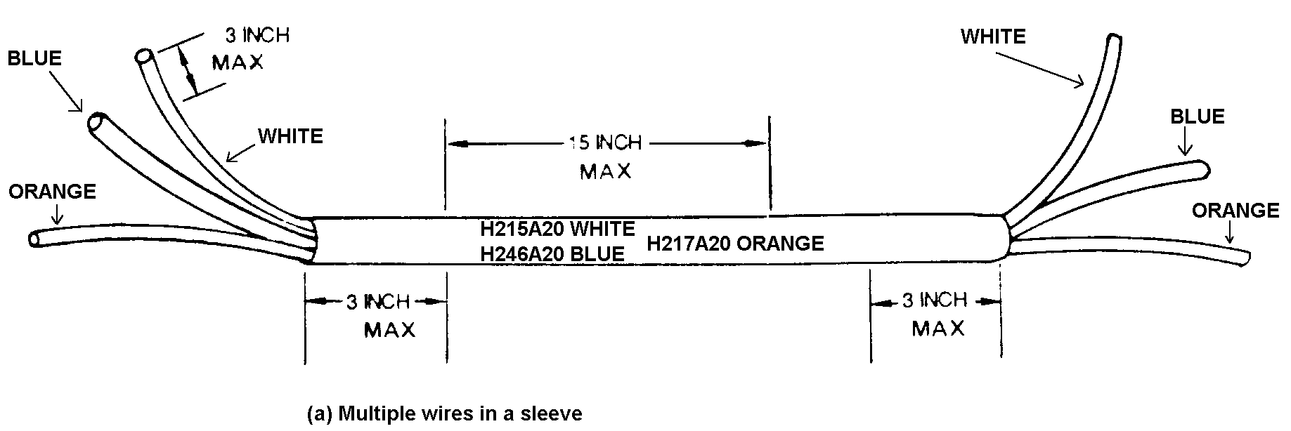

Figure 11-23. Spacing of printed identification marks (direct marking).

3” 15” 15” 3”
H215A20 H215A20 H215A20

(b) Single wire without sleeve

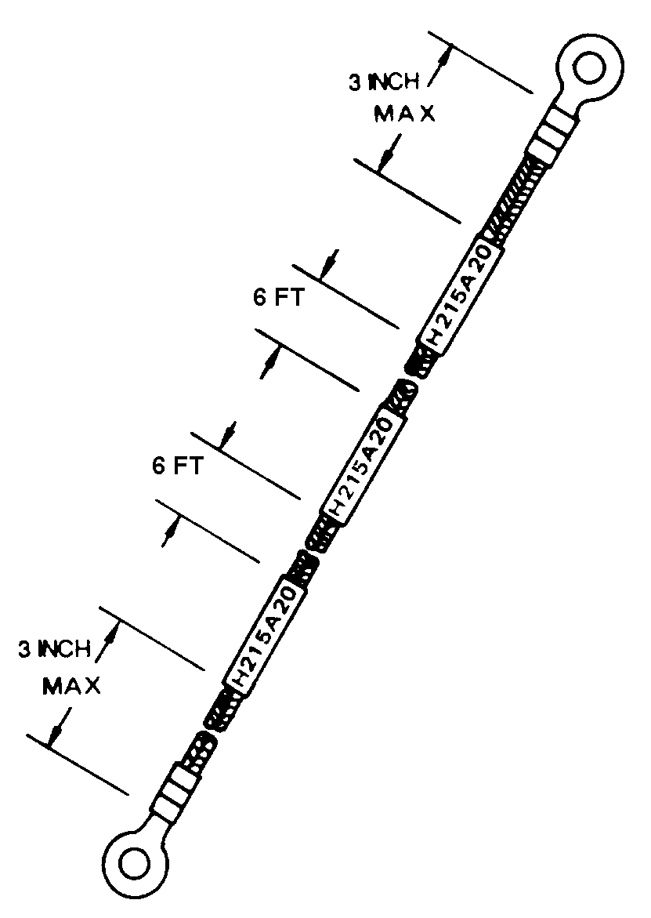Figure 11-24. Spacing of printed identification marks (indirect marking).

Extreme care must, therefore, be taken during circuit identification by a hot stamp machine on insulation wall 10 mils or thinner.

Alternative identification methods such as “Laser Printing”, “Ink Jet”, and “Dot Matrix” are preferred. When such modern equipment is not available, the use of stamped identification sleeving should be considered on insulation wall thickness of 10 mils or less.

HOT STAMP MARKING. Due to widespread use of hot stamp wire marking, personnel should refer to SAE ARP5369, Guidelines for Wire Identification Marking using the Hot Stamp Process, for guidance on minimizing insulation damage. Hot stamp process uses a heated typeface to transfer pigment from a ribbon or foil to the surface of wires or cables. The traditional method imprints hot ink marks onto the wire. Exercise caution when using this method, as it has been shown to damage insulation when incorrectly applied. Typeset characters, similar to that used in printing presses but shaped to the

contour of the wire, are heated to the desired temperature. Wire is pulled through a channel directly underneath the characters. The heat of the type set characters transfers the ink from the marking foil onto the wire.

Good marking is obtained only by the proper combination of temperature, pressure, and dwelling. Hot stamp will mark wire with an outside diameter of 0.038 to 0.25-inch.

b. Before producing hot stamp wire, it must be assured that the marking machine is properly adjusted to provide the best wire marking with the least wire insulation deterioration. The marking should never create an indent greater than 10 percent of the insulation wall.

CAUTION: The traditional Hot Stamp method is not recommended for use on wire with outside diameters of less than 0.035. (REF. SAE ARP5369). Stamping dies may cause fracture of the insulation wall and penetration to the conductor of these materials. When various fluids wet these opening in service, arcing and surface tracking damage wire bundles. Later in service, when various fluids have wet these openings, serious arcing and surface tracking will have damaged wire bundles.

DOT MATRIX MARKING. The dot matrix marking is imprinted onto the wire or cable very similar to that of a dot matrix computer printer. The wire must go through a cleaning process to make sure it is clean and dry for the ink to adhere. Wires marked with dot matrix equipment require a cure consisting of an UV curing process, which is normally applied by the marking equipment. This cure should normally be complete 16 to 24 hours after marking. Dot matrix makes a legible mark without damaging the insulation. Depending on equipment configuration, dot matrix can mark wire from 0.037 to 0.5-inch outside diameter. Multi-conductor cable can also be marked.

INK JET MARKING. This is a “non-impact” marking method wherein ink droplets are electrically charged and then directed onto the moving wire to form the characters. Two basic ink types are available: thermal cure and UV cure.

Thermal cure inks must generally be heated in an oven for a length of time after marking to obtain their durability. UV cure inks are cured in line much like dot matrix.

Ink jet marks the wire on the fly and makes a reasonably durable and legible mark without damaging the insulation. Ink jets normally mark wire from 0.030 to 0.25-inch outside diameter. Multiconductor cable can also be marked.

LASER MARKING. Of the variety of laser marking machines, UV lasers are proving to be the best. This method marks into the surface of the wire’s insulation without degradation to its performance. One common type of UV laser is referred to as an excimer laser marker. UV laser produces the most durable marks because it marks into the insulation instead of on the surface. However, excimer laser will only mark insulation that contain appropriate percentages of titanium dioxide (TiO₂). The wire can be marked on the fly. UV can mark from 0.030 to 0.25-inch outside diameter. The UV laser makes only gray marks and they appear more legible on white or pastel-colored insulation.

IDENTIFICATION SLEEVES.
Flexible sleeving, either clear or opaque, is satisfactory for general use. When color-coded or striped component wire is used as part of a cable, the identification sleeve should specify which color is associated with each wire identification code. Identification sleeves are normally used for identifying the following types of wire or cable:

Unjacketed shielded wire.

Thermocouple wire identification is normally accomplished by means of identification sleeves. As the thermocouple wire is usually of the duplex type (two insulated wires within the same casing), each wire at the termination point bears the full name of the conductor. Thermocouple conductors are alumel, chromel, iron, constantan, and copper
constantan.

Coaxial cable should not be hot stamped directly. When marking coaxial cable, care should be taken not to deform the cable as this may change the electrical characteristics of the cable. When cables cannot be printed directly, they should be identified by printing the identification code (and individual wire color, where applicable) on a nonmetallic material placed externally to the outer covering at the terminating end and at each junction or pressure bulkhead. Cables not enclosed in conduit or a common jacket should be identified with printed sleeves at each end and at intervals not longer than 3 feet. Individual wires within a cable should be identified within 3 inches from their termination.

Multiconductor cable normally use identification sleeves for identifying unshielded, unjacketed cable.

High-temperature wire with insulation is difficult to mark (such as Teflon and fiberglass).

IDENTIFICATION TAPE. Identification tape can be used in place of sleeving, in most cases (i.e. polyvinylfluoride).

OPERATING CONDITIONS. For sleeving exposed to high temperatures (over 400 °F), materials such as silicone fiberglass should be used.

INSTALLATION OF PRINTED SLEEVES. Polyolefin sleeving should be used in areas where resistance to solvent and synthetic hydraulic fluids is necessary. Sleeves may be secured in place with cable ties or by heat shrinking. The identification sleeving for various sizes of wire is shown in table 11-17.

Table 11-17. Recommended size of identification sleeving.
Wire Size |  | Sleeving Size
AN | AL | No. | Nominal ID (inches)
#24  #22  #20  #18  #16  #14  #12  #10  #8  #6  #4  #2  #1  #0  #00  #000  #0000 | #8  #6  #4  #2  #1  #0  #00  #000  #0000 | 12  11  10  9  8  7  6  4  2  0  3/8 inch  1/2 inch  1/2 inch  5/8 inch  5/8 inch  3/4 inch  3/4 inch | .085  .095  .106  .118  .113  .148  .166  .208  .263  .330  .375  .500  .500  .625  .625  .750  .750

IDENTIFICATION OF WIRE BUNDLES AND HARNESSES. The identification of wire bundles and harnesses is becoming a common practice and may be accomplished by the use of a marked sleeve tied in place or by the use of pressure-sensitive tape as indicated in figure 11-25.

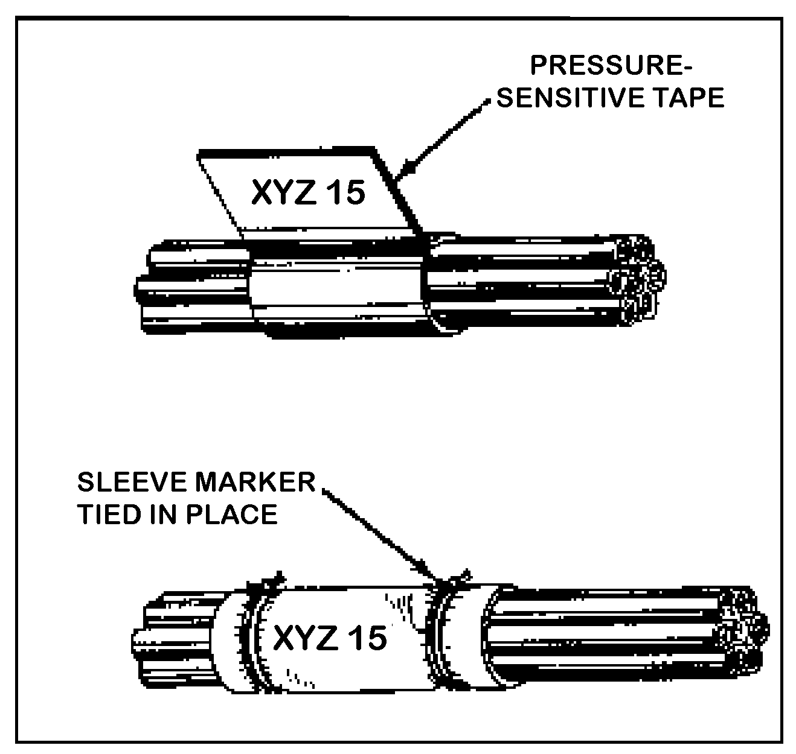
Figure 11-25. Identification of wire bundles and harnesses.

Wires for which identifications are reassigned after installation, may be remarked on sleeves at the termination of each wire segment. It may be necessary to reidentify such wires throughout their lengths to facilitate ease of maintenance.

For high-density harnessed, shielded, and jacketed multiconductor cables and when using nonsignificant wire identification, color coding or its alphanumeric equivalent may be interchanged within the same harnesses. The alphanumeric equivalent of the color code should be as set forth in MIL-STD-681.

TERMINAL MARKING SLEEVE AND TAGS. Typical cable markers are flat, nonheat-shrinkable tags. Heat-shrinkable marking sleeves are available for marking wires and cables, and should be inserted over the proper wire or cable and heat-shrunk using the proper manufacturer recommended heating tool. (See figures 11-26 and 11-27.)

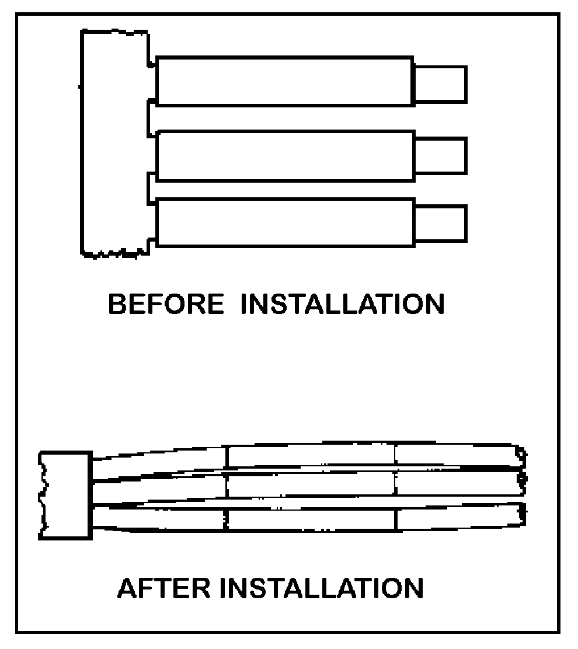
Figure 11-26. Standard sleeves (135 ºC).

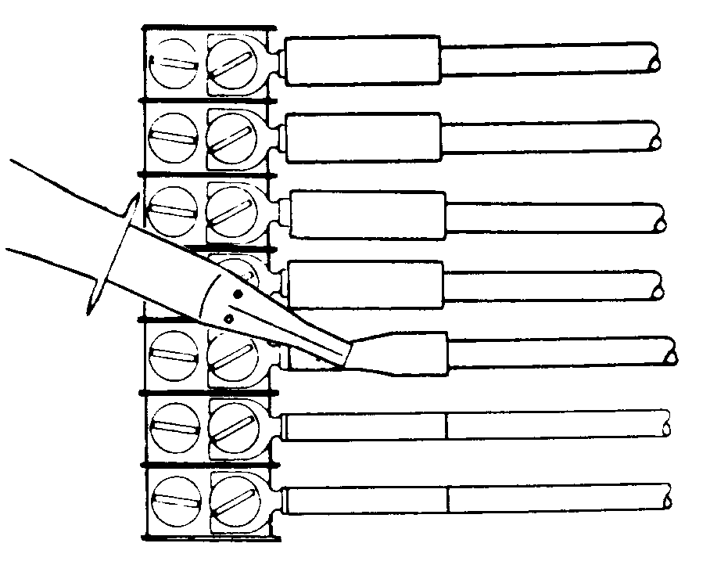
Figure 11-27. Installation of heat-shrinkable insulation sleeves.

SLEEVES AND CABLE MARKERS Selection. Sleeves and cable markers must be selected by cable size and operating conditions. (See tables 11-18 through 11-21).

Markers are printed using a typewriter with a modified roller. Blank markers on a bandolier are fed into the typewriter, where they are marked in any desired combination of characters. The typed markers, still on bandoliers, are heated in an infrared heating tool that processes the markers for permanency. The typed and heat-treated markers remain on the bandolier until ready for installation.

Markers are normally installed using the following procedure:

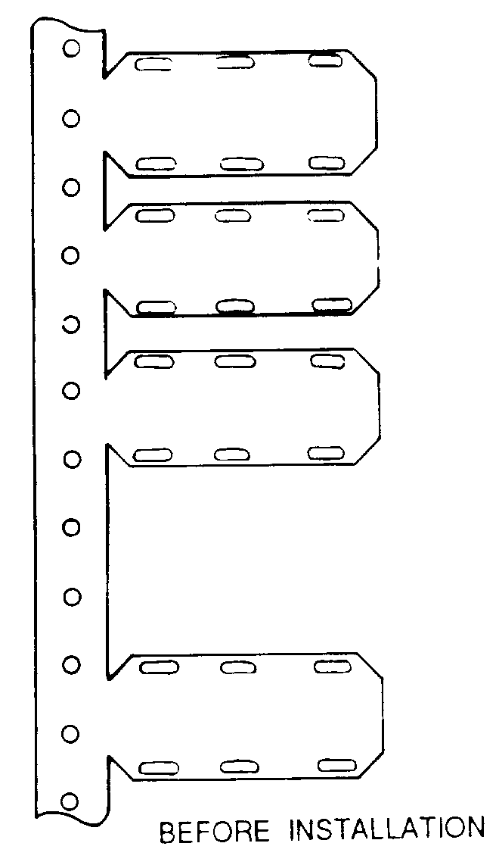
Figure 11-28. Cable markers.

Select the smallest tie-down strap that will accommodate the outside diameter of the cable. (See table 11-22.)

Cut the marking plate from the bandolier. (See figure 11-28.)

Thread the tie-down straps through holes in marking plate and around cable. Thread tip of tie-down strap through slot in head. (See figure 11-29.) Pull tip until strap is snug around cable.

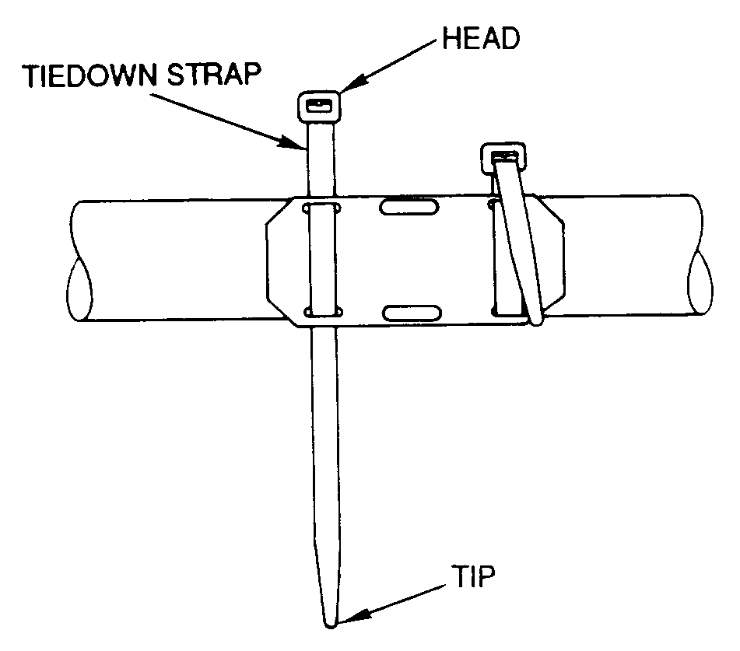
Figure 11-29. Tie-down strap installation.

Table 11-18. Selection table for standard sleeves.
Wire or Cable  Diameter Range.  (inches)  Min Max | Markable Length *  (inches) | Installed Sleeve Length (nom) (inches) | Installed Wall  Thickness (max inches) | As-supplied Inside  Diameter (min inches)
0.050 0.080  0.075 0.110  0.100 0.150  0.135 0.215  0.200 0.300  0.135 0.300  0.260 0.450 | 18  18  18  18  18  18  18 | 1.5  1.5  1.5  1.5  1.5  1.5  1.5 | 0.026  0.026  0.028  0.028  0.028  0.028  0.028 | 0.093  0.125  0.187  0.250  0.375  0.375  0.475
* Based on 12 characters per inch

Table 11-19. Selection table for thin-wall sleeves.
Wire or Cable  Diameter Range  (inches)  Min. Max. | Markable Length *  (inches) | Installed Sleeve Length (nom)  (inches) | Installed Wall  Thickness (max inches) | As-supplied Inside  Diameter (min inches)
0.035 0.080  0.075 0.110  0.100 0.150  0.135 0.225 | 22  22  21  21 | 1.75  1.75  1.75  1.75 | 0.020  0.020  0.021  0.021 | 0.093  0.125  0.187  0.250
* Based on 12 characters per inch

Table 11-20. Selection table for high-temperature sleeves.
Wire or Cable  Diameter Range  (inches)  Min. Max. | Markable Length *  (inches) | Installed Sleeve Length (nom) (inches) | Installed Wall  Thickness (max inches) | As-supplied Inside  Diameter (min inches)
0.035 0.080  0.075 0.110  0.100 0.150  0.135 0.215  0.200 0.300  0.260 0.450 | 18  18  18  18  18  18 | 1.5  1.5  1.5  1.5  1.5  1.5 | 0.019  0.016  0.018  0.018  0.018  0.018 | 0.093  0.125  0.187  0.250  0.375  0.475
* Based on 12 characters per inch

Table 11-21. Selection table for cable markers.
Cable Diameter Range  (inches) | Type of Cable Marker | Number of Attachment Holes | Number of Lines of Type | Marker Thickness (nom) (inches)
0.25-0.50  0.25-0.50  0.25-0.50  0.50-up  0.50-up  0.50-up  0.50-up  0.50-up  0.50-up | Standard, 135 °C  High Temperature,  200 °C  Nuclear, 135 °C  Standard, 135 °C  Standard, 135 °C  High Temperature,  200 °C  High Temperature,  200 °C  Nuclear, 135 °C  Nuclear, 135 °C | 4  4  4  4  6  4  6  4  6 | 2  2  2  3  3  3  3  3  3 | 0.025  0.020  0.025  0.025  0.025  0.020  0.020  0.025  0.025

Table 11-22. Plastic tie-down straps (MS3367, Type I, Class 1).
Cable Diameter  (inches)  Min Max | Tie-down Strap  MS3367- | Strap Identification * | Installation Tool | Tension Setting
1/16 5/8  1/16 1¼  1/16 4  3/16 8 | 4-9  5-9  2-9  6-9 | Miniature (MIN)  Intermediate (INT)  Standard (STD)  Heavy (HVY) | MS90387-1  MS90387-1  MS90387-1  MS90387-2 | 2  4  6  6
* The specified tool tension settings are for typical cable application. Settings less than or greater than those specified may be required for special applications.

Select the applicable installation tool and move the tension setting to the correct position. (See figure 11-30.)

Slide tip of strap into opening in the installation tool nose piece. (See figure 11-30.)

Keeping tool against head of tie-down strap, ensure gripper engages tie-down strap, and squeeze trigger of installation tool until strap installation is completed as shown in figure 11-31.

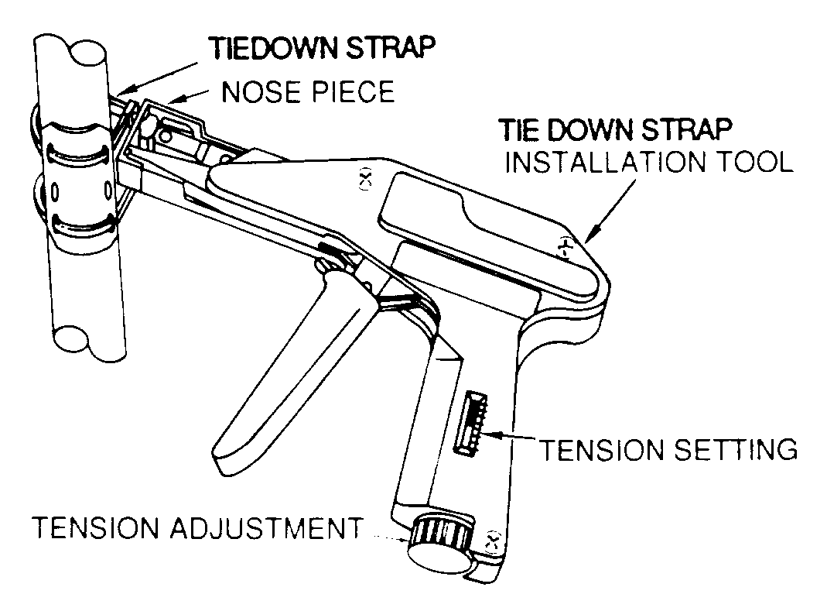
Figure 11-30. Tie-down strap installation tool.

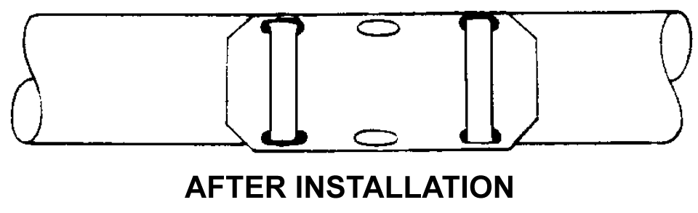
Figure 11-31. Completed installation.

TEMPORARY WIRE AND CABLE MARKING PROCEDURE. A temporary wire marking procedure follows but should be used only with caution and with plans for future permanence. (See figure 11-32.)

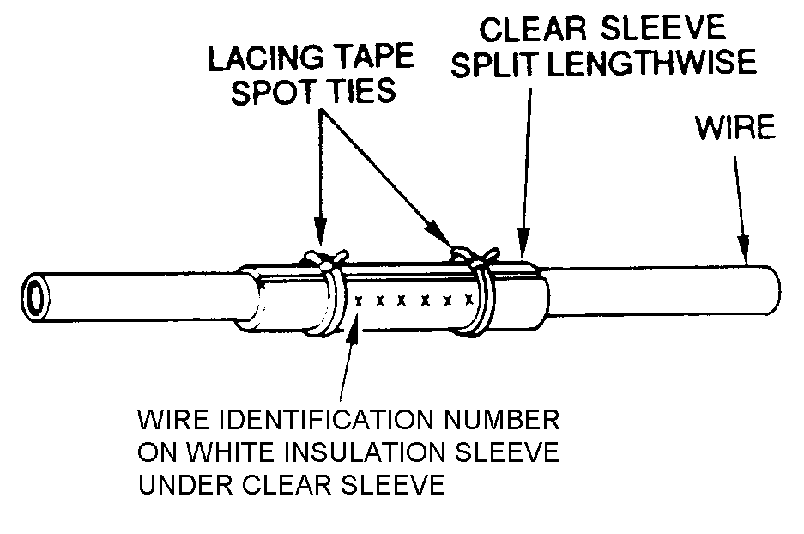
Figure 11-32. Temporary wire identification marker.

With a pen or a typewriter, write wire number on good quality white split insulation sleeve.

Trim excess white insulation sleeve, leaving just enough for one wrap around wire to be marked, with number fully visible.

Position marked white insulation sleeve on wire so that shielding, ties, clamps, or supporting devices need not be removed to read the number.

Obtain clear plastic sleeve that is long enough to extend 1/4 inch past white insulation sleeve marker edges and wide enough to overlap itself when wrapped around white insulation and wire.

Slit clear sleeve lengthwise and place around marker and wire.

Secure each end of clear sleeve with lacing tape spot tie to prevent loosening of sleeve.

MARKER SLEEVE INSTLATION AFTER PRINTING. The following general procedures apply:

Hold marker, printed side up, and press end of wire on lip of sleeve to open sleeve. (See figure 11-33.)

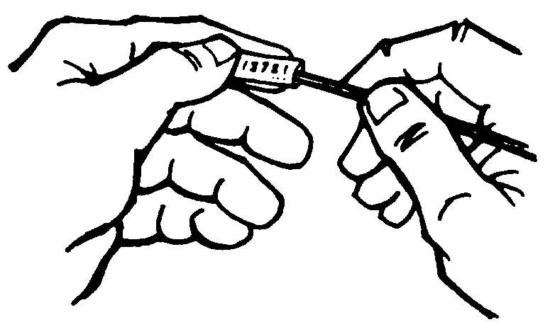
Figure 11-33. Inserting wire into marker.

If wire has been stripped, use a scrap piece of unstripped wire to open the end of the marker.

Push sleeve onto wire with a gentle twisting motion.

Shrink marker sleeve, using heat gun with shrink tubing attachment. (See figure 11-34.)

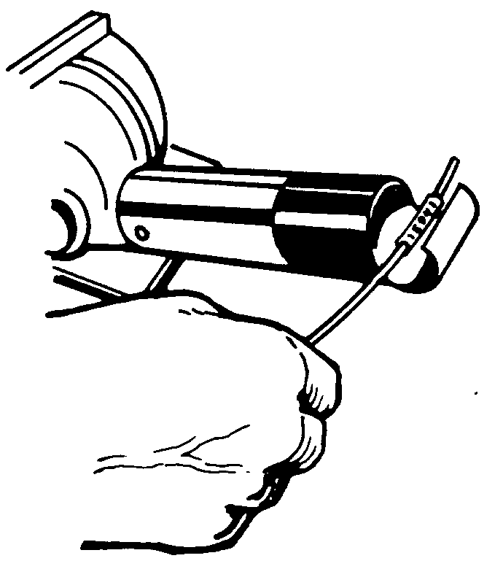
Figure 11-34. Shrinking marker on wire.
11-223.⎯11-229. [RESERVED.]

