Section 17. CONNECTORS

GENERAL. There is a multitude of types of connectors. Crimped contacts are generally used. Some of the more common are the round cannon type, the rectangular, and the module blocks. Environmental-resistant connectors should be used in applications subject to fluids, vibration, thermal, mechanical shock, and/or corrosive elements. When HIRF/Lightning protection is required, special attention should be given to the terminations of individual or overall shields. The number and complexity of wiring systems have resulted in an increased use of electrical connectors. The proper choice and application of connectors is a significant part of the aircraft wiring system. Connectors must be kept to a minimum, selected, and installed to provide the maximum degree of safety and reliability to the aircraft. For the installation of any particular connector assembly, the specification of the manufacturer or the appropriate governing agency must be followed.

SELECTION. . Connectors should be selected to provide the maximum degree of safety and reliability considering electrical and environmental requirements. Consider the size, weight, tooling, logistic, maintenance support, and compatibility with standardization programs. For ease of assembly and maintenance, connectors using crimped contacts are generally chosen for all applications except those requiring an hermetic seal. (Reference SAE ARP 1308, Preferred Electrical Connectors For Aerospace Vehicles and Associated Equipment.) A replacement connector of the same basic type and design as the connector it replaces should be used. With a crimp type connector for any electrical connection, the proper insertion, or extraction tool must be used to install or remove wires from such a connector. Refer to manufacturer or aircraft instruction manual. After the connector is disconnected, inspect it for loose soldered connections to prevent unintentional grounding. Connectors that are susceptible to corrosion difficulties may be treated with a chemically inert waterproof jelly.

TYPES OF CONNECTORS. Connectors must be identified by an original identification number derived from MIL Specification (MS) or OAM specification. Figure 11-35 provides some examples of MS connector types. Several different types are shown in figures 11-36 and 11-37.

Environmental Classes. Environment-resistant connectors are used in applications where they will probably be subjected to fluids, vibration, thermal, mechanical shock, corrosive elements, etc. Firewall class connectors incorporating these same features should, in addition, be able to prevent the penetration of the fire through the aircraft firewall connector opening and continue to function without failure for a specified period of time when exposed to fire. Hermetic connectors provide a pressure seal for maintaining pressurized areas. When EMI/RFI protection is required, special attention should be given to the termination of individual and overall shields. Backshell adapters designed for shield termination, connectors with conductive finishes, and EMI grounding fingers are available for this purpose.

Rectangular Connectors. The rectangular connectors are typically used in applications where a very large number of circuits are accommodated in a single mated pair. They are available with a great variety of contacts, which can include a mix of standard, coaxial, and large power types. Coupling is accomplished by various means. Smaller types are secured with screws which hold their flanges together. Larger ones have integral guide pins that ensure correct alignment, or jackscrews that both align and lock the connectors. Rack and panel connectors use integral or rack-mounted pins for alignment and box mounting hardware for couplings.

Module Blocks. These junctions accept crimped contacts similar to those on connectors. Some use internal busing to provide a variety of circuit arrangements. They are useful where a number of wires are connected for power or signal distribution.

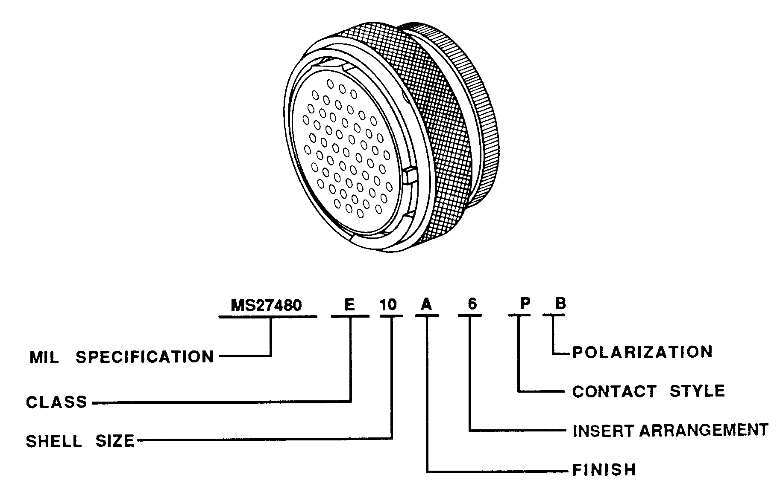

MS27472 WALL MOUNT RECEPTACLE
MS27473 STRAIGHT PLUG
MS27474 JAM NUT RECEPTACLE
MS27475 HERMITIC WALL MOUNT RECEPTACLE
MS27476 HERMETIC BOX MOUNT RECEPTACLE
MS27477 HERMETIC JAM NUT RECEPTACLE
MS27478 HERMETIC SOLDER MOUNT RECEPTACLE
MS27479 WALL MOUNT RECEPTACLE (NOTE 1)
MS27480 STRAIGHT PLUG (NOTE 1)
MS27481 JAM NUT RECEPTACLE (NOTE 1)
MS27482 HERMETIC WALL MOUNT RECEPTACLE (NOTE 1)
MS27483 HERMETIC JAM NUT RECEPTACLE (NOTE 1)
MS27484 STRAIGHT PLUG, EMI GROUNDING
MS27497 WALL RECEPTACLE, BACK PANEL MOUNTING
MS27499 BOX MOUNTING RECEPTACLE
MS27500 90° PLUG (NOTE 1)
MS27503 HERMETIC SOLDER MOUNT RECEPTACLE
(NOTE 1)
MS27504 BOX MOUNT RECEPTACLE (NOTE 1)
MS27508 BOX MOUNT RECEPTACLE, BACK PANEL
MOUNTING
MS27513 BOX MOUNT RECEPTACLE, LONG GROMMET
MS27664 WALL MOUNT RECEPTACLE, BACK PANEL
MOUNTING (NOTE 1)
MS27667 THRU-BULKHEAD RECEPTACLE

NOTE
1. ACTIVE | SUPERSEDES
MS27472 | MS27479
MS27473 | MS27480
MS27474 | MS27481
MS27475 | MS27482
MS27477 | MS27483
MS27473 WITH | MS27500
MS27507 ELBOW
MS27478 | MS27503
MS27499 | MS27504
MS27497 | MS27664
CLASS
E ENVIRONMENT RESISTING-BOX AND THRU-
BULKHEAD MOUNTING TYPES ONLY (SEE CLASS T)
P POTTING-INCLUDES POTTING FORM AND SHORT
REAR GROMMET
T ENVIRONMENT RESISTING-WALL AND JAM-NUT
MOUNTING RECEPTACLE AND PLUG TYPES: THREAD AND TEETH FOR ACCESSORY
ATTACHMENT
Y HERMETICALLY SEALED

FINISH
A SILVER TO LIGHT IRIDESCENT YELLOW COLOR
CADMIUM PLATE OVER NICKEL (CONDUCTIVE), -
65°C TO +150C° (INACTIVE FOR NEW DESIGN)
B OLIVE DRAB CADMIUM PLATE OVER SUITABLE
UNDERPLATE (CONDUCTIVE), -65°C TO +175°C
C ANODIC (NONCONDUCTIVE), -65°C TO +175°C
D FUSED TIN, CARBON STEEL (CONDUCTIVE),
-65°C TO 150°C
E CORROSION RESISTANT STEEL (CRES),
PASSIVATED (CONDUCTIVE), -65°C TO +200°C
F ELECTROLESS NICKEL COATING (CONDUCTIVE),
-65°C TO +200°C
N HERMETIC SEAL OR ENVIRONMENT RESISTING
CRES (CONDUCTIVE PLATING), -65°C TO +200°C
CONTACT STYLE
A WITHOUT PIN CONTACTS
B WITHOUT SOCKET CONTACTS
C FEED THROUGH
P PIN CONTACTS-INCLUDING HERMETICS WITH
SOLDER CUPS
S SOCKET CONTACTS-INCLUDING HERMETICS
WITH SOLDER CUPS
X PIN CONTACTS WITH EYELET (HERMETIC)
Z SOCKET CONTACTS WITH EYELET (HERMETIC)
POLARIZATION
A, B NORMAL-NO LETTER REQUIRED
C, OR
D

Figure 11-35. Connector information example.

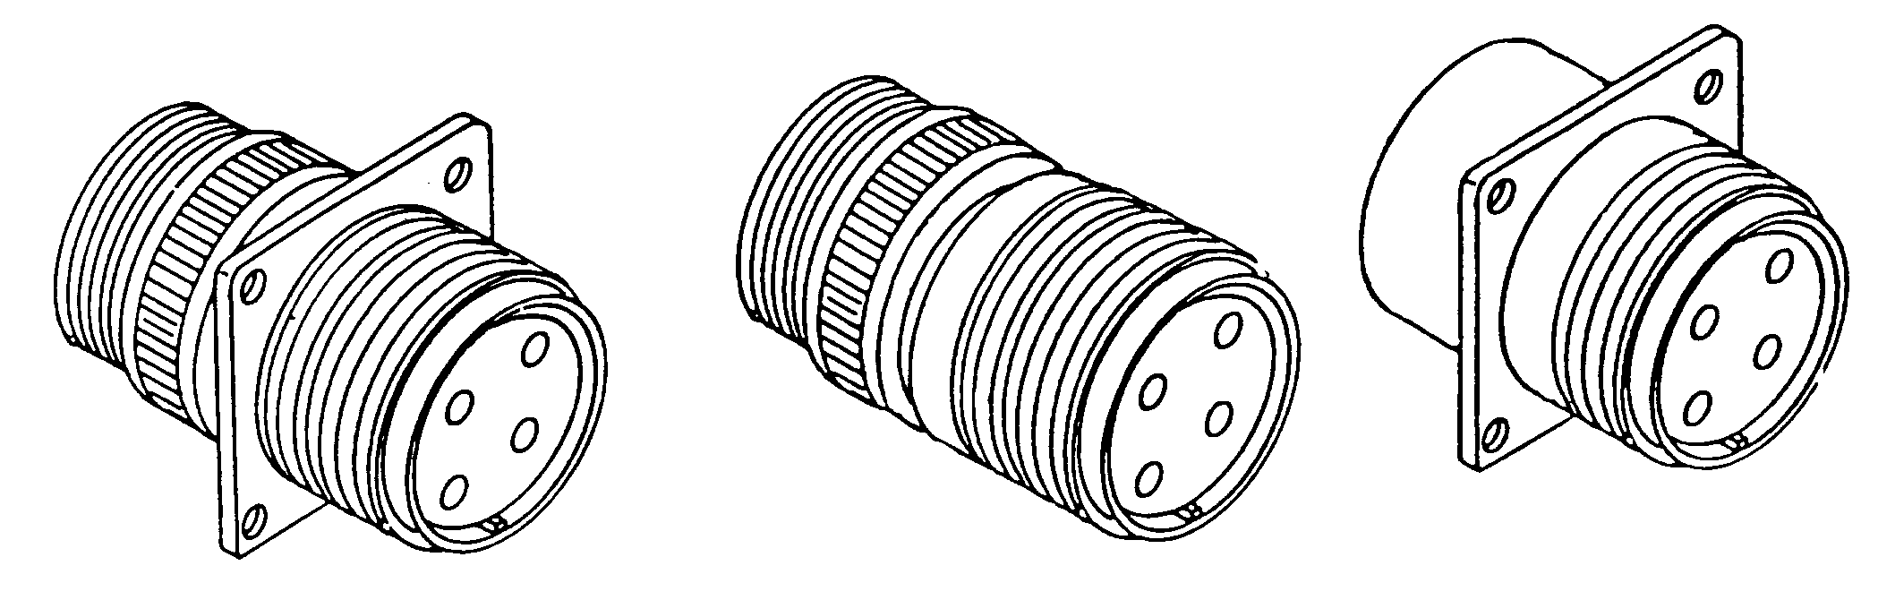
WALL CABLE BOX
RECEPTACLE RECEPTACLE RECEPTACLE
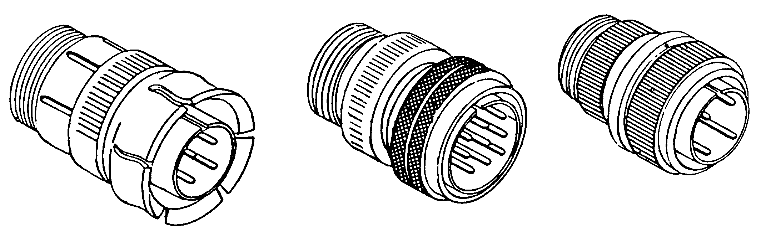
QUICK DISCONNECT STRAIGHT STRAIGHT
PLUG PLUG PLUG
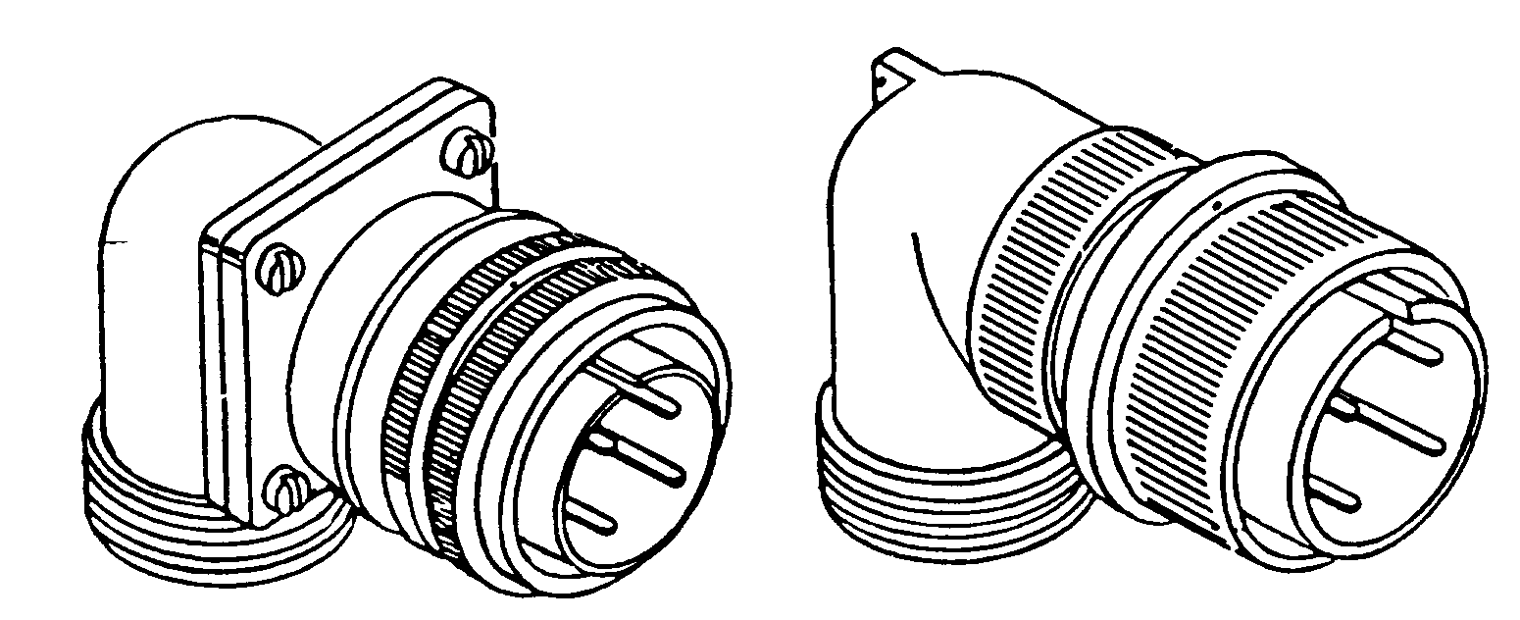
ANGLE PLUG ANGLE PLUG
MS CONNECTOR

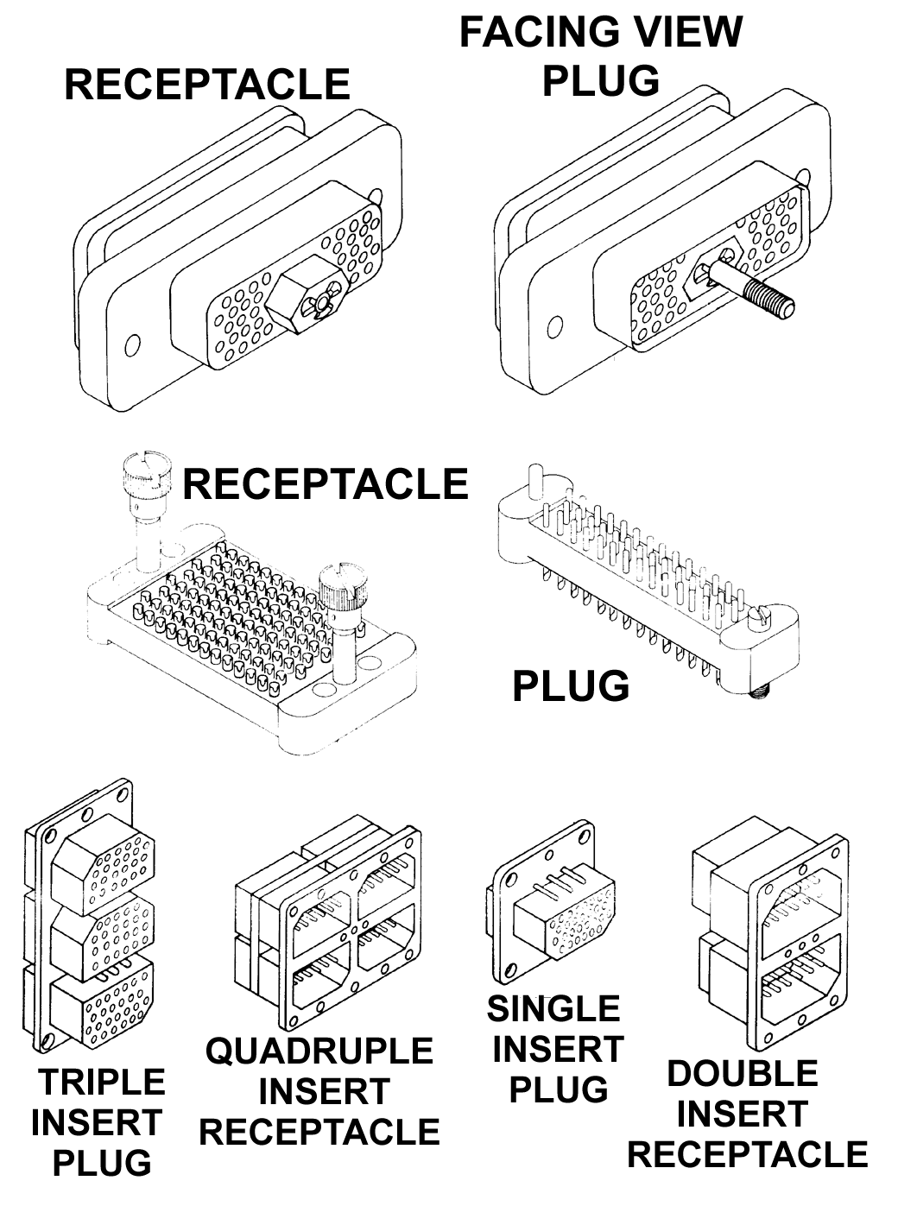
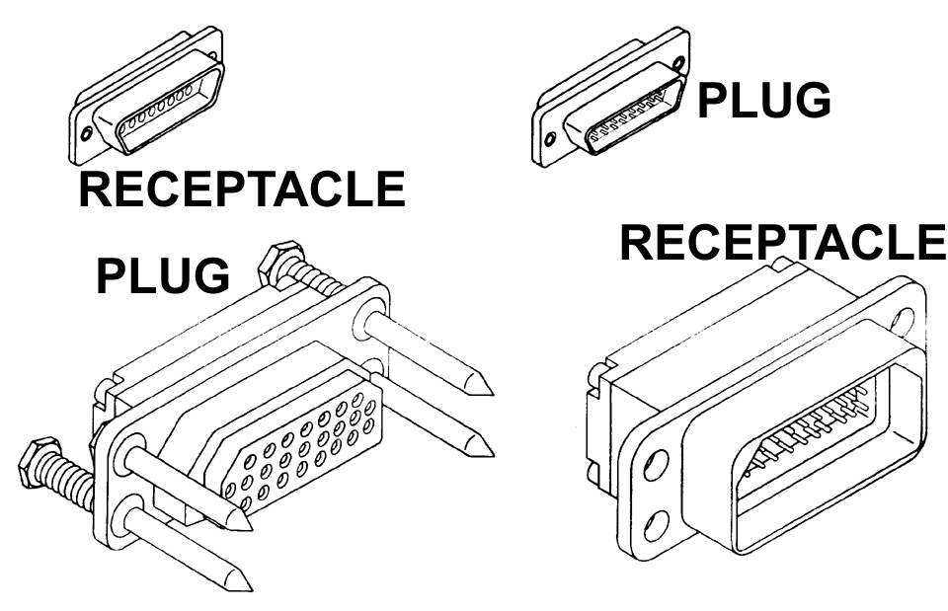
TYPICAL RACK AND PANEL CONNECTORS

Figure 11-36. Different types of connectors.

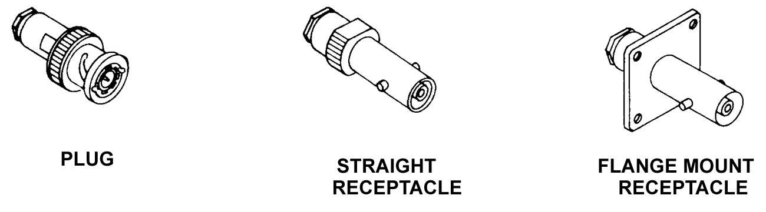
BNC Series Connectors
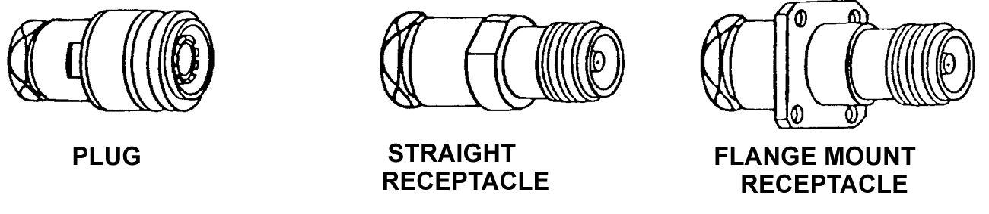
TNC Series Connectors
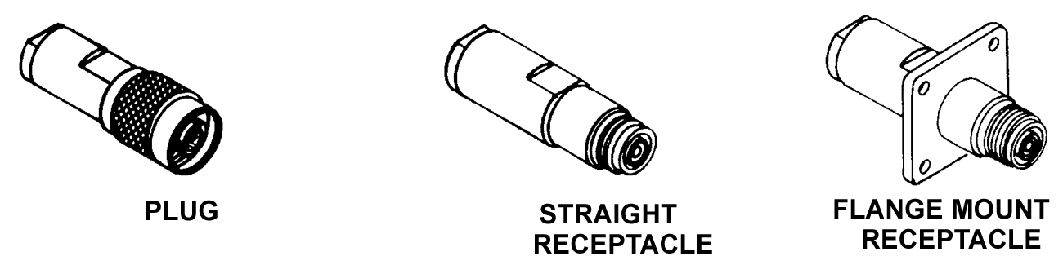
N Series Connectors
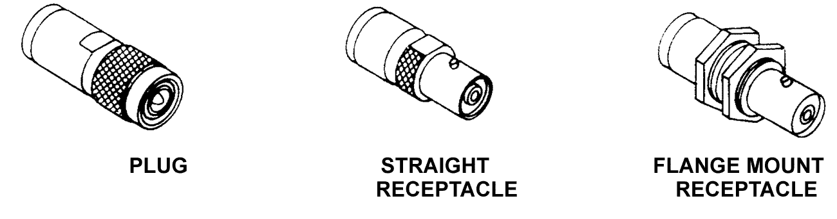
C Series Connectors
Figure 11-37. Coax cable connectors.

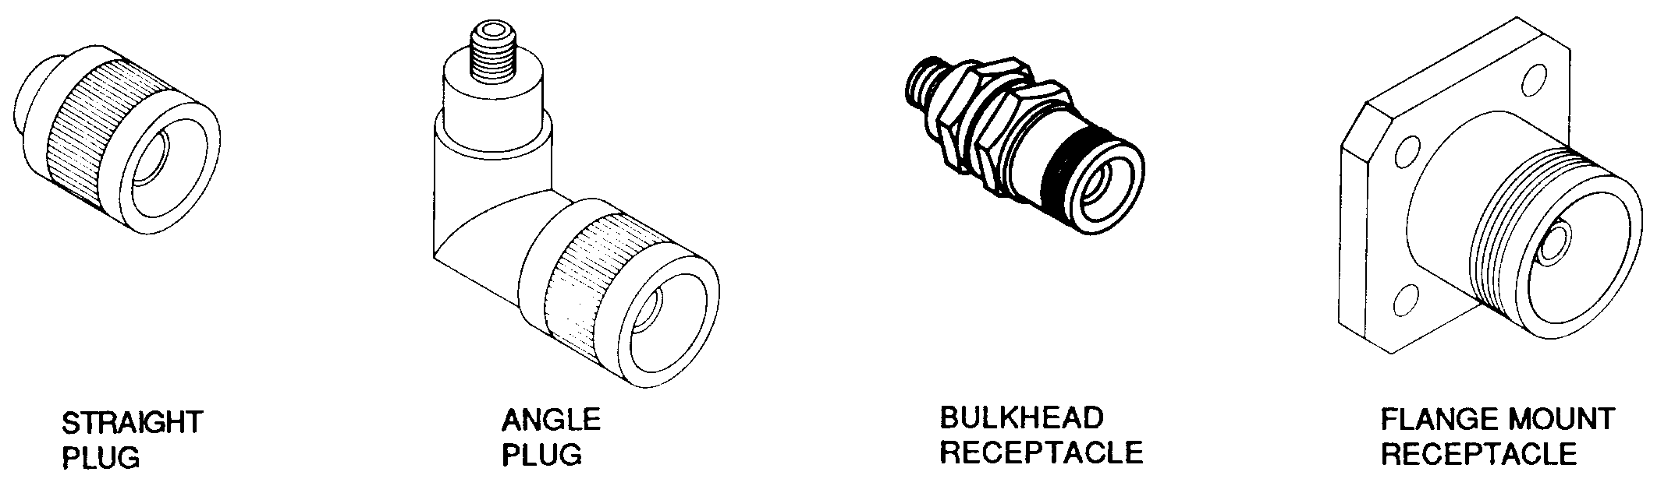
SC Series Connectors
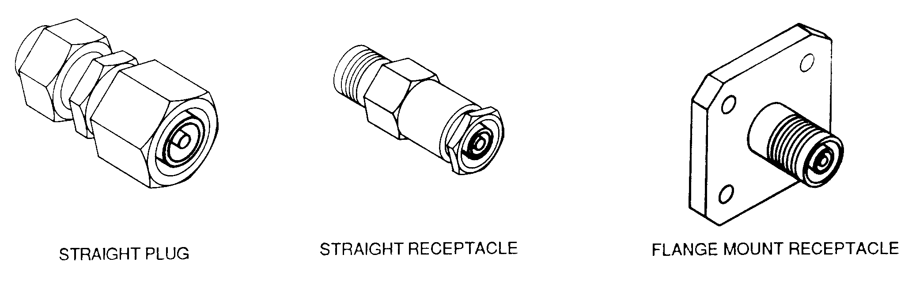
SMA Series Connectors
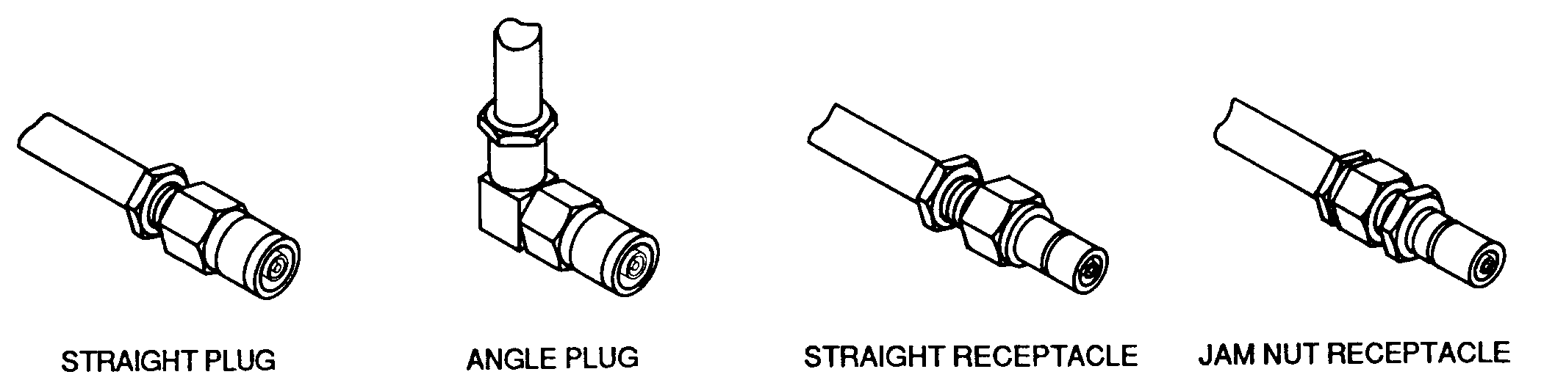
SMB Series Connectors
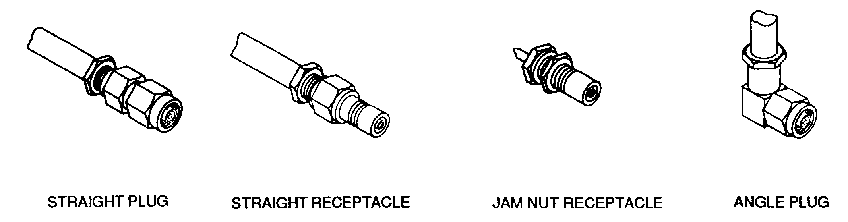
SMC Series Connectors
Figure 11-37. Coax cable connectors (continued).

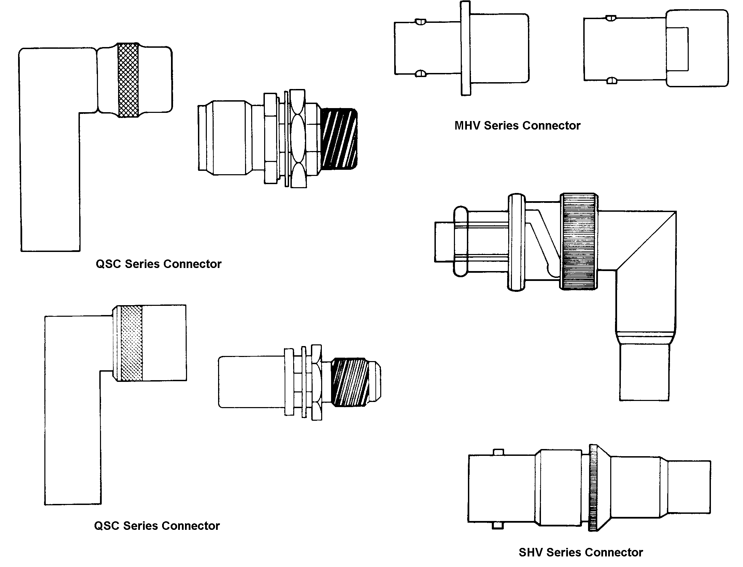
Figure 11-37. Coax cable connectors (continued).

When used as grounding modules, they save and reduce hardware installation on the aircraft. Standardized modules are available with wire end grommet seals for environmental applications and are track-mounted. Function module blocks are used to provide an easily wired package for environment-resistant mounting of small resistors, diodes, filters, and suppression networks. In-line terminal junctions are sometimes used in lieu of a connector when only a few wires are terminated and when the ability to disconnect the wires is desired. The in-line terminal junction is environment-resistant. The terminal junction splice is small and may be tied to the surface of a wire bundle when approved by the OAM.

VOLTAGE AND CURRENT RATING. Selected connectors must be rated for continuous operation under the maximum combination of ambient temperature and circuit current load. Hermetic connectors and connectors used in circuit applications involving high-inrush currents should be derated. It is good engineering practice to conduct preliminary testing in any situation where the connector is to operate with most or all of its contacts at maximum rated current load. When wiring is operating with a high conductor temperature near its rated temperature, connector contact sizes should be suitably rated for the circuit load. This may require an increase in wire size also. Voltage derating is required when connectors are used at high altitude in

nonpressurized areas. Derating of the connectors should be covered in the specifications.

SPARE CONTACTS (Future Wiring). To accommodate future wiring additions, spare contacts are normally provided. Locating the unwired contacts along the outer part of the connector facilitates future access. A good practice is to provide: Two spares on connectors with 25 or less contacts; 4 spares on connectors with 26 to 100 contacts; and 6 spares on connectors with more than 100 contacts. Spare contacts are not normally provided on receptacles of components that are unlikely to have added wiring. Connectors must have all available contact cavities filled with wired or unwired contacts. Unwired contacts should be provided with a plastic grommet sealing plug.

INSTALLATION.

Redundancy. Wires that perform the same function in redundant systems must be routed through separate connectors. On systems critical to flight safety, system operation wiring should be routed through separate connectors from the wiring used for system failure warning. It is also good practice to route a system’s indication wiring in separate connectors from its failure warning circuits to the extent practicable. These steps can reduce an aircraft’s susceptibility to incidents that might result from connector failures.

Adjacent Locations. Mating of adjacent connectors should not be possible. In order to ensure this, adjacent connector pairs must be different in shell size, coupling means, insert arrangement, or keying arrangement. When such means are impractical, wires should be routed and clamped so that incorrectly mated pairs cannot reach each other. Reliance on markings or color stripes is not recommended as they are likely to deteriorate with age.

Sealing. Connectors must be of a type that exclude moisture entry through the use of peripheral and interfacial seal that are compressed when the connector is mated. Moisture entry through the rear of the connector must be avoided by correctly matching the wire’s outside diameter with the connector’s rear grommet sealing range. It is recommended that no more than one wire be terminated in any crimp style contact. The use of heat-shrinkable tubing to build up the wire diameter, or the application of potting to the wire entry area as additional means of providing a rear compatibility with the rear grommet is recommended. These extra means have inherent penalties and should be considered only where other means cannot be used. Unwired spare contacts should have a correctly sized plastic plug installed. (See section 19.)

Drainage. Connectors must be installed in a manner which ensures that moisture and fluids will drain out of and not into the connector when unmated. Wiring must be routed so that moisture accumulated on the bundle will drain away from connectors. When connectors must be mounted in a vertical position, as through a shelf or floor, the connectors must be potted or environmentally sealed. In this situation it is better to have the receptacle faced downward so that it will be less susceptible to collecting moisture when unmated.

Wire Support. A rear accessory backshell must be used on connectors that are not enclosed. Connectors having very small size wiring, or are subject to frequent maintenance activity, or located in high-vibration areas must be provided with a strain-relief-type backshell. The wire bundle should be protected from mechanical damage with suitable cushion material where it is secured by the clamp. Connectors that are potted or have molded rear adapters do not normally use a
separate strain relief accessory. Strain relief clamps should not impart tension on wires between the clamp and contact.

Slack. Sufficient wire length must be provided at connectors to ensure a proper drip loop and that there is no strain on termination after a complete replacement of the connector and its contacts.

Identification. Each connector should have a reference identification that is legible throughout the expected life of the aircraft.

FEED-THROUGH BULKHEAD WIRE PROTECTION. Feed-through bushing protection should be given to wire bundles which pass through bulkheads, frames, and other similar structure. Feed-through bushings of hard dielectric material are satisfactory. The use of split plastic grommets (nylon) is recommended in lieu of rubber grommets in areas subject to fluids, since they eliminate the unsatisfactory features of rubber grommets and are resistant to fluids usually encountered in aircraft.

SPECIAL PURPOSE CONNECTOR. Many special-purpose connectors have been designed for use in aircraft applications, such as: subminiature connector, rectangular shell connector, connectors with short body shells, or connector of split-shell construction used in applications where potting is required. Make every attempt to identify the connector part number from the maintenance manual or actual part, and the manufacturer’s instruction used for servicing.

POTTING COMPOUNDS. Many types of potting compounds, both commercial and per military specifications, are available and offer various characteristics for different applications. Carefully consider the characteristics desired to ensure the use of the proper

compound. Preparation and storage of potting materials should receive special attention. Careful inspection and handling during all stages of the connector fabrication until the potting compound has fully cured is recommended. Potting compounds selected must not revert to liquid or become gummy or sticky due to high humidity or contact with chemical fluids.

Potting compounds meeting Specification MIL-S-8516 are prepared in ready-to-use tube-type dispensers and in the unmixed state, consisting of the base compound and an accelerator packed in paired containers. To obtain the proper results, it is important that the manufacturer’s instructions be closely followed.

Potting compounds normally cure at temperatures of 70 °F to 76 °F. If the mixed compound is not used at once, the working pot life (normally 90 minutes) can be prolonged by storing in a deep freeze at -20 °F for a maximum of 36 hours. The time factor starts from the instant the accelerator is added to the base compound and includes the time expended during the mixing and application processes.

Mixed compounds that are not to be used immediately should be cooled and thawed quickly to avoid wasting the short working life. Chilled compounds should be thawed by blowing compressed air over the outside of the container. Normally the compound will be ready for use in 5 to 10 minutes.

CAUTION: Do not use heat or blow compressed air into the container when restoring the compound to the working temperature.

POTTING CONNECTORS.
Connectors that have been potted primarily offer protection against concentration of

moisture in the connectors. A secondary benefit of potting is the reduced possibility of breakage between the contact and wire due to vibration.

Connectors specifically designed for potting compounds should be potted to provide environment resistance. An o-ring or sealed gasket should be included to seal the interface area of the mated connector. A plastic potting mold, that remains on the connector after the potting compounds have cured, should also be considered. To facilitate circuit changes, spare wires may be installed to all unused contacts prior to filling the connector with potting compound.

Connect wires to all contacts of the connector prior to the application of the potting compound. Wires that are not to be used should be long enough to permit splicing at a later date. Unused wires should be as shown in figure 11-38 and the cut ends capped with heat-shrinkable caps or crimped insulated end caps such as the MS 25274 prior to securing to

the wire bundle. Clean the areas to be potted with dry solvent and complete the potting operation within 2 hours after this cleaning. Allow the potting compound to cure for 24 hours at a room temperature of 70 °F to 75 °F or carefully placed in a drying oven at 100 °F for 3 to 4 hours. In all cases follow manufacturer’s instructions.

THROUGH BOLTS. Through bolts are sometimes used to make feeder connections through bulkheads, fuselage skin, or firewalls. Mounting plates for through bolts must be a material that provides the necessary fire barrier, insulation, and thermal properties for the application. Sufficient cross section should be provided to ensure adequate conductivity against overheating. Secure through bolts mechanically and independently of the terminal mounting nuts, taking particular care to avoid dissimilar metals among the terminal hardware. During inspection, pay particular attention to the condition of the insulator plate or spacer and the insulating boot that covers the completed terminal assembly.

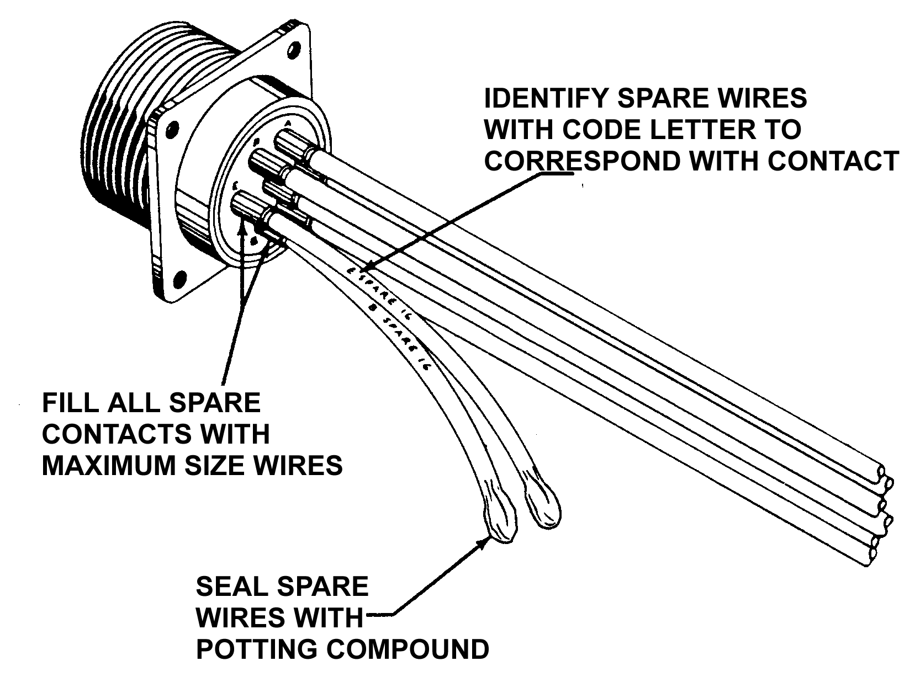

Figure 11-38. Spare wires for potting connector.
11-241.⎯11-247. [RESERVED.]

