Section 20. ELECTRICAL AND ELECTRONIC SYMBOLS

GENERAL. The electrical and electronic symbols shown here are those that are likely to be encountered by the aviation maintenance technician. They are in accordance with ANSI-Y32.2-1975.

SYMBOLS. Only those symbols associated with aircraft electrical and electronic wiring have been listed in general. Refer to ANSI-Y32.2-1975 for more specific detail on each symbol.

Table 11-27. Electronic/Electrical Symbols.
Symbol | Meaning
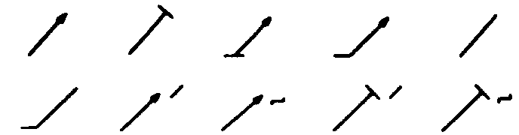 | Adjustability Variability
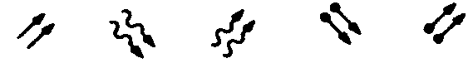 | Radiation Indicators
 | Physical State Recognition
 | Test-Point Recognition
 | Polarity Markings
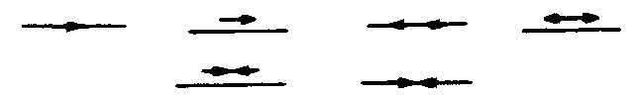 | Direction of Flow of Power, Signal, or Information
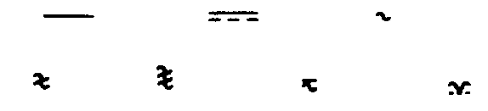 | Kind of Current
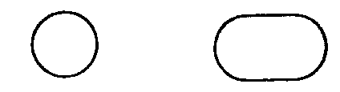 | Envelope Enclosure
 | Shield Shielding
 | Special Connector or Cable Indicator

Table 11-27. Electronic/Electrical Symbols (continued).
Symbol | Meaning
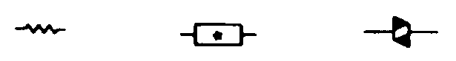 | Resistor
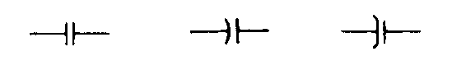 | Capacitor
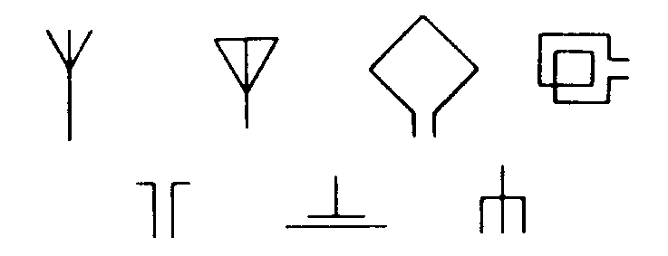 | Antenna
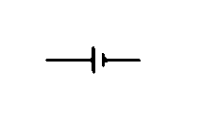 | Battery
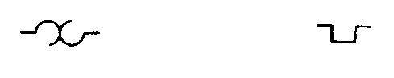 | Thermal Element Thermomechanical Transducer
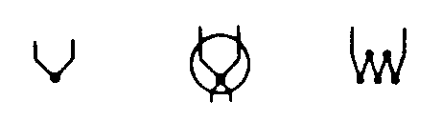 | Thermocouple
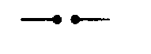 | Spark gap Ignitor gap
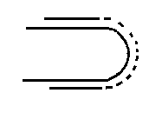 | Continuous Loop Fire Detector (temperature sensor)
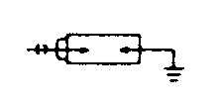 | Ignitor Plug

Table 11-27. Electronic/Electrical Symbols (continued).
Symbol | Meaning
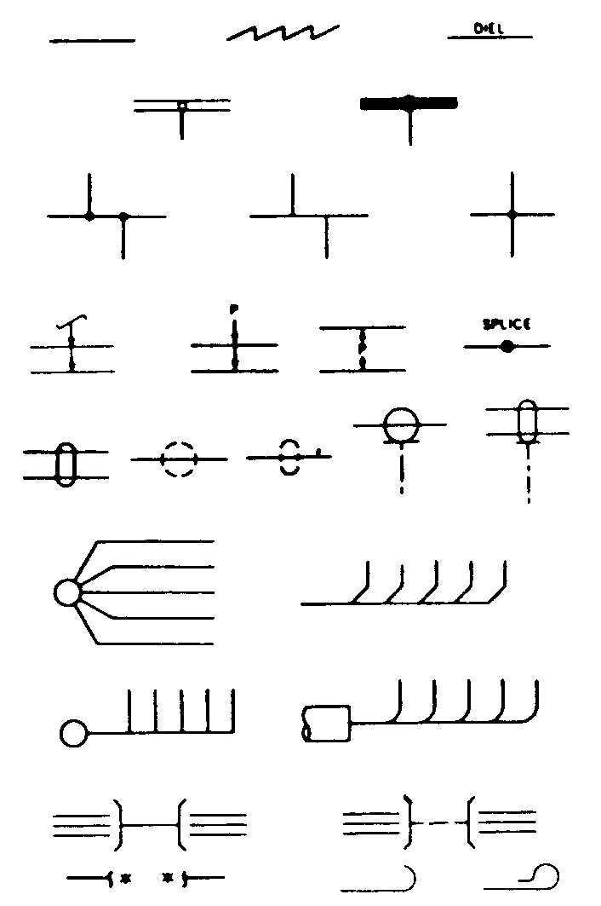 | Transmission Patch  Conductor  Cable  Wiring
Distribution Lines
Transmission lines
 | Alternative or Conditioned Wiring
 | Associated or Future

Table 11-27. Electronic/Electrical Symbols (continued).
Symbol | Meaning
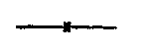 | Intentional Isolation of Direct-Current Path in Coaxial or  Waveguide Applications
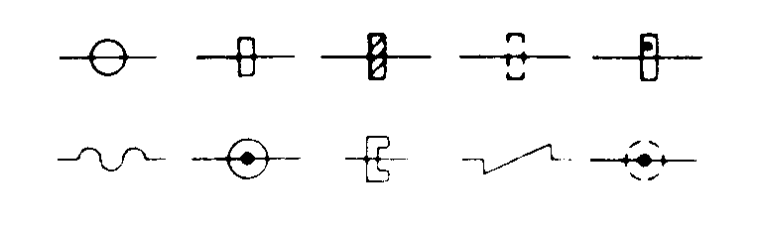 | Waveguide
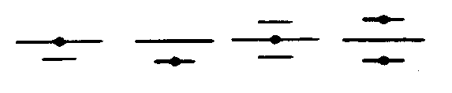 | Strip-Type Transmission Line
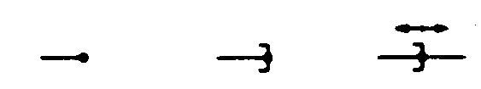 | Termination
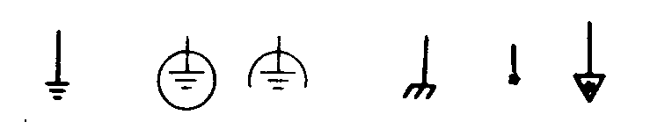 | Circuit Return
 | Pressure-Tight Bulkhead Cable  Gland  Cable Sealing End
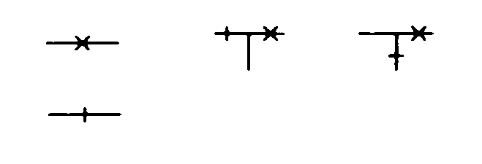 | Switching Function
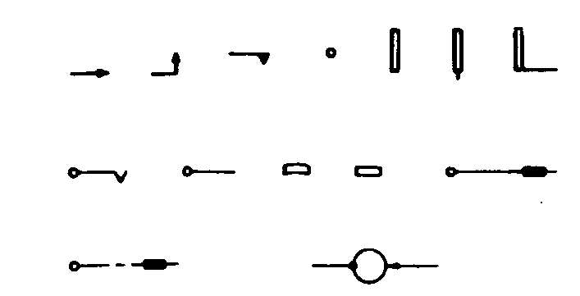 | Electrical Contact

Table 11-27. Electronic/Electrical Symbols (continued).
Symbol | Meaning
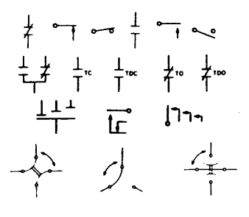 | Basic Contact Assemblies
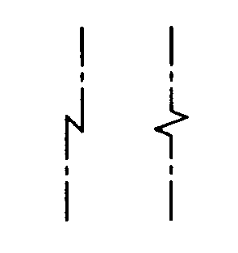 | Magnetic Blowout Coil
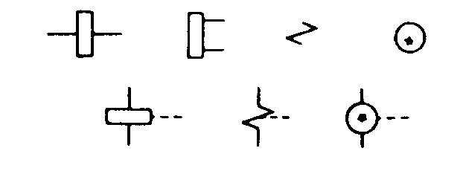 | Operating Coil  Relay Coil
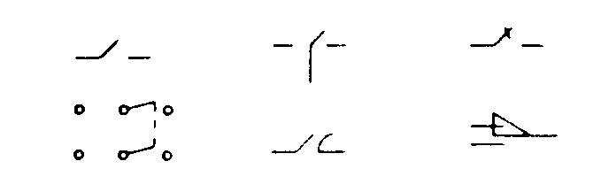 | Switch
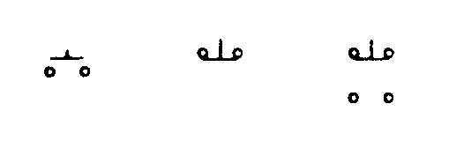 | Pushbutton, Momentary, or Spring-Return

Table 11-27. Electronic/Electrical Symbols (continued).
Symbol | Meaning
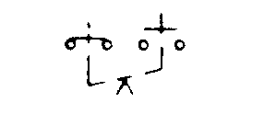 | Two-Circuit, Maintained, or Not Spring-Return
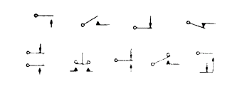 | Nonlocking Switching, Momentary, or Spring-Return
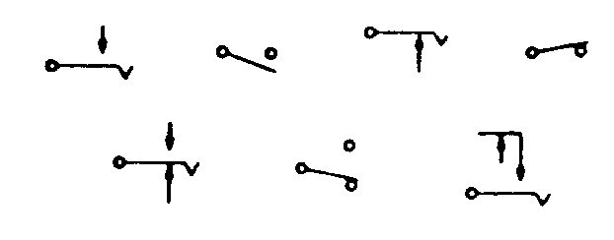 | Locking Switch
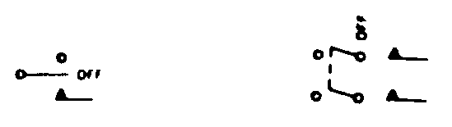 | Combination Locking and Nonlocking Switch
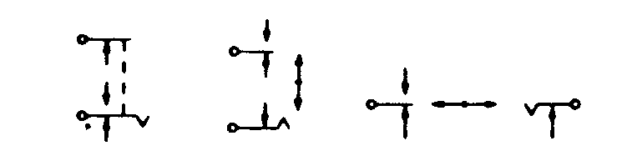 | Key-Type Switch  Lever Switch

Table 11-27. Electronic/Electrical Symbols (continued).
Symbol | Meaning
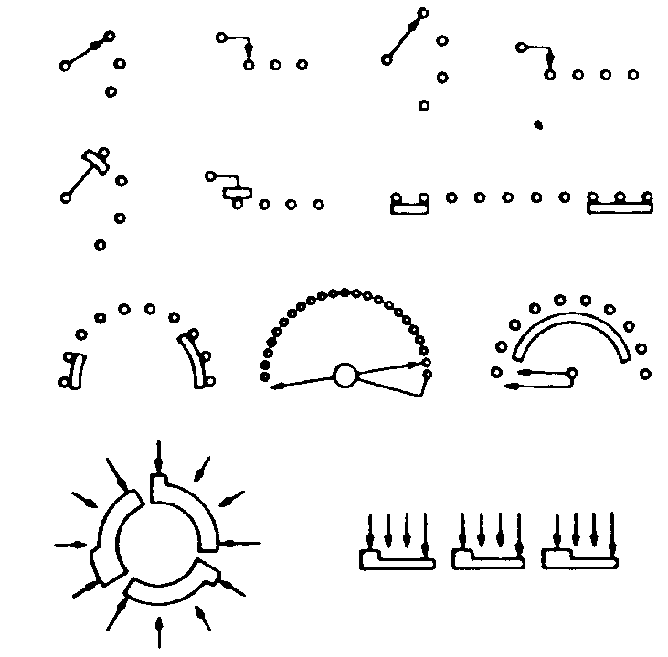 | Selector or Multiposition Switch
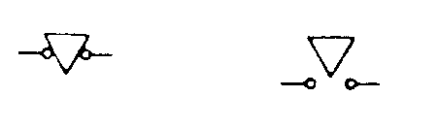 | Safety Interlock
Limit Switch
Sensitive Switch
 | Switches with Time-Delay Feature
 | Flow-Actuated Switch

Table 11-27. Electronic/Electrical Symbols (continued).
Symbol | Meaning
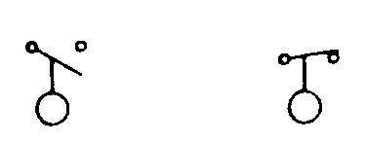 | Liquid-Level Actuated Switch
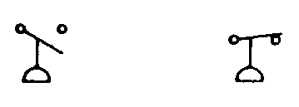 | Pressure- or Vacuum-Actuated Switch
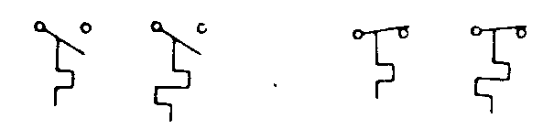 | Temperature-Actuated Switch
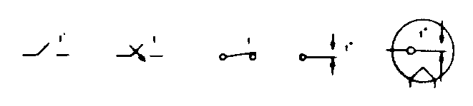 | Thermostat
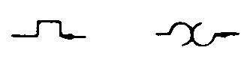 | Flasher  Self-interrupting Switch
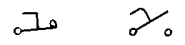 | Foot-Operated Switch  Foot Switch
 | Switch Operated by Shaft Rotation and Responsive to Speed or Direction
 | Switches with Specific Features

Table 11-27. Electronic/Electrical Symbols (continued).
Symbol | Meaning
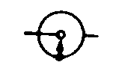 | Governor  speed regulator
 | Relay
 | Inertia Switch
 | Mercur Switch
 | Terminals

Table 11-27. Electronic/Electrical Symbols (continued).
Symbol | Meaning
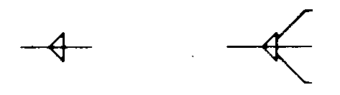 | Cable Termination
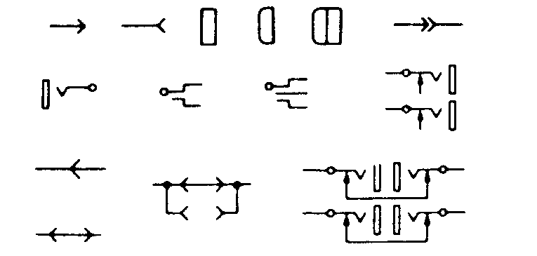 | Connector  Disconnecting Device
 | Connectors of the Type Commonly Used for Power-Supply Purposes
 | Test Blocks
 | Coaxial Connector
Waveguide Flanges
Waveguide Junction

Table 11-27. Electronic/Electrical Symbols (continued).
Symbol | Meaning
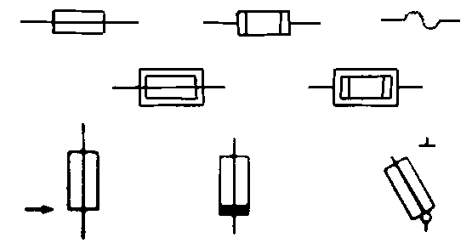 | Fuse
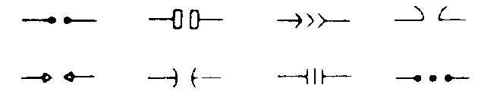 | Lightning Arrester  Arrester  Gap
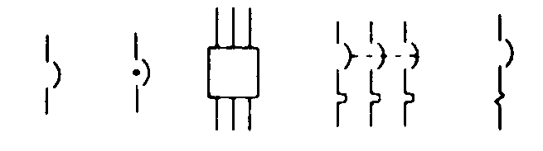 | Circuit Breaker
 | Protective Relay
 | Audible-Signaling Device
 | Microphone

Table 11-27. Electronic/Electrical Symbols (continued).
Symbol | Meaning
Handset
Operator’s Set
 | Lamp
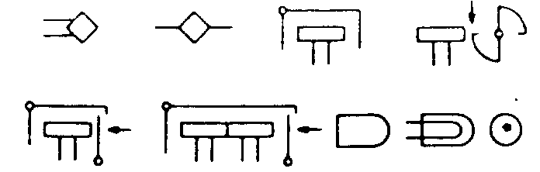 | Visual-Signaling Device
Mechanical Connection
Mechanical Interlock
 | Mechanical Motion
 | Clutch Brake

Table 11-27. Electronic/Electrical Symbols (continued).
Symbol | Meaning
 | Manual Control
Gyro
Gyroscope
Gyrocompass
 | Position Indicator
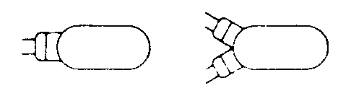 | Fire Extinguisher Actuator Head
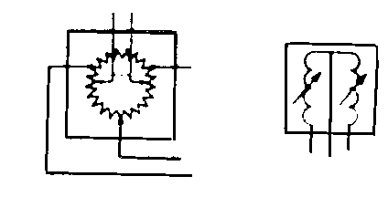 | Position Transmitter
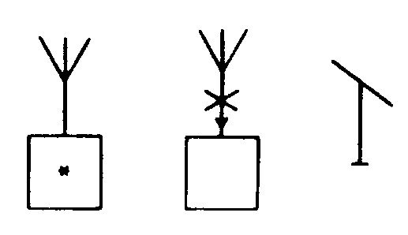 | Radio Station
 | Space Station
 | Integrated Circuit
 | Amplifiers
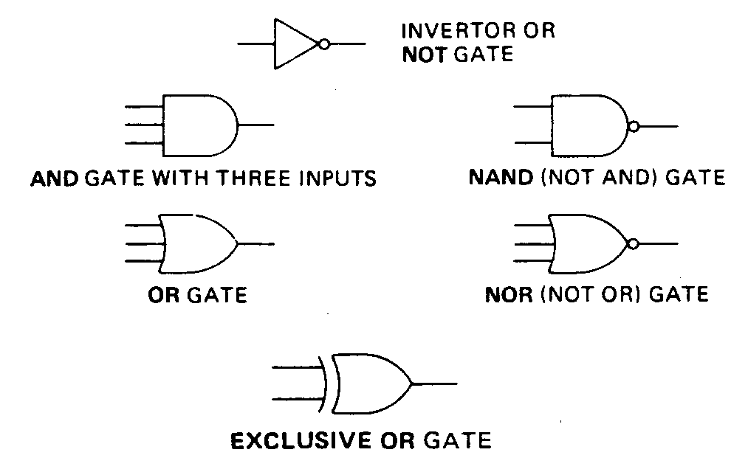 | Logic Gates
 | Diode
 | Transistor Symbols

11-273.⎯11-283. [RESERVED.]

