SECtion 3. GROUND OPERATIONAL CHECKS FOR AVIONICS EQUIPMENT (NON ELECTRICAL)

COMPASS SWING must be performed whenever any ferrous component of the system (i.e. flux valve compensator, or Standby Compass) is installed, removed, repaired, or a new compass is installed. The magnetic compass can be checked for accuracy by using a compass rose located on an airport. The compass swing is normally effected by placing the aircraft on various magnetic headings and comparing the deviations with those on the deviation cards. Refer to CFR14, 23.1327, 14 CFR 23.1547, and the equipment or aircraft manufacturer's manual.

A compass swing must be performed on the following occasions:

When the accuracy of the compass is suspected.

After any cockpit modification or major replacement involving ferrous metal.

Whenever a compass has been subjected to a shock; for example, after a hard landing or turbulence.

After aircraft has passed through a severe electrical storm.

After lighting strike.

Whenever a change is made to the electrical system.

Whenever a change of cargo is likely to affect the compass.

When an aircraft operation is changed to a different geographic location with a major change in magnetic deviation. (e.g., from Miami, Florida to Fairbanks, Alaska.)

After aircraft has been parked on one heading for over a year.

When flux valves are replaced.

Precautions.

The magnetic compass must be checked for accuracy in a location free of steel structures, underground pipes or cables, or equipment that produces magnetic fields.

Personnel engaged in the compensation of the compass shall remove all magnetic or ferrous material from their possession.

Use only nonmagnetic tools when adjusting the compass.

Position the aircraft at least 100 yards from any metal object.

All equipment in the aircraft having any magnetic effect on the compass must be secured in the position occupied in normal flight.

Compass Swing Procedures.

Have the aircraft taxied to the NORTH (0°) radial on the Compass Rose. Use a hairline sight compass (a reverse reading compass with a gun sight arrangement mounted on top of it) to place the aircraft in the general vicinity. With the aircraft facing North and the person in the cockpit running the engine(s) at 1000 rpm, a mechanic, standing approximately 30 feet in front of the aircraft and facing South, “shoots” or aligns the master compass with the aircraft center line. Using hand signals, the mechanic signals the person in the cockpit to make additional adjustments to align the aircraft with the master compass. Once aligned on the heading, the person in the cockpit runs the engine(s) to approximately 1,700 rpm to duplicate the aircraft’s magnetic field and then the person reads the compass.

Note: (1) For conventional gear aircraft, the mechanic will have to position the magnetic compass in the straight and level position or mount the tail of the aircraft on a moveable dolly to simulate a straight and level cruise configuration. (2) Remember the hairline sight compass is only intended to be used as a general piece of test equipment.

If the aircraft compass is not in alignment with the magnetic North of the master compass, correct the error by making small adjustments to the North-South brass adjustment screw with a nonmetallic screw driver (made out of brass stock, or stainless steel welding rod). Adjust the N-S compensator screw until the compass reads North (0°). Turn the aircraft until it is aligned with the East-West, pointing East. Adjust the E-W compensator screw until it reads 90°. Continue by turning the aircraft South 180° and adjust the N-S screw to remove one-half of the South’s heading error. This will throw the North off, but the total North-South should be divided equally between the two headings. Turn the aircraft until it is heading West 270°, and adjust the E-W screw on the compensator to remove one-half of the West error. This should divide equally the total E-W error. The engine(s) should be running.

With the aircraft heading West, start your calibration card here and record the magnetic heading of 270° and the compass reading with the avionics/electrical systems on then off. Turn the aircraft to align with each of the lines on the compass rose and record the compass reading every 30°. There should be not more than a plus or minus 10° difference between any of the compass’ heading and the magnetic heading of the aircraft.

If the compass cannot be adjusted to meet the requirements, install another one.

Note: A common error that affects the compass’ accuracy is the mounting of a compass or instruments on or in the instrument panel using steel machine screws/nuts rather than brass hardware, magnetized control yoke, structural tubing, and improperly routed electrical wiring, which can cause unreasonable compass error.

If the aircraft has an electrical system, two complete compass checks should be performed, one with minimum electrical equipment operating and the other with all electrical accessories on (e.g. radios, navigation, radar, and lights). If the compass readings are not identical, the mechanic should make up two separate compass correction cards, one with all the equipment on and one with the equipment off.

When the compass is satisfactorily swung, fill out the calibration card properly and put it in the holder in full view for the pilot’s reference.

Standby (wet) Compass. Adjustment and compensation of the Standby Compass may also be accomplished by using the “compass swing” method.

PNEUMATIC GYROS.

Venturi Systems. The early gyro instruments were all operated by air flowing out of a jet over buckets cut into the periphery of the gyro rotor. A venturi was mounted on the outside of the aircraft to produce a low pressure, or vacuum, which evacuated the instrument case, and air flowed into the instrument through a paper filter and then through a nozzle onto the rotor.

Venturi systems have the advantage of being extremely simple and requiring no power from the engine, nor from any of the other aircraft systems; but they do have the disadvantage of being susceptible to ice, and when they are most needed, they may become unusable.

There are two sizes of venturi tubes: those which produce four inches of suction are used to drive the attitude gyros, and smaller tubes, which produce two inches of suction, are used for the turn and slip indicator. Some installations use two of the larger venturi tubes connected in parallel to the two attitude gyros, and the turn and slip indicator is connected to one of these instruments with a needle valve between them. A suction gage is temporarily connected to the turn and slip indicator, and the aircraft is flown so the needle valve can be adjusted to the required suction at the instrument when the aircraft is operated at its cruise speed. (See figure 12-1.)

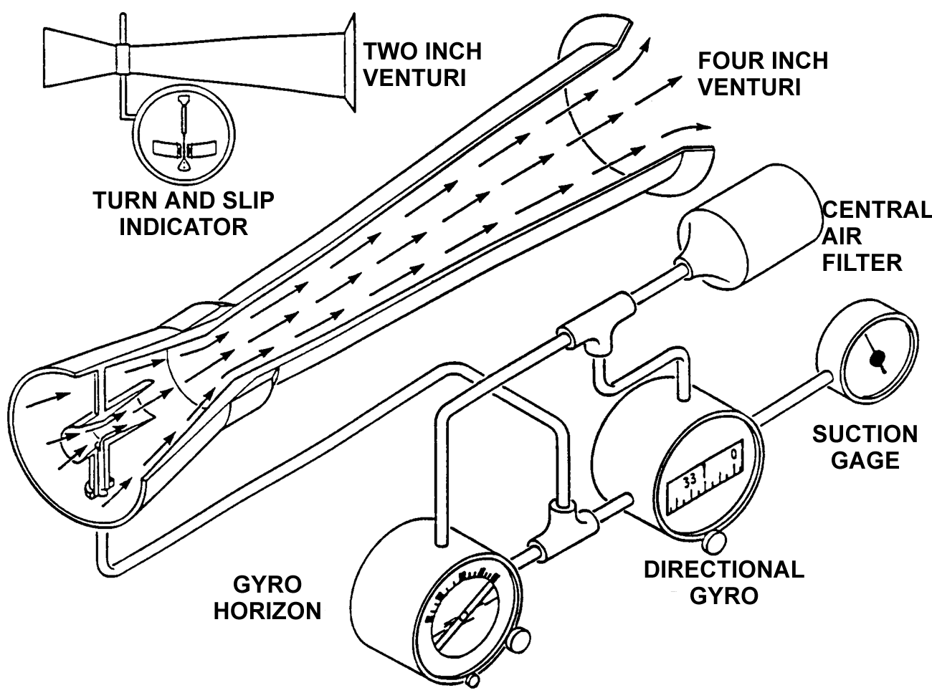
Figure 12-1. Venturi system for providing airflow through gyro instruments.

Vacuum Pump Systems. In order to overcome the major drawback of the venturi tube, that is, its susceptibility to ice, aircraft were equipped with engine driven vacuum pumps and the gyro instruments were driven by air pulled through the instrument by the suction produced by these pumps. A suction relief valve maintained the desired pressure (usually about four inches of mercury) on the attitude gyro instruments, and a needle valve between one of the attitude indicators and the turn and slip indicator restricted the airflow to maintain the desired 2 inches of suction in its case. Most of the early instruments used only paper filters in each of the instrument cases, but in some installations a central air filter was used to remove contaminants from the cabin air before it entered the instrument case.

The early vacuum pumps were vane-type pumps of what is called the wet type-one with a cast iron housing and steel vanes. Engine oil was metered into the pump to provide sealing, lubrication, and cooling, and then this oil, along with the air, was blown through an oil separator where the oil collected on baffles and was returned to the engine crankcase. The air was then exhausted overboard. Aircraft equipped with rubber deicer boots used this discharge air to inflate the boots. But before it could be used, this air was passed through a second stage of oil separation and then to the distributor valve and finally to the boots. (See figure 12-2.)

The airflow through the instruments is controlled by maintaining the suction in the instrument case at the desired level with a suction relief valve mounted between the pump and the instruments. This valve has a spring-loaded poppet that offsets to allow cabin air to enter the pump and maintain the correct negative pressure inside the instrument case.

The more modern vacuum pumps are of the dry type. These pumps use carbon vanes and do not require any lubrication, as the vanes provide their own lubrication as they wear away at a carefully predetermined rate. Other than the fact that they do not require an oil separator, systems using dry air pumps are quite similar to those using a wet pump. One slight difference, however, is in the need for keeping the inside of the pump perfectly clean. Any solid particles drawn into the system through the suction relief valve can damage one of the carbon vanes, and this can lead to destruction of the pump, as the particles broken off of one vane will damage all of the other vanes. To prevent particles entering the relief valve, its air inlet is covered with a filter, and this must be cleaned or replaced at the interval recommended by the aircraft manufacturer.

Positive Pressure Systems. Above about 18,000 feet there is not enough mass to the air drawn through the instruments to provide sufficient rotor speed, and, to remedy this problem, many aircraft that fly at high altitude use positive pressure systems to drive the gyros. These systems use the same type of air pump as is used for vacuum systems, but the discharged air from the pump is filtered and directed into the instrument case through the same fitting that receives the filtered air when the vacuum system is used. A filter is installed on the inlet of the pump, and then, before the air is directed into the instrument case, it is again filtered. A pressure regulator is located between the pump and the in-line filter to control the air pressure so only the correct amount is directed into the instrument case.

System Filters. The life of an air-driven gyro instrument is determined to a great extent by the cleanliness of the air that flows over the rotor. In vacuum systems, this air is taken

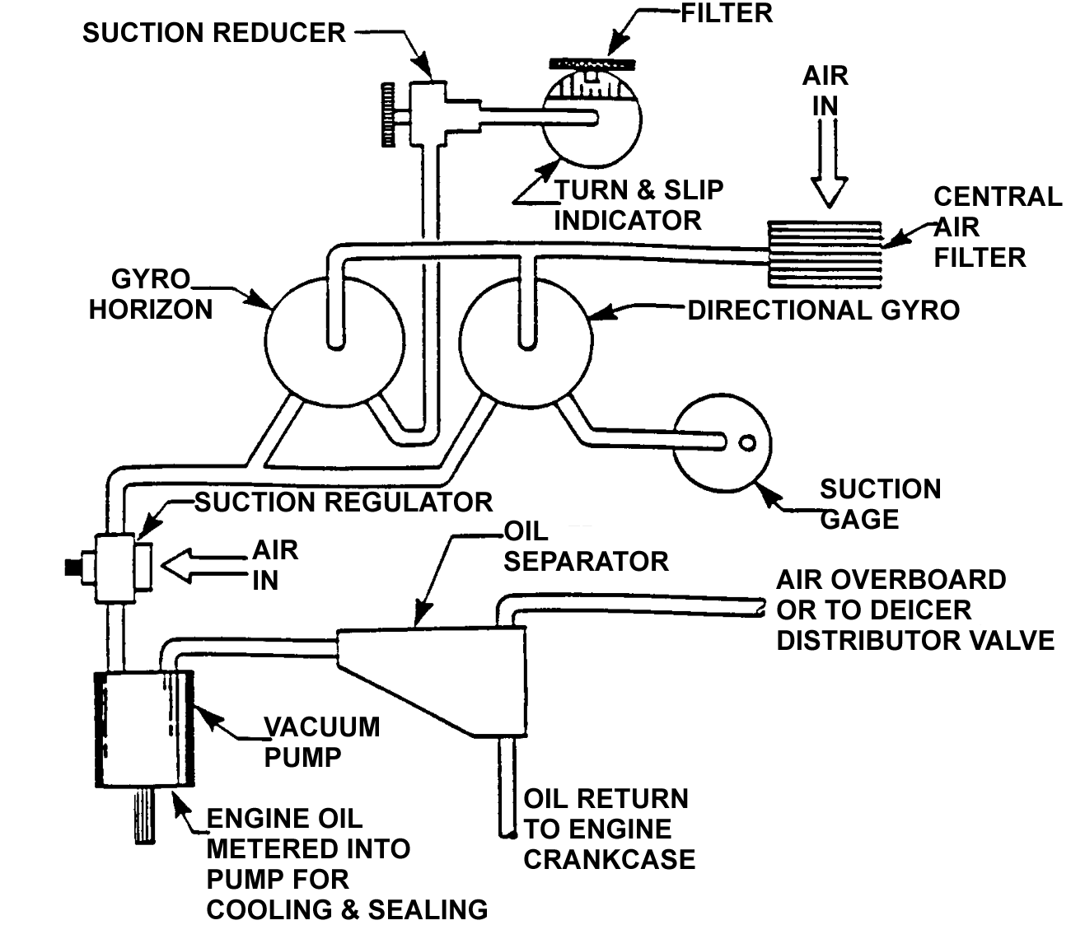

Figure 12-2. Instrument vacuum system using a wet-type vacuum pump.

from the cabin where there is usually a good deal of dust and very often tobacco smoke. Unless all of the solid contaminants are removed from the air before it enters the instrument, they will accumulate, usually in the rotor bearings, and slow the rotor. This causes an inaccurate indication of the instrument and will definitely shorten its service life. Dry air pumps are also subject to damage from ingested contaminants, and all of the filters in the system must be replaced on the schedule recommended by the aircraft manufacturer, and more often if the aircraft is operated under particularly dusty conditions, especially if the occupants of the aircraft regularly smoke while flying. (See figures 12-3 and 12-4.)

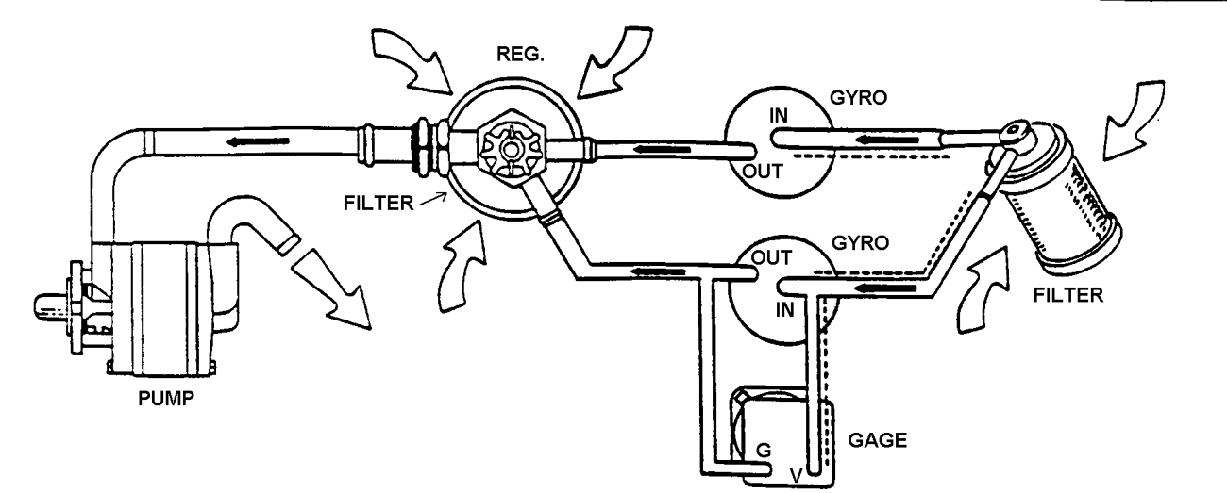
Figure 12-3. Instrument vacuum system using a dry-type air pump.

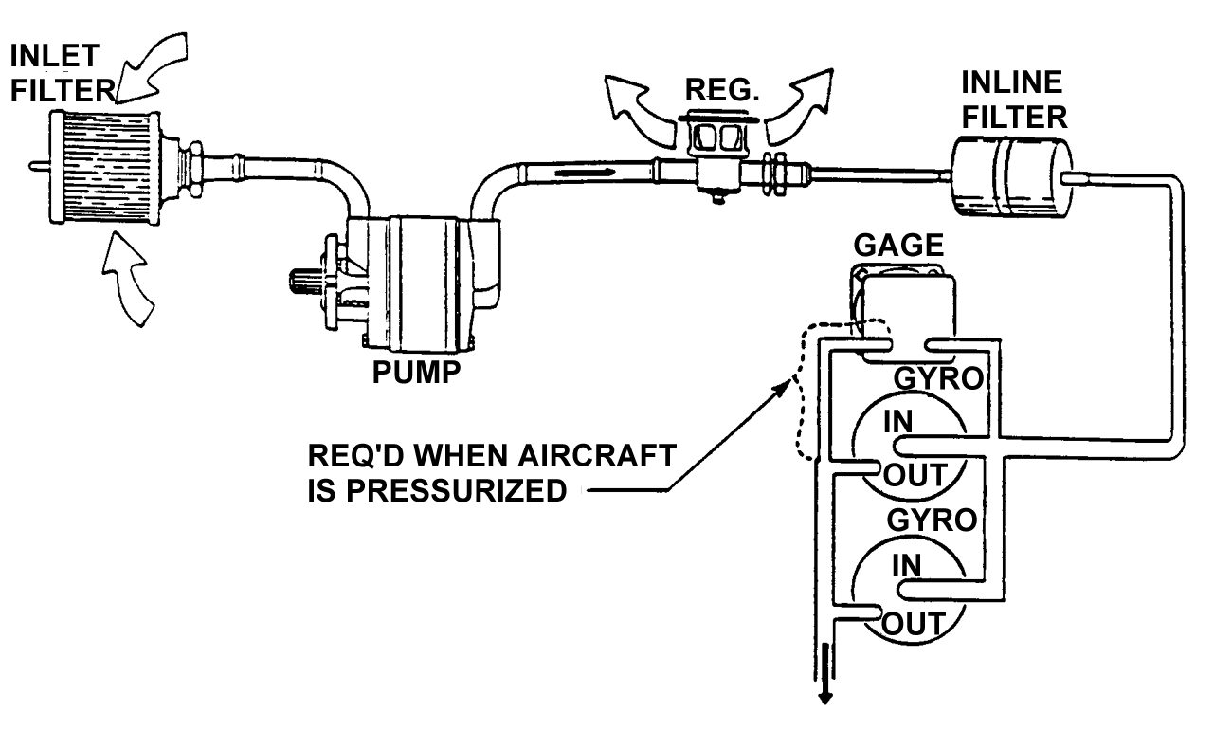
Figure 12-4. Instrument pressure system using a dry-type air pump.

12-39.⎯12-50. [RESERVED.]

