Section 4. PITOT/STATIC SYSTEMS

GENERAL. In order for the pitot-static instruments to work properly, they must be connected into a system that senses the impact air pressure with minimum distortion and picks up undisturbed static air pressure.

Pitot pressure is ram air pressure picked up by a small open-ended tube about a ¼-inch in diameter that sticks directly into the air stream that produces a pressure proportional to the speed of the air movement. Static pressure is the pressure of the still air used to measure the altitude and serves as a reference in the measurement of airspeed.

Airspeed requires pitot, altimeter, rate of climb, and transponder-required static.

SYSTEM COMPONENTS. The conventional design of the pitot system consists of pitot-static tubes or pitot tubes with static pressure parts and vents, lines, tubing, water drains and traps, selector valves, and various pressure-actuated indicators or control units such as the altimeter, airspeed and rate-of-climb indicators, and the encoding altimeter connected to the system. (See figure 12-5.)
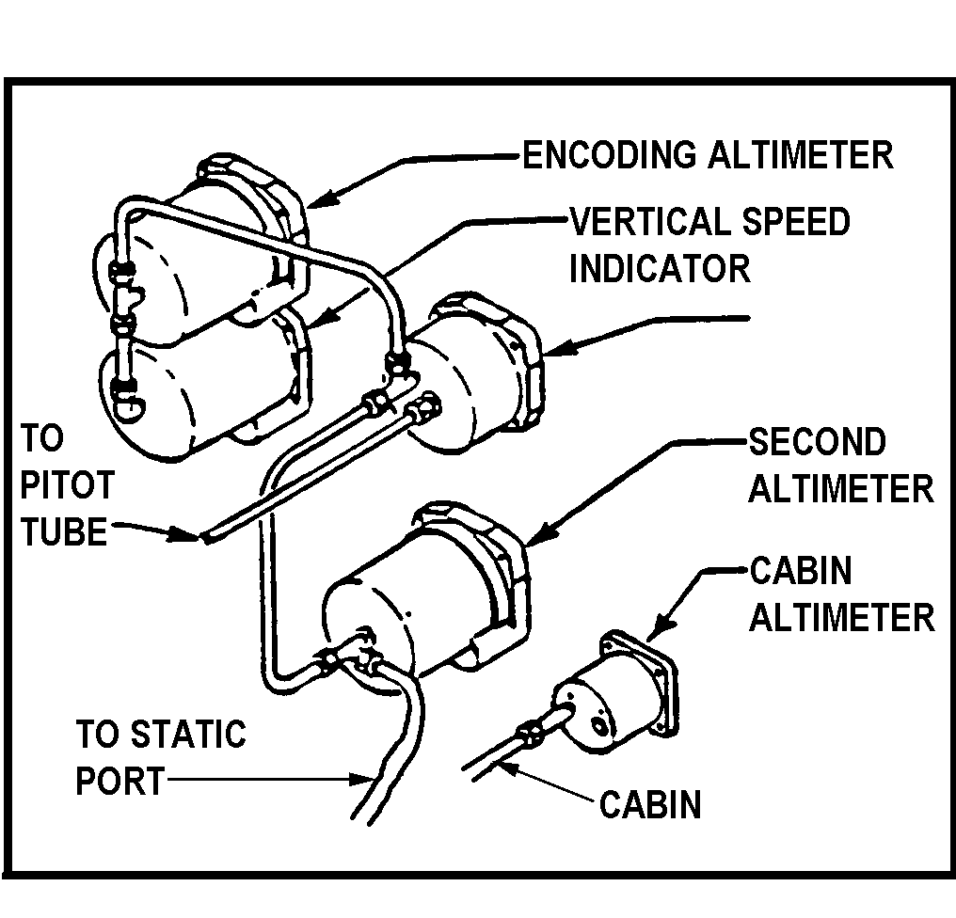
Figure 12-5. Pitot/static system for a small aircraft.

PITOT/STATIC TUBES AND LINES. The pitot tube (see figure 12-6) is installed at the leading edge of the wing of a single-engine aircraft, outside the propeller slipstream or on the fuselage of a multiengine aircraft with the axis parallel to the longitudinal axis of the aircraft, unless otherwise specified by the manufacturer.

STATIC PORTS AND VENTS (more modern trend) should be mounted flush with fuselage skin. One port is located on either side of the fuselage, usually behind the cabin.

Inspect for elevation or depression of the port or vent fitting. Such elevation or depression may cause airflow disturbances at high speeds and result in erroneous airspeed and altitude indications.

HEATER ELEMENTS. A heating element is located within the tube head to prevent the unit from becoming clogged during icing conditions experienced during flight. A switch in the cockpit controls the heater. Some pitot-static tubes have replaceable heater elements while others do not. Check the heater element or the entire tube for proper operation by noting either ammeter current or that the tube or port is hot to the touch. (See figure 12-6.)

SYSTEM INSPECTION.

Inspect air passages in the systems for water, paint, dirt or other foreign matter. If water or obstructive material has entered the system, all drains should be cleaned. Probe the drains in the pitot tube with a fine wire to remove dirt or other obstructions. The bottom static openings act as drains for the head’s static chamber. Check these holes at regular intervals to preclude system malfunctioning.

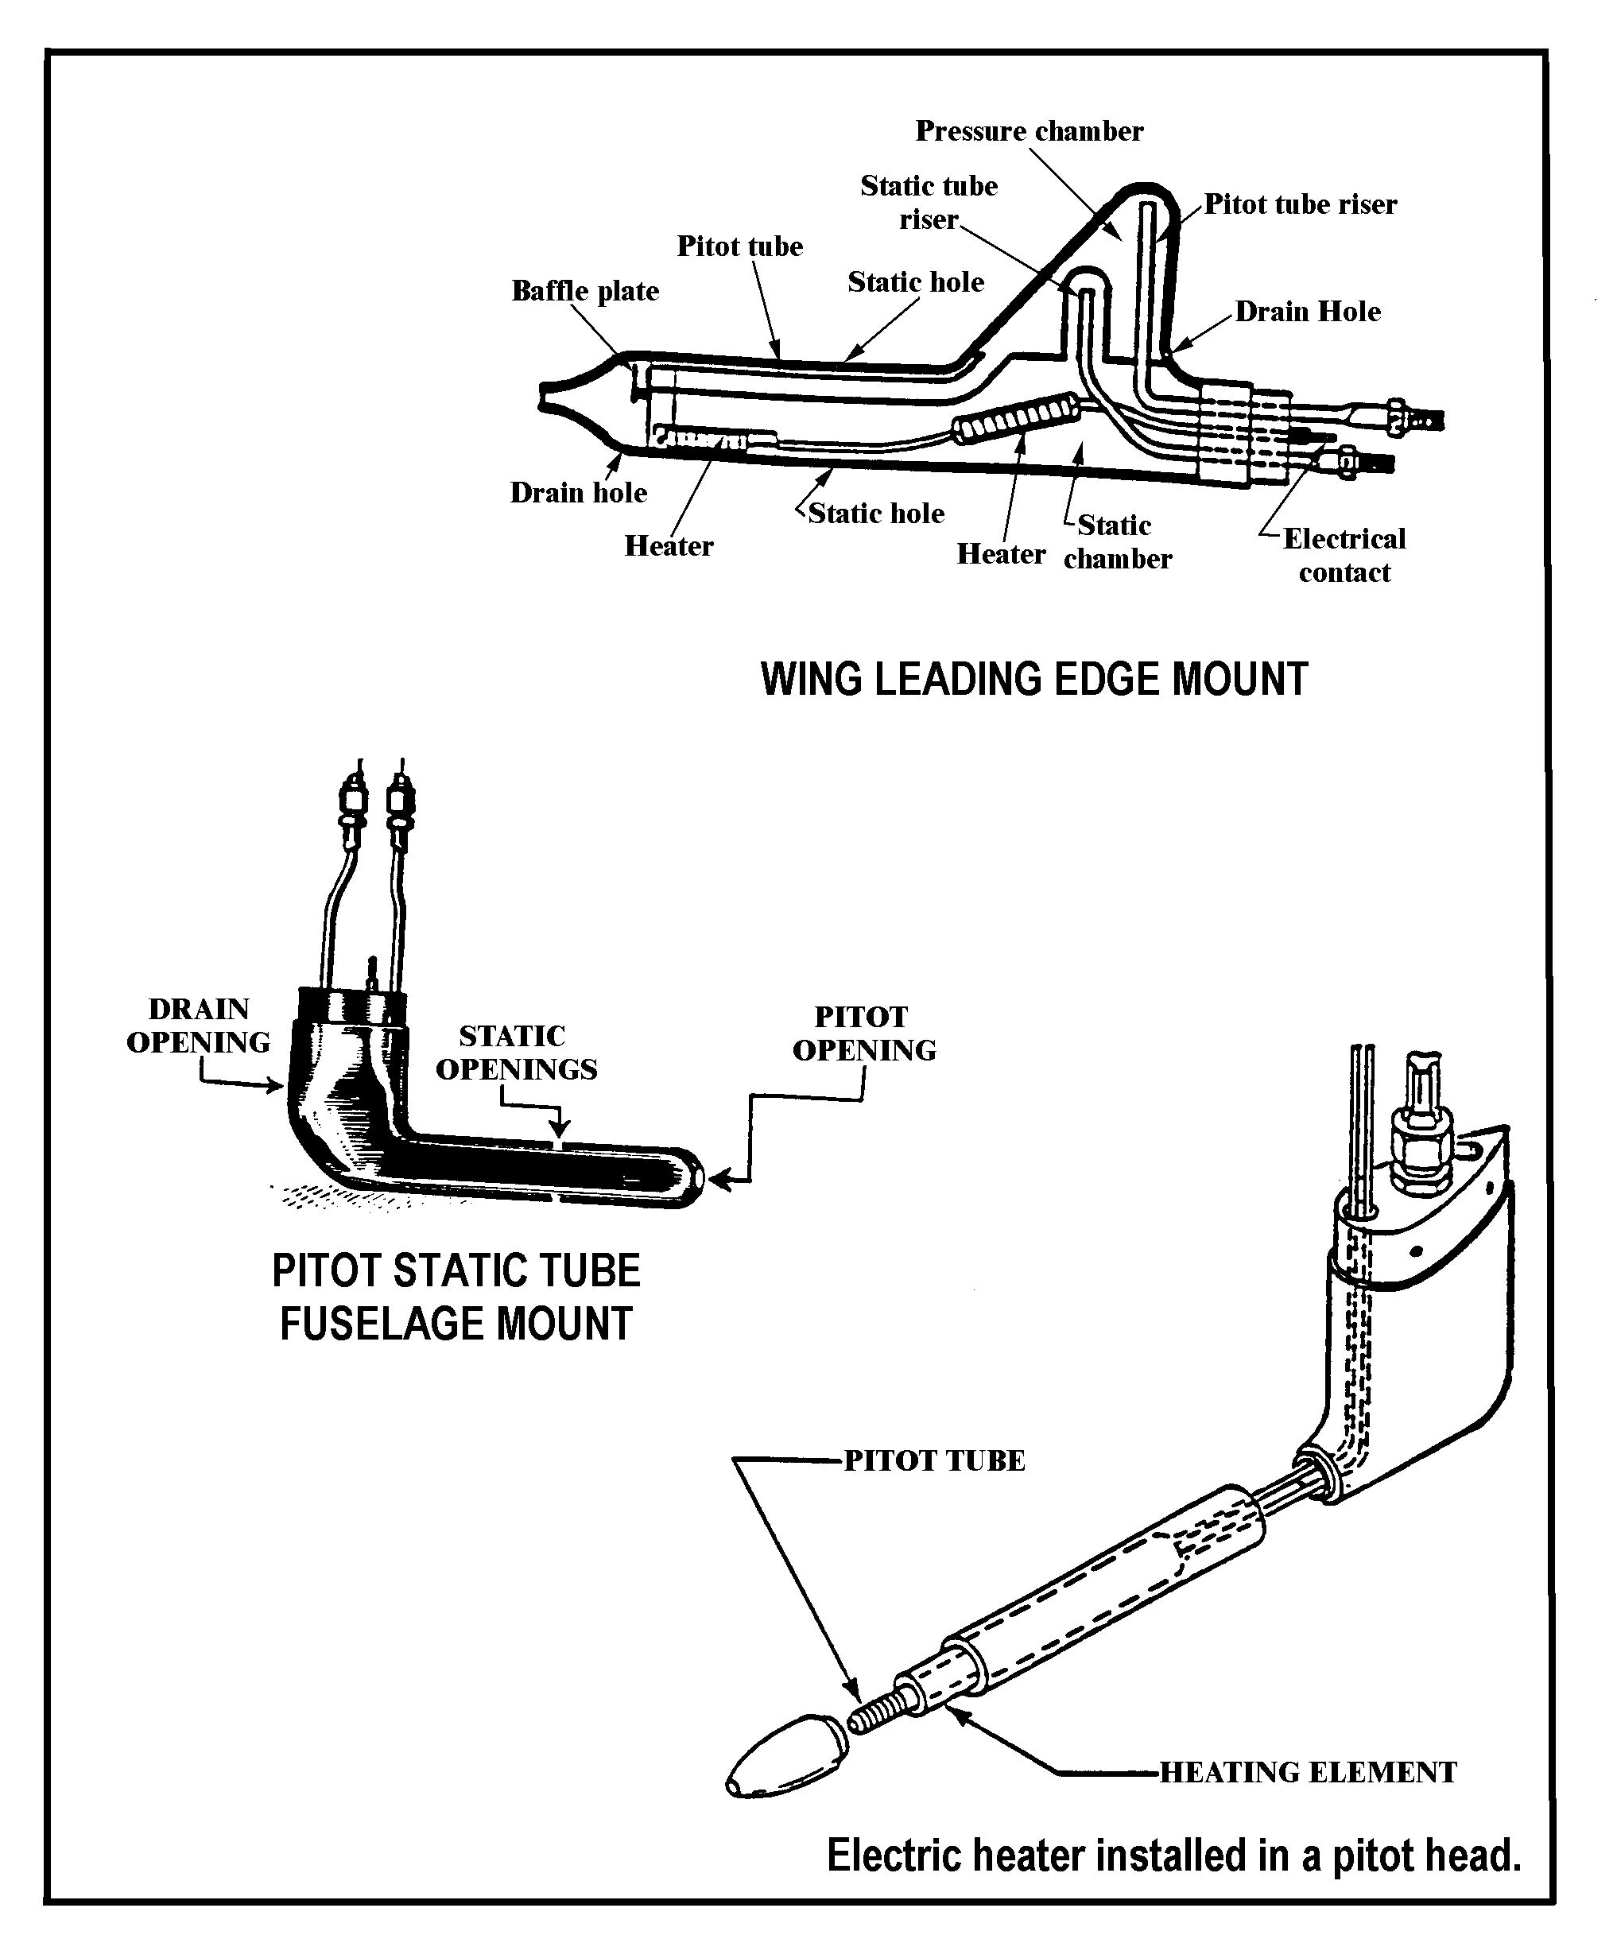
Figure 12-6. Pitot/Static Tube Head

Check to ensure the water drains freely. If a problem is experienced with the pitot-static system drainage or freezing at altitude, and the tubing diameter is less than 3/8-inch, replace it with larger tubing.

Check the pitot tube for corrosion.

The pitot probe should not have any corrosion within ½-inch of the probe tip.

Make sure there is no flaking which forms pits and irregularities in the surface of the tube.

NOTE: It is essential that the static air system be drained after the airplane has been exposed to rain.

SYSTEM LEAK TEST.

Pitot-static leak tests should be made with all instruments connected to assure that no leaks occur at instrument connections. Such tests should be accomplished whenever a connection has been loosened or an instrument replaced.

After the conclusion of the leak test, return the system to its normal flying configuration. Remove tape from static ports and pitot drain holes and replace the drain plug.

STATIC SYSTEM TESTS must comply with the static system tests required by 14 CFR 91.411 and be performed by an appropriately-rated repair station with the appropriate test equipment.

If the manufacturer has not issued instructions for testing static systems, the following may be used:

Connect the test equipment directly to the static ports, if practicable. Otherwise, connect to a static system drain or tee connection and seal off the static ports. If the test equipment is connected to the static system at any point other than the static port, it should be made at a point where the connection may be readily inspected for system integrity. Observe maintenance precautions given in paragraph 12-60 of this section.

Do not blow air through the line toward the instrument panel. This may seriously damage the instruments. Be sure to disconnect the instrument lines so no pressure can reach the instruments.

Apply a vacuum equivalent to 1,000 feet altitude, (differential pressure of approximately 1.07 inches of mercury or 14.5 inches of water) and hold.

After 1 minute, check to see that the leak has not exceeded the equivalent of 100 feet of altitude (decrease in differential pressure of approximately 0.0105 inches of mercury or 1.43 inches of water).

TEST PITOT SYSTEM in accordance with the aircraft manufacturer’s instructions. If the manufacturer has not issued in-

structions for testing pitot systems, the following may be used:

Seal the drain holes and connect the pitot pressure openings to a tee to which a source of pressure and manometer or reliable indicator is connected.

Restrain hoses that can whip due to applied pressure.

Apply pressure to cause the airspeed indicator to indicate 150 knots (differential pressure 1.1 inches of mercury or 14.9 inches of water), hold at this point and clamp off the source of pressure. After 1 minute, the leakage should not exceed 10 knots (decrease in differential pressure of approximately 0.15 inches of mercury or 2.04 inches of water).

CAUTION: To avoid rupturing the diaphragm of the airspeed indicator, apply pressure slowly and do not build up excessive pressure in the line. Release pressure slowly to avoid damaging the airspeed indicator.

If the airspeed indicator reading declines, check the system for leaky hoses and loose connections.

Inspect the hoses for signs of deterioration, particularly at bends and at the connection points to the pitot mast and airspeed indicator. Replace hoses that are cracked or hardened with identical specification hoses. Any time a hose is replaced, perform a pressure check.

Warning: Do not apply suction to pitot lines.

MAINTENANCE PRECAUTIONS. Observe the following precautions in all pitot-static system leak testing:

Before any pitot/static system is tested, determine that the design limits of instruments attached to it will not be exceeded during the test. To determine this, locate and identify all instruments attached to the system.

A system diagram will help to determine the location of all instruments as well as locate a leak while observing instrument indications. If a diagram is not available, instruments can be located by tracing physical installation.

Be certain that no leaks exist in the test equipment.

Run full range tests only if you are thoroughly familiar with the aircraft instrument system and test equipment.

Make certain the pressure in the pitot system is always equal to, or greater than, that in the static system. A negative differential pressure across an airspeed indicator can damage the instrument.

The rate of change or the pressure applied should not exceed the design limits of any pitot or static instruments connected to the systems.

When lines are attached to or removed from the bulkhead feed-through fitting or at a union, ensure the line attached to the opposite end is not loose, twisted, or damaged by rotation of the fitting. Such fittings normally are provided with a hex flange for holding the fitting.

REPLACING LINES. If necessary to replace lines, observe the following installation:

Attach lines at regular intervals by means of suitable clamps.

Do not clamp lines at end fittings.

Maintain the slope of lines toward drains to ensure proper drainage.

Check the lines for leaks.

RELOCATON OF PITOT TUBE. If pitot tube relocation is necessary, perform the relocation in accordance with the manufacturer’s recommendations and consider the following:

Freedom of aerodynamic disturbances caused by the aircraft.

Location protected from accidental damage.

Alignment with the longitudinal axis of the aircraft when in cruising flight.

TROUBLESHOOTING THE PITOT/STATIC PRESSURE SYSTEM.

If instruments are inoperative or erratic operation occurs, take the following action:

Table 12-1. Color codes for pitot-static systems.
CODE  ABBR. | DEFINITION | COLOR
PP | PITOT PRESSURE | NATURAL
SP | STATIC PRESSURE (PILOT) | RED
 | STATIC PRESSURE (CO-PILOT) | GREEN
 | STATIC PRESSURE (CABIN) | YELLOW
 | STATIC PRESSURE (STANDBY) | BLUE

Check for clogged lines. Drain lines at the valves (especially after aircraft has been exposed to rain). Disconnect lines at the instruments and blow them out with low-pressure air.

Check lines for leaks or looseness at all connections. Repair as required.

If the pitot heating element(s) are operative, check the following:

Are circuit breaker(s) tripped?

Reset the circuit breaker to determine if:

The system is OK, or

The circuit breaker trips again, if so:

1. Check the wiring continuity to the ground. If the switch(s) is defective, repair as necessary.

2. Check the heating element; replace it if it is defective.

12-64.⎯12-69. [RESERVED.]

