CHAPTER 13. HUMAN FACTORS

HUMAN FACTORS INFLUENCE ON MECHANIC’S PERFORMANCE. To accomplish any task in aviation maintenance at least three things must be in evidence. A mechanic must have the tools, data, and technical skill to perform maintenance. Only recently has the aviation industry addressed the mechanic job functions, pressures, and stress, by identifying those human factors (HF) that impact the mechanics performance.

THE FAA AVIATION SAFETY PROGRAM has condensed these HF reports into a personal minimums checklist, which asks the mechanic to answer 10 ‘yes or no’ questions before the maintenance task is begun and 10 ‘yes or no’ questions after the task is completed. If the mechanic answers “NO” to any of the 20 questions, the aircraft should not be returned to service. We have provided the checklist in figure 13-1 for your evaluation and review. A color copy of the checklist is available from any Flight Standards District Office. Just ask for the Airworthiness Safety Program manager.

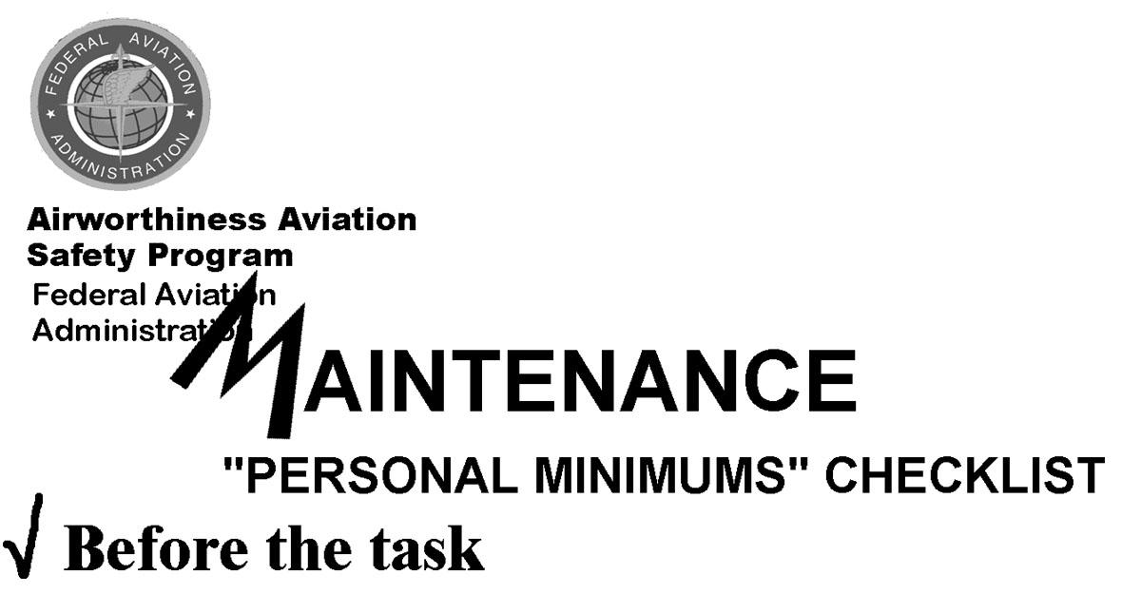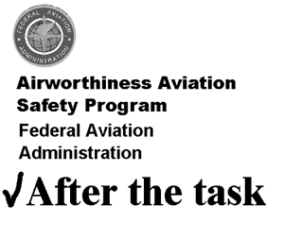
 | DO I HAVE THE KNOWLEDGE TO PERFORM THE TASK? |  |  | DID I PERFORM THE JOB TASK TO THE BEST OF MY ABILITIES?
 | DO I HAVE THE TECHNICAL DATA TO PERFORM THE TASK? |  |  | WAS THE JOB TASK PERFORMED TO BE EQUAL TO THE ORIGINAL?
 | HAVE I PERFORMED THE TASK PREVIOUSLY? |  |  | WAS THE JOB TASK PERFORMED IN ACCORDANCE WITH APPROPRIATE DATA?
 | DO I HAVE THE PROPER TOOLS AND EQUIPMENT TO PERFORM THE TASK? |  |  | DID I USE ALL THE METHODS, TECHNIQUES, AND PRACTICES ACCEPTABLE TO INDUSTRY?
 | HAVE I HAD THE PROPER TRAINING TO SUPPORT THE JOB TASK? |  |  | DID I PERFORM THE JOB TASK WITHOUT PRESSURES, STRESS, AND DISTRACTIONS?
 | AM I MENTALLY PREPARED TO PERFORM THE JOB TASK? |  |  | DID I REINSPECT MY WORK OR HAVE SOMEONE INSPECT MY WORK BEFORE RETURNING TO SERVICE?
 | AM I PHYSICALLY PREPARED TO PERFORM THE TASK? |  |  | DID I MAKE THE PROPER RECORD ENTRIES FOR THE WORK PERFORMED?
 | HAVE I TAKEN THE PROPER SAFETY PRECAUTIONS TO PERFORM THE TASK? |  |  | DID I PERFORM THE OPERATIONAL CHECKS AFTER THE WORK WAS COMPLETED?
 | DO I HAVE THE RESOURCES AVAILABLE TO PERFORM THE TASK? |  |  | AM I WILLING TO SIGN ON THE BOTTOM LINE FOR THE WORK PERFORMED?
 | HAVE I RESEARCHED THE FAR’S TO ENSURE COMPLIANCE? |  |  | AM I WILLING TO FLY IN THE AIRCRAFT ONCE IT IS APPROVED FOR THE RETURN TO SERVICE?
Figure 13-1. Personal Minimum’s Checklist

